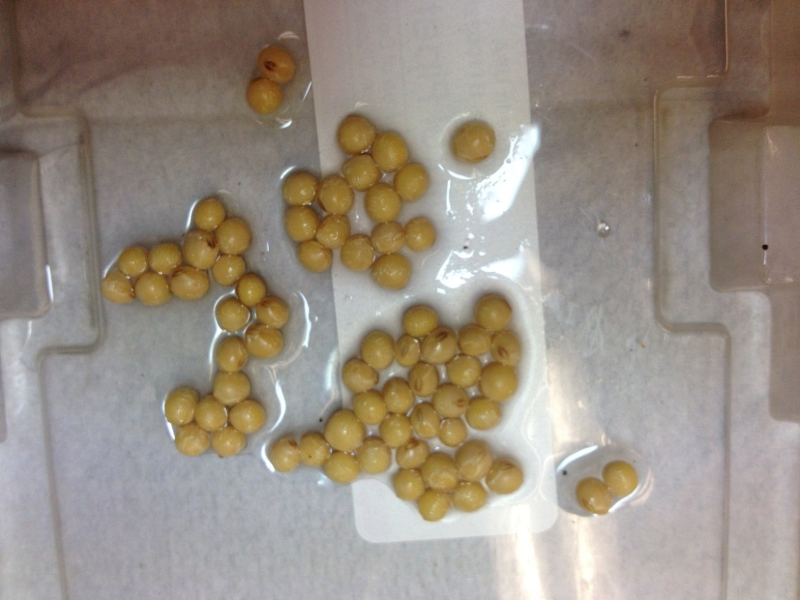
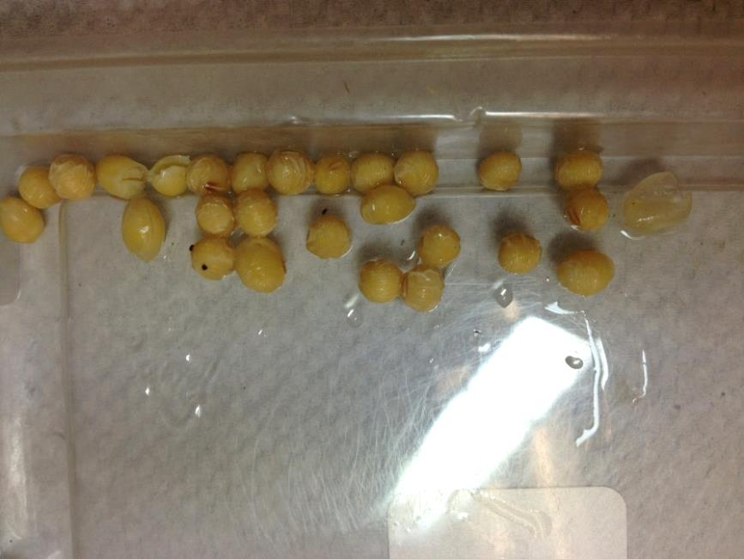
a b

Figure. 1S Soybean seeds show seed coat intact (a) and deficient (b) after soaked in 1% commercial bleach solution for ten minutes.

