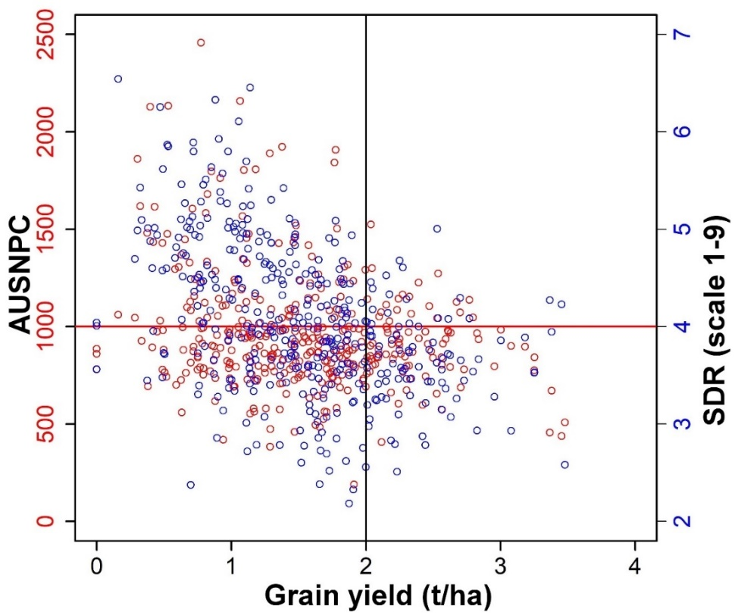
Supplementary Figure S1. Correlation of grain yield with area under Striga number progress curve (AUSNPC, in red circle) and Striga damage rating (SDR in blue circle).
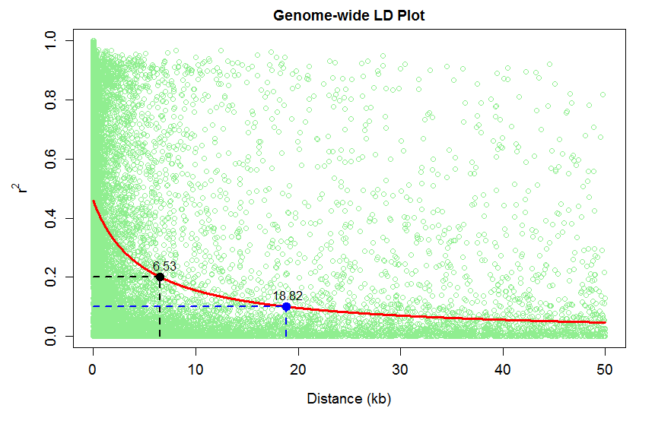
Supplementary Figure S2. Linkage disequilibrium (LD) plot representing the average genome-wide LD decay in the IMAS panel. Y axis represents the squared correlation coefficient r² while the X axis represents the physical distance on the chromosome.

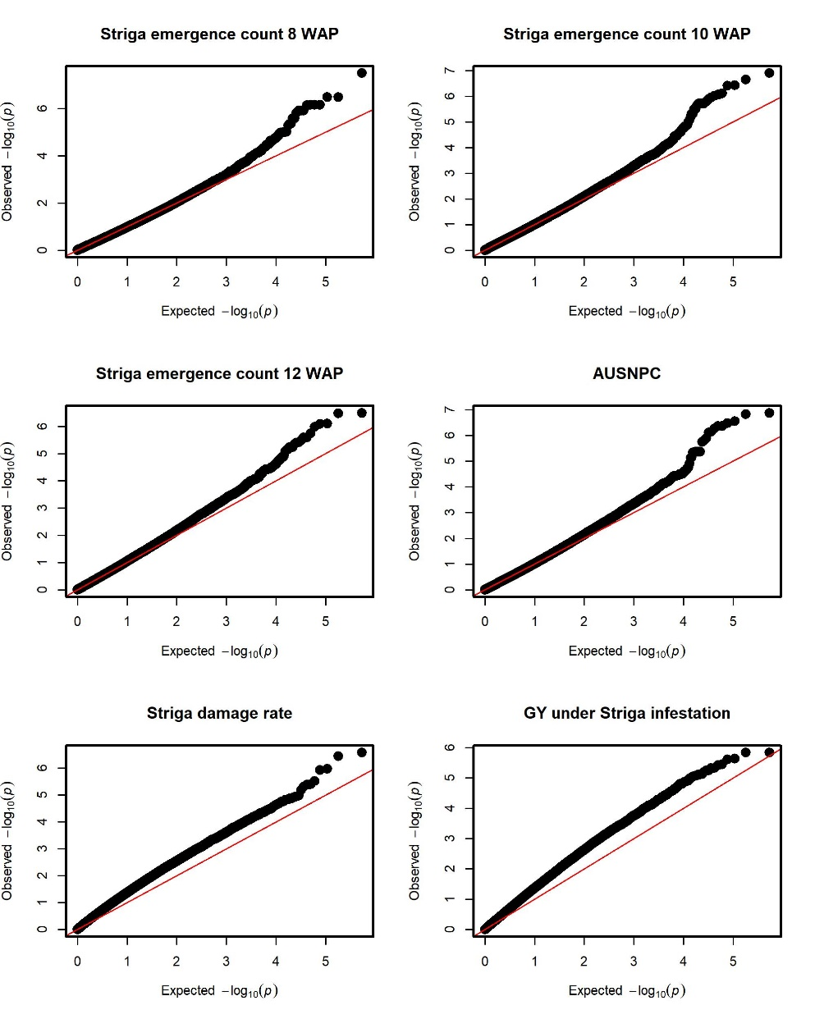
Supplementary Figure S3. Quantile-quantile plots for Striga hermonthica resistance related traits in the IMAS association panel.

