Supplementary Tables and Figures

Table S1 Primers for the markers used in this study
Marker | Position |  | Primers |  | Haplotype
KASP ª |  | FAM | VIC | COM | A10 | D10
3A-117.82 | 117,828,272 | CTCGTCGCCGTCCACCTT | CTCGTCGCCGTCCACCTC | CTCCCTTGGACATTCCCTCC | FAM | VIC
3A-118.6-R1 | 118,623,070 | CTCCTCCTCAGGCCACGG | CTCCTCCTCAGGCCACGA | CAGGTGAGACAACGAGCAGG | FAM | VIC
3A-120.2 | 120,227,651 | GTGACCTACGACGTTGGCAT | GTGACCTACGACGTTGGCAG | AGTTTTCTCTGGTCCGCTCG | FAM | VIC
3A-121.4 | 121,482,459 | CTACCTCCGCCACTGTGAG | CTACCTCCGCCACTGTGAA | GGACCTTCACTGTAGCCGAC | FAM | VIC
3A-122.540 | 122,540,617 | GTCGGATCTGTCGAGTTCTCC | GTCGGATCTGTCGAGTTCTCT | TGACAATGACGACGTGGACTA | VIC | FAM
3A-125.4-R1 | 125,402,254 | TCATGGACCTTGTCGATGCTA | TCATGGACCTTGTCGATGCTG | CCCAGCACCGACCTCACA | VIC | FAM
3A-126.5-L4 | 126,567,437 | GTCTAGCCGTCGCCGATC | GTCTAGCCGTCGCCGATG | TGCACCCATCTCAAATTTCCG | VIC | FAM
3A-127.8 | 127,821,835 | TAAGGAAGAAGAAGGCCCCA | TAAGGAAGAAGAAGGCCCCG | AAGACGCTCATCGCCCGT | FAM | VIC
CAPS |  | Forward | Reverse | Restriction enzyme | Band | Band
3A-121.64 | 121,646,195 | GGGTTCTTTGATACTGGCAATGT | AGCTTCGGGGTACTGCTGT | BssHII ^{b} | Low | High
FT-A2-L4 | 122,542,102 | GAGTCCTGTTTCCGTCTTCCCT | GTGTTGCCCATCTCGAATAT | SacII ^{c} | Low | High
FT-A2-D10A | 124,172,909 | CCGGACAGAGCAATGGACTT | TGAGTAAGCAGTCTAGGAGCAT | ApaI ^{d} | Low | High
FTA2-R1 | 125,094,949 | TCGTCGTCGTCGTCATCATC | AGTGGATTCGTTTCACGCCT | Hinfl ^{e} | Low | High
ª 94 °C for 15 min, 10 cycles of: 94 °C 20 s, -0.8 °C touch down from 65 to 57 °C 1 min, and 30 cycles of: 94 °C 20s, 57 °C 1 min.
^{b} 94 °C for 5 min, 35 cycles of: 94 °C 30 s, 55 °C 30 s, 72 °C 30 s, and a final cycle of: 72 °C for 5 min.
^{c} 94 °C for 5 min, 35 cycles of: 94 °C 30 s, 55 °C 30 s, 72 °C 40 s, and a final cycle of: 72 °C for 5 min.
^{d} 94 °C for 5 min, 10 cycles of: 94 °C 30 s, -0.8 °C touch down from 65 to 57 °C 20 s, 72 °C 30 s, followed by 30 cycles of: 94 °C 30 s, 57°C for 20 s, 72 °C for 30 s, and a final cycle of: 72 °C for 5 min.
^{e} 94 °C for 5 min, 35 cycles of: 94 °C for 30 s, 55 °C 20s, 72 °C 30 s, and a final cycle of: 72 °C for 5 min.

Table S2 Evaluation of BC₁F_{3:5} homozygous sister lines from recombinant line H2-14-18-5 in a field experiment performed at UC Davis in 2021. H2-14-18-5-#3-3 was homozygous for the recombinant chromosome and H2-14-18-5-#3-3 for the non-recombinant chromosome, and both carried the FT-A2 A10 (G) allele. Control lines H2-14-#16-2 and K, H2-14-#1-4 are separate lines from family H2-14 homozygous for the FT-A2 D10 (K) or the FT-A2 A10 (G) alleles, respectively.
Marker | Chr. 3AS CS | H2-14-18-5 | H2-14-18-5 | H2-14 | H2-14
Marker | Chr. 3AS CS | #3-3 | #3-5 | #16-2 | #1-4
3A-117.82 | 117,828,272 | K | G | K | G
3A-120.23 | 120,227,651 | K | G | K | G
3A-121.48 | 121,482,459 | G | G | K | G
FT-A2 | 124,172,909 | G | G | K | G
SNS PHENO. |  | G | G | K | G
3A-127.8 | 127,821,835 | G | G | K | G
Number of plants |  | 30 | 48 | 49 | 38
SNS Avg |  | 22.69 | 23.23 | 21.72 | 23.19
P values D10 (K) vs A10 (G) |  | 0.8056 |  | < 0.0001

Supplementary Figures

Fig. S1 Expression levels of FT2 homeologs in hexaploid (Chinese Spring) and tetraploid wheat (Kronos) a Transcript levels of FT-A2, FT-B2 and FT-D2 in leaves, spikes and stems and three developmental stages (Choulet et al. 2014). Developmental stages are based on Zadok’s scale z10= seedling, z23= three tillers, z30= spike 1 cm, z32= two nodes, z39= meiosis, z65= anthesis, z71= two days after anthesis (Zadok et al. 1974). b Quant-Seq data from developing spikes of Kronos spring line vrn1 vrn2 (Li et al. 2020). c Unpublished RNAseq from our lab at the same spike development stages in Kronos wild type (Vrn-A1). VEG = vegetative stage, DR = double ridge, PDR = post-double ridge, and TS = terminal spikelet stage. TPM= transcripts per million. Values are transcripts per million based on four biological replications per stage in each experiments and error bars are s.e.m.

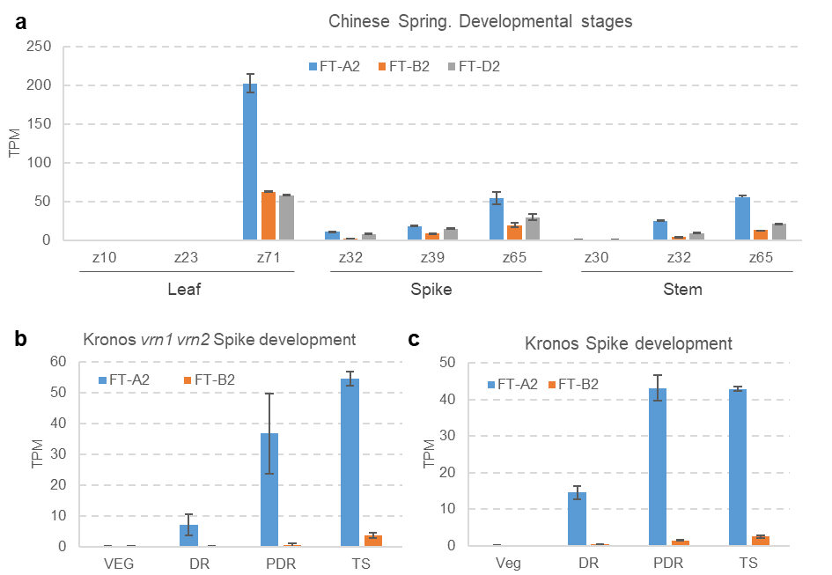

References Fig. S1
Choulet F et al. 2014. Structural and functional partitioning of bread wheat chromosome 3B. Science 345:1249721
Zadoks JC, Chang TT, Konzak CF. 1974.A decimal code for the growth stages of cereals. Weed Res. 14: 415-21.
Li K, Debernardi JM, Li C, Lin H, Zhang C, Dubcovsky J. 2020 Interactions between SQUAMOSA and SVP MADS-box proteins regulate meristem transitions during wheat spike development. bioRxiv:2020.2012.2001.405779

Fig. S2 Yeast-two-hybrid interactions between FT-A2 and six 14-3-3 proteins. FT-A2 alleles D10 and A10 were used as baits and the six different 14-3-3 proteins as preys. Selection for yeast transformants containing both bait and prey vectors was performed in SD medium lacking Leucine and Tryptophan (-L-W). Interaction strength was tested on SD media lacking Leucine, Tryptophan, Histidine and Adenine (-L-W-H-A). As positive control, we used FT1 as bait and 14-3-3A as pray. As negative controls we tested the FT-A2 alleles D10 and A10 against the empty vector LAW11.

