Online resource 2

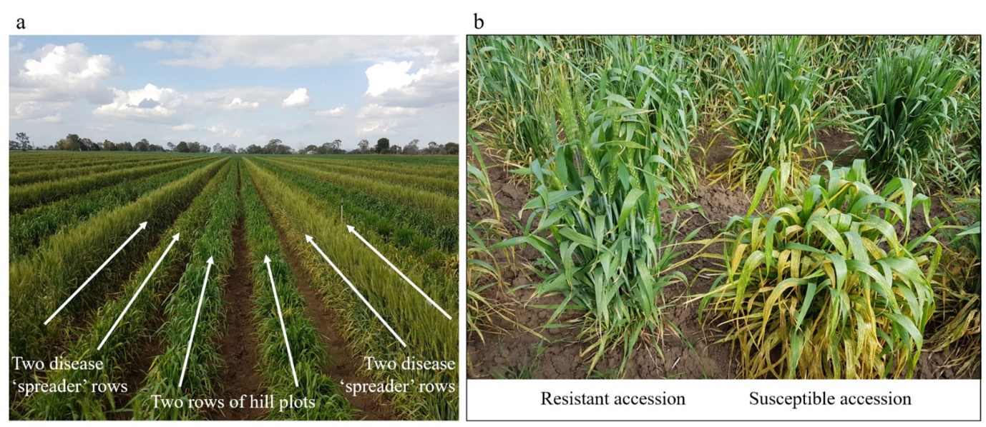

Phenotyping adult wheat plants for resistance to stripe rust in the field. (a) The layout of rust spreader rows and hill plots of test material to maximise infection throughput the screening nursery. (b) Examples of Vavilov wheat accessions showing highly resistant and susceptible responses to stripe rust disease.

