Supplementary Figures

Supplementary Figure 1 LD decay plots showing differences in the LD decay distance. A. An overall LD decay distance of 250 kbp. B. LD decay distance of 388 kbp for sub-genome A. C. LD decay distance of 177 kbp for sub-genome B
Supplementary Figure 2 Manhattan and QQ plots generated after marker-trait-association (MTA) using BLUPs from phenotypic data collected from Serere. No obvious peaks were detected. Ai. Manhattan plot generated using Serere 2020A data. Aii. Corresponding QQ plot generated using observed data for 2020A versus expected. Bi. Manhattan plot generated using Serere 2020B data. Bii. Corresponding QQ plot generated using observed data for 2020B versus the expected. Ci. Manhattan plot generated using combined dataset from Serere 2020A and 2020B datasets. Cii. Corresponding QQ plot generated by plotting observed means for 2020A and 2020B versus the expected

Supplementary Figure 3 Box plots drawn for the identified haplotypes showing clear differences between the favorable haplotypes (AAAA, CCT, CCA and CTGTCGCA) and alternative haplotypes across the different seasons tested

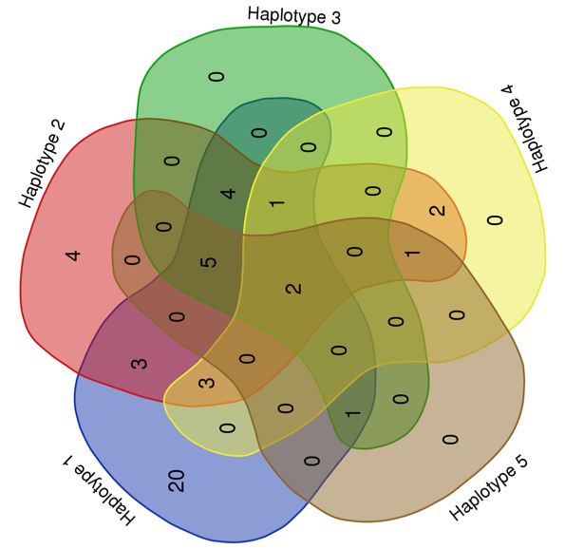

Supplementary Figure 4. A Venn diagram showing the number of genotypes harboring different haplotypes, and how the haplotypes are shared among them

