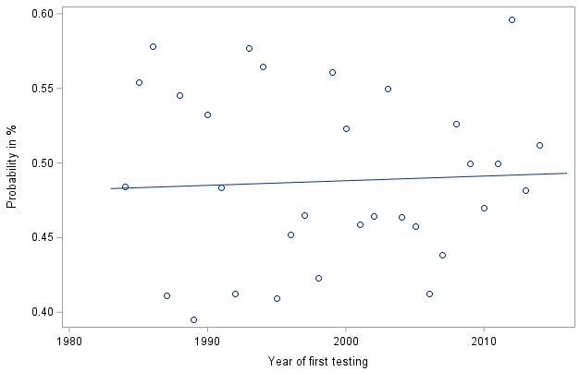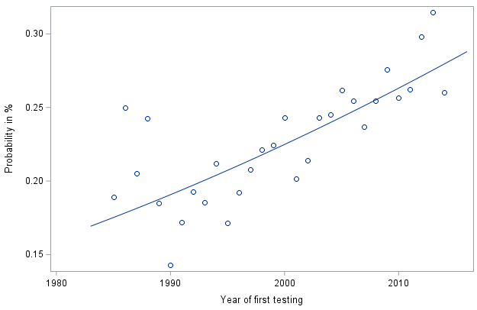
Figure S1: Probability that a genotype tested in the first year is tested in the (a) second and (b) third year. A logistic regression was fitted in (a) with $logit\left(p_{year}\right)=-2.54+0.0012∙year$, the slope was non-significant (p=0.7681) and (b) with $logit\left(p_{year}\right)=-42.80+0.0208∙year$, the slope was significant (p=0.0005).

Table S1: Simulated and average estimated variance component (VC) values as well as simulated, estimated trends, the mean squared error (MSE) of estimated genotype best linear unbiased predictions (BLUPs) for simulated datasets I, I-1 and I-2 across 500 simulations.
Parameter | Values used for simulation | Estimate for dataset (95% confidence interval)
Parameter | Values used for simulation | I | I-1 | I-2
Variance component
Year | 25.13 | 25.19 (24.57;25.81) | 25.45 (24.81;26.06) | 25.50 (24.85;26.14)
Location | 53.15 | 53.59 (52.81;54.36) | 53.74 (52.96;54.52) | 53.67 (52.89;54.44)
Year-by-location | 74.14 | 74.20 (73.89;74.51) | 73.73 (73.83;74.45) | 74.28 (73.96;74.59)
Year-by-location-by-trial | 8.83 | 8.73 (8.66;8.79) | 8.83 (8.76;8.90) | 8.70 (8.63;8.76)
Genotype | 13.27 | 13.38 (13.23;13.30) | 5.31 (5.21;5.40) | 5.41 (5.30;5.52)
Genotype-by-year | 55.75 | 55.67 (55.52;55.82) | 52.39 (52.24;52.53) | 52.01 (51.84;52.19)
Genotype-by-location | 2.25 | 2.52 (2.51;2.53) | 2.56 (2.54;2.57) | 2.54 (2.52;2.55)
Genotype-by-year-by-location | 9.62 | 18.68 (18.67;18.70) | 18.55 (18.63;18.66) | 18.65 (18.63;18.67)
Error | 9.36 | 18.68 (18.67;18.70) | 18.55 (18.63;18.66) | 18.65 (18.63;18.67)
Trend
Genetic | 0 | 0.002 (-0.005;0.009) | 0.525 (0.518;0.532) | 0.640 (0.633;0.647)
Non-genetic | 0 | -0.000 (-0.011;0.010) | -0.531 (-0.542;-0.521) | -0.667 (-0.678;-0.657)
Evaluation criterion
MSE§ | - | 7.51 (6.71;8.31) | 11.87 (10.62;13.12) | 13.46 (12.08;14.84)
Note. The datasets I-1 and I-2 were created from I by dropping genotypes tested up to one or two years, respectively. Values printed in bold have a confidence interval that does not include the value used for simulation. Values in parenthesis represent the 95% confidence interval. Values are given in dt² ha⁻² for VC and MSE and dt ha⁻¹ year⁻¹ for trend estimates.
§ Mean squared error between genotype BLUPs and simulated true values.

