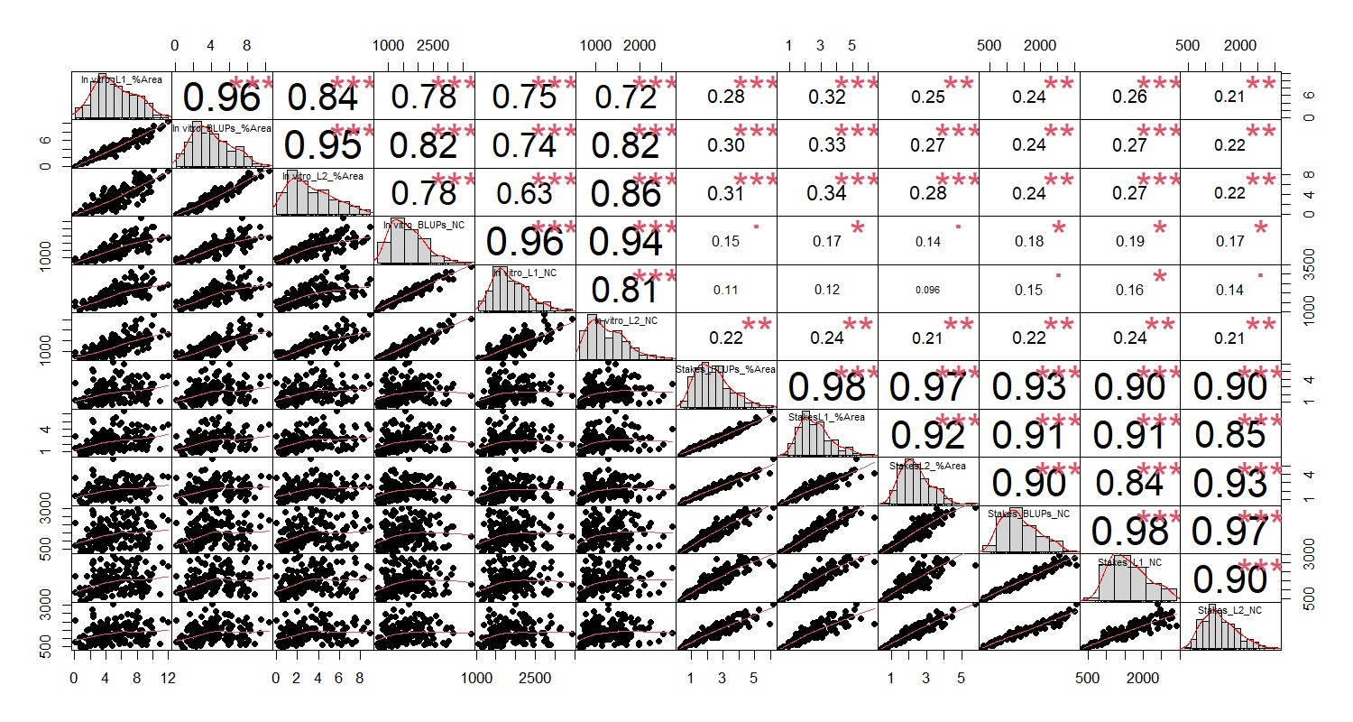
Fig. S1 Correlation among different traits used in mapping

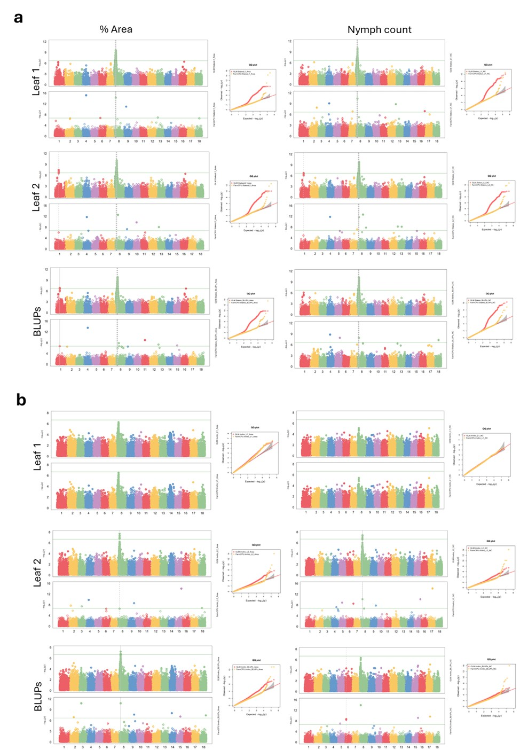

Fig. S2 Manhattan and respective QQ plots for GWAS of 12 traits using GLM and FarmCPU models in plants propagated from a) stakes and b) in vitro. The horizontal continuous line represents the Bonferroni threshold

