Supplementary data

Supplementary Figures
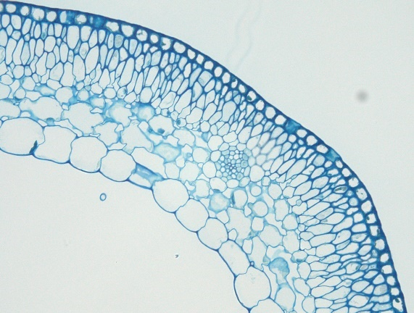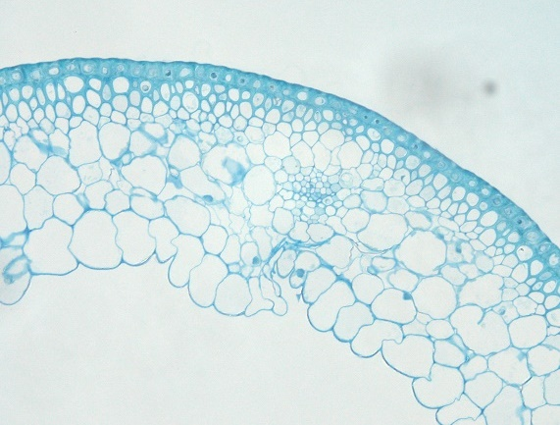
WT
M4IGRI_11
Palea
Lemma
Supplementary Fig. 1 Palea and lemma transverse sections of wild-type Igri (WT) and the pendant awn mutant M4IGRI_11 (M). Toluidine blue-stained cross sections of palea and lemma from WT and pendant awn mutants showing vascular bundles surrounded by parenchyma cells. Arrow heads indicate variable cell wall thickenings and cell layering patterns visible across the WT and mutant organs. Images acquired at 40x magnification. Black bar=50 µm.
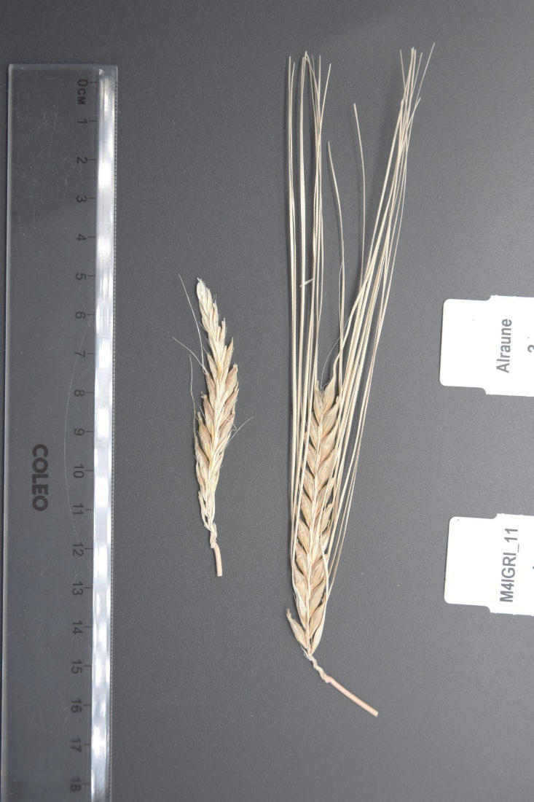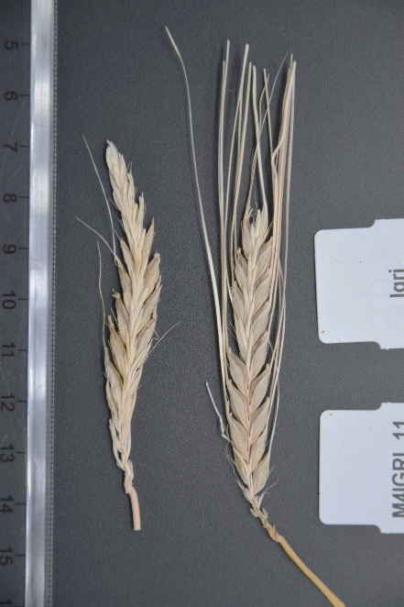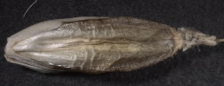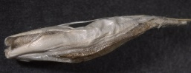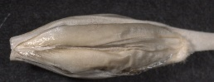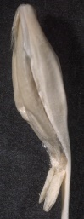
a
b
c
d
e
f
Supplementary Fig. 2 The pendant awn mutation alters spike fertility and grain development. Mature and dried spikes from the primary tillers of the a) M4IGRI_11 mutant (left) and wild-type Alraune (right), b) M4IGRI_11 mutant (left) and wild-type Igri (right). Awns from wild-type spikes were trimmed before image acquisition. Grains harvested from c,d) wild-type Igri and e,f) M4IGRI_11 mutant plants. Yellow bar=1 mm.
***
***
***
Supplementary Fig. 3 Differences in flag leaf area, length and width between the wild-type Igri and the M4IGRI_11 mutants. Area, length and width of flag leaves of the mutant M4IGRI_11 (gray; n=8) and the wild-type Igri (green; n=11). Asterisks indicate significant statistical differences (Welch’s t-test; α=0.05).

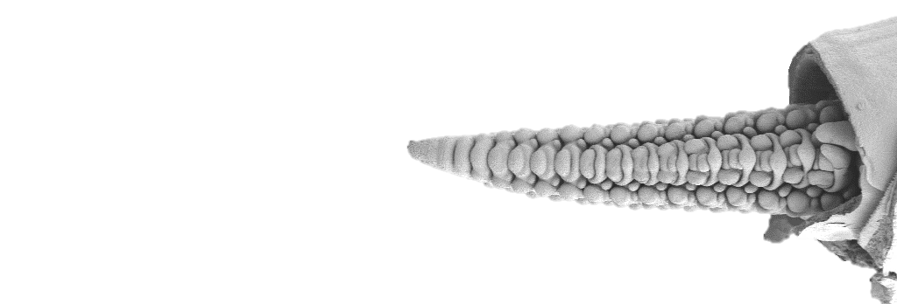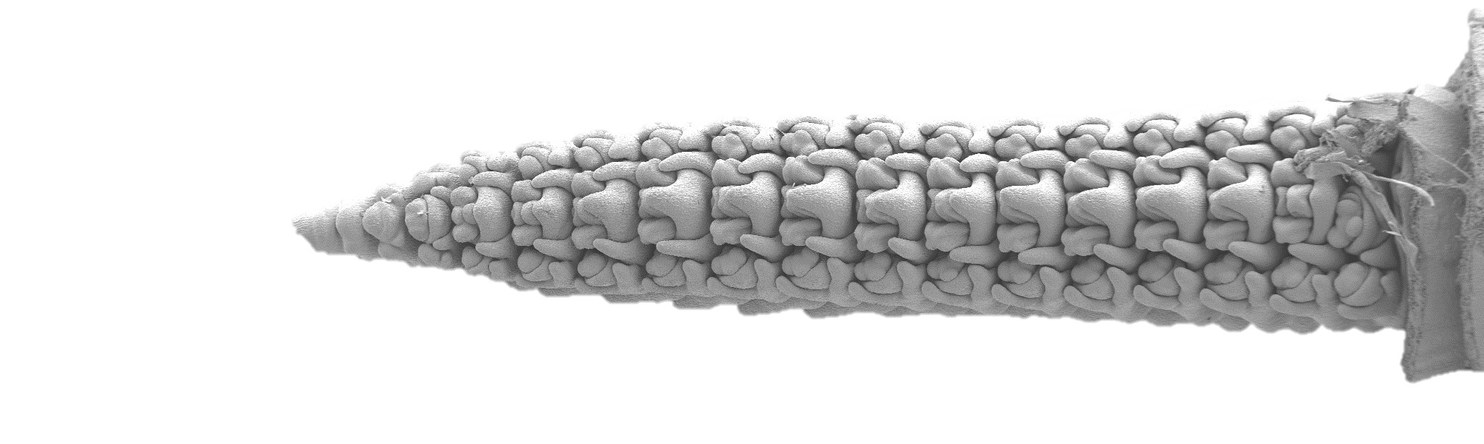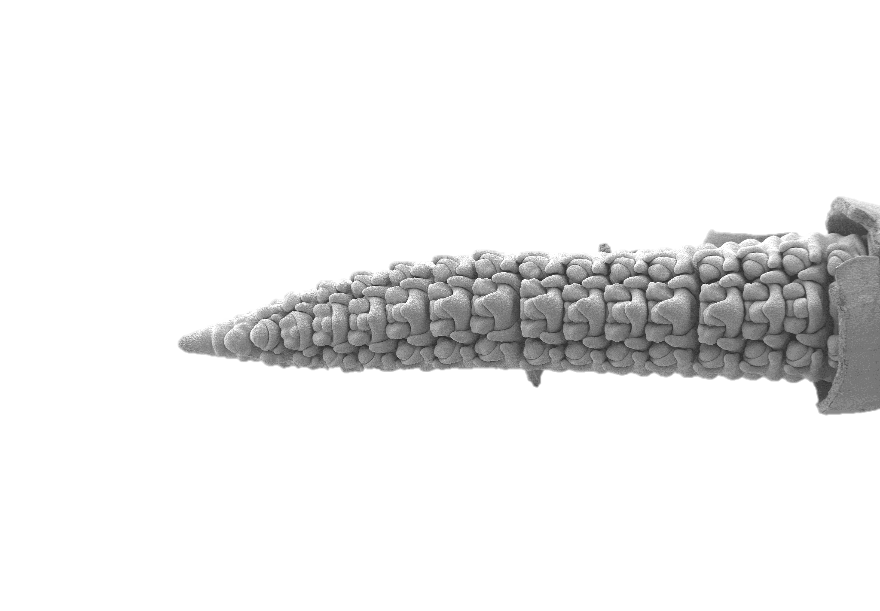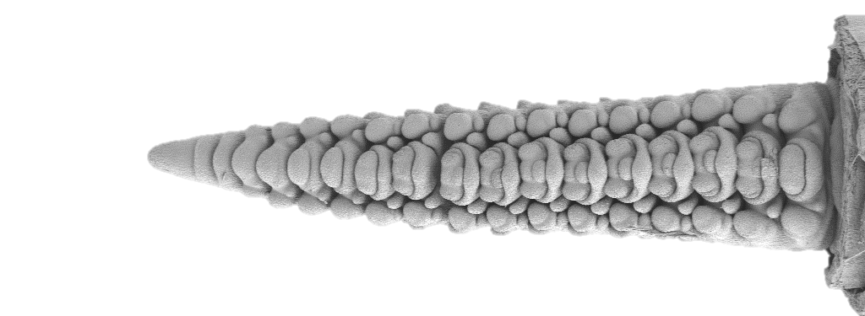
W4.0
WT
M
W4.5
WT
M
a
b
c
d
Supplementary Fig. 4 Scanning electron micrographs from immature spike meristems of wild-type Igri (WT) and the M4IGRI_11 pendant awn mutant (M). Representative images of immature spike meristems dissected from the primary tillers of WT and M) at Waddington stages a,b) W4.0 and c,d) W4.5 Spikes were sampled from plants grown under greenhouse conditions (16°C-20°C, long-day photoperiod; 16 h light) with a six-week vernalization period (4°C, 10 h light). White bar=1 mm.

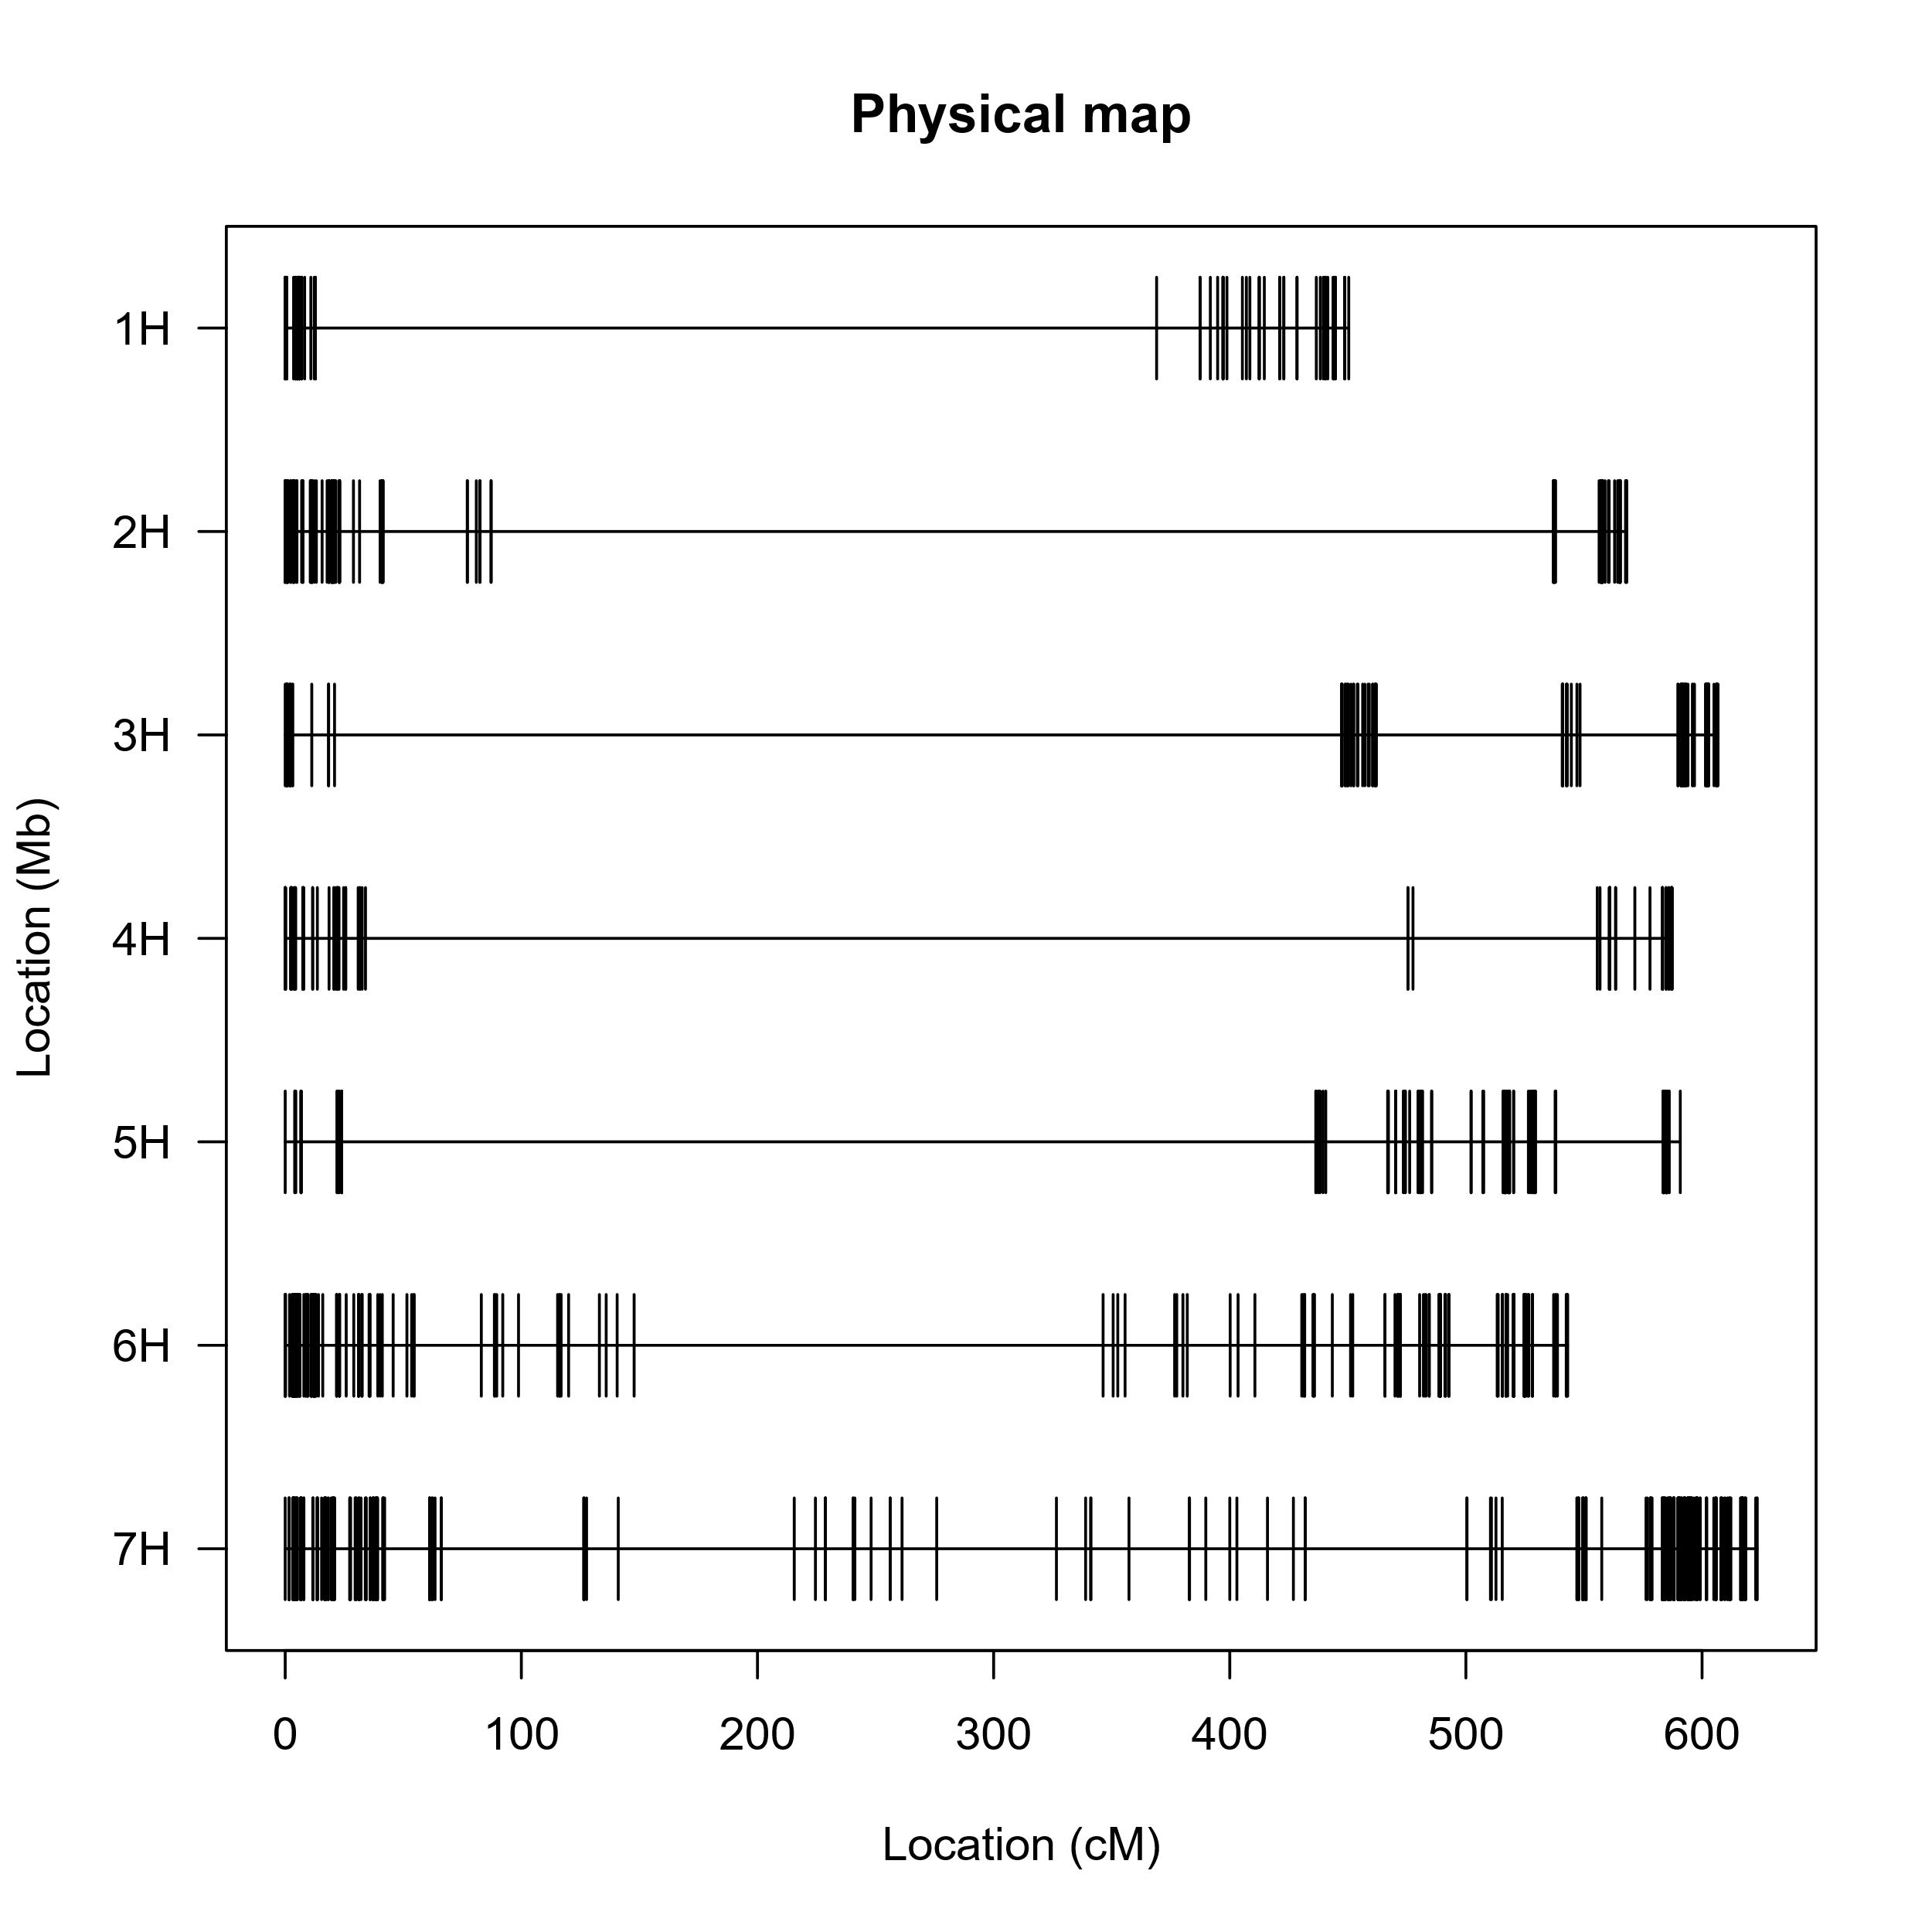
Chromosomes
Physical position (Mbp)
Supplementary Fig. 5 Genome-wide distribution and physical coordinates of 1,128 high-confidence SNP markers used for mapping the pendant awn trait in the F₂ population. The physical positions in Megabase pairs (Mbp) of the markers along the seven chromosomes (1H-7H) of barley are shown as black vertical lines, based on the Igri reference genome assembly (Jayakodi et al., 2024).

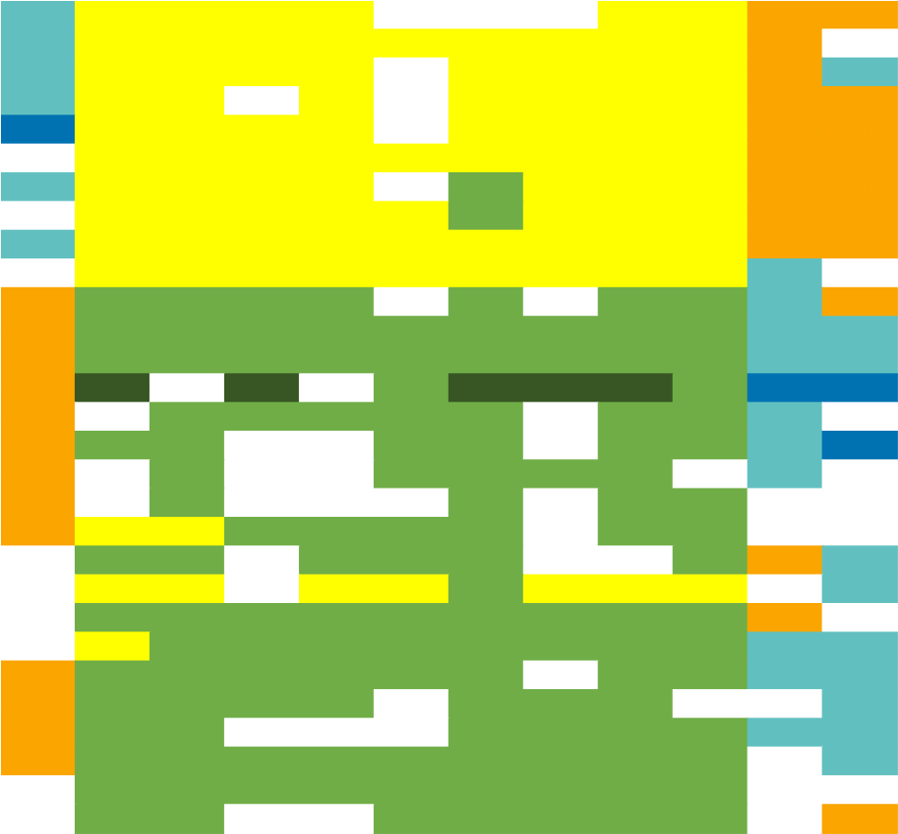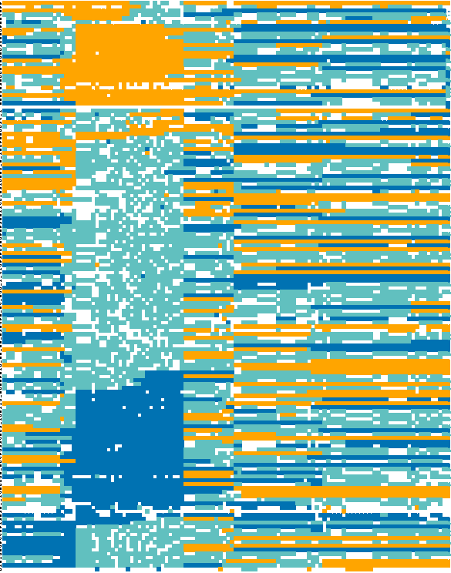
F₂ individuals
Pendant awn (n=10)
Wild-type (n=19)
23.3
59.4
84.7
103.0
247.7
266.4
285.8
325.8
375.2
441.6
449.8
463.9
365.1 Mbp
b
AA (Homozygous wild-type)
Aa (Heterozygous)
aa (Homozygous mutant)
AA (Homozygous wild-type)
Aa (Heterozygous)
aa (Homozygous mutant)
GBS markers:
KASP markers:
a
Pendant awn (n=27)
Wild-type (n=119)
Markers along chromosome 3H
F₂ individuals
440.6 Mbp
23.3
463.9
Supplementary Fig. 6 Graphical genotypes of GBS- and KASP-based SNP markers in the F₂ mapping population along chromosome 3H. a) Genotypes of 114 GBS-based markers across 146 phenotyped F₂ individuals derived from the Alraune x M4IGRI_11_11 cross. b) Genotypes of a subset of 29 individuals selected based on presence of recombination events within the 440.6 Mbp interval, using a combination of three GBS based and nine KASP markers. F₂ individuals are grouped based on their phenotype, with those showing the pendant awn (top) and the wild-type phenotype (bottom). Dark blue and dark green blocks represent homozygous calls for the wild-type Alraune, orange and yellow for the homozygous mutant type, and turquoise blue and light green for heterozygous calls from GBS- and KASP-based markers, respectively. White indicates missing genotyping calls. Vertically oriented black boxes are the intervals which were significantly associated with the pendant awn trait based on linkage mapping. Marker positions are shown as numeric values based on their physical coordinates in Megabase pairs (Mbp) along chromosome 3H as per the Igri reference genome assembly (Jayakodi et al., 2024).

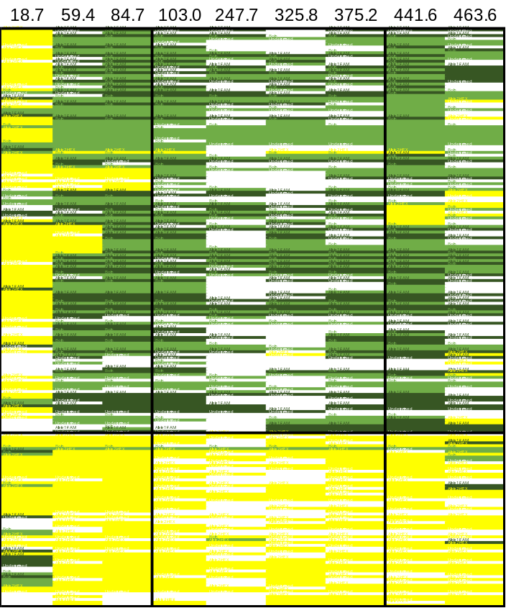
Pendant awn (n=61)
Wild-type (n=142)
F₃ individuals
356.8 Mbp
AA (Homozygous wild-type)
Aa (Heterozygous)
aa (Homozygous mutant)
KASP markers:
Supplementary Fig. 7 Graphical genotypes KASP-based SNP markers in F₃ individuals phenotyped for the wild-type and pendant awn trait. Genotypes of 9 KASP-based markers across 203 phenotyped F₃ progenies derived from 29 F₂ recombinants within the previously delimited 440.6 Mbp interval. White blocks indicate missing genotyping calls. Marker positions are shown as numeric values based on their physical coordinates in Megabase pairs (Mbp) along chromosome 3H as per the Igri reference genome assembly (Jayakodi et al., 2024).

Supplementary Tables
Supplementary Table 1 Chi-squared ($χ$²) test evaluating Mendelian monogenic inheritance of the pendant awn trait in the F₂ population.
Phenotype | No. F₂ individuals | Observed [%] | Expected [%] | $χ$^{2*}
Pendant awn | 28 | 18.79 | 25 | 2.30
Wild-type | 121 | 81.21 | 75 | 0.77
Total | 149 | 100 | 100 | 3.06
*df=1, $χ_{0.95;1;two-sided }^{2}$=5.025. Observed segregation ratios were tested against the expected 3:1 ratio (wild-type:mutant phenotype) under the hypothesis of a single recessive gene. The table includes the number of individuals scored, observed and expected counts for each phenotype and the $χ$² values.

Supplementary Table 2 Chromosome-wise counts of GBS-based SNP markers used in the F₂ mapping population.
Chromosome | Unfiltered SNPs | Filtered SNPsª
chr1H | 25,498 | 85
chr2H | 32,072 | 130
chr3H | 29,654 | 114
chr4H | 28,079 | 85
chr5H | 29,430 | 115
chr6H | 31,961 | 225
chr7H | 38,440 | 374
chrUn^{b} | 640 | 0
Total | 215,774 | 1,128
ª High-confidence SNP markers with mapping quality ≥ 20, excluding all InDels and including SNP calls with read depth ≥ 5, missingness ≤ 76 % and minor allele frequency ≥ 5 %.
^{b} Unanchored contigs that could not be assigned to any of the seven barley chromosomes (chr1H-chr7H).
Supplementary Table 3 Summary of phenotyping experiments with F₃ progeny originating from 29 F₂ individuals recombinant within the target interval.
Selected F₂ parents | F₂ Phenotype | No. F₃ seeds sown | No. F₃ plants left after vernalization | No. F₃ progeny with pendant awns | % Pendant awn mutants
MZ44-12_2_25 | Mutant | 2 | 1 | 1 | 100.0
MZ44-12_2_48 | Mutant | 2 | 2 | 2 | 100.0
MZ44-12_2_53ª | Mutant | 3 | 2 | 2 | 100.0
MZ44-12_2_66 | Mutant | 3 | 1 | 1 | 100.0
MZ44-12_2_69 | Mutant | 13 | 4 | 4 | 100.0
MZ44-12_2_80 | Mutant | 14 | 5 | 5 | 100.0
MZ44-12_2_83 | Mutant | 12 | 6 | 6 | 100.0
MZ44-12_2_143 | Mutant | 2 | 1 | 2 | 100.0
MZ44-12_2_158 | Mutant | 6 | 1 | 1 | 100.0
MZ44-12_2_178ª | Mutant | 12 | 5 | 5 | 100.0
MZ44-12_2_1 | Wild | 14 | 8 | All WT | 0.0
MZ44-12_2_8 | Wild | 15 | 7 | 1 | 16.7
MZ44-12_2_11 | Wild | 15 | 8 | 2 | 25.0
MZ44-12_2_20 | Wild | 15 | 10 | 1 | 10.0
MZ44-12_2_31ª | Wild | 15 | 9 | 1 | 11.1
MZ44-12_2_35 | Wild | 15 | 13 | 3 | 23.1
MZ44-12_2_42 | Wild | 15 | 14 | 5 | 35.7
MZ44-12_2_54 | Wild | 15 | 11 | 3 | 27.3
MZ44-12_2_55 | Wild | 15 | 6 | 1 | 16.7
MZ44-12_2_63ª | Wild | 7 | 5 | All WT | 0.0
MZ44-12_2_95 | Wild | 15 | 9 | 2 | 22.2
MZ44-12_2_99 | Wild | 15 | 12 | 2 | 15.4
MZ44-12_2_109ª | Wild | 15 | 11 | 2 | 15.4
MZ44-12_2_113 | Wild | 15 | 14 | 2 | 14.3
MZ44-12_2_144 | Wild | 15 | 10 | 1 | 10.0
MZ44-12_2_148 | Wild | 4 | 3 | 1 | 25.0
MZ44-12_2_156 | Wild | 15 | 4 | 1 | 25.0
MZ44-12_2_167 | Wild | 15 | 7 | All WT | 0.0
MZ44-12_2_174 | Wild | 15 | 10 | 3 | 27.3
ªRemoved due to sampling discrepancies.

Supplementary Table 4 Sequencing and mapping statistics from the whole-genome re-sequencing of selected EMS mutants and the wild-type parent controls. Three libraries per individual (indicated by suffixes A-C) were generated and pooled for sequencing.
Sample name | Raw reads [M] | Trimmed reads [M] | Trimming rate [%] | Duplication rate [%] | Coverage without duplicates [x] | Mapped reads [%]
Alraune-A | 129 | 127 | 1.79 | 57.91 | 5.44 | 88.35
Alraune-B | 134 | 131 | 1.7 | 58.96 | 5.34 | 88.36
Alraune-C | 113 | 111 | 1.66 | 57.04 | 3.54 | 88.38
M3IGRI_3_17_1-A | 574 | 566 | 1.5 | 60.08 | 10.11 | 90.63
M3IGRI_3_17_1-B | 295 | 290 | 1.82 | 56.94 | 5.19 | 91.52
M3IGRI_3_17_1-C | 335 | 331 | 1.41 | 56.4 | 5.91 | 91.36
M4IGRI_4_19-A | 568 | 559 | 1.66 | 59.49 | 5.05 | 90.81
M4IGRI_4_19-B | 287 | 282 | 1.61 | 59.81 | 5.86 | 90.69
M4IGRI_4_10-C | 333 | 328 | 1.65 | 62.48 | 9.99 | 89.97
M4IGRI_8_12_2-A | 622 | 613 | 1.53 | 61.82 | 10.96 | 90.98
M4IGRI_8_12_2-B | 327 | 322 | 1.51 | 60.29 | 5.76 | 91.01
M4IGRI_8_12_2-C | 367 | 362 | 1.43 | 58.42 | 6.47 | 91.25
M4IGRI_10_21_2-A | 332 | 327 | 1.54 | 59.86 | 7.28 | 90.78
M4IGRI_10_21_2-B | 477 | 470 | 1.6 | 58.29 | 3.68 | 91.18
M4IGRI_10_21_2-C | 253 | 249 | 1.57 | 58.61 | 5.85 | 90.69
M4IGRI_11_11-A | 477 | 470 | 1.55 | 62.76 | 8.4 | 90.69
M4IGRI_11_11-B | 253 | 249 | 1.65 | 57.95 | 4.46 | 91.26
M4IGRI_11_11-C | 423 | 417 | 1.42 | 62.36 | 7.45 | 90.99
I-2821-6_2_1-A | 577 | 568 | 1.62 | 57.67 | 10.15 | 91.82
I-2821-6_2_1-B | 314 | 308 | 1.63 | 56.3 | 5.52 | 92.28
I-2821-6_2_1-C | 363 | 357 | 1.61 | 57.22 | 6.39 | 92.05
Supplementary Table 5 Summary statistics of high-confidence genome-wide variations unique to M4IGRI_11_11.
Variant type | chr 1H | chr 2H | chr 3H | chr 4H | chr 5H | chr 6H | chr 7H | chr Unn | Total
C→Tª | 526 | 128 | 393 | 42 | 388 | 498 | 470 | 31 | 2,476
G→Aª | 443 | 73 | 386 | 75 | 344 | 187 | 223 | 25 | 1,756
Other transitions^{b} | 374 | 24 | 66 | 14 | 54 | 70 | 137 | 37 | 776
Transversions | 816 | 167 | 450 | 106 | 467 | 450 | 595 | 158 | 3,209
Insertions | 94 | 40 | 31 | 31 | 29 | 33 | 39 | 161 | 458
Deletions | 207 | 197 | 163 | 136 | 150 | 143 | 174 | 151 | 1,321
 | 2,460 | 629 | 1,489 | 404 | 1,432 | 1,381 | 1,638 | 563 | 9,996
ª Canonical C to T/G to A transitions characteristic to EMS-induced mutagenesis.
^{b} All SNPs other than C to T/G to A transitions.

Supplementary Table 6 Effect predictions of single nucleotide variants (SNVs) and insertions and deletions (InDels) within the 356.8 Mbp target interval on chromosome 3H.
 | No. variant effects
Predicted mutation effect | SNVs | InDels
Stop codon gained | 1 | 0
Missense | 2 | 0
Synonymous | 6 | 0
Intron | 10 | 2
Downstreamª | 21 | 7
Upstreamª | 14 | 3
Intergenic | 802 | 91
Total | 856^{b} | 103
ª Variants within ±5 Kb of the translation start and stop sites.
^{b} Contains four overlaps.

Supplementary Table 7 Summary of plant lines used for whole-genome re-sequencing.
Name | Phenotype | Generation
Igri | Wild-typeª | P
Alraune | Wild-typeª | P
M4IGRI_11_11 | Pendant awn | M₅
I-2821_6_2_1 | Short awned^{b} | M₆
M3IGRI_3_17_1 | Glume-to-lemma^{b} | M₆
M4IGRI_4_10 | Leafy lemma^{b} | M₅
M4IGRI_8_12_2 | Leafy lemma^{b} | M₆
M4IGRI_10_21_2 | Yellow striped^{b} | M₆
ª Wild-type parental controls.
^{b} Non-pendant awn mutants from the same Igri-EMS population used as controls.

Supplementary Table 8 Primer sequences used for KASP genotyping assays targeting SNP markers linked to the pendant awn trait in barley. Each marker is represented by a pair of allele-specific forward primers (Allele-1 and Allele-2) and a shared reverse primer.
No. | Position (Mbp) | Primer | Sequence (5'→3')
1 | 187.5 | Allele-1 | GAAGGTGACCAAGTTCATGCTCAATATATGCCCTAAGAGCATCTAAAG
1 | 187.5 | Allele-2 | GAAGGTCGGAGTCAACGGATTAACAATATATGCCCTAAGAGCATCTAAAA
1 | 187.5 | Reverse | CGCGGATGCGTCCGTAGACATT
2 | 594.8 | Allele-1 | GAAGGTGACCAAGTTCATGCTGGAGATATCATGATTCACTTTATAAGTTTC
2 | 594.8 | Allele-2 | GAAGGTCGGAGTCAACGGATTAAGGAGATATCATGATTCACTTTATAAGTTTT
2 | 594.8 | Reverse | CGTGAATTTGAATATTGTGATGAAGTGTTA
3 | 84.7 | Allele-1 | GAAGGTGACCAAGTTCATGCTGATTTTGATTTTATTCTTTTTGCTACGGC
3 | 84.7 | Allele-2 | GAAGGTCGGAGTCAACGGATTGTGATTTTGATTTTATTCTTTTTGCTACGGT
3 | 84.7 | Reverse | TACTCCACAGTAAGATATAATCACTAGGAA
4 | 103 | Allele-1 | GAAGGTGACCAAGTTCATGCTTTCATGTCGGGATTGCTCCCG
4 | 103 | Allele-2 | GAAGGTCGGAGTCAACGGATTTCATGTCGGGATTGCTCCCA
4 | 103 | Reverse | CTAGTGGTTATGGGGGTGGCTATTT
4ª | 103 | Allele-1 | GAAGGTGACCAAGTTCATGCTGTTATGGGGGTGGCTATTTATAGTC
4ª | 103 | Allele-2 | GAAGGTCGGAGTCAACGGATTGGTTATGGGGGTGGCTATTTATAGTT
4ª | 103 | Reverse | GGCATTAATGTCATTTCATGTCGGGATT
5 | 156 | Allele-1 | GAAGGTGACCAAGTTCATGCTATGCCCGGTCCGCATCCTC
5 | 156 | Allele-2 | GAAGGTCGGAGTCAACGGATTGATGCCCGGTCCGCATCCTT
5 | 156 | Reverse | GCAGTTGGTCGCCACCGAGTTA
5ª | 156 | Allele-1 | GAAGGTGACCAAGTTCATGCTGTCGCCACCGAGTTAACGACG
5ª | 156 | Allele-2 | GAAGGTCGGAGTCAACGGATTGTCGCCACCGAGTTAACGACA
5ª | 156 | Reverse | ACATACGATGCCCGGTCCGCAT
6ª | 194.9 | Allele-1 | GAAGGTGACCAAGTTCATGCTGCGCCACCATTTGAGCCATAAC
6ª | 194.9 | Allele-2 | GAAGGTCGGAGTCAACGGATTGGCGCCACCATTTGAGCCATAAT
6ª | 194.9 | Reverse | GCTATGGTACTAGCGGTGGCCAT
6 | 194.9 | Allele-1 | GAAGGTGACCAAGTTCATGCTGCCATGGCCCTAGCAGCTG
6 | 194.9 | Allele-2 | GAAGGTCGGAGTCAACGGATTGGCCATGGCCCTAGCAGCTA
6 | 194.9 | Reverse | ATAGGCGCCACCATTTGAGCCATAA
7 | 223.3 | Allele-1 | GAAGGTGACCAAGTTCATGCTCAAGTTCCGCCTCGTGAC
7 | 223.3 | Allele-2 | GAAGGTCGGAGTCAACGGATTGCTCAAGTTCCGCCTCGTGAT
7 | 223.3 | Reverse | AAAATTAGGGAGGAGCTTTTTCGTGGATT
7ª | 223.3 | Allele-1 | GAAGGTGACCAAGTTCATGCTTTTTCGTGGATTCGCCGTCG
7ª | 223.3 | Allele-2 | GAAGGTCGGAGTCAACGGATTGCTTTTTCGTGGATTCGCCGTCA
7ª | 223.3 | Reverse | CGGAGCTCTAGATTGATTCTGCTCAA
8 | 247.8 | Allele-1 | GAAGGTGACCAAGTTCATGCTCTGTGATGGCAGACGGCAAAG
8 | 247.8 | Allele-2 | GAAGGTCGGAGTCAACGGATTGTCTGTGATGGCAGACGGCAAAA
8 | 247.8 | Reverse | CCTCCGGTGTCAATCACTATAGGAA
9 | 266.4 | Allele-1 | GAAGGTGACCAAGTTCATGCTAACAAAGATATATTTTTCTTCAATCTTGTTCC
9 | 266.4 | Allele-2 | GAAGGTCGGAGTCAACGGATTGAACAAAGATATATTTTTCTTCAATCTTGTTCT
9 | 266.4 | Reverse | CACCAAGCTGAAATGTCAATCTTCACAAT
10 | 285.8 | Allele-1 | GAAGGTGACCAAGTTCATGCTACCACCGCTTGAAAAAGTATTCGC
10 | 285.8 | Allele-2 | GAAGGTCGGAGTCAACGGATTCTACCACCGCTTGAAAAAGTATTCGT
10 | 285.8 | Reverse | CTGAGCGGTTGTACTAAGTTGGACTT
10ª | 285.8 | Allele-1 | GAAGGTGACCAAGTTCATGCTGCGGTTGTACTAAGTTGGACTTTTTG
10ª | 285.8 | Allele-2 | GAAGGTCGGAGTCAACGGATTAGCGGTTGTACTAAGTTGGACTTTTTA
10ª | 285.8 | Reverse | GGCCTACCACCGCTTGAAAAAGTAT
11 | 325.9 | Allele-1 | GAAGGTGACCAAGTTCATGCTGCGCCGCCTTGAACTCCAG
11 | 325.9 | Allele-2 | GAAGGTCGGAGTCAACGGATTCAGCGCCGCCTTGAACTCCAA
11 | 325.9 | Reverse | CCTGGCCTCTGCGGCGGAT
12 | 375.2 | Allele-1 | GAAGGTGACCAAGTTCATGCTGAAGGTCTATTTTCACAGAGTCAGC
12 | 375.2 | Allele-2 | GAAGGTCGGAGTCAACGGATTGGAAGGTCTATTTTCACAGAGTCAGT
12 | 375.2 | Reverse | CCGGCAACGGCGCGAGAAAAAT
13 | 395.2 | Allele-1 | GAAGGTGACCAAGTTCATGCTGTGTTACAAACCTTACCCCCTTAG
13 | 395.2 | Allele-2 | GAAGGTCGGAGTCAACGGATTGGTGTTACAAACCTTACCCCCTTAA
13 | 395.2 | Reverse | TGGCAATCTCGAGGACGAGATTCTT
13ª | 395.2 | Allele-1 | GAAGGTGACCAAGTTCATGCTCAATCTCGAGGACGAGATTCTTC
13ª | 395.2 | Allele-2 | GAAGGTCGGAGTCAACGGATTGCAATCTCGAGGACGAGATTCTTT
13ª | 395.2 | Reverse | GGGTGTTACAAACCTTACCCCCTTA
14 | 441.6 | Allele-1 | GAAGGTGACCAAGTTCATGCTGCCCTCTGGCCTCGAAAGC
14 | 441.6 | Allele-2 | GAAGGTCGGAGTCAACGGATTGGCCCTCTGGCCTCGAAAGT
14 | 441.6 | Reverse | CAGGCGGCAGAACTCCGGAAA
15 | 463.7 | Allele-1 | GAAGGTGACCAAGTTCATGCTCGGTCAATGTTGGCTTGATGAAG
15 | 463.7 | Allele-2 | GAAGGTCGGAGTCAACGGATTGCGGTCAATGTTGGCTTGATGAAA
15 | 463.7 | Reverse | GGTTGCACGGGTCGGGCGTA
ªRedesigned due to failures.

