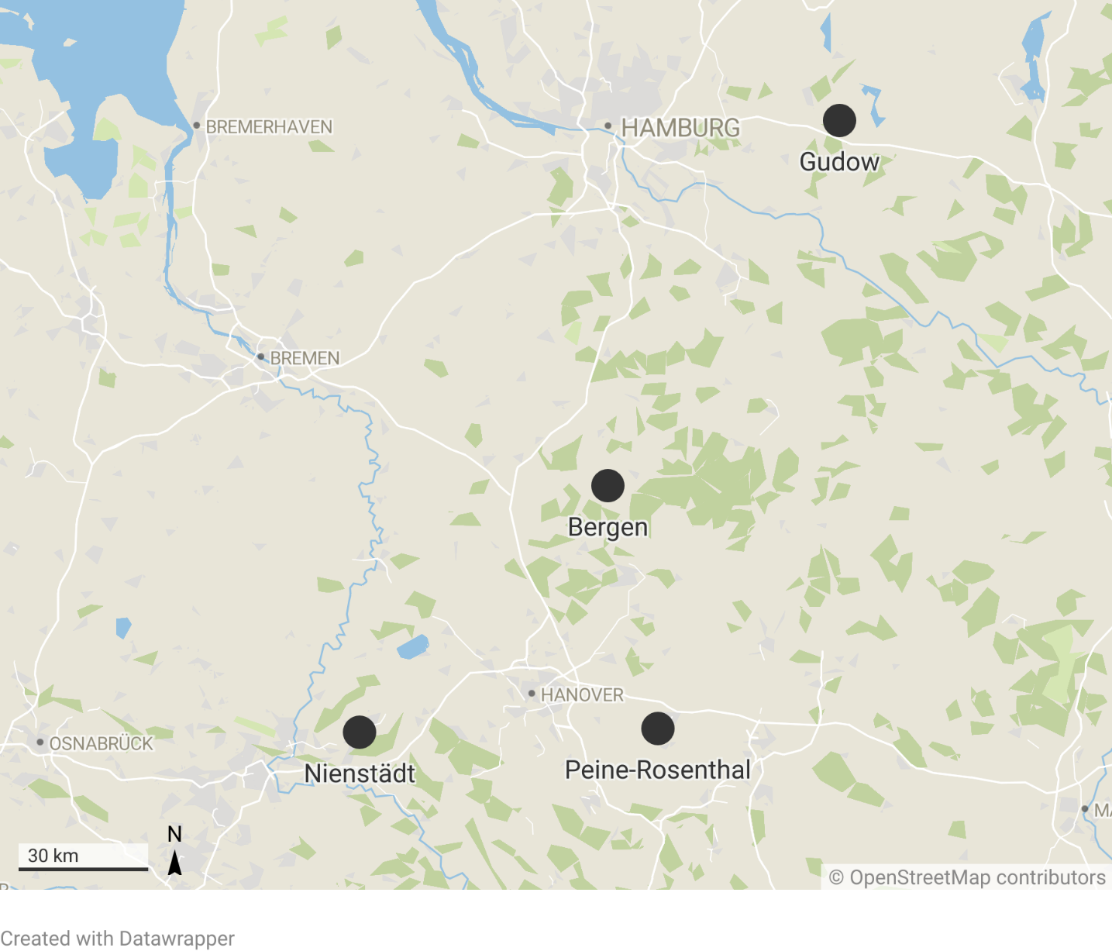
Supplementary Fig. S1 Geographic locations of the four validation sites where the experiments were conducted.

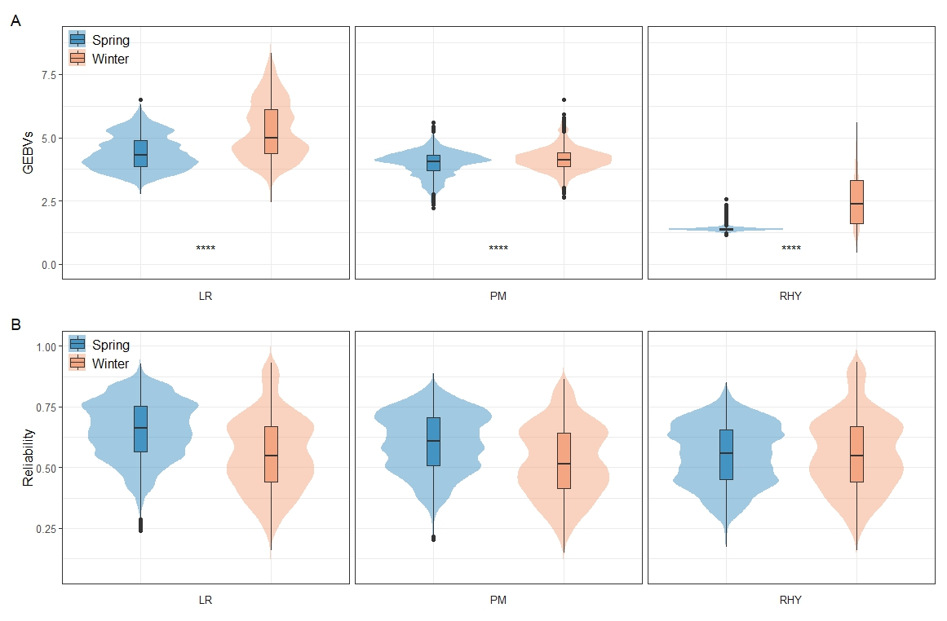Supplementary Fig. S2 Genomic estimated breeding values (A) and Prediction reliability (B) for three disease resistance traits of non-phenotyped spring and winter population. GEBVs: genomic estimated breeding values; PM: Blumeria graminis hordei; LR: Puccinia hordei; RHY: Rhynchosporium commune; ****: significance levels at p = 0.0001.

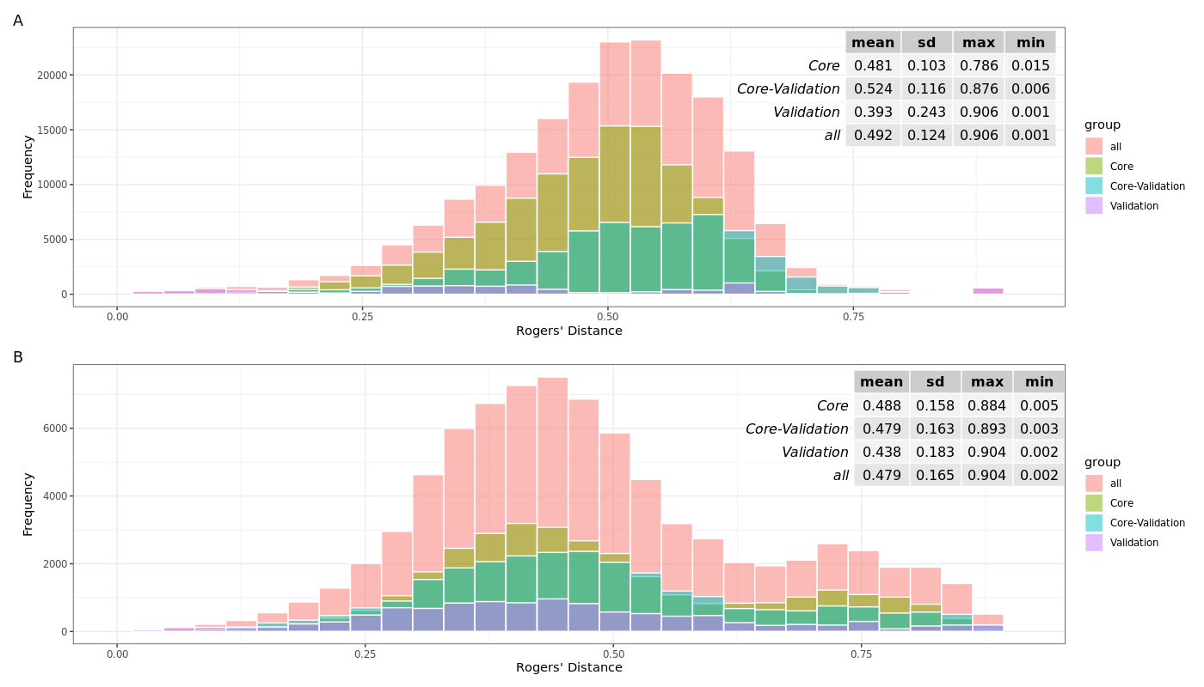
Supplementary Fig. S3 Distribution of Rogers’ distance between genotypes in (A) the spring population and (B) the winter population. Bars show the frequency distribution for all pairwise comparisons (pink) and for specific subsets: core collection (yellow-green), core collection vs. validation set (blue-green), and validation set (purple). The inset tables summarize the mean, standard deviation (sd), maximum (max), and minimum (min) distances for each group.

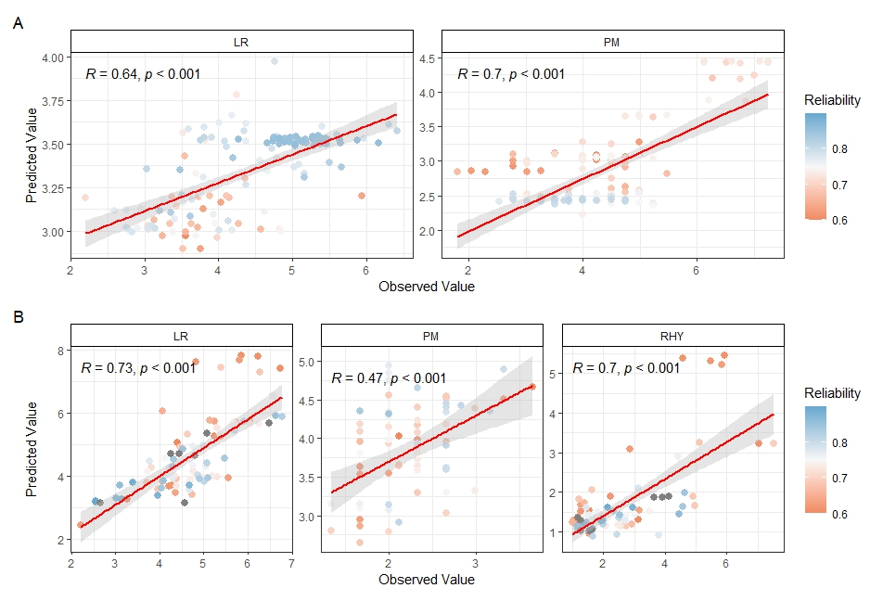
Supplementary Fig. S4 Pearson correlation coefficients (r) of observed and predicted phenotypic data in spring (A) and winter (B) validation set with prediction reliability larger than 0.6. PM: Blumeria graminis hordei; LR: Puccinia hordei; RHY: Rhynchosporium commune.
Supplementary Fig. S5 Quantile–quantile plot (left side) and Manhattan plots (right side) of the genome association analysis results in validation set of the resistance of Blumeria graminis hordei in spring population by BLINK (A), Puccinia hordei in winter population by BLINK (B), and Rhynchosporium commune in winter population by GEMMA and BLINK (C). The black horizontal dashed line in Manhattan plots corresponds to the significance threshold.

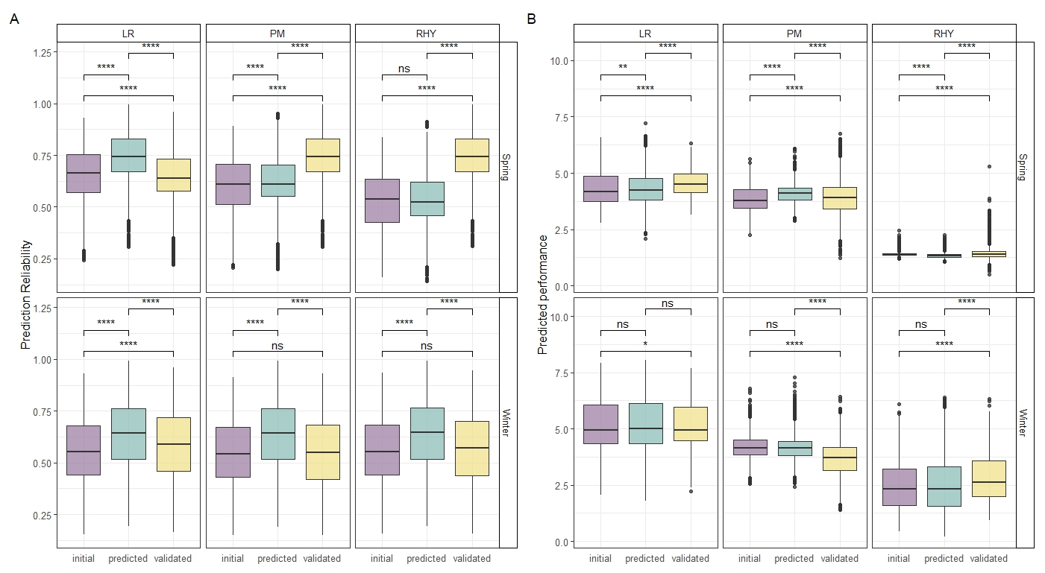Supplementary Fig. S6 Prediction reliability (A) and predicted performance (B) for three disease resistance traits of non-phenotyped spring and winter population using initial core collection as training set (initial); augment training set adding predicted performance of validation set (predicted); augment training set adding the observed value of validation set (validated). PM: Blumeria graminis hordei; LR: Puccinia hordei; RHY: Rhynchosporium commune; ****: significance levels at p = 0.0001; ^{ns}: not significant

