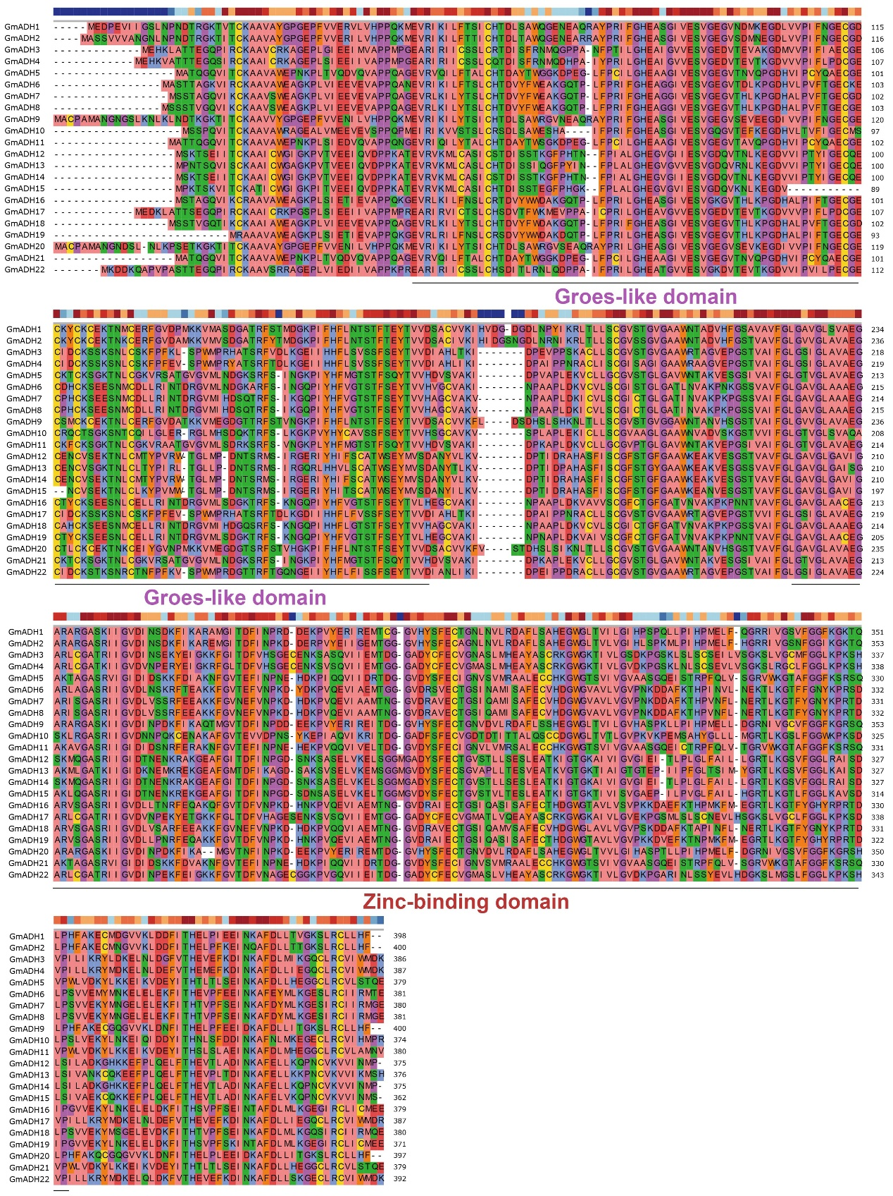
Fig. S1. Groes-like and Zinc-binding domain multiple sequence alignment analyses for soybean ADH genes.
Fig. S2. Conserved domain structures of ADHs. The purple box represented the GroES-like (ADH_N) domain. The green box represented the zinc-binding (ADH_zinc_N) domain.
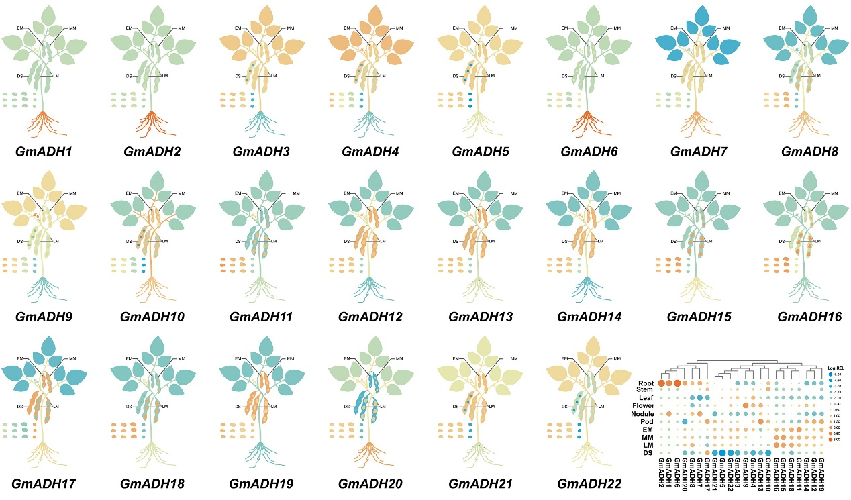
Fig. S3. Transcriptional profiles of GmADHs in multiple tissues. TBtools generated the heatmap using log2 expression values, with red representing high transcription levels and blue representing low transcription levels.
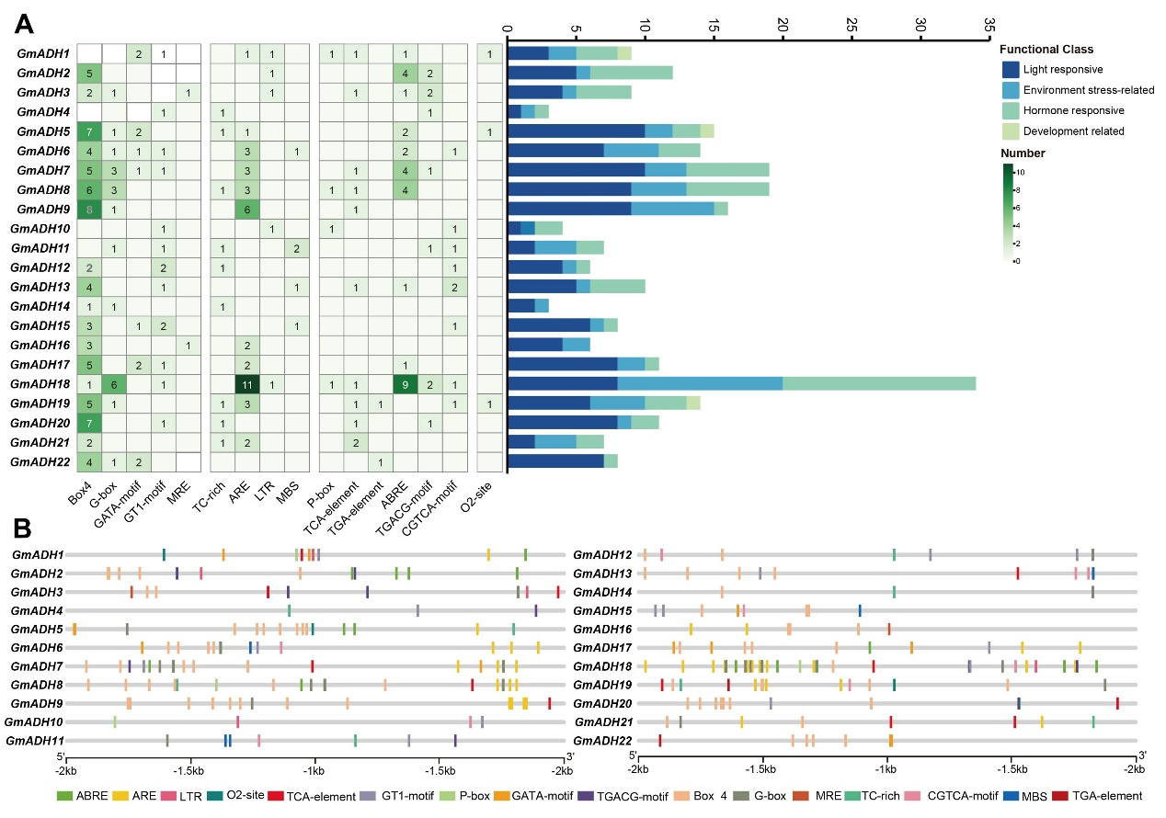
Fig. S4. Analysis of cis-acting elements in the promoter region of GmADH genes. (A) The classification and statistical analysis of cis-acting elements are presented. Sixteen types of cis-acting elements, are categorized into four groups: light responsive elements (blue), environment stress-related elements (azure), hormone responsive elements (aquamarine) and development elements (greenyellow). In the left grid, each element’s count is represented numerically, with a color gradient from white to green indicating an increase in element count. The bar chart on the right counts the total number of different categories of cis-acting elements in each GmADH gene. (B) The distribution of cis-acting elements in the promoter region of GmADH genes (−2000 bp) is represented by different colors. The ruler at the bottom indicates the sequence’s direction and length.
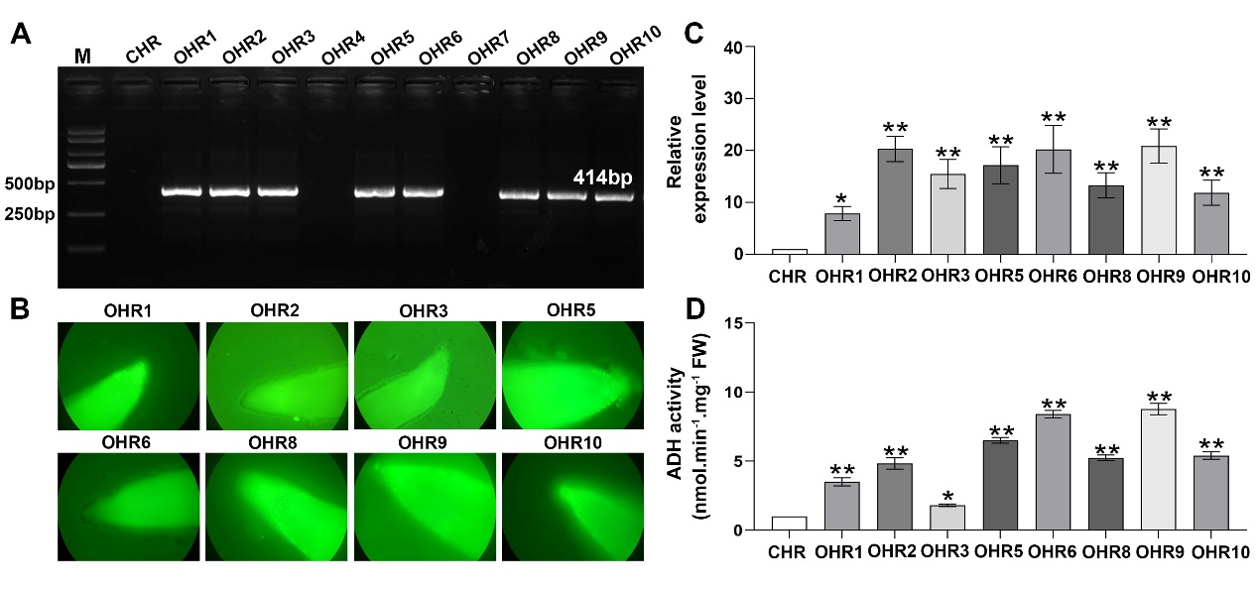
Fig. S5. Identification of overexpressing GmADH13 transgenic soybean hairy roots. (A) PCR verification of Bar gene in GmADH13-overexpresing hairy roots (OHR1-10). (B) Photographs were taken approximately 2 weeks after transformation to check for GFP fluorescence. Transcripts (C) and activities (D) of GmADH13 in OHR and CHR plants. Asterisks denote Student's t-test significance (*p <0.05; **p <0.01) of difference from CHR plants.
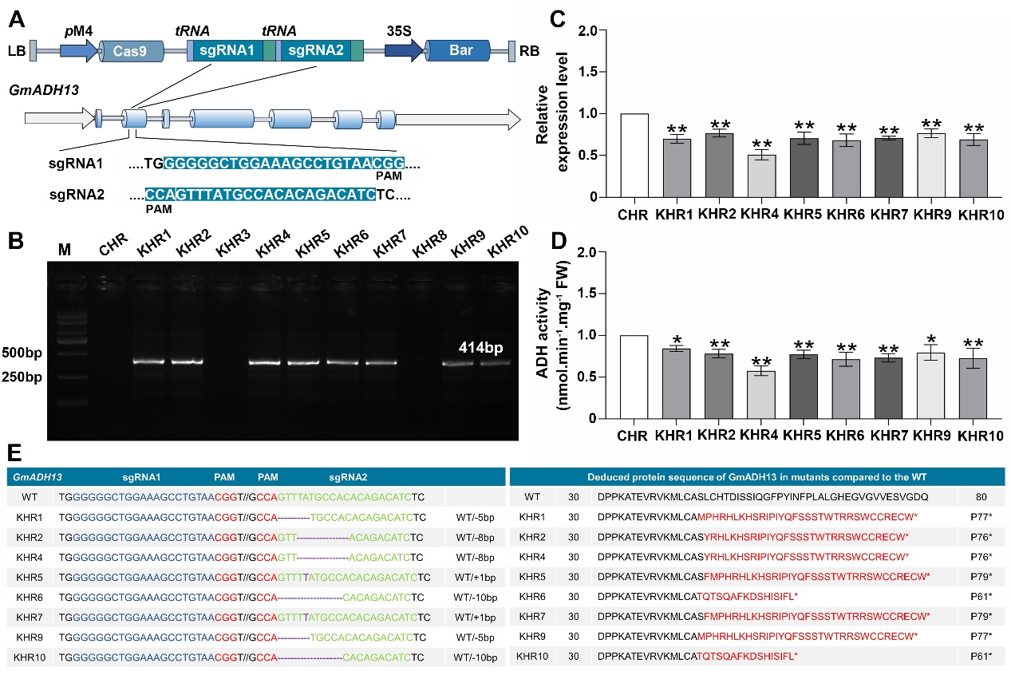
Fig. S6. Identification of knockout GmADH13 transgenic soybean hairy roots. (A) Schematic Diagram of pGES401-GmADH13 Vector. (B) PCR verification of Bar gene in GmADH13-knockout hairy roots (KHR1-10). Transcripts (C) and activities (D) of GmADH13 in KHR and CHR plants. Asterisks denote Student's t-test significance (*p <0.05; **p <0.01) of difference from CHR plants. (E) The outcomes of sgRNA gene editing results in mutants were assessed through Sanger sequencing. Purple letters denote insertions, while purple dashes correspond to deletions. Amino acid deletions are marked with dashes, amino acid substitutions are represented by red letters, and asterisks denote stop codons.
Table S1. Basic information of the soybean ADH genes.
Gene Name | Gene ID | Gene location | ORF length (bp) | Protein length | Isoelectric point | Molecular weight (KDa) | Subcellular localization
GmADH1 | Glyma.01G116300 | Chr01:40139172  ..40153209 | 1197 | 399 | 5.83 | 43.43 | Cytoplasm
GmADH2 | Glyma.01G116700 | Chr01:40191697  ..40199492 | 1203 | 401 | 6.54 | 43.57 | Cytoplasm
GmADH3 | Glyma.02G274000 | Chr02:45712024  ..45716278 | 1161 | 387 | 6.38 | 41.55 | Cytoplasm
GmADH4 | Glyma.02G274100 | Chr02:45717304  ..45720843 | 1164 | 388 | 5.97 | 41.99 | Cytoplasm
GmADH5 | Glyma.03G168700 | Chr03:38304383  ..38307615 | 1140 | 380 | 6.32 | 40.34 | Cytoplasm. Nucleus
GmADH6 | Glyma.04G213900 | Chr04:48558151  ..48562318 | 1146 | 382 | 5.69 | 41.23 | Cytoplasm
GmADH7 | Glyma.04G240800 | Chr04:50907552  ..50910551 | 1143 | 381 | 5.97 | 40.92 | Cytoplasm
GmADH8 | Glyma.06G122600 | Chr06:9998468  ..10001762 | 1146 | 382 | 5.97 | 41.05 | Cytoplasm
GmADH9 | Glyma.07G149400 | Chr07:17949040  ..17956139 | 1203 | 401 | 5.79 | 43.21 | Cytoplasm
GmADH10 | Glyma.09G161600 | Chr09:38584893  ..38589678 | 1125 | 375 | 6.75 | 40.36 | Cytoplasm
GmADH11 | Glyma.10G041000 | Chr10:3597306  ..3601274 | 1581 | 381 | 6.51 | 40.68 | Cytoplasm
GmADH12 | Glyma.12G015100 | Chr12:1092652  ..1096887 | 1128 | 376 | 5.52 | 40.02 | Cytoplasm
GmADH13 | Glyma.12G015300 | Chr12:1100878  ..1104057 | 1131 | 377 | 6.03 | 40.03 | Cytoplasm
GmADH14 | Glyma.12G015400 | Chr12:1105882  ..1108270 | 1128 | 376 | 5.52 | 40.02 | Cytoplasm
GmADH15 | Glyma.12G015500 | Chr12:1112165.  .1114351 | 1089 | 363 | 5.73 | 38.64 | Cytoplasm
GmADH16 | Glyma.13G035200 | Chr13:10928699  ..10935155 | 1140 | 380 | 6.56 | 41.15 | Cytoplasm
GmADH17 | Glyma.14G042000 | Chr14:3170002  ..3173590 | 1164 | 388 | 5.68 | 41.89 | Cytoplasm
GmADH18 | Glyma.14G121200 | Chr14:17460373  ..17463978 | 1143 | 381 | 6.07 | 40.83 | Cytoplasm
GmADH19 | Glyma.14G156400 | Chr14:34149028  ..34161293 | 1116 | 372 | 6.33 | 40.44 | Cytoplasm
GmADH20 | Glyma.18G200300 | Chr18:47969050  ..47975187 | 1194 | 398 | 6.31 | 42.74 | Cytoplasm
GmADH21 | Glyma.19G170100 | Chr19:43081670  ..43084907 | 1140 | 380 | 6.51 | 40.36 | Cytoplasm. Nucleus
GmADH22 | Glyma.20G050300 | Chr20:10226319  ..10241515 | 1179 | 393 | 6.41 | 42.35 | Cytoplasm

Table S2. The gene ID and location of ADH genes used in this study.
Gene Name | Gene ID | Gene Location
Gene Name | Gene ID | Chromosome | Start | End
AtADH1 | AT1G22440 | At1 | 7922427 | 7924944
AtADH2 | AT1G64710 | At1 | 24044544 | 24046552
AtADH3 | AT1G77120 | At1 | 28975393 | 28977417
AtADH4 | AT4G22110 | At4 | 11711313 | 11714228
AtADH5 | AT5G24760 | At5 | 8494790 | 8497419
AtADH6 | AT5G42250 | At5 | 16894008 | 16897620
AtADH7 | AT5G43940 | At5 | 17684155 | 17686534
GmADH1 | Glyma.01G116300 | Gm1 | 40139172 | 40153209
GmADH2 | Glyma.01G116700 | Gm1 | 40191697 | 40199492
GmADH3 | Glyma.02G274000 | Gm2 | 45712024 | 45716278
GmADH4 | Glyma.02G274100 | Gm2 | 45717304 | 45720843
GmADH5 | Glyma.03G168700 | Gm3 | 38304383 | 38307615
GmADH6 | Glyma.04G213900 | Gm4 | 48558151 | 48562318
GmADH7 | Glyma.04G240800 | Gm4 | 50907552 | 50910551
GmADH8 | Glyma.06G122600 | Gm6 | 9998468 | 10001762
GmADH9 | Glyma.07G149400 | Gm7 | 17949040 | 17956139
GmADH10 | Glyma.09G161600 | Gm9 | 38584893 | 38589678
GmADH11 | Glyma.10G041000 | Gm10 | 3597306 | 3601274
GmADH12 | Glyma.12G015100 | Gm12 | 1092652 | 1096887
GmADH13 | Glyma.12G015300 | Gm12 | 1100878 | 1104057
GmADH14 | Glyma.12G015400 | Gm12 | 1105882 | 1108270
GmADH15 | Glyma.12G015500 | Gm12 | 1112165 | 1114351
GmADH16 | Glyma.13G035200 | Gm13 | 10928699 | 10935155
GmADH17 | Glyma.14G042000 | Gm14 | 3170002 | 3173590
GmADH18 | Glyma.14G121200 | Gm14 | 17460373 | 17463978
GmADH19 | Glyma.14G156400 | Gm14 | 34149028 | 34161293
GmADH20 | Glyma.18G200300 | Gm18 | 47969050 | 47975187
GmADH21 | Glyma.19G170100 | Gm19 | 43081670 | 43084907
GmADH22 | Glyma.20G050300 | Gm20 | 10226319 | 10241515
PvADH1 | Phvul.001G064000 | Pv1 | 7777594 | 7780580
PvADH2 | Phvul.001G067300 | Pv1 | 8461118 | 8465727
PvADH3 | Phvul.001G167100 | Pv1 | 42225704 | 42228788
PvADH4 | Phvul.004G136700 | Pv4 | 43639676 | 43644544
PvADH5 | Phvul.007G154200 | Pv7 | 26062838 | 26070320
PvADH6 | Phvul.008G104700 | Pv8 | 11504751 | 11512491
PvADH7 | Phvul.008G207700 | Pv8 | 55554434 | 55557957
PvADH8 | Phvul.008G207800 | Pv8 | 55562059 | 55565184
PvADH9 | Phvul.008G207900 | Pv8 | 55573812 | 55577340
PvADH10 | Phvul.009G134700 | Pv9 | 20373267 | 20376400
PvADH11 | Phvul.009G149500 | Pv9 | 22288682 | 22292208
PvADH12 | Phvul.011G018000 | Pv11 | 1438869 | 1441943
OsADH1 | LOC_Os02g42520 | Os2 | 25565859 | 25569036
OsADH2 | LOC_Os02g57040 | Os2 | 34930269 | 34934184
OsADH3 | LOC_Os03g09020 | Os3 | 4682684 | 4685130
OsADH4 | LOC_Os07g42924 | Os7 | 25696799 | 25704080
OsADH5 | LOC_Os10g07229 | Os10 | 3793862 | 3804018
OsADH6 | LOC_Os11g10480 | Os11 | 5712640 | 5716288
OsADH7 | LOC_Os11g10510 | Os11 | 5744960 | 5748152
OsADH8 | LOC_Os11g10520 | Os11 | 5755643 | 5760026
MtADH1 | Medtr1g069430 | Mt1 | 30034661 | 30038767
MtADH2 | Medtr3g079180 | Mt3 | 35613643 | 35616622
MtADH3 | Medtr3g089940 | Mt3 | 40878690 | 40882545
MtADH4 | Medtr3g089970 | Mt3 | 40898626 | 40901003
MtADH5 | Medtr3g089977 | Mt3 | 40903128 | 40906106
MtADH6 | Medtr3g099460 | Mt3 | 45584462 | 45588966
MtADH7 | Medtr5g045710 | Mt5 | 20050497 | 20052759
MtADH8 | Medtr5g087710 | Mt5 | 38027253 | 38030633
MtADH9 | Medtr6g068930 | Mt6 | 24773658 | 24778258
MtADH10 | Medtr7g068320 | Mt7 | 24984144 | 24991777
MtADH11 | Medtr7g068330 | Mt7 | 24992390 | 24995004
MtADH12 | Medtr7g099040 | Mt7 | 39689916 | 39692564
SbADH1 | Sobic.001G097600 | Sb1 | 7571520 | 7574977
SbADH2 | Sobic.001G263900 | Sb1 | 52838433 | 52845778
SbADH3 | Sobic.001G264000 | Sb1 | 52973596 | 52978553
SbADH4 | Sobic.001G475800 | Sb1 | 78963541 | 78966370
SbADH5 | Sobic.001G475900 | Sb1 | 78970763 | 78976369
SbADH6 | Sobic.002G379100 | Sb2 | 74854620 | 74857923
SbADH7 | Sobic.002G379200 | Sb2 | 74858503 | 74862614
SbADH8 | Sobic.004G226500 | Sb4 | 60168828 | 60172220
SbADH9 | Sobic.004G343200 | Sb4 | 69905472 | 69909785
SbADH10 | Sobic.005G103300 | Sb5 | 18584173 | 18587440
SbADH11 | Sobic.005G103500 | Sb5 | 18681550 | 18685112

Table S3. The syntenic relationships among G.max, A.thaliana, O.sativa, P. vulgaris, M. truncatula and S.bicolor ADH genes.
Block | Arabidopsis thaliana gene location |  |  | Arabidopsis thaliana gene ID | Arabidopsis thaliana gene name | Arabidopsis thaliana gene location |  |  | Arabidopsis thaliana gene ID | Arabidopsis thaliana gene name
Block | Chr | start | end |  |  | Chr | start | end
107 | At1 | 24044544 | 24046552 | AT1G64710 | AtADH4 | At5 | 8494790 | 8497419 | AT5G24760 | AtADH7
104 | At1 | 24044544 | 24046552 | AT1G64710 | AtADH4 | At5 | 16894008 | 16897620 | AT5G42250 | AtADH8
Block | Arabidopsis thaliana gene location |  |  | Arabidopsis thaliana gene ID | Arabidopsis thaliana gene name | Glycine max gene location |  |  | Glycine max  gene ID | Glycine max  gene name
Block | Chr | start | end |  |  | Chr | start | end
338 | At1 | 28975393 | 28977417 | AT1G77120 | AtADH5 | Gm14 | 17460373 | 17463978 | Glyma.14G121200 | GmADH18
113 | At1 | 28975393 | 28977417 | AT1G77120 | AtADH5 | Gm6 | 9998468 | 10001762 | Glyma.06G122600 | GmADH8
83 | At1 | 28975393 | 28977417 | AT1G77120 | AtADH5 | Gm4 | 50907552 | 50910551 | Glyma.04G240800 | GmADH7
82 | At1 | 28975393 | 28977417 | AT1G77120 | AtADH5 | Gm4 | 48558151 | 48562318 | Glyma.04G213900 | GmADH6
1831 | At5 | 17684155 | 17686534 | AT5G43940 | AtADH9 | Gm19 | 43081670 | 43084907 | Glyma.19G170100 | GmADH21
1641 | At5 | 17684155 | 17686534 | AT5G43940 | AtADH9 | Gm10 | 3597306 | 3601274 | Glyma.10G041000 | GmADH11
1462 | At5 | 17684155 | 17686534 | AT5G43940 | AtADH9 | Gm3 | 38304383 | 38307615 | Glyma.03G168700 | GmADH5
Block | Glycine max gene location |  |  | Glycine max  gene ID | Glycine max  gene name | Glycine max gene location |  |  | Glycine max  gene ID | Glycine max gene name
Block | Chr | start | end |  |  | Chr | start | end
46 | Gm1 | 40139172 | 40153209 | Glyma.01G116300 | GmADH1 | Gm7 | 17949040 | 17956139 | Glyma.07G149400 | GmADH9
116 | Gm1 | 40139172 | 40153209 | Glyma.01G116300 | GmADH1 | Gm18 | 47969050 | 47975187 | Glyma.18G200300 | GmADH20
253 | Gm2 | 45712024 | 45716278 | Glyma.02G274000 | GmADH3 | Gm14 | 3170002 | 3173590 | Glyma.14G042000 | GmADH17
347 | Gm3 | 38304383 | 38307615 | Glyma.03G168700 | GmADH5 | Gm10 | 3597306 | 3601274 | Glyma.10G041000 | GmADH16
409 | Gm3 | 38304383 | 38307615 | Glyma.03G168700 | GmADH5 | Gm19 | 43081670 | 43084907 | Glyma.19G170100 | GmADH21
427 | Gm4 | 50907552 | 50910551 | Glyma.04G213900 | GmADH6 | Gm4 | 50907552 | 50910551 | Glyma.04G240800 | GmADH7
440 | Gm4 | 50907552 | 50910551 | Glyma.04G213900 | GmADH6 | Gm6 | 9998468 | 10001762 | Glyma.06G122600 | GmADH8
446 | Gm4 | 50907552 | 50910551 | Glyma.04G240800 | GmADH7 | Gm6 | 9998468 | 10001762 | Glyma.06G122600 | GmADH8
512 | Gm4 | 50907552 | 50910551 | Glyma.04G240800 | GmADH7 | Gm14 | 17460373 | 17463978 | Glyma.14G121200 | GmADH18
730 | Gm6 | 9998468 | 10001762 | Glyma.06G122600 | GmADH8 | Gm14 | 17460373 | 17463978 | Glyma.14G121200 | GmADH18
880 | Gm7 | 17949040 | 17956139 | Glyma.07G149400 | GmADH9 | Gm18 | 47969050 | 47975187 | Glyma.18G200300 | GmADH20
1133 | Gm10 | 3597306 | 3601274 | Glyma.10G041000 | GmADH11 | Gm19 | 43081670 | 43084907 | Glyma.19G170100 | GmADH21
1315 | Gm13 | 10928699 | 10935155 | Glyma.13G035200 | GmADH16 | Gm14 | 34149028 | 34161293 | Glyma.14G156400 | GmADH19
1403 | Gm14 | 3170002 | 3173590 | Glyma.14G042000 | GmADH17 | Gm20 | 10226319 | 10241515 | Glyma.20G050300 | GmADH22
Block | Glycine max gene location |  |  | Glycine max  gene ID | Glycine max gene name | Oryza sativa gene location |  |  | Oryza sativa  gene ID | Oryza sativa gene name
Block | Chr | start | end |  |  | Chr | start | end
116 | Gm3 | 38304383 | 38307615 | Glyma.03G168700 | GmADH5 | Os2 | 34930269 | 34934184 | LOC_Os02g57040 | OsADH2
452 | Gm10 | 3597306 | 3601274 | Glyma.10G041000 | GmADH11 | Os2 | 34930269 | 34934184 | LOC_Os02g57040 | OsADH2
877 | Gm19 | 43081670 | 43084907 | Glyma.19G170100 | GmADH21 | Os2 | 34930269 | 34934184 | LOC_Os02g57040 | OsADH2
Block | Phaseolus vulgaris  gene location |  |  | Phaseolus vulgaris gene ID | Phaseolus vulgaris  gene name | Phaseolus vulgaris gene location |  |  | Phaseolus vulgaris gene ID | Phaseolus vulgaris  gene name
Block | Chr | start | end |  |  | Chr | start | end
69 | Pv1 | 7777594 | 7780580 | Phvul.001G064000 | PvADH1 | Pv9 | 20373267 | 20376400 | Phvul.009G134700 | PvADH10
32 | Pv1 | 42225704 | 42228788 | Phvul.001G167100 | PvADH3 | Pv7 | 26062838 | 26070320 | Phvul.007G154200 | PvADH5
Block | Oryza sativa gene location |  |  | Oryza sativa  gene ID | Oryza sativa gene name | Oryza sativa gene location |  |  | Oryza sativa  gene ID | Oryza sativa gene name
Block | Chr | start | end |  |  | Chr | start | end
141 | Os3 | 4667479 | 4668917 | LOC_Os03g08999 | OsADH3 | Os7 | 25696799 | 25704080 | LOC_Os07g42924 | OsADH4
Block | Medicago truncatula  gene location |  |  | Medicago truncatula  gene ID | Medicago truncatula  gene name | Medicago truncatula gene location |  |  | Medicago truncatula  gene ID | Medicago truncatula gene name
Block | Chr | start | end |  |  | Chr | start | end
69 | Mt1 | 30034661 | 30038767 | Medtr1g069430 | MtADH1 | Mt7 | 39689916 | 39692564 | Medtr7g099040 | MtADH12
Block | Sorghum bicolor gene location |  |  | Sorghum bicolor gene ID | Sorghum bicolor  gene name | Sorghum bicolor gene location |  |  | Sorghum bicolor gene ID | Sorghum bicolor  gene name
Block | Chr | start | end |  |  | Chr | start | end
25 | Sb1 | 78963541 | 78966370 | Sobic.001G475800 | SbADH4 | Sb2 | 74858503 | 74862614 | Sobic.002G379200 | SbADH7
78 | Sb2 | 74858503 | 74862614 | Sobic.002G379200 | SbADH7 | Sb4 | 60168828 | 60172220 | Sobic.004G226500 | SbADH8

Table S4. Primers used in this study..
Primer Names | Sequence (5'-3') | Description
GmADH13-F | ATGCCAAACACCTCGCAGG | cloning
GmADH13-R | ATGTGACATCTTGATGACAACTTTCA | cloning
pYES2-ADH13-F | ATGTGACATCTTGATGACAACTTTCA | cloning
pYES2-ADH13-R | ATGCCAAACACCTCGCAGGT | cloning
pGEX-4T-ADH13-F | ATGCCAAACACCTCGCAGGTTAT | cloning
pGEX-4T-ADH13-R | TCAATGTGACATCTTGATG | cloning
pSOY1-ADH13-F | ATGCCAAACACCTCGCAGG | PCR verification
pSOY1-GFP-R | AGGTCAGGGTGGTCACGAGGGT | PCR verification
Bar-F | CTGCACCATCGTCAACCACTA | PCR verification
Bar-R | TGCCAGTTCCCGTGCTTGAA | PCR verification
GmADH1-qF | TTTCACGGAGTACACGGTGG | qRT-PCR
GmADH1-qR | CGGTATTCCAAGCAGCTCCA | qRT-PCR
GmADH2-qF | TTAGGTGTTGTGGGTCTCGC | qRT-PCR
GmADH2-qR | AAACTATAGTGCACGCCCCC | qRT-PCR
GmADH3-qF | ATGCCTCCTCAGTTGTGGTG | qRT-PCR
GmADH3-qR | CCAATACTTCCCAGCCCGAA | qRT-PCR
GmADH4-qF | GATCCGGCAATACCACCCAA | qRT-PCR
GmADH4-qR | ATCCAATACTCCCCAGCCCA | qRT-PCR
GmADH5-qF | GAGAGCTGCTTTGGAGTGCT | qRT-PCR
GmADH5-qR | CAGACACGTCCACTCACCAA | qRT-PCR
GmADH6-qF | GGGAGCTAGACTTGCTGGTG | qRT-PCR
GmADH6-qR | TGCACTCAACACTTCGGTCA | qRT-PCR
GmADH7-qF | CAGGTCTTGGGGCCACTATC | qRT-PCR
GmADH7-qR | CACCAGAAATCCTTGCCCCT | qRT-PCR
GmADH8-qF | GTTTACCGGGGAGTGTGGAG | qRT-PCR
GmADH8-qR | TCCGGCATGAACAACAGTGT | qRT-PCR
GmADH9-qF | GAACCTCACCTTGCTCAGCT | qRT-PCR
GmADH9-qR | AGCCCAACAACTCCTAAGCC | qRT-PCR
GmADH10-qF | GAAGTGAGTCCTCCCCAACC | qRT-PCR
GmADH10-qR | GAAGTGAGTCCTCCCCAACC | qRT-PCR
GmADH11-qF | TTGGAGTGCTGCCATAAGGG | qRT-PCR
GmADH11-qR | TACAAGCCAAGGCACCTGAG | qRT-PCR
GmADH12-qF | GAATAGGAAAACCTGTGACT | qRT-PCR
GmADH12-qR | CTCTATAATACCAACTCCTT | qRT-PCR
GmADH13-qF | TCCAACCATTGATCCAGCCC | qRT-PCR
GmADH13-qR | CAGCATTTTGGCGCCACTTA | qRT-PCR
GmADH14-qF | CGGTGATCAAGTAACGAATC | qRT-PCR
GmADH14-qR | CATCTTACTGGGTATGTCAT | qRT-PCR
GmADH15-qF | AGCTACGATATGCTGGGGGA | qRT-PCR
GmADH15-qR | GGGAATCCTTCGGTGCTTGA | qRT-PCR
GmADH16-qF | CCAGACTCCGCTGTTTCCTC | qRT-PCR
GmADH16-qR | GAGAGCATGGTCACCTGGTT | qRT-PCR
GmADH17-qF | GGGTTGTGGAAAGCGTAGGA | qRT-PCR
GmADH17-qR | GTGGCATGTCTAGGCATCCA | qRT-PCR
GmADH18-qF | AAGATCAACCCTGCTGCTCC | qRT-PCR
GmADH18-qR | GGCAACAGAGGAACCAGGTT | qRT-PCR
GmADH19-qF | GCCCCACTTGACAAAGTTGC | qRT-PCR
GmADH19-qR | TTCACAGGCAGCAAGACCAA | qRT-PCR
GmADH20-qF | CAGCGTGCTTATCCTCGGAT | qRT-PCR
GmADH20-qR | GCACCACTATGTCCCCTTCC | qRT-PCR
GmADH21-qF | TATCAGGCTGAGTGTGGGGA | qRT-PCR
GmADH21-qR | TCGAGAACCGACTCTTCCCA | qRT-PCR
GmADH22-qF | AATGCTGGAGAATGTGGGGG | qRT-PCR
GmADH22-qR | GGTTTATCCTAGCTCCGGGC | qRT-PCR
GmSOD1-qF | ATGGTGAAGGCTGTGGCAG | qRT-PCR
GmSOD1-qR | CATTCCCAAGATCACCAGC | qRT-PCR
GmSOD2-qF | AGTCAATGCGAAGTTCGAG | qRT-PCR
GmSOD2-qR | TCAAGTGTCTGCTGGCTCAT | qRT-PCR
GmCAT1-qF | CATTGATAACTTCTTTGC | qRT-PCR
GmCAT1-qR | CTTCCCACCTAGGATACG | qRT-PCR
GmCAT2-qF | ACAACTCATCGCTGACTGT | qRT-PCR
GmCAT2-qR | GGCTGCCACGTTCGTGGAT | qRT-PCR
GmsAPX-qF | GGCATGATGCTGGTACAT | qRT-PCR
GmsAPX-qR | CAGGAAGTCTCCCTTCTT | qRT-PCR
GmGR1-qF | ACACAGCAAAGCACATATT | qRT-PCR
GmGR1-qR | CATGCCACGCCATATAGAT | qRT-PCR
GmMDAR1-qF | GTAGCACCTTATGAACGTC | qRT-PCR
GmMDAR1-qR | GTGCTAAGAATTAACTCT | qRT-PCR
GmGLDH-qF | AACTAGCTAATCCAAGCAT | qRT-PCR
GmGLDH-qR | CTCAATCTTAGCCCAGTGT | qRT-PCR
GmMDH2-qF | TGCTCGTGGATGCAATTCCT | qRT-PCR
GmMDH2-qR | TGTAGGAGATTGAGCCGGGA | qRT-PCR
GmACTIN4-qF | GTGTCAGCCATACTGTCCCCATTT | qRT-PCR
GmACTIN4-qR | GTTTCAAGCTCTTGCTCGTAATCA | qRT-PCR

