Dissecting the genetic architecture of early root-related traits in grapevine rootstocks across propagation methods and different scions
Theoretical and Applied Genetics

Marine Morel^{1*}, Nabil Girollet¹, Pierre-François Bert¹, Marina de Miguel¹, Elisa Marguerit¹
¹EGFV, Univ. Bordeaux, Bordeaux Sciences Agro, INRAE, ISVV, F-33882 Villenave d’Ornon, France
*Corresponding author email: marinemorel15@gmail.com
*Corresponding author ORCID: https://orcid.org/0009-0003-0566-3479
Supplementary Figures
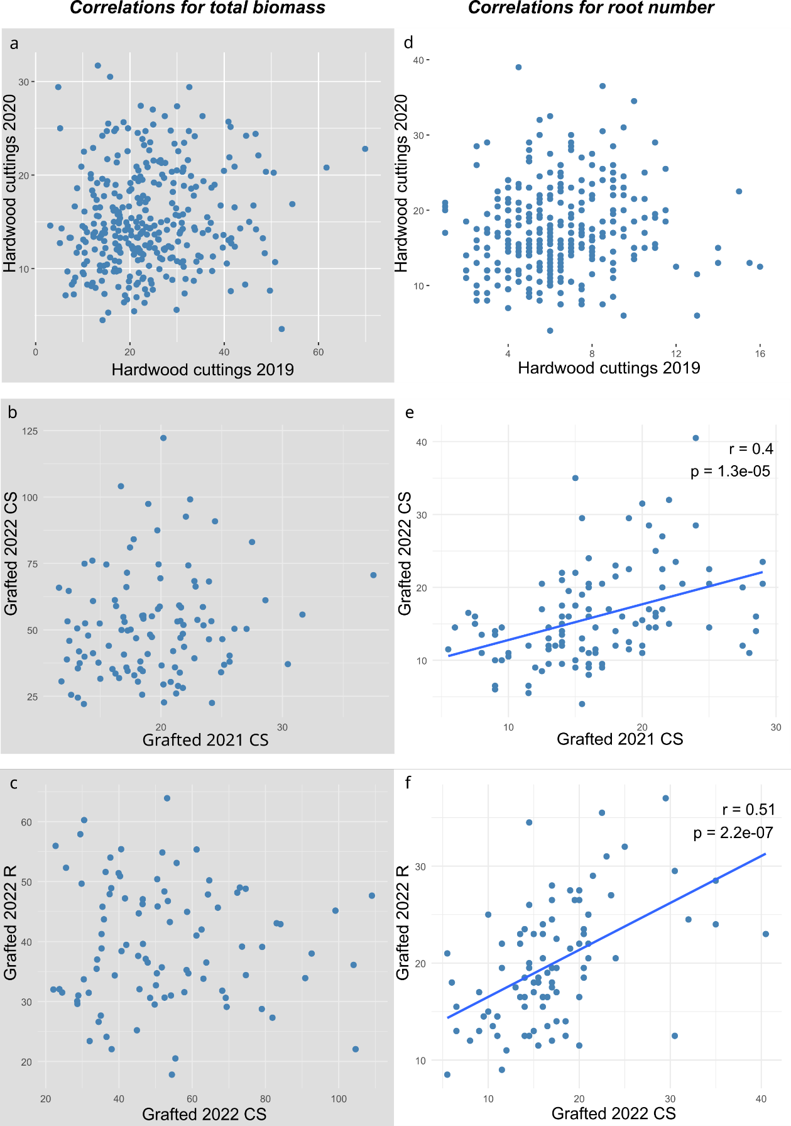
Fig. S1 Scatter plots showing relationships across years for hardwood cuttings (a, d) and grafted plants (b, e), and scion effect (c, f). Panels a-c depict correlations for the total biomass, and panels d-f depict correlations for the root number trait. Correlation coefficients (r) and significance (p) are shown only when the relationship was significant (p-value <0.05). Scions are indicated by CS for Cabernet-Sauvignon and R for Riesling

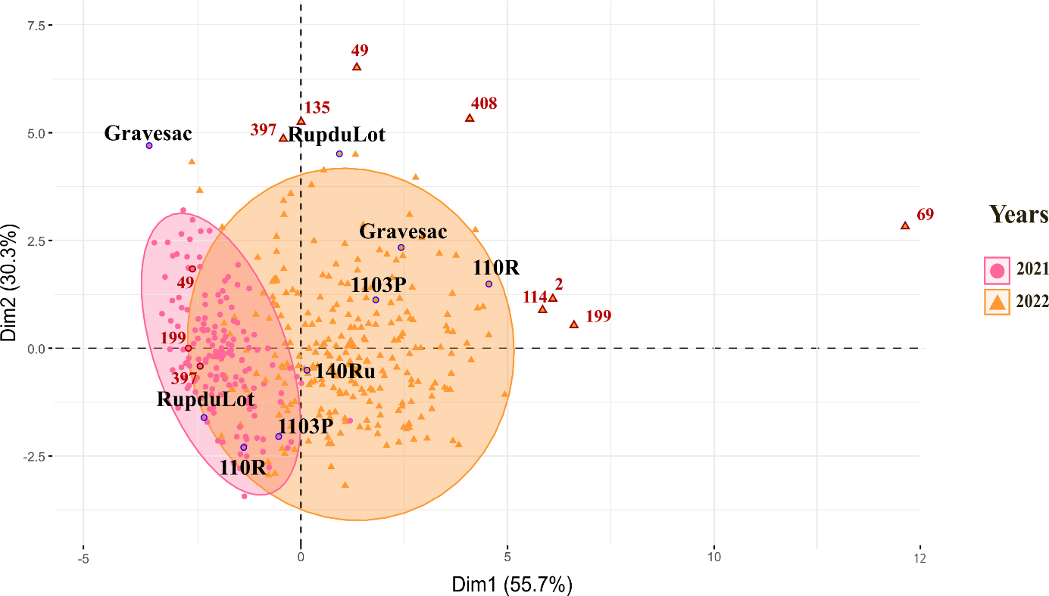
Fig. S2 Graph of individuals obtained from the PCA analyses. Commercial rootstocks are labelled in black and outperformers of 2022 in red on the PCA plot

