Supplementary Materials
Table S1 Analysis of variance testing the effects of genotype and environment on root rot severity in PR-20 RIL population challenged with Fusarium avenaceum
 | Sum Sq | Mean Sq | NumDF | DenDF | F value | Pr(>F)
RIL | 1511595 | 9388.8 | 161 | 647 | 56 | <0.0001
Repeat | 55708 | 18569.3 | 3 | 647 | 111 | <0.0001
RIL:Repeat | 186190 | 385.5 | 483 | 647 | 2 | <0.0001

Table S2 Analysis of variance testing the effects of plant genotype, growth stage, pathogen inoculation, and their interactions on disease severity of Fusarium avenaceum in CDC Dakota and CDC Amarillo.
Source of Variation | Sum Sq | Mean Sq | NumDF | DenDF | F value | Pr(>F)
Genotype | 14294.5 | 14294.5 | 1 | 33 | 199.7708 | 1.49E-15
Treatment | 28967.4 | 28967.4 | 1 | 33 | 404.8294 | < 2.2e-16
Growth_stage | 517.3 | 258.7 | 2 | 33 | 3.615 | 0.03805
Genotype:Treatment | 12513 | 12513 | 1 | 33 | 174.8739 | 9.69E-15
Genotype:Growth_stage | 457 | 228.5 | 2 | 33 | 3.193 | 0.05399
Treatment:Growth_stage | 451 | 225.5 | 2 | 33 | 3.1515 | 0.05591
Genotype:Treatment:Growth_stage | 494.8 | 247.4 | 2 | 33 | 3.4576 | 0.04332

Table S3: Additional file in Excel sheet with the list of candidate genes in QTL Fav-Ps2.1

Table S4: Additional file in Excel sheet with the list of candidate genes in QTL Fav-Ps5.1

Figure S1 Phenotypic differences in Fusarium avenaceum root rot severity between lines with (A) dun and speckled seed coat pattern (F_{(1:1306)} = 0.01, p = 0.932, ns indicates non-significant difference) and (B) pigmented and non-pigmented flowers and seedcoat colours (F_{(1:1306)} = 3464, p <0.001, *** indicates p <0.001).

Figure S2 Frequency distributions of Fusarium avenaceum root rot severity (%) of pea PR-20 recombinant inbred line population.

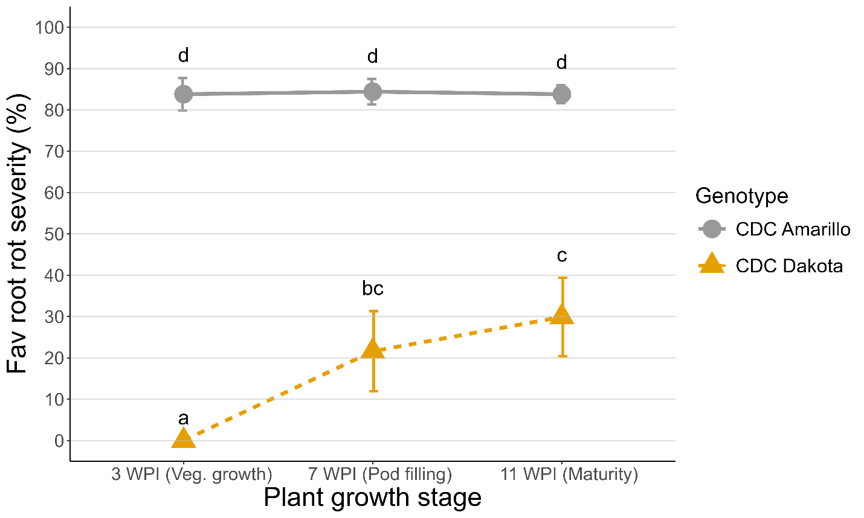
Figure S3 Fusarium avenaceum root rot severity at the early vegetative, pod filling, and maturity stages for the parental cultivars, CDC Dakota and CDC Amarillo, of the PR-20 RIL population. The error bar indicates the standard error of the mean. The same letters are not significantly (ns) different at P > 0.05. WPI: weeks post-inoculation.
Figure S4 Relationship between Fusarium avenaceum root rot resistance and polyphenol concentrations (μg g⁻¹ dry weight) in the whole seeds of PR-20 lines and parents. Polyphenol data for PR-20 was sourced from Jha et al. (2019).

