Machine learning for geochemical exploration: classifying metallogenic fertility in arc magmas and insights into porphyry copper deposit formation

Chetan L. Nathwani^{1,2}, Jamie J. Wilkinson^{1,2}, George Fry³, Robin N. Armstrong¹, Daniel J. Smith⁴, Christian Ihlenfeld³

Supplementary Material 1

This document contains supplementary figures and tables
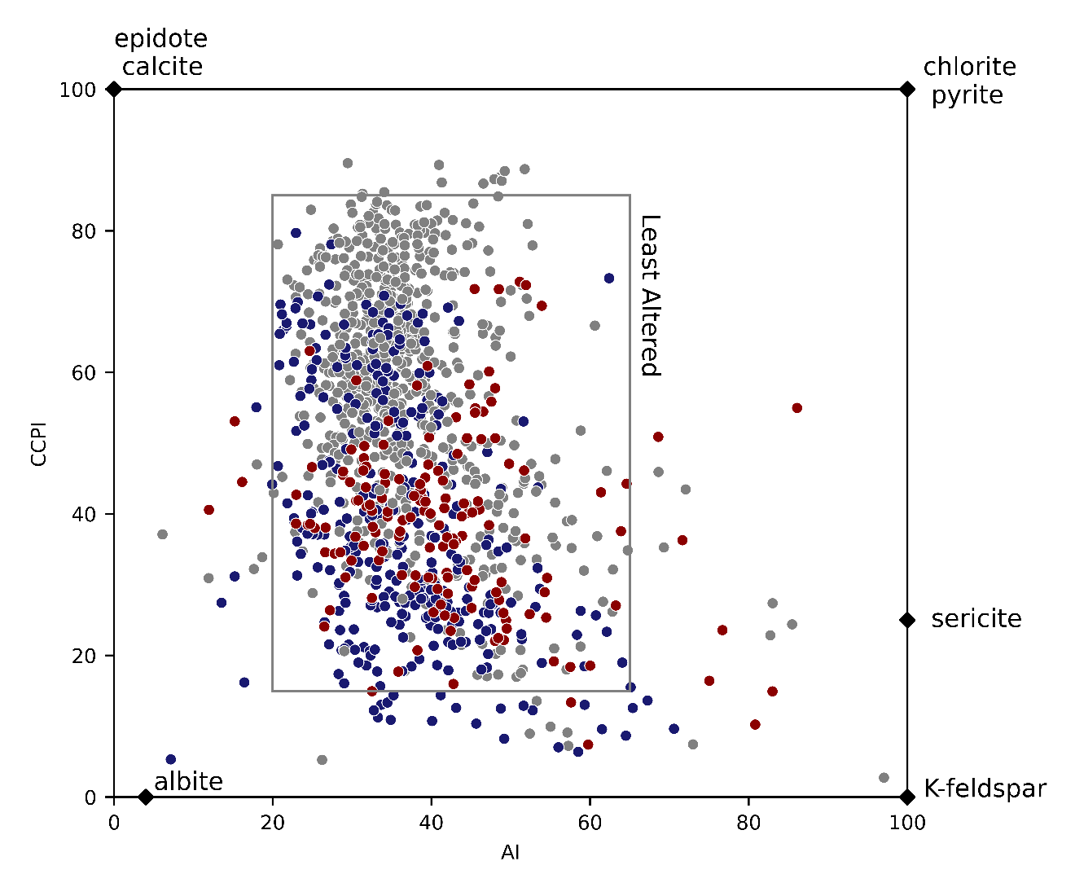
Figure S1. Alteration box plot after Large (2001) of Ishikawa alteration index vs chlorite-carbonate-pyrite index with the entire dataset plotted. The least altered box proposed by Large (2001) for felsic, intermediate and mafic compositions is shown. The composition of common alteration minerals in porphyry systems are shown. Overall, the filtered dataset largely conforms to the least altered field.

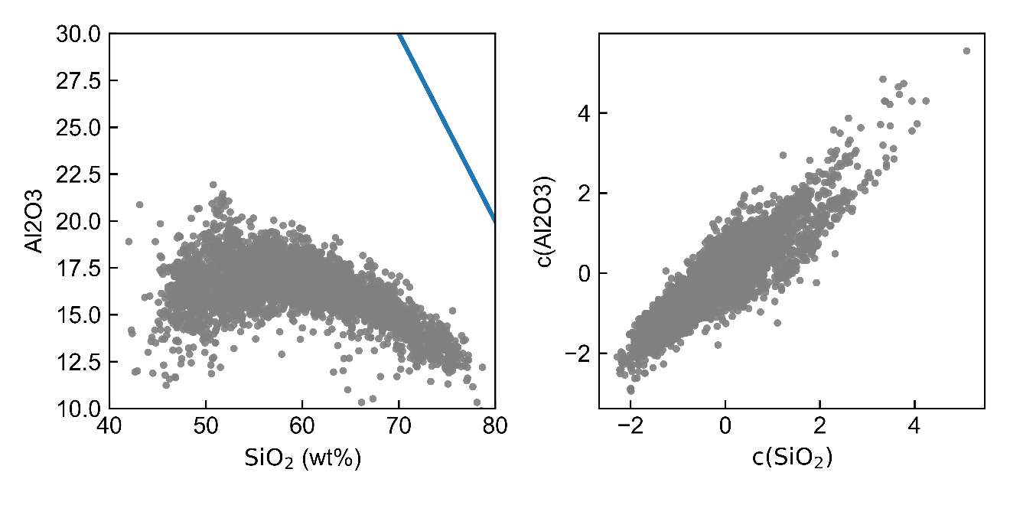
Figure S2. (a) A Harker variation diagram for GEOROC data from the Andean arc showing SiO₂ vs. Al₂O₃, with the inflection point at 50 wt.% and subsequent negative correlation typically interpreted as feldspar fractionation. Blue line indicates the constant sum of 100 wt.% which influences the trend observed here between the raw components. (b) Scatterplot of clr-transformed co-ordinates for SiO₂ vs. Al₂O₃ showing no obvious inflection point. Note that formal correlation analysis is challenging with clr-coordinates as the covariance matrix of clr-transformed data is singular.
Al₂O₃ (wt.%)
c(Al₂O₃)
a
b

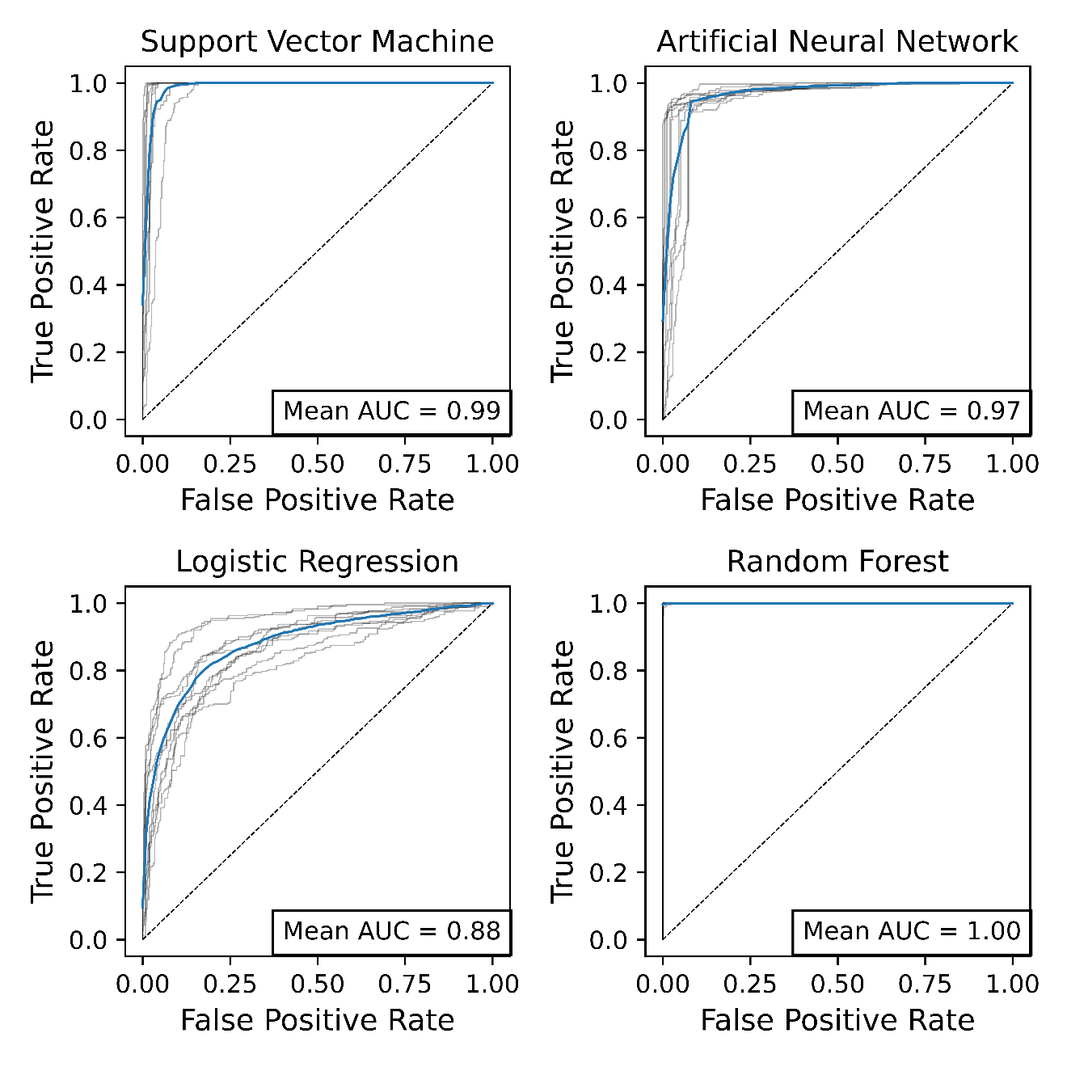
Figure S3. ROC curves generated using an oversampling with replacement strategy for the fertile dataset, scaled to have the same number of observations as the unfertile dataset (in contrast to undersampling of the majority that is used in the manuscript). These model outputs indicate that overfitting has taken place, since an AUC result of ~1.00 is returned which is unrealistic, and little variance is seen between each of the 10-fold iterations.

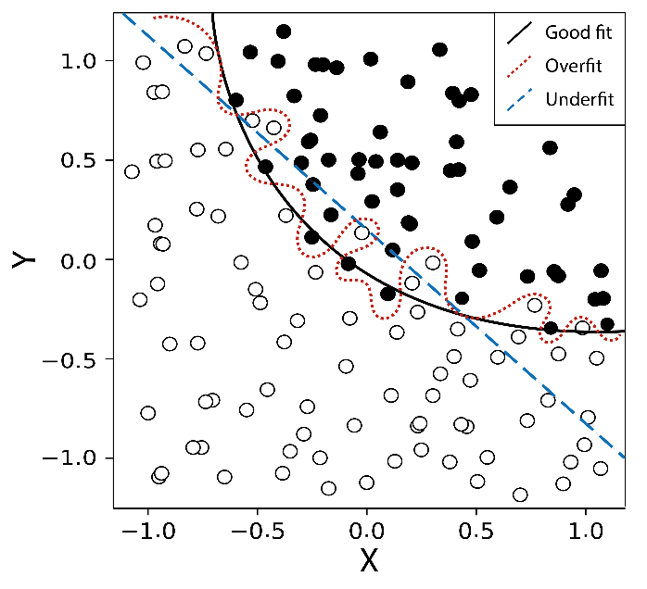
Figure S4: Schematic illustration of a classification problem for a fictive bivariate dataset separated by three theoretical hyperplanes – a good fit, an overfit and an underfit. Though the overfitted plane models the data well, it is likely to produce a high error rate on unseen data since it models noise in the training dataset. The underfit plane does not accurately generalise the data. The good fit curve generalises the underlying data better and would produce optimal results on unseen data.

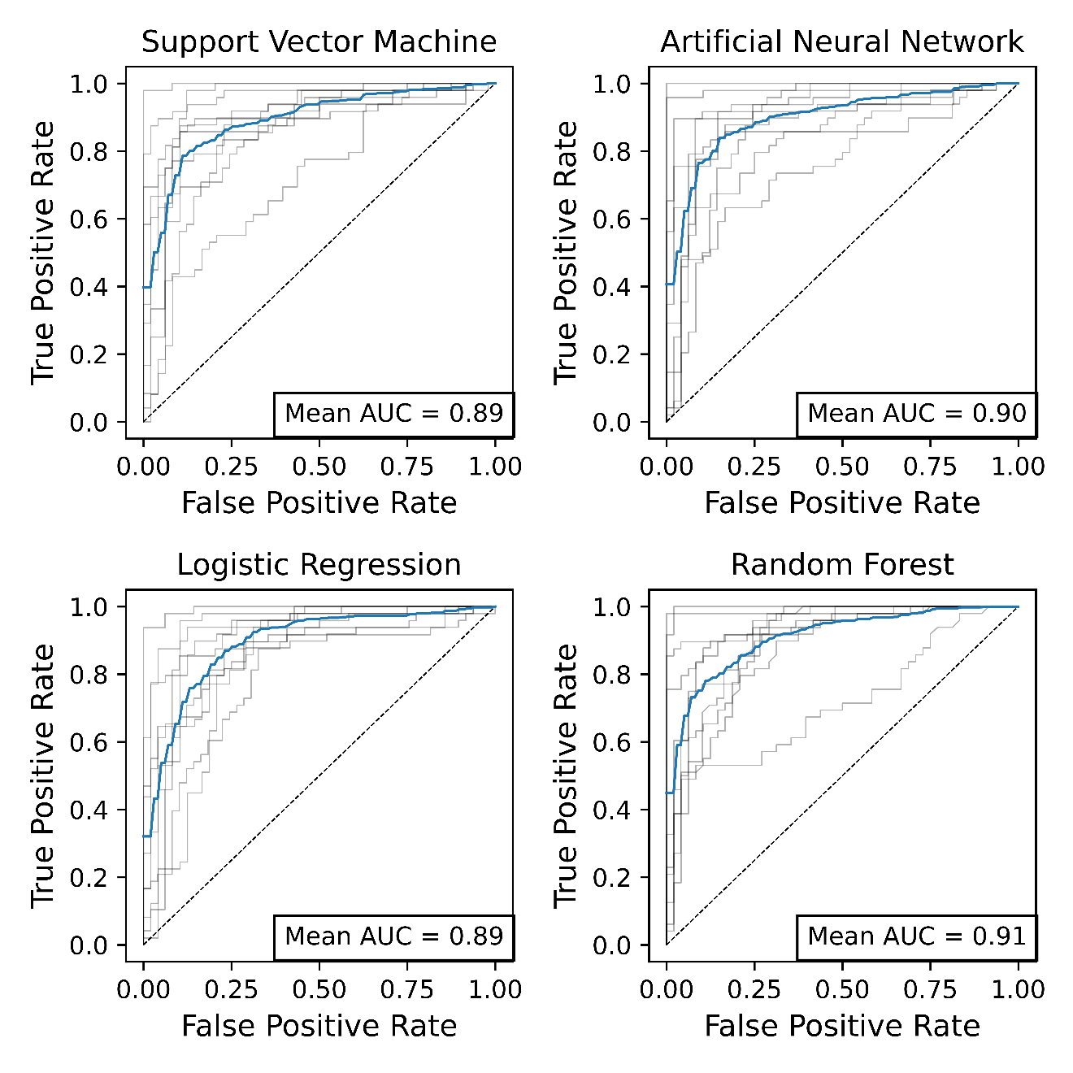
Figure S5. ROC curves generated from re-running the models without dimensionality reduction (PCA), showing similar results to those with dimensionality reduction. Dimensionality reduction is still included as this can reduce overfitting (e.g. excluding the higher principal components) and these unsupervised approaches provide useful interpretations.

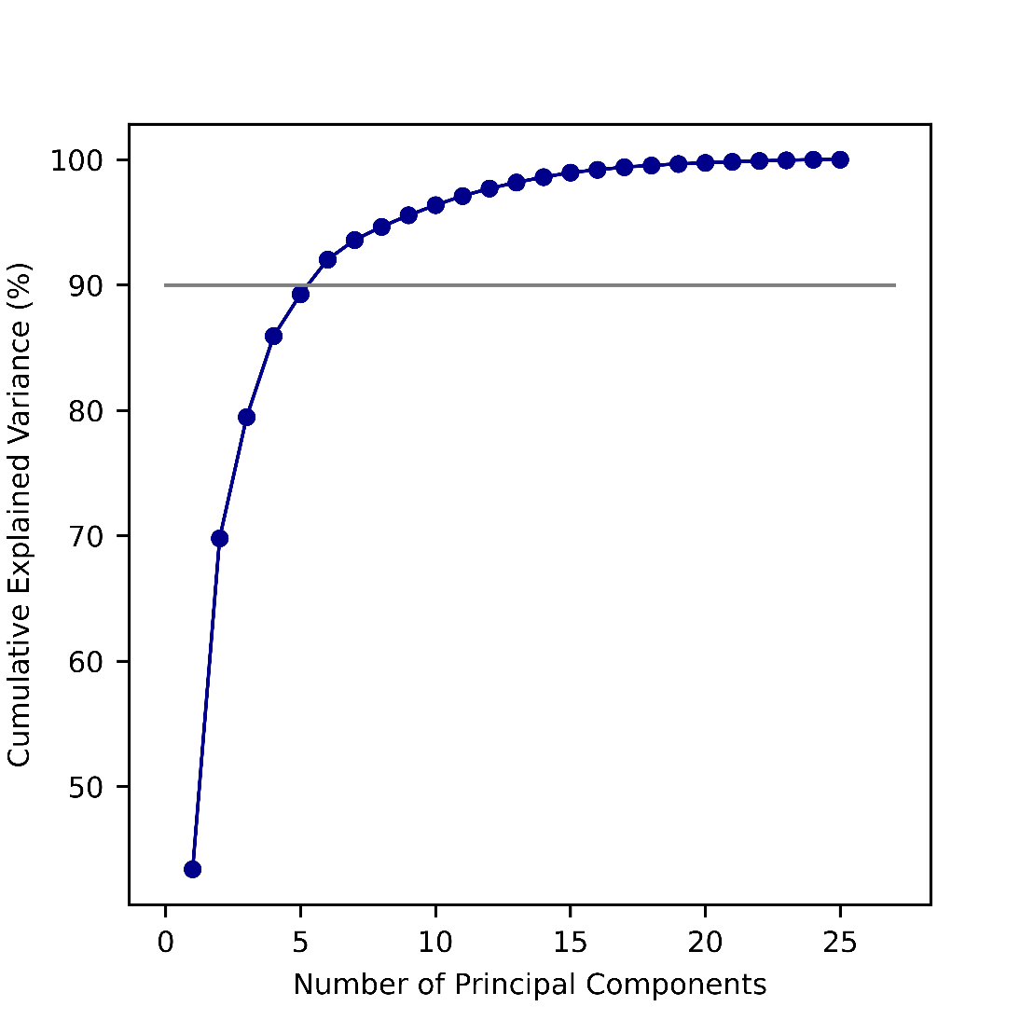
Figure. S6. Scree plot showing the percentage explained variance for each PC. The grey horizontal line indicates 90% variance of the dataset, which can be captured by the first 6 PCs. This number of PCs is used herein as the model input, removing the remaining PCs which may add noise to the classification modelling.

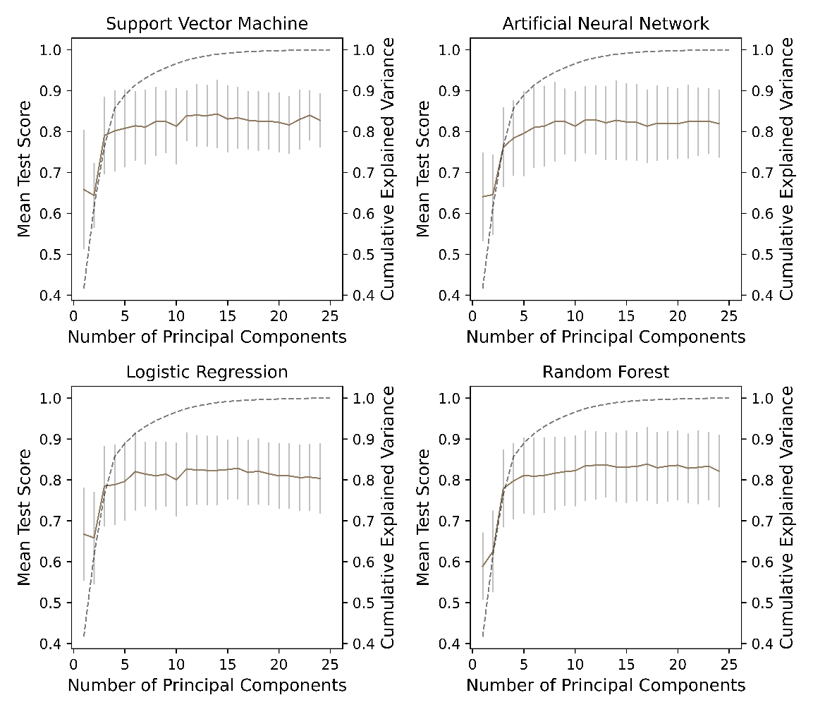

Figure S7. Mean test scores (brown lines) from 10 fold cross validation as a function of the number of PCs included in the training and testing of each supervised machine learning technique. Error bars show the 2σ error. Dashed grey curve shows the cumulative explained variance of each principal component.

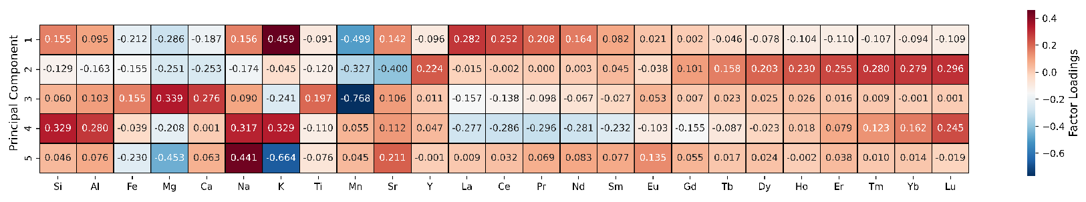
Figure S8. Heatmap displaying factor loadings for each element in each of the first five principal components in the PCA. The magnitude of loading indicates the contribution of the variable to the principal component. The sign of a loading indicates whether the variable correlates positively or negatively with the principal component. Generally, each principal component can be related to a geological process: PC1 = magma differentiation, PC2 = amphibole ± garnet fractionation, PC3 = mafic mineral fractionation, PC4 = hydrothermal alteration (?), PC5 = feldspar fractionation/accumulation/alteration (?).
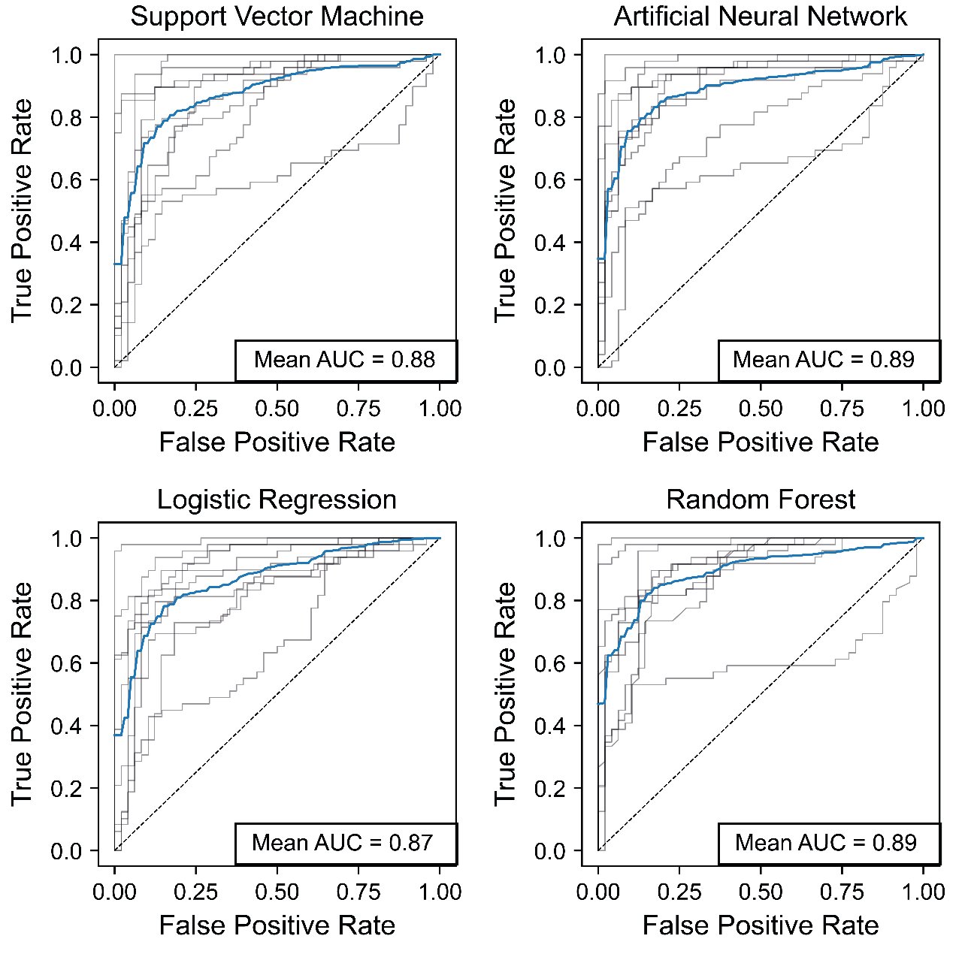
Figure S9: Receiver operating characteristic curves (ROC) for all four classifiers, with curves for each step in the 10-fold cross validation (grey) and the average (blue) shown. Dashed line indicates ROC curve for a random classifier (AUC = 0.5). Area under curve (AUC) metrics are displayed for the averaged ROC curve.

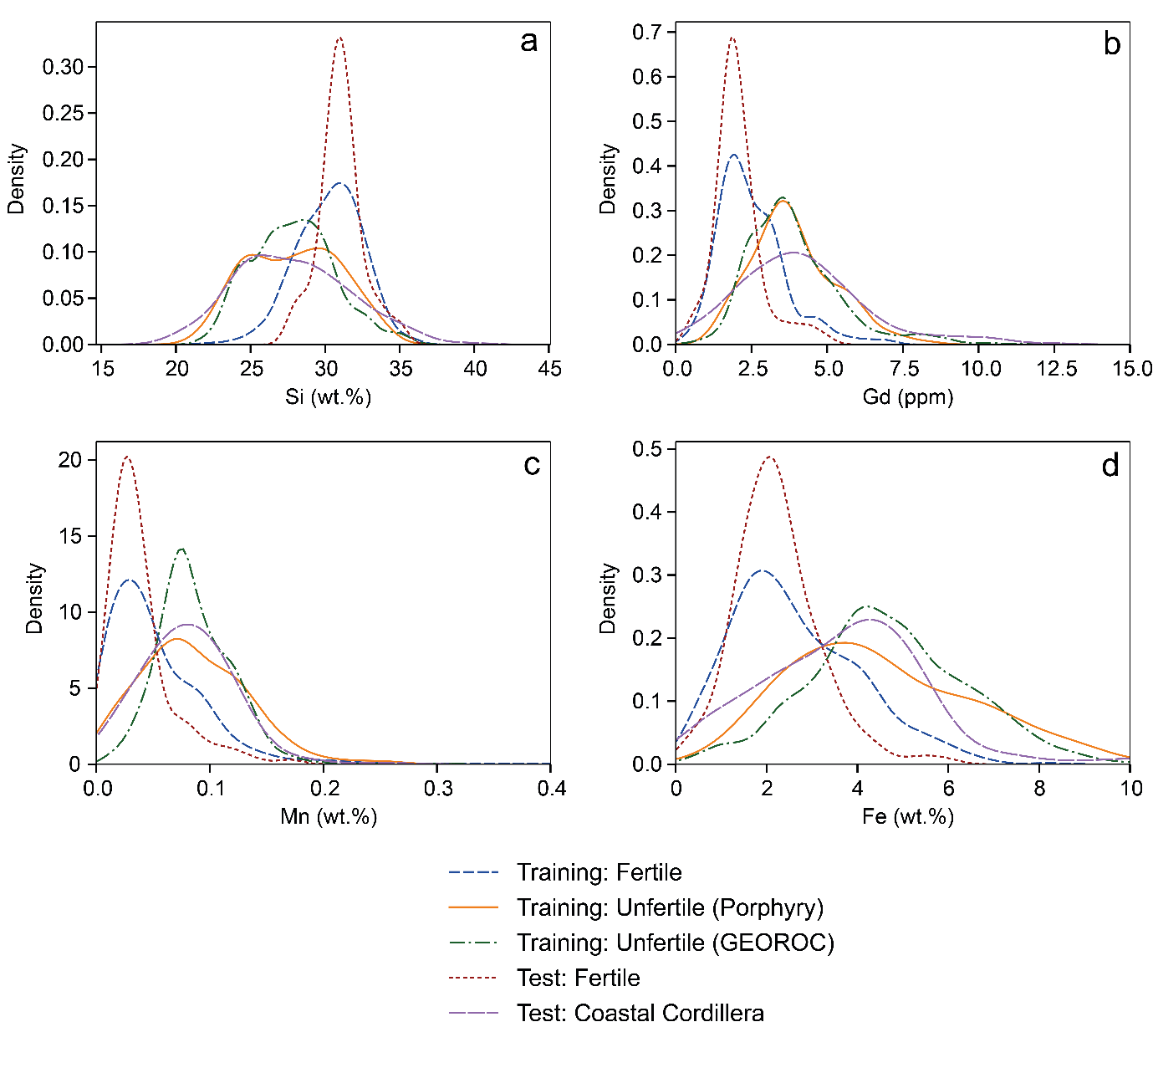
Figure S10. Kernel density diagrams for (a) Si, (b) Gd, (c) Mn and (d) Fe showing that the training vs test datasets are statistically equivalent permitting their use in training and testing the machine learning models.

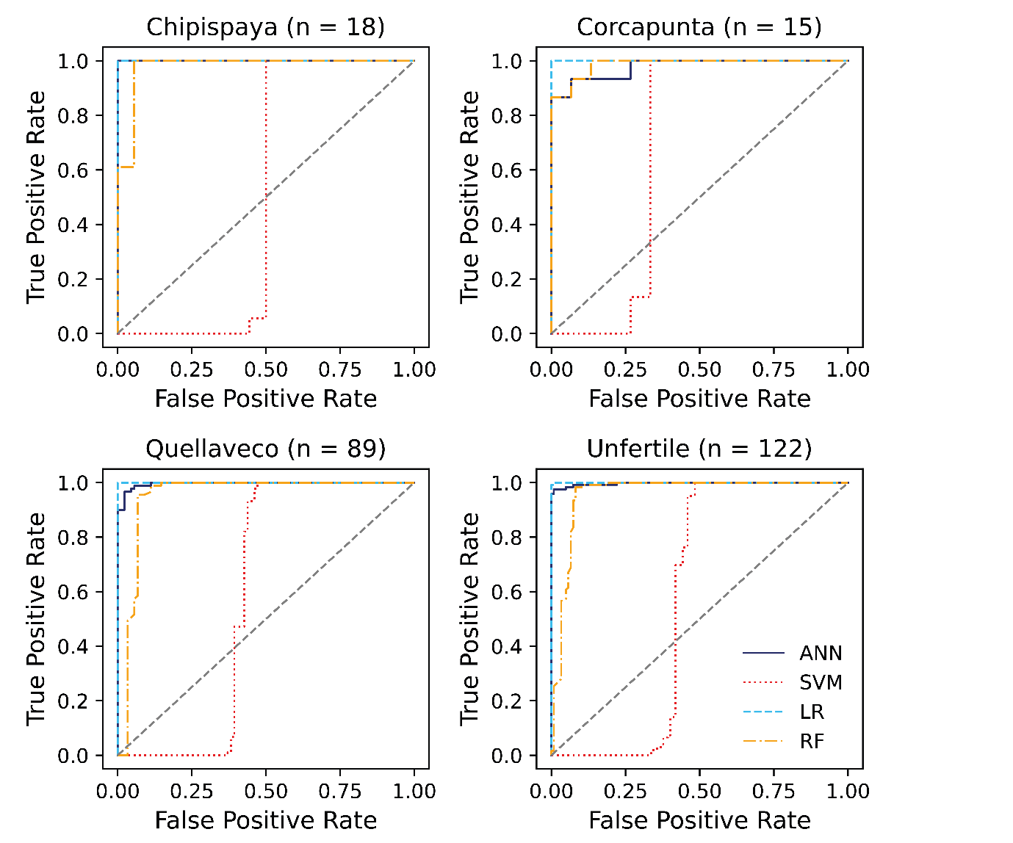
Figure S11: Separate receiver operating characteristic (ROC) curves for each of the three porphyry Cu deposits in the test dataset and withheld GEOROC data (test 1). Model performance is equivalent regardless of the deposit. Each machine learning classifier is denoted by a separate curve (ANN = artificial neural network, SVM = support vector machine, LR = logistic regression, RF = Random Forest).

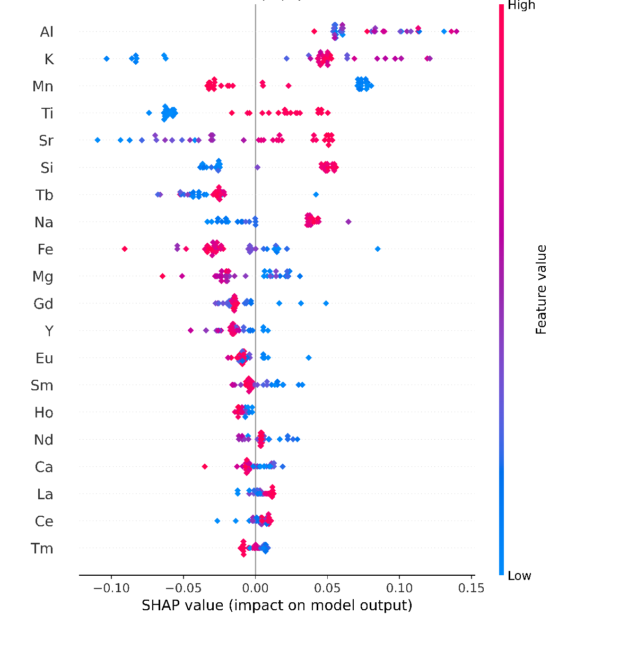
Figure S12. SHAP summary plot for Chipispaya whole-rock geochemistry vs. randomly selected unprospective GEOROC data showing SHAP values (feature importance values) generated during classification of the fertile (Chipispaya) vs unfertile (GEOROC) data during Random Forest classification. Higher magnitude scores indicate higher importance in classifying the data. Elements are ranked top to bottom by their importance. Positive and negative SHAP values represent importance in classifying as positive (fertile) and negative (unfertile) respectively, with colours (red to blue) illustrating the magnitude of the feature in the test data. For example, high K concentrations (red symbols) contribute towards a fertile prediction (positive SHAP value), whereas low K concentrations (blue symbols) contribute towards an unfertile prediction (negative SHAP value).
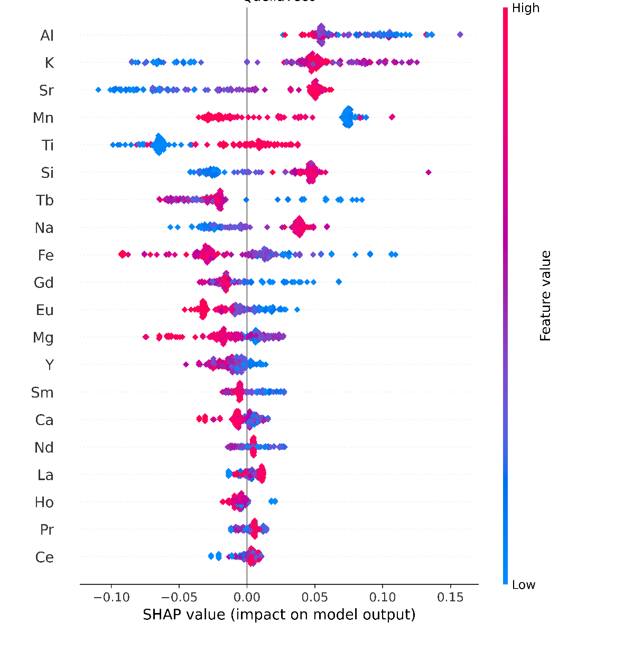
Figure S13. SHAP summary plot for Quellaveco whole-rock geochemistry vs. randomly selected unfertile GEOROC data showing SHAP values (feature importance values) generated during classification of the fertile (Chipispaya) vs unfertile (GEOROC) data during Random Forest classification. See Figure S11 caption.
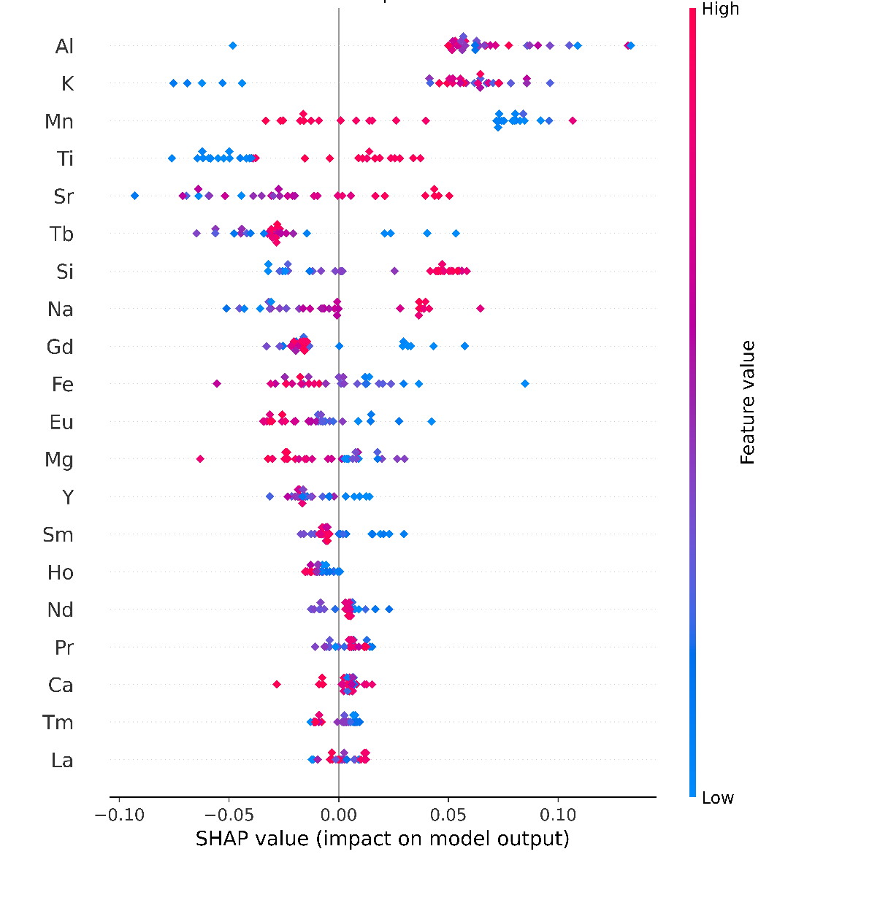
Figure S14. SHAP summary plot for Corcapunta whole-rock geochemistry vs. randomly selected unfertile GEOROC data showing SHAP values (feature importance values) generated during classification of the fertile (Chipispaya) vs unfertile (GEOROC) data during Random Forest classification. See Figure S11 caption.

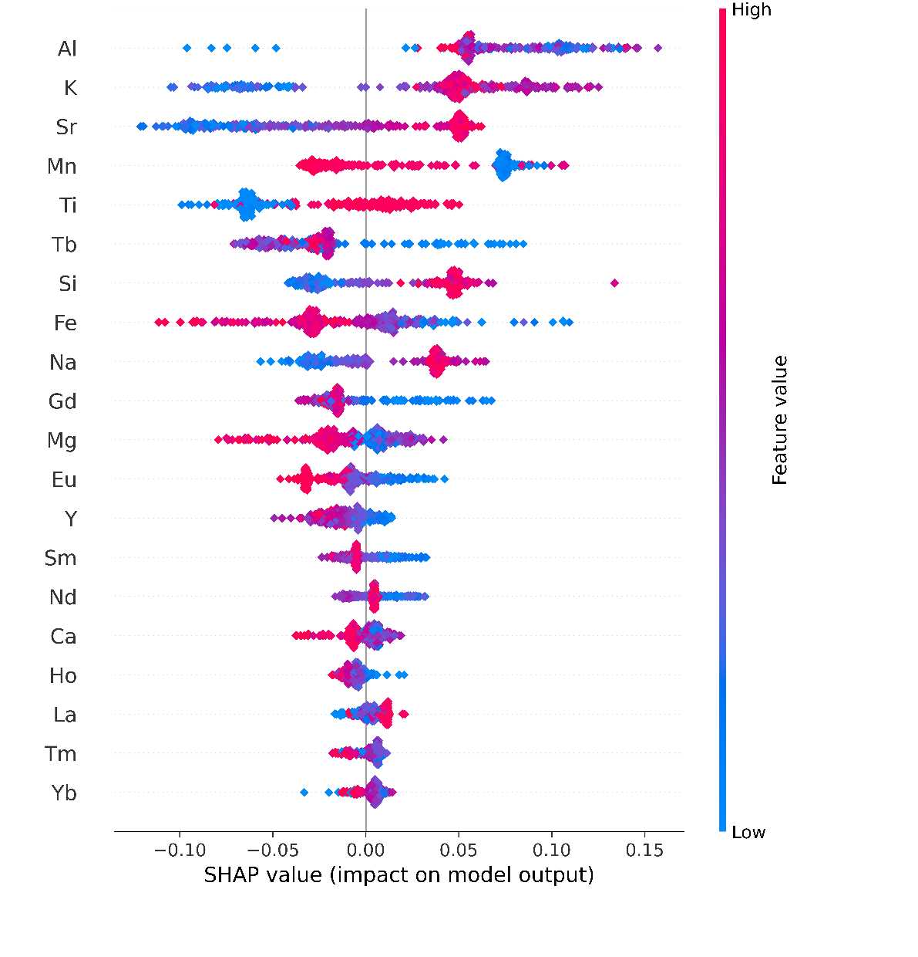
Figure S15. SHAP summary plot for discrimination of GEOROC (unfertile) whole-rock data vs. the fertile data in the validation set (Chipispaya, Corcapunta and Quellaveco) showing SHAP values (feature importance values) generated during classification of the infertile (GEOROC) vs fertile data during Random Forest. See Figure S11 caption.

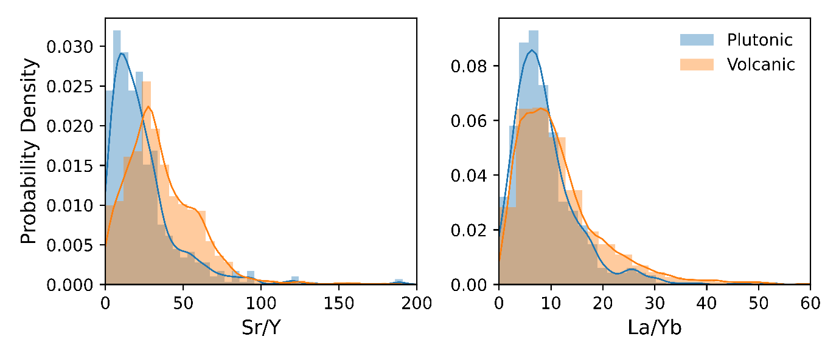
Figure S16. Histograms with kernel density plots for plutonic vs. volcanic rocks in the GEOROC data used in this study. For Sr/Y, the volcanic rocks have higher average Sr/Y compared to plutonic rocks, whereas for La/Yb there is no discernible difference between the populations.
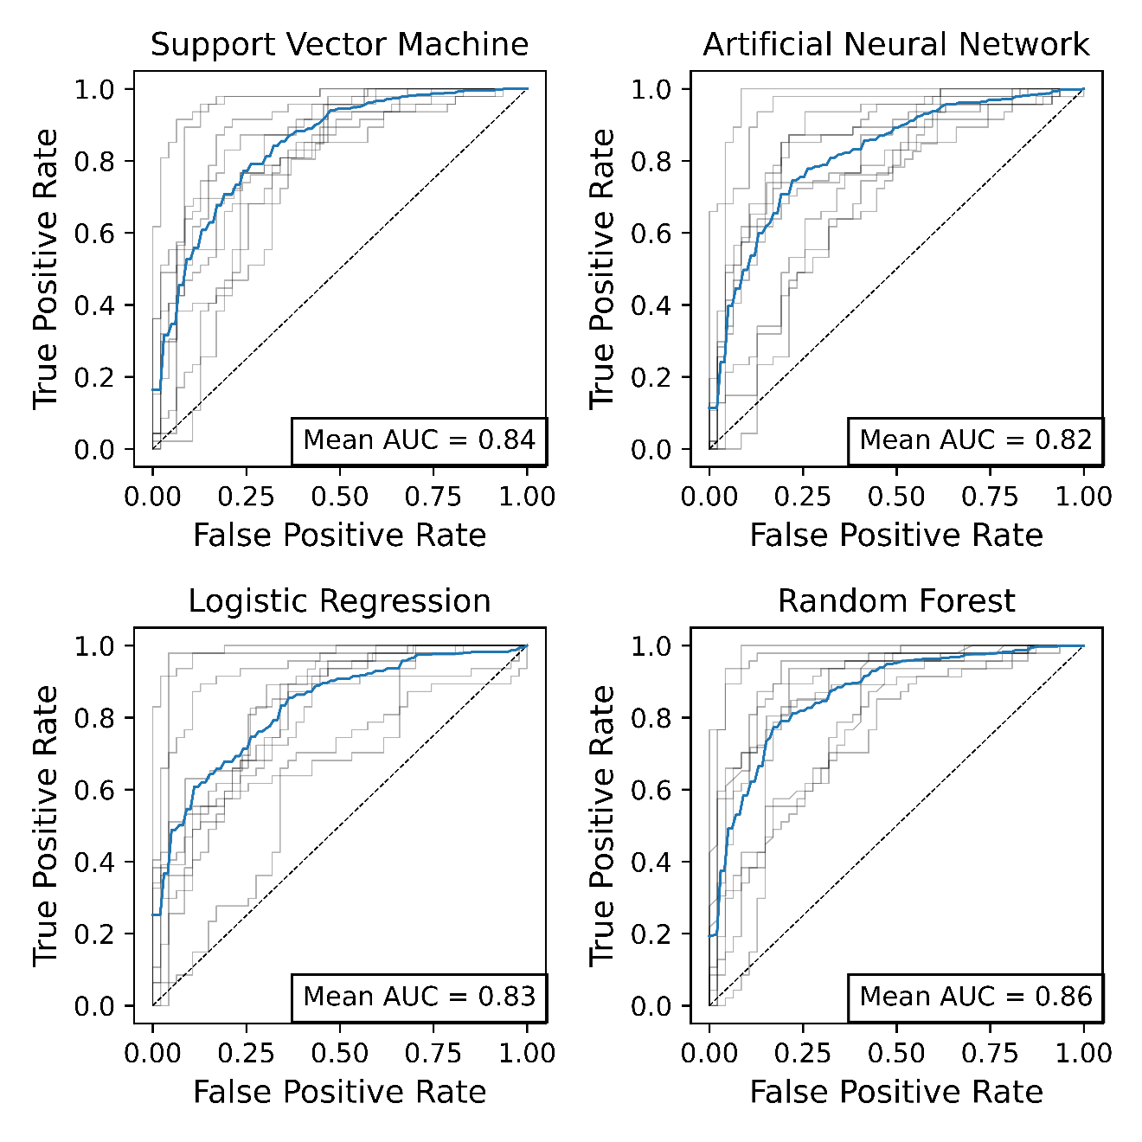
Figure S17. ROC curves for the machine learning classifiers where the GEOROC database is refined to only include plutonic rocks (volcanic rocks excluded). These produce models with ~5% lower ROC-AUC scores.

Table S1: Composition of the upper continental crust (Rudnick and Gao 2003) and the clr-transformed co-ordinates. The geometric mean of the composition is given as g(x).
 | UCC | c(UCC)
SiO₂ | 66.6 | 3.37
TiO₂ | 0.64 | -12.8
Al₂O₃ | 15.4 | 1.9
FeO_{T} | 5.04 | 0.79
MnO | 0.1 | -3.13
MgO | 2.48 | 0.08
CaO | 3.59 | 0.45
Na₂O | 3.27 | 0.35
K₂O | 2.8 | 0.2
P₂O₅ | 0.15 | -2.73
g(x) | 2.29 | -

Table S2: Hyperparameters tuned in the supervised machine learning algorithms used in this study (in Python’s scikit-learn), their meaning, the values tested in a grid-search 10 fold cross validation process and the optimal value determined. The scikit-learn function used is given in parentheses.
Hyperparameter | Meaning | Values tested | Optimal value
Support Vector Machine (‘sklearn.svm.SVC’)
Kernel | Kernel function used to map to high dimension space | ‘linear’, - (linear function)  ‘poly’ – (polynomial function)  ‘rbf’ – (radial basis function)  ‘sigmoid’ (sigmoid function) | ‘rbf’
C | Regularisation parameter – penalty for misclassifications (high C – small margin and less misclassification, low C large margin, high misclassifications) - | 1, 10, 100 | 100
gamma | Coefficient for kernel function, defines the influence of each training point (high = more weight on points close to margin, low = more weight on points distant to margin) | ‘auto’ (1/no. features)  ‘scale’ (no. features/variance)  (0.001, 0.01, 0.1, 1, 10) | ‘auto’
Artificial Neural Network (‘sklearn.neural_network.MLPClassifier’)
Solver | The solver for weight optimisation | ‘lbfgs’ (quasi-Newton method)  ‘sgd’ (stochastic gradient descent)  ‘adam’ (stochastic gradient based optimiser) | ‘adam’
Max_iter | The maximum number of iterations prior to solver convergence | 100, 500, 1000 | 500
Hidden layer size | The number of neurones in each layer in the neural network | (72, 25), (100, 50), (150, 100) | (150, 100)
Activation function | The function used within the neurones to transform input values into a useful and readable range | ‘identity’ (linear function)  ‘logistic’ (logistic sigmoid function)  ‘tanh’ (hyperbolic tan function)  ‘relu’ (rectified linear unit function) | ‘tanh’
Logistic Regression (‘sklearn.linear_model.LogisticRegression’)
Solver | Algorithm for optimisation of weightings | ‘newton-cg’ (linear conjugate gradient  ‘lbfgs’ (quasi-Newton method)  ‘liblinear’ (library for large linear classification)  ‘sag’ (stochastic average gradient)  ‘saga’(variation of ‘sag’) | ‘newton-cg’
C | Regularisation parameter – penalty for misclassifications | 50, 100, 200, 500 | 200
Max_iter | The maximum number of iterations prior to solver convergence | 10, 100, 200, 500 | 100
Random Forest (‘sklearn.ensemble.RandomForestClassifier’)
n_estimators | Number of trees in the random forest | 10, 100, 1000, 1000 | 1000
criterion | Function used to measure the quality of a split (purity) | ‘gini’  ‘entropy’ | Gini
min_samples_split | Minimum number of samples required to split an internal node | 2, 3, 4 | 2
max_depth | Maximum length of a tree | 10,100,1000 | 100
min_samples_leaf | Minimum number of samples required to be at a leaf (terminal node) | 1,2,3 | 1
max_features | Maximum number of features to consider when looking for the best split | ‘auto’  ‘sqrt’ (square root of no. features)  ‘log2’ (log2 of no. features)  ‘none’ (= no. features) | ‘auto’

Table S3A: Performance metrics for Support Vector Machine from 10-fold cross validation
Fold | Accuracy | F1 Score | Precision | Recall | ROC AUC | FPR
1 | 0.66 | 0.55 | 0.83 | 0.41 | 0.84 | 0.08
2 | 0.81 | 0.81 | 0.83 | 0.80 | 0.89 | 0.17
3 | 0.69 | 0.59 | 0.88 | 0.45 | 0.80 | 0.06
4 | 0.68 | 0.63 | 0.76 | 0.53 | 0.61 | 0.17
5 | 0.75 | 0.73 | 0.79 | 0.69 | 0.87 | 0.18
6 | 0.90 | 0.90 | 0.87 | 0.94 | 0.93 | 0.14
7 | 0.90 | 0.89 | 0.91 | 0.88 | 0.94 | 0.08
8 | 0.98 | 0.98 | 0.96 | 1.00 | 1.00 | 0.04
9 | 0.89 | 0.89 | 0.84 | 0.96 | 0.96 | 0.19
10 | 0.88 | 0.87 | 0.89 | 0.85 | 0.92 | 0.10
Mean | 0.81 | 0.79 | 0.86 | 0.75 | 0.88 | 0.12
σ | 0.11 | 0.14 | 0.06 | 0.21 | 0.11 | 0.05

Table S3B: Performance metrics for Artificial Neural Network from 10-fold cross validation
Fold | Accuracy | F1 Score | Precision | Recall | ROC AUC | FPR
1 | 0.68 | 0.58 | 0.88 | 0.43 | 0.76 | 0.06
2 | 0.84 | 0.82 | 0.90 | 0.76 | 0.89 | 0.08
3 | 0.76 | 0.72 | 0.91 | 0.59 | 0.90 | 0.06
4 | 0.68 | 0.63 | 0.76 | 0.53 | 0.63 | 0.17
5 | 0.79 | 0.78 | 0.82 | 0.75 | 0.91 | 0.16
6 | 0.89 | 0.89 | 0.88 | 0.90 | 0.95 | 0.12
7 | 0.90 | 0.89 | 0.93 | 0.85 | 0.94 | 0.06
8 | 0.98 | 0.98 | 0.96 | 1.00 | 0.99 | 0.04
9 | 0.92 | 0.92 | 0.88 | 0.96 | 0.97 | 0.13
10 | 0.83 | 0.83 | 0.86 | 0.79 | 0.92 | 0.13
Mean | 0.83 | 0.80 | 0.88 | 0.76 | 0.89 | 0.10
σ | 0.09 | 0.12 | 0.05 | 0.18 | 0.10 | 0.04

Table S3C: Performance metrics for Logistic Regression from 10-fold cross validation
Fold | Accuracy | F1 Score | Precision | Recall | ROC AUC | FPR
1 | 0.73 | 0.68 | 0.85 | 0.57 | 0.82 | 0.10
2 | 0.85 | 0.84 | 0.89 | 0.80 | 0.90 | 0.10
3 | 0.84 | 0.83 | 0.87 | 0.80 | 0.90 | 0.13
4 | 0.63 | 0.55 | 0.71 | 0.45 | 0.67 | 0.19
5 | 0.72 | 0.69 | 0.77 | 0.63 | 0.78 | 0.18
6 | 0.88 | 0.88 | 0.86 | 0.90 | 0.91 | 0.14
7 | 0.79 | 0.78 | 0.82 | 0.75 | 0.87 | 0.16
8 | 0.96 | 0.96 | 0.94 | 0.98 | 0.99 | 0.06
9 | 0.90 | 0.90 | 0.88 | 0.92 | 0.96 | 0.13
10 | 0.85 | 0.86 | 0.83 | 0.90 | 0.90 | 0.19
Mean | 0.81 | 0.80 | 0.84 | 0.77 | 0.87 | 0.14
σ | 0.09 | 0.12 | 0.06 | 0.16 | 0.09 | 0.04

Table S3D: Performance metrics for Random Forest from 10-fold cross validation
Fold | Accuracy | F1 Score | Precision | Recall | ROC AUC | FPR
1 | 0.66 | 0.55 | 0.83 | 0.41 | 0.86 | 0.08
2 | 0.84 | 0.83 | 0.88 | 0.78 | 0.90 | 0.10
3 | 0.81 | 0.79 | 0.92 | 0.69 | 0.89 | 0.06
4 | 0.67 | 0.62 | 0.74 | 0.53 | 0.60 | 0.19
5 | 0.76 | 0.74 | 0.82 | 0.67 | 0.88 | 0.14
6 | 0.92 | 0.92 | 0.88 | 0.96 | 0.95 | 0.12
7 | 0.85 | 0.83 | 0.90 | 0.77 | 0.94 | 0.08
8 | 0.96 | 0.96 | 0.92 | 1.00 | 1.00 | 0.08
9 | 0.95 | 0.95 | 0.92 | 0.98 | 0.98 | 0.08
10 | 0.82 | 0.81 | 0.86 | 0.77 | 0.91 | 0.13
Mean | 0.82 | 0.80 | 0.87 | 0.76 | 0.89 | 0.11
σ | 0.10 | 0.13 | 0.05 | 0.18 | 0.11 | 0.04

Table S4b: Classification metrics for each classifier for model test 2.

Model | Accuracy | F1 Score | Precision | TPR (Recall) | ROC-AUC | FPR
ANN | 0.95 | 0.95 | 0.96 | 0.95 | 0.97 | 0.04
SVM | 0.48 | 0 | 0 | 0 | 0.94 | 0.05
LR | 0.93 | 0.94 | 0.88 | 1 | 1 | 0.13
RF | 0.98 | 0.98 | 0.96 | 1 | 0.99 | 0.04

Table S4a: Classification metrics for each classifier for model test 1.

Model | Accuracy | F1 Score | Precision | TPR (Recall) | ROC-AUC | FPR
ANN | 0.7 | 0.75 | 0.59 | 1 | 0.98 | 0.54
SVM | 0.7 | 0.75 | 0.6 | 1 | 0.66 | 0.54
LR | 0.8 | 0.82 | 0.69 | 1 | 1 | 0.36
RF | 0.73 | 0.76 | 0.62 | 1 | 0.98 | 0.49

