ESM 2. SUPPLEMENTARY MATERIAL
Analytical methods – Obtained from EGRU Advanced Geochemical & Isotopic Services, James Cook University.

Sample Preparation
Rock samples were washed, and oven dried before being crushed using a rock splitter equipped with a set of tungsten carbide jaws and plates. The crushed rock chips were milled using a Rocklabs ring mill to rock powders, which were then sieved to <300 μm for heavy mineral concentration using a Wilfley table. Heavy concentrates were examined under stereo microscope to understand what heavy minerals may be present and suitable for dating. The mineral(s) suitable for dating may be hand-picked straight away if it is rich in the concentrates, or otherwise concentrated further using Frantz magnetic separator and heavy liquid before hand picking.
Hand-picked minerals were carefully laid in lines on flat double-sided adhesive tape glued to glass plates. Epoxy resin (Struers branded Epofix) was poured into a 1-inch diameter mould to hold mineral grains in place. After curing, mineral pucks can be ground gently to expose mounted minerals and their interior. All samples were polished to a 1 μm finish and cleaned in an ultrasonic bath.
Samples were examined for surface and internal (e.g., polish and inclusions) properties using reflected and transmitted lights of a polarized microscope. A microscope camera was used to take photos and document the above observations.

CL imaging
Sample surface was cleaned using ethanol and Kimwipes, before being carbon coated for CL (cathodoluminescence) imaging. CL images were taken using a field emission scanning electron microscope (FE-SEM, HITACHI, SU5000) equipped with a panchromatic CL. A representative example is shown in ESM 2 Fig 1a below for illustration. It is noted that zircons show a large variation in luminescence between samples, and even within samples in a few cases.

LA-ICP-MS methodology
Data acquisition was carried out at the Advanced Analytical Centre of James Cook University, using a Teledyne Cetac Analyte.G2 193 nm ArF Excimer laser ablation system connected to a Thermo iCAP-RQ ICP-MS. The ablation cell was connected to the iCAP-RQ via Tygon tubing. Ablation was conducted in a HelEx II Active 2-Volume Cell using high-purity He as the carrier gas, which was subsequently mixed with ~0.7 L/min Ar and ~7 ml/min N2 prior to introduction into the ICP-MS. The ICP-MS was optimized using auto tune on a solution basis. It was tuned further for maximum sensitivity in laser ablation mode using standard glass NIST 612 under robust plasma conditions (U/Th = 0.9-1) while maintaining oxide production rates (ThO/Th) to < 0.3%. RSD of U and Th signals of NIST 612 are typically better than 3% when laser fluence was set to ~3 J/cm² at the sample surface with a laser repetition rate and a beam diameter of 10 Hz and 50 μm, respectively. Detailed method is similar to that described in Huang et al. (2021).
Conventional round spot analyses were used for data acquisition with a spot size of 20 μm only for zircon samples. A laser fluence of 3 J/cm² and a rate of repetition of 7 Hz were applied. Analytes include ²⁹Si, ⁴⁹Ti, ⁵⁶Fe, ²⁰⁶Pb, ²⁰⁷Pb, ²⁰⁸Pb, ²³²Th, and ²³⁸U. Zircon samples were intercalated with NIST612 glass and 91500, GJ-1, and Temora 2 zircon references.
A larger spot size of 30 μm and higher repetition rate of 10 Hz were applied for the dating of apatite samples due to their lower U and radiogenic Pb. Apatite dating was repeated in a second session aiming to test reproducibility and to improve precision. A spot size of 25 μm and a repetition rate of 8 Hz were applied in this session as limited by the sample size. Same conditions were applied for the dating of titanite sample.
Conventional round spot analyses were used for data acquisition with a spot size of 10 µm only for monazite samples. A laser fluence of 3 J/cm² and a rate of repetition of 6 Hz were applied. Analytes include ³¹P, ⁵⁶Fe, ²⁰⁶Pb, ²⁰⁷Pb, ²³²Th, and ²³⁸U. Samples were intercalated with NIST612 glass, and RW-1 and 44069 monazite references rich in Th.
Iolite 4 (https://iolite.xyz/) was used for data reduction using the reduction scheme U-Pb Geochronology for zircon and monazite samples and VizualAge UcomPbine for apatite and titanite. Relevant information can be found in Paton et al. (2010) and Chew et al. (2014).

Quality Assurance and Quality Control
Temora 2 zircon, which has an ²⁰⁶Pb/²³⁸U age of 416.78 ± 0.33 Ma (95% conf.) (Black et al., 2004), was used for the calibration of U-Pb isotopes. GJ1, with an ²⁰⁶Pb/²³⁸U age of 601.86 ± 0.37 Ma (Horstwood et al., 2016) was used as secondary reference. The total 104 analyses on GJ1 gave a concordia age of 601.43 ± 1.65 Ma and a weighted mean ²⁰⁶Pb/²³⁸U age of 600.22 ± 2.02 Ma (MSWD = 0.44; ESM 2 Fig 1b), demonstrating excellent accuracy of the analyses.
Madgascar apatite was used as the primary reference for U-Pb isotope calibration, while McClure Mountain was used as a secondary for quality check. Madgascar apatite used here is the same grain as that described in Chew et al. (2014) and has a weighted mean ²⁰⁶Pb/²³⁸U age of 473.5 ± 0.7 Ma. McClure Mountain apatite has a weighted mean ²⁰⁷Pb/²³⁵U age of 523.51 ± 2.09 Ma determined using ID-TIMS (Schoene and Bowring, 2006). A total of 70 spot analyses from the two sessions define a lower intercept age of 516.10 ± 11.11 Ma (ESM 2 Fig 1c), again demonstrating the accuracy of the method.

References
Black LP, Kamo SL, Allen CM, Davis DW, Aleinikoff JN, Valley JW, Mundil R, Campbell IA, Korsch RJ, Williams IS, Foudoulis C (2004) Improved ²⁰⁶Pb/²³⁸U microprobe geochronology by the monitoring of a trace-element-related matrix effect; SHRIMP, ID–TIMS, ELA–ICP–MS and oxygen isotope documentation for a series of zircon standards. Chem Geol 205:115–140. https://doi.org/10.1016/j.chemgeo.2004.01.003
Chew DM, Petrus JA, Kamber BS (2014) U–Pb LA–ICPMS dating using accessory mineral standards with variable common Pb. Chem Geol 363:185–199. https://doi.org/10.1016/j.chemgeo.2013.11.006
Horstwood MSA, Košler J, Gehrels G, Jackson SE, McLean NM, Paton C, Pearson NJ, Sircombe K, Sylvester P, Vermeesch P, Bowring JF, Condon DJ, Schoene B (2016) Community-Derived Standards for LA-ICP-MS U-(Th) Pb Geochronology – Uncertainty Propagation, Age Interpretation and Data Reporting. Geostand Geoanal Res 40:311–332. https://doi.org/10.1111/j.1751-908X.2016.00379.x
Huang HQ, Guillong M, Hu Y, Spandler C (2021) Fine tuning laser focus for improved reproducibility of U–Pb isotope analysis by LA-ICP-MS. J Anal At Spectrom 36:836–844. https://doi.org/10.1039/D1JA00044F
Paton C, Woodhead JD, Hellstrom JC, Hergt JM, Greig A, Maas R (2010) Improved laser ablation U-Pb zircon geochronology through robust downhole fractionation correction. Geochem Geophys Geosyst 11:1–36. https://doi.org/10.1029/2009GC002618
Schoene B, Bowring SA (2006) U–Pb systematics of the McClure Mountain syenite: thermochronological constraints on the age of the ⁴⁰Ar/³⁹Ar standard MMhb. Contrib Mineral Petrol 151:615–630. https://doi.org/10.1007/s00410-006-0077-4

Figures
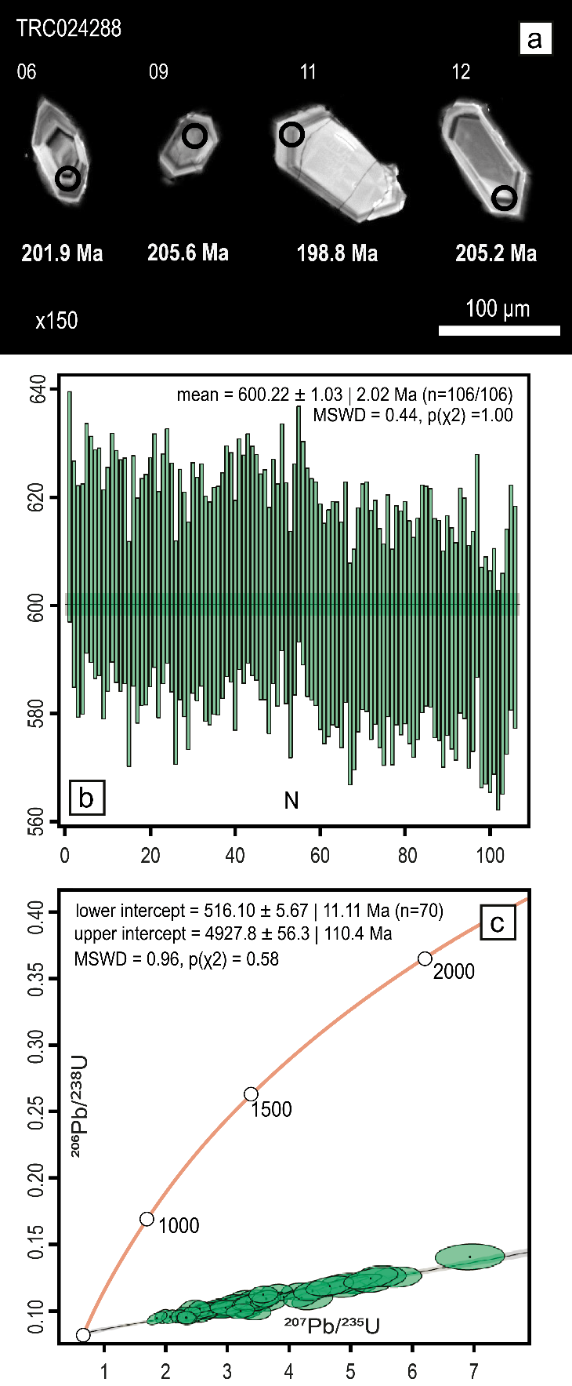
ESM 2 Fig 1 (a) Representative CL images of TRC024288 Zrn samples with spot positions and ages labelled. (b) Weighted mean average ²⁰⁶Pb/²³⁸U age of 104 concordant analyses on GJ1 Zrn. (c) Wetherill concordia plot of McClure Mountain Ap dating results.

