Multi-source hydrothermal mineralisation in the ultramafic-hosted Mirae-2 vent field, Central Indian Ridge

Sun Ki Choi^{1,*}, Jonguk Kim¹, Sang Joon Pak², Wonnyon Kim¹, Hwimin Jang³, Ryoung Gyun Kim^{1,4}

¹Ocean Georesources Research Department, Korea Institute of Ocean Science and Technology, Busan, South Korea
²Critical Minerals Research Center, Korea Institute of Geoscience and Mineral Resources, Daejeon, South Korea
³Vessel Operation and Observation Team, Korea Institute of Ocean Science and Technology, Geoje, South Korea
⁴Department of Earth and Environmental Sciences, Pukyong National University, Busan, South Korea

*Corresponding author: chlsunki@kiost.ac.kr

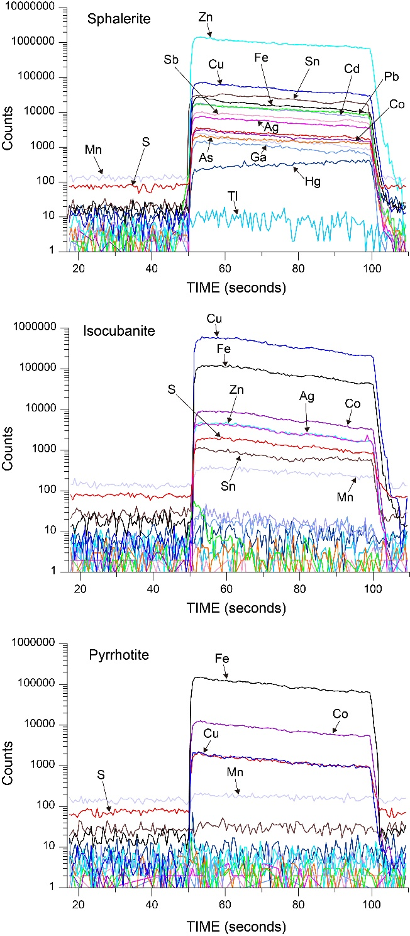
Fig. S1 (ESM 2) Representative time-resolved LA-ICP-MS depth profiles in the dominant sulfide minerals.

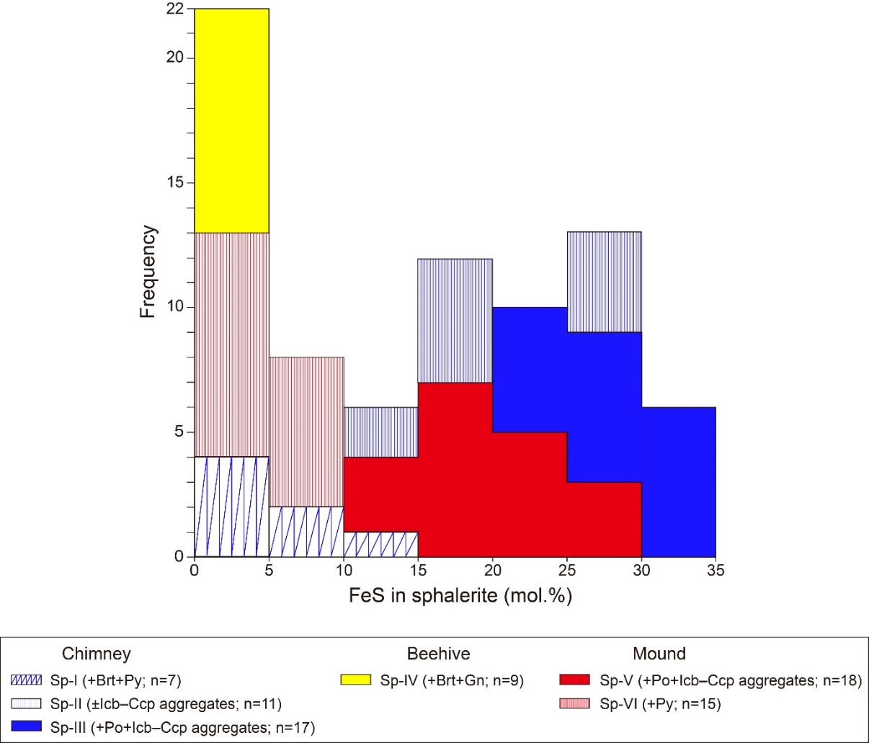
Fig. S2 (ESM 2) Histogram of FeS contents in sphalerite according to mineral assemblage. Abbreviations are as in Fig. 5.

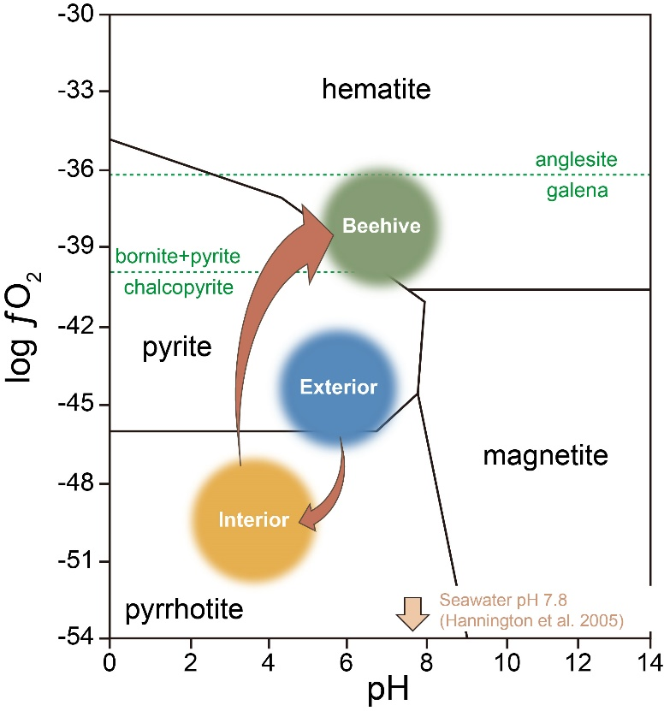
Fig. S3 (ESM 2) A logƒO₂-pH diagram, modified from Zhai et al. (2019), showing the mineral stabilities in Fe–Cu–S–O–H system at 200°C and 500 bars. The circular symbols represent the approximate fluid conditions associated with hydrothermal mineralisation on the exterior, interior, and beehive structure of the chimney, based on the preliminary pH values (~3) determined from shipboard analysis

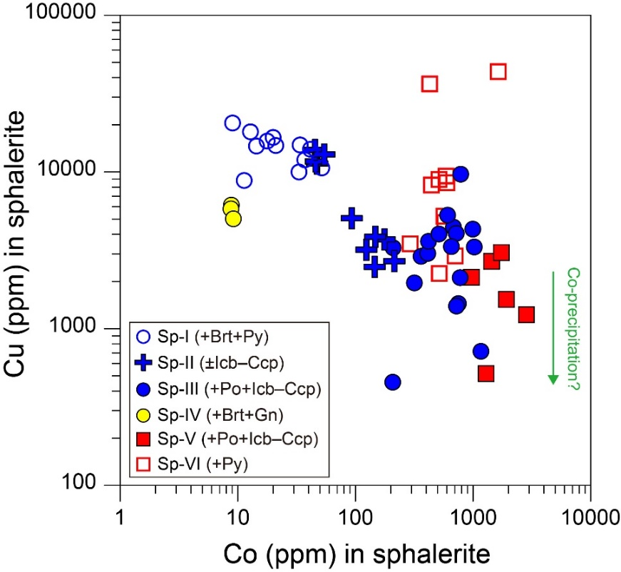
Fig. S4 (ESM 2) Copper and cobalt contents of sphalerite determined by LA–ICP–MS showing the relatively depletion in sphalerite associated with Cu minerals.

