Electronic Supplementary Material

Textural, mineralogical, and geochemical evidence for apatite metasomatism and REE mobility within the Corvo orebody at the Neves Corvo Cu-Zn-Pb(-Sn) VMS deposit (Iberian Pyrite Belt)

Marta S. Codeço^{1,2*}, Sarah A. Gleeson^{1,3}, Vitor Barrote^{1,4}, Daniel Harlov¹, Christof Kusebauch¹, Monika Koch-Müller¹, Jorge M.R.S. Relvas⁵, Anja M. Schleicher¹, Christian Schmidt¹, Jessica A. Stammeier¹, Marcin D. Syczewski¹, Franziska D.H. Wilke¹

¹GFZ German Research Centre for Geosciences, Telegrafenberg, 14473 Potsdam, Germany
²Lowell Institute for Mineral Resources & Department of Geosciences, College of Science, The University of Arizona, Tucson, AZ, USA
³Freie Universität Berlin, Institute for Geological Sciences, Malteserstraße 74-100, 12249 Berlin, Germany
⁴Paul Scherrer Institut (PSI), Forschungsstrasse 111, 5232 Villigen PSI, Switzerland
⁵Universidade de Lisboa, Faculdade de Ciências, Instituto Dom Luiz, 1749-016 Lisboa, Portugal

*Corresponding author
Present address: Lowell Institute for Mineral Resources & Department of Geosciences, College of Science, The University of Arizona, Tucson, AZ, USA
Email: mscodeco@arizona.edu

Contents of this supplement

I. Bulk rock geochemistry and mineralogy 2
II. Footwall sequence – Corvo orebody and Tin corridor 3
III. Whole rock chemistry of the footwall sequence 5
IV. Electron probe microanalyzer (EPMA) 8
V. Laser Ablation-Inductively Coupled Plasma-Mass Spectrometry (LA-ICP-MS) and scanning electron microscopy (SEM) 8
VI. Raman Spectroscopy 13
VII. Fourier transform infrared (FTIR) spectroscopy 13
VIII. Supplementary Figures 16
References 20

Bulk rock geochemistry and mineralogy

Bulk rock geochemical and mineralogical composition were analyzed at the ElMiE-Lab at the German Centre for Geosciences (GFZ, Potsdam). The samples were crushed and powdered in an agate mill to a grain size of < 62 μm. Sulphur (S) was determined using an Element Analyzer (CS 2000, Eltra). The concentrations of CO₂ and H₂O were analyzed using an Element Analyzer (Euro). Two samples, C595-105 and C600-97, with S contents >10 wt.%, were excluded from borate fusion (see below). These samples were digested by sodium peroxide fusion (after Bokhari and Meisel 2017). In brief, the samples were fused with Na₂O₂ in a vitreous carbon crucible at 480°C. The sinter cake was dissolved in ultrapure water. Undissolved residues were separated by centrifugation, dissolved in HCl, and added to the supernatant. Concentrations were determined using standard addition. Major element oxides (except for Na₂O) were determined by inductively coupled plasma optical emission spectrometry (ICP-OES, 5110 Agilent Technologies).
For all other samples, major element oxides (SiO₂, TiO₂, Al₂O₃, Fe₂O₃, MnO, MgO, CaO, Na₂O, K₂O, P₂O₅) and minor elements (Ba, Cr, Ga, Nb, Ni, Rb, Sr, V, Y, Zn, Zr) were analyzed on fused disks after borate fusion using wavelength-dispersive X-ray fluorescence spectrometry (XRF, Axios Advanced, Malvern-PANalytical). The measured concentrations of S, CO_{2,} and H₂O were used to compensate for the loss of ignition (LOI), i.e., the weight difference before and after fusion of the sample.
For the analysis of Fluoride concentrations, F was extracted by pyrohydrolysis and brought into an aqueous solution. The F concentration was then determined in aqueous solution by potentiometric titration using an F-selective electrode (DX 219 with InLab® Reference Plus, Mettler-Toledo).
Additional trace element concentrations (As, Ba, Be, Bi, Cd, Co, Cr, Cs, Cu, Ga, Hf, Li, Mo, Ni, Pb, Rb, REE, Sb, Sc, Sn, Sr, Th, Tl, U, V, Zn, Zr) were determined by high-resolution inductively coupled plasma mass spectrometry (HR-ICP-MS, Element 2XR, Thermo Fisher). Samples were digested using the common 4-Acid digestion (HF, HCl-HNO3, HClO4), e.g., Pretorius et al. (2006) and Romer and Hahne (2010). Reproducibility was ensured by digestion of certified reference material (crm) JR-1, JA-1 (rhyolite and andesite powder, respectively; Geological Survey of Japan, Tsukuba, Japan), DR-N (diorite powder; Centre de Recherches Petrographiques et Geochimiques, France) and SCO-1 (cody shale powder; U.S. Geological Survey, USA). Dissolved samples were spiked with 1 µg/kg⁻¹ Indium as an internal standard to correct for instrumental drift. The acid blank was subtracted from each measurement. The procedural blank was negligible compared to sample concentration. For data processing purposes, we used elements acquired by ICP-MS for elements that were analyzed by both techniques (XRF and ICP-MS). The whole procedural precision, including repeatability, analytical precision, and reproducibility for the geochemical determinations, is within 10%.
For quantification of the bulk rock mineral composition, the samples were homogenized to a grain size of < 10 mm with a micromill, and the powder was loaded from the back side of the sample holder in random orientation. XRD analyses were performed using an X-ray diffractometer (XRD, Empyrean, Malvern-PANalytical), operating with Bragg-Brentano geometry at 40mA and 40kV with CuKalpha radiation and a PIXel3D detector at a sept size of 0.013°2theta from 4.6 to 85 °2theta and 60s per step.
The EVA software (version 11.0.0.3) by Bruker was used to determine the mineralogy of the rock samples. Rietveld refinement for quantitative mineralogy was further performed using the program BGMN and the graphical user interface Profex 5.0.2 (Doebelin and Kleeberg 2015) calibrated accordingly to the used diffractometer. The uncertainty of the quantitative mineralogy was better than 3 wt.% for individual phases.

Footwall sequence – Corvo orebody and Tin corridor

The samples studied in this work include volcanic and volcaniclastic rocks (or metasediments with volcanic contribution) as well as black shales from the footwall sequence of the Corvo orebody, which hosts the central stockwork for the massive sulfides and from the massive cassiterite-related stockwork (Tin’s corridor). Figure S1 displays the results from the bulk mineralogical composition; for the quantification, we only considered phases whose amounts are greater than 5 wt.%. The felsic volcanic rocks are highly altered rhyolites mainly composed of primary quartz phenocrysts (40-70%) and altered to an assemblage of chlorite (mostly 20-40%), sericite (fine-grained muscovite <10%), and albitic plagioclase (around 7%) (Fig. S1). Accessory amounts of prehnite (1-3%), calcite (1-4%), and fluor-apatite (1-2%) could be identified in the XRD spectra; however, they were not included in Fig. S1 due to the uncertainty in their quantification. Some samples contain up to 5% pyrite, which occurs either disseminated or in veinlets with carbonates or chlorite. The mineralized felsic volcanic rock from the V2 unit (C595-105) associated with the central copper stockwork is composed of 30% of quartz, 22% of chlorite, 27% of pyrite, 6% of chalcopyrite, and 8% of sphalerite. Minor siderite, albite, and fluor-apatite could also be detected by XRD (<4%). The volcaniclastic rocks have similar proportions of quartz and chlorite (40-42%) and <20% of other phases, with sericite, illite, and carbonates as the most abundant accessory phases.

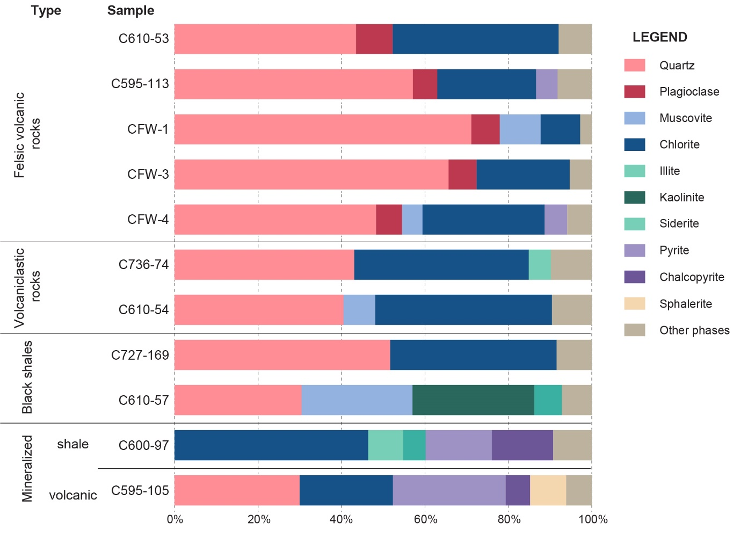
Figure S1 Mineralogical composition of samples from the Corvo orebody deposit. The bar plot of individual samples is split by lithology.

The sample from the massive sulfide footwall (C610-57) is likely a black shale or metasediment with volcanic contribution and is mainly composed of quartz (30%), sericite (27%), and kaolinite (29%). Accessory phases include chlorite, illite, and siderite. In contrast, the black shale sampled in the tin stockwork (C727-169) has 50% of quartz and 40% of chlorite, with the remaining 10% including sericite, illite, and calcite. The mineralized black shale hosting the massive sulfide mineralization has 46% chlorite and 30% sulfides (pyrite and chalcopyrite). Illite, siderite, ankerite, and fluorapatite constitute accessory phases in this sample.

Whole rock chemistry of the footwall sequence

The eleven analyzed samples cover the lithostratigraphic interval hosting the mineralization at the Corvo orebody, including the deeper coherent volcanic facies (V2) and the overlying volcaniclastic facies (V1) that constitute the immediate footwall to the massive sulfides. Our results have been compared in Fig. S2 with published values from Neves Corvo (Relvas 2000; Relvas et al. 2006; Rosa 2007) and unmineralized/unaltered regional volcanic rocks [Albernoa-Roxo area: Rosa et al. (2004) and Codeço et al. (2018) and various other locations within the Portuguese and Spanish sectors of the IPB: Munhá and Kerrich (1980), Munhá (1982, 1983), Leistel et al. (1997), Mitjavila et al. (1997), Almodóvar et al. (1998), Sánchez-España et al. (2000), Thiéblemont et al. (2002) and Boulter et al. (2004). Figure S2 shows that felsic volcanics from Neves have lower TiO₂, Al₂O₃, MgO, CaO, Na₂O, K₂O, and P₂O₅, and higher Fe₂O₃ compared with their unaltered counterparts, suggesting that, without exception, all major elements were mobile under hydrothermal conditions. As shown in section II, the samples contain alteration minerals such as chlorite, sericite, carbonates (ankerite, calcite, siderite), and sulfides (pyrite, chalcopyrite, sphalerite). The absence of Na₂O is indicative of feldspar destruction or replacement, whereas CaO is lost due to the destruction of plagioclase and its replacement by sericite or chlorite (Figs. S2a, b). On the other hand, samples from Neves Corvo have high Fe₂O₃ and low MgO, indicating the presence of Fe-rich chlorite (chamosite) and high Fe-rich sulfide contents (Figs. S2c, d). On the other hand, the relatively low K₂O contents (Figs. S2e) imply that sericitization is minor, which confirms the results obtained by XRD (section II). Another indicator of alteration is elevated loss on ignition (LOI) values [> 2%, Le Maitre (2002): see Table D2 (Codeço et al. 2025)], which accounts for CO₂, water, and S contents of the rock. Phosphorus contents in the volcanic rocks are almost negligible (<0.05 %) in comparison with most regional samples (Fig. S2f), except for one sample (CFw4), where we identified fluorapatite (2.5%) with XRD. This is also compatible with the high contents in fluorine (1122 ppm) and CaO (1.39 wt.%) in comparison with the other samples (Table D2 (Codeço et al. 2025), Alumina and TiO₂, typically considered immobile elements, have much lower concentrations than their regional counterparts (Figs. S2g, h), thus suggesting that some Ti and Al were lost during metasomatic processes. Expectably, in such hydrothermal alteration conditions, the MnO contents are consistently low in all samples analyzed in this study, especially in the felsic volcanic rocks of the V2 unit (Figs. S2i).
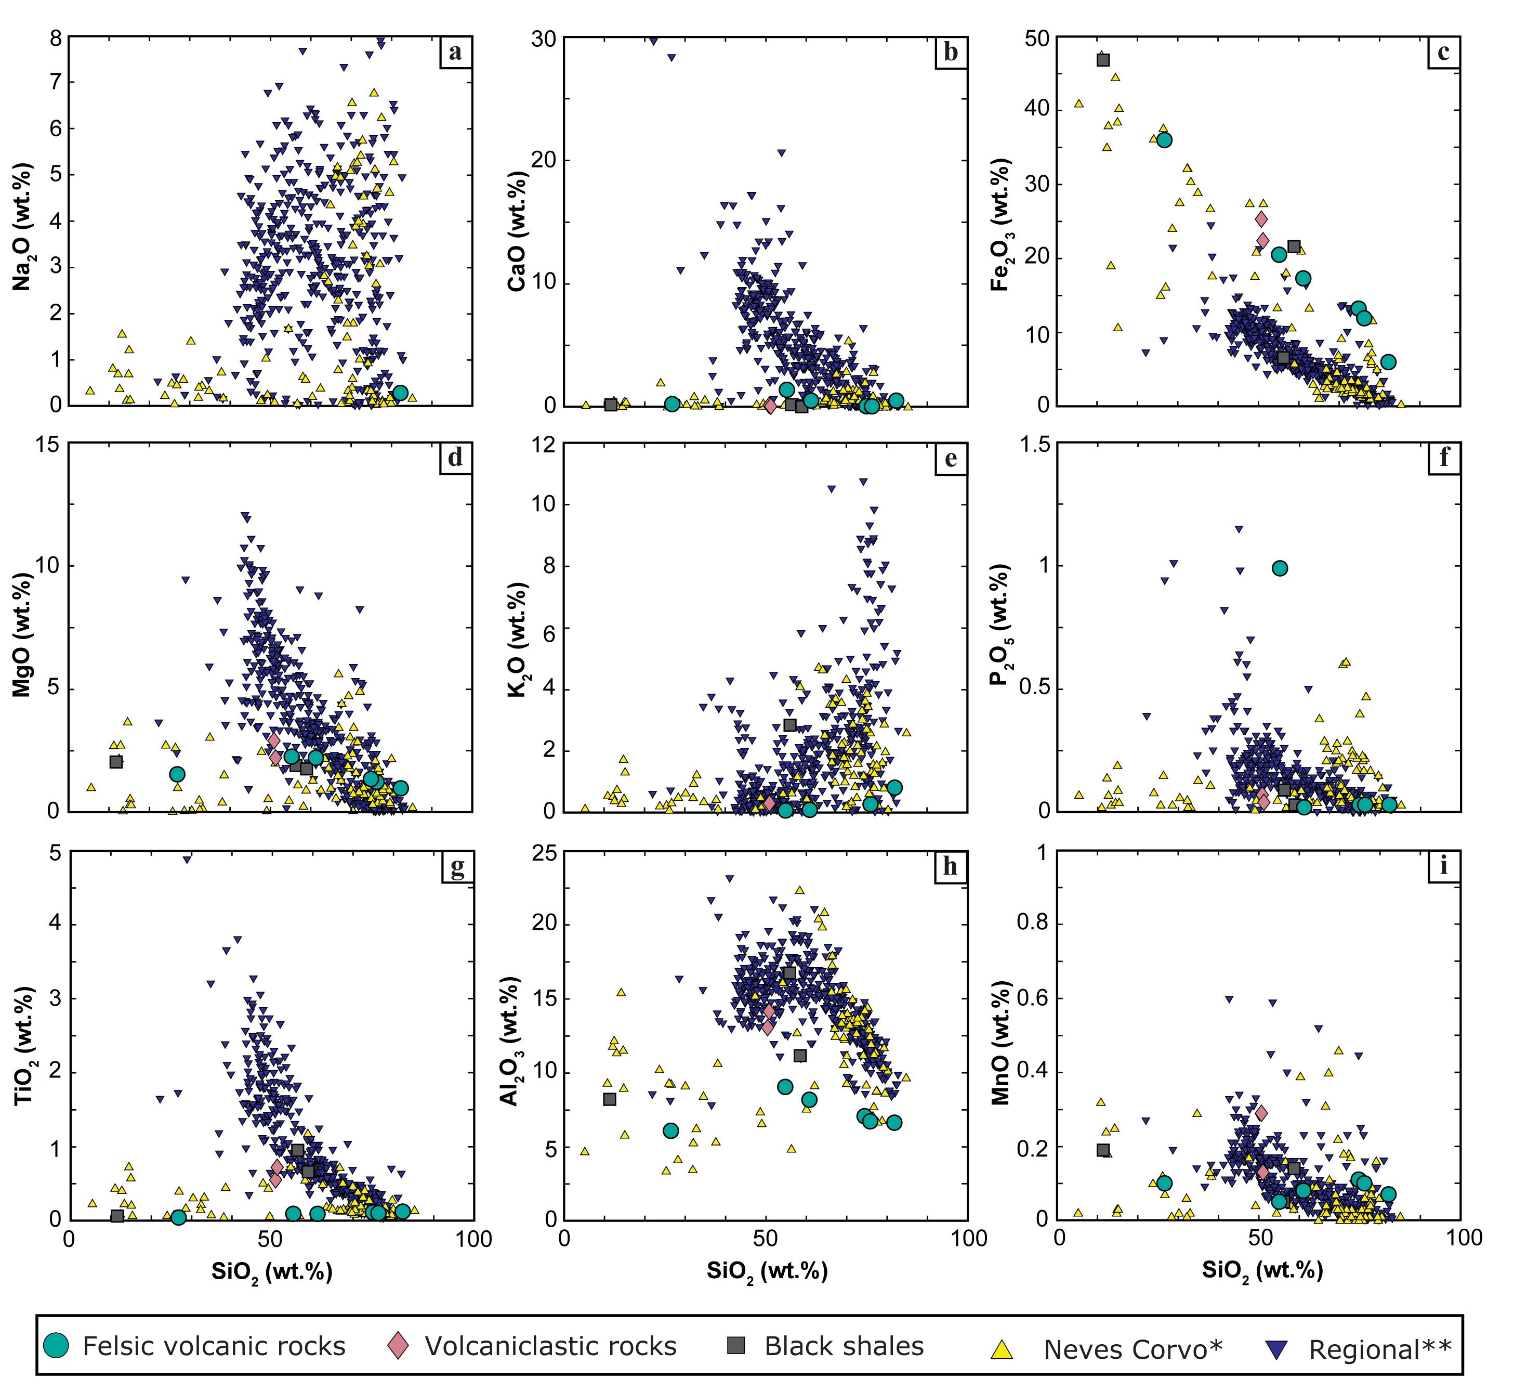
Figure S2 Hacker-type diagrams for felsic volcanic and volcaniclastic rocks, and black shales from Neves Corvo. Literature data from Neves Corvo (*) and a regional database (**) were added for comparison (see text for the references).

The Rare Earth Element (REE) patterns for both the felsic volcanic and volcaniclastic rocks are shown in Fig. S3 and were normalized to the chondrite values of McDonough and Sun (1995). In general, all samples have a moderate enrichment in the LREE but near flat middle to heavy REE; however, the felsic volcanic rocks have lower REE contents than the volcaniclastic rocks and black shales. The samples with lower LREE contents correspond to the samples where higher apatite contents were identified with XRD (i.e., CFW-4, C595-105, and C610-53). Interestingly, the felsic volcanic mineralized sample (C595-105) registers among the lowest REE enrichment in the data set, whereas the mineralized black shale, even though presenting higher LREE contents, displays the lowest MREE and HREE values. Similarly to the felsic volcanics, the apatite is present in the mineralized shale and absent in the unmineralized counterparts. The unmineralized black shales and volcaniclastic rocks generally have high LREE and relatively high MREE and HREE. As shown in Fig S3, these samples have greater amounts of chlorite, sericite, and clays. Barrett et al. (2008) have suggested that REEs are increased by net mass loss resulting from chloritization and sericitization of the Aljustrel rhyolites (IPB).

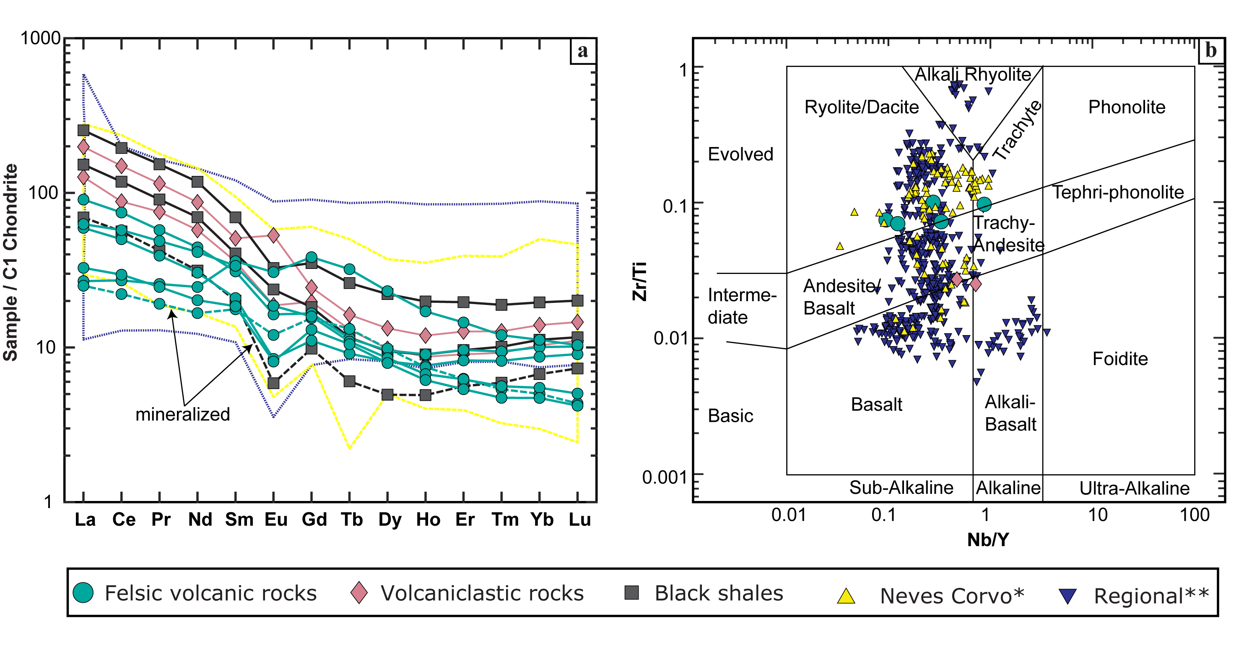
Figure S3 (a) Rare Earth Element (REE) plots for the felsic volcanic and volcaniclastic rocks and black shales from Neves Corvo. Mineralized samples are indicated on the plot (dashed lines). The data was chondrite normalized to the values of McDonough and Sun (1995). (b) Zr/Ti–Nb/Y discrimination diagram for rock classification plot from Pearce (1996) modified after Winchester and Floyd (1977). Literature data from Neves Corvo and a regional database were added as shadowed areas in (a) or symbols in (b) for comparison (see text above for the list of references used).

In a Zr/Ti versus Nb/Y discrimination plot (Fig. S3b), most felsic volcanic rocks fall within the rhyolite/dacite fields, whereas the volcaniclastic samples plot within the andesite/basalt and alkali-basalt fields. As noted above, these samples likely experienced intense alteration and, therefore, similarly to LREE, the Zr, Ti, Nb, and Y may experience some degree of alteration.

Electron probe microanalyzer (EPMA)

Quantitative analyses of apatite, xenotime, and florencite were performed using a JEOL Hyperprobe JXA-8530F+ EPMA at GFZ Potsdam, equipped with a thermal field emission cathode and five wavelength-dispersive spectrometers. The operating conditions for apatite and florencite were 15 kV, 20 nA using a probe size of 15 μm where applicable in order to minimize beam-induced volatile (F, Cl) diffusion (Stormer et al. 1993; Goldoff et al. 2012). Also, volatiles were measured simultaneously and prior to other elements. Natural Astimex standards were used for calibration such as orthoclase (Si, Al), fluorite (F), tugtupite (Cl), celestine (Sr), barite (Ba, S), hematite (F), sphalerite (Zn), rhodonite (Mn), copper metal (Cu) as well as the Durango apatite (Ca, P) and artificial Smithsonian standards for REY phosphates. Detection limits were ca. 200 to 300 ppm for all elements analyzed except Pr (≈790 ppm) and Nd (≈460 ppm) for apatite, whereas those for florencite were <100 ppm, except for Zn (≈150 ppm), Mn (≈178 ppm) and Mg (≈205 ppm). Analyses of xenotime were carried out using a 20 kV, 40nA, and a 1-2µm probe size. In addition to the previously mentioned calibration material, metal oxides of U, Th, and Pb from Cannon standardization material were also used. Peak overlap corrections for X-rays affecting Er, Ho, Dy, and Tb were performed. Detection limits are ≈180 ppm for the MREEs and HREEs, ≈130 ppm for Th, and < 100 ppm for U and Pb. Background counting times were half to peak measurement time. Backgrounds were set carefully elementwise, partly directly on the material itself, to avoid peak-background overlaps. Table D3 (Codeço et al. 2025), provides the complete microprobe dataset.

Laser Ablation-Inductively Coupled Plasma-Mass Spectrometry (LA-ICP-MS) and scanning electron microscopy (SEM)

A total of 63 apatite analyses for apatite major, minor, and trace element concentrations were carried out at the EleMap LA-ICP-MS Lab (GFZ Potsdam) by laser ablation-inductively coupled plasma mass spectrometry (LA-ICP-MS) using a Teledyne Analyte Excite, 193 nm ArF excimer laser, equipped with a HelEx II 2-volume ablation cell and coupled to a quadrupole-ICP-MS iCAP-RQ from Thermo Scientific. Helium (0.95 LPM) was used as a carrier gas for aerosol transport from the sample surface to the ICP-MS and was mixed downstream with Ar (ca. 0.9 Lmin⁻¹) as a make-up gas before entering the plasma. A laser repetition rate of 10 Hz and a spot diameter of 25 μm were used. The laser was run in voltage mode, at 1.1 kV and 50% laser output, resulting in a fluence at the sample from 3.5 to 4.0 Jcm⁻². The baseline was analyzed for 20s, followed by 60s of ablation and 45s washout. The following isotopes were analyzed: ⁷Li, ²³Na, ²⁴Mg, ²⁷Al, ²⁹Si, ³¹P, ³²S, ³⁵Cl, ³⁹K, ⁴³Ca, ⁴⁴Ca, ⁴⁵Sc, ⁴⁷Ti, ⁵¹V, ⁵²Cr, ⁵⁵Mn, ⁵⁷Fe, ⁵⁹Co, ⁶⁰Ni, ⁶³Cu, ⁶⁶Zn, ⁷⁵As, ⁸⁵Rb, ⁸⁸Sr, ⁸⁹Y, ⁹⁰Zr, ⁹³Nb, ⁹⁵Mo, ¹¹¹Cd, ¹¹⁸Sn, ¹²¹Sb, ¹³⁷Ba, ¹³⁹La, ¹⁴⁰Ce, ¹⁴¹Pr, ¹⁴³Nd, ¹⁴⁶Nd, ¹⁴⁷Sm, ¹⁵³Eu, ¹⁵⁷Gd, ¹⁵⁹Tb, ¹⁶³Dy, ¹⁶⁵Ho, ¹⁶⁷Er, ¹⁶⁹Tm, ¹⁷²Yb, ¹⁷⁵Lu, ¹⁷⁸Hf, ¹⁸²W, ²⁰⁶Pb, ²⁰⁸Pb, ²⁰⁹Bi, ²³²Th and ²³⁸U. The dwell times were 0.20s for Th, U, and REE (except La and Ce, 0.50s) and 0.10s for the remaining elements.
The concentration of the major, minor, and trace elements in apatite was calculated based on external calibration against the primary reference materials NIST SRM 612 for all elements except for ³¹P, ⁴⁷Ti, ⁵⁷Fe, ⁶⁰Ni, ⁶³Cu, ⁶⁶Zn, ⁷⁵As, and ¹³⁷Ba, which were calculated based on GSE-2G (Wilson 2019) and ³²S on NIST SRM 610. The Ca concentrations obtained by EPMA were used as an internal standard.
Primary reference materials were measured twelve times as brackets over 5 to 10 unknown samples. Furthermore, with each reference material block, an internal secondary reference material was measured (GFZ-Ap) in order to assess and control analytical quality. The optimal ablation intervals were selected for each ablated pit by individual inspection of the time-resolved intensities and elemental and/or isotopic ratios and processed using Iolite software v. 4 (Paton et al. 2011) and the data reduction scheme “Trace Elements” (Woodhead et al. 2007). Possible interferences were assessed and corrected for, when necessary, by measuring non-interfering isotopes of the same elements and assuming natural abundances.
Scanning Electron Microscope (SEM) imaging in both BSE and SE mode was obtained after the LA-ICP-MS session to check the location and the features of the laser pits. This procedure is important to verify whether the desired domains were analyzed and if variation in the time-resolved intensities can be linked to mixed domains, fractures, or hit other features/phases that could make the analysis unreliable. The SEM images were collected using a Quanta 3D field emission scanning electron microscope (Thermo Fischer Scientific) operated at 15 kV and a beam current of 4 nA at GFZ Potsdam. Prior to SEM analysis, the samples were cleaned with ethanol and subsequently coated with carbon.
LA-ICP-MS data was then screened for contamination by other mineral phases, in particular, quartz, florencite, sericite, chlorite, sulfides, and cassiterite, by using a combination of SEM imaging and the elements Si, Al, Mg, Na, K, Fe, S, La, Ce, Pr, Nd, Sn, and W. Analyses with high concentrations of these elements were evaluated individually and signals were integrated around the potential inclusion (see Fig. S4). Despite a thorough screening and integration around the contaminated time-resolved signals, it was not always possible to remove contamination from the signal (see Fig. S5), and therefore, the major elements will not be presented in the manuscript, and any potential contamination of other elements will be discussed accordingly.
The minimum limits of detection (LOD) were obtained from Iolite using the method of Pettke et al. (2005) , and the uncertainty (2SE) was calculated following the formulation of Paton et al. (2011). All results, LOD, and 2SE, are presented in Table D4 (Codeço et al. 2025).

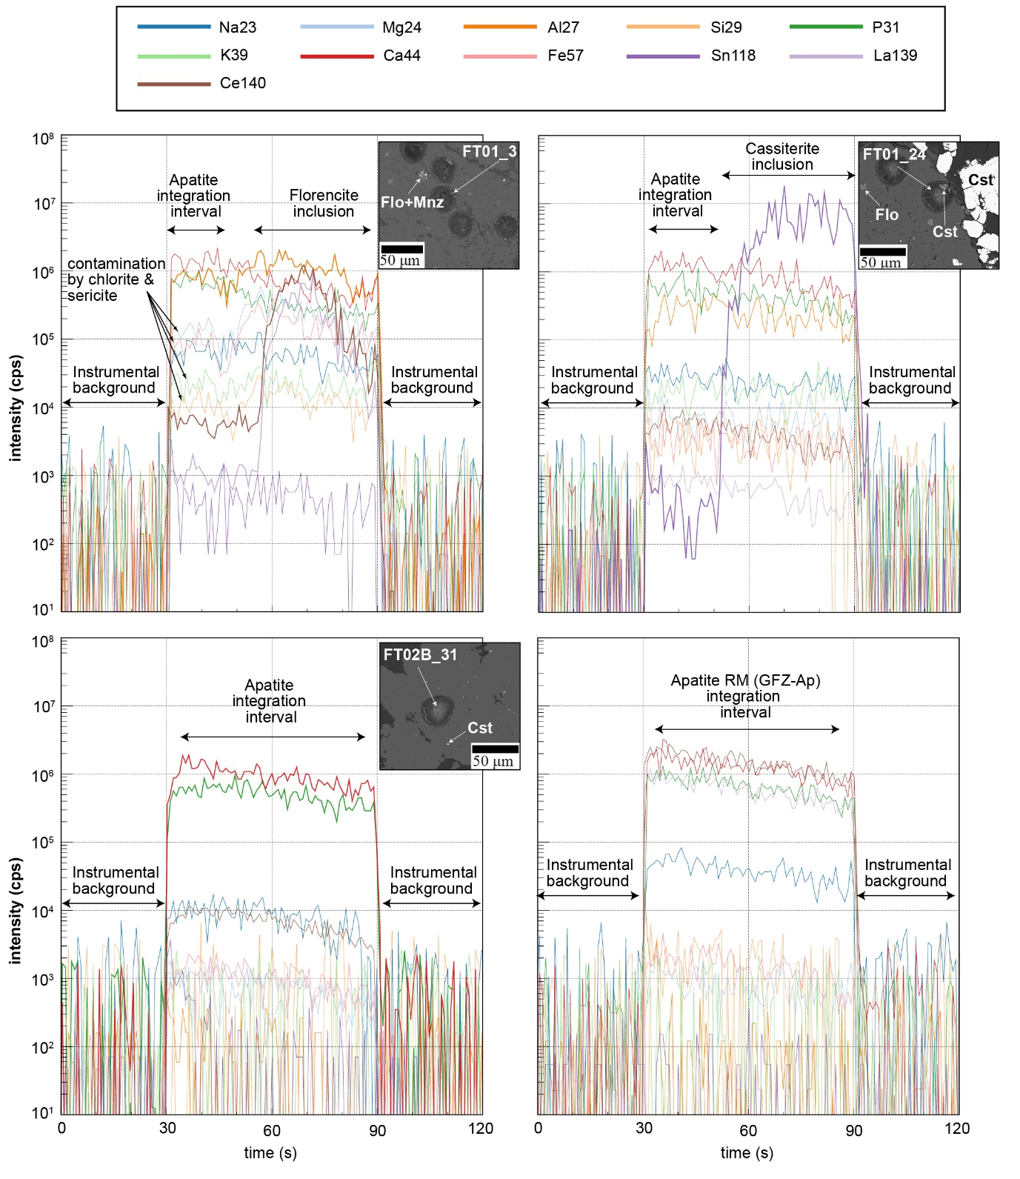
Figure S4 Time-resolved laser ablation inductively coupled plasma mass spectrometer (LA-ICP-MS) signals derived from the ablation of different grains of apatite, showing the contamination by inclusions in sample (FT01) in comparison with sample FT02B where microporosity is lower. The apatite reference material (RM) is shown for comparison.

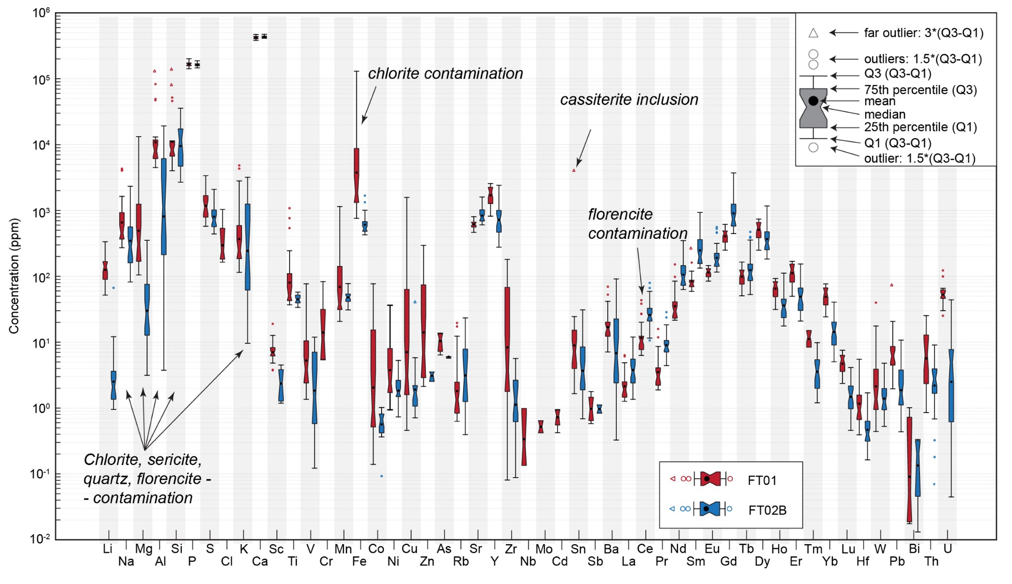
Figure S5 Box and whisker plot of apatite major and trace element contents from the Corvo orebody. Data was plotted after screening for inclusions and contamination (see text for details).

Raman Spectroscopy

Raman spectra were acquired using a HORIBA Jobin Yvon LabRAM HR800 Vis Raman spectrometer (grating 1800 lines/mm, focal length 800 mm), equipped with a Synapse back-illuminated CCD detector (2048 × 512 pixels) and an Olympus BXFM microscope with a motorized XYZ sample stage. The spectra were recorded in backscattering geometry in the wavenumber range from 980 to 1150 cm⁻¹ (average of 20 or 10 accumulations of 20 s each) using an Olympus MPlan 10× objective (numerical aperture 0.25) for apatite crystals or an Olympus MPlanFL N 100× objective (numerical aperture 0.90) for apatites in the polished section. A COBOLT Blues™ DPSS laser (wavelength 473 nm, power stability <2%) was used for excitation of Raman scattering. The Raman results are provided in Table D5 (Codeço et al. 2025),

Fourier transform infrared (FTIR) spectroscopy

Fluorapatite from Mount Mica Quarry, Maine (USA) was investigated by Fourier transform infrared spectroscopy in order to confirm or disprove the presence of carbonate ion (CO₃²⁻). For the infrared measurements, we used a Bruker VERTEX 80v FTIR spectrometer at GFZ Potsdam. We applied the KBr method: Two mg of sample was ground for several minutes in an agate mortar and subsequently homogeneously mixed with 450 mg of KBr. The sample was kept in the oven at 170°C overnight to eliminate absorbed water. The powdered homogenized sample was put in a special pressing tool to make pellets with 10 mm in diameter. The material was pressurized with a load of 7 to for ca. 20 min while the sample in the tool was under a vacuum. The same procedure was repeated for 450 mg of pure KBr, which served as a reference. The two samples were transferred to the oven at 170°C for two days.
MIR absorbance spectra were recorded internally in the FTIR spectrometer using a globar light source, a KBr beam splitter, and Deuterated Lanthanum α-alanine doped TriGlycine sulfate (DLaTGs) detector. The spectral resolution was 2 cm^{-1,} and spectra averaged over 128 scans.
The FTIR spectrum of the Mount Mica fluorapatite is shown in Figure S6, and the positions and assignments of the IR active modes are in Table S1 (the complete dataset is provided in Table D6 (Codeço et al. 2025). The most prominent bands found in the spectra are characteristic bands for different vibrational modes of the (PO₄)³⁻ functional group, which include: ν1 symmetric stretching at 965 cm⁻¹, ν2 out-of-plane bending at 473 cm⁻¹, ν3 antisymmetric stretching at 1044 and 1094 cm⁻¹ and ν4 in-plane bending at 602 cm⁻¹ (Freund and Knobel 1977; Koutsopoulos 2002; Fleet et al. 2004; Zhang et al. 2020; Marincea et al. 2022). Bands at 2056, 2011, and 1997 cm⁻¹ likely correspond to ν1 + ν3 combination bands of the group (PO₄)³⁻ (Baddiel and Berry 1966). Carbon ion [(CO₃)²⁻] doublet can be observed at 1430 and 1455 cm⁻¹ corresponding to ν3 antisymmetric stretching bands (Freund and Knobel 1977; Marincea et al. 2022). These bands correspond to B-type substitution in apatite, i.e., CO₃ substituting for PO₄. An additional vibrational mode for (CO₃)²⁻ is registered at 865 cm⁻¹ (ν2 out-of-plane bending) (e.g., Marincea et al. 2022). The peak observed at 1384 cm⁻¹ probably corresponds to an artifact related to the KBr matrix (Abdu et al. 2018). In contrast, bands centered at 2961, 2925, and 2854 cm⁻¹ likely correspond to impurities and are assigned as C-H stretching modes. The absorption peak at 746 cm⁻¹ corresponds to the F-F-OH-F bending mode (Zhang et al. 2020). Vibrational bands observed at 2365 and 2340 cm⁻¹ correspond to atmospheric carbon dioxide. A weak band identified at 1737 cm cm⁻¹ could be assigned and likely corresponds to an impurity.
The bands in the high-frequency region of the FTIR spectra (3000-4000 cm⁻¹) correspond to hydrogen-bounded (OH) groups, with the band at 3675 cm⁻¹ corresponding to the F-OH symmetric stretching mode (e.g., Freund and Knobel 1977; Marincea et al. 2022), and 3538 cm⁻¹ to the F-OH antisymmetric stretching (e.g., Freund and Knobel 1977; Marincea et al. 2022), whereas 3571 and 3523 cm⁻¹ to the OH-stretching mode (e.g., Koutsopoulos 2002; Fleet et al. 2004; Hassan et al. 2022). Adsorbed water band is relatively broad with peak maximum at ca. 3461 cm⁻¹.
The investigation of Mount Mica fluorapatite by FTIR allowed us to confirm the presence of CO₃ for comparison with the Raman results obtained for Mount Mica fluorapatite and samples FT01 and FT02B.

Table S1 Positions and assignments of the Mount Mica fluorapatite FTIR bands. References: Baddiel and Berry (1966), Freund and Knobel (1977), Ren et al. (2014), Abdu et al. (2018), Hammerli et al. (2021) and Marincea et al. (2022).
Wavenumber (cm⁻¹) | Vibrational mode | Structural Group
3675 | F-OH symmetric stretching | F⁻, (OH)⁻
3571 | OH stretching mode | (OH)⁻
3538 | F-OH antisymmetric stretching | F⁻, (OH)⁻
3522 | OH stretching mode | (OH)⁻
3461 | Adsorbed H₂O | H₂O
2961 | C-H stretching – possibly impurity | ?
2925 | C-H stretching – possibly impurity | ?
2854 | C-H stretching – possibly impurity | ?
2365 | CO₂ atmosphere | -
2340 | CO₂ atmosphere | -
2056 | ν1 + ν3’ combination band | (PO₄)³⁻
2011 | ν1 + ν3” combination band | (PO₄)³⁻
1997 | ? | (PO₄)³⁻
1737 | impurity? | -
1455 | ν3 antisymmetric stretching, B type substitution | (CO₃)²⁻
1430 | ν3 antisymmetric stretching, B type substitution | (CO₃)²⁻
1384 | Artifact KBr matrix? | -
1094 | ν3 antisymmetric stretching | (PO₄)³⁻
1044 | ν3’ antisymmetric stretching | (PO₄)³⁻
965 | ν1 symmetric stretching | (PO₄)³⁻
865 | ν2 out-of-plane bending (O-C-O) | (CO₃)²⁻
746 | bending mode (F-F-OH-F) | F⁻, (OH)⁻
602 | ν4 in-plane bending (O-P-O) | (PO₄)³⁻
576 | ν4’ in-plane bending (O-P-O) | (PO₄)³⁻
473 | ν2 out-of-plane bending (O-P-O) | (PO₄)³⁻
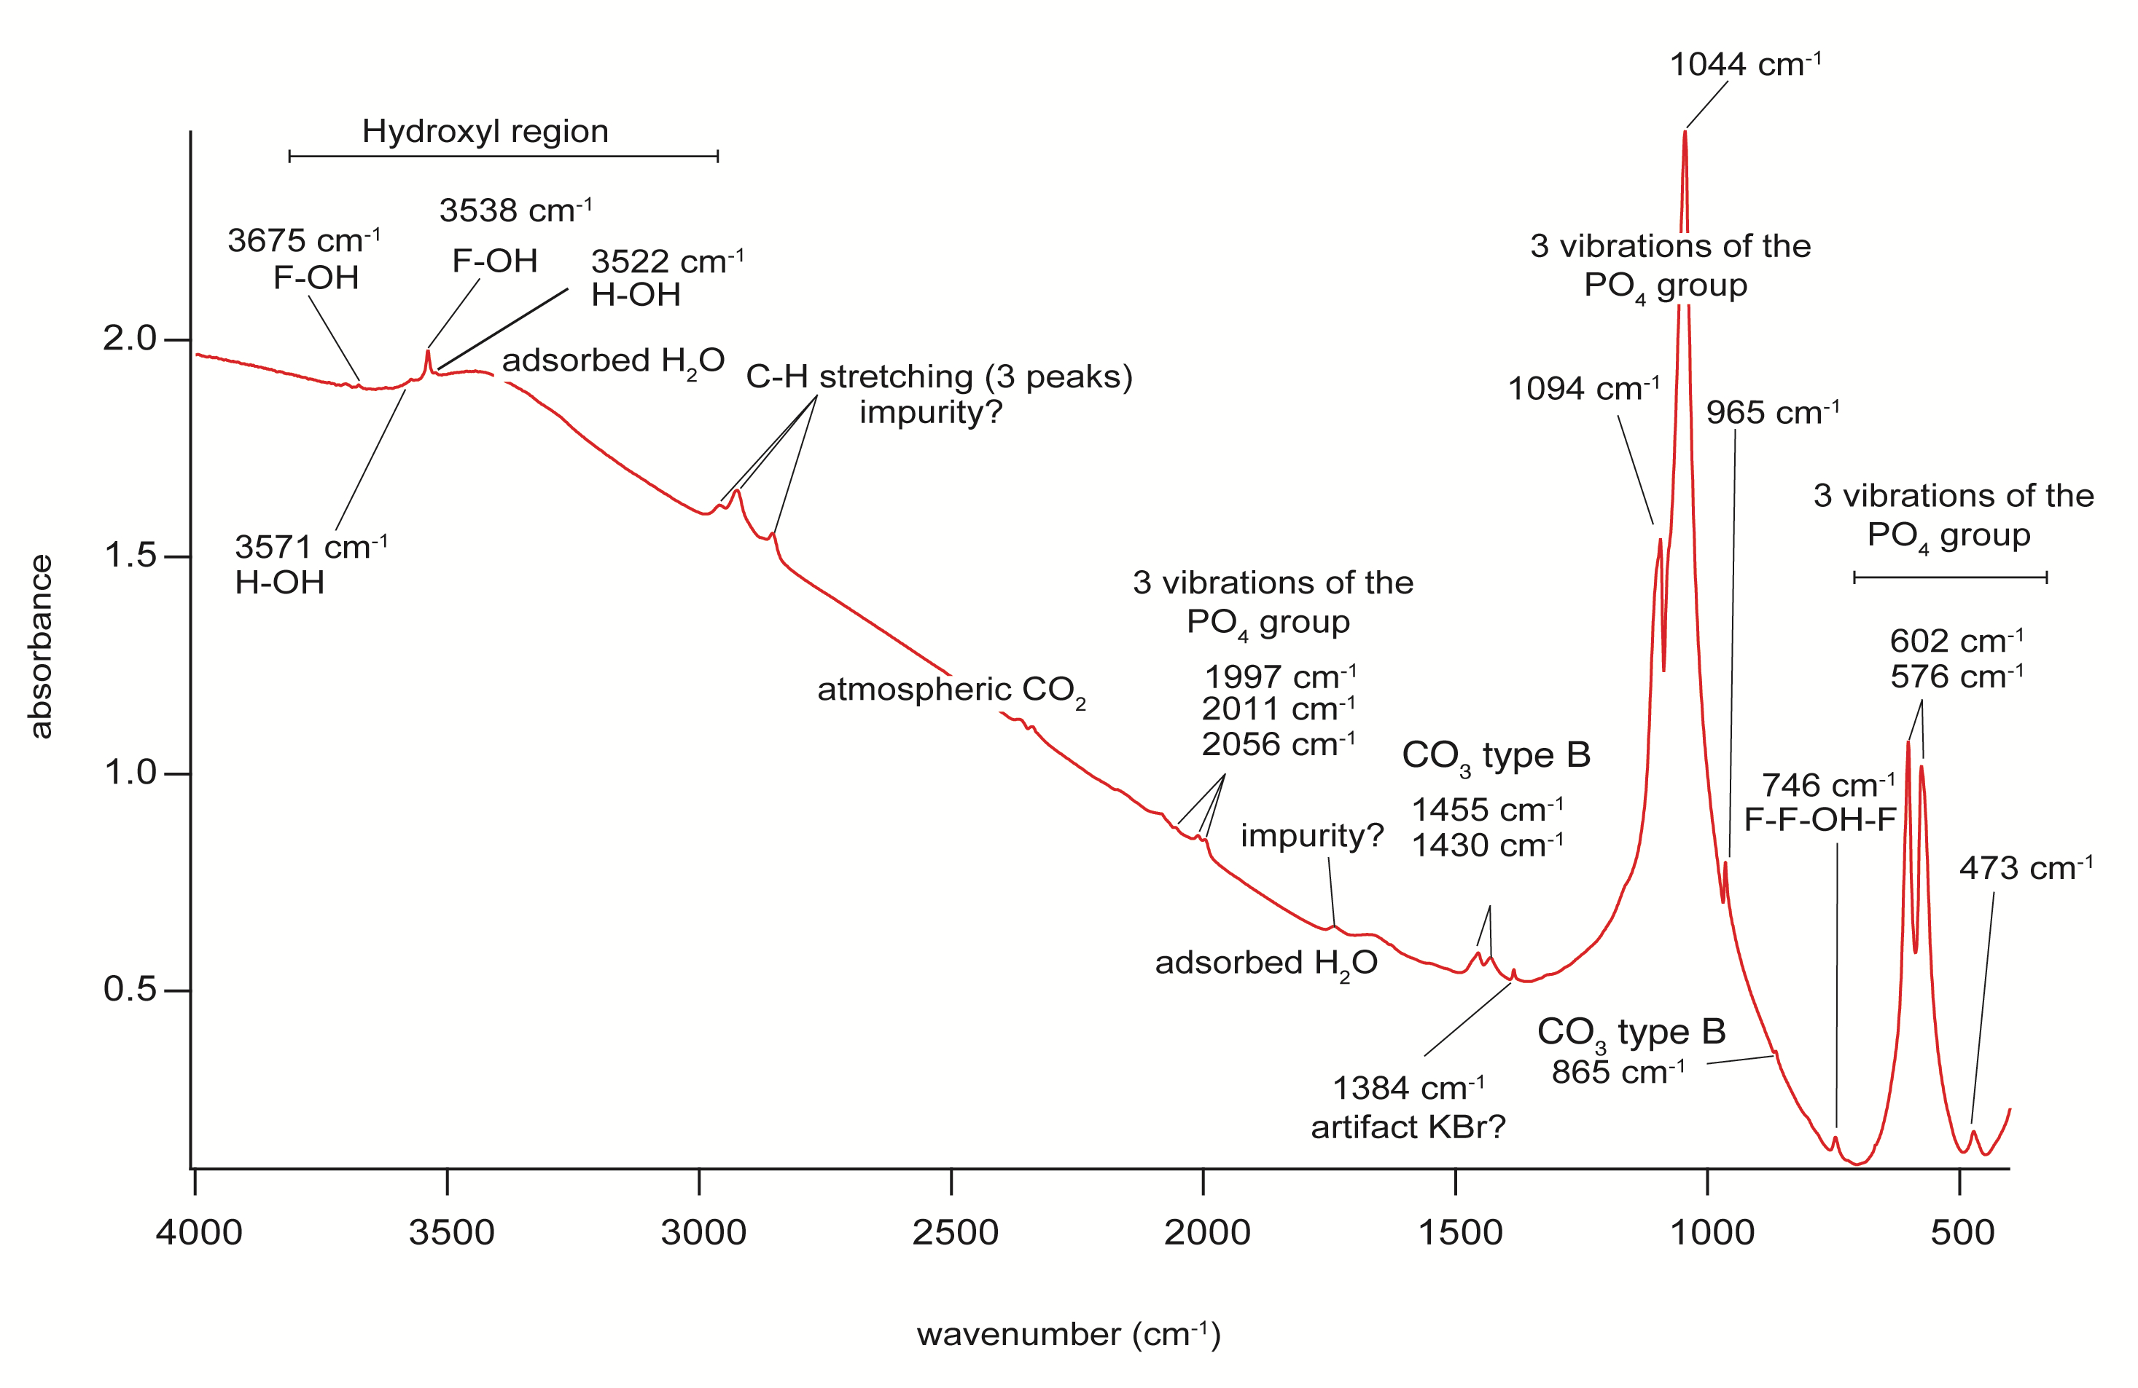
Figure S6 FTIR spectrum of a representative sample of fluorapatite from Mount Mica Quarry.

Supplementary Figures

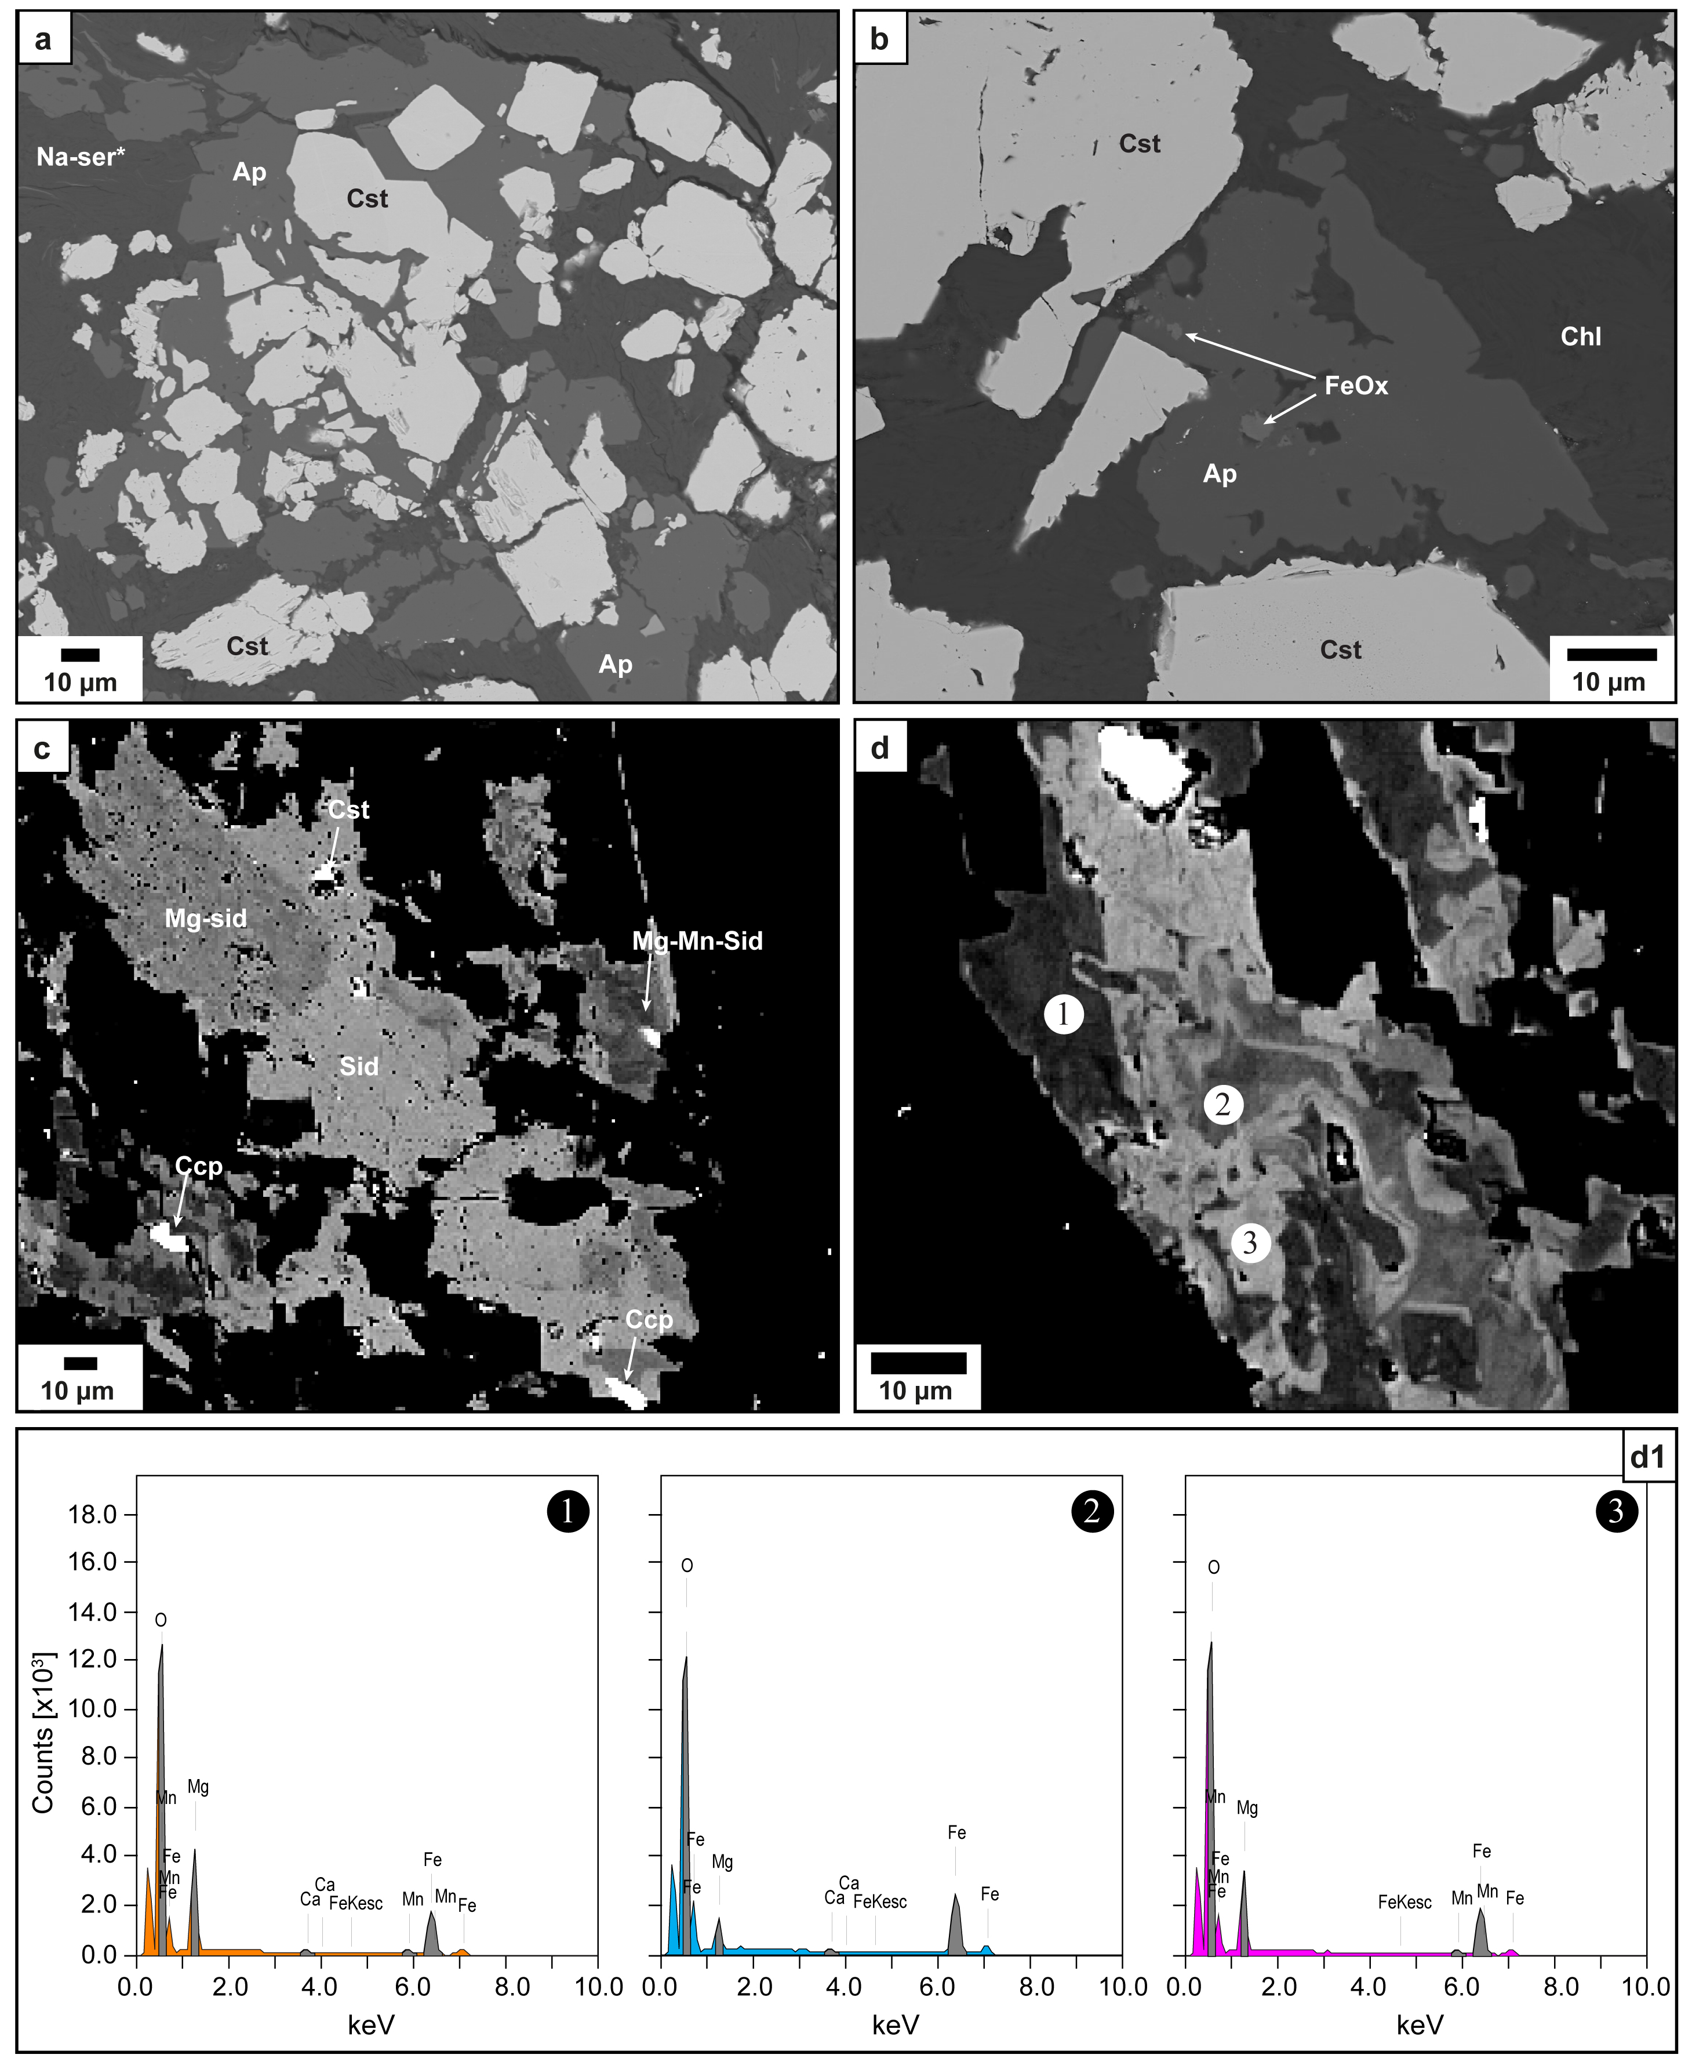
Figure S7 (a) and (b) Backscatter Electron (BSE) images of apatite intergrown with cassiterite in sample FT01. (c) and (d) BSE images of zoned Mn-Mg-bearing siderite from the “in-situ type” cassiterite ore veins. Examples of EDX/EDS (Energy-Dispersive X-ray Spectroscopy) spectra are given in D1, showing the variation in Mn and Mg content. Abbreviations: Cst, cassiterite; Ccp, chalcopyrite; Mg-sid, Mg-bearing siderite; Mg-Mn-sid, Mg-Mn-bearing siderite, and Sid, siderite.

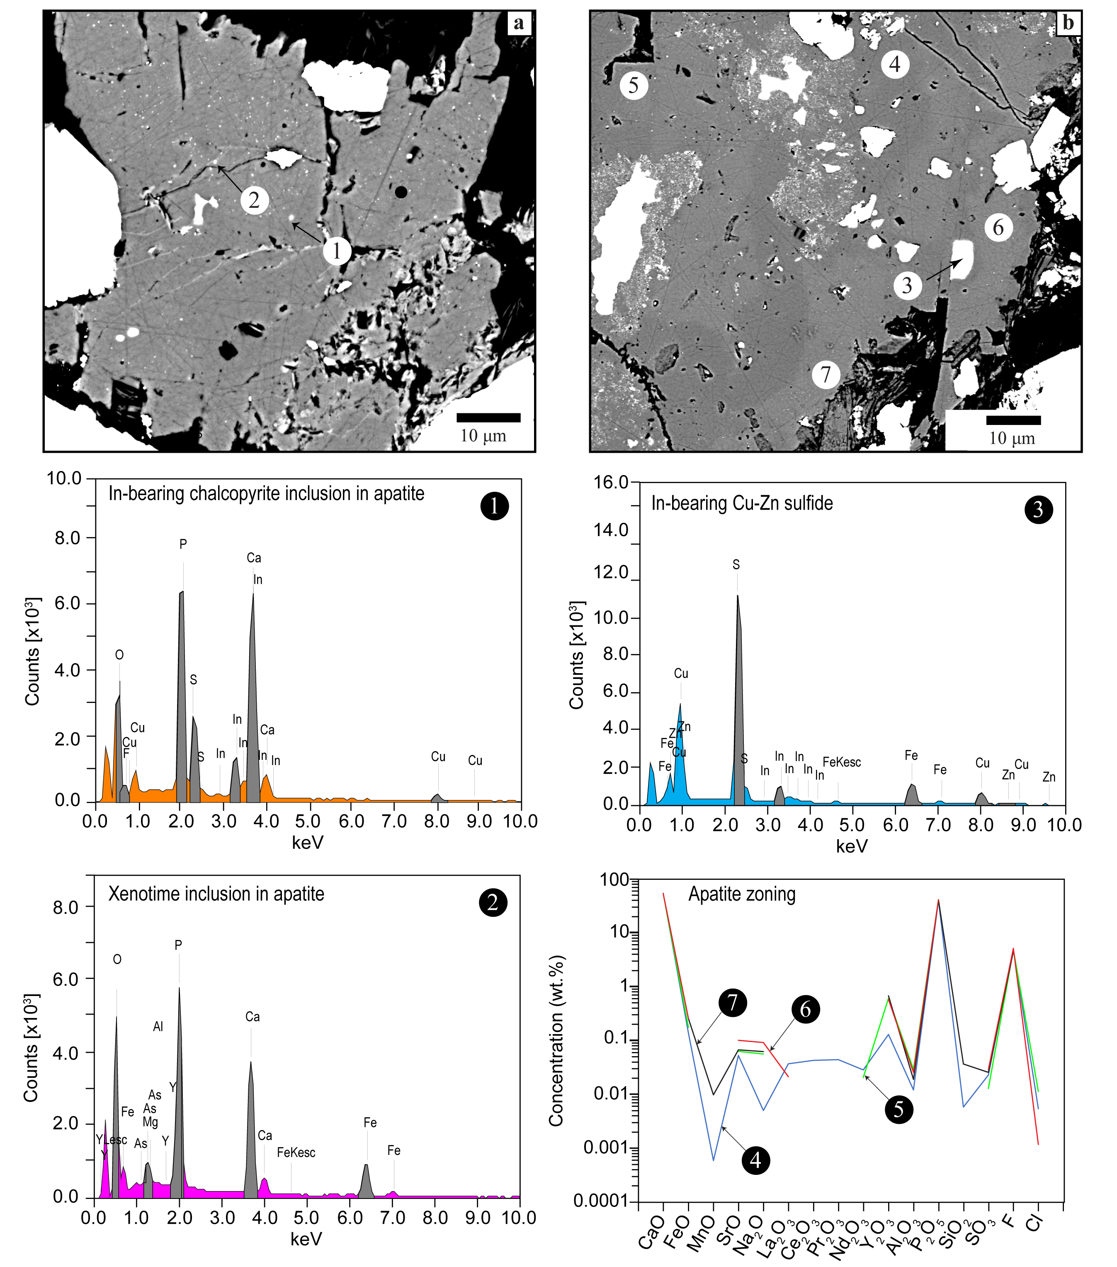
Figure S8 Backscatter Electron (BSE) images showing (a) In-bearing chalcopyrite and xenotime inclusions in apatite and (b) numerous sulfide inclusions in zoned apatite. Corresponding EDX/EDS (Energy-Dispersive X-ray Spectroscopy) spectra are given in 1, 2, and 3. The major element variation of the zoned apatite is also shown.
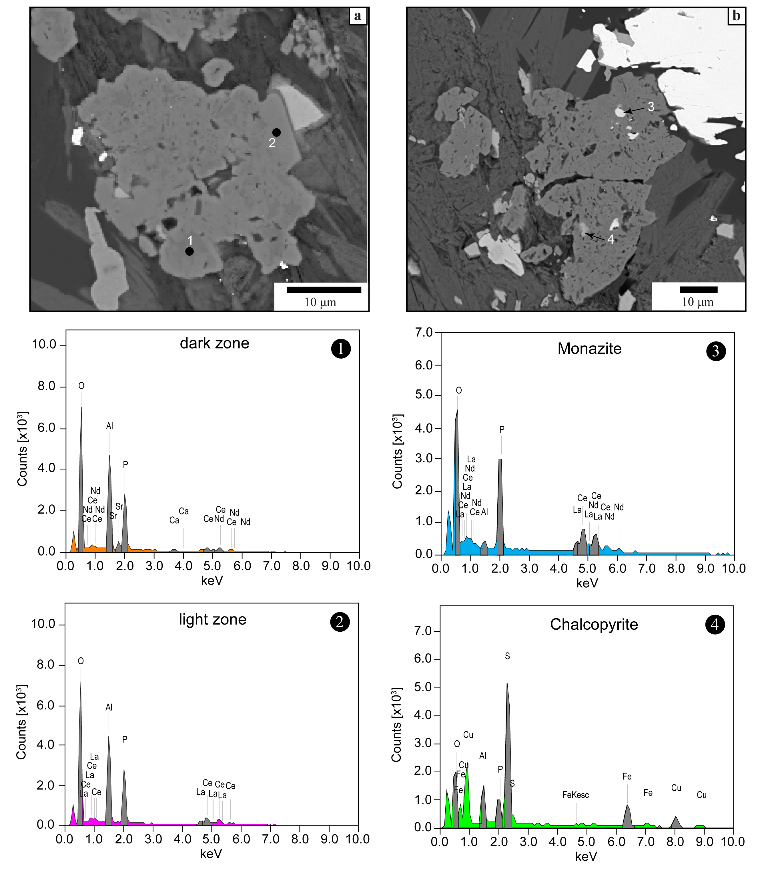
Figure S9 Backscatter Electron (BSE) images of florencite zoning and its solid inclusions with the corresponding EDX/EDS (Energy-Dispersive X-ray Spectroscopy) semi-quantitative elemental composition.

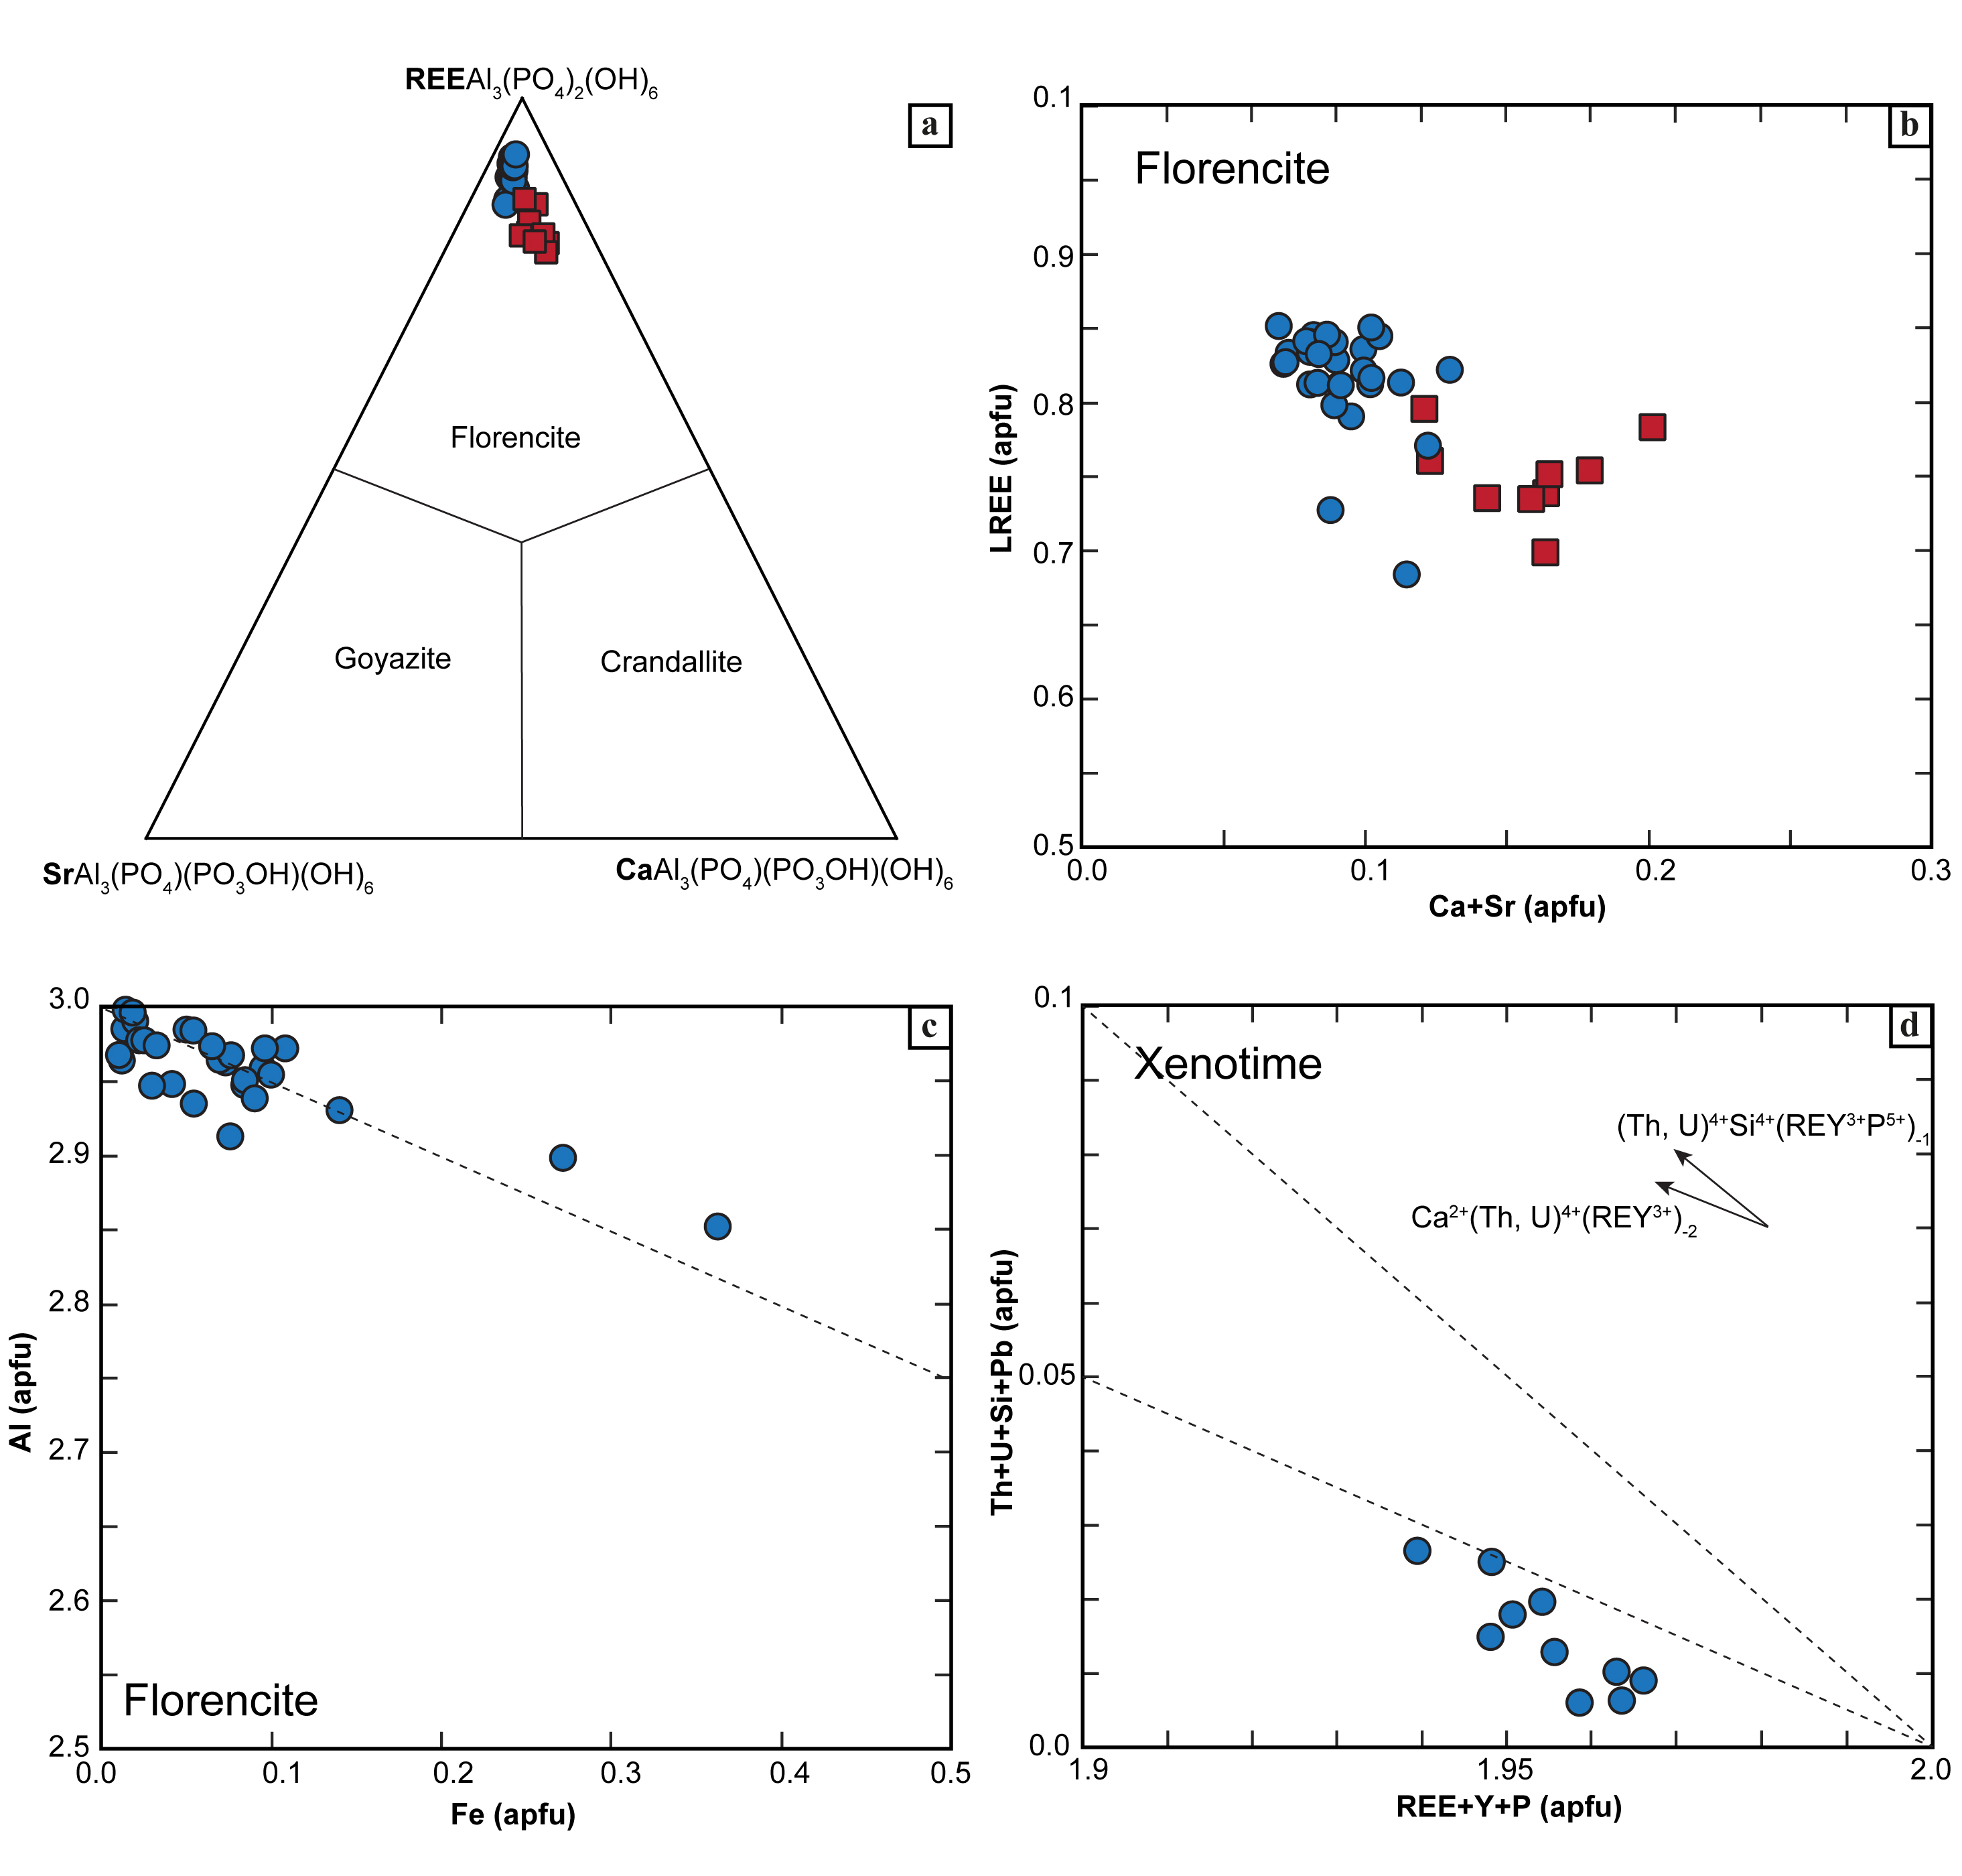
Figure S10 (a) Ternary REE–Ca–Sr plot showing EPMA data for florencite to represent APS (aluminum phosphate-sulfate minerals) endmembers florencite–crandallite–goyazite based on A-site occupancy. (b)–(c) Binary diagrams of florencite showing variations of Ca+Sr vs. REE in the A-site and Al vs. Fe suggesting the potential substitution of Al by Fe. (d) Th+U+Si+Pb vs. REE+Y+P binary plot for xenotime showing minimal substitution of Y by Th and U.

References

Abdu YA, Hawthorne FC, Varela ME (2018) Infrared Spectroscopy of Carbonaceous-chondrite Inclusions in the Kapoeta Meteorite: Discovery of Nanodiamonds with New Spectral Features and Astrophysical Implications. Astrophys J Lett 856:L9. https://doi.org/10.3847/2041-8213/AAB433
Almodóvar GR, Saéz R, Pons JMM, Mestre A, Toscano M, Pascual E (1998) Geology and genesis of the Aznalcollar massive sulphide deposits Almodovar et al 1998. Miner Deposita 33:111–136
Baddiel CB, Berry EE (1966) Spectra structure correlations in hydroxy and fluorapatite. Spectrochim Acta 22:1407–1416. https://doi.org/10.1016/0371-1951(66)80133-9
Barrett TJ, Dawson GL, MacLean WH (2008) Volcanic stratigraphy, alteration, and sea-floor setting of the Paleozoic Feitais massive sulfide deposit, Aljustrel, Portugal. Econ Geol 103:215–239. https://doi.org/10.2113/gsecongeo.103.1.215
Bokhari SNH, Meisel TC (2017) Method Development and Optimisation of Sodium Peroxide Sintering for Geological Samples. Geostand Geoanalytical Res 41:181–195. https://doi.org/10.1111/ggr.12149
Boulter C a., Hopkinson LJJJ, Ineson MGGG, Brockwell JSSS (2004) Provenance and geochemistry of sedimentary components in the Volcano-Sedimentary Complex, Iberian Pyrite Belt: discrimination between the sill-sediment-complex and volcanic-pile models. J Geol Soc 161:103–115. https://doi.org/10.1144/0016-764902-159
Codeço MS, Mateus A, Figueiras J, Rodrigues P, Gonçalves L (2018) Development of the Ervidel-Roxo and Figueirinha-Albernoa volcanic sequences in the Iberian pyrite Belt, Portugal: Metallogenic and geodynamic implications. Ore Geol Rev 98:80–108. https://doi.org/10.1016/j.oregeorev.2018.05.009
Codeço, Marta; Gleeson, Sarah; Barrote, Vitor; Harlov, Daniel; Koch-Müller, Monika; Kusebauch, Christof; Relvas, Jorge; Schleicher, Anja; Schmidt, Christian; Stammeier, Jessica; Syczewski, Marcin; Wilke, Franziska (2025): Lithogeochemistry of the Volcanic-Sedimentary Complex and major and trace element contents in apatite from the Neves Corvo Cu-Zn-Pb(-Sn) deposit (Portugal). GFZ Data Services. https://doi.org/10.5880/GFZ.3.1.2023.004
Doebelin N, Kleeberg R (2015) Profex: a graphical user interface for the Rietveld refinement program BGMN. J Appl Crystallogr 48:1573–1580. https://doi.org/10.1107/S1600576715014685
Fleet ME, Liu X, King PL (2004) Accommodation of the carbonate ion in apatite: An FTIR and X-ray structure study of crystals synthesized at 2–4 GPa. Am Mineral 89:1422–1432. https://doi.org/10.2138/am-2004-1009
Freund F, Knobel RM (1977) Distribution of fluorine in hydroxyapatite studied by infrared spectroscopy. J Chem Soc Dalton Trans 1136–1140. https://doi.org/10.1039/DT9770001136
Goldoff B, Webster JD, Harlov DE (2012) Characterization of fluor-chlorapatites by electron probe microanalysis with a focus on time-dependent intensity variation of halogens. Am Mineral 97:1103–1115. https://doi.org/10.2138/am.2012.3812
Hammerli J, Hermann J, Tollan P, Naab F (2021) Measuring in situ CO2 and H2O in apatite via ATR-FTIR. Contrib Mineral Petrol 176:1–20. https://doi.org/10.1007/s00410-021-01858-6
Hassan M, Sulaiman M, Yuvaraju PD, Galiwango E, Rehman IU, Al-Marzouqi AH, Khaleel A, Mohsin S (2022) Biomimetic PLGA/Strontium-Zinc Nano Hydroxyapatite Composite Scaffolds for Bone Regeneration. J Funct Biomater 13:13. https://doi.org/10.3390/JFB13010013/S1
Koutsopoulos S (2002) Synthesis and characterization of hydroxyapatite crystals: A review study on the analytical methods. J Biomed Mater Res 62:600–612. https://doi.org/10.1002/jbm.10280
Le Maitre RW, Streckeisen A, Zanettin B, Le Bas MJ, Bonin B, Bateman P (eds) (2002) Igneous Rocks: A Classification and Glossary of Terms. Cambridge University Press, Cambridge
Leistel JM, Marcoux E, Thiéblemont D, Quesada C, Sánchez A, Almodóvar GR, Pascual E, Sáez R (1997) The volcanic-hosted massive sulphide deposits of the Iberian Pyrite Belt. Miner Deposita 33:2–30. https://doi.org/10.1007/s001260050130
Marincea Ş, Dumitraş D-G, Sava Ghineţ C, Dal Bo F (2022) Carbonate-Bearing, F-Overcompensated Fluorapatite in Magnesian Exoskarns from Valea Rea, Budureasa, Romania. Minerals 12:1083. https://doi.org/10.3390/min12091083
McDonough WF, Sun S -s. (1995) The composition of the Earth. Chem Geol 120:223–253. https://doi.org/10.1016/0009-2541(94)00140-4
Mitjavila J, Martí J, Soriano G (1997) Magmatic evolution and tectonic setting of the Iberian Pyrite Belt volcanism. J Petrol 38:727–755. https://doi.org/10.1093/petroj/38.6.727
Munhá J (1983) Hercynian magmatism in the Iberian Pyrite Belt. Carbonif. Port. 39–81
Munhá J (1982) Igneous And Metamorphic Petrology Of The Iberian Pyrite Belt Volcanic Rocks. Digit Theses 712
Munhá J, Kerrich R (1980) Sea water basalt interaction in spilites from the Iberian Pyrite Belt. Contrib Mineral Petrol 73:191–200. https://doi.org/10.1007/BF00371394
Paton C, Hellstrom J, Paul B, Woodhead J, Hergt J (2011) Iolite: Freeware for the visualisation and processing of mass spectrometric data. J Anal At Spectrom 26:2508. https://doi.org/10.1039/c1ja10172b
Pearce JA (1996) A User’s Guide to Basalt Discrimination Diagrams. In: Wyman DA (ed) Trace Element Geochemistry of Volcanic Rocks: Applications for Massive Sulphide Exploration, Geological Association of Canada, Short Course Notes. pp 79–113
Pettke T, Audétat A, Schaltegger U, Heinrich CA (2005) Magmatic-to-hydrothermal crystallization in the W-Sn mineralized Mole Granite (NSW, Australia). Part II: Evolving zircon and thorite trace element chemistry. Chem Geol 220:191–213. https://doi.org/10.1016/j.chemgeo.2005.02.017
Pretorius W, Weis D, Williams G, Hanano D, Kieffer B, Scoates J (2006) Complete trace elemental characterisation of granitoid (USGS G-2, GSP-2) reference materials by high resolution inductively coupled plasma-mass spectrometry. Geostand Geoanalytical Res 30:39–54. https://doi.org/10.1111/j.1751-908X.2006.tb00910.x
Relvas JMRS (2000) Geology and metallogeny at the Neves Corvo deposit, Portugal. University of Lisbon
Relvas JMRS, Barriga FJAS, Longstaffe FJ (2006) Hydrothermal Alteration and Mineralization in the Neves-Corvo Volcanic-Hosted Massive Sulfide Deposit, Portugal. II. Oxygen, Hydrogen, and Carbon Isotopes. Econ Geol 101:791–804. https://doi.org/10.2113/gsecongeo.101.4.791
Ren F, Ding Y, Leng Y (2014) Infrared spectroscopic characterization of carbonated apatite: a combined experimental and computational study. J Biomed Mater Res A 102:496–505. https://doi.org/10.1002/JBM.A.34720
Romer RL, Hahne K (2010) Life of the Rheic Ocean: Scrolling through the shale record. Gondwana Res 17:236–253. https://doi.org/10.1016/j.gr.2009.09.004
Rosa CJ (2007) Facies Architecture of the Volcanic Sedimentary Complex of the Iberian Pyrite Belt, Portugal and Spain. PhD Thesis Univ Tasman 1–19
Rosa DRN, Inverno CMC, Oliveira VMJ, Rosa CJP (2004) Geochemistry of Volcanic Rocks, Albernoa Area, Iberian Pyrite Belt, Portugal. Int Geol Rev 46:366--383 pp. https://doi.org/10.2747/0020-6814.46.4.366
Sánchez-España J, Velasco F, Yusta I (2000) Hydrothermal alteration of felsic volcanic rocks associated with massive sulphide deposition in the northern Iberian Pyrite Belt (SW Spain). Appl Geochem 15:1265–1290. https://doi.org/10.1016/S0883-2927(99)00119-5
Stormer JC, Pierson ML, Tacker RC (1993) Variation of F and Cl X-ray intensity due to anisotropic diffusion in apatite during electron microprobe analysis. Am Mineral 78:641–648
Thiéblemont D, Pascual E, Stein G (2002) Magmatism in the Iberian Pyrite Belt: petrological constraints on a metallogenic model. Miner Deposita 33:98–110. https://doi.org/10.1007/s001260050135
Wilson SA (2019) G-probe 21 summary report: International Association of Geoanalysts Gprobe 21
Winchester JA, Floyd PA (1977) Geochemical discrimination of different magma series and their differentiation products using immobile elements. Chem Geol 20:325–343. https://doi.org/10.1016/0009-2541(77)90057-2
Woodhead JD, Hellstrom J, Hergt JM, Greig A, Maas R (2007) Isotopic and Elemental Imaging of Geological Materials by Laser Ablation Inductively Coupled Plasma-Mass Spectrometry. Geostand Geoanalytical Res 331–343. https://doi.org/10.1111/j.1751-908X.2007.00104.x
Zhang X, Xing Q, Liao L, Han Y (2020) Effect of the fluorine substitution for –OH group on the luminescence property of Eu3+ doped hydroxyapatite. Crystals 10:. https://doi.org/10.3390/cryst10030191

