Electronic Supplementary Material (ESM)

ESM 1. The lithostratigraphy of the Karibib district with detailed subdivisions of the Karibib and Kuiseb formations, and stratigraphic positions of gold occurrences (modified after Geological Survey of Namibia 2010; Creus 2011; Owen 2011)
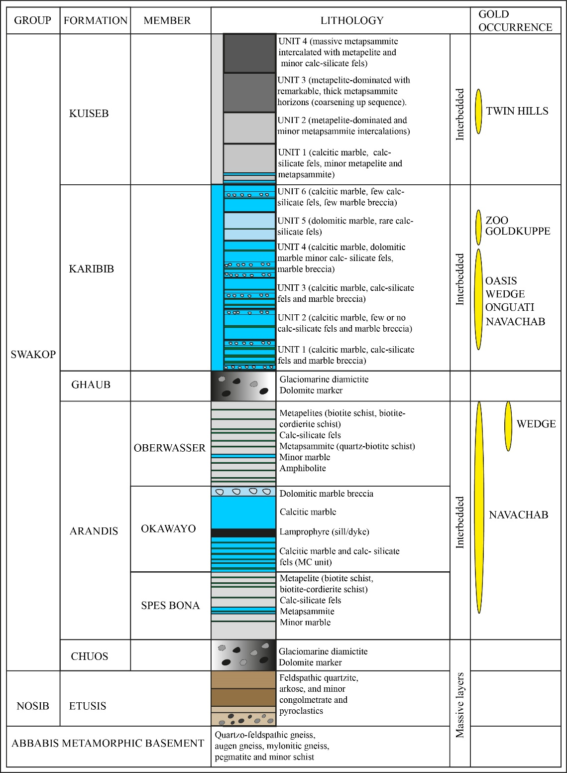

ESM 2. Detailed accounts of the marble-hosted gold occurrences.

Zoo Prospects
The Zoo prospects describe a cluster of smaller deposits and prospects (Gecko, Grid A, Klipspringer and Steenbok) that are located to the northwest of the Navachab mine (Fig. 6a). The Gecko and Grid A deposits have been mined in the recent past, while the Klipspringer and Steenbok prospects are in the advanced stage of exploration. Host rocks of the prospects are different marble units of the Karibib Formation that form intermittent outcrops along the southeastern and northwestern limbs of the Navachab Syncline, adjacent to the Karibib Dome. The hinge of the syncline is, for the most part, concealed under thick sand and calcrete cover and one thin erosional outlier of the Kuiseb Formation in the core of the fold. The Navachab Syncline is a highly non-cylindrical fold. Along its southwestern extent, the syncline is open as it bifurcates around the broad, shallow northeasterly plunging hinge of the Usakos Dome (Fig. 6a). Fabric intensities in Karibib Formation marbles are low and primary sedimentary features are well preserved, except for a more or less upright axial planar foliation (S₂). Along its northern strike extent, the axial trace of the syncline shows a marked clockwise deflection and bedding is rotated by about 20-25⁰, from northeasterly to east-northeasterly trends into parallelism with highly strained schist and marble units that constitute the KFZ (Fig. 6a and Fig. 8). The clockwise rotation of bedding into the high-strain zone is consistent with the dextral component of shear along the KFZ suggested by Shilunga and Kisters (2023). The bedding deflection coincides with the progressive tightening of the syncline. The first-order fold limbs are subvertical and lower-order parasitic folds (down to fifth- and sixth-order folds; Creus 2011) are tight-to-isoclinal. The tightening of the fold is associated with a dramatic increase in fabric intensity and the transposition of bedding into the steep S₂ foliation, which is particularly prominent in calcareous marbles. Importantly, the majority of the Zoo prospects are located at, or close to, this regional bedding deflection and associated strain increase (Fig. 8). Gecko, Grid A and Klipspringer form a ~4 km long, northeast-trending and intermittently mineralized corridor on the northwestern limb of the syncline (Fig. 6a). The Steenbok prospect, in contrast, is located on the southeastern limb of the Navachab Syncline that it shares with the Karibib Dome, forming a satellite to the immediate north of the Navachab mine.

Gold mineralization is associated with several sets of intersecting quartz-sulfide veins that are almost exclusively developed in and adjacent to the dolomitic marble Unit 5, emphasizing the lithological control on the mineralization (Fig. 8). Unit 5 shows subtle compositional and textural variations and Creus (2011) distinguished a basal banded marble made up of intercalated calcareous and dolomitic marble (Subunit 5a), from a more dolomitic marble (Subunit 5b). The overlying Subunit 5c is a massive dolomitic marble with a sharp lithological contact with the overlying matrix supported, dolomitic, clast-dominated dolomitic breccia (Subunit 5d). The overlying Subunit 5e is another massive dolomite, similar to Subunit 5c. Mineralized veins show variable thicknesses (1 mm to 10 cm) and are, for the most part folded and/or boudinaged, largely recrystallized and lacking primary growth textures. Folded veins show shallow northeasterly or southwesterly plunges, parallel to F₂ folds. Hydrothermal veining is typically associated with the bleaching and recrystallization of marbles and tremolite-dominated alteration halos along vein margins. Creus (2011) distinguished up to five vein sets with distinct geometries (ESM 3). Auriferous vein sets include the following: (1) steep, foliation (S₂) or bedding-parallel, northeast striking veins; (2) northwest to west-northwest trending, subvertical to steep northeast dipping veins that cut at high angles through bedding. These veins are relatively short (rarely longer than 5 m) and lensoidal, preferentially developed in massive dolomitic horizons, with a massive core of quartz, surrounded by tremolite alteration. Tremolite needles form radial aggregates or oriented normal to the walls of the veins, suggesting an origin as extensional (mode I) fracture. As such, the veins have the orientation of AC veins, normal to the plunge of F_{2/3} folds. The intersection of AC veins with S₂ foliation-parallel veins are sites of intense wall rock alteration. (3) Shallow, sheeted veins are closely spaced and show westerly to northwesterly trends with shallow northerly dips. These veins have a similar orientation to the main swarm of sheeted veins of the Navachab deposit but seem only developed at Gecko and not other Zoo prospects. The majority of veins are gently folded into shallow northeasterly plunging folds. (4) En-echelon vein arrays comprise short (>1 cm to 10 cm), stubby and sigmoidal veins with north-northeasterly trends and moderate westerly to northwesterly dips. The sigmoidal geometry and northwesterly dips of the veins are indicative of a top-to-the-southeast shear and subvertical extension during northwest-southeast directed subhorizontal shortening. (5) Conjugate vein sets describe steeply dipping, north to north-northeast trending veins. (6) Vein stockworks are located along the intersection of prominent vein sets (e.g., foliation parallel and AC veins) or in dilational sites, largely confined to Subunit 5e. Dilational sites are boudin necks or strain incompatibilities that formed during deformation and folding along the contact between dolomitic units (Subunit 5e) against the overlying calcareous marble Unit 6. These mainly include meter-scale detachment folds along the contacts characterized by irregularly-shaped, silicified pods and associated tremolite alteration.

Onguati, Western Workings and Brown Mountain
The Onguati Cu±Au Mine, Western Workings and Brown Mountain prospects are located between 15 km and 20 km north-northeast of the Navachab mine (Fig. 2). Although the renewed exploration efforts are for gold occurrence, these prospects have been previously mined for copper. Onguati and Western Workings were mined between 1950 and 1977, primarily for copper with a total production of about 3,400 t of 20% Cu concentrate, mainly from Onguati (Schneider and Seeger 1992). Recently, these deposits have been the focus of renewed exploration efforts.
Onguati, Western Workings and Brown Mountain form a ~5 km long, northeast trending and intermittently mineralized corridor along the southeastern normal limb of the Onguati Anticline that it shares with the Kranzberg/Twin Hills Syncline to the south. The east-northeast trending and northwest verging Onguati Anticline forms the southwestern extent of the Goldkuppe Anticline. Similar top-to-the-north and northwest verging thrusts are developed on the shallowly dipping southeastern limb of the anticline, forming part of the regional vergence direction of F_{2/3} folds and thrusts in the Karibib district. For the most part, the fold is cored by marbles of the Karibib Formation. Deeper stratigraphic levels are exposed along the northeastern and southwestern extremities of the fold, including a several hundred-meter-thick section of the Etusis Formation in the southwest and a pre-tectonic (D_{2/3}) granite pluton in the northeast. This also gives the Onguati Anticline a distinctly doubly plunging geometry and the younger marble units in the central parts of the anticline are exposed in the axial depression between the uplifts on either end of the fold. The Karibib Formation in the Onguati Mine is similar to that of the Zoo, Goldkuppe and Oasis prospects and grey, banded, calcareous marble (Units 1-4; Creus 2011) and interlayered calc-silicate fels are preserved in the cores of lower-order parasitic anticlines. The stratigraphically higher dolomitic marble (Unit 5; Creus 2011), is only sporadically exposed in the cores of parasitic synclines.
Gold-sulfide mineralization at Onguati and Western Workings was associated with quartz-sulfide veins that are primarily hosted by calcareous marble units and, to a lesser extent, dolomitic marble units. These veins show mainly northeasterly trends and moderate to steep southeasterly dips, subparallel to the axial planar S₂ foliation. The veins are commonly boudinaged indicating post-emplacement overprint during the progressive D₂ shortening (Viljoen 2005). The sulfide assemblage in quartz-sulfide veins consists of pyrrhotite, chalcopyrite, sphalerite and pyrite with subordinate arsenopyrite. Volumetrically minor massive sulfides and gossaneous marbles are only locally developed in the Onguati Mine.
Gold-sulfide occurrences at Brown Mountain is associated with two vein sets with distinct lithological controls. They include thin (1-2 cm), commonly boudinaged, north-northeast-striking veins hosted by calcareous marble units and up to 3 cm-thick veins developed in the dolomitic marble units and close to the contact with the lower laminated calcareous marble. The latter are generally dominated by quartz with minor amounts of sulfides and have tremolite margins as an alteration halo. The veins in the dolomitic marbles are not folded but rather planar and show pinch-and-swell structures. The localization of quartz-sulfide veins in either of the marbles highlights subtle lithological controls on veining and vein geometry in addition to structural controls, particularly, the regional stress field, during fluid-flow.

Goldkuppe and Oasis
The Goldkuppe and Oasis prospects are located nearly 30 km northeast of the town of Karibib (Fig. 2). The prospects align along a ~ 3.5 km long, northeast-trending corridor, parallel to the trend of the northwest-verging Goldkuppe Anticline that exposes a stratigraphic succession similar, though not identical, to that of the Zoo prospects (e.g. Fig. 8-9). The steep east-southeast plunge of the anticline exposes a progressively deeper stratigraphy, from the Karibib Formation marble units in the northeast at Goldkuppe and Oasis to the underlying Oberwasser Formation in the southwest. The northwest vergence of the anticline is the result of an overturned and thrusted northwestern limb and a normal southeastern limb giving the anticline the geometry of a fault-propagation fold. Meter-scale thrust duplexes are exposed at the Goldkuppe prospect and indicate top-to-the-north and northwest thrusting, similar to the regional vergence direction of folds and thrusts. The thrusting may also account for the steep fold plunges of the first-order anticline (Fig. 9a) and parasitic folds that resulted from the rotation of fold hinges into the thrust direction.
White, banded calcareous marbles and interlayered calc-silicate bands of the Karibib Formation at the Oasis prospect probably correlate with the lower calcareous marble units (Unit 1 to 4) of the Zoo prospects. The stratigraphically higher dolomitic marble exposed at Goldkuppe is likely an equivalent of Unit 5 at the Zoo prospects, although only two Subunits are developed at Goldkuppe. The dolomitic marble forms a prominent, positively weathering marker horizon. Meter-scale parasitic F₂ folds and boudinage of the competent marbles delineate both fold limbs and the easterly plunging fold closure of the anticline. The dolomitic marble is stratigraphically overlain by a grey, banded calcareous marble, which could correlate with Unit 6 at the Zoo prospects.
Gold and sulfides in both prospects are hosted by two main sets of quartz-sulfide. Vein orientations describe a conjugate set of (1) north to northeast trending, steep southeast dipping banding and/ S₂ foliation parallel veins, (2) and subordinate north to northwest trending, steep northeast dipping veins (Fig. 9b). Massive sulfide lodes, mainly pyrrhotite with subordinate pyrite and chalcopyrite, and gossaneous marbles are only found at Goldkuppe. Intersecting vein sets describing stockwork textures are developed at Goldkuppe along the contact of the competent dolomitic marble Unit 5 (Creus 2011) against the lower banded marbles on the southeastern normal limb of the anticline (Fig. 9c). This contact also shows bedding-parallel massive pyrrhotite and gossaneous marble that form meter-scale elongated pods. Both the cm-scale sulfide veins and massive sulfides are intergrown with, and enveloped by, a pervasive calc-silicate-type alteration distinguished by a diopside-actinolite±wollastonite assemblage. The contact between the upper massive Subunit 5e and calcareous marble Unit 6 is not mineralized.
Gold mineralization at the Oasis prospect is associated with thin (<1 cm up to 2 cm) and up to 20 m long, closely spaced sheeted quartz-sulfide veins hosted by white, banded calcareous marble of the Karibib Formation (Unit 1 to 4; Creus 2011). The more prominent vein set shows north to north-northeasterly trends and steep southeasterly dips, at low angles to the regional fold trend of the Goldkuppe Anticline. The second, less prominent vein set shows north-northwesterly strikes and steep east-northeasterly dips. The calcareous marbles are tightly folded with centimeter- to meter-scale parasitic folds defined particularly by calc-silicate fels in the coarsely recrystallized marble. The steep southeasterly plunges of parasitic folds are unusual for F_{2/3} folds and may point to the rotation of folds parallel to the top-to-the-northwest thrust kinematics along the anticline. Quartz veins are largely undeformed and cut at high-angles through the folded bedding, indicating a relatively late timing of veining. The clustering of veins and variations in the spacing of veins relate to compositional differences in the marble package. The closest vein spacing correlates with areas of thicker intercalations of tightly folded calc-silicate fels, underlining the lithological (rheological) controls on fracturing and vein formation.

ESM 3. Lower hemisphere equal-area projection of quartz-sulfide veins showing orientations of different vein sets in the Zoo prospects (Creus 2011).
