Online data supplement I: Inclusion and exclusion criteria for review

 | Included | Excluded
Publication type | Any date Any country All languages Peer reviewed articles
Study design | RCTs | All other study designs
Study population | General adult population | Children and adolescents
Study population | HIC and LAMIC
Definition of mental illness | Mental and behavioural disorders classified in ICD-10 or DSM-IV respectively, measured using a validated tool.
Definition of a peer | Non-professional health workers who have no formal health background and who possess knowledge of a disease or a specific stressor from personal experience rather than from formal training and who may share salient target population similarities with the recipient. [1] | All cadres of professional health workers.  Paraprofessionals.  Other professionals with health roles such as teachers.
Peer interventions | Interventions which place individuals with a mental disorder in direct contact with at least one peer. In this intervention, the peer is the provider of a conventional service in an intentional, one-directional relationship.[2] | Prevention and educational interventions.  Mutual aid or support groups in which persons voluntarily come together to help each other address common problems or shared concerns.[2]
Outcome | Clinical outcomes  Psychosocial outcomes
Control Group | Any comparison group including: treatment as usual or treatment delivered by a professional health worker.

Online data supplement II: Search strategy used for Medline

OVID search strategy – November 25 2012
- self-help groups/
- social support/
- (mutual support group or support group or group support or psychosocial support or user group or psychosocial care).mp.
- peer adj3 (support? or group? or intervention?).mp.
- peer?.tw
- (peer adj3 (volunteer? or worker? counsel? or expert? or advisor? or consultant? or leader? or educator? or tutor? or instructor? or facilitator? or therap? or assistant? or caregiver? or care giver? or attendant? or aide? or staff or helper?)).tw.
- (lay led or lay run).tw.
- lay person?.tw.
- expert patient?.tw.
- user led.tw.
- peer led. tw
- peer to peer.tw.
- non professional.mp. or non-professional.tw.
- or 1-13
- exp Mental disorders/
- exp Substance related disorders/
- (mental* adj3 (health or ill* or disorder* or disab*)).ab,ti.
- psychotic or mood or bipolar or affective or obsessive?compulsive or panic or stress or common mental) adj3 disorder*.ab,ti.
- (psychiatric or psychiatry or neuropsych* or psycholog* or neurotic or neurosis or neuroses or depress* or anxiet* or anxious or schizophreni* or schizotyp* or psychos* or mania or manic or delusion* or OCD or phobia* or phobic or somatic or somatoform or suicid* or dement* or amnes* or eating or anorex* or bulimi* or personalit*).ab,ti.
- ((substance or drug* or alcohol or opioid* or prescribed opioid* or cannab* or cocaine or hallucinog* or inhalant* or sedative* or ATS) adj3 (dependence or misuse or abus*)).ab,ti.
- or/15-20
- 14 AND 21
- adults/
- randomized controlled trial.pt
- controlled clinical trial.pt
- (randomised or randomized or randomly).tw
- trial.ti,ab.
- groups.ti,ab.
- intervention*.ti,ab.
- evaluat*.ti,ab.
- control*.ti,ab.
- effect?.ti,ab.
- impact.ti,ab.
- (time series or time points).ti,ab.
- ((pretest or pre test) and (posttest or post test)).ti,ab.
- (quasi experiment* or quasiexperiment*).ti,ab.
- Or/24-36
- 22 AND 23 AND 37

Online data supplement III: Extended summary of findings table of included studies
 | Study participants |  |  | Peers |  |  | Peer intervention |  | Outcomes and findings
Author, Year, Country | Study design & setting | Pop-ulation | MH con-dition | Def-inition | Training | Super-vision | Intervention components | Intervention and control group | MH outcomes |  | Summary of findings | Risk of bias
Disorder: Serious Mental Illness (SMI)
Group interventions
Cook (2012a), USA[3] | RCT (indivi-dual); Com-munity | Adults | SMI | Persons in recovery from SMI | WRAP Mental Health Recovery Educator certificate in addition to a 2.5 days refresher session prior to study. | Local study coordinator provides weekly supervision and monitors service delivery of module through entire period. | Illness self-management intervention (WRAP) delivered in 8 weekly session of 2.5 hours. 5-12 participants per group. | Intervention: WRAP + TAU (outpatient community mental health care) (n=276). Control: WRAP waitlist + TAU (n=279) | Clinical: Symptoms (Brief Symptom Inventory, BSI). QoL: Quality of Life, Environment (Quality of Life Brief Instrument, WHOQOL-BREF). Other psychosocial: Hopefulness (Hope Scale, HS). |  | Over time, greater symptom reduction (BSI: -0.05, p=0.023), significant improvements in quality of life related to the environment (WHO-QOL: 0.39, p=0 .001) and hopefulness (HS: 0.40, p= 0.018) compared to the control group. | 1= low 2= low 3= low 4= low 5= low 6= low 7= unclear
Cook (2012b), USA[4] | RCT (indivi-dual); Com-munity | Adults | SMI | Persons in recovery from SMI | A 10 session, 2.5 hour course to receive the BRIDGES Recovery Education certificate. | Local study coordinator provides weekly supervision and monitors service delivery of modules through entire period. | Recovery education intervention (BRIDGES) delivered in 8 weekly sessions of 2.5 hours. 4-13 participants per group. | Intervention: BRIDGES + TAU (outpatient community mental health care) (n=212) Control: BRIDGES waitlist + TAU (n=216) | Other psychosocial: Hopefulness (State Hope Scale, SHS); Self-perceived recovery (Recovery Assessment Scale, RAS). |  | Individuals participating in BRIDGES showed significantly greater improvement than controls in self-perceived recovery (RAS total: 1.55, p=0.013) and in some aspects of hopefulness (SHS agency: 0.33, p=0.006) but not in the total hope score (SHS total: 0.20, p=0.347). | 1= low 2= low 3= low 4= low 5= low 6= unclear 7= unclear
Druss (2010), USA[5] | RCT (indivi-dual); Com-munity | Adults | SMI with co-morbid chronic conditions | Mental health consumers with co-morbid chronic illnesses | Community-based 5 day master training course in addition to a 3 day long session on HARP. | Health educator observes and supervises initial sessions. | Health and Recovery Peer Program (HARP): Disease self-management program. Participants met in 6 weekly sessions, 8 participants per group. | Intervention: HARP only (n=41). Control: Professional health care: outpatient community mental health care provided by health professionals (n=39). (equivalence trial) | QoL: Health Related Quality of Life, HRQoL (SF-36). |  | Patients in HARP scored higher than the control group on physical (42.9 +/-14.2 vs. 40.0 +/-13.7) as well as mental HRQoL (36.8 +/-10.0 vs. 36.8 +/-11.1) at 6 months follow up but group*time interaction is not significant. | 1= low 2= low 3= low 4= low 5= low 6= unclear 7= unclear
van Gestel-Timmermans (2012), Netherlands[6] | RCT (indivi-dual); Com-munity | Adults | SMI | Persons in advanced state of recovery | Completion of "train the trainer course" in addition to on-the-job training (working with experienced course instructors). | Experienced course instructor, entire period. | "Recovery is up to you" program (structured program consisting of psycho-education, illness management, learning from other's experiences, social support, homework assignments) provided in a group setting over 12 weekly two hour sessions. | Intervention: "Recovery is up to you" + TAU (continuation of usual treatment regimes, no further specification) (n=168). Control: "Recovery is up to you" waitlist + TAU (n=165). | QoL: Quality of Life (Manchester Short Assessment of Quality of Life, MANSA). Other psychosocial: Hope (Herth Hope Index, HHI); Loneliness (Loneliness Scale); Self-efficacy beliefs (Mental Health Confidence Scale, MHCS); Empowerment (Dutch Empowerment Scale). |  | The intervention had a significant and positive effect on empowerment (χ2=10.42, p=0.015), hope (χ2=15.57, p=0.001) and self-efficacy (χ2=11.46, p=0.009) but not on quality of life (χ2=2.66, p=0.45) and loneliness (χ2=4.81, p=0.19). | 1= low 2= low 3= low 4= low 5= high 6= high 7= low
Individual interventions
Davidson (2004), USA[7] | RCT (indivi-dual); Com-munity | Adults | SMI | Person in recovery from SMI | Initial orientation and training session (duration not mentioned). | Ongoing monthly peer support meetings facilitated by consumer and non-consumer staff. | The Partnership Project: Patients spent individual time with peer (2-4 hours per week for a period of 9 months) and participated with the peer in social or recreational activities in the community promoting recovery. | Intervention: 1) Partnership Project with a volunteer who had a personal history of psychiatric disability + TAU (outpatient care received at state-run community mental health centres) (n=95); 2) Partnership Project with a volunteer partner who had no history of psychiatric disability +TAU (n=95). Control: Not matched with a volunteer partner (participated in social activities alone) +TAU (n=70). | Clinical: Symptoms (Brief Psychiatric Rating Scale, BPRS; Centre for Epidemiological Studies Depression Scale, CESD; Global Health Questionnaire, GHQ). Other psychosocial: Social functioning (Social Functioning Scale, SFS; Global Assessment of Functioning, GAF); Self-Esteem (Rosenberg Self-Esteem Scale, RSES); Well-being (Well-being Scale, WBS). |  | Differences between groups on clinical and psychosocial outcomes were only found when participant's frequency of contact was considered: Participants in the volunteer group improved in terms of social functioning and self-esteem when meeting regularly with their partners (F(2,44)=2.95, p=0.06), those assigned to the peer group only improved when they did not meet regularly (F(2,214) = 3.73, p<0.05). | 1= unclear 2= unclear 3= unclear 4= unclear 5= unclear 6= unclear 7= unclear
Forchuk (2005), Canada[8] | RCT (cluster), Community | Adults | SMI | Former mental health consumers | Completion of a peer-training program provided by consumer-survivor groups. | Ongoing support from part time volunteer coordinators within the consumer-survivor organization | Transitional discharge model (TDM): Peers assisted individuals hospitalized with chronic mental illness in successful community living, taught community living skills, provided understanding and promoted friendship (duration of programme: 1 year). | Intervention: Peer support + TDM + TAU (traditional community mental health care) (n=201). Control: TAU (n=189) | QoL: Quality of Life (Lehman Quality of Life-Brief Version, QOLI-Brief). |  | Quality of life of the intervention group was not significantly improved compared with the control group, F(1,22)=0.38, p=0.27). | 1= unclear 2= unclear 3= low 4= low 5= unclear 6= unclear 7= low
Greenfield (2008), USA[9] | RCT (indivi-dual); Com-munity | Adults | SMI | Mental health consumers | Trained in a community college curriculum on "consumers as case managers". | No information provided. | Crisis residential program (CRP) managed by peers in which consumers acted as case managers for patients (emphasizing client decisions and recovery). Minimum length of stay in CRP were 8 days (max 30 days). | Intervention:  Peer managed CRP + TAU (treatment by a psychiatrist for medication) (N=196). Control: TAU (treatment by a psychiatrist in locked inpatient psychiatric facility) (n=197) | Clinical: Symptoms (Brief Psychiatric Rating Scale, BPRS). QoL: Quality of Life (Quality of Life Interview, QoLI). Other psychosocial: Global functioning (Global Assessment of Functioning scale, GAF); Self-Esteem (Rosenberg-Self-Esteem Scale, RSES). |  | Significantly greater improvement in psychiatric symptoms in the CRP compared to control group (BPRS: -0.11, p = 0.002). Gains were also seen in both groups in GAF and QoLI but group by time interactions were not significant (p>0.05). Self-esteem improvements were only seen in the peer-based intervention (RSES: 0.64, p<0.05). | 1= low 2= low 3= low 4= high 5= high 6= unclear 7= unclear
Rivera (2007), USA[10] | RCT (indivi-dual); Com-munity | Adults | SMI | Persons in recovery from severe mental im-pairment. | 40 hours training and orientation to address case management and role of peers. | Social workers, entire period. | Peer-assisted case management over 12 months. Peers engaged clients in social activities, developed supportive social networks among clients, and contributed to treatment planning. | Intervention: Peer-assisted case management (n=70). Control: TAU (strength-based intensive case management without the peer enhancement) (n=66) | Clinical: Symptoms (Brief Psychiatric Rating Scale, BPRS). QoL: Quality of Life (Lehman Quality of Life Inventory). |  | No significant differences between the peer-assisted group and the control arm in clinical or psychosocial outcome measures at 6 or 12 months (results from analyses of covariances and p-value not reported). | 1= unclear 2= unclear 3= unclear 4= unclear 5= high 6= unclear 7= unclear
Sells (2008), USA[11] | RCT (indivi-dual); Com-munity | Adults | SMI and (co-occurring) substance use disorders | Persons in recovery from SMI and co-occurring substance use problems | Several didactic, experiential and practical training sessions in applying personal experiences to working with clients. | Clinical supervisors, entire period. | Individual case management provided by peers over 12 months. | Intervention:  Peer case management + TAU (continued other treatment received before; no further specification). Control: Case management with traditional providers + TAU (n=69) | QoL: Quality of Life (Quality of Life Inventory-Brief Version, QOLI-B) |  | There is no statistically difference in quality of life between the intervention and the control group at 12 months (t-tests and p-values not reported). | 1= unclear 2= unclear 3= unclear 4= low 5= low 6= low 7= unclear
Solomon (1995a, 1995b), USA [12, 13] | RCT (indivi-dual); Com-munity | Adults | SMI | Mental health service consumers | Intensive case manager training including specific training on consumer issues (length and duration not specified). | Individual weekly supervision from project director over the entire period. | Individual case management according to the assertive community treatment model provided over 12 months. Goals were determined with the client and included psychiatric treatment, social and family relations, living situation and income. | Intervention: Consumer case management provided by peers (n=48). Control: Case management provided by health professional) (n = 48; equivalence trial) | Clinical: Symptoms (Brief Psychiatric Rating Scale, BPRS). QoL: Quality of Life (Lehman's Quality of Life Interview). Other psychosocial: Social functioning (Lehman's Quality of Life Interview). |  | No significant differences between the conditions in symptom observations, social functioning or quality of life (ᴧ=0.84, F(12, 78)=1.19 (p>0.05). | 1= low 2= low 3= low 4= unclear 5= low 6= unclear 7= unclear
Disorder: Depression
Group interventions
Ludman (2007), USA[14] | RCT (Indivi-dual), Tele-phone contacts and group-based meetings (community) | Adults | Depr-ession | Persons with a variety of chronic conditions including depression | 4 day training workshop | Study psychologist. Ongoing bi-weekly supervision. | Group-based chronic disease self-management program led by a peer in addition to telephone care management provided by a counsellor. Intervention of 6 weeks with ongoing bi-monthly meetings focusing on problem solving activities. | Intervention: Peer-led chronic disease self-management group in addition to telephone care management + TAU (continued behavioural health care) (n=26). Control: TAU (n=26) | Clinical: Depression score (Structured Clinical Interview for DSM-IV, SCID) |  | No significant differences were found among the different groups in mean SCID scores over months 6, 9 and 12. (p-values not reported) | 1 = low  2 = low  3 = low  4 = low  5 = high  6 = unclear  7 = unclear
Individual interventions
Dennis (2009), Canada[15] | RCT (Indivi-dual), Tele-phone-based/ com-munity | Mothers (2 weeks postpartum or less) | Depr-ession | Mothers in recovery from postpartum depression | 4 hour training session on training manual | Peer volunteer coordinator monitors and supervises peers through entire period. | Individually-based social support incorporating informational, appraisal (feedback) and emotional assistance until 24 weeks postpartum. Minimum of four contacts, further contact deemed as necessary. | Intervention: Telephone-based peer support + TAU (standard community postpartum care from public health nurses, physicians and other providers) (n=349) Control: TAU (n=352) | Clinical: Depressive symptoms (Edinburgh postnatal depression scale, EPDS & Structured Clinical Interview for Depression, SCID). Anxiety (State-trait anxiety inventory, STAI). Other psychosocial: Loneliness (UCLA Loneliness scale, LS). |  | At 12 weeks 14% of women in the intervention group had an EPDS score >12 compared with 25% in the control group (χ2=12.5, p < 0.001). There were also significant differences in anxiety between the groups at 12 weeks (p=0.055). No significant group differences were found in loneliness or in depression and anxiety scores at 24 weeks. | 1= low 2= low 3= low 4= low 5= unclear 6= low 7= low
Dennis (2003), Canada[16] | RCT (Indivi-dual), Tele-phone-based/ com-munity | Mothers (8-12 weeks postpartum) | Depr-ession | Mothers in recovery from postpartum depression | 4 hour training session on training manual | Peer volunteer coordinator monitors and supervises peers through entire period. | Individually-based social support over 8 weeks incorporating informational, appraisal (feedback) and emotional assistance. Contact frequency not standardized. | Intervention: Telephone-based peer support + TAU (standard community postpartum care) (n=20). Control: TAU (n=22) | Clinical: Depressive symptoms (Edinburgh postnatal depression scale, EPDS). Other psychosocial: Self-Esteem (Rosenberg Self-Esteem Scale, SES), Loneliness (UCLA Loneliness scale, LS). |  | Significantly more mothers in the intervention group showed decreased depressive symptomatology at the 4 week (χ2=5.18, p=0.02) and 8 week assessment (χ2=6.37, p=0.01). Data from SES and LS not reported. | 1= low 2= low 3= low 4= low 5= low 6= unclear 7= unclear
Letourneau (2011), Canada[17] | RCT (Indivi-dual), Home-visits and telephone contacts/com-munity | Mothers with a baby less than 9 months of age | Depr-ession | Mothers in recovery from postpartum depression | 8 hour classroom-based training session | Regular follow up and debriefing with peer mentors. | Individually-based peer support over 12 weeks: Provision of informational, emotional, affirmational and practical support, weekly visits. | Intervention:  Peer support (home visits and telephone contacts) + TAU (standard postpartum care provided by family physician) (n=27). Control: TAU + waiting list for intervention (n=33) | Clinical: Depressive symptoms (Edinburgh postnatal depression scale, EPDS). |  | EPDS scores improved in both groups over time (F = 104, p > 0.001) but favouring the control condition (F = 5.51, p = 0.02). | 1= unclear 2= low 3= unclear 4= low 5= unclear 6= unclear 7= low

Online data supplement IV: Sensitivity analyses
Figures 1: Sensitivity analyses for SMI studies
- Figure 1.1: Complete analyses for SMI irrespective of study quality
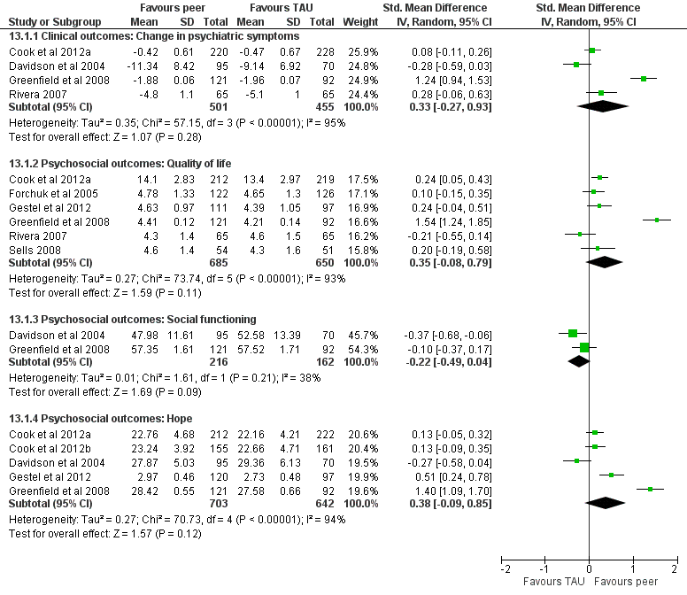

Additional SMI analyses for clinical outcomes
- Figure 1.2: SMI: Individual and group interventions for clinical outcomes
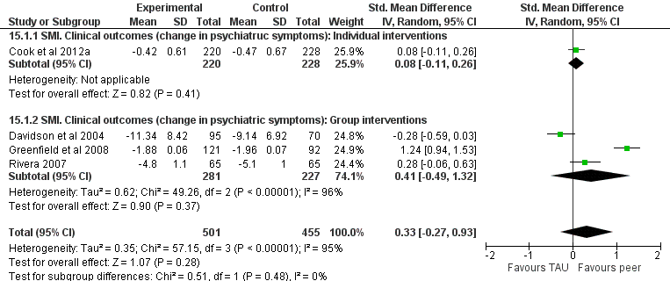

- Figure 1.3: SMI: Short and long-term follow up for clinical outcomes 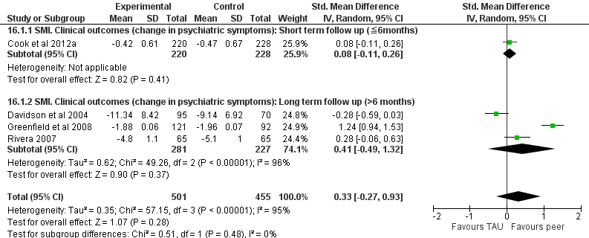

Psychosocial outcomes for SMI: Quality of life

- Figure 1.4: SMI: Individual and group interventions for psychosocial outcomes*. Quality of life

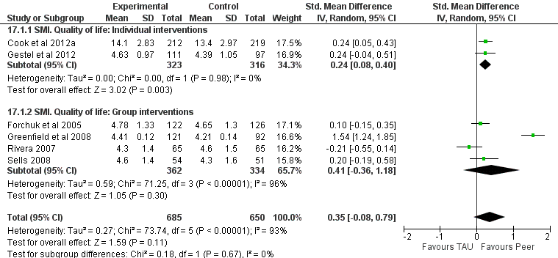

*Sensitivity analyses for psychosocial outcomes are only conducted for quality of life and hope (hope presented in figure 1.6) as studies reporting social functioning are all group interventions.

- Figure 1.5: SMI: Short and long term follow up for psychosocial outcomes*. Quality of life.

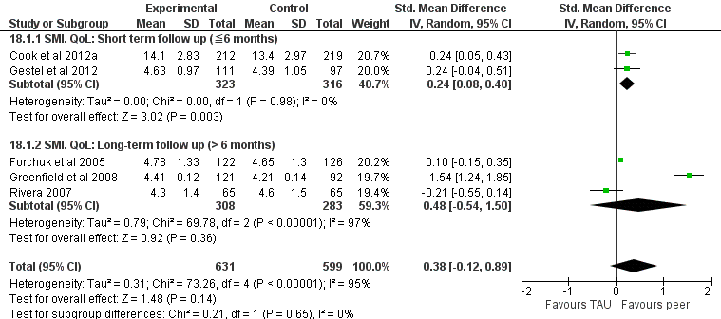

*Sensitivity analyses for psychosocial outcomes are only conducted for quality of life and hope (for hope see figure 1.6) as studies reporting social functioning are all of long-term follow up.

Psychosocial outcomes for SMI: Hope

- Figure 1.6: SMI: Individual and group interventions for psychosocial outcomes*. Hope.

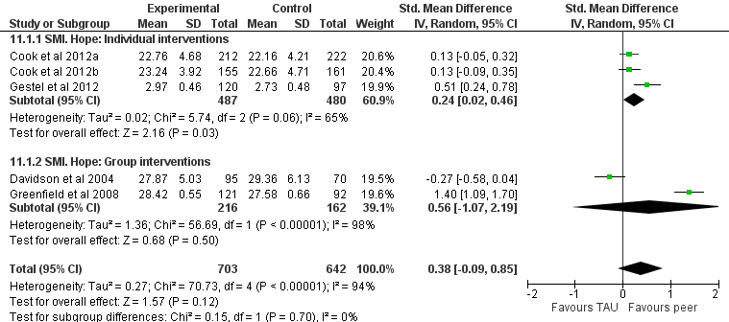
*Sensitivity analyses for psychosocial outcomes are only conducted for quality of life (see figure 1.4) and hope as studies reporting social functioning are all group interventions. Figure 1.6: All individual interventions for hope are of short term follow up (≤6 months), all group interventions are of long term follow up (≥6 months).

Figures 2: Sensitivity analyses for depression studies
- Figure 2.1: Complete analyses for depression irrespective of study quality
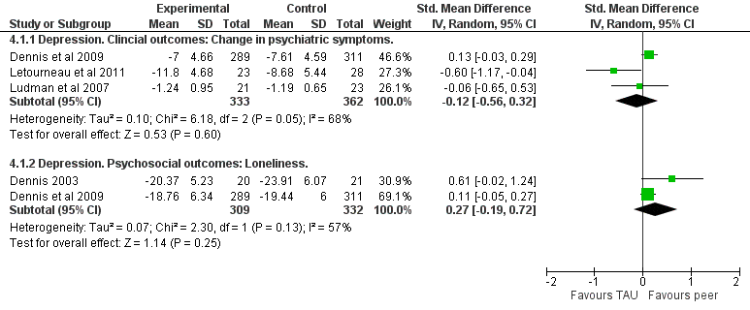

Clinical outcomes for depression
- Figure 2.2: Depression. Individual and group interventions for clinical outcomes*

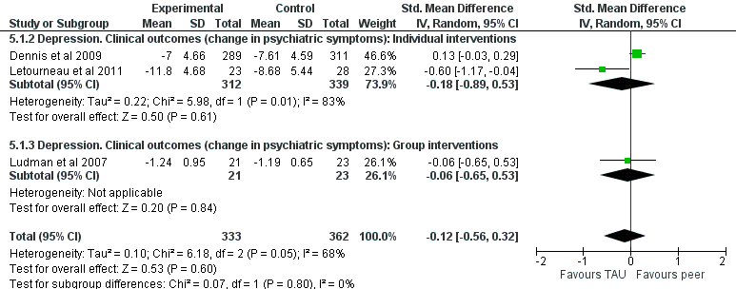
*Sensitivity analyses for psychosocial outcomes (loneliness) were not conducted as all studies reporting loneliness were individual interventions.

- Figure 2.3: Depression. Short and long term follow up for clinical outcomes*
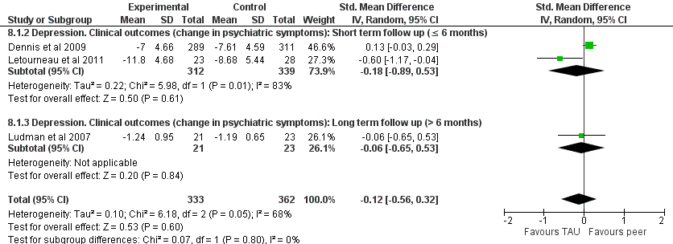
*Sensitivity analyses for psychosocial outcomes (loneliness) were not conducted as all studies reporting loneliness were of short term follow up.

Clinical and psychosocial outcomes for depression: High quality studies only
- Figure 2.4: Depression. High quality studies only
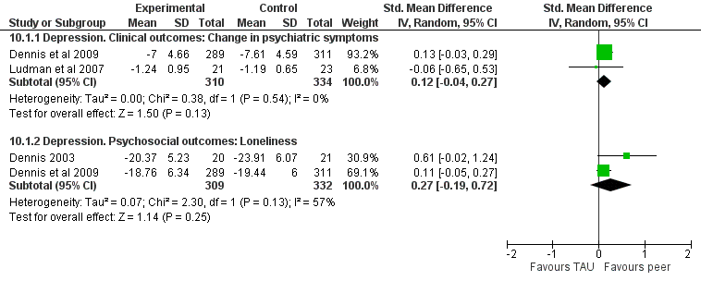

Online data supplements V: Funnel Plots
Figure 3: Funnel plot of main SMI analysis

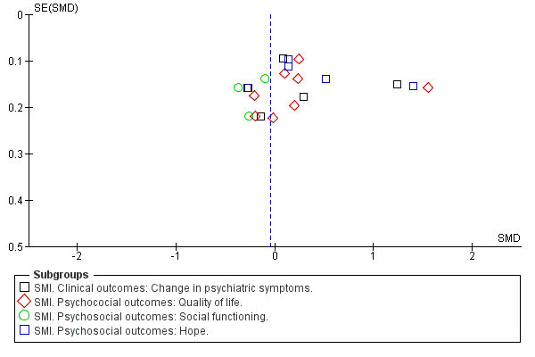

Figure 4: Funnel plot of main depression analysis

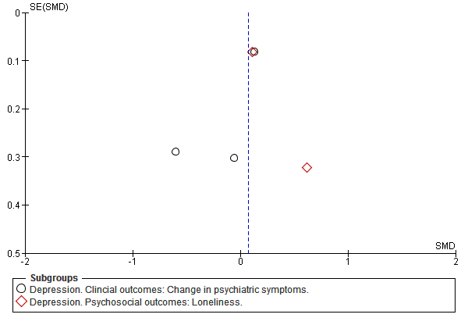

References

1. Dennis, C.L., Peer support within a health care context: a concept analysis. Int J Nurs Stud, 2003. 40(3): p. 321-32.
2. Davidson, L., et al., Peer support among adults with serious mental illness: a report from the field. Schizophrenia Bulletin, 2006. 32(3): p. 443-50.
3. Cook, J.A., et al., Results of a randomized controlled trial of mental illness self-management using Wellness Recovery Action Planning. Schizophr Bull, 2012a. 38(4): p. 881-91.
4. Cook, J.A., et al., Randomized controlled trial of peer-led recovery education using Building Recovery of Individual Dreams and Goals through Education and Support (BRIDGES). Schizophrenia Research, 2012b. 136(1-3): p. 36-42.
5. Druss, B.G., et al. The Health and Recovery Peer (HARP) Program: a peer-led intervention to improve medical self-management for persons with serious mental illness. Schizophrenia research, 2010. 118, 264-70.
6. van Gestel-Timmermans, H., et al., Effects of a peer-run course on recovery from serious mental illness: a randomized controlled trial. Psychiatric Services, 2012. 63(1): p. 54-60.
7. Davidson, L., G. Shahar, and D.A. Strayner, Supported socialization for people with psychiatric disabilities: Lessons from a randomized controlled trial. Journal of Community Psychology, 2004. 32(4): p. 453-477.
8. Forchuk, C., et al., Therapeutic relationships: from psychiatric hospital to community. Journal of Psychiatric and Mental Health Nursing, 2005. 12: p. 556-564.
9. Greenfield, T.K., et al., A randomized trial of a mental health consumer-managed alternative to civil commitment for acute psychiatric crisis. Am J Community Psychol, 2008. 42(1-2): p. 135-44.
10. Rivera, J.J., A.M. Sullivan, and S.S. Valenti, Adding consumer-providers to intensive case management: does it improve outcome? Psychiatr Serv, 2007. 58(6): p. 802-9.
11. Sells, D., et al. Beyond generic support: incidence and impact of invalidation in peer services for clients with severe mental illness. Psychiatric services (Washington, D.C.), 2008. 59, 1322-7 DOI: 10.1176/appi.ps.59.11.1322.
12. Solomon, P. and J. Draine, The efficacy of a consumer case management team: 2-year outcomes of a randomized trial. J Ment Health Adm, 1995. 22(2): p. 135-46.
13. Solomon, P. and J. Draine, One-year outcomes of a randomized trial of consumer case management. Evaluation and Program Planning, 1995. 18(2): p. 117-127.
14. Ludman, E.J., et al., A pilot study of telephone care management and structured disease self-management groups for chronic depression. Psychiatr Serv, 2007. 58(8): p. 1065-72.
15. Dennis, C.L., et al., Effect of peer support on prevention of postnatal depression among high risk women: multisite randomised controlled trial. BMJ, 2009. 338: p. a3064.
16. Dennis, C.L., The effect of peer support on postpartum depression: a pilot randomized controlled trial. Canadian Journal of Psychiatry - Revue Canadienne de Psychiatrie, 2003. 48(2): p. 115-24.
17. Letourneau, N., et al., Effect of home-based peer support on maternal-infant interactions among women with postpartum depression: a randomized, controlled trial. International Journal of Mental Health Nursing, 2011. 20(5): p. 345-57.

