Supplementary material

Low level cognitive ability in young adulthood increases the risk of depression after military deployment: an observational cohort study among Danish soldiers

Journal: Social Psychiatry and psychiatric epidemiology

Authors and affiliations/addresses:

1. Lars Ravnborg Nissen (corresponding author)
Research and Knowledge Centre, Danish Defense Veteran Centre, DK-4100 Ringsted, Denmark.
E-mail: lrnissen@dadlnet.dk
Tel.: +45 72819705

2. Karen-Inge Karstoft
Research and Knowledge Centre, Danish Defense Veteran Centre, DK-4100 Ringsted, Denmark.

3. Mia Sadowa Vedtofte
Research and Knowledge Centre, Danish Defense Veteran Centre, DK-4100 Ringsted, Denmark.

4. Anni Brit Sternhagen Nielsen
Research and Knowledge Centre, Danish Defense Veteran Centre, DK-4100 Ringsted, Denmark.

5. Merete Osler
Center for Clinical Research and Prevention, Bispebjerg and Frederiksberg Hospital, Capital Region, Nordre Fasanvej 57, DK-2000 Frederiksberg, Denmark.

6. Erik Lykke Mortensen
Department of Public Health, University of Copenhagen, Øster Farimagsgade 5, P.O.Box 2099, DK-1014 Copenhagen K, Denmark.

7. Gunhild Tidemann Christensen
Danish Aging Research Centre, Department of Public Health, University of Southern Denmark, DK-5000 Odense C, Denmark.

8. Søren Bo Andersen
Research and Knowledge Centre, Danish Defense Veteran Centre, DK-4100 Ringsted, Denmark.

1. ROC curve analysis for establishment of PRIM-Depression cutoff score

To establish a cutoff score for the PRIM-Depression scale with 8-items for categorizing individuals with possible and probable depression, we conducted a Receiver Operating Characteristics (ROC) Curve analysis. We did so in a sample of military personnel deployed to Afghanistan as part of the International Security Assistance Force (ISAF) team 7 in 2009 (N=294). This cohort was selected for the ROC curve analysis since in addition to the PRIM questionnaire, they also responded to a range of validated questionnaires among them the Beck Depression Inventory [1]. For the ROC curve analysis, a BDI-score equaling moderate or severe depression (≥ 19) was set to indicate presence of depression, with PRIM-Depression total score being the test variable. While a clinical diagnostic interview would have been preferred to identify depression caseness, previous validations of the BDI indicates that the moderate and severe categories derived from BDI gives us a fairly accurate estimation of individuals who are likely to fulfill diagnostic criteria for depression [2].

The resulting ROC curve had an Area Under the Curve of 0.94 (95% CI: 0.89-0.98; see Figure 1), indicating high overall accuracy of PRIM-Depression compared to BDI. Sensitivity and specificity of varying cutoff scores can be seen in Table 1. When deciding a reasonable cutoff a general rule of thumb is that acceptable sensitivity is > 0.70 and acceptable specificity is ≥ 0.90 [3]. This means that cutoff scores of ≥ 6 and ≥ 7 both seems adequate.

When evaluating positive predictive value (PPV) and negative predictive value (NPV), it is clear that while the number of false negatives (as reflected by NPV) is low for both scores, the number of false positives is relatively high, especially for the score-6 cutoff. Given that PPV and NPV vary with prevalence, and since the prevalence of depression as assessed with the BDI in this particular sample is low (6%), it is expected that PPV will be relatively low. Based on the ROC curve analyses, we suggest that a PRIM-Depression score of 6 is a relevant cutoff for depression screening, i.e. for identifying those, that might need further assessment or clinical attention. We term this category possible depression. Further, we suggest that a PRIM-Depression score of 7 is a relevant cutoff for estimating prevalence and likely depression in this sample. We term this category probable depression. When estimating prevalence with the cutoff scores for probable depression, we find a prevalence of 7.8%, which as expected based on the low PPV is slightly higher than when estimated with the BDI.

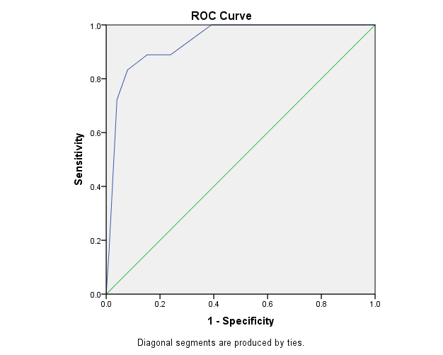
Figure 1. ROC curve of the PRIM-Depression measured against moderate or severe depression as indicated by the BDI

In order to obtain a prevalence-independent measure we also calculated the likelihood ratios, (positive likelihood ratio (LR+), which is the ratio between the positive test probability in a person with depression and in a person without depression; and negative likelihood ratio (LR−), which is the ratio between the negative test probability in a person without depression and in a person with depression [4]. Generally, LR+ greater than 10 and LR- smaller than 0.1 is regarded as being adequate in identifying conclusive changes from the pre- to the post­test probability [5]. The results from the LR+ and LR- (Table 1) confirms that depression score 6 and 7 are reasonable cutoffs also in cohorts with other prevalence of depression: the likelihood of a positive test result is 10.38 and 18 times higher, respectively, in those with possible and probable depression than in those without.

Table 1. Sensitivity, Specificity, PPV, NPV, LH+ and LH- for all possible cutoff scores
Cutoff score (≥) | Sensitivity | Specificity | LH + | LH - | PPV | NPV
1 | 1.00 | 0.27 | 1.37 | 0.00 | 0.08 | 1.00
2 | 1.00 | 0.45 | 1.82 | 0.00 | 0.10 | 1.00
3 | 1.00 | 0.61 | 2.56 | 0.00 | 0.14 | 1.00
4 | 0.89 | 0.76 | 3.71 | 0.14 | 0.19 | 0.99
5 | 0.89 | 0.85 | 5.93 | 0.13 | 0.27 | 0.99
6 | 0.83 | 0.92 | 10.38 | 0.18 | 0.40 | 0.99
7 | 0.72 | 0.96 | 18.00 | 0.29 | 0.53 | 0.98
8 | 0.17 | 0.99 | 17.00 | 0.84 | 0.52 | 0.95
Notes. LR− = negative likelihood ratio; LR+ = positive likelihood ratio, PPV= positive predictive value, NPV= Negative predictive value.

2. Examination of cognitive ability score performance as a test for post-deployment depression.

We performed ROC-curve analysis for both outcomes, possible depression and probable depression. As the test variable, we used the inverse of the cognitive probability score (CAS), because increase of CAS decreases risk of post-deployment PTSD.

The results are shown on the figures 2 and 3 below:

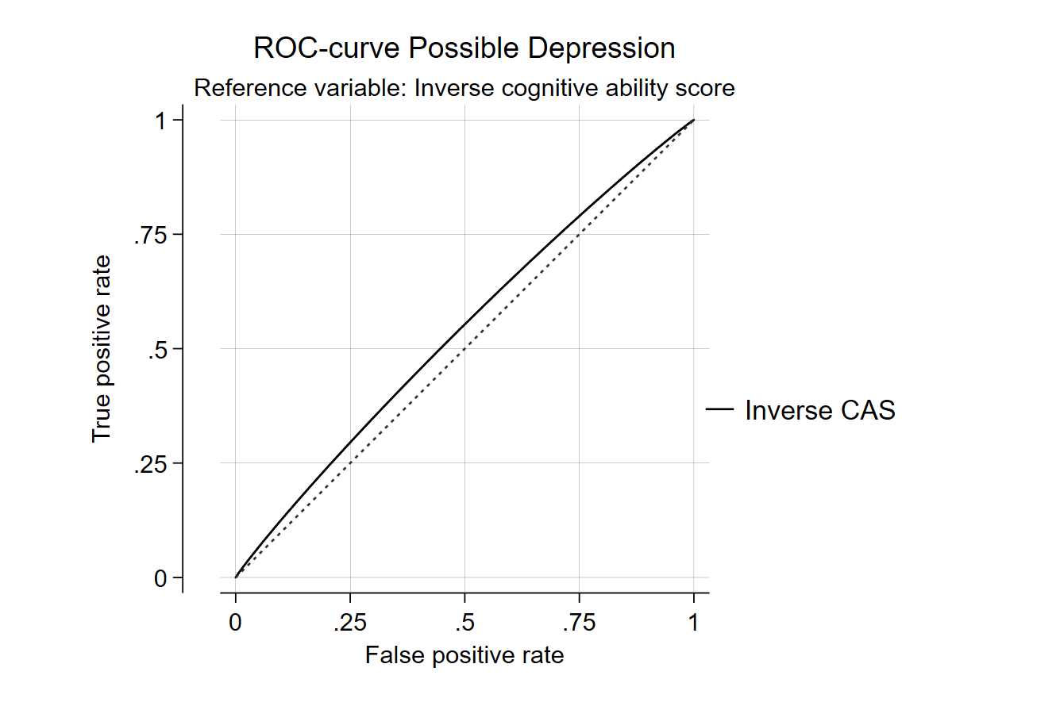
Figure 2: For possible depression, the area under the ROC-curve (AUC) was 0.54

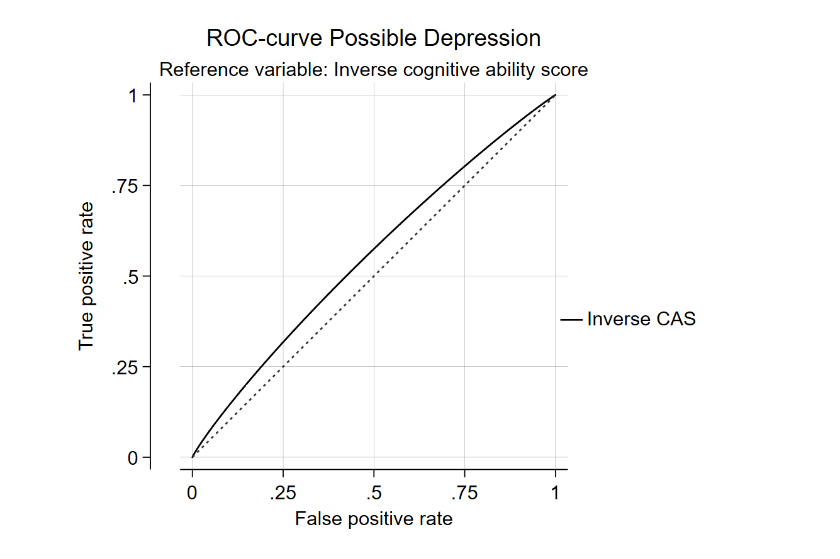
Figure 3: For probable depression, the AUC was 0.55

In conclusion, for both outcomes, the AUC was below 0.60, showing that the test performance, that is, predictive power of the inverse CAS was very poor.

References
1. Beck AT, Ward CH, Mendelson M, et al (1961) An inventory for measuring depression. Arch Gen Psychiatry 4:561–71
2. Beck AT, Steer RA, Carbin MG (1988) Psychometric properties of the Beck Depression Inventory: Twenty-five years of evaluation. Clin Psychol Rev 8:77–100
3. McDonald SD, Calhoun PS (2010) The diagnostic accuracy of the PTSD checklist: a critical review. Clin Psychol Rev 30:976–987 . doi: 10.1016/j.cpr.2010.06.012
4. Greenhalgh T (1998) Papers that report diagnostic or screening tests. Br Med J 315:540–543
5. Jaeschke R, Guyatt GH, Sackett DL, et al (1994) Users’ Guides to the Medical Literature: III. How to Use an Article About a Diagnostic Test. Jama 271:703–707

