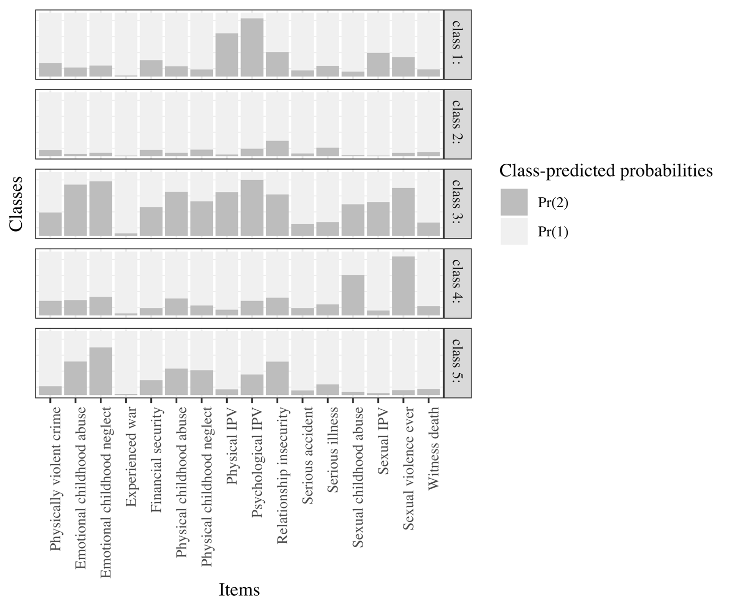

Figure S1. 5 class solution in females.

