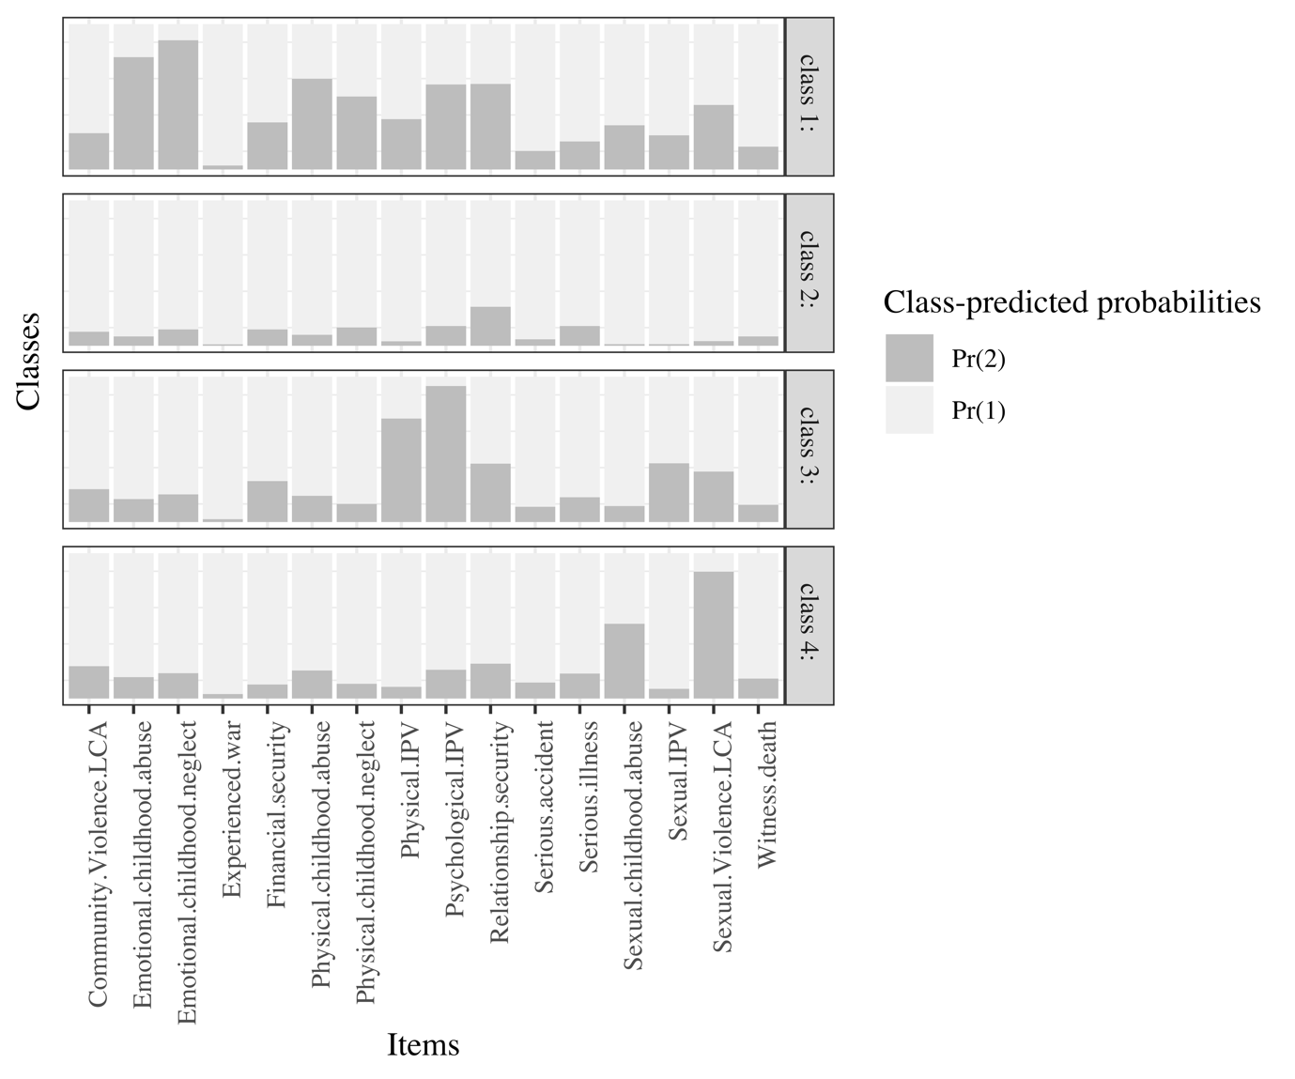

Figure S2. 4 class solution in females.

