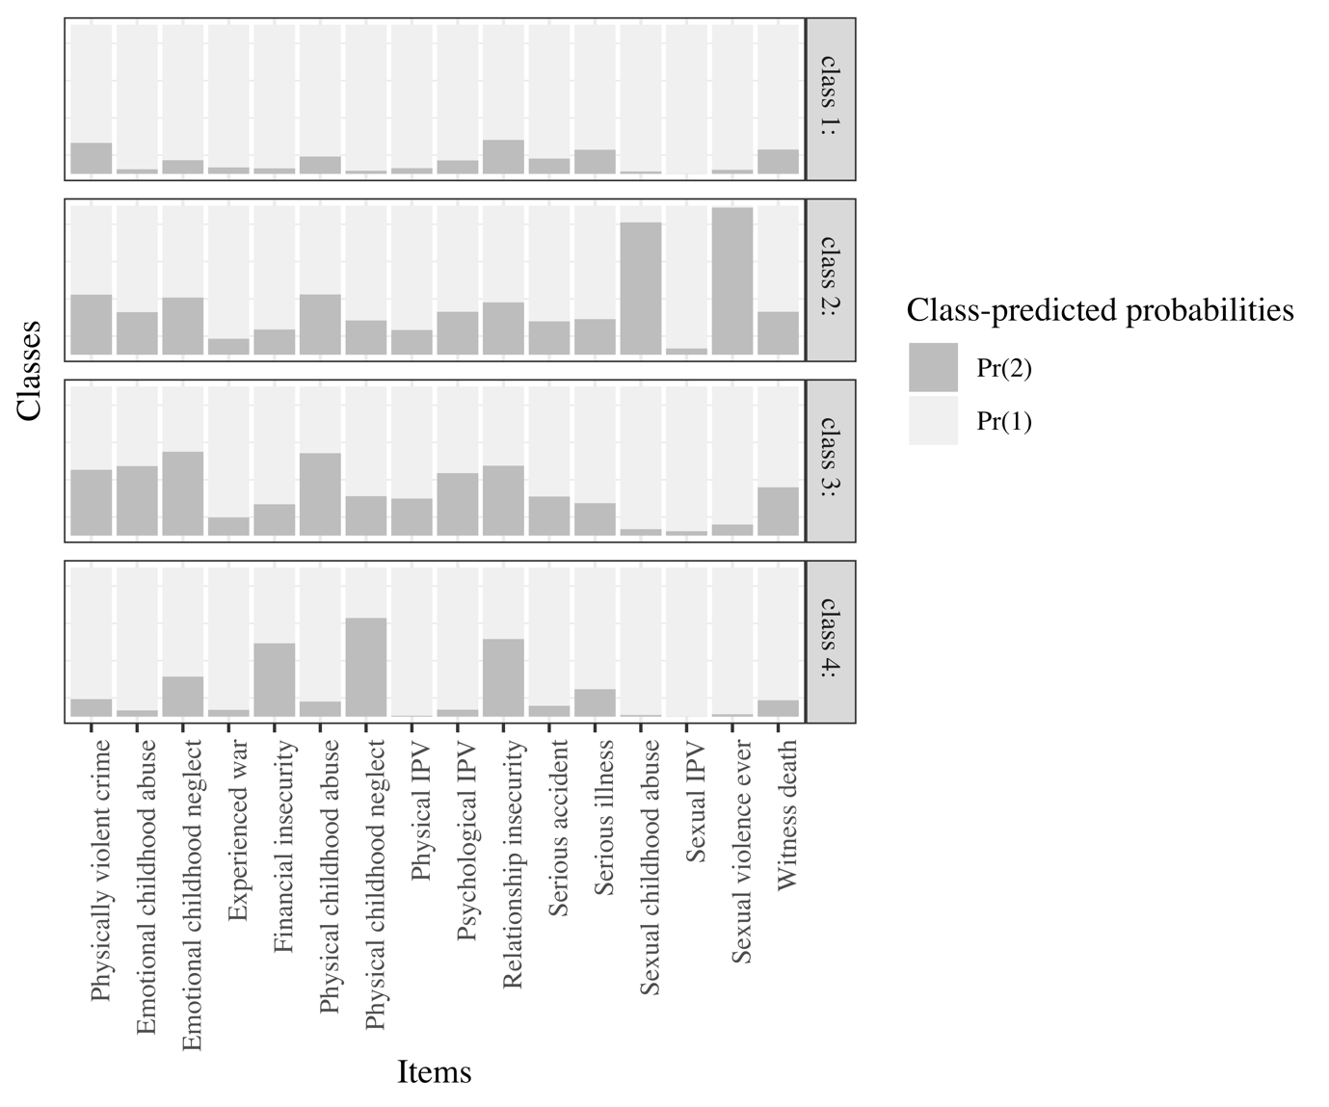

Figure S3. 4 class solution males.

