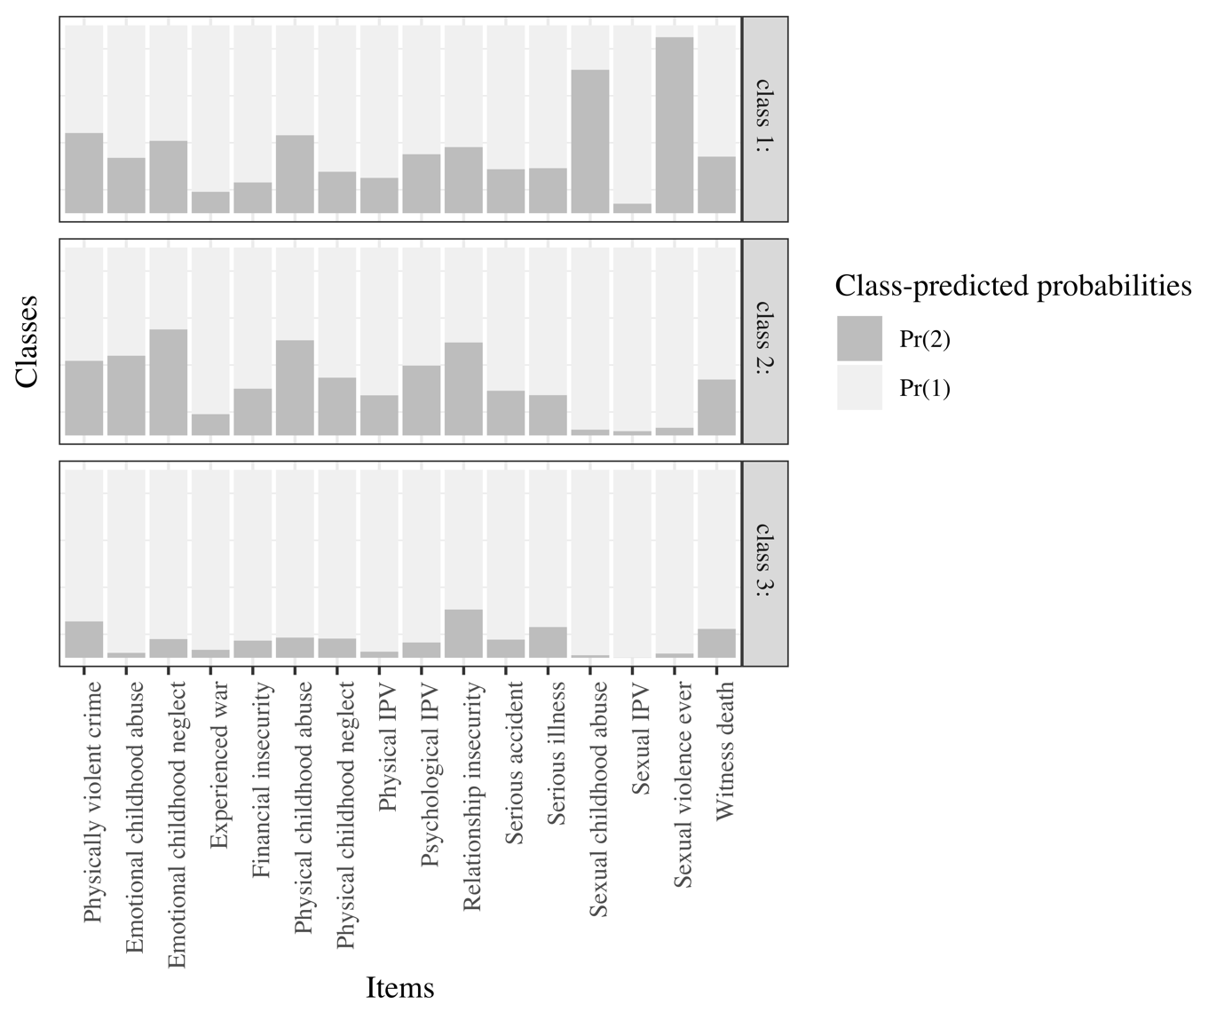

Figure S4. 3 class solution in males.

