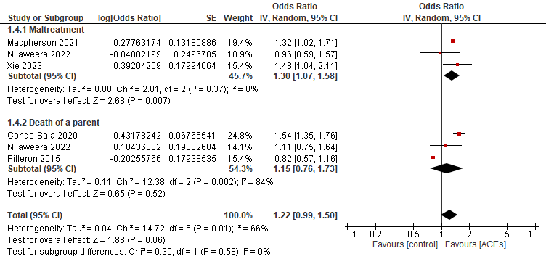Fig.1 Forrest plot of Risk of dementia based on the type of adversity

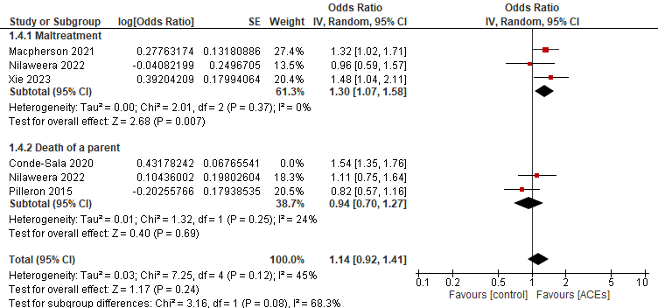
Fig.2 Forrest plot of sensitivity analysis of Risk of dementia based on the type of adversity
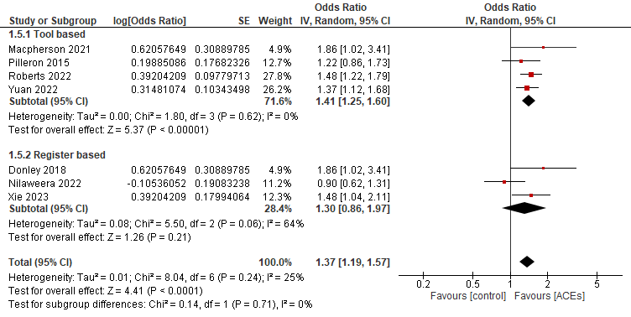
Fig.3 Forrest plot analysis of Risk of dementia based on the Definition of dementia
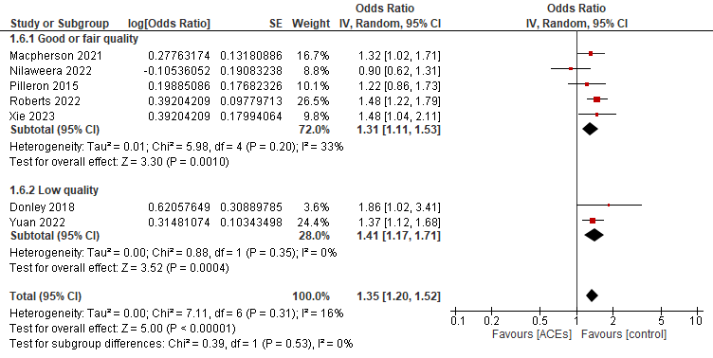
Fig.4 Forrest plot of Risk of dementia based on Quality of studies

