Supplementary materials
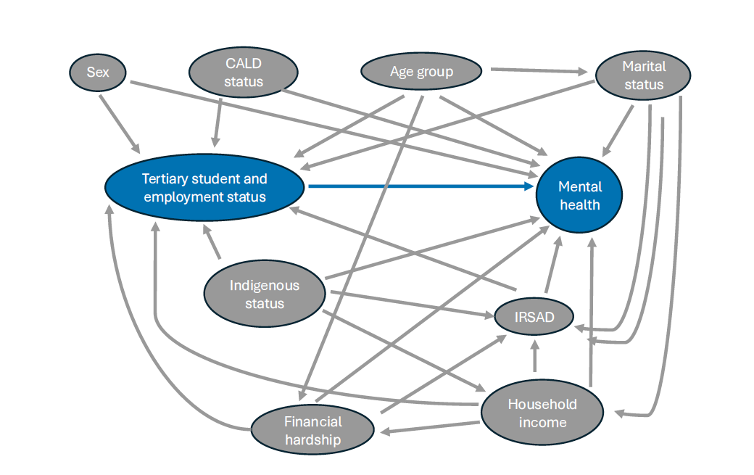
Figure S1: Directed Acyclic Graph (DAG) illustrating the relationships between psychological distress/mental wellbeing (outcome) and tertiary student and employment status of young people (exposure), including possible factors that influence the exposure and/or outcome.

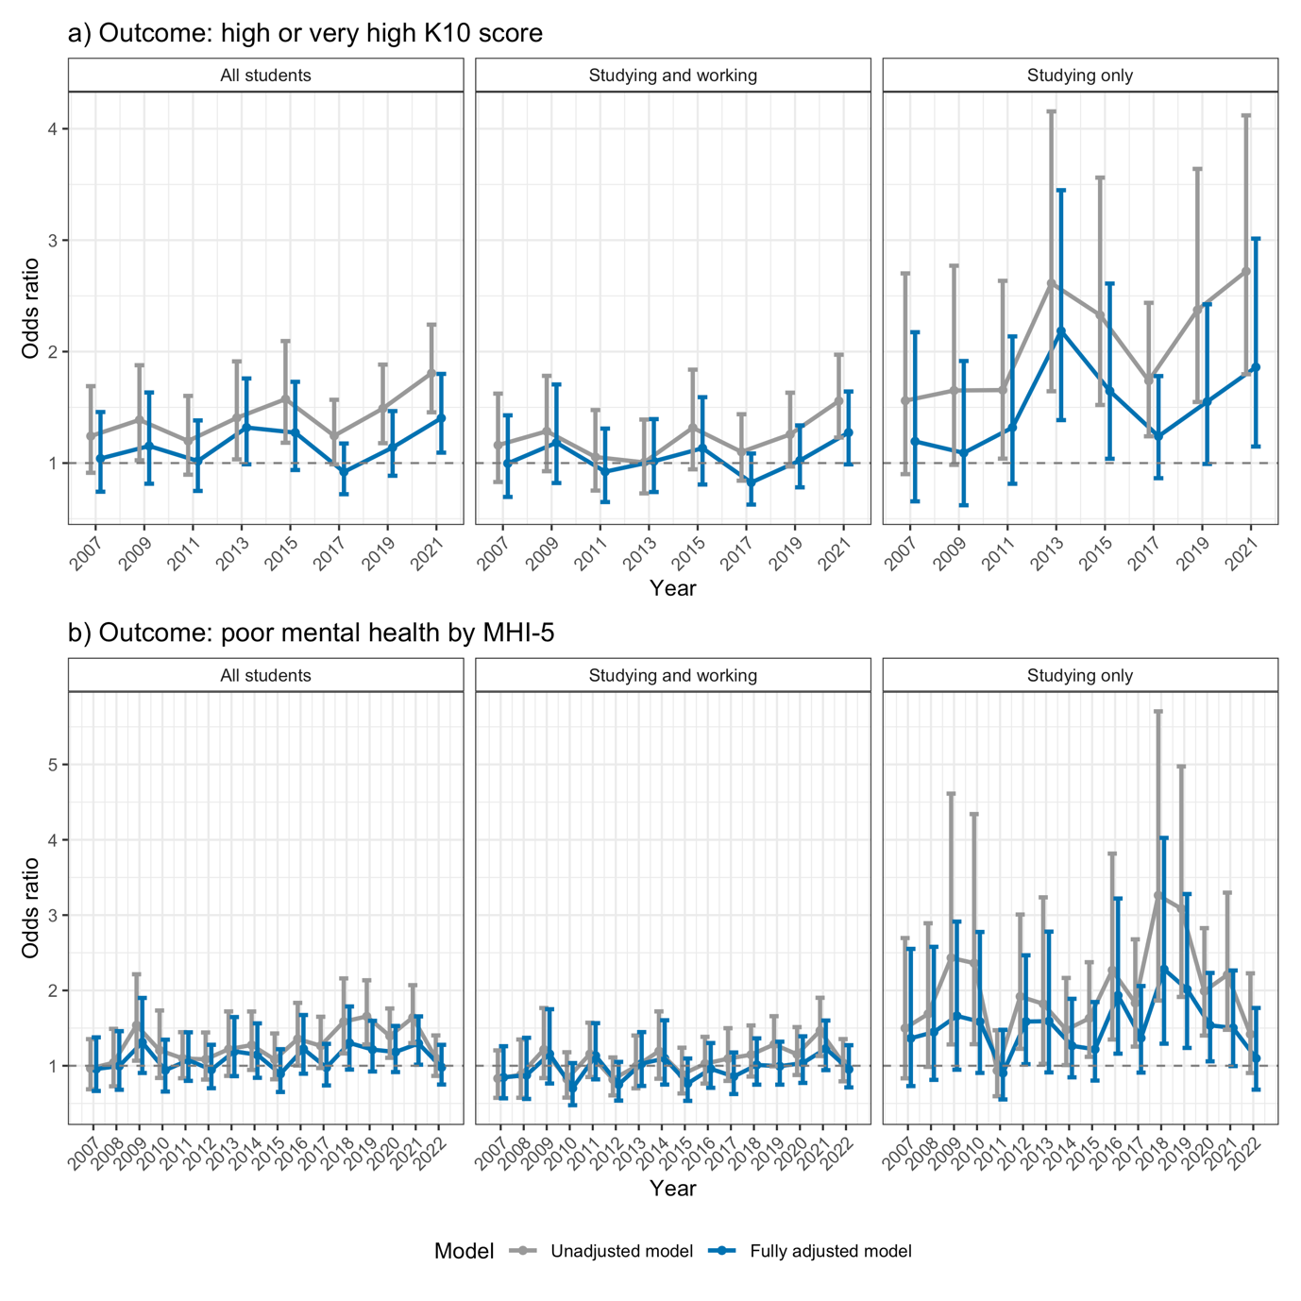
Figure S2: Odds ratios and 95% confidence intervals from weighted logistic regression of (a) K10 ≥ 22, (b) MHI-5 ≤ 52 against tertiary student and employment status. (Left) compares all students with working only young people, (Middle) compares studying and working young people with working only young people, (Right) compares studying only young people with working only young people. The adjusted model included the following covariates: age, sex, IRSAD, equivalised household income, experience of financial hardship, CALD status, Aboriginal status, and marital status. Corresponds to Figure 2 in main manuscript.

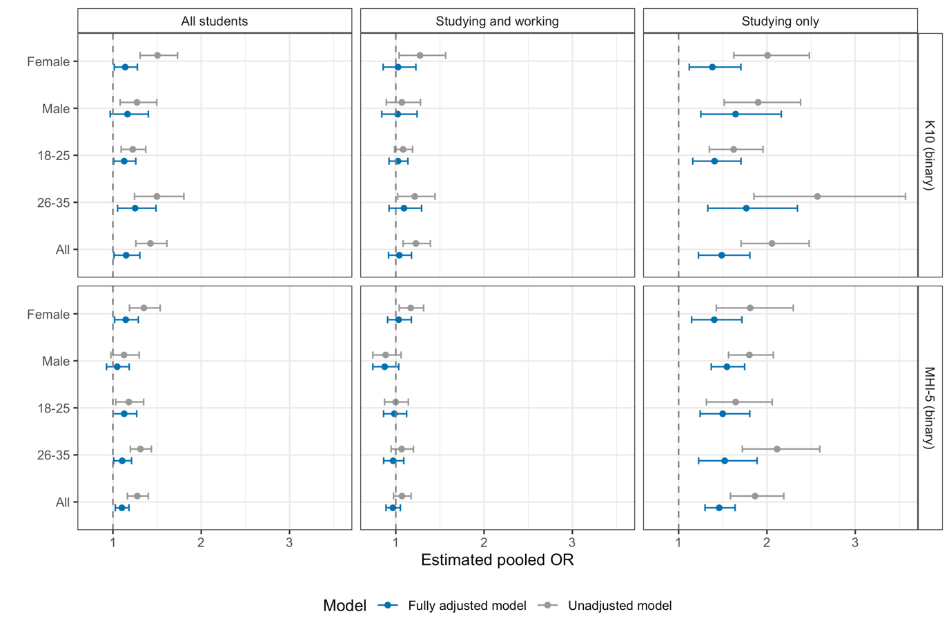
Figure S3: Average (across all years) odds ratios and 95% confidence intervals of weighted logistic regression of (top panels) K10 ≥ 22, (bottom panels) MHI-5 ≤ 52 against tertiary student and employment status. Coefficients were averaged using a random effects meta-analysis with the REML method. Corresponds to Figure 3 in main manuscript.
Table S1. Items from K10 and MHI-5
Items from K10 (In the last four weeks, about how often did you feel …) | Items from MHI-5 (How much of time during the past 4 weeks have you …)
- Tired out for no reason  - Nervous  - So nervous that nothing could calm you down  - Hopeless  - Restless or fidgety  - So restless that you could not sit still  - Depressed  - That everything was an effort  - So sad that nothing could cheer you up  - Worthless | - Been a nervous person  - Felt so down in the dumps that nothing could cheer you up  - Felt calm and peaceful  - Felt down  - Been a happy person

Table S2. Variables used in this study
Variable | Definition
Age group | 18–25 or 26–35
Sex | Male or Female
Culturally and linguistically diverse (CALD) | Speak a language other than English or Country of birth not Australia/Main English speaking
Aboriginal or Torres Straits islander | Aboriginal and/or Torres Strait Islander and born in Australia
Index of Relative Socio-economic Advantage and Disadvantage (IRSAD) | Decile of ABS 2011 IRSAD based on household statistical local area
Equivalised household income | Household financial year disposable regular income divided by the square root of number of in-scope persons in household
Financial hardship | Yes if the respondent answered positively to “Since January [insert year of study] did any of the following happen to you because of a shortage of money?”: “Could not pay electricity, gas or telephone bills on time”, “Asked for financial help from friends or family”, “Could not pay the mortgage or rent on time”, “Pawned or sold something”, “Was unable to heat home”, “Went without meals”, or “Asked for help from welfare or community organizations”.
Current marital status | Legally married or de facto are classified as “married”
Disability/impairment | Answer to the question: Do you have any long-term health condition, impairment or disability (such as these) that restrict you in your everyday activities, and has lasted or is likely to last, for 6 months or more? “Yes” or “No” were accepted. “Refused” or “Don’t know” were treated as missing.
Lonely or socially isolated | Those in the lowest quartile (the lowest 25%) based on the sum of 10-item social support (seven-point scale, 1: strongly disagree, 7: strongly agree), ranges from 10 to 70 (scales are inverted for five items).(Scutella, 2009)  - People don’t come to visit me as often as I would like (scale inverted)  - I often need help from other people but can’t get it (scale inverted)  - I seem to have a lot of friends  - I don’t have anyone I can confide in (scale inverted)  - I have no one to lean on in times of trouble (scale inverted)  - There is someone who can always cheer me up when I’m down  - I often feel very lonely (scale inverted)  - I enjoy the time I spend with the people who are important to me  - When something’s on my mind, just talking with the people I know can make me feel better  - When I need someone to help me out, I can usually find someone
Poor general health | Score less than or equal to 37 on the SF-36 general health scale(Wilkins et al., 2024)
Table S3: Chi-Square Test Results for Conditional Independence Assumptions in the Directed Acyclic Graph (see Figure S1)
Assumptions tested | In K10 model |  |  | In MHI-5 model
Assumptions tested | rmsea | x2 | p.value | rmsea | x2 | p.value
agegroup || household income | marital status | 0.066 | 20.252 | 0.005 | 0.066 | 33.741 | 0.003
agegroup || CALD status | 0.052 | 4.022 | 0.019 | 0.055 | 4.005 | 0.013
agegroup || irsad | financial hardship, household income, marital status | 0.051 | 17.758 | 0.009 | 0.052 | 12.568 | 0.021
CALD status || financial hardship | 0.046 | 0.004 | 0.113 | 0.042 | 0.736 | 0.131
ATSI status || CALD status | 0.044 | 9.261 | 0.017 | 0.045 | 15.492 | 0.031
ATSI status || financial hardship | household income, marital status | 0.044 | 6.569 | 0.039 | 0.036 | 9.600 | 0.093
Sex || agegroup | 0.033 | 2.223 | 0.053 | 0.024 | 0.001 | 0.175
Sex || financial hardship | 0.030 | 3.338 | 0.110 | 0.030 | 7.734 | 0.118
agegroup || ATSI status | 0.023 | 1.564 | 0.112 | 0.024 | 1.466 | 0.098
CALD status || household income | 0.021 | 0.146 | 0.296 | 0.015 | 1.211 | 0.327
CALD status || marital status | 0.014 | 4.705 | 0.407 | 0.008 | 1.541 | 0.442
CALD status || irsad | 0.012 | 4.418 | 0.417 | 0.013 | 0.290 | 0.396
Sex || ATSI status | 0.005 | 0.028 | 0.533 | 0.005 | 0.121 | 0.535
Sex || irsad | 0.004 | 0.318 | 0.451 | 0.002 | 0.082 | 0.520
Sex || household income | 0.003 | 1.121 | 0.529 | 0.003 | 1.823 | 0.480
ATSI status || marital status | 0.002 | 0.856 | 0.513 | 0.003 | 0.412 | 0.509
Sex || marital status | 0.001 | 0.477 | 0.492 | 0.002 | 1.078 | 0.478
Sex || CALD status | 0.000 | 0.390 | 0.544 | 0.002 | 0.310 | 0.528
Notes: || = “conditional independent”, | = “given”, rmsea = Root Mean Square Error of Approximation, X² = chi-square statistic. Rmsea < 0.05 indicates a close fit of the model and supports the conditional independence assumption, rmsea of 0.05 to 0.08 indicates a reasonable fit. All statistics were averaged across all imputed datasets and years.

Table S4: Sample sizes and proportions for the groups of interest, from 2007 to 2022.
Year | Working only | Studying and working | Studying only | NEET
2007 | 2319 (76.6%) | 558 (18.4%) | 152 (5.0%) | 517
2008 | 2227 (73.7%) | 627 (20.7%) | 169 (5.6%) | 485
2009 | 2137 (70.7%) | 629 (20.8%) | 256 (8.5%) | 596
2010 | 2293 (70.6%) | 686 (21.1%) | 268 (8.3%) | 537
2011 | 2662 (65.9%) | 1026 (25.4%) | 353 (8.7%) | 790
2012 | 2715 (68.0%) | 937 (23.5%) | 340 (8.5%) | 823
2013 | 2752 (67.9%) | 913 (22.5%) | 387 (9.6%) | 819
2014 | 2795 (69.2%) | 877 (21.7%) | 364 (9.0%) | 872
2015 | 2817 (67.6%) | 964 (23.1%) | 386 (9.3%) | 750
2016 | 2991 (68.7%) | 954 (21.9%) | 407 (9.3%) | 799
2017 | 3038 (69.8%) | 984 (22.6%) | 328 (7.5%) | 766
2018 | 3089 (72.0%) | 897 (20.9%) | 306 (7.1%) | 757
2019 | 3072 (71.9%) | 905 (21.2%) | 296 (6.9%) | 824
2020 | 2788 (68.9%) | 851 (21.0%) | 407 (10.1%) | 805
2021 | 2665 (68.8%) | 893 (23.1%) | 316 (8.2%) | 681
2022 | 2780 (71.9%) | 890 (23.0%) | 197 (5.1%) | 599
Note: All statistics reported were weighted, proportions do not include NEET. NEET = Not in education, employment, or training.

Table S5: Participant characteristics in 2021, including NEET. Corresponds to Table 1 in main manuscript.
 | Working only | Studying and working | Studying only | NEET
Age group
18-25 | 817 (30.7%) | 574 (64.2%) | 219 (69.2%) | 254 (37.3%)
26-35 | 1847 (69.3%) | 319 (35.8%) | 97 (30.8%) | 427 (62.7%)
Sex
Male | 1383 (51.9%) | 435 (48.7%) | 147 (46.4%) | 311 (45.6%)
Female | 1281 (48.1%) | 458 (51.3%) | 169 (53.6%) | 370 (54.4%)
IRSAD, (mean, SD) | 5.9 (2.8) | 6.3 (2.8) | 6.1 (2.9) | 4.5 (2.8)
Equivalised household income, (mean, SD) | 78566.8 (34956.7) | 79938.9 (56045.6) | 64827.4 (67233.1) | 50545.7 (25956.9)
Financial Hardship | 471 (18.5%) | 182 (21.7%) | 106 (34.6%) | 246 (38.0%)
CALD | 437 (16.4%) | 176 (19.7%) | 106 (33.5%) | 118 (17.3%)
Marital status: Married | 1444 (54.2%) | 291 (32.6%) | 57 (18.0%) | 263 (38.6%)
MHI-5
Mean (SD) | 68.2 (17.3) | 64.5 (18.1) | 58.3 (20.0) | 62.3 (20.5)
Median (Q1, Q3) | 72.0 (56.0, 80.0) | 68.0 (52.0, 80.0) | 64.0 (44.0, 72.0) | 64.0 (48.0, 80.0)
MHI-5 < 52 | 553 (20.9%) | 249 (28.0%) | 116 (37.4%) | 231 (34.0%)
K10 score
Mean (SD) | 19.1 (7.6) | 20.7 (7.9) | 22.8 (8.8) | 21.9 (9.2)
Median (Q1, Q3) | 17.0 (13.0, 23.0) | 19.0 (14.0, 27.0) | 22.0 (15.0, 29.0) | 20.0 (14.0, 29.0)
K10 ≥ 22 | 779 (29.8%) | 338 (39.0%) | 167 (54.1%) | 310 (46.5%)

Table S6: Participant characteristics in 2019
 | Working only | Studying and working | Studying only | NEET
Age group
18-25 | 1004 (32.7%) | 587 (64.8%) | 214 (72.3%) | 302 (36.6%)
26-35 | 2068 (67.3%) | 318 (35.2%) | 82 (27.7%) | 522 (63.4%)
Sex
Male | 1679 (54.6%) | 386 (42.7%) | 126 (42.6%) | 355 (43.1%)
Female | 1394 (45.4%) | 519 (57.3%) | 170 (57.4%) | 469 (56.9%)
IRSAD, (mean, SD) | 6.0 (2.8) | 6.2 (2.8) | 5.7 (3.1) | 4.7 (2.8)
Equivalised household income, (mean, SD) | 73858.3 (40998.2) | 74751.4 (43144.2) | 57578.5 (67538.5) | 48477.0 (31653.2)
Financial Hardship | 610 (20.2%) | 214 (24.2%) | 113 (40.0%) | 309 (38.9%)
CALD | 674 (21.9%) | 151 (16.6%) | 67 (22.7%) | 184 (22.3%)
Marital status: Married | 1629 (53.0%) | 277 (30.6%) | 80 (27.1%) | 352 (42.7%)
MHI-5
Mean (SD) | 71.2 (17.0) | 69.4 (17.1) | 62.0 (20.4) | 64.3 (20.8)
Median (Q1, Q3) | 76.0 (60.0, 84.0) | 72.0 (60.0, 80.0) | 64.0 (52.0, 80.0) | 68.0 (52.0, 80.0)
MHI-5 < 52 | 451 (14.8%) | 164 (18.3%) | 102 (34.6%) | 247 (30.0%)
K10 score
Mean (SD) | 17.3 (7.0) | 18.3 (7.2) | 22.0 (9.5) | 20.5 (9.1)
Median (Q1, Q3) | 15.0 (12.0, 21.0) | 16.0 (13.0, 23.0) | 21.0 (14.0, 27.0) | 18.0 (13.0, 27.0)
K10 ≥ 22 | 696 (22.7%) | 244 (27.1%) | 120 (41.0%) | 305 (37.4%)

Table S7: Participant characteristics in 2017
 | Working only | Studying and working | Studying only | NEET
Age group
18-25 | 1009 (33.2%) | 692 (70.4%) | 226 (68.8%) | 318 (41.6%)
26-35 | 2029 (66.8%) | 292 (29.6%) | 102 (31.2%) | 448 (58.4%)
Sex
Male | 1642 (54.0%) | 481 (48.9%) | 151 (46.1%) | 283 (37.0%)
Female | 1396 (46.0%) | 503 (51.1%) | 177 (53.9%) | 483 (63.0%)
IRSAD, (mean, SD) | 6.0 (2.8) | 6.2 (2.9) | 6.2 (2.9) | 4.8 (3.0)
Equivalised household income, (mean, SD) | 69043.2 (33029.6) | 71223.5 (55839.5) | 52470.1 (30229.0) | 43463.5 (26897.9)
Financial Hardship | 592 (20.9%) | 220 (23.4%) | 78 (25.8%) | 254 (36.1%)
CALD | 736 (24.2%) | 256 (26.1%) | 82 (24.9%) | 211 (27.5%)
Marital status: Married | 1665 (54.8%) | 234 (23.7%) | 73 (22.2%) | 317 (41.4%)
MHI-5
Mean (SD) | 72.1 (17.7) | 71.7 (16.8) | 66.3 (18.6) | 63.6 (20.5)
Median (Q1, Q3) | 76.0 (60.0, 84.0) | 76.0 (64.0, 84.0) | 68.0 (56.0, 80.0) | 68.0 (48.0, 80.0)
MHI-5 < 52 | 459 (15.2%) | 151 (15.6%) | 80 (24.6%) | 247 (32.4%)
K10 score
Mean (SD) | 17.2 (7.1) | 17.2 (7.1) | 19.5 (7.8) | 20.4 (8.8)
Median (Q1, Q3) | 15.0 (12.0, 21.0) | 15.0 (12.0, 21.0) | 17.0 (13.5, 24.0) | 18.0 (13.0, 28.0)
K10 ≥ 22 | 677 (22.3%) | 236 (24.0%) | 108 (33.1%) | 286 (37.4%)

Table S8: Participant characteristics in 2015
 | Working only | Studying and working | Studying only | NEET
Age group
18-25 | 938 (33.3%) | 644 (66.8%) | 267 (69.2%) | 284 (37.9%)
26-35 | 1878 (66.7%) | 320 (33.2%) | 119 (30.8%) | 466 (62.1%)
Sex
Male | 1530 (54.3%) | 474 (49.1%) | 144 (37.4%) | 312 (41.6%)
Female | 1287 (45.7%) | 491 (50.9%) | 242 (62.6%) | 438 (58.4%)
IRSAD, (mean, SD) | 5.9 (2.7) | 5.9 (2.9) | 6.4 (3.0) | 4.7 (2.9)
Equivalised household income, (mean, SD) | 64639.6 (33429.9) | 67417.2 (40320.6) | 55542.8 (60622.6) | 44664.4 (25891.1)
Financial Hardship | 690 (24.8%) | 229 (24.0%) | 134 (35.1%) | 291 (39.8%)
CALD | 779 (27.7%) | 245 (25.4%) | 120 (30.9%) | 215 (28.7%)
Marital status: Married | 1548 (55.0%) | 256 (26.6%) | 89 (23.0%) | 363 (48.4%)
MHI-5
Mean (SD) | 72.9 (16.4) | 72.9 (16.2) | 68.2 (19.9) | 66.8 (20.1)
Median (Q1, Q3) | 76.0 (64.0, 84.0) | 76.0 (60.0, 84.0) | 72.0 (56.0, 84.0) | 72.0 (56.0, 80.0)
MHI-5 < 52 | 405 (14.5%) | 125 (13.0%) | 83 (21.9%) | 173 (23.2%)
K10 score
Mean (SD) | 16.7 (6.6) | 17.2 (6.6) | 19.3 (8.3) | 19.9 (8.7)
Median (Q1, Q3) | 15.0 (12.0, 20.0) | 15.0 (12.0, 21.0) | 17.0 (13.0, 25.0) | 17.0 (13.0, 25.0)
K10 ≥ 22 | 517 (18.4%) | 219 (22.8%) | 133 (34.5%) | 267 (35.7%)

Table S9: Participant characteristics in 2013
 | Working only | Studying and working | Studying only | NEET
Age group
18-25 | 897 (32.6%) | 606 (66.4%) | 286 (73.9%) | 323 (39.5%)
26-35 | 1855 (67.4%) | 306 (33.6%) | 101 (26.1%) | 496 (60.5%)
Sex
Male | 1507 (54.8%) | 469 (51.4%) | 177 (45.8%) | 283 (34.6%)
Female | 1244 (45.2%) | 444 (48.6%) | 210 (54.2%) | 536 (65.4%)
IRSAD, (mean, SD) | 5.6 (2.9) | 6.3 (2.7) | 6.0 (2.9) | 4.8 (2.9)
Equivalised household income, (mean, SD) | 63367.7 (34719.9) | 66643.4 (44346.8) | 49567.0 (32100.7) | 43268.5 (26736.9)
Financial Hardship | 631 (23.6%) | 219 (24.3%) | 108 (29.3%) | 368 (46.2%)
CALD | 820 (29.8%) | 246 (27.0%) | 164 (42.3%) | 244 (29.8%)
Marital status: Married | 1526 (55.5%) | 250 (27.3%) | 84 (21.7%) | 374 (45.7%)
MHI-5
Mean (SD) | 74.1 (16.5) | 74.5 (16.0) | 67.3 (18.7) | 69.6 (18.5)
Median (Q1, Q3) | 76.0 (68.0, 84.0) | 80.0 (68.0, 84.0) | 68.0 (56.0, 80.0) | 72.0 (58.0, 84.0)
MHI-5 < 52 | 371 (13.6%) | 122 (13.4%) | 86 (22.1%) | 169 (20.7%)
K10 score
Mean (SD) | 16.4 (6.2) | 16.3 (6.3) | 19.8 (7.7) | 18.3 (7.4)
Median (Q1, Q3) | 15.0 (12.0, 19.0) | 14.0 (12.0, 19.0) | 18.0 (13.0, 24.0) | 16.0 (13.0, 22.0)
K10 ≥ 22 | 469 (17.2%) | 161 (17.7%) | 138 (35.7%) | 221 (27.3%)

Table S10: Participant characteristics in 2011
 | Working only | Studying and working | Studying only | NEET
Age group
18-25 | 854 (32.1%) | 690 (67.2%) | 257 (72.9%) | 353 (44.6%)
26-35 | 1855 (67.4%) | 306 (33.6%) | 101 (26.1%) | 496 (60.5%)
Sex
Male | 1503 (56.5%) | 538 (52.5%) | 148 (42.1%) | 253 (32.0%)
Female | 1159 (43.5%) | 487 (47.5%) | 204 (57.9%) | 537 (68.0%)
IRSAD, (mean, SD) | 5.9 (2.8) | 6.2 (2.8) | 5.5 (2.9) | 4.7 (3.0)
Equivalised household income, (mean, SD) | 58991.7 (28783.4) | 59855.3 (32943.0) | 42803.0 (26079.0) | 41093.9 (27968.4)
Financial Hardship | 742 (28.2%) | 305 (29.8%) | 119 (34.8%) | 370 (47.6%)
CALD | 693 (26.0%) | 317 (30.9%) | 161 (45.6%) | 255 (32.3%)
Marital status: Married | 1433 (53.9%) | 292 (28.4%) | 99 (28.2%) | 393 (49.7%)
MHI-5
Mean (SD) | 74.6 (15.9) | 73.2 (16.1) | 73.3 (16.5) | 67.8 (18.9)
Median (Q1, Q3) | 76.0 (64.0, 88.0) | 76.0 (64.0, 84.0) | 76.0 (64.0, 85.0) | 68.0 (56.0, 84.0)
MHI-5 < 52 | 282 (10.6%) | 123 (12.0%) | 35 (10.0%) | 174 (22.0%)
K10 score
Mean (SD) | 15.9 (5.9) | 16.4 (6.3) | 17.5 (7.0) | 18.9 (7.9)
Median (Q1, Q3) | 14.0 (12.0, 19.0) | 14.0 (12.0, 19.0) | 15.0 (12.0, 21.0) | 16.0 (13.0, 25.0)
K10 ≥ 22 | 408 (15.4%) | 166 (16.3%) | 82 (23.4%) | 244 (31.1%)

Table S11: Participant characteristics in 2009
 | Working only | Studying and working | Studying only | NEET
Age group
18-25 | 778 (36.4%) | 449 (71.3%) | 175 (68.2%) | 241 (40.4%)
26-35 | 1359 (63.6%) | 180 (28.7%) | 82 (31.8%) | 355 (59.6%)
Sex
Male | 1194 (55.9%) | 289 (46.0%) | 124 (48.2%) | 198 (33.3%)
Female | 942 (44.1%) | 340 (54.0%) | 133 (51.8%) | 397 (66.7%)
IRSAD, (mean, SD) | 5.9 (2.8) | 6.6 (2.7) | 6.0 (3.0) | 4.4 (2.9)
Equivalised household income, (mean, SD) | 58519.9 (32554.1) | 58839.7 (30766.2) | 43779.0 (24326.2) | 37699.8 (25394.4)
Financial Hardship | 511 (24.2%) | 140 (22.8%) | 100 (40.0%) | 272 (48.0%)
CALD | 340 (15.9%) | 92 (14.6%) | 106 (41.4%) | 149 (25.1%)
Marital status: Married | 1124 (52.6%) | 163 (25.9%) | 78 (30.6%) | 282 (47.4%)
MHI-5
Mean (SD) | 74.5 (15.6) | 73.6 (15.4) | 68.6 (18.2) | 66.7 (19.2)
Median (Q1, Q3) | 80.0 (64.0, 84.0) | 76.0 (64.0, 84.0) | 72.0 (56.0, 84.0) | 68.0 (52.0, 84.0)
MHI-5 < 52 | 239 (11.3%) | 77 (12.4%) | 60 (23.7%) | 160 (27.1%)
K10 score
Mean (SD) | 15.7 (5.8) | 16.7 (6.8) | 17.6 (6.7) | 19.2 (8.1)
Median (Q1, Q3) | 14.0 (11.0, 18.0) | 15.0 (12.0, 19.0) | 16.0 (13.0, 20.0) | 17.0 (13.0, 25.0)
K10 ≥ 22 | 311 (14.6%) | 113 (18.1%) | 57 (22.4%) | 186 (31.7%)

Table S12: Participant characteristics in 2007
 | Working only | Studying and working | Studying only | NEET
Age group
18-25 | 895 (38.6%) | 392 (70.3%) | 111 (73.1%) | 208 (40.1%)
26-35 | 1425 (61.4%) | 165 (29.7%) | 41 (26.9%) | 309 (59.9%)
Sex
Male | 1295 (55.8%) | 260 (46.6%) | 73 (47.9%) | 198 (33.3%)
Female | 1024 (44.2%) | 298 (53.4%) | 79 (52.1%) | 397 (66.7%)
IRSAD, (mean, SD) | 5.9 (2.9) | 6.3 (2.9) | 5.7 (3.1) | 4.6 (2.9)
Equivalised household income, (mean, SD) | 53107.1 (44114.8) | 49776.5 (25908.2) | 37706.2 (21255.9) | 33581.8 (20220.5)
Financial Hardship | 613 (27.0%) | 168 (30.7%) | 59 (39.6%) | 223 (44.6%)
CALD | 452 (19.5%) | 106 (19.0%) | 59 (38.7%) | 108 (20.9%)
Marital status: Married | 1120 (48.3%) | 147 (26.4%) | 37 (24.5%) | 270 (52.2%)
MHI-5
Mean (SD) | 73.9 (16.0) | 73.3 (14.9) | 68.4 (17.0) | 68.6 (20.9)
Median (Q1, Q3) | 76.0 (64.0, 84.0) | 76.0 (64.0, 84.0) | 72.0 (60.0, 80.0) | 75.0 (56.0, 84.0)
MHI-5 < 52 | 304 (13.1%) | 62 (11.1%) | 28 (18.4%) | 116 (22.4%)
K10 score
Mean (SD) | 16.2 (6.0) | 16.6 (5.8) | 17.9 (6.2) | 18.6 (8.4)
Median (Q1, Q3) | 14.0 (12.0, 19.0) | 15.0 (12.0, 20.0) | 17.0 (13.0, 21.0) | 15.0 (12.0, 23.0)
K10 ≥ 22 | 386 (16.9%) | 106 (19.1%) | 36 (24.1%) | 145 (28.6%)

