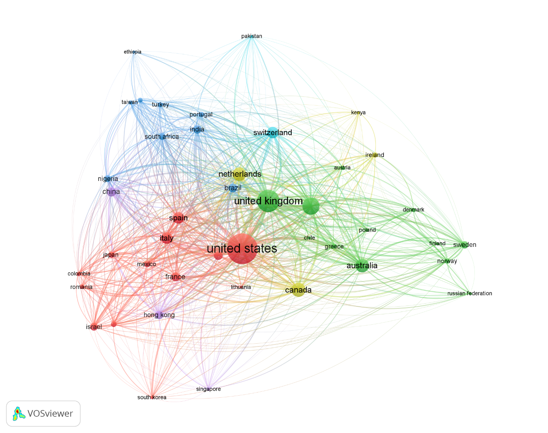
Supplementary Figure 1. Network visualization of global research collaborations: This diagram illustrates bibliometric linkages between countries, visualized using VOSviewer. Node size reflects each country’s total link strength within the network, while line thickness indicates the number of collaborative linkages. Diverse colour clusters represent regional or thematic research collaborations.

