Supplementary Information
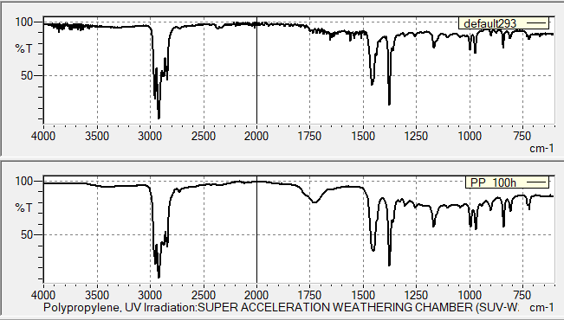  (A) Polypropylene (PP) | 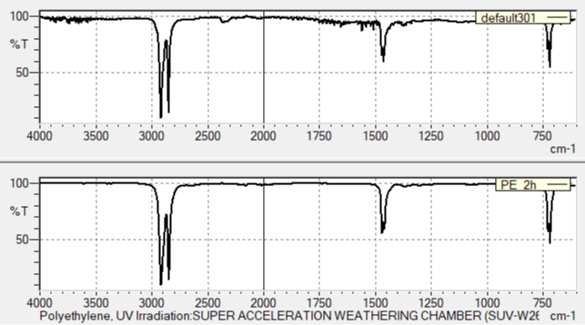  (B) Polyethylene (PE)
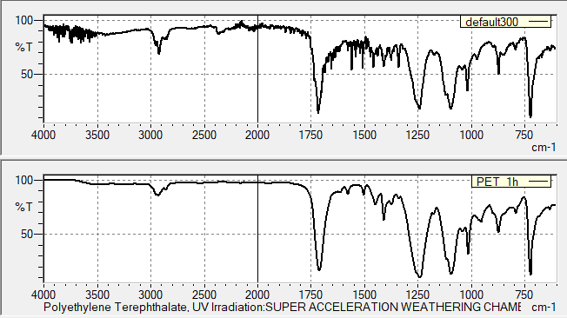  (C) Polyethylene Terephthalate (PET) | 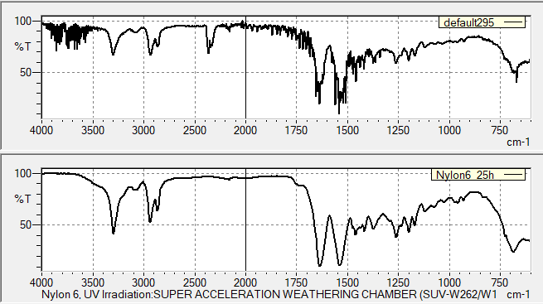  (D) Nylon 6
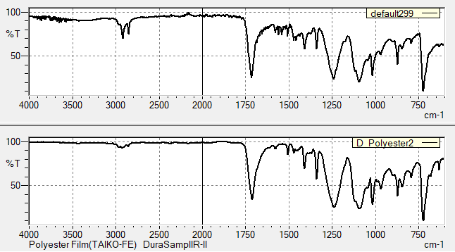
(E) Polystyrene (PS)
Fig. S1: FTIR spectra of identified polymers of MPs and their reference spectra (presented on the bottom).

Supplementary Table S1: Microplastics found in fish GIT around the globe. PET- Polyethylene terephthalate, PE- Polyethylene, PS- Polystyrene, PU- Polyurethane, PVC- Polyvinyl chloride, PP- Polypropylene, PAN- Polyacrylonitrile
Country | Scientific Name | Sample | Number of MPs | Dominant shape | Dominant colours | Dominant polymer | Reference
Present study
Bangladesh | Tenualosa Ilisha | 15 | 287 | Fiber | Transparent | - | Siddique et al., 2022
Malaysia | Atule mate  Crenimugil seheli  Sardinella fimbriata  Rastrelliger brachysoma | 72 | 432 | Fragment | - | PET | Foo et al., 2022
India | Harpadon nehereus | 213 | 3409 | Thread | Black, Blue | PE, PS, PU | Prusty et al., 2023
Japan | Scomber japonicus  Trachurus japonicus  Zeus faber  Macroramphosus scolopax  Carangoides equula | 321 | 501 | Fiber | Transparent, Blue | PE, Fiber | Yagi et al., 2022
Turkey | Mullus barbatus | 82 | 62 | Fiber | Black | Poly-chloroprene | Atamanalp et al., 2021
Turkey | Alosa immaculata | 82 | 103
Portugal | Dicentrarchus labrax  Diplodus vulgaris  Platichthys flesus | 120 | 157 | Fiber | Blue | Polyester | Bessa et al., 2018
Brazil | Cynoscion acoupa | 552 | 1073 | Filaments | Blue | - | Ferreira et al., 2018
Canada | Gadus morhua | 1010 | 19 | Fiber | White | PE | Liboiron et al., 2019
USA | Ariopsis felis | 40 | 8 | Fragment | Blue | PP | Gad & Midway, 2022
USA | Paralichthys lethostigma | 50 | 16 | Fiber | Blue, Black | PS, PAN | Gad & Midway, 2022
Australia | Plectropomus leopardus  Upeneichthys lineatus  Lutjanus gibbus  Mugil cephalus | 73 | 110 | Fiber | - | PE | Wootton et al., 2021
Fiji | Plectropomus leopardus  Lutjanus gibbus  Parupeneus indicus  Mugil cephalus | 120 | 102 | Film | - | PE | Wootton et al., 2021

