Certified material | Certified value  (μg/g) | Determined value  (μg/g) | SD  [%]
Lake sediment BCR® - 280 R | 1.46 ± 0.20 | 1.373 ± 0.023 | 0.025
Loam soil ERM® - CC141 | 0.083 ± 0.017 | 0.084 ± 0.01 | 0.010
Rye grass ERM® - CD281 | 0.0164 ± 0.0022 | 0.0171 ± 0.001 | 0.001
Channel sediment BCR® - 320R | 0.85 ± 0.09 | 0.777 ± 0.017 | 0.015
Fish muscle ERM® - BB422 | 0.601 ± 0.030 | 0.548 ± 0.02 | 0.017
Table S1 The total mercury (THg) content in certified materials

Fish species | Hg |  |  | References
Fish species | muscle tissue | liver | gills | References
Scardinius erythrophthalmus L. | 0.030 | - | - | Kapuściński et al. Bull Environ Contam Toxicol 93(5):567–573, 2014.
Scardinius erythrophthalmus L. | 0.070 | - | - | Mahjoub et al. Reg Stud Mar Sci 46(2):101881, 2021.
Scardinius erythrophthalmus L. | 0.230 | - | - | Esmaili-Sari et al. Material Conference, Madison, Wisconsin, 2006.
Perca fluviatilis L. | 0.016 | - | - | Łuczyńska et al. Int J Environ Res Public Health 14(10):1120, 2017.
Perca fluviatilis L. | 0.09 – 0.50* | 0.13* | 0.07* | Svecevičius et al. Material Conference, Vilnius, Lithuania, 2014.
Perca fluviatilis L. | 0.138 | - | - | Brodziak-Dopierała and Fischer. Toxics 11(8):717, 2023.
Perca fluviatilis L. | 0.152 | 0.225 | - | Havelková et al. Sensors 8(7):4095–4109, 2008.
Perca fluviatilis L. | 0.168 | 0.040 | 0.027 | Łuczyńska et al. J Elementol. 21(1):113–129, 2016.
Perca fluviatilis L. | 0.210 | 0.110 | - | Teunen et al. Environ Sci Pollut Res. 29(5):7853–7865, 2022.
Perca fluviatilis L. | 0.271 | 0.055 | 0.028 | Łuczyńska i Paszczyk. Int J Environ Res Public Health 16(19):3780, 2019.
* – predatory species (perch and pike)
Table S2 Levels of total mercury (THg) in the muscle tissue, liver and gills of perch and rudd (μg/g wet weight) described in the different literature

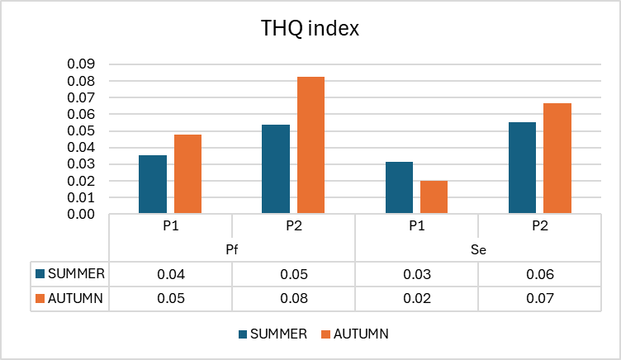

Fig. S1 Target Hazard Quotient (THQ) in Perca fluviatilis L. (Pf) and Scardinius erythrophthalmus L. (Se) taken from Koronowo Reservoir (P1) and Wierzchucińskie Duże Lake (P2) (Poland)

