Supplement 8. Measurement of IAP

Should We Measure Intra-abdominal Pressure (IAP)?; Should We Measure it Via the Bladder?; Should We Use An IAP Measurement Protocol?

As clinical examination is inaccurate for detecting raised IAP, IAH and ACS research and management relies upon accurate serial or continuous IAP measurements [1]. Although there is an increasing number of IAP measurement techniques, trans-bladder measurement remains a commonly used method, and was recomended by the WSACS in 2006 due to its simplicity and low cost [2, 3].

Evidence Summary:
We identified only one relevant RCT [4]. This trial compared the outcomes of patients with severe acute pancreatitis who received IAP measurement and management with a control group that did not [4]. While those in the IAP measurement/management group had a lower risk of mortality and a reduced length of hospital stay, the quality of evidence afforded by this study was assessed to be very low due to risk of bias, indirectness, and imprecision (see section and summary of findings table on Percutaneous Catheter Drainage for details). We also found six before-and-after observational studies of IAP measurement protocols or interventions triggered by IAP measurements [5-10]. Although all of these studies suggested improved surrogate or clinical outcomes associated with measuring or treating IAP, they suffered from risk of bias and enrolled varied populations of adults with diagnoses that included decompensated heart failure, burns, and pancreatitis. They also examined a number of medical or surgical interventions, making it difficult to determine whether measurement of IAP or the intervention resulted in the observed outcomes.

Recommendation:
The WSACS RECOMMENDED measuring intra-abdominal pressure versus not when any known risk factor for IAH/ACS is present in a critically ill/injured patient (Management Recommendation 1; [GRADE 1C]. The panelists also RECOMMENDED that studies in this area adopt the trans-bladder technique as a standard IAP measurement technique (Management Recommendation 2; [not GRADED]). Finally, the panelists RECOMMENDED use of protocolized monitoring and management of IAP versus no monitoring (Management Recommendation 3; [GRADE 1C).

Rationale for Recommendation:
The ease and accuracy of IAP measurement via a bladder catheter significantly influenced our recommendation as the associated adverse effects are likely to be minimal and the information obtained has the potential to influence patient care. It was acknowledged that these were high level recommendations, largely based on the perceived value to patients and the resource implications.

Addendum

Technical Notes on Intra-Abdominal Pressure Measuring.

The World Society of the Abdominal Compartment Syndrome does not recoomend or endorse any particular commercial device for IAP monitoring. While IAP measurements are essential to the diagnosis and management of IAH/ACS a variety of measurement techniques using an almost limitless variety of devices (some simple some complex) have been described. Interested readers are refered to further more comprehensive dicussions on this topic[3, 11-18]. Various techniques have been described in the literature that permit the trans-blader monitoring technique recommended by the WSACS, including the Harrahill Method[19, 20], the Folymanometer or Uno-Meter Abdo-Pressure device [21], the AbViser system[18, 22], the Bard Intra-abdominal pressure monitoring device, and the PreOx Intra-abdominal pressure adaptor. While continuous trans-bladder presure monitoring systems have been described[13, 16, 23], it is critical that recommended baseline measurement conditions are present before interpertting any contionous IAP measurement.

Examples of Intra-Abdominal Presure Monitoring Techniques¹

A Technique Appropriate for Intensive Care Unit Patients for Whom a Bedside Multi-Channel Monitor is Available²

Set-Up:
- Wash hands and follow universal antiseptic precautions
- A Foley catheter is sterile placed and the urinary drainage system connected.
- Using a sterile field and gloves, the drainage tubing is cut (with sterile scissors) 40cm after the culture aspiration port after desinfection.
- A ramp with 3 stopcocks (e.g. Manifold set, Pvb Medizintechnik Gmbh, a SIMS Trademark, 85614 Kirchseeon, Germany, REF: 888-103-MA-11; or any other manifold set or even 3 stopcocks connected together will do the job) is connected to a conical connection piece (e.g. Conical Connector with female or male lock fitting, B Braun, Melsungen, Germany, REF: 4896629 or 4438450) at each side with a male/male adaptor (e.g. Male to Male connector piece, Vygon, Ecouen, France, REF: 893.00 or 874.10).
- The ramp is then inserted in the drainage tubing.
- A standard intravenous (IV) infusion set is connected to a bag of 500mL of normal saline or D5W and attached to the first stopcock.
- A 60-mL syringe is connected to the second stopcock and the third stopcock is connected to a pressure transducer via rigid pressure tubing.
- The system is flushed with normal saline
- The pressure transducer is fixed at the symphysis or the thigh.
- Connect the transducer to the monitor via the special pressure module and ensure a normal waveform on the scope.
- Select a scale from 0 to 20 or 40 mmHg

Method of measurement:
- If the patient is awake, explain the procedure.
- If the patient is sedated, ensure good sedation.
- Place the patient in a complete supine position.
- Zero the pressure module at the midaxillary line of the patient at the level of the iliac crest (mark for future reference) by turning the proximal stopcock on to the air and the transducer
- At rest the 3 stopcocks are turned “off” to the IV bag, the syringe and transducer giving an open way for urine to flow into the urometer or drainage bag, said otherwise the 3 stopcocks are turned “on” to the patient.
- To measure IVP, the urinary drainage tubing is clamped distal to the ramp-device and the third stopcock is turned “on” to the transducer and the patient and “off” to the drainage system.
- The third stopcock also acts as a clamp.
- The first stopcock is turned “off” to the patient and “on” to the IV infusion bag, the second stopcock is turned “on” to the IV bag and the 60-mL syringe.
- Aspirate 20-25ml of normal saline from the IV bag into the syringe.
- The first stopcock is turned “on” to the patient and “off” to the IV bag and the 20-25ml of normal saline is instilled in the bladder through the urinary catheter.
- The first and second stopcock are then turned “on” to the patient, and thus turned “off” to IV tubing and the syringe.
- The third stopcock already being turned “on” to the transducer and patient allows then immediate IVP reading on the monitor.

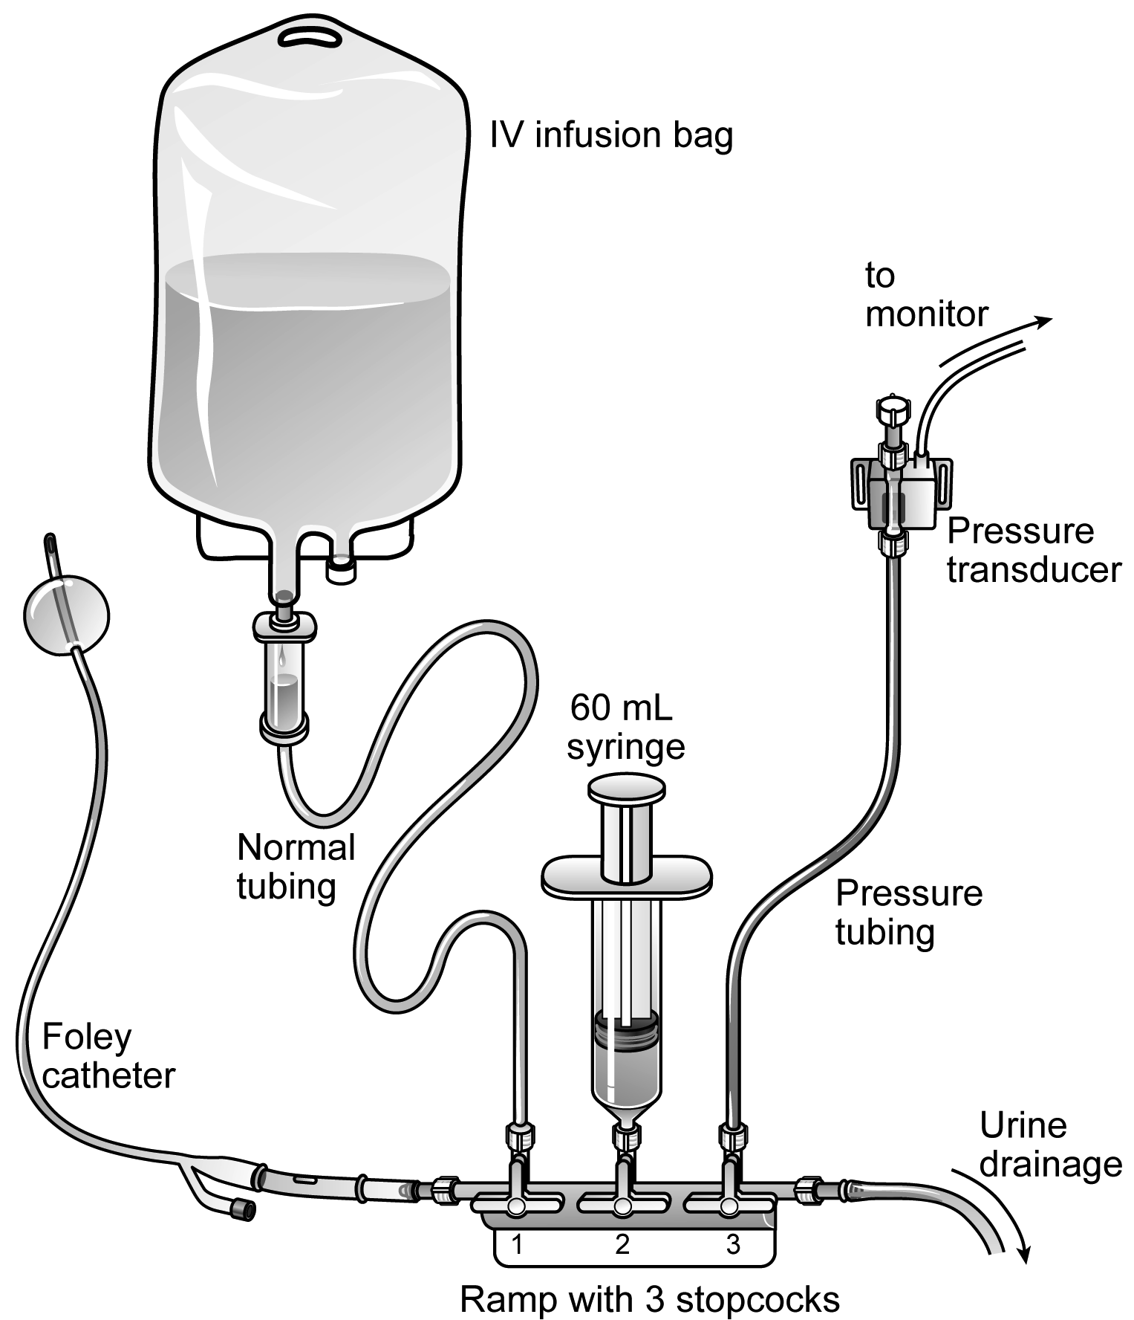
A Technique Appropriate for patients in either an Intensive Care Unit, Other Ward, in Whom a Bedside Multi-Channel Monitor is not required²

This technique that uses the patient’s own urine as pressure transmitting medium is a surprisingly simple, reliable, and cost-effective clinical tool. Based on a modified version of the IAP monitoring technique described by Kron et al[24]., the disposable FoleyManometer provides a closed sterile circuit which connects between the patient´s Foley catheter and the urine collection device. Each IAP determination takes about 10 seconds, and no subsequent correction of urine output is required. The technique uses a low bladder infusion volume, has a needle-free sampling port and can measure IAP in a range from 0 - 40 mmHg. Therefore it is an ideal technique to screen critically ill patients for IAH.

PANEL A, Initial set-up:
- Open the FoleyManometer LV (Holtech Medical, Charlottenlund, Denmark, www.holtech-medical.com) pouch and close the tube clamp
- Place the urine collection device under the patient's bladder and tape the drainage tube to the bed sheet.
- Insert the FoleyManometer between catheter and drainage device.
- Prime the FoleyManometer with 20ml of sterile saline through its needle-free injection/sampling port.
- Prime only once i.e. at initial set-up, or subsequently to remove any air in the manometer tube.

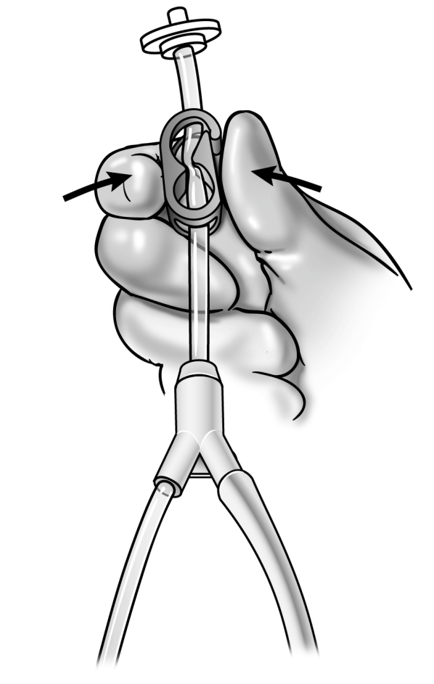

PANEL B, Urine drainage
- Let the urine drain in between IVP measurements
- Urine sampling from the needle-free port is facilitated by temporarily opening the red clamp. Remember to close clamp afterwards.
- Avoid a U-bend of the large urimeter drainage tube (which will impede urine drainage).
- Replace the FoleyManometer whenever the Foley catheter or the urine collection device is replaced, or at least every 7 days.

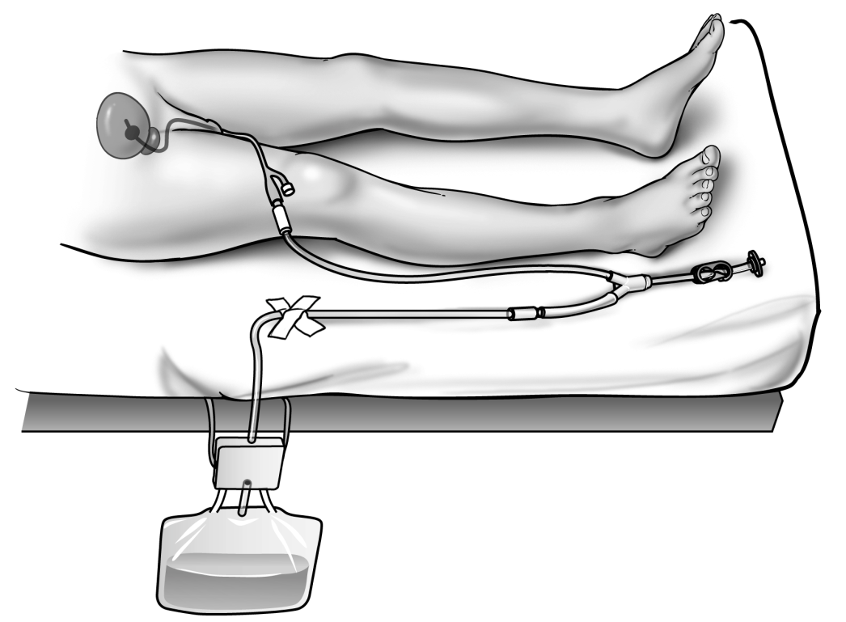

PANEL C, Intravesical pressure Monitoring:
- Place the "0 mmHg" mark of the manometer tube at the midaxillary line at the level of the iliac crest (mark for future reference) and elevate the filter vertically above the patient.
- Open the bio-filter clamp, and read IVP (end-expiration value) when the meniscus has stabilized after about 10 seconds.
- Close clamp after IVP measurement and place the FoleyManometer in its drainage position.

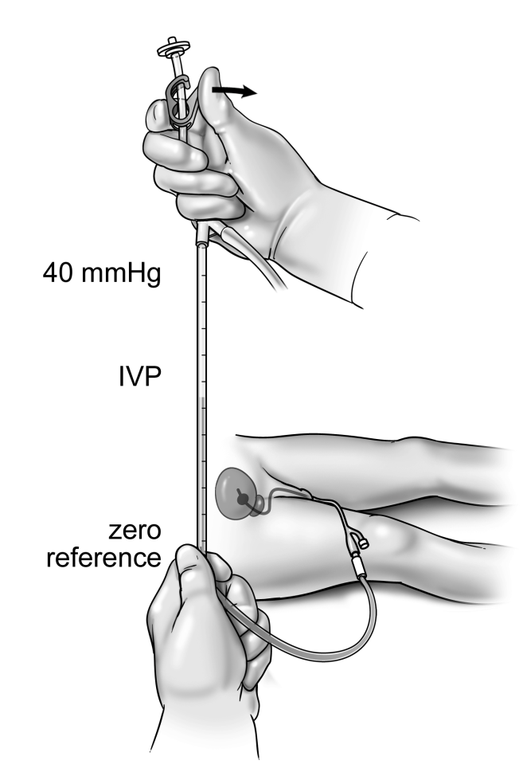

Notes
¹No specific technique or commercial device is recommended, the procedures detailed is an example of one institutions technical approach.
²These techniques are those described and found to be optimal by Dr Manu Malbrain, MD, PhD, ICU and High Care Burn Unit Director, ZNA Stuivenberg, Lange Beeldekensstraat 267, B-2060 Antwerpen, Belgium and may not be the best or most appropriate techniques for other institutions.

References

1. Kirkpatrick AW, Brenneman FD, McLean RF, Rapanos T, Boulanger BR, (2000) Is clinical examination an accurate indicator of raised intra-abdominal pressure in critically injured patients. Can J Surg 43: 207-211
2. Malbrain ML, Cheatham ML, Kirkpatrick A, Sugrue M, Parr M, De Waele J, Balogh Z, Leppaniemi A, Olvera C, Ivatury R, D'Amours S, Wendon J, Hillman K, Johansson K, Kolkman K, Wilmer A, (2006) Results from the International Conference of Experts on Intra-abdominal Hypertension and Abdominal Compartment Syndrome. I. Definitions. Intensive Care Med 32: 1722-1732
3. Malbrain ML, (2004) Different techniques to measure intra-abdominal pressure (IAP): time for a critical re-appraisal. Intensive Care Med 30: 357-371
4. Sun ZX, Huang HR, Zhou H, (2006) Indwelling catheter and conservative measures in the treatment of abdominal compartment syndrome in fulminant acute pancreatitis. World J Gastroenterol 12: 5068-5070
5. Mullens W, Abrahams Z, Francis GS, Taylor DO, Starling RC, Tang WH, (2008) Prompt reduction in intra-abdominal pressure following large-volume mechanical fluid removal improves renal insufficiency in refractory decompensated heart failure. Journal of cardiac failure 14: 508-514
6. Cheatham ML, Safcsak K, (2010) Is the evolving management of intra-abdominal hypertension and abdominal compartment syndrome improving survival? Crit Care Med 38: 402-407
7. Batacchi S, Matano S, Nella A, Zagli G, Bonizzoli M, Pasquini A, Anichini V, Tucci V, Manca G, Ban K, Valeri A, Peris A, (2009) Vacuum-assisted closure device enhances recovery of critically ill patients following emergency surgical procedures. Critical care 13: R194
8. Pupelis G, Zeiza K, Plaudis H, Suhova A, (2008) Conservative approach in the management of severe acute pancreatitis: eight-year experience in a single institution. HPB : the official journal of the International Hepato Pancreato Biliary Association 10: 347-355
9. Ennis JL, Chung KK, Renz EM, Barillo DJ, Albrecht MC, Jones JA, Blackbourne LH, Cancio LC, Eastridge BJ, Flaherty SF, Dorlac WC, Kelleher KS, Wade CE, Wolf SE, Jenkins DH, Holcomb JB, (2008) Joint Theater Trauma System implementation of burn resuscitation guidelines improves outcomes in severely burned military casualties. The Journal of trauma 64: S146-151; discussion S151-142
10. Oda S, Hirasawa H, Shiga H, Matsuda K, Nakamura M, Watanabe E, Moriguchi T, (2005) Management of intra-abdominal hypertension in patients with severe acute pancreatitis with continuous hemodiafilter using a polymethyl methacrylate membrane hemofilter. Ther Apher Dial 9: 355-361
11. De Keulenaer BL, Regli A, Malbrain ML, (2011) Intra-abdominal measurement techniques: is there anything new? The American surgeon 77 Suppl 1: S17-22
12. De Waele JJ, De laet I, Malbrain ML, (2007) Rational intraabdominal pressure monitoring: how to do it? Acta Clin Belg Suppl: 16-25
13. Balogh Z, Jones F, D'Amours S, Parr M, Sugrue M, (2004) Continuous intra-abdominal pressure measurement technique. Am J Surg 188: 679-684
14. Regli A, De Keulenaer BL, Hockings LE, Musk GC, Roberts B, van Heerden PV, (2011) The role of femoral venous pressure and femoral venous oxygen saturation in the setting of intra-abdominal hypertension: a pig model. Shock 35: 422-427
15. De Keulenaer BL, De Waele JJ, Powell B, Malbrain ML, (2009) What is normal intra-abdominal pressure and how is it affected by positioning, body mass and positive end-expiratory pressure? Intensive Care Med 35: 969-976
16. Zengerink I, McBeth PB, Zygun DA, Ranson K, Ball CG, Laupland KB, Widder S, Kirkpatrick AW, (2008) Validation and experience with a simple continuous intra-abdominal pressure measurement technique in a multidisciplinary medical/surgical critical care unit. The Journal of trauma 64: 1159-1164
17. McBeth PB, Zygun DA, Widder S, Cheatham M, Zengerink I, Glowa J, Kirkpatrick AW, (2007) Effect of patient positioning on intra-abdominal pressure monitoring. Am J Surg 193: 644-647; discussion 647
18. Ejike JC, Bahjri K, Mathur M, (2008) What is the normal intra-abdominal pressure in critically ill children and how should we measure it? Critical care medicine 36: 2157-2162
19. Harrahill M, (1998) Intra-abdominal pressure monitoring. Journal of emergency nursing: JEN : official publication of the Emergency Department Nurses Association 24: 465-466
20. Otto J, Binnebosel M, Junge K, Jansen M, Dembinski R, Schumpelick V, Schachtrupp A, (2010) Harrahill's technique: a simple screening test for intra-abdominal pressure measurement. Hernia : the journal of hernias and abdominal wall surgery 14: 415-419
21. Desie N, Willems A, De Laet I, Dits H, Van Regenmortel N, Schoonheydt K, Van De Vyvere M, Malbrain ML, (2012) Intra-abdominal pressure measurement using the FoleyManometer does not increase the risk for urinary tract infection in critically ill patients. Annals of intensive care 2 Suppl 1: S10
22. Basterra Longas A, Arizcun Gonzalez S, Erdozain Rios B, (2008) [Abviser Kit intra-abdominal pressure monitoring]. Rev Enferm 31: 43-44
23. Balogh Z, De Waele JJ, Malbrain ML, (2007) Continuous intra-abdominal pressure monitoring. Acta Clin Belg Suppl: 26-32
24. Kron IL, Harman PK, Nolan SP, (1984) The measurement of intra-abdominal pressure as a criterion for abdominal re-exploration. Ann Surg 199: 28-30

