Supplementary Materials for
Prevention of cardiac surgery-associated AKI by implementing the KDIGO guidelines in high risk patients identified by biomarkers: the PrevAKI randomized controlled trial

The PrevAKI Investigators

Table of contents
Content Page
Supplementary Methods 2

Supplementary Figures
Figure S1. - Hemodynamic algorithm in the intervention group 5

Supplementary Tables
Table S1. – KDIGO criteria according to the KDIGO guidelines 6
Table S2. – Patient characteristics at the time point of randomization 7
Table S3. – CVP and volume therapy over the first 12 hours after randomization 8

Supplementary References 9

Supplementary Methods
Study Design
After obtaining approval from the Research Ethics Committee of the Chamber of Physicians Westfalen-Lippe and the Westfalian Wilhelms University Muenster (2014-180-f-S) (trial registration in the German Clinical Trials Register DRKS00006139), we performed a single-center, randomized, parallel-group, controlled trial. The study was conducted according to the principles of the Declaration of Helsinki in the version of October 2008 (49th General Assembly of the World Medical Association, Somerset West, Republic of South Africa). Consent procedures followed local requirements, as approved by the ethics committee Muenster. The treating investigator informed patients or legally authorized representatives, in case of patient incapacity, about the nature of the trial, its aims and expected disadvantages and obtained written informed consent. In case of patient incapacity and non-availability of a legally authorized representative, a consultant physician independent of the trial was involved (according to the local ethics requirement). Once the patient regained capacity or the legally authorized representative was available, he/she was asked to affirm or withdraw consent.

Randomization
Patients were randomized on a 1:1 basis without stratification. Randomization codes were computer generated and concealed from investigators. Four hours after cardiac surgery, [TIMP-2]•[IGFBP7] was measured in all cardiac surgery patients. Only patients with a [TIMP-2]•[IGFBP7] ≥ 0.3 were randomized and assigned to receive either standard care (control) or implementation of the KDIGO bundle (intervention). The allocation of the patients was performed by an independent investigator neither involved in the standard care of patients nor in the application of the intervention. Data collectors, outcome adjudicators and analysts were completely independent of the standard care of the patients as well as the physician who applied the intervention.

Exclusion criteria
Exclusion criteria were age < 18 years, off-pump heart surgery, pre-existing AKI, AKI caused by (glomerulo)nephritis, interstitial nephritis or vasculitis, kidney transplantation, chronic kidney disease with a glomerular filtration rate (GFR) < 30 ml/min., chronic kidney disease with dialysis dependency, patients on mechanical assist devices, pregnancy (study protocol in the Supplement).

Intervention
Patients assigned to the intervention group received a strictly controlled implementation of the KDIGO guidelines (“KDIGO CT surgery bundle”) consisting of the following measures: avoidance of nephrotoxic agents, discontinuation of ACE inhibitors and ARBs for the first 48 hours after surgery, close monitoring of serum creatinine and urinary output, avoidance of hyperglycemia for the first 72 hours after surgery, consideration of alternatives to radio contrast, close hemodynamic monitoring by using a PICCO catheter with an optimization of the volume status and hemodynamic parameters according to pre-specified algorithm: Stroke volume variation (SVV) < 11 (otherwise therapy with 500-1000ml crystalloids), CI > 3l/min/m² (otherwise therapy with dobutamine or epinephrine), MAP > 65 mmHg (otherwise therapy with norepinephrine). Pre-specified parameters were initially established after randomization and then checked every 3 hours up to 12 hours after randomization and optimized according to the algorithm. The hemodynamic intervention was performed during the first 12 hours after randomization, whereas the intervention period for avoidance of nephrotoxic agents and discontinuation of ACE inhibitors and ARBs lasted 48h after randomization (Supplementary Figure S1). In contrast to our planned approach, we abstained from consulting a nephrologist in the intervention group.

Supplementary Figures
Figure S1: Hemodynamic algorithm in the intervention group
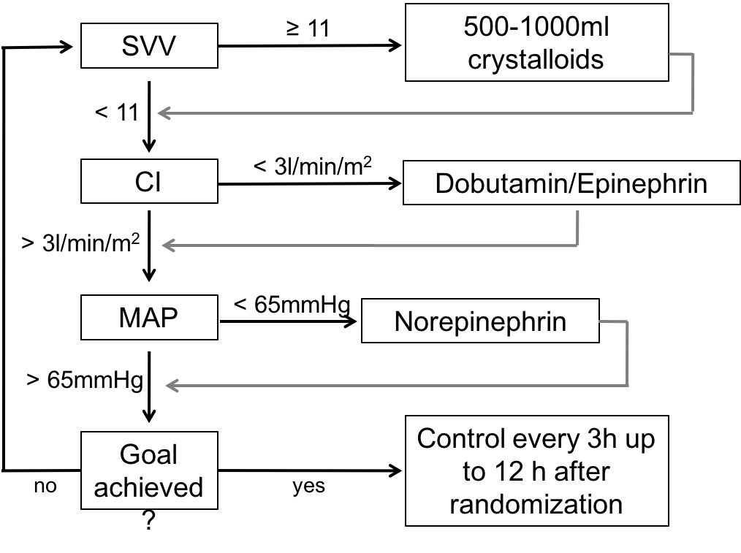

Supplementary Tables

eTable S1: KDIGO criteria according to the KDIGO guidelines ¹
Stage | Serum creatinine | Urine output
1 | 1.5-1.9 times baseline  OR  ≥ 0.3 mg/dl increase | < 0.5 ml/kg/h for 6-12 hours
2 | 2.0-2.9 times baseline | < 0.5 ml/kg/h for ≥ 12 hours
3 | 3.0 times baseline  OR  Increase in serum creatinine to ≥ 4.0 mg/dl  OR  Initiation of renal replacement therapy | < 0.3 ml/kg/h for ≥ 24 hours OR  Anuria for ≥ 12 hours

eTable S2: Patient characteristics at the time point of randomization (ICU admission to randomization)
 | Control (n=138) | Intervention (n=138) | p-value
Patients with catecholamines before randomization, No. (%)
Dobutamine | 15 (10.9) | 14 (10.1) |  | 0.844
Epinephrine | 21 (15.2) | 26 (18.8) |  | 0.423
Norepinephrine | 120 (87.0) | 124 (89.9) |  | 0.452
Volume therapy before randomization, median (Q1, Q3), ml
Total volume | 1682.0 (1064, 2303) | 1723.7 (1136, 2300) |  | 0.672
Crystalloids | 1682.0 (1064, 2300) | 1620.0 (1125, 2240) |  | 0.406
Colloids | 0 (0, 0) | 0 (0, 0) |  | 0.417
Blood products | 0 (0, 0) | 0 (0, 0) |  | 0.480
H₂O | 0 (0, 0) | 0 (0, 0) |  | 0.779

eTable S3: CVP and volume therapy over the first 12 hours after randomization
 | Control (n=138) | Intervention (n=138) | p-value
CVP within 8-10 mmHg at the different time points, No./No. total (%)
randomization | 42/138 (30.4) | 37/138 (26.8) | 0.506
3h | 43/138 (31.2) | 30/138 (21.7) | 0.076
6h | 28/138 (20.3) | 36/138 (26.1) | 0.254
9h | 42/138 (30.4) | 28/138 (20.3) | 0.053
12h | 32/138 (23.2) | 34/138 (24.6) | 0.778
Volume therapy during intervention period, median (Q1, Q3), ml
3h | 839 (274, 1280) | 1085 (654, 1200) | 0.518
6h | 680 (195, 1180) | 680 (323, 1180) | 0.304
9h | 455 (225, 793) | 380 (180, 780) | 0.453
12h | 380 (180, 943) | 280 (180, 693) | 0.024
total (randomization to 12h) | 2745 (1968, 3625) | 2575 (1965, 3518) | 0.699

Supplementary References
1. KDIGO AKI Work Group: KDIGO clinical practice guideline for acute kidney injury. Kidney international Supplement 2012;2:1-138.

CVP was calibrated at 3h, 6h, 9h, and 12h after randomization and these time points were used to adapt therapy regime.

