SUPPLEMENTARY INFORMATION

Supplementary Methods
Statistical analysis
To adapt the study to accumulating data, a group-sequential adaptive design was chosen that allows design modifications such as sample size re-estimation or planning of further analyses based on interim results. This design combines features of a classic group-sequential design with the theory of adaptive designs based on combination tests. Group-sequential design allows performance of preplanned interim analyses on the accumulating data and stopping of the study at an interim stage if the study objective has been met or if it is unlikely that the study will reach its objectives. In this study, a combination test based on the inverse normal method was used to combine the stage-wise test-statistics [1].
The initial sample size was calculated using a one-sided Wilcoxon–Mann–Whitney rank-sum test with a significance level of 0.025. A fixed-sample design with a sample size of 40 patients per group was planned to have 80% power to detect a probability of 0.681 that ventilator-free days (VFDs) in the trimodulin group are stochastically greater than in the placebo group. The probability of 0.681 corresponded to a difference between treatment arms in VFDs of 2 units relative to a standard deviation of 3 if VFDs were normally distributed.
The sample size was adjusted for the adaptive group-sequential design with O’Brien–Fleming boundaries (α₁ = 0.0023, α₂= 0.0241) using ADDPLAN® 5.0 [2]; this resulted in 20 (48.8%) patients per group for interim analysis and 21 (51.2%) patients per group for final analysis. Assuming 20% nonevaluable patients, a total of approximately 100 patients was planned to be enrolled to have 82 patients evaluable for the primary endpoint. Based on the results of this interim analysis (40 patients), the statistician and the Data and Safety Monitoring Board recommended including another 120 patients (60 in the placebo group and 60 in the trimodulin group), resulting in a total sample size of 160 patients. It was also recommended to perform a second interim analysis after 100 patients were randomized and treated, to allow early stopping in case of a highly significant result in favor of trimodulin.
Baseline characteristics, VFDs (analyzed using a Wilcoxon rank-sum test with continuity correction [0.5]), and 28-day all-cause mortality (analyzed with a two-sided Fisher exact test) were examined for each subset. Two-sided hypotheses were tested with an α level of 0.05.

References
1. Lehmacher W, Wassmer G (1999) Adaptive sample size calculations in group sequential trials. Biometrics 55:1286-1290
2. Wassmer G, Eisebitt R (2009) ADDPLAN Adaptive Designs – Plans and Analyses® User’s Guide, Release 5.0, 2009. ADDPLAN GmbH, Cologne. http://help.addplan.com/index.html?n=211GrpSqBounds.html. Accessed 21 Feb 2018

SUPPLEMENTARY TABLES

Supplementary Table S1 Microbiology and viral pneumonia results for all patients

Characteristic |  | Trimodulin  (n = 81) | Placebo  (n = 79)
Patients with bacteria identifiedª |  | 35 (43.2) | 42 (53.2)
Streptococci spp. |  | 15 (18.5) | 23 (29.1)
Staphylococci spp. |  | 11 (13.6) | 9 (11.4)
Pseudomonas aeruginosa |  | 2 (2.5) | 6 (7.6)
Escherichia coli |  | 5 (6.2) | 1 (1.3)
Chlamydia spp. |  | 1 (1.2) | 2 (2.5)
Enterococcus faecium |  | 1 (1.2) | 2 (2.5)
Haemophilus influenzae |  | 2 (2.5) | 1 (1.3)
Klebsiella pneumoniae |  | 1 (1.2) | 2 (2.5)
Other bacteria |  | 5 (6.2) | 6 (7.6)
Patients diagnosed with viral pneumonia^{b} |  | 18 (22.2) | 15 (19.0)
Influenza virus |  | 17 (21.0) | 11 (13.9)
Other virus |  | 1 (1.2) | 4 (5.1)
Data are n (%)
ªA patient can be counted in more than one category
^{b}Specification of viral pneumonia are only recorded at day 28/discontinuation

Supplementary Table S2 Antibiotic treatment at day of randomization

Antibiotic | Trimodulin  (n = 81) | Placebo  (n = 79) | Two-sided  p-value*
β-lactam + macrolide | 36 (44.4) | 27 (34.2) | 0.200
β-lactam + fluoroquinolone | 20 (24.7) | 29 (36.7) | 0.123
β-lactam monotherapy | 4 (4.9) | 5 (6.3) | 0.744
Fluoroquinolone monotherapy | 1 (1.2) | 1 (1.3) | 1.000
Other | 20 (24.7) | 17 (21.5) | 0.709
Data are n (%)
*Fisher exact test

Supplementary Table S3 Systemic corticosteroids at baseline (previous medication) and during the trial (concomitant medication)

Treatment | Trimodulin (n = 81) | Placebo (n = 79) | Two-sided  p-value*
Corticosteroids at baseline | 24 (29.6) | 21 (26.6) | 0.727
Corticosteroids during the trial | 53 (65.4) | 59 (74.7) | 0.229
Data are n (%)
*Fisher exact test

Supplementary Table S4 Demographics and other baseline characteristics in trimodulin and placebo treatment groups of the high CRP subset (CRP ≥70 mg/L)

Characteristic | Trimodulin (n = 65) |  | Placebo (n = 59) |  | p-value*
Sex, n (%) |  |  |  |  | 0.635
Male | 46 (70.8) |  | 44 (74.6)
Female | 19 (29.2) |  | 15 (25.4)
 | Mean (SD) | Median (IQR) | Mean (SD) | Median (IQR)
Age (years) | 62.5 (15.0) | 65.0 (50.0–74.0) | 63.3 (15.0) | 64.0 (55.0–76.0) | 0.768
BMI (kg/m²)ª | 26.5 (5.1) | 25.9 (23.3–29.6) | 25.3 (4.1) | 25.5 (23.0–27.6) | 0.162
APACHE II^{b} | 22.3 (8.1) | 21.0 (16–29) | 25.2 (8.2) | 24.5 (20–30) | 0.079
SOFA | 9.2 (3.8) | 9.0 (6.0–12.0) | 10.6 (3.6) | 10.0 (8.0–14.0) | 0.055
CURB-65ª | 2.7 (1.1) | 3.0 (2.0–3.5) | 2.8 (1.3) | 3.0 (2.0–4.0) | 0.646
PaO₂/FiO₂^{c} | 137.4 (74.4) | 115.0 (83.0–173.6) | 136.7 (68.8) | 108.4 (81.7–188.1) | 0.956
IgM (g/L) | 0.7 (0.77) | 0.5 (0.4–0.7) | 0.6 (0.43) | 0.6 (0.3–0.9) | 0.823
IgG (g/L) | 6.5 (2.66) | 6.1 (4.9–8.0) | 6.3 (2.85) | 6.0 (4.2–8.1) | 0.688
IgA (g/L) | 2.2 (1.12) | 2.1 (1.5–3.0) | 2.5 (1.90) | 1.9 (1.3–3.1) | 0.437
CRP (mg/L) | 262 (105.5) | 254 (176.0–346.0) | 285 (115.0) | 282 (202.7–349.3) | 0.263
PCT (ng/mL)^{d} | 9.7 (14.0) | 4.1 (0.9–11.3) | 27.2 (33.8) | 15.7 (2.9–37.8) | 0.001
Medical history, n (%)
Cardiac disorders^{e} | 28 (43.1) |  | 27 (45.8) |  | 0.857
Hypertension^{f} | 33 (50.8) |  | 30 (50.8) |  | 1.000
Diabetes mellitus^{f} | 13 (20.0) |  | 3 (5.1) |  | 0.016
Nervous system disorders^{e} | 18 (27.7) |  | 13 (22.0) |  | 0.537
Neoplasm (benign, malignant, and unspecified)^{e} | 17 (26.2) |  | 13 (22.0) |  | 0.677
Renal and urinary disorders^{e} | 34 (52.3) |  | 30 (50.8) |  | 1.000
Sepsis^{e} | 10 (15.4) |  | 7 (11.9) |  | 0.611
Septic shock^{f} | 28 (43.1) |  | 35 (59.3) |  | 0.076
Hepatic cirrhosis^{f} | 2 (3.1) |  | 0 (0.0) |  | 0.497
Medication at baseline
Corticosteroids for systemic use, n (%) | 20 (30.8) |  | 15 (25.4) |  | 0.553
Data not available for ª4 patients; ^{b}1 patient; ^{c}6 patients; ^{d}12 patients; ^{e}System Organ Class; ^{f}Preferred Term
Data are n (%), mean (SD), or median (IQR, 25th–75th percentile). APACHE II Acute Physiology and Chronic Health Evaluation; BMI body mass index; CRP C-reactive protein; CURB-65 Confusion, elevated blood Urea nitrogen, Respiratory rate, Blood pressure, 65 years of age and older; IgM, IgG, IgA immunoglobulin M, -G, -A; IQR interquartile range; PaO₂/FiO₂ ratio of arterial oxygen partial pressure to fractional inspired oxygen; PCT procalcitonin; SD standard deviation; SOFA Sequential Organ Failure Assessment
*p-values were calculated post-hoc by chi square test for sex, two-sided t-test for age, BMI, PaO₂/FiO₂, IgM/A/G, CRP, and PCT; by two-sided Wilcoxon rank sum test for APACHE II, SOFA, and CURB-65; or by Fisher exact test for all medical history outcomes and concomitant medication

Supplementary Table S5 Demographics and other baseline characteristics of the IgM subset (IgM ≤0.8 g/L)

Characteristic | Trimodulin (n = 56) |  | Placebo (n = 55) |  |  | p-value*
Sex, n (%) |  |  |  |  |  |  | 0.954
Male | 41 (73.2) |  |  | 40 (72.7)
Female | 15 (26.8) |  |  | 15 (27.3)
 | Mean (SD) | Median (IQR) |  | Mean (SD) | Median (IQR)
Age (years) | 62.8 (14.89) | 65.5 (51.5–74.0) |  | 66.8 (12.8) | 67.0 (59.0–77.0) |  | 0.123
BMI (kg/m²)ª | 26.5 (4.5) | 26.1 (23.4–29.6) |  | 26.0 (4.9) | 25.8 (23.1–28.4) |  | 0.554
APACHE II^{b} | 22.3 (8.6) | 21.0 (15.5–29.0) |  | 25.9 (8.5) | 25.0 (20.0–31.0) |  | 0.036
SOFA | 9.4 (4.2) | 10.5 (5.5–12.0) |  | 10.6 (3.5) | 11.0 (8.0–13.0) |  | 0.138
CURB-65ª | 2.6 (1.1) | 3.0 (2.0–3.0) |  | 2.8 (1.3) | 3.0 (2.0–4.0) |  | 0.316
PaO₂/FiO₂^{c} | 126.0 (65.9) | 109.2 (82.8–149.3) |  | 136.2 (75.0) | 107.3 (77.0–191.4) |  | 0.466
IgM (g/L) | 0.5 (0.16) | 0.5 (0.3–0.6) |  | 0.4 (0.16) | 0.4 (0.3–0.6) |  | 0.361
IgG (g/L) | 6.4 (2.59) | 6.1 (4.9–8.5) |  | 5.7 (2.41) | 5.7 (3.9–7.0) |  | 0.129
IgA (g/L) | 2.2 (1.06) | 2.1 (1.4–3.0) |  | 2.1 (1.28) | 1.9 (1.2–2.9) |  | 0.904
CRP (mg/L)^{d} | 244 (120.6) | 230 (172.7–335.3) |  | 220 (145.3) | 238 (78.0–308.6) |  | 0.354
PCT (ng/mL) | 9.5 (14.6) | 2.6 (0.8–9.9) |  | 22.1 (27.0) | 15.4 (1.4–30.6) |  | 0.005
Medical history, n (%)
Cardiac disorders^{e} | 27 (48.2) |  |  | 30 (54.5) |  |  | 0.571
Hypertension^{f} | 28 (50.0) |  |  | 31 (56.4) |  |  | 0.570
Diabetes mellitus^{f} | 9 (16.1) |  |  | 4 (7.3) |  |  | 0.237
Nervous system disorders^{e} | 13 (23.2) |  |  | 16 (29.1) |  |  | 0.523
Neoplasm (benign, malignant, and unspecified)^{e} | 19 (33.9) |  |  | 15 (27.3) |  |  | 0.538
Renal and urinary disorders^{e} | 28 (50.0) |  |  | 27 (49.1) |  |  | 1.000
Sepsis^{f} | 12 (21.4) |  |  | 7 (12.7) |  |  | 0.314
Septic shock^{f} | 21 (37.5) |  |  | 27 (49.1) |  |  | 0.336
Hepatic cirrhosis^{f} | 4 (7.1) |  |  | 0 (0.0) |  |  | 0.118
Medication at baseline
Corticosteroids for systemic use, n (%) | 16 (28.6) |  |  | 17 (30.9) |  |  | 1.000
Data not available for ª3 patients; ^{b}2 patients; ^{c}8 patients; ^{d}1 patient; ^{e}System Organ Class; ^{f}Preferred Term
Data are n (%), mean (SD), or median (IQR, 25th–75th percentile)
APACHE II Acute Physiology and Chronic Health Evaluation; BMI body mass index; CRP C-reactive protein; CURB-65 Confusion, elevated blood Urea nitrogen, Respiratory rate, Blood pressure, 65 years of age and older; IgM, IgG, IgA immunoglobulin M, -G, -A; IQR interquartile range; PaO₂/FiO₂ ratio of arterial oxygen partial pressure to fractional inspired oxygen; PCT procalcitonin; SD standard deviation; SOFA Sequential Organ Failure Assessment
*p-values were calculated post-hoc by chi squared test for sex, two-sided t-test for age, BMI, PaO₂/FiO₂, IgM/A/G, CRP, and PCT; by two-sided Wilcoxon rank sum test for APACHE II, SOFA, and CURB-65; or by Fisher exact test for all medical history outcomes and concomitant medication

Supplementary Table S6 Demographics and other baseline characteristics of the CRP/IgM subset (CRP ≥70 mg/L and IgM ≤0.8 g/L)

Characteristic | Trimodulin (n = 51) |  | Placebo (n = 41) |  | p-value*
Sex, n (%) |  |  |  |  | 0.947
Male | 37 (72.5) |  | 30 (73.2)
Female | 14 (27.5) |  | 11 (26 8)
 | Mean (SD) | Median (IQR) | Mean (SD) | Median (IQR)
Age (years) | 61.6 (14.9) | 64.0 (50.0–73.0) | 66.1 (13.0) | 65.0 (58.0–77.0) | 0.127
BMI (kg/m²)ª | 26.6 (4.7) | 26.2 (23.3–30.1) | 25.0 (3.9) | 25.6 (22.9–27.5) | 0.073
APACHE II^{b} | 21.7 (8.3) | 21.0 (15.0–29.0) | 25.0 (8.3) | 22.0 (20.0–29.5) | 0.086
SOFA | 9.1 (4.1) | 9.0 (5.0–12.0) | 10.2 (3.5) | 10.0 (8.0–12.0) | 0.229
CURB-65ª | 2.6 (1.1) | 3.0 (2.0–3.0) | 2.9 (1.3) | 3.0 (2.0–4.0) | 0.239
PaO₂/FiO₂^{c} | 122.6 (66.0) | 103.1 (82.3–143.9) | 141.5 (72.6) | 108.4 (81.9–191.4) | 0.216
IgM (g/L) | 0.5 (0.17) | 0.5 (0.3–0.6) | 0.4 (0.16) | 0.4 (0.3-0.6) | 0.275
IgG (g/L) | 6.2 (2.52) | 6.0 (4.9–8.0) | 5.6 (2.33) | 5.6 (4.1–6.9) | 0.191
IgA (g/L) | 2.1 (1.03) | 2.0 (1.3–2.9) | 2.0 (1.14) | 1.8 (1.2–2.7) | 0.472
CRP (mg/L) | 264 (106.9) | 250 (176.0–346.0) | 280 (111.7) | 280 (214.0–349.0) | 0.476
PCT (ng/mL)^{d} | 10.3 (15.2) | 3.4 (0.9–11.8) | 25.0 (26.9) | 18.2 (3.0–35.5) | 0.004
Medical history, n (%)
Cardiac disorders^{e} | 23 (45.1) |  | 19 (46.3) |  | 1.000
Hypertension^{f} | 26 (51.0) |  | 23 (56.1) |  | 0.678
Diabetes mellitus^{f} | 8 (15.7) |  | 1 (2.4) |  | 0.040
Nervous system disorders^{e} | 13 (25.5) |  | 10 (24.4) |  | 1.000
Neoplasm (benign, malignant, and unspecified)^{e} | 16 (31.4) |  | 12 (29.3) |  | 1.000
Renal and urinary disorders^{e} | 25 (49.0) |  | 20 (48.8) |  | 1.000
Sepsis^{f} | 9 (17.6) |  | 5 (12.2) |  | 0.566
Septic shock^{f} | 20 (39.2) |  | 23 (56.1) |  | 0.142
Hepatic cirrhosis^{f} | 2 (3.9) |  | 0 (0.0) |  | 0.500
Medication at baseline
Corticosteroids for systemic use, n (%) | 15 (29.4) |  | 13 (31.7) |  | 0.824
Data not available for ª3 patients; ^{b}1 patient; ^{c}6 patients; ^{d}7 patients; ^{e}System Organ Class; ^{f}Preferred Term
Data are n (%), mean (SD), or median (IQR, 25th–75th percentile)
APACHE II Acute Physiology and Chronic Health Evaluation; BMI body mass index; CRP C-reactive protein; CURB-65 Confusion, elevated blood Urea nitrogen, Respiratory rate, Blood pressure, 65 years of age and older; IgM, IgG, IgA immunoglobulin M, -G, -A; IQR interquartile range; PaO₂/FiO₂ ratio of arterial oxygen partial pressure to fractional inspired oxygen; PCT procalcitonin; SD standard deviation; SOFA Sequential Organ Failure Assessment
*p-values were calculated post-hoc by chi square test for sex, two-sided t-test for age, BMI, PaO₂/FiO₂, IgM/A/G, CRP, and PCT; by two-sided Wilcoxon rank sum test for APACHE II, SOFA, and CURB-65; or by Fisher exact test for all medical history outcomes and concomitant medication

Supplementary Table S7 Demographics and other baseline characteristics of the PCT subset (PCT ≥2 ng/mL)

Characteristic | Trimodulin (n = 43) |  | Placebo (n = 51) |  | p-value*
Sex, n (%) |  |  |  |  | 0.423
Male | 27 (62.8) |  | 36 (70.6)
Female | 16 (37.2) |  | 15 (29.4)
 | Mean (SD) | Median (IQR) | Mean (SD) | Median (IQR)
Age (years) | 64.9 (13.8) | 67 (57–75) | 64.8 (16.3) | 67 (57–78) | 0.976
BMI (kg/m²)ª | 25.5 (4.5) | 24.5 (22.3–27.7) | 25.8 (5.1) | 25.6 (23.1–28.7) | 0.752
APACHE II^{b} | 23.9 (8.2) | 23.0 (18–29) | 27.2 (8.8) | 26.0 (21–34) | 0.075
SOFA | 9.8 (4.1) | 11 (7–12) | 11.5 (3 3) | 11 (10–14) | 0.060
CURB-65^{b} | 2.8 (1.1) | 3.0 (2–4) | 2.8 (1.3) | 3.0 (2–4) | 0.994
PaO₂/FiO₂^{c} | 144.3 (78.3) | 126.3 (85.0–190.0) | 134.9 (71.5) | 108.5 (77.6–191.0) | 0.558
IgM (g/L) | 0.8 (1.00) | 0.5 (0.3–0.9) | 0.6 (0.32) | 0.6 (0.4–0.9) | 0.241
IgG (g/L) | 6.6 (2.61) | 6.6 (5.0–8.7) | 6.3 (2.82) | 6.0 (4.2–8.0) | 0.570
IgA (g/L) | 2.4 (1.19) | 2.5 (1.3–3.2) | 2.5 (1.71) | 2.2 (1.4–3.1) | 0.752
CRP (mg/L)^{b} | 262 (132.2) | 274 (179.0–357.0) | 272 (146.6) | 282 (180.0–383.0) | 0.724
PCT (ng/mL) | 14.0 (14.7) | 9.5 (4.2–15.6) | 31.7 (33.5) | 21.6 (6.4–43.8) | 0.001
Medical history, n (%)
Cardiac disorders^{d} | 24 (55.8) |  | 26 (51.0) |  | 0.682
Hypertension^{e} | 21 (48.8) |  | 26 (51.0) |  | 1.000
Diabetes mellitus^{e} | 8 (18.6) |  | 4 (7.8) |  | 0.135
Nervous system disorders^{d} | 10 (23.3) |  | 12 (23.5) |  | 1.000
Neoplasm (benign, malignant, and unspecified)^{d} | 10 (23.3) |  | 10 (19.6) |  | 0.801
Renal and urinary disorders^{d} | 23 (53.5) |  | 27 (52.9) |  | 1.000
Sepsis^{e} | 11 (25.6) |  | 7 (13.7) |  | 0.190
Septic shock^{e} | 19 (44.2) |  | 30 (58.8) |  | 0.214
Hepatic cirrhosis^{e} | 3 (7.0) |  | 0 (0.0) |  | 0.092
Medication at baseline
Corticosteroids for systemic use, n (%) | 15 (34.9) |  | 13 (25.5) |  | 0.370
Data not available for: ª6 patients; ^{b}2 patients; ^{c}5 patients; ^{d}System Organ Class; ^{e}Preferred Term
Data are n (%), mean (SD), or median (IQR, 25th–75th percentile)
APACHE II Acute Physiology and Chronic Health Evaluation; BMI body mass index; CRP C-reactive protein; CURB-65 Confusion, elevated blood Urea nitrogen, Respiratory rate, Blood pressure, 65 years of age and older; IgM, IgG, IgA immunoglobulin M, -G, -A; IQR interquartile range; PaO₂/FiO₂ ratio of arterial oxygen partial pressure to fractional inspired oxygen; PCT procalcitonin; SD standard deviation; SOFA Sequential Organ Failure Assessment
*p-values were calculated post-hoc by chi square test for sex, two-sided t-test for age, BMI, PaO₂/FiO₂, IgM/A/G, CRP, and PCT; by two-sided Wilcoxon rank sum test for APACHE II, SOFA, and CURB-65; or by Fisher exact test for all medical history outcomes and concomitant medication

Supplementary Table S8 28-day all cause mortality in subsets of patients

Patients analyzed | Patient  deaths, n/n (%)  Trimodulin | Patient  deaths, n/n (%) Placebo | Mortality delta* | p-value†
All randomized patients (N = 160) | 18/81 (22.2) | 22/79 (27.8) | 5.63 | 0.4673‡
Patient subsets (post hoc analyses)
IgM ≤0.8 g/L (n = 111) | 8/56 (14.3) | 17/55 (30.9) | 16.62 | 0.0427
IgM >0.8 g/L (n = 49) | 10/25 (40.0) | 5/24 (20.8) | –19.17 | 0.2165
CRP ≥70 mg/L (n = 124) | 9/65 (13.8) | 18/59 (30.5) | 16.66 | 0.0301
CRP <70 mg/L (n = 32) | 9/15 (60.0) | 3/17 (17.6) | –42.35 | 0.0269
CRP ≥70 mg/L and IgM ≤0.8 g/L (n = 92) | 6/51 (11.8) | 15/41 (36.6) | 24.82 | 0.0062
CRP ≥70 mg/L and IgM >0.8 g/L (n = 32) | 3/14 (21.4) | 3/18 (16.7) | –4.76 | 1
CRP <70 mg/L and IgM ≤0.8 g/L (n = 18) | 2/5 (40.0) | 2/13 (15.4) | –24.62 | 0.5327
CRP <70 mg/L and IgM >0.8 g/L (n = 14) | 7/10 (70.0) | 1/4 (25.0) | –45.00 | 0.2448
PCT ≥2 ng/mL (n = 94) | 10/43 (23.3) | 16/51 (31.4) | 8.12 | 0.4887
PCT <2 ng/mL (n = 51) | 7/32 (21.9) | 3/19 (15.8) | –6.09 | 0.7251
*Mortality delta is the percentage of patient deaths in the placebo group minus the percentage patients deaths in the trimodulin group
†Two-sided Fisher exact test
‡Mantel–Haenszel test: p-value of 0.465

Supplementary Figures

Supplementary Fig. S1 Mortality stratified by baseline C-reactive protein (CRP) levels using different cut-off values for CRP
Dashed vertical line indicates the cut-off value used in the exploratory post-hoc analyses

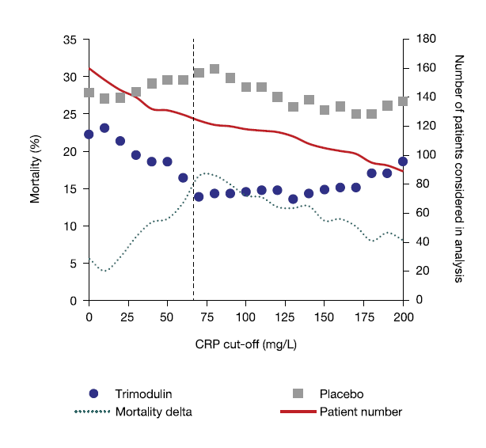

Supplementary Fig. S2 Mortality stratified by baseline immunoglobulin (Ig) M levels using different cut-off values for IgM
Dashed vertical line indicates the cut-off value used in the exploratory post-hoc analyses

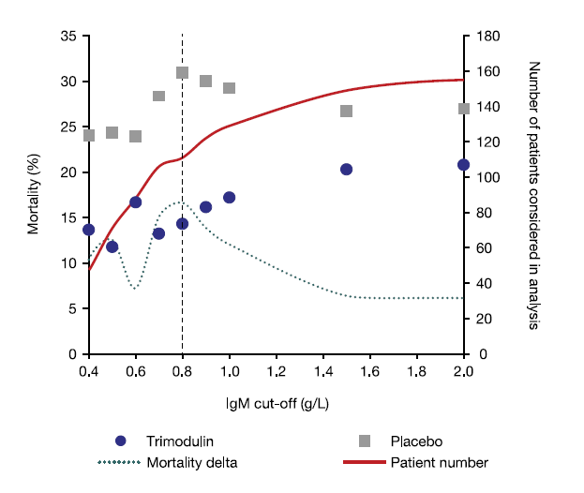

Supplementary Fig. S3 Kaplan–Meier survival curve of the C-reactive protein (CRP) subset (CRP ≥70 mg/L)
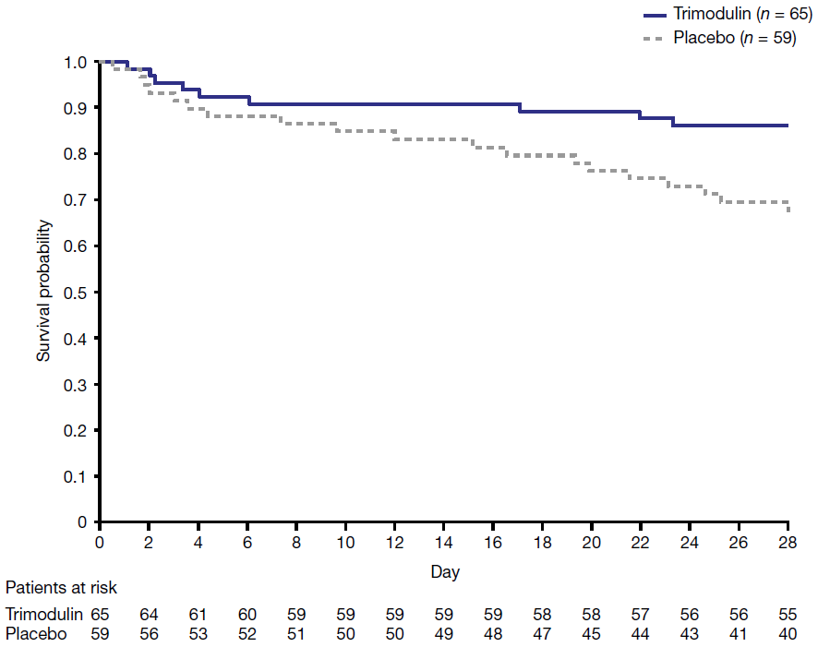

Supplementary Fig. S4 Kaplan–Meier survival curve of the immunoglobulin (Ig) M subset (IgM ≤0.8 g/L)
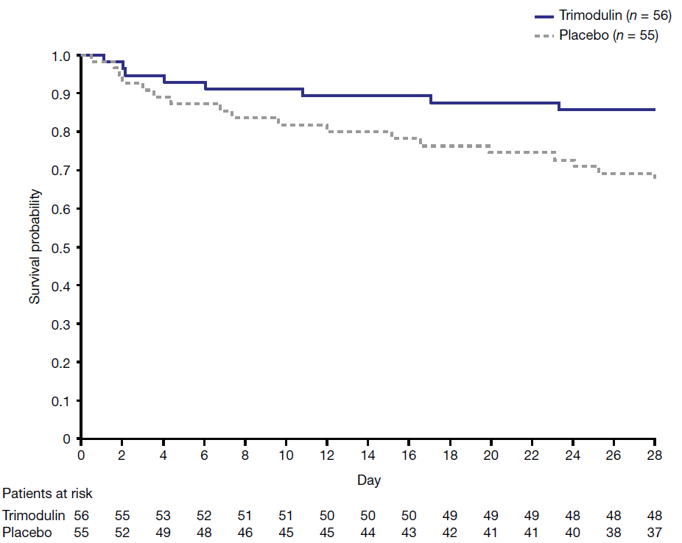

Supplementary Fig. S5 Kaplan–Meier survival curve of the C-reactive protein (CRP)/immunoglobulin (Ig) M subset (CRP ≥70 mg/L and IgM ≤0.8 g/L)
