ORI monitoring allows a reduction of time with hyperoxia in critically ill patients: The randomized control ORI² study.

Electronic Supplementary material

Material and Methods
Study design and participants
This is a prospective, randomized, open, single-center study conducted in the 12-bed Surgical Intensive Care Unit of the Angers University Hospital. This study has been approved by an IRB (Comité de Protection des Personnes (CPP) Ouest 2, number 2016-11). The protocol has been registered by the competent authority (ANSM - Agence Nationale de Sécurité du Médicament et des produits de santé) under the reference number 2016-A01026-45 (Registry Identifier: ID RCB ANSM). This study was registered in ClinicalTrials.gov, under the following reference NCT02878460.

All adult (age≥18 years) patients hospitalized in the intensive care unit, intubated and mechanically ventilated for a predictable duration of at least two days were eligible. The two exclusion criteria were pregnancy and legal guardianship. Inclusion and randomization had to be done within six hours of admission for patients already intubated at ICU admission, or at the time of intubation (when it was done while in the ICU). Consent of the patient or of his/her relative was obtained either prior to inclusion or (when not possible) after for all enrolled subjects.
Randomization was performed in a 1:1 ratio to either the ORI or the control group, with stratification on the PaO₂:FiO₂ ratio (PF ratio) at admission (< or ≥ 200mmHg) using an eCRF (Capture System® Software).

Study procedures
The Oxygen Reserve Index (ORI) is a new non-invasive parameter obtained from the pulse-oximeter signal. It was initially proposed as an early detection of desaturation notably in the operating room, as it decreases before SpO2 for elevated PaO2 [1]. However it may also help to limit hyperoxia in critically ill patients [2]. Indeed, the ORI is an index between 0 and 1 and is a glance of the changing PaO₂ of the patient [3]. It increases (above 0), when PaO2 exceeds 80-100 mmHg [3].
All the patients were monitored using Rainbow® sensors connected to ROOT monitors (MASIMO Corp, Irvine CA, USA), but ORI was made visible only for patients in the ORI group. It has been an established practice of the ICU (for almost 2 years) to prescribe targets of SpO2 (with lower and upper limits, according to the patient’s condition) rather than FiO2 or O₂ rates (figure 1e). In both groups, the lower limit of SpO2 was prescribed daily by the clinicians. An SpO2 ≥90% was recommended in case of ARDS, an SpO2≥92% in case of chronic respiratory pulmonary disease or chronic oxygen therapy and an SpO2≥95% for all other patients, including trauma, brain-injured or septic ones. These targets may change during the patient’s stay. In both groups, FiO2 (or O2 rate) was increased (by 10% increment) when SpO2 was below the defined lower limit. In the Control group, FiO2 (or O2 rate) had to be decreased (by 10% decrement) when SpO2 was higher than the upper limit. These upper limits were defined according to the range prescribed (ie 95% for ARDS or COPD, 99% for all other patients). In the ORI group, FiO2 (or O2 rate) had to be decreased when ORI was ≥0.01 (Figure 1e).
Arterial blood gases (ABG) were drawn according to current practice: at least once daily as long as the patient received oxygen (with or without mechanical ventilation), and when clinically indicated. Patient’s follow-up was interrupted at the end of oxygen therapy, at the ICU discharge or at D28 (the first occurrence).

Outcomes
The primary endpoint was the percentage of days with moderate hyperoxia (percentage of days with at least one PaO₂ ≥ 100mmHg on ABG during patient follow up). Secondary endpoints were mean daily PaO₂ and FiO₂ per patient, proportion of days with hypoxemia (percentage of days with at least one PaO₂ < 60mmHg during patient follow up), length of mechanical ventilation, ventilator free days at D28 and occurrence of atelectasis requiring treatment (fibro-aspiration or posture of the patient). We also calculate the time (in hours) with Pao2 ≥ 100 mmHg or ≥120 mmHg, as follows: duration of hyperoxia (in hours) = a + b. With a = the sum of the durations (in hours) between two ABG with a PaO2 ≥100 mmHg (or ≥120 mmHg) and b = the sum of the half times (in hours) between a ABG with a PaO2 ≥100 mmHg (or ≥120 mmHg) and a ABG with a PaO2 <100mmHg (or ≤120 mmHg).

Statistical analysis
As it was not possible to draw hypothesis, we first estimated that a total of 60 patients could be sufficient to allow a calculation and we conducted an intermediate analysis on the first 40 patients. We observed a non-significant decrease in the percentage of days with hyperoxia (11 vs 22%). The number of patients needed was then increased to a total of 150 patients with the assumption of a reduction in the percentage of days with moderate hyperoxia from 22 to 11% (considering an alpha risk at 5% and a beta risk at 20%). The significance threshold for the primary endpoint was therefore reassessed to p<0.0294 considering a Pocock’s correction for intermediate analysis. Quantitative variables are expressed as mean (SD) or median (IQR). We compared variables with Student t-test or Wilcoxon-Mann-Whitney test when appropriate. We compared qualitative variables using χ² test or Fisher’s exact test. All statistics were performed using the JMP software (version 12.0.1, SAS institute, Brie Comte Robert, France).

Results

Patients
Between April 27, 2017 and April 24, 2018, 551 patients were hospitalized in the ICU. Among them, 374 patients were ventilated and screened and 150 were randomized; 76 patients were assigned to the ORI group and 74 to the control group. Finally, 75 patients were analyzed in the ORI group and 71 in the control group (Figure 2e).
Patients in both groups were similar, except for the presence of shock at ICU admission (48(64%) vs 32(45%) in the ORI and control groups respectively, p=0.022; Table 1e).

Discussion
In this prospective randomized controlled study, the use of ORI monitoring to titrate oxygen rates allowed an important reduction of the time spent with hyperoxia compared with the use of SpO2 alone, without increasing time spent with hypoxemia. This is an important finding, since limiting hyperoxia is now an important goal of critical care [4].

Indeed, hyperoxia has recently been recognized as potentially deleterious to critically ill patients, with increased mortality associated with more “liberal” oxygenation strategies (risk ratio for mortality of 1.21, 95% CI 1.03-1.43 in the recent meta-analysis by Chu et al. [5]). However, hypoxia is also recognized as potentially deleterious [6, 7]. As health care professionals, we all have learned for decades to be cautious of hypoxia, and thus to monitor SpO2 in order to prevent these episodes. Monitoring SpO2 allowed a reduction of perioperative mortality [8]. This may explain, at least in part, why nurses and ICU physicians may remain reluctant to decrease FiO2 (or O2 rate) when SpO2 remains in the “normal range”, even if they claim the opposite when asked about the implementation of “conservative oxygen strategies”[9]. In a recent observational study, the authors observed that when SpO2 was ≥99%, FiO2 remained unchanged in 88% of cases when FiO2 is between 0.3 and 0.5 [10]. This highlights that changing habits may be difficult. Indeed, when a conservative oxygen strategy was tested with a target SpO2 of [90-92%], FiO2 was decreased in less than 50% of the cases even when SpO2 was 100% [11]. This may explain why using a new parameter, the ORI [3], may be more effective. In addition, using SpO2 to avoid hyperoxia, thus targeting SpO2 around 90-92% to start oxygen as recently proposed [4], exposes the patient to hypoxia. Indeed, when a conservative oxygen strategy is implemented based on SpO2, patients spend much more time with hypoxia [11]. The ORI starts to increase only when PaO2 is above 80-100 mmHg. An ORI ≥ 0.24 indicates a PaO₂ ≥ 100mmHg in virtually all the patients [3]. This is the reason we choose an upper limit of 0.01, to be very sensitive to elevated PaO2. Using this parameter to set oxygen rates, we observed a non-significant decrease in median FiO2 (from 0.36 to 0.32). It should be noted that the observed FiO2 in our control group is less than the ones usually reported (around 0.40)[6, 11], but the FiO2 observed in the ORI group was not as low as the ones observed in a feasibility study (0.27, targeting SpO2 between 90-92%)[11]. This may indicate that FiO2 were not systematically reduced in the ORI group, unless when ORI was too high. Indeed, median PaO2 were similar in both groups. However, the time spent with a FiO2 of 0.21 under mechanical ventilation was greater in the ORI group suggesting that FiO2 was decreased more strictly using ORI. A protocol to adjust FiO2 was already in place in our unit and the percentage of days with hyperoxia we observed in the control group (33% of the days or 17% of the time in hours) was much less than the percentage of time with hyperoxia described in conventional practice (around 60%)[10]. This indicates that this strategy to decrease oxygen rate according to ORI may be even more efficient in units where there is no protocol to adjust oxygen rates.
One strength of our study is that we did not limit the follow-up of the patients to the mechanical ventilation period, but included the total duration of oxygen therapy. Indeed, oxygen is often poorly prescribed in these patients [12], but more liberal oxygen is deleterious in non-intubated patients too [5]. We did not observe a significant reduction in clinical outcomes such as atelectasis, compared to more strict oxygen strategy [13]. However, we choose to only consider clinically significant atelectasis (i.e. requiring a therapeutic intervention) rather than a radiologic score [13]. In addition, our control group had much less hyperoxia than standard of care because a nurse-driven protocol for FiO2 setting was already in place.

This study has some limitations: it is a prospective and randomized, but open study. Indeed, it was not possible to blind the 2 groups. However, the blood gases were drawn according to the same protocol in both groups. In addition, we observed relatively low FiO2 in the control group compared to reported values, suggesting that patients in the control group received a relatively conservative oxygen therapy. We did not observe significant clinical outcomes, but the study was not powered for this. In addition, one may speculate that these results could have been more interesting if the PaO2 in the control group were higher, as described in other studies [11, 14].

Conclusion
In conclusion, adjusting oxygen rate according to ORI monitoring reduces the percentage of days with moderate hyperoxia by more than 50% in critically ill patients without increasing the rate of hypoxia, compared to usual practice.

Table 1e: Patient’s characteristics
Value are median (Q1-Q3), mean ± SD or n (%)
BMI, Body Mass Index ; COPD, Chronic Obstructive Pulmonary Disease; CAD, Coronary Artery Disease ; SAPS II, Simplified Acute Physiology Score II ; SOFA score, Sequential Organ Failure Assessment score ; ICU, Intensive Care Unit ; PaO2 = partial pressure of arterial oxygen ; FiO2, fraction of inspired oxygen
Shock at admission was defined as catecholamine infusion (norepinephrine in all cases).

 | ORI  (n=75) | Control  (n=71) | p
Age, years | 60 ±18 | 60 ±19 | 0.96
Male Gender, | 53 (71) | 49 (69) | 0.83
BMI, kg/m² | 27 ±6 | 28 ±7 | 0.62
Comorbidities
None | 15 (20) | 17 (24) | 0.57
COPD | 6 (8) | 6 (9) | 0.92
Hypertension | 34 (45) | 32 (45) | 0.98
CAD | 4 (5) | 3 (4) | 0.75
Type of Admission |  |  | 0.89
Elective surgery, | 2 (3) | 2 (3)
Emergency surgery | 47 (63) | 47 (66)
Medical | 26 (35) | 22 (31)
Reason for admission
Trauma | 14 (19) | 18 (25) | 0.33
Sepsis | 24 (32) | 23 (32) | 0.96
Brain injury | 24 (32) | 23 (32) | 0.96
SAPS II at admission | 52 ±16 | 52 ±17 | 0.99
SOFA at admission | 8 (5-10) | 6 (4-10) | 0.08
Shock at ICU admission | 48 (64) | 32 (45) | 0.022
Lung damage at inclusion | 30 (40) | 33 (47) | 0.43
PaO2/FiO2 at inclusion, mmHg | 267 (171-360) | 279 (161-372) | 0.98

Figure 1e: Setting of Oxygen rate according to the study group

In the control group, nurses adjusted the oxygen rate (under Mechanical ventilation or not) according to the measured SpO2 (expressed in %). The ORI was not visible. In the ORI group, oxygen rate was increased when SpO2 was below the lower limit prescribed and was decreased when ORI was ≥0.01.

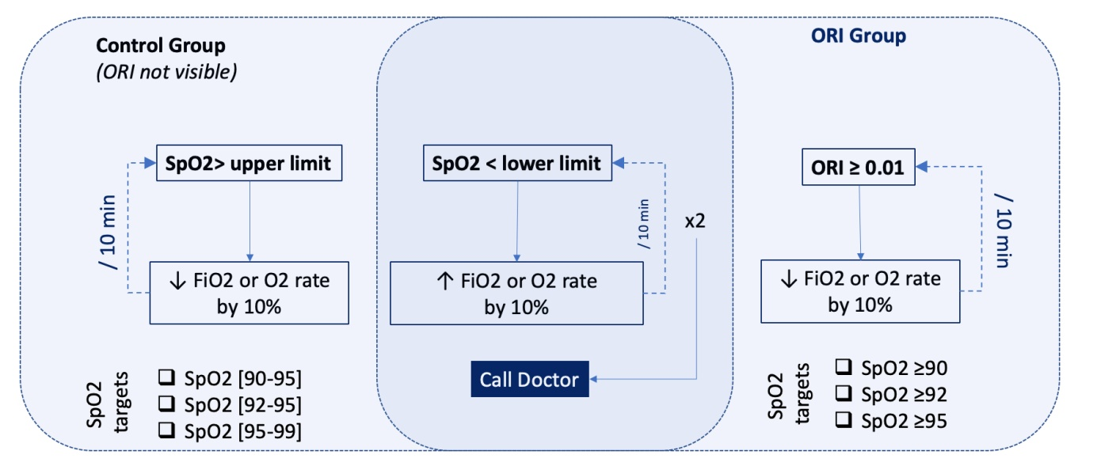

Figure 2e: Study Flow-chart.
ICU, intensive care unit; pts, patients; MV, mechanical ventilation

Figure 3e: Percentage of days with hyperoxia and hypoxia
The percentage of days with hyperoxia (i.e. with at least one PaO2 ≥100 mmHg)was significantly reduced in the ORI group, without increasing the percentage of days with hypoxia (i.e. with at least one PaO2 <60 mmHg).

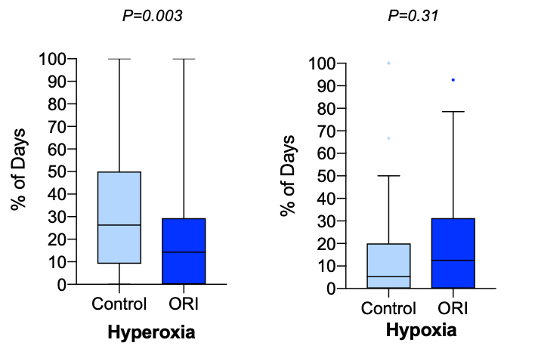

References

1. Szmuk P, Steiner JW, Olomu PN, Ploski RP, Sessler DI, Ezri T, (2016) Oxygen Reserve Index: A Novel Noninvasive Measure of Oxygen Reserve--A Pilot Study. Anesthesiology 124: 779-784
2. Scheeren TWL, Belda FJ, Perel A, (2018) The oxygen reserve index (ORI): a new tool to monitor oxygen therapy. J Clin Monit Comput 32: 379-389
3. Applegate RL, 2nd, Dorotta IL, Wells B, Juma D, Applegate PM, (2016) The Relationship Between Oxygen Reserve Index and Arterial Partial Pressure of Oxygen During Surgery. Anesth Analg 123: 626-633
4. Siemieniuk RAC, Chu DK, Kim LH, Guell-Rous MR, Alhazzani W, Soccal PM, Karanicolas PJ, Farhoumand PD, Siemieniuk JLK, Satia I, Irusen EM, Refaat MM, Mikita JS, Smith M, Cohen DN, Vandvik PO, Agoritsas T, Lytvyn L, Guyatt GH, (2018) Oxygen therapy for acutely ill medical patients: a clinical practice guideline. BMJ 363: k4169
5. Chu DK, Kim LH, Young PJ, Zamiri N, Almenawer SA, Jaeschke R, Szczeklik W, Schunemann HJ, Neary JD, Alhazzani W, (2018) Mortality and morbidity in acutely ill adults treated with liberal versus conservative oxygen therapy (IOTA): a systematic review and meta-analysis. Lancet 391: 1693-1705
6. Helmerhorst HJ, Arts DL, Schultz MJ, van der Voort PH, Abu-Hanna A, de Jonge E, van Westerloo DJ, (2017) Metrics of Arterial Hyperoxia and Associated Outcomes in Critical Care. Crit Care Med 45: 187-195
7. Eastwood G, Bellomo R, Bailey M, Taori G, Pilcher D, Young P, Beasley R, (2012) Arterial oxygen tension and mortality in mechanically ventilated patients. Intensive Care Med 38: 91-98
8. Eichhorn JH, Cooper JB, Cullen DJ, Maier WR, Philip JH, Seeman RG, (1986) Standards for patient monitoring during anesthesia at Harvard Medical School. JAMA 256: 1017-1020
9. Eastwood GM, Peck L, Young H, Suzuki S, Garcia M, Bellomo R, (2014) Intensive care clinicians' opinion of conservative oxygen therapy (SpO(2) 90-92%) for mechanically ventilated patients. Aust Crit Care 27: 120-125
10. Suzuki S, Eastwood GM, Peck L, Glassford NJ, Bellomo R, (2013) Current oxygen management in mechanically ventilated patients: a prospective observational cohort study. J Crit Care 28: 647-654
11. Suzuki S, Eastwood GM, Glassford NJ, Peck L, Young H, Garcia-Alvarez M, Schneider AG, Bellomo R, (2014) Conservative oxygen therapy in mechanically ventilated patients: a pilot before-and-after trial. Crit Care Med 42: 1414-1422
12. Parke RL, Eastwood GM, McGuinness SP, George Institute for Global H, Australian, New Zealand Intensive Care Society Clinical Trials G, (2013) Oxygen therapy in non-intubated adult intensive care patients: a point prevalence study. Crit Care Resusc 15: 287-293
13. Suzuki S, Eastwood GM, Goodwin MD, Noe GD, Smith PE, Glassford N, Schneider AG, Bellomo R, (2015) Atelectasis and mechanical ventilation mode during conservative oxygen therapy: A before-and-after study. J Crit Care 30: 1232-1237
14. Girardis M, Busani S, Damiani E, Donati A, Rinaldi L, Marudi A, Morelli A, Antonelli M, Singer M, (2016) Effect of Conservative vs Conventional Oxygen Therapy on Mortality Among Patients in an Intensive Care Unit: The Oxygen-ICU Randomized Clinical Trial. JAMA 316: 1583-1589

