Supplementary material 2
Epidemiology and burden of sepsis acquired in hospitals and intensive care units: A systematic review and meta-analysis
Robby Markwart, Hiroki Saito, Thomas Harder, Sara Tomczyk, Alessandro Cassini, Carolin Fleischmann-Struzek, Felix Reichert, Tim Eckmanns, Benedetta Allegranzi

Contents
Supplementary figure 1 2
Supplementary figure 2 3
Supplementary table 1 4
Supplementary table 2 8
Supplementary table 3 10
Supplementary table 4 11
Supplementary table 5 12
Supplementary table 6 15
Supplementary table 7 16
Supplementary table 8 18
Reference list of Supplementary material 2 18

Supplementary figure 1
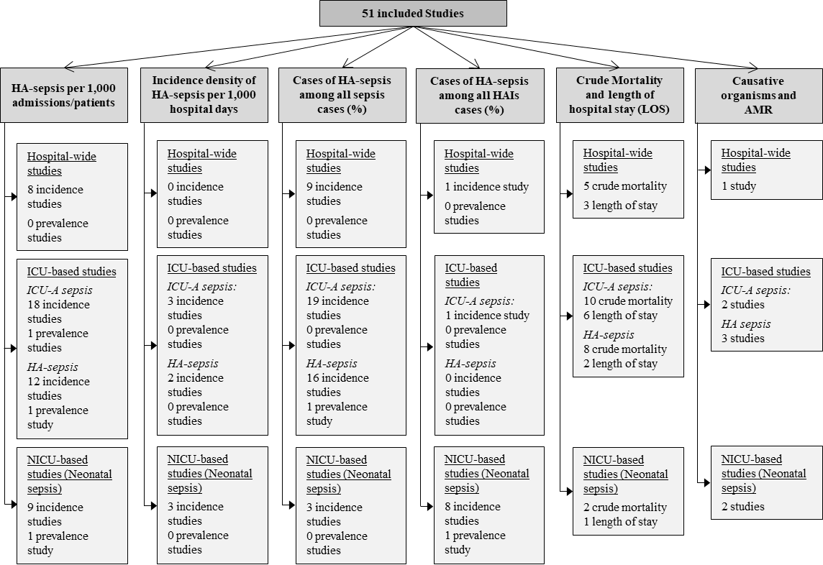
Supplementary figure 1: Overview of outcomes and the number of studies included for each outcome among the 51 studies retained for study inclusion. AMR = antimicrobial resistance, HA= hospital-acquired, HAIs = healthcare-associated infections, ICU-A = ICU-acquired

Supplementary figure 2
A
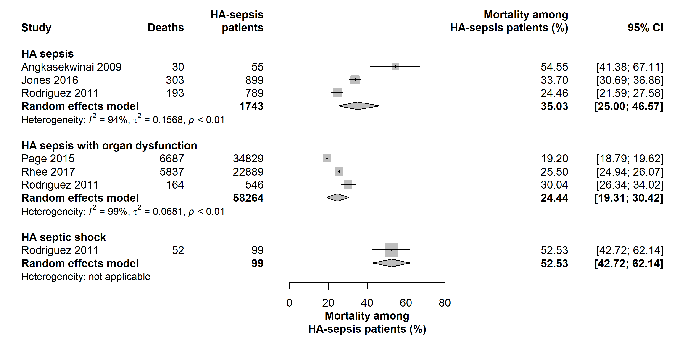
B
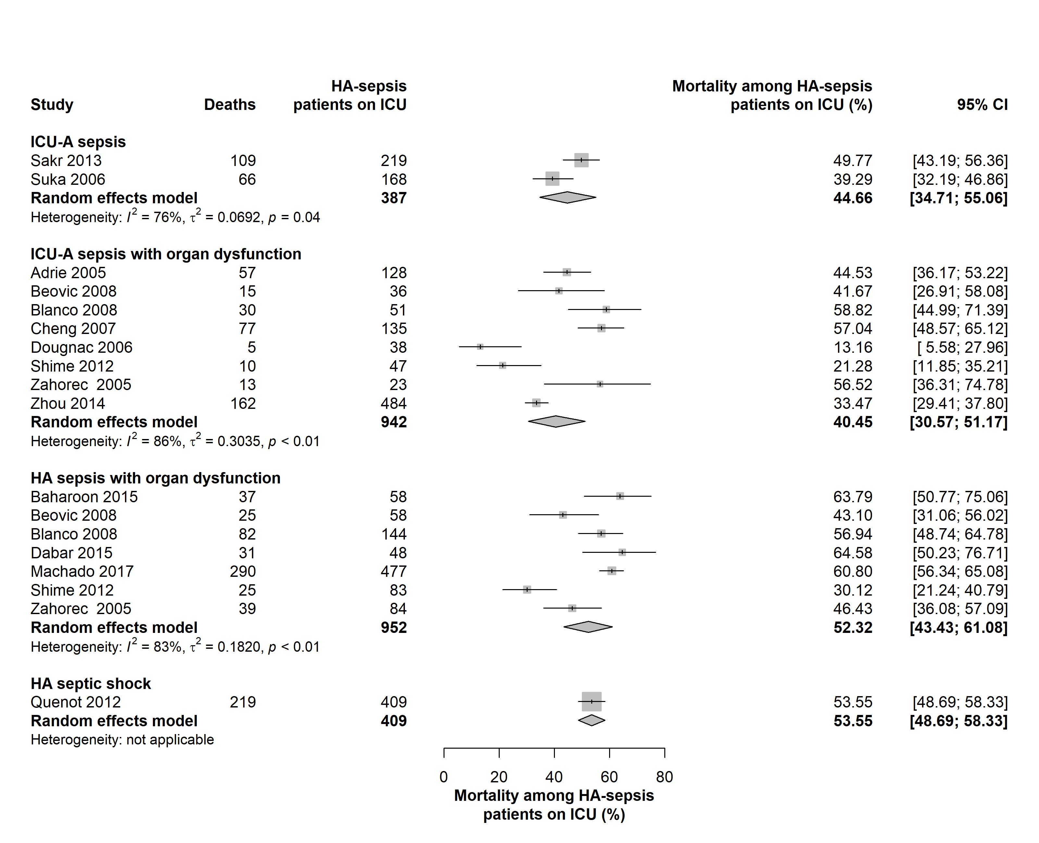
Supplementary figure 2: Pooled mortality of patients with hospital-acquired sepsis
(A) Pooled mortality (%) among hospital patients, including ICU patients, with hospital-acquired sepsis, sepsis with organ dysfunction, or septic shock. (B) Pooled mortality (%) among ICU patients with ICU-acquired and hospital-acquired sepsis, sepsis with organ dysfunction, and septic shock.
The “sepsis” group comprises studies on patients with sepsis, sepsis with organ dysfunction, and septic shock. The “sepsis with organ dysfunction” group comprises studies on patients with sepsis with organ dysfunction and septic shock. HA = hospital-acquired; ICU-A = ICU-acquired sepsis; 95% CI = 95% confidence interval.

Supplementary table 1
First author, year | Country, WHO region | Income | Study period | Study design | Characteristics of hospital/wards and included patients | Sepsis case definition
Hospital-wide studies
Angkasekwinai, 2009 [1] | Thailand, South-East Asia Region | Upper middle | 2007 | Single centre, incidence study | All medical wards of Siriraj Hospital in Bangkok; all patients | Sepsis-1
Chaudhary, 2017 (conference abstract) [2] | USA, Region of the Americas | High | 2012-2014 | Multicentre incidence study | Vizient Consortium, a collaboration of 300 academic medical centres affiliated across the USA; all hospital discharges | ICD-9 codes for a serious infection plus organ dysfunction
Esteban, 2007 [3] | Spain, European Region | High | 2003 | Multicentre, incidence study | 3 academic hospitals south of metropolitan Madrid (medical-surgical ICU, general and specialty medical wards, general surgery ward, orthopaedic and trauma surgery ward, neurosurgical ward, and gynaecology ward); all consecutively admitted patients (>18 yrs, exclusion of patients discharged from hospital alive within 48 h of admission) | Sepsis-1
Hagel, 2013 [4] | Germany, European Region | High | 2011-2012 | Single centre, incidence study | University hospital in Jena (departments of internal medicine/ cardiology, neurology, surgery, anaesthesiology, gynaecology, geriatrics); all patients (adults with hospital stay ≥ 48 h) | Sepsis-1
Jones, 2016 [5] | USA, Region of the Americas | High | 2012-2013 | Multicentre, incidence study | 1 tertiary academic medical centre and 5 community hospitals participating in the Texas Gulf Coast Sepsis Network and the Sepsis Early Recognition and Response Initiative; all hospital discharges (patients ≥18 yrs) | ICD-9-CM codes for 038 (septicaemia),  995.91 (sepsis), 995.92 (severe sepsis), or 785.52 (septic shock)
Padro, 2018  (conference abstract) [6] | USA, Region of the Americas | High | not reported | Single centre, incidence study | Academic, level 1 trauma center in Jacksonville, Florida; all sepsis admissions (patients ≥18 yrs) | ICD-9 (derived from 2019 and 2017 full text publications by the authors)
Page, 2015 [7] | USA, Region of the Americas | High | 2012 | Multicentre, incidence study | 300 academic hospitals and associated community hospital affiliates spanning 42 states (University Health System Consortium); hospital discharges (patients ≥18) | ICD-9 discharge diagnoses for both a serious infection, as well as organ dysfunction
Rhee, 2017 [8] | USA, Region of the Americas | High | 2009-2014 | Multicentre, incidence study | 409 academic, community, and federal acute care hospitals; all patients (≥20 yrs) | Sepsis-3
Rodriguez, 2011 [9] | Colombia, Region of the Americas | Upper middle | 2007-2008 | Multicentre, incidence study | 10 hospitals in the four main cities of Colombia; all patients (≥18 yrs, from emergency rooms, ICUs and hospital wards) | Sepsis-1
Zhou, 2017 [10] | China, Western Pacific Region | Upper middle | 2012-2014 | Multicentre, incidence study | 111 hospitals within the Beijing Public Health Information System; all patients (≥18 yrs, resident in Yuetan sub-district based on home address) | Sepsis and septic shock: Sepsis-1, severe sepsis: Sepsis-2
ICU-based studies (paediatric and adult patients)
Adrie, 2005 [11] | France, European Region | High | 1997-2000 | Multicentre, incidence study | 6 ICUs (with 65 beds, 2 surgical, 2 medical, 2 general) in Paris or near Paris; all hospitalised patients (>16 yrs with stay >48 h) | Sepsis-1
Baharoon, 2015 [12] | Saudi Arabia, Eastern Mediterranean Region | High | 2010-2011 | Single centre, incidence study | General ICU (mixed medical-surgical and trauma unit with 21 beds) in Mecca; all patients (adults with severe sepsis and septic shock) | Sepsis-2
Beović, 2008 [13] | Slovenia, European Region | High | 2004 | Multicentre, incidence study | 28 ICUs in 15 hospitals; all patients (adults) | Sepsis-1
Blanco, 2008 [14] | Spain, European Region | High | 2002 | Multicentre, incidence study | 14 ICUs in 13 hospitals (10 in the region of Castilla y Leon, 3 in the region of Asturia); all consecutive patients (≥18 yrs with severe sepsis) | Sepsis-1
Carvajal-Estupinan, 2016 [15] | Colombia, Region of the Americas | Upper middle | 2010-2011 | Single center, incidence study | ICU in Bucaramanga; all patients (12-85 yrs with sepsis) | Sepsis-1/-2
Cheng, 2007 [16] | China, Western Pacific Region | Upper middle | 2004-2005 | Multicentre, incidence study | Surgical ICUs of 10 university hospitals in 6 major provinces; all patients (≥18 yrs with stay >24 h) | Sepsis-1
Dabar, 2015 [17] | Lebanon, Eastern Mediterranean Region | Upper middle | 2005-2006 | Multicentre, incidence study | Medical and surgical ICUs at 3 tertiary teaching hospitals in Beirut; all patients (≥18 yrs with severe sepsis) | Sepsis-1
Dougnac, 2006 [18] | Chile, Region of the Americas | High | 2004 | Multicentre, 1-day point prevalence study | All 64 ICUs in Chile; all patients (≥16 yrs) | Sepsis-2
Gašparovic, 2006 [19] | Croatia, European Region | High | 2004-2005 | Multicentre, incidence study | 24 ICUs (general, specialized, neonatal, paediatric and adult) in 18 university hospitals, 3 in county hospitals, and 4 in city hospitals; all patients | Sepsis-1
Karlsson, 2007 [20] | Finland, European Region | High | 2004-2005 | Multicentre, incidence study | 24 closed multidisciplinary ICUs in 21 hospitals (4 university and 17 tertiary hospitals); all patients (>18 yrs) | Sepsis-1
Kübler, 2015 [21] | Poland, European Region | High | 2003-2009 | Multicentre, incidence study, analysis of web-based severe sepsis cases registry | 130 (2003-2007) and 40 active ICUs; all patients (voluntary registered with severe sepsis) | Sepsis-1
Levy, 2012 [22] | USA,  Region of the Americas;  Europe, European Region | USA: High,  Europe: - | 2005-2010 | Multicentre, incidence study, analysis of the database of the Surviving Sepsis campaign (SSC) | USA: 107 sites, Europe: 79 hospital sites; all patients (registered with conﬁrmed severe sepsis or septic shock according to the SSC diagnosis screening approach and treate in the ICU) | Sepsis-2
Machado, 2017 [23] | Brazil, Region of the Americas | Upper middle | 2014 | Multicentre, 1-day point prevalence study | 317 ICUs from a nationally representative pseudo-random sample; all patients (≥18 yrs) | Sepsis-1
Malacarne, 2008 [24] | Italy, European Region | High | 2002 | Multicenter, incidence study | 71 adult ICUs (medical-surgical [general], neurosurgical, other); all patients (adults with ICU stay >48 h) | Sepsis-1/-2
Martin, 2009 [25] | Canada, Region of the Americas | High | 2003-2004 | Multicentre, incidence study | 12 ICUs (medical and medical-surgical), 2 sites in British Columbia, 1 site in Manitoba, 7 sites in Ontario, 2 sites in Newfoundland; 5 sites in community hospitals; all patients ( with ICU stay > 24 h or who had severe sepsis at the time of ICU admission) | Sepsis-1
Ortíz, 2014 [26] | Colombia, Region of the Americas | Upper middle | 2007-2008 | Multicentre, incidence study | 10 ICUs (medical-surgical) in 4 Colombian cities; patients (>18 yrs with stay >24 h) | Sepsis-1/-2 (based on other publications by the authors from the same study)
Vila Pérez, 2014 [27] | Spain, European Region | High | 2011-2012 | Multicentre, incidence study | Paediatric ICUs in 7 tertiary centres; all patients (7days - 18 yrs with sepsis) | 2005 consensus pediatric sepsis definition of Barcelona
Quenot, 2012 (conference abstract) [28] | France, European Region | High | 2009-2011 | Multicentre, incidence study | 14 ICUs from 10 university and community (nonacademic) hospitals in Northeast France; all patients (>18 yrs with septic shock) | Septic shock: metabolic acidosis oliguria/renal insufﬁciency or hepatic dysfunction (based on other publications by the authors from the same study)
Ribak, 2008 [29] | Argentina, Region of the Americas | Upper middle | 2006-2007 | Single centre, incidence study | ICU of a teaching hospital in Corrientes; all patients (>18 yrs) | based on Sepsis-1
Sakr, 2013 [30] | Italy, European Region | High | 2006 | Multicentre, incidence study | 24 ICUs (medical-surgical, surgical, neurosurgical) from 17 hospitals (university and non-university) in the Piedmont region; all patients (>18 yrs) | Sepsis-1
SepNet Critical Care Trials Group, 2016 [31] | Germany, European Region | High | 2013 | Multicentre, incidence study | 133 ICUs at 95 hospitals (SepNet members); all patients | Sepsis-1
Shime, 2012 [32] | Japan, Western Pacific Region | High | 2006-2008 | Multicentre, incidence study | 9 paediatric ICUs (4-20 beds in the Paediatric Intensive Care Unit Network; all patients (0-15 yrs) | 2005 consensus paediatric sepsis definition of Barcelona
Suka, 2006 [33] | Japan, Western Pacific Region | High | 2002-2004 | Multicentre, incidence study, analysis of data from the Japanese Nosocomial Infection Surveillance system (JANIS) | 28 ICUs where more than 100 patients were available for analysis; all patients (≥16 yrs with ICU stay ≥24 h) | Sepsis-1
The Irish Critical Care Trials Group, 2016 [34] | Republic of Ireland and Northern Ireland,  European Region | High | 2006 | Multicentre, incidence study | 14 ICUs (general, neurosurgical, other) from The Irish Critical Care Trials Group, 97 beds in the Republic of Ireland and 37 beds in Northern Ireland; all patients (adults) | Sepsis-1
Vesteinsdottir,  2011 [35] | Iceland, European Region | High | 2008-2009 | Multicentre, incidence study | 3 ICUs in Reykjavik and Akureyri (all ICUs in Iceland); all patients (≥18 yrs) | Sepsis-1
Vincent, 2013 (conference abstract) [36] | Worldwide, 84 countries | - | 2012 | Multicentre, incidence study | 730 ICUs from 84 countries; all patients (≥16 yrs with stay >24 h) | Sepsis-3 (based on full text publication)
Záhorec, 2005 [37] | Slovakia, European Region | High | 2002 | Multicentre, incidence study | 12 randomly chosen ICUs from Slovakia (74 beds, university and non-university hospitals); all patients (≥17 yrs) | Sepsis-1
Zhou, 2014 [38] | China, Western Pacific Region | Upper middle | 2009 | Multicentre, incidence study | 22 closed multidisciplinary ICUs from the China Critical Care Clinical Trials Group; all patients (≥15 yrs with stay >24 h) | Sepsis-1
Neonatal sepsis in NICUs
Baş, 2010 [39] | Turkey, European Region | Upper middle | 2000-2006 | Single centre, incidence study | NICU in children’s hospital in Ankara; all admitted neonates | Clinical signs and laboratory findings described in [40]
Crivaro, 2015 [41] | Italy, European Region | High | 2006-2010 | Single centre, incidence study | NICU (level 3) in a high-risk pregnancy centre and an obstetric emergency service in Naples; all admitted neonates | Clinical signs as defined by CDC [42]
de Castro Romanelli, 2013 [43] | Brazil, Region of the Americas | Upper middle | 2008-2009 | Single centre, incidence study | NICU (20 beds) at a university hospital in Belo Horizonte; all admitted neonates | Clinical signs and laboratory findings as defined by NHSN/CDC [42, 44]
Djordjevic, 2015 [45] | Serbia, European Region | Upper middle | 2012 | Single centre, incidence study | NICU (30 beds) at a university hospital in Kragujevac; all admitted neonates (stay > 48 h) | Clinical signs as defined by CDC [42]
Fernandes Távora, 2008 [46] | Brazil, Region of the Americas | Upper middle | 2003 | Single centre, incidence study | NICU (22 beds ) in a general teaching hospital and tertiary care referral centre in Northeast Brazil; all admitted neonates | Clinical signs and laboratory findings as defined by NHSN/CDC [42, 47]
Kamath, 2010 [48] | India,  South-East Asia Region | Lower middle | 2005-2006 | Single centre, incidence study | Two NICUs in a teaching hospital in Mangalore; admitted neonates (with sepsis and stay > 48 h) | Clinical signs and laboratory signs: poor sucking reflex, lethargy, refusal of feeds and respiratory distress, C-reactive protein and erythrocyte sedimentation rate levels
Malla, 2013 [49] | Nepal, South-East Asia Region | Low | 2011 | Single centre, incidence study | NICU (22 beds) in a teaching hospital in Pokhara; all admitted neonates (with sepsis) | Clinical and laboratory signs: positive C-reactive protein plus presence of one or more clinical signs consistent with sepsis, lethargy, refusal of feeds, abdominal distension, vomiting, grunting, respiratory distress, hypothermia, hyperthermia or sclerema, seizures, apnea, changes in skin colour, petechia
Mohammed, 2014 [50] | Egypt, Eastern Mediterranean Region | Lower middle | 2012-2013 | Single center, incidence study | NICU in anuniversity hospital in Sharkia Governorate; all admitted neonates (without infection at admission and stay ≥48 h) | Clinical signs: respiratory dysfunction, circulatory dysfunction, gastrointestinal track dysfunction and neurological dysfunction
Molina-Cabrillana, 2006 [51] | Spain, European Region | High | 1999-2005 | Single centre, incidence study | NICU (10 beds) in a maternity and children's hospital in Las Palmas; all admitted neonates | Clinical signs as defined by CDC [42]
Sarvikivi, 2010 [52] | Finland, European Region | High | 2008-2009 | Multicentre, six separate 1-day point prevalence studies | All 24 NICUs in Finland (19 level 2, 5 level 3); all patients | Clinical signs as defined by CDC [42]
Shaw, 2012 [53] | Nepal, South-East Asia Region | Low | 2000-2005 | Single centre, incidence study | NICU (level 3) in a teaching hospital in Pokhara; all admitted neonates (with suspected sepsis) | Clinical signs (lethargy, poor feeding, icterus, temperature instability, abdominal distension, tachypnea chest retractions, grunting, diarrhoea, shock, renal failure, sclerema, seizures and bulging fontanels) and laboratory findings (C-reactive protein, absolute neutrophil count, immature to total neutrophil ratio, presence of toxic granules in the white blood cell count)
Su, 2007 [54] | Taiwan, Western Pacific Region | Upper middle | 2004-2005 | Single centre, incidence study | NICU (30 beds, level 3) in a university hospital in central Taiwan; all admitted infants | Clinical signs as defined by CDC [42] and [55], laboratory findings: white blood cells count, C-reactive protein
Trapani, 2013 (conference abstract) [56] | Brazil, Region of the Americas | Upper middle | 2010 | Single centre, incidence study | Neonatal and paediatric ICU in Tubarão; all admitted neonates (with stay >48 h) | Clinical signs as defined by CDC [42] and ANVISA

Supplementary table 1: Descriptive characteristics of included studies
ANVISA = Agência Nacional de Vigilância Sanitária (National Health Surveillance Agency Brazil); CDC = Centers for Disease Control and Prevention; ICD-9-CM = International Classification of Diseases, 9th revision, Clinical Modification; ICU = intensive care unit; NHSN = National Healthcare Safety Network; NICU = neonatal intensive care unit; WHO = World Health Organization; h = hours; yrs = years

Supplementary table 2
Item | 1 | 2 | 3 | 4 | 5 | 6 | 7 | 8 | 9 | 10 | Summary risk of bias
Hospital-wide studies
Angkasekwinai 2009 | 1 | 1 | 0 | 0 | 0 | 0 | 0 | 0 | 0 | 0 | High
Chaudhary 2017 | 2 | 0 | 0 | 0 | 0 | 1 | 0 | 0 | 0 | 0 | Moderate
Esteban 2007 | 2 | 1 | 0 | 0 | 0 | 0 | 0 | 0 | 0 | 0 | Moderate
Hagel 2013 | 1 | 1 | 0 | 0 | 0 | 0 | 0 | 0 | 0 | 0 | High
Jones 2016 | 2 | 0 | 0 | 0 | 0 | 1 | 0 | 0 | 0 | 0 | Moderate
Padro 2018 | 1 | 0 | 0 | 0 | 0 | 1 | 0 | 0 | 0 | 0 | High
Page 2015 | 2 | 0 | 0 | 0 | 0 | 1 | 0 | 0 | 0 | 0 | Moderate
Rhee 2017 | 2 | 0 | 0 | 0 | 0 | 0 | 0 | 0 | 0 | 0 | Low
Rodriguez 2011 | 1 | 0 | 0 | 0 | 0 | 0 | 0 | 0 | 0 | 0 | Moderate
Zhou 2017 | 1 | 0 | 0 | 0 | 0 | 0 | 0 | 0 | 0 | 0 | Moderate
ICU-based studies
Adrie 2005 | 2 | 0 | 0 | 0 | 0 | 0 | 0 | 0 | 0 | 0 | Low
Baharoon 2015 | 1 | 0 | 0 | 0 | 0 | 0 | 0 | 0 | 0 | 0 | Moderate
Beovic 2008 | 0 | 0 | 0 | 0 | 0 | 0 | 0 | 0 | 0 | 0 | Low
Blanco 2008 | 2 | 0 | 0 | 0 | 0 | 0 | 0 | 0 | 0 | 0 | Low
Carvajal-Estupinan 2016 | 1 | 0 | 0 | 0 | 0 | 0 | 0 | 0 | 0 | 0 | Moderate
Cheng 2007 | 2 | 1 | 0 | 0 | 0 | 0 | 0 | 0 | 0 | 0 | Moderate
Dabar 2015 | 1 | 0 | 0 | 0 | 0 | 0 | 0 | 0 | 0 | 0 | Moderate
Dougnac 2006 | 0 | 0 | 0 | 0 | 0 | 0 | 0 | 0 | 0 | 0 | Low
Gašparovic 2006 | 2 | 0 | 0 | 0 | 0 | 0 | 0 | 0 | 0 | 0 | Low
Karlsson 2007 | 0 | 0 | 0 | 0 | 0 | 0 | 0 | 0 | 0 | 0 | Low
Kübler 2015 | 2 | 2 | 2 | 0 | 0 | 0 | 0 | 0 | 0 | 0 | Moderate
Levy 2012 | 2 | 2 | 2 | 0 | 0 | 0 | 0 | 0 | 0 | 0 | Moderate
Machado 2017 | 0 | 1 | 0 | 0 | 0 | 0 | 0 | 0 | 0 | 0 | Moderate
Malacarne 2008 | 2 | 0 | 0 | 0 | 0 | 0 | 0 | 0 | 0 | 0 | Low
Martin 2009 | 2 | 0 | 0 | 0 | 0 | 0 | 0 | 0 | 0 | 0 | Low
Ortíz 2014 | 2 | 0 | 0 | 0 | 0 | 0 | 0 | 0 | 0 | 0 | Low
Pérez 2014 | 0 | 0 | 0 | 0 | 0 | 0 | 0 | 0 | 0 | 0 | Low
Quenot 2012 | 2 | 0 | 0 | 0 | 0 | 0 | 0 | 0 | 0 | 0 | Low
Ribak 2008 | 1 | 0 | 0 | 0 | 0 | 0 | 0 | 0 | 0 | 0 | Moderate
Sakr 2013 | 0 | 0 | 0 | 0 | 0 | 0 | 0 | 0 | 0 | 0 | Low
SepNet CCTG 2016 | 2 | 0 | 0 | 0 | 0 | 0 | 0 | 0 | 0 | 0 | Low
Shime 2012 | 1 | 0 | 2 | 0 | 0 | 0 | 0 | 0 | 0 | 0 | Moderate
Suka 2006 | 1 | 0 | 0 | 0 | 0 | 0 | 0 | 0 | 0 | 0 | Moderate
The Irish CCTG 2008 | 2 | 0 | 0 | 0 | 0 | 0 | 0 | 0 | 0 | 0 | Low
Vesteinsdottir 2011 | 0 | 0 | 0 | 0 | 0 | 0 | 0 | 0 | 0 | 0 | Low
Vincent 2013 | 2 | 0 | 0 | 0 | 0 | 0 | 0 | 0 | 0 | 0 | Low
Zahorec 2005 | 2 | 0 | 0 | 0 | 0 | 0 | 0 | 0 | 0 | 0 | Low
Zhou 2014 | 1 | 0 | 0 | 0 | 0 | 0 | 0 | 0 | 0 | 0 | Moderate
Neonatal studies
Bas 2010 | 1 | 0 | 0 | 0 | 0 | 1 | 0 | 0 | 0 | 0 | High
Crivaro 2015 | 1 | 0 | 0 | 0 | 0 | 1 | 0 | 0 | 0 | 0 | High
de Castro RomanelliI 2013 | 1 | 0 | 0 | 0 | 0 | 1 | 0 | 0 | 0 | 0 | High
Djordjevic 2015 | 1 | 0 | 0 | 0 | 0 | 1 | 0 | 0 | 0 | 0 | High
Fernandes Távora 2008 | 1 | 0 | 0 | 0 | 0 | 1 | 0 | 0 | 0 | 0 | High
Kamath 2010 | 1 | 0 | 2 | 0 | 0 | 1 | 0 | 0 | 0 | 0 | High
Malla 2013 | 1 | 0 | 0 | 0 | 0 | 1 | 0 | 0 | 0 | 0 | High
Mohammed 2014 | 1 | 0 | 0 | 0 | 0 | 1 | 0 | 0 | 0 | 0 | High
Molina-Cabrillana 2006 | 1 | 0 | 0 | 0 | 0 | 1 | 0 | 0 | 0 | 0 | High
Sarvikivi 2010 | 0 | 0 | 0 | 0 | 0 | 1 | 0 | 0 | 0 | 0 | Moderate
Shaw 2012 | 1 | 0 | 0 | 0 | 0 | 1 | 0 | 0 | 0 | 0 | High
Su 2007 | 1 | 0 | 0 | 0 | 0 | 1 | 0 | 0 | 0 | 0 | High
Trapani 2013 | 1 | 0 | 0 | 0 | 0 | 1 | 0 | 0 | 0 | 0 | High

Supplementary table 2: Hoy Risk of Bias Assessment (0 = low risk of bias, 1 = high risk of bias, 2 = unclear risk of bias)
- Was the study’s target population a close representation of the national population in relation to relevant variables?
- Was the sampling frame a true or close representation of the target population?
- Was some form of random selection used to select the sample, or was a census undertaken?
- Was the likelihood of nonresponse bias minimal?
- Were data collected directly from the subjects (as opposed to a proxy)?
- Was an acceptable case definition used in the study?
- Was the study instrument that measured the parameter of interest shown to have validity and reliability?
- Was the same mode of data collection used for all subjects?
- Was the length of the shortest prevalence period for the parameter of interest appropriate?
- Were the numerator(s) and denominator(s) for the parameter of interest appropriate?
The summary risk of bias of studies was graded as “high risk” if the risk of bias of two or more items was judged as “high”. The summary risk of bias was graded as “moderate risk” if the risk of bias of one item was judged as “high” and a maximum of one other item was judged as “moderate”. In addition, the overall risk of bias was graded as “moderate” if two or a maximum of three items were judged as “moderate” risk of bias. The summary risk of bias of studies was judged as “low” if the risk of bias of a maximum of one item was judged as “moderate”.

Supplementary table 3
Study setting | Sepsis type | Number of studies | Pooled estimate  (95% CI) | Inter-study heterogeneity (I² statistics) (%) | Range of individual study estimates (%)
Proportion of hospital-acquired sepsis among all cases of sepsis (incidence studies)
Hospital patients | Hospital-acquired sepsis | 6 | 23.6 (17.0-31.8) | I² = 99 | 16.0 - 36.4
Hospital patients | Hospital-acquired sepsis with organ dysfunction | 5 | 16.4 (14.3-18.7) | I² = 100 | 11.3 - 32.9
Hospital patients | Hospital-acquired septic shock | 2 | 31.7 (23.4-41.4) | I² = 50 | 25.4 - 35.0
ICU patients | ICU-acquired sepsis | 8 | 31.4 (24.9-38.8) | I² = 96 | 18.6 - 49.1
ICU patients | Hospital-acquired sepsis | 2 | 35.1 (14.7-63.1) | I² = 97 | 22.8 - 48.9
ICU patients | ICU-acquired sepsis with organ dysfunction | 11 | 24.4 (16.7-34.2) | I² = 99 | 10.3 - 42.5
ICU patients | Hospital-acquired sepsis with organ dysfunction | 14 | 48.7 (38.3-59.3) | I² = 100 | 18.7 - 69.4
ICU patients | ICU-acquired septic shock | 2 | 6.8 (4.5-10.1) | I² = 78 | 5.6 - 8.4
ICU patients | Hospital-acquired septic shock | 2 | 35.8 (33.2-38.5) | I² = 0 | 35.7 - 37.4
Neonates in NICUs | Hospital-acquired neonatal sepsis | 1 | - | - | 39.8
Neonates in NICUs | Blood culture-proven Hospital-acquired neonatal sepsis | 1 | - | - | 40.0
Proportion of hospital-acquired sepsis among all cases of sepsis (prevalence studies)
Hospital patients | - | 0 | - | - | -
ICU patients | Hospital-acquired sepsis with organ dysfunction | 1 | - | - | 60.4
Neonates in NICUs | - | 0 | - | - | -

Supplementary table 3: Summary of studies reporting data on the proportion (%) of hospital-acquired sepsis among all cases of sepsis
The “sepsis” group comprises studies on patients with sepsis, sepsis with organ dysfunction and septic shock. The “sepsis with organ dysfunction” group comprises studies on patients with sepsis with organ dysfunction and septic shock. 95% CI = 95% confidence interval.

Supplementary table 4
Study setting | Sepsis type | Number of studies | Pooled estimate (%)  (95% CI) | Inter-study heterogeneity (I² statistics)  (%) | Range of individual study estimates  (%)
Proportion of hospital-acquired sepsis among all HAIs (incidence studies)
Hospital patients | Hospital-acquired sepsis | 0 | - | - | -
Hospital patients | Hospital-acquired sepsis with organ dysfunction | 1 | - | - | 38.6
Hospital patients | Hospital-acquired septic shock | 0 | - | - | -
ICU patients | ICU-acquired sepsis | 1 | - | - | 18.1
ICU patients | Hospital-acquired sepsis | 0 | - | - | -
ICU patients | ICU-acquired sepsis with organ dysfunction | 0 | - | - | -
ICU patients | Hospital-acquired sepsis with organ dysfunction | 0 | - | - | -
ICU patients | ICU-acquired septic shock | 0 | - | - | -
ICU patients | Hospital-acquired septic shock | 0 | - | - | -
Neonates in NICUs | Hospital-acquired neonatal sepsis | 8 | 56.6 (43.5-68.8) | I² = 95 | 9.5 - 80.0
Neonates in NICUs | Blood culture-proven hospital-acquired neonatal sepsis | 5 | 25.0% (15.9-37.0) | I² = 94 | 16.5 - 50.7
Proportion of hospital-acquired sepsis among all HAIs (prevalence studies)
Hospital patients | - | 0 | - | - | -
ICU patients | - | 0 | - | - | -
Neonates in NICUs | Hospital-acquired neonatal sepsis | 1 | - | - | 64.8
Neonates in NICUs | Blood culture-proven Hospital-acquired neonatal sepsis | 1 | - | - | 10.5

Supplementary table 4: Summary of studies reporting data on the proportion of hospital-acquired sepsis among all cases of hospital-acquired infections
The “sepsis” group comprises studies on patients with sepsis, sepsis with organ dysfunction and septic shock. The “sepsis with organ dysfunction” group comprises studies on patients with sepsis with organ dysfunction and septic shock. HAIs = hospital-acquired infections; 95% CI = 95% confidence interval.

Supplementary table 5
Study setting | Sepsis type | Number of studies | Pooled estimate  (95% CI) | Inter-study heterogeneity (I² statistics)  (%) | Range of individual study estimates  (%)
Mortality among patients with hospital-acquired sepsis (%)
Hospital patients | Hospital-acquired sepsis | 3 | 35.0 (25.0-46.6) | I² = 94 | 24.5 - 54.6
Hospital patients | Hospital-acquired sepsis with organ dysfunction | 3 | 24.4 (19.3-30.4) | I² = 99 | 19.2 - 25.5
Hospital patients | Hospital-acquired septic shock | 1 | - | - | 52.5
ICU patients | ICU-acquired sepsis | 2 | 44.7 (34.7-55.1) | I² = 76 | 39.3 - 49.8
ICU patients | Hospital-acquired sepsis | 0 | - | - | -
ICU patients | ICU-acquired sepsis with organ dysfunction | 8 | 40.5 (30.6-51.2) | I² = 86 | 13.2 - 58.8
ICU patients | Hospital-acquired sepsis with organ dysfunction | 7 | 52.3 (43.4-61.1) | I² = 83 | 30.1 - 64.6
ICU patients | ICU-acquired septic shock | 0 | - | - | -
ICU patients | Hospital-acquired septic shock | 1 | - | - | 53.6
Neonates in NICUs | Hospital-acquired neonatal sepsis | 0 | - | - | -
Neonates in NICUs | Blood culture-proven Hospital-acquired neonatal sepsis | 2 | 21.9 (5.0-59.7) | I² = 89 | 10.0 - 38.0

Supplementary table 5: Summary of studies reporting data on mortality among patients with hospital-acquired sepsis
The “sepsis” group comprises studies among patients with sepsis, sepsis with organ dysfunction, and septic shock. The “sepsis with organ dysfunction” group comprises studies among patients with sepsis with organ dysfunction, and septic shock. 95% CI = 95% confidence interval.

Supplementary table 6

Study setting | Sepsis type | Number of studies | Pooled estimate  (95% CI) | Inter-study heterogeneity (I² statistics)  (%) | Range of individual study estimates  (%)
Incidence density of hospital-acquired sepsis per 1000 patients days
Hospital patients | Hospital-acquired sepsis | 0 | - | - | -
Hospital patients | Hospital-acquired sepsis with organ dysfunction | 0 | - | - | -
Hospital patients | Hospital-acquired septic shock | 0 | - | - | -
ICU patients | ICU-acquired sepsis | 1 | - | - | 1.6
ICU patients | Hospital-acquired sepsis | 0 | - | - | -
ICU patients | ICU-acquired sepsis with organ dysfunction | 2 | 12.0 (10.4-13.9) | I² = 22 | 11.6 - 14.1
ICU patients | Hospital-acquired sepsis with organ dysfunction | 2 | 25.6 (24.0-27.3) | I² = 0 | 22.7 - 25.8
ICU patients | ICU-acquired septic shock | 0 | - | - | -
ICU patients | Hospital-acquired septic shock | 0 | - | - | -
Neonates in NICUs | Hospital-acquired neonatal sepsis | 3 | 5.9 (2.0-17.4) | I² = 99 | 1.6 - 14.2
Neonates in NICUs | Blood culture-proven hospital-acquired neonatal sepsis | 2 | 3.6 (2.1-6.2) | I² = 89 | 2.7 - 4.7

Supplementary table 6: Summary of studies reporting incidence density of hospital-acquired sepsis
The “sepsis” group comprises studies on patients with sepsis, sepsis with organ dysfunction and septic shock. The “sepsis with organ dysfunction” group comprises studies on patients with sepsis with organ dysfunction and septic shock. 95% CI = 95% confidence interval.

Supplementary table 7
Supplementary table 7Outcome | Sepsis type | Pooled estimates  (95% CI) | Q, d. f., p-value
Incidence of hospital-acquired sepsis per 1000 hospitalised patients
Hospital patients | Hospital-acquired sepsis | Moderate risk of bias (n=3): 15.1 (8.1-27.9)  High risk of bias (n=1): 16.2 (12.5-21.0) | 0.04, 1, 0.833
Hospital patients | Hospital-acquired sepsis with organ dysfunction | Low risk of bias (n=1): 7.9 (7.8-8.0)  Moderate risk of bias (n=3): 8.2 (6.5-10.3)  High risk of bias (n=1): 20.6 (19.1-22.3) | 571.9, 2, <0.001
Hospital patients | Hospital-acquired septic shock | Moderate risk of bias (n=1): 0.95 (0.57-1.57) | -
ICU patients | ICU-acquired sepsis | Low risk of bias (n=5): 54.3 (40.6-72.3)  Moderate risk of bias (n=2): 27.5 (2.4-248.1) | 0.32, 1, 0.575
ICU patients | Hospital-acquired sepsis | Low risk of bias (n=1): 59.7 (54.3-65.6) | -
ICU patients | ICU-acquired sepsis with organ dysfunction | Low risk of bias (n=8): 33.0 (20.2-53.5)  Moderate risk of bias (n=4): 42.5 (4.9-285.5) | 0.05, 1, 0.820
ICU patients | Hospital-acquired sepsis with organ dysfunction | Low risk of bias (n=8): 71.0 (44.4-111.6)  Moderate risk of bias (n=3): 30.5 (7.5-116.0) | 1.32, 1, 0.250
ICU patients | ICU-acquired septic shock | Low risk of bias (n=1): 4.2 (3.1-5.7)  Moderate risk of bias (n=1): 91.8 (77.2-108.7) | -
ICU patients | Hospital-acquired septic shock | Moderate risk of bias (n=1): 23.2 (16.6-32.3) | -
Proportion of hospital-acquired sepsis among all cases of sepsis (incidence studies)
Hospital patients | Hospital-acquired sepsis | Moderate risk of bias (n=4): 24.0% (15.0-36.2%)  High risk of bias (n=2): 22.6% (14.9-32.6%) | 0.04, 1, 0.833
Hospital patients | Hospital-acquired sepsis with organ dysfunction | Low risk of bias (n=1): 13.2% (13.0-13.3%)  Moderate risk of bias (n=5): 17.5% (14.5-21.0%) | 8.46, 1, 0.004
Hospital patients | Hospital-acquired septic shock | Moderate risk of bias: 31.7% (23.4-41.4%) | -
ICU patients | ICU-acquired sepsis | Low risk of bias (n=5): 32.7% (23.9-43.0%)  Moderate risk of bias (n=3): 29.2% (20.3-40.0%) | 0.24, 1, 0.623
ICU patients | Hospital-acquired sepsis | Low risk of bias (n=2): 35.1% (14.6-63.1%) | -
ICU patients | ICU-acquired sepsis with organ dysfunction | Low risk of bias (n=7): 24.0% (17.3-32.2%)  Moderate risk of bias (n=4): 25.2% (9.6-51-7%) | 0.01, 1, 0.913
ICU patients | Hospital-acquired sepsis with organ dysfunction | Low risk of bias (n=8): 52.4% (45.3-59.3%)  Moderate risk of bias (n=6): 43.9% (29.7-59.2%) | 0.96, 1, 0.328
ICU patients | ICU-acquired septic shock | Low risk of bias (n=2): 6.8% (4.5-10.1%) | -
ICU patients | Hospital-acquired septic shock | Low risk of bias (n=1): 35.7% (32.9-38.5%)  Moderate risk of bias (n=1): 37.4% (28.1-47.7%) | -
Mortality among patients with hospital-acquired sepsis (%)
Hospital patients | Hospital-acquired sepsis | Low risk of bias (n=1): 54.6% (41.4-67.1%)  Moderate risk of bias (n=2): 28.9% (20.7-38.8%) | 9.43, 1, 0.002
Hospital patients | Hospital-acquired sepsis with organ dysfunction | Low risk of bias (n=1): 25.5% (25.0-26.1%)  Moderate risk of bias (n=2): 24.1% (15.1-36.2%) | 0.07, 1, 0.796
Hospital patients | Hospital-acquired septic shock | Moderate risk of bias (n=1): 52.5% (42.7-62.1%) | -
ICU patients | ICU-acquired sepsis | Low risk of bias (n=1): 49.8% (43.2-56.4%)  Moderate risk of bias (n=1): 39.3% (34.755.1%) | -
ICU patients | ICU-acquired sepsis with organ dysfunction | Low risk of bias (n=5): 42.6% (29.4-57.0%)  Moderate risk of bias (n=3): 37.1% (21.2-56.4%) | 0.21, 1, 0.643
ICU patients | Hospital-acquired sepsis with organ dysfunction | Low risk of bias (n=3): 49.9% (41.2-58.5%)  Moderate risk of bias (n=4): 45.7% (39.3-69.2%) | 0.28, 1, 0.594
ICU patients | Hospital-acquired septic shock | Low risk of bias (n=1): 53.6% (48.7-58.3%) | -
Supplementary table 7: Summary and comparison of pooled estimates of studies with different overall risk of bias.
The “sepsis” group comprises studies on patients with sepsis, sepsis with organ dysfunction and septic shock. The “sepsis with organ dysfunction” group comprises studies on patients with sepsis with organ dysfunction and septic shock. 95% CI = 95% confidence interval, d. f.: degree of freedom

Supplementary table 8
Knowledge gaps | Explanation
Epidemiology of hospital- and ICU-acquired sepsis in resource limited countries | Healthcare-associated infections are frequent complications in low- and middle-income countries. However, only a limited number of studies from resource limited countries report data on hospital- and ICU-acquired sepsis.
Population-based estimates of hospital- and ICU-acquired sepsis | Only a limited number of studies provide population-based data on the incidence/prevalence and mortality of hospital- and ICU-acquired sepsis. Global population estimates are important to assess the global burden of sepsis including cases that originated in healthcare settings.
Attributable mortality of hospital- and ICU-acquired sepsis | Data on attributable mortality of patients with hospital- and ICU-acquired sepsis are very scarce and are needed to assess the global burden of sepsis including cases that originated in healthcare settings.
Causative microorganisms, including bacteria, fungi and viruses | Only a limited number of studies report complete microbiological profiles of microorganisms isolated from patients with hospital- and ICU-acquired sepsis.
Antimicrobial resistance profiles of causative microorganisms and its impact on mortality and morbidity | Antimicrobial resistance is recognised as a significant public health challenge. However, little is known about antimicrobial resistance profiles of microorganisms that cause hospital- and ICU-acquired sepsis and their effects on outcomes.
Methodological aspects | Explanation
Harmonisation of sepsis case definitions in epidemiological studies | Different sepsis cases definitions are used in epidemiological studies making comparisons between studies difficult. Current clinical consensus definitions (such as the “Sepsis-3” for adult sepsis) should be used consistently in all epidemiological studies. The reliability of administrative data, such as ICD-codes, to identify healthcare-associated sepsis cases has to be addressed in future studies.
Nationally representative epidemiological studies | Nationally representative epidemiological data are important to accurately assess the burden of hospital- and ICU-acquired sepsis in countries and regions. Only a limited number of studies provide nationally representative data on sepsis that originated in healthcare settings.
Clear distinction between community and healthcare-associated of sepsis | Although healthcare-associated sepsis may differ from sepsis acquired in the community in terms of aetiology and outcomes, many epidemiological studies on sepsis do not discriminate between both types.
Supplementary table 8: Summary of open research questions and methodological aspects that should be addressed and considered in future studies on the epidemiology of hospital- and ICU-acquired sepsis.

Reference list for Supplementary material 2
1. Angkasekwinai N, Rattanaumpawan P, Thamlikitkul V: Epidemiology of sepsis in Siriraj Hospital 2007. Journal of the Medical Association of Thailand = Chotmaihet thangphaet 2009, 92 Suppl 2:S68-78.
2. Chaudhary NS, Donnelly JP, Wang HE, Puskarich M: Racial Disparities in Severe Sepsis in United States Academic Medical Centers. In: 2017 Annual Meeting of the Society for Academic Emergency Medicine. Edited by Kline JL. Orlando, USA; 2017.
3. Esteban A, Frutos-Vivar F, Ferguson ND, Penuelas O, Lorente JA, Gordo F, Honrubia T, Algora A, Bustos A, Garcia G et al: Sepsis incidence and outcome: contrasting the intensive care unit with the hospital ward. Critical care medicine 2007, 35(5):1284-1289.
4. Hagel S, Ludewig K, Frosinski J, Hutagalung R, Porzelius C, Gastmeier P, Harbarth S, Pletz MW, Brunkhorst FM: [Effectiveness of a hospital-wide educational programme for infection control to reduce the rate of health-care associated infections and related sepsis (ALERTS)--methods and interim results]. Deutsche medizinische Wochenschrift (1946) 2013, 138(34-35):1717-1722.
5. Jones SL, Ashton CM, Kiehne LB, Nicolas JC, Rose AL, Shirkey BA, Masud F, Wray NP: Outcomes and Resource Use of Sepsis-associated Stays by Presence on Admission, Severity, and Hospital Type. Medical care 2016, 54(3):303-310.
6. Padro TS, C.; Gautam, S.; Gerdik, C.; Fultz, C.; Lester, D.; Guirgis, F.: Hospital-acquired sepsis: A descriptive study and comparison to communityacquired sepsis. In., vol. 2018;46():3 2018: Critical Care Medicine; 2018.
7. Page DB, Donnelly JP, Wang HE: Community-, Healthcare-, and Hospital-Acquired Severe Sepsis Hospitalizations in the University HealthSystem Consortium. Critical care medicine 2015, 43(9):1945-1951.
8. Rhee C, Dantes R, Epstein L, Murphy DJ, Seymour CW, Iwashyna TJ, Kadri SS, Angus DC, Danner RL, Fiore AE et al: Incidence and Trends of Sepsis in US Hospitals Using Clinical vs Claims Data, 2009-2014. Jama 2017, 318(13):1241-1249.
9. Rodriguez F, Barrera L, De La Rosa G, Dennis R, Duenas C, Granados M, Londono D, Molina F, Ortiz G, Jaimes F: The epidemiology of sepsis in Colombia: a prospective multicenter cohort study in ten university hospitals. Critical care medicine 2011, 39(7):1675-1682.
10. Zhou J, Tian H, Du X, Xi X, An Y, Duan M, Weng L, Du B: Population-Based Epidemiology of Sepsis in a Subdistrict of Beijing. Critical care medicine 2017, 45(7):1168-1176.
11. Adrie C, Alberti C, Chaix-Couturier C, Azoulay E, De Lassence A, Cohen Y, Meshaka P, Cheval C, Thuong M, Troche G et al: Epidemiology and economic evaluation of severe sepsis in France: age, severity, infection site, and place of acquisition (community, hospital, or intensive care unit) as determinants of workload and cost. Journal of critical care 2005, 20(1):46-58.
12. Baharoon S, Telmesani A, Tamim H, Alsafi E, Aljohani S, Mahmoud E, Al-Jahdali H: Community- versus nosocomial-acquired severe sepsis and septic shock in patients admitted to a tertiary intensive care in Saudi Arabia, etiology and outcome. Journal of infection and public health 2015, 8(5):418-424.
13. Beovic B, Hladnik Z, Pozenel P, Siuka D: Epidemiology of severe sepsis in Slovenian intensive care units for adults. Journal of chemotherapy (Florence, Italy) 2008, 20(1):134-136.
14. Blanco J, Muriel-Bombin A, Sagredo V, Taboada F, Gandia F, Tamayo L, Collado J, Garcia-Labattut A, Carriedo D, Valledor M et al: Incidence, organ dysfunction and mortality in severe sepsis: a Spanish multicentre study. Critical care (London, England) 2008, 12(6):R158.
15. Carvajal-Estupiñán JF N-JF, Ospina-Díaz JM.: Characterizing patients with diagnosis of sepsis in an intensive care unit, at Bucaramanga, Colombia 2010-2011. Arch Med (Manizales) 2016, 16(1):53-0.
16. Cheng B, Xie G, Yao S, Wu X, Guo Q, Gu M, Fang Q, Xu Q, Wang D, Jin Y et al: Epidemiology of severe sepsis in critically ill surgical patients in ten university hospitals in China. Critical care medicine 2007, 35(11):2538-2546.
17. Dabar G, Harmouche C, Salameh P, Jaber BL, Jamaleddine G, Waked M, Yazbeck P: Community- and healthcare-associated infections in critically ill patients: a multicenter cohort study. International journal of infectious diseases : IJID : official publication of the International Society for Infectious Diseases 2015, 37:80-85.
18. Dougnac AL, Mercado MF, Cornejo RR, Cariaga MV, Hernandez GP, Andresen MH, Bugedo GT, Castillo LF: [Prevalence of severe sepsis in intensive care units. A national multicentric study]. Revista medica de Chile 2007, 135(5):620-630.
19. Gasparovic V, Gornik I, Ivanovic D: Sepsis syndrome in Croatian intensive care units: piloting a national comparative clinical database. Croatian medical journal 2006, 47(3):404-409.
20. Karlsson S, Varpula M, Ruokonen E, Pettila V, Parviainen I, Ala-Kokko TI, Kolho E, Rintala EM: Incidence, treatment, and outcome of severe sepsis in ICU-treated adults in Finland: the Finnsepsis study. Intensive care medicine 2007, 33(3):435-443.
21. Kubler A, Adamik B, Durek G, Mayzner-Zawadzka E, Gaszynski W, Karpel E, Duszynska W: Results of the severe sepsis registry in intensive care units in Poland from 2003-2009. Anaesthesiology intensive therapy 2015, 47(1):7-13.
22. Levy MM, Artigas A, Phillips GS, Rhodes A, Beale R, Osborn T, Vincent JL, Townsend S, Lemeshow S, Dellinger RP: Outcomes of the Surviving Sepsis Campaign in intensive care units in the USA and Europe: a prospective cohort study. The Lancet Infectious diseases 2012, 12(12):919-924.
23. Machado FR, Cavalcanti AB, Bozza FA, Ferreira EM, Angotti Carrara FS, Sousa JL, Caixeta N, Salomao R, Angus DC, Pontes Azevedo LC: The epidemiology of sepsis in Brazilian intensive care units (the Sepsis PREvalence Assessment Database, SPREAD): an observational study. The Lancet Infectious diseases 2017, 17(11):1180-1189.
24. Malacarne P, Langer M, Nascimben E, Moro ML, Giudici D, Lampati L, Bertolini G: Building a continuous multicenter infection surveillance system in the intensive care unit: findings from the initial data set of 9,493 patients from 71 Italian intensive care units. Critical care medicine 2008, 36(4):1105-1113.
25. Martin CM, Priestap F, Fisher H, Fowler RA, Heyland DK, Keenan SP, Longo CJ, Morrison T, Bentley D, Antman N: A prospective, observational registry of patients with severe sepsis: the Canadian Sepsis Treatment and Response Registry. Critical care medicine 2009, 37(1):81-88.
26. Ortiz G, Duenas C, Rodriguez F, Barrera L, de La Rosa G, Dennis R, Granados M, Londono D, Molina F, Jaimes F: Epidemiology of sepsis in Colombian intensive care units. Biomedica : revista del Instituto Nacional de Salud 2014, 34(1):40-47.
27. Vila Perez D, Jordan I, Esteban E, Garcia-Soler P, Murga V, Bonil V, Ortiz I, Flores C, Bustinza A, Cambra FJ: Prognostic factors in pediatric sepsis study, from the Spanish Society of Pediatric Intensive Care. The Pediatric infectious disease journal 2014, 33(2):152-157.
28. Quenot JPP, A.; Binquet, C.; Kara, F.; Martinet, O.; Ganster, F.; Navellou, J. C.; Castelain, V.; Barraud, D.; Cousson, J.; Poussel, J. F.; Perez, P.; Kuteifan, K.; Noirot, A.: Predictive and prognostic factors of septic shock of nosocomial origin. In., vol. 2012;16():S17 2012: Critical Care 2012.
29. Ribak SL, S.; Sosa, L.; Ojeda, J.: Sepsis en una unidad de terapia intensiva polivalente: revisión de 2 años. Revista De La Facultad De Medicina De La Unne 2008.
30. Sakr Y, Elia C, Mascia L, Barberis B, Cardellino S, Livigni S, Fiore G, Filippini C, Ranieri VM: Epidemiology and outcome of sepsis syndromes in Italian ICUs: a muticentre, observational cohort study in the region of Piedmont. Minerva anestesiologica 2013, 79(9):993-1002.
31. SepNet Critical Care Trials Group: Incidence of severe sepsis and septic shock in German intensive care units: the prospective, multicentre INSEP study. Intensive care medicine 2016, 42(12):1980-1989.
32. Shime N, Kawasaki T, Saito O, Akamine Y, Toda Y, Takeuchi M, Sugimura H, Sakurai Y, Iijima M, Ueta I et al: Incidence and risk factors for mortality in paediatric severe sepsis: results from the national paediatric intensive care registry in Japan. Intensive care medicine 2012, 38(7):1191-1197.
33. Suka M, Yoshida K, Takezawa J: Incidence and outcome of sepsis in Japanese intensive care units: The Japanese nosocomial infection surveillance system. Environmental health and preventive medicine 2006, 11(6):298-303.
34. The Irish Critical Care Trials Group: Intensive care for the adult population in Ireland: a multicentre study of intensive care population demographics. Critical care (London, England) 2008, 12(5):R121.
35. Vesteinsdottir E, Karason S, Sigurdsson SE, Gottfredsson M, Sigurdsson GH: Severe sepsis and septic shock: a prospective population-based study in Icelandic intensive care units. Acta anaesthesiologica Scandinavica 2011, 55(6):722-731.
36. Vincent JLS, Y.: The intensive care over nations (icon) audit: Epidemiology of sepsis. In: ESICM LIVES 2013 26th Annual Congress. vol. 39():S229 2013. Paris, France: Intensive Care Medicine 2013; 2013.
37. Zahorec R, Firment J, Strakova J, Mikula J, Malik P, Novak I, Zeman J, Chlebo P: Epidemiology of severe sepsis in intensive care units in the Slovak Republic. Infection 2005, 33(3):122-128.
38. Zhou J, Qian C, Zhao M, Yu X, Kang Y, Ma X, Ai Y, Xu Y, Liu D, An Y et al: Epidemiology and outcome of severe sepsis and septic shock in intensive care units in mainland China. PloS one 2014, 9(9):e107181.
39. Bas AY, Demirel N, Zenciroglu A, Gol N, Tanir G: Nosocomial blood stream infections in a neonatal intensive care unit in Ankara, Turkey. The Turkish journal of pediatrics 2010, 52(5):464-470.
40. Klein JO: Bacterial Sepsis and Meningitis. Philadelphia, USA: WB Saunders; 2001.
41. Crivaro V, Bogdanovic L, Bagattini M, Iula VD, Catania M, Raimondi F, Triassi M, Zarrilli R: Surveillance of healthcare-associated infections in a neonatal intensive care unit in Italy during 2006-2010. BMC infectious diseases 2015, 15:152.
42. Garner JS, Jarvis WR, Emori TG, Horan TC, Hughes JM: CDC definitions for nosocomial infections, 1988. American journal of infection control 1988, 16(3):128-140.
43. Romanelli RM, Anchieta LM, Mourao MV, Campos FA, Loyola FC, Jesus LA, Armond GA, Clemente WT: [Notification of healthcare associated infections based on international criteria performed in a reference neonatal progressive care unity in Belo Horizonte, MG]. Revista brasileira de epidemiologia = Brazilian journal of epidemiology 2013, 16(1):77-86.
44. Horan TC, Andrus M, Dudeck MA: CDC/NHSN surveillance definition of health care-associated infection and criteria for specific types of infections in the acute care setting. American journal of infection control 2008, 36(5):309-332.
45. Djordjevic ZM, Markovic-Denic L, Folic MM, Igrutinovic Z, Jankovic SM: Health care-acquired infections in neonatal intensive care units: risk factors and etiology. American journal of infection control 2015, 43(1):86-88.
46. Tavora AC, Castro AB, Militao MA, Girao JE, Ribeiro Kde C, Tavora LG: Risk factors for nosocomial infection in a Brazilian neonatal intensive care unit. The Brazilian journal of infectious diseases : an official publication of the Brazilian Society of Infectious Diseases 2008, 12(1):75-79.
47. Emori TG, Culver DH, Horan TC, Jarvis WR, White JW, Olson DR, Banerjee S, Edwards JR, Martone WJ, Gaynes RP et al: National nosocomial infections surveillance system (NNIS): description of surveillance methods. American journal of infection control 1991, 19(1):19-35.
48. Kamath S, Mallaya S, Shenoy S: Nosocomial infections in neonatal intensive care units: profile, risk factor assessment and antibiogram. Indian journal of pediatrics 2010, 77(1):37-39.
49. Malla K, Malla T, Rao K: Bacteriological Profile of Sepsis Outbreak in the NICU of a Tertiary Care Hospital in Western Nepal. Journal of Nepal Paediatric Society 2013:8-14.
50. Mohammed D, El Seifi OS: Bacterial nosocomial infections in neonatal intensive care unit, Zagazig University Hospital, Egypt. Egyptian Pediatric Association Gazette 2014, 62(3):72-79.
51. Molina-Cabrillana J, Santana-Reyes C, Hernandez J, Lopez I, Dorta E: [Incidence of nosocomial infections at a neonatal intensive care unit: a six-year surveillance study]. Enfermedades infecciosas y microbiologia clinica 2006, 24(5):307-312.
52. Sarvikivi E, Karki T, Lyytikainen O: Repeated prevalence surveys of healthcare-associated infections in Finnish neonatal intensive care units. The Journal of hospital infection 2010, 76(2):156-160.
53. Shaw CK, Shaw P, Malla T, Malla KK: The clinical spectrum and outcome of neonatal sepsis in a neonatal intensive care unit at a tertiary care hospital in western Nepal: January 2000 to December 2005 - A retrospective study. Eastern J Med 2012, 17(3):119-125.
54. Su BH, Hsieh HY, Chiu HY, Lin HC, Lin HC: Nosocomial infection in a neonatal intensive care unit: a prospective study in Taiwan. American journal of infection control 2007, 35(3):190-195.
55. McGuire W, Clerihew L, Fowlie PW: Infection in the preterm infant. BMJ 2004, 329(7477):1277-1280.
56. Trapani AD, K.; Da Silva, R.; Sakae, T.; Silveira, S.; Feuerschuette, O.: Incidence and epidemiology of nosocomial infection in a neonatal intensive care unit in southern Brazil. In., vol. 41 (2013): J. Perinat. Med.; 2013.

