Electronic supplementary materials 6

Videos description and additional figures for vascular CCUS

Video S1 (https://vimeo.com/561966694 ): Demonstration of internal jugular vein cannulation.

Figure S1: Short-axis view of the right internal jugular vein (IJV), external jugular vein (EJV) and carotid artery (CA)
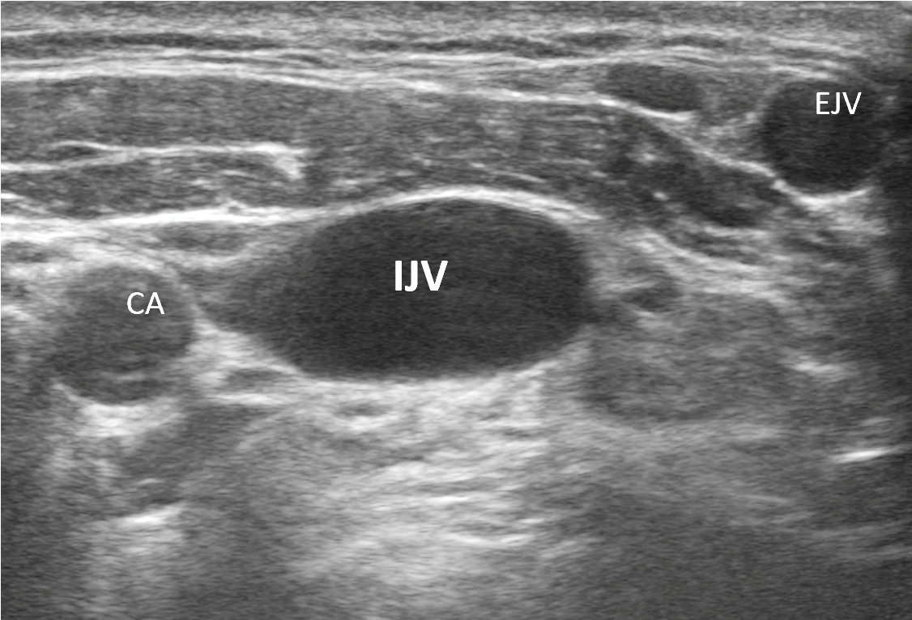

Figure S2: Out-of-plane puncture of the internal jugular vein (IJV) the arrow shows the pressure on the anterior wall of the vein of the tip of the needle
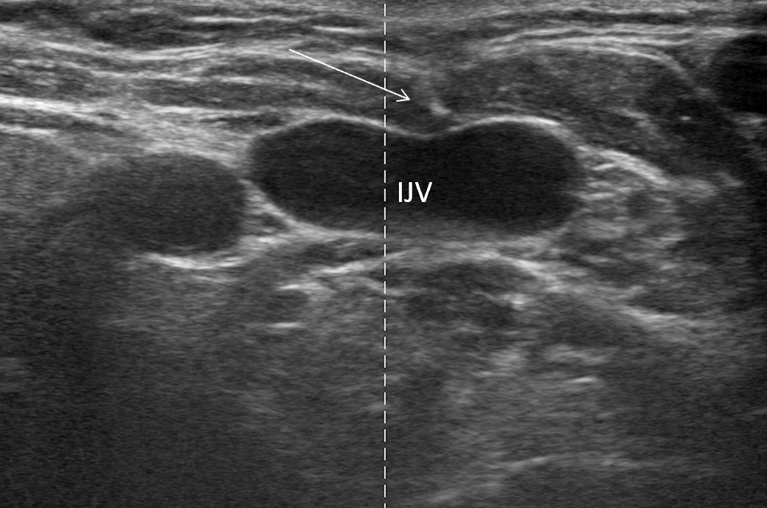

Figure S3: The arrow shows the tip of the needle in the middle of the internal jugular vein. The tip is visualized as a small hyperechoic dot.
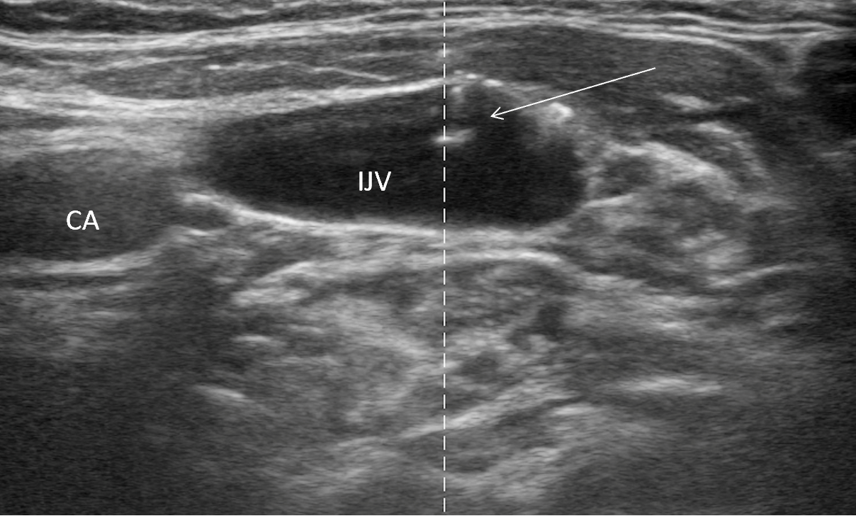

Figure S4: Long-axis visualization of the IJV. The arrows are showing the entrance of the guide-wire in the vein
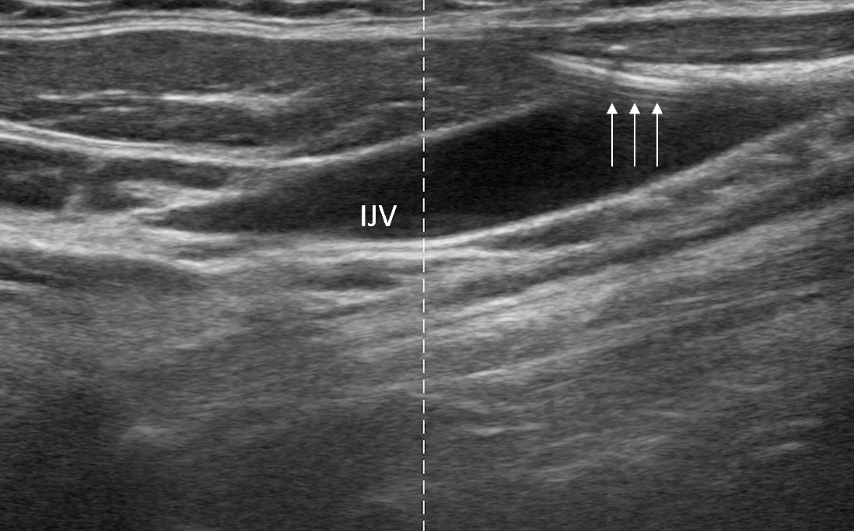

Video S2 (https://vimeo.com/561966905 ): Long-axis view of clot visible in internal jugular vein.
Figure S5 : Thrombus visible in non-compressible femoral vein