Supplementary tables and figures:

Characteristics/  therapy | Total number of patients | Days on therapy | Materials used | Weight  (kg) | Amount | Total mass (kg) and% of total inflow | % of total plastic
Total admissions (n) | 2839
Male/Female (n,%) | 1894 (67%) / 945 (33%)
Length of stay ICU (days, average) | 4.6
Mechanical ventilation | 2010 | 5442 | ventilation kits  filters  water | 0.2  0.2  1.0 | 2500  8920  6000 | 500(0.20%)  223 (0.09%)  6282 (2.5%) | 1.6%  0.69%  0.88%*
CRRT | 263 | 2058 | CRRT kits | 1.0 | 965 | 965 (0.39%) | 3.0%
ECMO | 64 | 391 | ECMO kits | 3.85 | 70 | 269 (0.11%) | 0.84%
Supplementary table 1: patient characteristics of the ICU in 2019 together with product use and total mass of ventilation, ECMO and CRRT therapies; Sterile water infusion bag and its packaging has a mass of 0.047 kg per bag (empty bag), representing a total plastic mass of 282 kg.

Water* |  | 146,000
Hydrochloric acid** |  | 33,100
Other medicine ingredients |  | 5,090
Glass |  | 9,710
Synthetic plastics and rubbers |  | 32,167
PP | 8,760
LDPE | 5,730
Nitrile | 5,360
HDPE | 3,650
PC | 2,550
PVC | 1,690
PA | 1,240
PS | 1,140
Laminated paper | 805
Elastic | 778
PET | 324
PU | 140
ABS | 0.1
Rubber | 0.2
Synthetic fabrics |  | 9,930
PP/PE fabric | 8,740
Polyester | 606
Viscose | 584
Biobased materials |  | 8,148
Fluff pulp | 6,080
Cardboard/Paper | 1,560
Cotton | 490
Wood | 18
Chemicals |  | 4,038
Laundry Detergent | 1,860
Cleaning chemicals | 298
Metals |  | 770
Stainless steel | 667
Aluminium | 102
Other Metals | 1
Supplementary table 2: Mass of materials types and summation of mass per material group. *48% of the water is used for CRRT purpose (5 liter bags). These bags contain hydrochloric acid** as main ingredient. The additional water percentage (52%) consists of intravenous infusion fluids.

Outflow | Treatment | Mass (kg)
Hazardous Waste | Hazardous Waste Incineration | 3,910
Glass waste | Glass Recycling | 1,120
Solid Fraction Pharmafilter | Incineration | 6,580
Specific Hospital Waste | Incineration | 39,400
Sewage | Sewage Treatment Plant | 172,000

Supplementary table 3: total mass outflows of waste and treatments of waste
Outflow of solid and liquid waste: The hospital uses Pharmafilter© (Amsterdam, The Netherlands). This is a system that can process both solid waste and liquid waste (sewage). The liquid waste is filtered from drug residue and bacterial and viral loads before it leaves the hospital through the sewer. The solid part is grinded and is transferred to the incinerator, together with the rest of the hospital waste
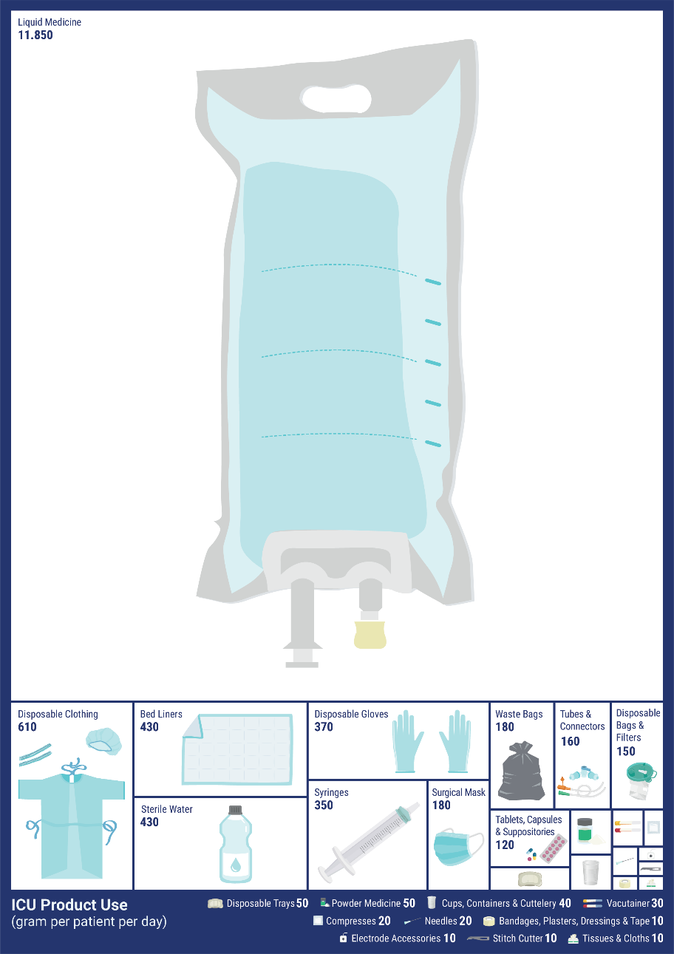

Supplementary figure 1: mass of product used per patient per day (in gram)

