Supplements to the Letter “The cytokine adsorber Cytosorb® does not reduce ammonia concentrations in critically ill patients with liver failure – a prospective study”

T1: Conventional therapeutic approaches to lower ammonia concentrations
Ammonia is a 5 Dalton molecule that is produced in the gut during urea breakdown by intestinal bacteria [1]. There are various therapeutic approaches for the treatment of hyperammonemia aiming to reduce the production of ammonia in the intestine. Exemplary, mild hypothermia was shown to result in decreased production in the gut and less cerebral edema [2]. If conservative therapy attempts fail, ammonia can be eliminated by extracorporeal elimination procedures that also have the opportunity of a good temperature control. Several studies revealed a linear relationship between ammonia clearance and intensity of kidney replacement therapy. Slack et al. investigated the effect of low (35 ml/kg/h) versus high (90 ml/kg/h) filtration volume on ammonia clearance. A strong positive correlation (r = 0.82) was observed between ammonia clearance and filtration volume [3]. Warrilow et al. found no difference in ammonia clearances in different CKRT modalities. The duration of CKRT was mostly relevant for the decrease in ammonia blood concentration [4]. In contrast, blood flow, effluent rate, and modality of the dialysis were also observed as influencing factors on ammonia clearance [5].

T2: Study setting
The Cyto-SOLVE study included 20 adult patients (≥ 18 years) between May 2021 and August 2022 with acute liver failure, the necessity of Cytosorb® application initiated by the attending physicians, total bilirubin >10 mg/dl, and acute kidney injury (AKI) requiring CKRT. Exclusion criteria were no consent to the participation in the study and prior Cytosorb® application. The primary intention for the initiation of CKRT was an anuric or oliguric renal failure and not liver support. AKI was diagnosed by the KDIGO consensus criteria [6]. The motivation for the use of Cytosorb® was to remove hepatotoxic substances. Only the first Cytosorb® application (=12 hours) was evaluated in this study. In some patients, the cartridge was changed during their stay at the ICU; this was performed independently of the study. Cytosorb® was installed post-dialyzer into the Fresenius MultiFiltrate circuit (MultiFiltrate Ultraflux® AV 1000S).
The mode of dialysis was chosen by the physicians; 15 patients were treated with CVVHD (CiCa®) and 5 patients with CVVHDF post-dilution (MultiBic®). Effluent flow rate was calculated for both modalities [7]:
$$Effluent flow CVVHD=\frac{\left(dialysate+net ultrafiltration\right) }{body weight }$$
$$Effluent flow CVVHDF=\frac{\left(dialysate+substituate+net ultrafiltration\right) }{body weight}$$
Blood samples were taken according to the study protocol ten minutes after the initiation of Cytosorb®, six hours after initiation, and 12 hours after initiation. The arterial ammonia concentration can be considered equivalent to the blood in-flow line concentration pre-dialyzer. In four patients (2 out of 15 patients with CVVHD (13.3%) and 2 out of 5 patients with CVVHDF (40%)), the CKRT system clotted before the 12-hour measurement, so these data points are missing. This resulted in the loss of the blood within the extracorporeal circuit. The particularly high rate of clotting events in the group with CVVHDF should be noted in terms of its safe use as well.

T3: Ammonia measurement
All laboratory parameters were assayed at the institute of laboratory medicine using standard test methods. EDTA anticoagulated plasma was obtained by centrifugation of whole blood at the intensive care unit immediately after sampling. Given that ammonia is unstable, separated plasma samples were immediately frozen and stored stably at -80°C for up to three weeks to measure plasma ammonia concentrations using a glutamate-dehydrogenase based assay on the Cobas 8000 c702 clinical chemistry analyzer (Roche Diagnostics) [8]. This sample preparation procedure prevented the decay of ammonia in the best possible way. Furthermore, the arterial concentration was measured in routine clinical practice for quality control (transport on ice, immediate measurement). There were no relevant differences between the deep frozen and the directly measured samples (deviation <10%).

T4: Statistical analysis
Statistics were performed with IBM SPSS statistics (Version 26.0. IBM Corp., Armonk, NY, USA). T-test with associated samples was used after examination of a normal distribution of the examined parameters (Shapiro- Wilk Test). Ammonia concentration in the blood at baseline was compared with the concentration after six and twelve hours. Furthermore, ammonia concentration pre-dialyzer was compared with post-dialyzer and pre-Cytosorb® was compared with post-Cytosorb® at the different time points. In addition, the clearance of patients with CVVHD and CVVHDF of both the dialyzer and Cytosorb® was compared. A correlation analysis (Pearson correlation coefficient) was performed between blood flow and ammonia clearance and between effluent flow and ammonia clearance of the dialyzer.

T5: Potential factors influencing the ammonia clearance of the dialyzer
The ammonia clearance of patients treated with CVVHD was compared with those treated with CVVHDF. There was a significant higher clearance of the dialyzer in patients treated with CVVHDF compared to those with CVVHD (p < 0.001). Nevertheless, the blood flow and effluent rate was also significantly higher (p < 0.001). Furthermore, a strong correlation (r > 0.8, p < 0.001) between blood flow and ammonia clearance of the dialyzer at the three time points was observed. A strong correlation was also detected between effluent rate and ammonia clearance of the dialyzer (r = 0.85, p < 0.001). These results are in line with existing literature [5, 9, 10].

T6: Potential factors influencing the ammonia clearance of Cytosorb®
There might be a higher ammonia elimination by Cytosorb® in patients with higher initial ammonia concentrations in the blood. We saw no difference in ammonia clearance of Cytosorb® depending on the initial ammonia concentration in the blood which is reflected by no correlation between ammonia concentration and clearance of Cytosorb® (r = -0.28; 0.13; 0.32; each p>0.05). There might also be a difference in the ammonia elimination by Cytosorb® between patients treated with CVVHD or CVVHDF. Furthermore, no significant difference in the ammonia clearance of Cytosorb® was detected between patients treated with CVVHD and those with CVVHDF (each p>0.05). It cannot be assumed that the mode of dialysis influences the ammonia clearance of Cytosorb®.

1. Romero-Gomez, M., et al., Gut ammonia production and its modulation. Metab Brain Dis, 2009. 24(1): p. 147-57.
2. Butterworth, R.F., Pathogenesis of hepatic encephalopathy and brain edema in acute liver failure. J Clin Exp Hepatol, 2015. 5(Suppl 1): p. S96-S103.
3. Slack, A.J., et al., Ammonia clearance with haemofiltration in adults with liver disease. Liver Int, 2014. 34(1): p. 42-8.
4. Warrillow, S., C. Fisher, and R. Bellomo, Correction and Control of Hyperammonemia in Acute Liver Failure: The Impact of Continuous Renal Replacement Timing, Intensity, and Duration. Crit Care Med, 2020. 48(2): p. 218-224.
5. Naorungroj, T., et al., Extracorporeal Ammonia Clearance for Hyperammonemia in Critically Ill Patients: A Scoping Review. Blood Purif, 2021. 50(4-5): p. 453-461.
6. Andrassy, K.M., Comments on 'KDIGO 2012 Clinical Practice Guideline for the Evaluation and Management of Chronic Kidney Disease'. Kidney Int, 2013. 84(3): p. 622-3.
7. Vasquez Jimenez, E., S.J. Anumudu, and J.A. Neyra, Dose of Continuous Renal Replacement Therapy in Critically Ill Patients: A Bona Fide Quality Indicator. Nephron, 2021. 145(2): p. 91-98.
8. Goldstein, B.N., et al., Investigations of blood ammonia analysis: Test matrices, storage, and stability. Clin Biochem, 2017. 50(9): p. 537-539.
9. Boer, D.P., et al., Successful Treatment of Severe Hyperammonaemia with Ultra-High Dose Continuous Veno-Venous Haemodiafiltration. Blood Purif, 2019. 48(3): p. 283-285.
10. Ronco, C., et al., Effects of different doses in continuous veno-venous haemofiltration on outcomes of acute renal failure: a prospective randomised trial. Lancet, 2000. 356(9223): p. 26-30.

Table S1
Table S1: Detailed patient characteristics and study information
Patient characteristics | Median (IQR) or n [%]
Age (years) | 53 (37, 63)
Weight (kg) | 79 (64, 85)
Height (m) | 1.69 (1.65, 1.80)
Male / Female | 14 [70] / 6 [30]
SAPS II | 78 (69,90)
28-day mortality | 9 [45]
Dialysis characteristics | Median (IQR) or free text
Dialyzer | Multifiltrate, Fresenius Ultraflux AV 1000S, surface area 1.4 m², elimination spectrum: 0 – 15kDa
CVVHD (CiCa®) / CVVHDF (MultiBic®) | 15 [75] / 5 [25]
Blood Flow (ml/min)  - Blood flow CVVHD (ml/min)  - Blood flow CVVHDF (ml/min) | 100 (100, 162)  100 (100, 100)  200 (200, 300)
Dialysate Flow (ml/h) | 2000 (2000, 2125)
Pre-dilution / Post-dilution in patients with CVVHDF | 0 [0] / 5 [100]
Post-dilution substitution fluid rate in patients with CVVHDF | 2000 (1000, 3500)
Anticoagulation  - Citrate (n)  - Unfractioned Heparin <1000IE/h (n)  - Unfractioned Heparin >1000IE/h (n)  - Agatroban (n)  - None (n) | 15 [75] (all patients with CVVHD)  8 [40]  4 [20]  5 [25]  3 [15]
Net ultrafiltration (ml/h) | 50 (0, 100)
Effluent rate (ml/kg/h)  - All patients  - CVVHD  - CVVHDF | 30 (25, 49)  27 (25, 35)  59 (56, 65)
Cytosorb® | Integrated “post-Dialyzer”, Cytosorbents
Reasons for liver failure | n (%)
- Multi organ failure  - Graft failure  - secondary sclerosing cholangitis  - Sepsis  - acute on chronic liver failure  - unclear | 8 (40)  5 (25)  2 (10)  2 (10)  2 (10)  1 (5)
Comorbidities (extract) | n (%)
- arterial hypertension  - cirrhosis of the liver  - diabetes type II  - coronary artery disease  - pulmonary arterial hypertension  - chronic obstructive pulmonary disease | 6 (30)  5 (25)  3 (15)  3 (15)  2 (10)  2 (10)
Further therapies to lower ammonia concentration | n (%)
- ursodesoxycholacid (Ursofalk®)  - lactulose | 19 (95)  15 (75)
Nutrition management | n (%)
- Survimed® (without fiber)  - Diben HP® (rich in protein)  - Fresubin energy® (without fiber) | 12 (60)  4 (20)  4 (20)

Table S2
Table S2: Laboratory parameters before the initiation of Cytosorb®
Laboratory parameters before initiation of Cytosorb® | Median (IQR)
Ammonia (µmol/l) | 77 (45, 104)
Total bilirubin (mg/dl) | 14.7 (11.6, 18.6)
Total bile acid (µmol/l) | 60.5 (40.7, 141.9)
Urea (mg/dl) | 65 (56, 86)
Creatinine (mg/dl) | 1.8 (1.2, 2.4)
Alanine aminotransferase (U/l) | 160 (96, 271)
Aspartate aminotransferase (U/l) | 180 (115, 677)
Thrombocytes (G/l) | 73 (51, 123)
INR | 1.4 (1.3, 1.9)
partial thromboplastin time (sec.) | 38 (35, 57)

Table S3
Table S3: Ammonia concentration (µmol/L) at different time and sampling points.
ID | ammonia (µmol/L) d1, pre-dialyzer | ammonia (µmol/L) d1, post-dialyzer | ammonia (µmol/L) d1, post-Cytosorb | ammonia (µmol/L) d2, pre-dialyzer | ammonia (µmol/L) d2, post-dialyzer | ammonia (µmol/L) d2, post-Cytosorb | ammonia (µmol/L) d3, pre-dialyzer | ammonia (µmol/L) d3, post-dialyzer | ammonia (µmol/L) d3, post-Cytosorb
1 | 67 | 33 | 30 | 60 | 31 | 37 | 66 | 43 | 40
2 | 28 | 16 | 14 | 28 | 13 | 15 | 28 | 17 | 21
3 | 134 | 51 | 54 | 115 | 81 | 71
4 | 74 | 32 | 31 | 71 | 39 | 43 | 75 | 40 | 43
5 | 333 | 211 | 206 | 340 | 244 | 238 | 325 | 229 | 234
6 | 192 | 149 | 175 | 126 | 92 | 84 | 145 | 98 | 108
7 | 79 | 52 | 50 | 75 | 49 | 72
8 | 24 | 12 | 9 | 23 | 13 | 12 | 23 | 11 | 13
9 | 22 | 11 | 12 | 23 | 13 | 11 | 18 | 10 | 12
10 | 46 | 28 | 30 | 38 | 23 | 26 | 39 | 22 | 26
11 | 72 | 48 | 46 | 58 | 45 | 43 | 57 | 37 | 44
12 | 123 | 85 | 81 | 86 | 65 | 76 | 80 | 63 | 66
13 | 44 | 26 | 24 | 54 | 29 | 32 | 41 | 20 | 25
14 | 82 | 40 | 41 | 116 | 67 | 75
15 | 99 | 40 | 43 | 76 | 43 | 45 | 76 | 40 | 41
16 | 84 | 61 | 67 | 76 | 61 | 63
17 | 112 | 51 | 47 | 89 | 51 | 50 | 95 | 47 | 48
18 | 28 | 28 | 20 | 27 | 23 | 21 | 24 | 21 | 22
19 | 70 | 30 | 24 | 56 | 23 | 25 | 49 | 17 | 18
20 | 101 | 64 | 69 | 84 | 74 | 68 | 68 | 57 | 52

Table S4
Table S4: Ammonia clearance (ml/min) of the dialyzer and Cytosorb® and Pearson correlation coefficient between blood flow and ammonia clearance and effluent rate and ammonia clearance
Ammonia clearance (mL/min) | Median (IQR)
Dialyzer  - 0 hours  - 6 hours  - 12 hours | 52 (40 – 59)  42 (29 – 54)  42 (34 – 57)
Cytosorb®  - 0 hours  - 6 hours  - 12 hours | 4 (-7 – 11)  -6 (-15 – 8)  -7 (-17 – -4)
Correlation between ammonia clearance and blood flow | Correlation coefficient (p-value)
- 0 hours  - 6 hours  - 12 hours | 0.88 (< 0.001)  0.87 (<0.001)  0.94 (<0.001)
Correlation between ammonia clearance and effluent rate | 0.85 (<0.001)

Figure S1
Figure S1: Setup of the CKRT and Cytosorb® circuit with sampling points
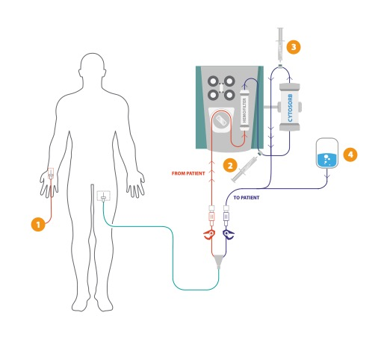
Note: 1. Sampling of the arterial concentration out of an arterial cannula, whereby the ammonia concentration represents the blood in-flow line concentration pre-dialyzer. 2. Sampling of the blood out-flow line concentration post-dialyzer, which also represents the concentration “pre-Cytosorb®”. 3. Sampling of the blood out-flow line concentration post-Cytosorb®. 4: Substituate added in 5 patients treated with CVVHDF post-Cytosorb®.

Figure S2
Figure S2: Ammonia clearance of the dialyzer depending on the blood flow and effluent rate
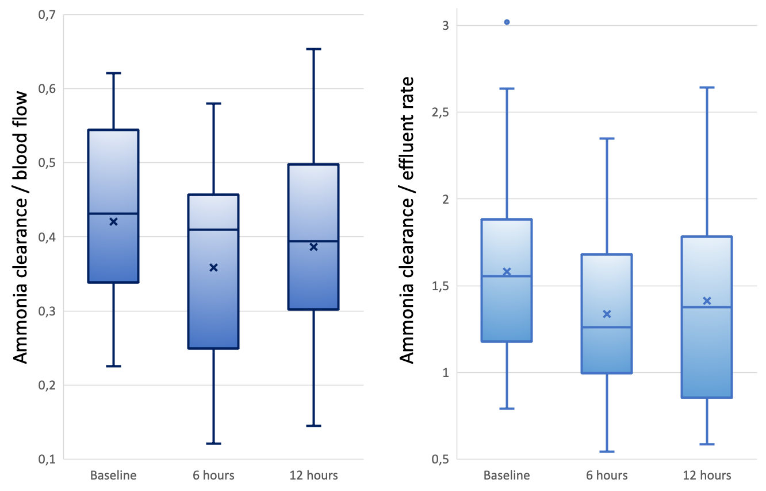
Note: Lift-side boxplots show the ammonia clearance depending on the blood flow at different time points and right-side boxplots the ammonia clearance depending on the effluent rate. The boxes of the boxplots represent the interquartile-range and the line the median. Whiskers were limited to 1.5 times of the interquartile range. The cross represents the mean.

