Supplementary material: Machine learning to predict poor school performance in paediatric survivors of intensive care – a population-based study
Patricia Gilholm PhD¹, Kristen Gibbons PhD¹, Sarah Brüningk PhD^{2,3}, Juliane Klatt PhD^{2,3}, Rhema Vaithianathan⁴, Debbie Long PhD^{1,5} Johnny Millar^{6,7,8}, Wojtek Tomaszevski⁴, Luregn J Schlapbach^{1,9}

- Child Heath Research Centre, The University of Queensland, Brisbane, Queensland, Australia
- Department of Biosystems Science and Engineering, ETH Zurich, Basel 4058, Switzerland
- SIB Swiss Institute of Bioinformatics, Lausanne 1015, Switzerland
- Institute for Social Science Research, The University of Queensland, Brisbane, Queensland, Australia
- School of Nursing, Centre for Healthcare Transformation, Queensland University of Technology, Brisbane, Queensland, Australia
- Paediatric Intensive Care Unit, The Royal Children’s Hospital, Melbourne, Victoria, Australia
- The Australian and New Zealand Intensive Care Society (ANZICS) Centre for Outcome and Resource Evaluation (CORE), ANZICS House, Melbourne, Victoria, Australia
- Murdoch Children’s Research Institute, Melbourne, Victoria, Australia
- Department of Intensive Care and Neonatology, and Children’s Research Center, University Children’s Hospital Zurich, Zurich, Switzerland

Corresponding Author:
Prof. Luregn Schlapbach, MD, PhD, FCICM
Department of Intensive Care and Neonatology
University Children’s Hospital Zurich – Eleonore Foundation
Steinwiesstrasse 75
CH-8032 Zurich Switzerland
Email: luregn.schlapbach@kispi.uzh.ch
Phone: +41 44 266 71 11

Table of Contents:
Supplementary Methods
Supplementary Table 1: Diagnostic and procedural codes with principal component loadings >0.3 for the 116 extracted principal components.
Supplementary Table 2: Demographic and clinical outcomes of Queensland PICU survivors who did and did not have linked NAPLAN educational data.
Supplementary Table 3: Demographic and clinical characteristics of children who died outside PICU after their last admission compared to PICU survivors who sat a NAPLAN test after their last admission.
Supplementary Table 4: Demographic and clinical outcomes of children included and excluded from the analysis.
Supplementary Table 5. Counts and percentages of primary and secondary outcomes for each grade cohort.
Supplementary Table 6: Mean AUROC, Mean AUPRC, and mean relative AUPRC of the five cross-validation folds for each model within each grade.
Supplementary Table 7: Mean AUROC, Mean AUPRC, and mean relative AUPRC of the five cross-validation folds for the secondary outcome of failing to meet the NMS on the reading or the numeracy domains.
Supplementary Table 8: Mean AUROC, Mean AUPRC, and mean relative AUPRC of the five cross-validation folds for the secondary outcome of failing to meet the NMS on any of the five domains.
Supplementary Table 9: Mean AUROC, Mean AUPRC, and mean relative AUPRC of the five cross-validation folds for the secondary outcome of failing to meet the NMS on at least two domains.
Supplementary Table 10: Mean AUROC, Mean AUPRC, and mean relative AUPRC of the five cross-validation folds for the secondary outcome of failing to meet the NMS all five domains.
Supplementary Table 11: Mean AUROC, mean AUPRC and mean relative AUPRC of the five cross validation folds of the combined model for subgroup predictions comprising key diagnostic groups, any comorbidity/no comorbidity, elective admission/non-elective admission, admission year between 1997-2008/admission year between 2009-2019, lead metropolitan PICU/Other ICUs
Supplementary Figure 1: Percentage of children failing to meet the national minimum standard on the reading and numeracy domains for the analysed ICU cohort compared to 2019 Queensland population data.
Supplementary Figure 2: Mean area under the receiver operating characteristic curve (AUROC) and mean relative area under the precision recall curve (AUPRC) for each model predicting the primary outcome using the last admission.
Supplementary Figure 3: Mean area under the receiver operating characteristic curve (AUROC) and mean relative area under the precision recall curve (AUPRC) for each model predicting the primary outcome using the last admission, worst admission and first admission.
Supplementary Figure 4: Mean receiver operating characteristic curves across cross-validation folds for each grade.
Supplementary Figure 5: Mean precision recall curves across cross-validation folds for each grade
Supplementary Figure 6: Mean normalised Shapley additive explanations (SHAP) importance scores for the top 20 predictors for each grade.
Supplementary Figure 7: Mean normalised Shapley additive explanations (SHAP) importance scores for the top 10 modifiable factors.
Supplementary Figure 8: Mean normalised Shapley additive explanations (SHAP) importance scores for the top 20 risk factors for the combined model including children who died outside of PICU.
Supplementary Figure 9: Mean receiver operating characteristic (ROC) ROC curve with mean area under the receiver operating characteristic curve (AUROC) (panel A) and mean precision-recall curve and mean area under the precision recall curve (AUPRC) (panel B) across cross-validation folds for the combined model including deaths outside PICU, with shading indicating ± two standard deviation error. Mean AUROCs ± one standard deviation error for patient subgroups for the model including deaths outside of PICU (panel C). The horizontal lines indicate the mean AUROC ± one standard deviation of the entire cohort.

Supplementary Methods
Linkage and cohort selection
The base cohort was extracted from the Australian and New Zealand Paediatric Intensive Care Registry (ANZPICR) and comprised all Queensland records from the registry since its inception in 1997 (1st January) until 31 December 2019, encompassing 43,244 admissions from 28,882 children (Figure 1). These ANZPICR records were then linked to the National Assessment Program - Literacy and Numeracy (NAPLAN) data by the Queensland Health Statistical Services Branch. The ANZPICR records were linked for Queensland NAPLAN records only. Therefore, children who were admitted to PICU in Queensland but did not sit their NAPLAN examinations in Queensland were not linked. There were 4,233 children admitted to PICU in Queensland, who were of an eligible age for NAPLAN testing (children born between 1993 and 2011) but did not have corresponding NAPLAN data. Of these children, 576 children died in ICU/hospital and 406 died outside of hospital. The remaining 3,251 were assumed to be alive at the time of NAPLAN testing. Reasons for missing NAPLAN data for survivors included residing or moving interstate or overseas, home-schooling, compliance and reporting errors, changing definitions for exemptions, children repeating a year level, as well as linkage errors. The final linked cohort consisted of 21,304 admissions from 13,957 children and 37,200 NAPLAN tests (Figure 1).
Queensland paediatric ICU records
28,882 children, 43,244 ICU admissions

Excluded children born before 1993 or after 2011
10,692 children, 15,252 admissions

Children of an eligible age to sit at least one NAPLAN test
18,190 children, 27,992 admissions

Excluded children who did not have Queensland NAPLAN records
4,233 children, 6,688 admissions
- 576 children died in ICU/hospital
- 406 children died outside hospital
- 3,251 children assumed to be alive at NAPLAN testing

Children with linked NAPLAN records
13,957 children, 21,304 admissions, 37,200 NAPLAN tests

Figure 1: Flowchart describing linkage and cohort selection. Qld: Queensland, ANZPICR: Australian and New Zealand Paediatric Intensive Care Registry; NAPLAN: National Assessment Program – Literacy and Numeracy.

Data pre-processing: ANZPICR
Deaths. The linked ANZPICR data contained 21,304 admissions from 13,957 children. Admissions were removed if they occurred after all the NAPLAN tests taken by each child leaving 18,532 admissions from 12,252 children included. Of the 2,771 excluded admissions, 114 resulted in death in ICU/hospital. Prior admissions from 33 children who died in ICU/hospital that occurred before their NAPLAN test were included. Children who died outside of hospital were identified through linkage with the Queensland Deaths Registry. Out of the total 13,957 children with linked NAPLAN data, 191 children died outside of hospital, of which 160 had admissions and NAPLAN tests prior to their death and were included in the analysis. An additional 3 children had an admission with a recorded death in hospital. However, these children had linked NAPLAN testing data that occurred after this admission and these deaths were not recorded in the Queensland Death Registry. Therefore, these children were assumed to be alive for their admission and were included in the analysis.
Missing data imputation. Data imputation was performed for all variables with missing data. The method of imputation varied based on the type of data (Table 1).
Table 1: Variable name, number and percentage missing, and imputation strategy for all imputed variables in the ANZPICR dataset. Denominator is the 21,304 ICU admissions.
Variable | N (%) missing | Imputation Strategy
Indigenous status | 7750 (36.4) | Coded as zero (not Indigenous)
Weight | 42 (0.2) | Replaced with random draw from normal distribution based on weight and gender,
Regionality | 66 (0.3) | Replaced with random draw from multinomial distribution with class probabilities equal to the observed proportions.
Index of Relative Socio-economic Disadvantage (IRSD) deciles | 66 (0.3) | Replaced with random draw from multinomial distribution with class probabilities equal to the observed proportions.
Systolic blood pressure on admission | 1734 (8.1) | If missing, assumed normal, impute as normal value based on age and gender.
PaO₂: Oxygen pressure (mmHg) on admission | 13086 (61.4) | If missing, assumed normal, imputed value drawn from a uniform distribution between 86-90.
FiO₂ at time of PaO₂ sample (fraction of oxygen inspired) | 12925 (60.1) | If missing, assumed normal, imputed with 0.21.
Base excess in arterial, capillary, or venous blood | 11778 (55.3) | If missing, assumed normal, drawn from a random uniform distribution from -2 to 2.
Time intubated (hours) | 8128 (38.2) | If missing, assumed not intubated, code time as zero.

Data pre-processing: NAPLAN
Children with linked education data were excluded from the analyses if all NAPLAN tests preceded their ICU admissions (N = 7,909 NAPLAN tests) or if the child was marked as absent or withdrawn from the Reading and Numeracy subtests (N=3,255 NAPLAN tests).
Remove duplicate tests. In order to ensure that each child had only one recorded test result for each grade, duplicate test results were removed. The strategy to remove the duplicates was dependent on the duplicate type and is outlined in Table 2. After removing duplicates and excluded tests the total number of tests analysed was 25,691.
Table 2: Type of duplicate, removal strategy and number of tests removed.
Duplicate type | Removal Strategy | Number of tests removed
Same test year, same grade, same test result | Remove duplicate entry | 3
Same test year, same grade, different test result | Remove both instances of the tests as cannot determine which are the correct test scores | 24
Different test year, same grade | Corresponds to children who have repeated a grade. The most recent test year was retained and an indicator variable identifying that it is a repeated test was created and included in the analysis. | 318

Principal component analysis for dimension reduction of diagnostic and procedural codes.
The ANZPICR registry contains over 500 diagnostic and procedural codes used to record the principal, underlying and associated diagnoses for each admission. The heterogeneous nature of the paediatric ICU means that most of these diagnostic codes represent rare conditions, present in less than 1% of the ICU population. Furthermore, many of the diagnostic codes represent symptoms or complications of other diagnostic codes and therefore, would be more predictive in combination with related diseases, than if evaluated individually.
In order to identify disease clusters, we performed dimension reduction of the 427 diagnostic and procedural codes present in the data, through principal components analysis (PCA). We first one-hot encoded the diagnostic and procedural codes recorded for the principal, underlying and associated diagnoses. We then performed a PCA with oblimin rotation using the tetrachoric correlation matrix (i.e. inferred Pearson Correlation of a 2x2 contingency table) of the diagnostic and procedural codes. Empty cells were imputed with 0.5 to correct for continuity. We extracted 116 principal components that had an eigenvalue >1. These 116 components explained 81% of the total variation. The codes with loadings >0.3 for each principal component have been recorded in Supplementary Table 1. These provide a general overview of which diagnostic and procedural codes are most strongly represented within each component.
Derivation of predictors
The following variables were derived from the original ANZPICR and NAPLAN data:
- Regionality index
- Index of Relative Socio-economic Disadvantage (IRSD) deciles
- The Principal Component (PC) cluster scores for diagnosis and procedural codes
- Risk Adjustment for Congenital Heart disease Scores (RACHS)
- Aggregate variables describing the ICU history
- Socioeconomic status class
- Repeated test

Regionality index. The regionality index was derived from the postcode provided for each ICU admission. The regionality index divides Australia into 5 classes of remoteness (Major City, Inner Regional, Outer Regional, Remote, Very Remote) based on their relative access to services (https://www.abs.gov.au/).
IRSD deciles. The IRSD deciles were derived from the postcode provided for each ICU admission. The IRSD is a general socio-economic index that summarises the economic and social conditions of households within an area (https://www.abs.gov.au/). The IRSD deciles range from 1 to 10, with 1 indicating the areas with the most disadvantage and 10 indicating the areas with the most advantage.
PC cluster scores. The Principal Component (PC) scores were extracted from the 116 PCs obtained from the PCA using the regression method, where the regression weights correspond to the inverse of the correlation matrix times the component loadings. The resulting PC cluster scores are standardised with a mean of zero and standard deviation of one.
RACHS. The Risk Adjustment for Congenital Heart disease Score (RACHS) is a classification system describing the procedural complexity for cardiac surgery¹. Each cardiac surgery procedural code is assigned a RACHS risk category ranging from 1 to 6, with 1 indicating the least complex and 6 indicating the most complex procedures. Children with no cardiac surgery procedural codes were coded as 0.The procedural codes used to derive the RACHS risk category variable were not included in the construction of the PCs.
Aggregate variables describing ICU history. To consider the PICU history for children with multiple ICU admissions, three aggregate variables were constructed, which were number of previous ICU admissions, total duration of ICU stay across all ICU admissions (hours) and total intubation time across all ICU admissions (hours).
Socioeconomic status (SES). The SES category variable was calculated from the parental occupation and education variables included in the NAPLAN data. The SES classification system was informed by literature²⁻⁴ and has been previously described.⁵ In brief, maternal and paternal education and occupational status were assessed for each parent on a scale of 1 to 5 (see below), and then averaged to calculate the status at the family level. If education and occupational information were only available for one parent, this was considered to represent the family level.
The resulting averaged score was then multiplied by 4 and subsequently categorized into Low SES (4 ≤ SES score ≤ 9), Medium SES (10 ≤ SES score ≤ 13), and High SES (14 ≤ SES score ≤ 20).
- Occupation:
5=Senior management in large business organisation, government administration and defence, and qualified professionals,
4=Other business managers, arts/media/sportspersons and associate professionals,
3=Tradespeople, clerks and skilled office, sales and service staff,
2=Machine operators, hospitality staff, assistants, labourers and related workers,
1=Not in paid work in last 12 months,
0=Not stated/Unknown

- Education – highest education completed, combining post-school and school education:
5=Bachelor degree or above,
4=Advanced diploma/Diploma,
3=Certificate I to IV (including trade certificate),
2=High school (Y12 completed)
1= Less than high school (up to Y11)
0=Not stated/Unknown
If no information was available, SES was missing, and no imputation was performed.
Repeated test. A repeated test variable was created to indicate children who had repeated a grade (Table 2).
Description of all predictor variables

Table 3: Variables included as predictors and their categories or units of measurement.
Variables | Categories/unit of measurement
Demographics
Gender | Male/Female
Indigenous Status | Not Indigenous/Indigenous
Age | Months
Regionality (Remoteness Areas)ª | 1 Major City  2 Inner Regional  3 Outer Regional  4 Remote  5 Very Remote
Index of regional socioeconomic  advantage and disadvantage  Deciles (IRSD)ª | 10 Deciles, 1 = most disadvantage, 10 = most advantage
Admission Information
ICU Admission Source | 1 OT recovery  2 Emergency Department  3 Ward  4 Other ICU/NICU Same Hospital  5 Direct ICU admission  6 OT (direct admission from another ICU/NICU via OT)
Hospital Admission Source | 1 Home or accident scene  2 Other hospital – ED  3 Other hospital – Operating theatre or recovery  4 Other hospital – ICU or NICU  5 Other hospital – Ward  6 Inborn
Interhospital Transfer | Yes/No
Elective Admission | Elective admission/non-elective admission
Recovery from surgery or  Procedure | Yes/No
Cardiac Bypass | Admitted following cardiac bypass/No
ICU length of stay (current  admission) | Hours
Total ICU length of stay (all  admissions)ª | Hours
Number of previous ICU  admissionsª | Count of previous admissions
Severity on admission to ICU^{b}
Respiratory support in the first hour | Yes/No
Systolic blood pressure at  Admission | mmHg
PaO₂: arterial oxygen pressure at admission | mmHg
FiO₂ at time of PaO₂ sample  (fraction of oxygen inspired) | Expressed as fraction PaO₂ /FiO₂
Base excess in arterial, capillary, or  venous blood at admission | mmol/L
Pupillary reaction at admission | Both fixed and dilated/ all other responses including reactive and unknown
Specific Therapies used during PICU stay
Continuous hemofiltration | Yes/No
Intermittent haemodialysis | Yes/No
Peritoneal dialysis | Yes/No
Plasma filtration | Yes/No
High frequency oscillation | Yes/No
Inhaled nitric oxide | Yes/No
ECMO | Yes/No
Time intubated (current admission) | Hours
Total time intubated (all  admissions)ª | Hours
Intubated | Yes/No
Paediatric Index of Mortality (PIM)
PIM2 | Predicted risk of mortality (expressed as proportion between 0 and 1)
Diagnostic and procedural codes
PC scores derived from 427  diagnostic/procedural codesª | 116 principal component variables derived using Principal Component Analysis. The principal component scores follow a standard normal distribution, i.e. N(0,1)
Risk adjustment for congenital  heart surgery score (RACHS)ª | 0 No congenital heart surgery  1 RACHS level 1 (lowest complexity)  2 RACHS level 2  3 RACHS level 3  4 RACHS level 4  5 RACHS level 5  6 RACHS level 6 (highest complexity)
NAPLAN variables
SES categoryª | 0 Missing SES  1 Low SES  2 Mid SES  3 High SES
Repeated testª | Test taker repeated the grade/No
ª See Supplementary Table 1 for PC loadings ^{b} Physiology variables are based on the first available measurement at first contact with ICU doctor or specialist paediatric retrieval team; ICU = Intensive Care Unit, OT = Operating Theatre, NICU = Neonatal Intensive Care Unit, ED = Emergency Department, ECMO = Extracorporeal Membrane Oxygenation, PC = Principal Component, SES = Socioeconomic Status

Cross-validation and Hyperparameter Optimisation

In order to control bias and avoid overfitting, the models were trained, validated, and tested using five-fold stratified nested cross-validation, which is comprised of an inner loop for hyperparameter optimisation and an outer loop for model evaluation. In nested cross-validation the data is split into k folds, where for each iteration of the outer loop, one fold is reserved for testing. The remaining k-1 folds (training set) are passed through the inner-loop, where the model parameters are tuned through k-fold cross-validation of the training set, using grid search. The best hyperparameters selected through the inner-loop cross-validation procedure are then used to train the model using the complete training set and tested using the hold out test set in the outer-loop. In our application we split the data into five inner and five outer folds. For all models, both the inner and outer folds were stratified by the primary outcome prevalence and the SES category variable, to control for any bias across the folds.
Hyperparameters for each of the four machine learning algorithms are described in Table 4, along with the values for each parameter which were specified within the grid search during the nested cross-validation procedure. Python code for the nested cross-validation procedure for all models is available online (https://github.com/TrishGilholm/ML_prediction_school_outcomes).

Table 4. Hyperparameter grid used to optimise models in the inner cross-validation loop
Model | Hyperparameter | Values
LR | C: Inverse of regularisation strength | 0.0000001, 0.000001, 0.00001, 0.0001, 0.001, 0.01, 0.1, 1, 10, 100
RF | Max features: Maximum number of predictors to be considered for each tree | 13, 25, 50, 75
RF | Max depth: Maximum depth of each tree | 7, 10, 13
RF | Minimum Samples Leaf: Minimum number of samples required to be at a leaf node | 3, 6, 9
RF | N estimators: The number of trees in the forest | 100, 300, 500
GBM | Number of leaves: Maximum number of tree leaves for base learners | 15, 31, 50
GBM | Learning rate: Boosting learning rate | 0.1, 0.3, 0.5
GBM | Regularisation alpha: L1 regularisation term on weights | 0.001, 0.01, 0
GBM | Regularisation beta: L2 regularisation term on weights | 0.001, 0.01, 0
GBM | N estimators: Number of boosted trees | 50, 100, 200
MLP | Alpha: L2 penalty (regularisation) parameter | 0, 0.01, 0.001, 0.000001
MLP | Hidden layer sizes: The ith element represents the number of neurons in the ith hidden layer | (128, 64, 32, 16, 8)  (64, 32, 16, 8)  (32, 16, 8)  (16, 8)
MLP | Learning rate initialisation: The initial learning rate used | 0.001, 0.0001, 0.00001

All remaining hyperparameters not specified in the grid were set to the default values for the LR, RF and GBM models. For the MLP, the following hyperparameters were fixed to these specified values:
- Solver: “Adam”
- Activation: “ReLu”
- Early stopping: True
- Batch size: 500
- Validation fraction: 0.25

References for Supplementary Methods

1. Jenkins KJ, Gauvreau K, Newburger JW, Spray TL, Moller JH, Iezzoni LI. Consensus-based method for risk adjustment for surgery for congenital heart disease. The Journal of thoracic and cardiovascular surgery 2002; 123(1): 110-8.
2. Werner H, Latal B, Valsangiacomo Buechel E, Beck I, Landolt MA. Health-related quality of life after open-heart surgery. J Pediatr 2014; 164(2): 254-8 e1.
3. Landolt MA, Vollrath M, Laimbacher J, Gnehm HE, Sennhauser FH. Prospective study of posttraumatic stress disorder in parents of children with newly diagnosed type 1 diabetes. Journal of the American Academy of Child and Adolescent Psychiatry 2005; 44(7): 682-9.
4. Schlapbach LJ, Aebischer M, Adams M, et al. Impact of sepsis on neurodevelopmental outcome in a Swiss National Cohort of extremely premature infants. Pediatrics 2011; 128(2): e348-57.
5. Tomaszewski W, Ablaza C, Straney L, et al. Educational Outcomes of Childhood Survivors of Critical Illness-A Population-Based Linkage Study. Crit Care Med 2022; 50(6): 901-12.

Supplementary Table 1: Diagnostic and procedural codes with principal component loadings >0.3 for the 116 extracted principal components.
PCA number | Codes with loadings >0.3 | Loading
PC1 | 439: Bronchiectasis | 0.302
PC2 | 117: Trauma - Head  151: Cyclist  152: Fall  159: Sports Injury  164: Horse Related Injury  332: Intracranial Haemorrhage - Traumatic  1308: Intracranial Haematoma Evacuation | 0.539  0.343  0.798  0.424  0.422  0.645  0.598
PC3 | 215: Pulmonary Atresia or Stenosis  223: VSD  229: RV Outflow Obstruction  235: MAPCAs  266: Previous Cardiac Surgery  1102: Cardiac Catheter - Diagnostic | 0.508  0.566  0.364  0.682  0.343  0.360
PC4 | 501: Haemolytic Uraemic Syndrome  503: Renal Failure - Acute | 0.525  0.749
PC5 | 307: CSF Shunt Malfunction or Infection  314: Hydrocephalus  318: Meningomyelocele or Spina Bifida  1303: CSF Shunt Insertion or Revision | 0.888  0.651  0.405  0.920
PC6 | 454: Aspiration  465: Pneumonia or Pneumonitis | 0.354  0.521
PC7 | 325: Muscular Dystrophy  844: Scoliosis  865: Skeletal Dysplasia  1802: Spinal Instrumentation | 0.366  0.666  0.335  0.806
PC8 | 603: Gastroenteritis  723: Rotavirus  806: Dehydration  831: Shock - Hypovolaemic | 0.868  0.751  0.547  0.386
PC9 | 107: Hanging or Strangulation  121: Ingestion - drug  158: Self Injury  863: Behavioural Disorder | 0.449  0.911  0.948  0.307
PC10 | 459: Empyema  462: Lung Abscess  465: Pneumonia or Pneumonitis  721: Pneumococcus  1404: Lung Decortication  1410: Thoracoscopy  1411: VATS procedure | 0.887  0.357  0.359  0.386  0.721  0.353  0.748
PC11 | 458: Cystic Fibrosis  610: Liver Failure - Chronic  619: Varices - Oesophageal or Gastric  625: Portal Hypertension  1612: Transplant - Liver | 0.485  0.564  0.800  0.805  0.435
PC12 | 436: Stenosis - Trachea and/or Bronchi  739: Aspergillosis  843: Previous Bone Marrow Transplant  849: Graft vs Host Disease  1510: Dilatation of Airway | 0.379  0.531  0.816  0.628  0.465
PC13 | 505: Previous Renal Transplant  737: Staphylococcus aureus - Methicillin Sensitive  860: Osteomyelitis | 0.318  0.710  0.362
PC14 | 110: Immersion (Near Drowning)  309: Encephalopathy, Acute - Hypoxic Ischaemic  454: Aspiration  467: Pulmonary Oedema  803: Cardiac arrest - Out of Hospital  828: Respiratory arrest - Out of Hospital | 0.850  0.650  0.415  0.326  0.615  0.790
PC15 | 506: Urinary Tract Infection  730: E Coli  731: Klebsiella | 0.834  0.729  0.386
PC16 | 203: Aortic Insufficiency  212: Mitral Insufficiency  221: Tricuspid Insufficiency  265: Rheumatic Heart Disease | 0.559  0.826  0.495  0.859
PC17 | 500: Renal - Other  502: Nephrotic and/or Nephritic Syndrome  504: Renal Failure - Chronic  505: Previous Renal Transplant  819: Immunosuppression - Acquired  1611: Transplant - Kidney | 0.404  0.421  0.785  0.387  0.378  0.854
PC18 | 305: Brain Infarction or Stroke  316: Intracranial Hypertension (Raised ICP) | 0.739  0.345
PC19 | 839: Craniosynostosis  1105: Massive Intraoperative Transfusion (>1 blood vol)  1701: Cranial Vault Reshaping | 0.907  0.628  0.939
PC20 | 102: Burns  105: Electrocution  112: Smoke Inhalation  150: Injury Mechanism - Other  833: SIRS  1604: Burns Surgery | 0.965  0.392  0.404  0.369  0.435  0.917
PC21 | 306: Brain Tumour  329: Brain Cyst  808: Diabetes Insipidus  1302: Craniotomy - Posterior Fossa  1311: Third Ventriculostomy | 0.843  0.521  0.515  0.677  0.445
PC22 | 434: Malacia - Trachea and/or Bronchi  437: Tracheo-oesophageal Fistula  612: Oesophageal Atresia  1405: Oesophageal Atresia Repair  1408: Tracheo-oesophageal Fistula Repair | 0.309  0.853  0.853  0.547  0.684
PC23 | 116: Trauma - Facial  1700: Craniofacial Surgery - Other  1702: Dental Surgery  1704: Mandibular Mobilisation | 0.344  0.815  0.473  0.342
PC24 | 405: Obstructive Sleep Apnoea  1501: Adenoidectomy and/or Tonsillectomy | 0.568  0.650
PC25 | 604: Gastrointestinal Haemorrhage  618: Ulcer - Gastric or Gastritis  831: Shock - Hypovolaemic  1607: GI Endoscopy and/or Sclerotherapy  1617: Laparotomy - GI Haemorrhage | 0.834  0.616  0.353  0.575  0.521
PC26 | 847: Haematological Disorder | 0.756
PC27 | 201: Absent Pulmonary Valve  218: Tetralogy of Fallot  228: Pulmonary Insufficiency  229: RV Outflow Obstruction  1240 (new): PA Plasty or Repair | 0.514  0.927  0.693  0.384  0.430
PC28 | 317: Meningitis  717: Meningococcus  721: Pneumococcus  734: Streptococcus Group B  832: Shock - Septic | 0.903  0.707  0.363  0.356  0.338
PC29 | 122: Ingestion - non-drug  621: Bowel Perforation  1616: Laparotomy - Bowel Perforation | 0.366  0.790  0.756
PC30 | 412: Vocal Cord Paresis  456: Congenital Diaphragmatic Hernia  466: Pulmonary Hypoplasia  1402: Diaphragm Repair | 0.333  0.906  0.355  0.831
PC31 | 207: Coarctation  211: Interrupted or Hypoplastic Aortic Arch  221: Tricuspid Insufficiency  830: Shock - Cardiogenic | 0.628  0.542  -0.301  0.305
PC32 | 202: Anomalous Coronary Artery  251: Cardiac Failure  253: Cardiomyopathy/Myocarditis  262: Vasculitis | 0.476  0.368  0.900  0.447
PC33 | 455: Chylothorax  817: ICU Procedure (e.g., CVC Insertion) | 0.337  0.867
PC34 | 601: Bowel Obstruction  605: Gastroschisis or Exomphalos  616: Short Gut Syndrome  627: Volvulus  1615: Laparotomy - Bowel Obstruction | 0.822  0.481  0.306  0.567  0.940
PC35 | 431: Asthma | 0.755
PC36 | 222: Truncus Ateriosis  256: Endocarditis  854: Velo Cardio Facial Syndrome (22q11.2) | 0.622  0.308  0.767
PC37 | 457: Congenital Lung Anomaly  1406: Pneumonectomy or Lobectomy | 0.918  0.947
PC38 | 408: Subglottic Stenosis  1503: Cricoid Split  1504: Laryngeal Reconstruction  1509: Tracheal Reconstruction/Tracheoplasty | 0.865  0.540  0.485  0.408
PC39 | 626: Previous Liver Transplant  705: Candida  810: Diabetes Mellitus without Ketoacidosis  819: Immunosuppression - Acquired  829: Sepsis | 0.567  0.316  0.562  0.411  0.320
PC40 | 203: Aortic Insufficiency  204: Aortic Stenosis  227: LV Outflow Obstruction  1107: Cardiac Catheter - Interventional | 0.443  0.793  0.650  0.556
PC41 | 104: Drug Toxicity - Iatrogenic  310: Encephalopathy, Acute - Other  609: Liver Failure - Acute | 0.553  0.327  0.717
PC42 | 206: AVSD - Complete/Transitional w VSD component  853: Down Syndrome | 0.404  0.843
PC43 | 727: Streptococcus - Other  822: Necrotising Fasciitis  837: Toxic Shock Syndrome | 0.788  0.438  0.480
PC44 | 407: Retropharyngeal Abscess  1507: Retropharyngeal Abscess Drainage | 0.980  0.874
PC45 | 303: Brain AV Malformation  315: Intracranial Haemorrhage - Spontaneous  324: Cerebral Aneurysm  1307: ICP Monitor or Vent. Drain Insertion  1308: Intracranial Haematoma Evacuation | 0.722  0.887  0.490  0.317  0.480
PC46 | 615: Pyloric Stenosis  1103: Ex-prem, Post GA  1600: General Surgery - Other | 0.766  0.572  0.812
PC47 | 464: Pleural Effusion | 0.514
PC48 | 318: Meningomyelocele or Spina Bifida  328: Arnold Chiari Malformation  1304: Decompression - Cranial  1310: Decompression - Craniocervical | 0.310  0.922  0.323  0.777
PC49 | 319: Myopathy  814: Home Ventilation Patient  816: ICU Diagnostic Monitoring - Elective | 0.571  0.320  0.803
PC50 | 804: Chromosomal Anomaly | 0.880
PC51 | 701: Adenovirus | 0.780
PC52 | 818: Immunodeficiency - Congenital | 0.560
PC53 | 406: Pierre Robin Syndrome  415: Cleft Palate  1706: Cleft Palate Repair | 0.883  0.414  0.959
PC54 | 452: Apnoea - Central  470: Pertussis Syndrome  720: Pertussis  830: Shock - Cardiogenic | 0.430  0.895  0.952  0.307
PC55 | 430: Lower Airway - Other | 0.778
PC56 | 404: Laryngotracheobronchitis (Croup)  409: Tracheitis  719: Parainfluenza Virus | 0.871  0.560  0.663
PC57 | 226: Double Outlet Right Ventricle  254: Dysrhythmia - Supraventricular  830: Shock - Cardiogenic  901: Cardioversion/Defibrillation | 0.315  0.852  0.536  0.312
PC58 | 728: Varicella  741: Staphylococcus - Coagulase Negative  807: Dermatological Disorder | 0.474  0.425  0.732
PC59 | 500: Renal - Other | 0.396
PC60 | 320: Neuropathy  740: Human Metapneumovirus | 0.846  0.389
PC61 | 115: Trauma- Chest  118: Trauma - Skeletal  153: Farm Equipment  156: MVA - Pedestrian  162: Crush Injury  451: Air Leak Syndrome | 0.469  0.368  0.457  0.682  0.776  0.315
PC62 | 233: l-TGA (Levo-Transposition of Great Arteries)  269: Heart Block  1203 (new): Pacemaker Insertion or Revision | 0.480  0.693  0.831
PC63 | 402: Epiglottitis  711: Haemophilus Influenzae Type b | 0.352  0.822
PC64 | 331: Cerebral Oedema  1307: ICP Monitor or Vent. Drain Insertion | 0.590  0.329
PC65 | 700: Infection - Other | 0.860
PC66 | 1100: Post Procedure - Other | 0.913
PC67 | 600: Gastrointestinal - Other | 0.668
PC68 | 411: Upper Respiratory Infection - Other  461: Hypoventilation - Central  799: No Organism Identified  814: Home Ventilation Patient | 0.836  0.502  0.317  0.398
PC69 | 733: Pseudomonas | 0.565
PC70 | 300: Neurological - Other | 0.822
PC71 | 435: Mediastinal Mass  1400: Thoracic Surgery - Other | 0.348  0.765
PC72 | 403: Foreign Body - Inhaled  413: Subglottic Haemangioma  1500: ENT - Other  1505: Laryngobronchoscopy | 0.754  0.385  0.329  0.601
PC73 | 726: Staphylococcus | 0.843
PC74 | 607: Intussusception  1608: Intussusception Repair | 0.930  0.845
PC75 | 800: Miscellaneous - Other | 0.887
PC76 | 401: Choanal Atresia or Stenosis  836: Syndrome or Malformation (not Chromosomal)  1502: Choanal Atresia Repair | 0.935  0.335  0.842
PC77 | 111: Ingestion  468: Respiratory Failure | 0.359  0.439
PC78 | 852: Cardiac Arrest - In ICU  1102: Cardiac Catheter - Diagnostic  1989: ECMO cannulation/exploration | 0.643  0.332  0.403
PC79 | 1403: Lung Biopsy  1407: Thoracic Tumour Resection | 0.582  0.332
PC80 | 473: Atelectasis | 0.771
PC81 | 308: Encephalitis  310: Encephalopathy, Acute - Other  713: Herpes Simplex Virus  718: Mycoplasma | 0.827  0.336  0.463  0.503
PC82 | 703: Bacterium - Gram Negative - Other  704: Bacterium - Gram Positive - Other | 0.606  0.726
PC83 | 260: Pericardial Effusion or Tamponade  438: Vascular Ring  846: Wound Infection  1200 (new): Cardiac Surgery Closed - Other | 0.468  0.447  0.317  0.838
PC84 | 216: Single Ventricle  217: TAPVD | 0.775  0.593
PC85 | 1104: Invasive Radiology Procedure | 0.789
PC86 | 302: Brain Abscess  334: Congenital Brain Anomaly  710: Fungus - Other  1301: Craniotomy - Anterior Fossa | 0.440  0.323  0.334  0.733
PC87 | 1610: Laparotomy | 0.749
PC88 | 200: Cardiovascular - Congenital - Other  1230 (new): Cardiac Surgery Open - Other  1240 (new): PA Plasty or Repair | 0.657  0.740  0.364
PC89 | 312: Encephalopathy, Chronic Static (e.g. CP)  628: Gastro Oesophageal Reflux  864: Failure to Thrive  1109: PEG (Percutaneous Endoscopic Gastrostomy)  1605: Fundoplication | 0.442  0.584  0.392  0.416  0.738
PC90 | 101: Anaphylaxis  1101: Anaesthetic Complication | 0.851  0.344
PC91 | 113: Trauma - Other  159: Sports Injury  161: Motor Bike Rider/Passenger | 0.662  0.321  0.655
PC92 | 214: PDA  219: Transposition of Great Arteries (dTGA)  223: VSD  1106: Cardiac Catheter - Balloon Septostomy | 0.450  0.862  0.318  0.693
PC93 | 250: Cardiovascular - Acquired - Other | 0.867
PC94 | 258: Hypertension - Systemic  1108: Post operative bleeding | 0.698  0.384
PC95 | 313: Guillain Barre Syndrome  1506: Tracheostomy | 0.431  0.722
PC96 | 205: ASD secundum/sinus venosus ASD/PFO  217: TAPVD  234: ASD - Primum/Partial AVSD (no VSD component)  236: PAPVD | 0.901  0.332  0.318  0.627
PC97 | 611: Necrotising Enterocolitis  1618: Laparotomy – Necrotising Enterocolitis | 0.689  0.507
PC98 | 812: Endocrine Disorder  815: Hypoglycaemia | 0.365  0.747
PC99 | 827: Respiratory Arrest - In Hospital | 0.650
PC100 | 150: Injury Mechanism - Other  1300: Neurosurgery - Other | 0.353  0.837
PC101 | 620: Biliary Atresia  1609: Kasai  1612: Transplant - Liver | 0.851  0.775  0.323
PC102 | 736: Staphylococcus aureus - MRSA  860: Osteomyelitis | 0.798  0.451
PC103 | 834: Solid Neoplasm - Malignant (not Lymphoma)  835: Solid Neoplasm - Non Malignant  1407: Thoracic Tumour Resection  1601: Abdominal Tumour Resection  1614: Urogenital Surgery - Other | 0.750  0.505  0.417  0.850  0.334
PC104 | 400: Upper Airway - Other  1108: Post operative bleeding  1500: ENT - Other | 0.746  0.310  0.309
PC105 | 614: Peritonitis  1602: Appendicectomy  1619: Laparotomy - Peritonitis | 0.687  0.411  0.767
PC106 | 806: Dehydration  809: Diabetes Mellitus with Ketoacidosis  855: Diabetes (comorbidity)  857: Acid-Base Disorder | 0.478  0.856  0.740  0.526
PC107 | 838: Transplant - Bone Marrow  255: Dysrhythmia - Ventricular | 0.253  -0.601
PC108 | 322: Spinal Cord Lesion  1305: Decompression - Spinal Cord | 0.885  0.835
PC109 | 311: Encephalopathy, Chronic Degenerative (e.g., Leigh’s Syndrome)  330: Epilepsy (comorbidity)  820: Inborn Error of Metabolism | 0.873  0.313  0.463
PC110 | 118: Trauma - Skeletal  861: Rhabdomyolysis  1622: Wound Debridement  1801: Fracture Fixation | 0.445  0.336  0.477  0.758
PC111 | 414: Laryngomalacia  434: Malacia - Trachea and/or Bronchi  1508: Laryngoplasty | 0.856  0.305  0.635
PC112 | 210: Hypoplastic Left Heart Syndrome | 0.867
PC113 | 114: Trauma - Abdominal  151: Cyclist  155: MVA - Passenger  613: Pancreatitis  1620: Laparotomy - Trauma | 0.631  0.498  0.310  0.490  0.788
PC114 | 860: Osteomyelitis  1800: Orthopaedic Surgery - Other | 0.319  0.811
PC115 | 729: Virus - Other | 0.737
PC116 | 450: Respiratory - Other | 0.743

Supplementary Table 2: Demographic and clinical characteristics of Queensland children admitted to PICU who did and did not have linked NAPLAN educational data. Data reported correspond to the last ICU admission per child.
Characteristic | Eligible children admitted to PICU not linked to educational data*  N = 4,233 | Children admitted to PICU with linked educational data  N = 13,957
Demographics
Male | 2,400 (56.7%) | 8,035 (57.6%)
Aboriginal and Torres Strait Islander | 229 (5.4%) | 755 (5.4%)
IRSD Decile | 5 (3, 8) | 6 (3, 8)
Age (months)ª | 34 (7, 88) | 58 (13, 127)
Number of admissions
1 | 3,142 (74.2%) | 10,738 (76.9%)
2-4 | 908 (21.5%) | 2,740 (19.6%)
5 or more | 183 (4.3%) | 479 (3.4%)
Comorbidities
No comorbidities | 1,996 (47.2%) | 7,334 (52.5%)
Prematurity | 169 (4.0%) | 395 (2.8%)
Congenital heart disease | 672 (15.9%) | 1,903 (13.6%)
Congenital syndrome | 320 (7.6%) | 872 (6.2%)
Oncologic conditions | 179 (4.2%) | 444 (3.2%)
Chronic respiratory conditions | 394 (9.3%) | 1,252 (9.0%)
Chronic neurological conditions | 524 (12.4%) | 1,321 (9.5%)
Infections
Respiratory infections | 644 (15.2%) | 1,886 (13.5%)
Pneumonia or Pneumonitis | 278 (6.6%) | 779 (5.6%)
Bronchiolitis | 243 (5.7%) | 747 (5.4%)
Invasive infection | 591 (14.0%) | 1,491 (10.7%)
Sepsis/Septic shock | 264 (6.2%) | 552 (4.0%)
Other
Asthma | 203 (4.8%) | 845 (6.1%)
Diabetic ketoacidosis | 99 (2.3%) | 716 (5.1%)
Trauma
All trauma | 615 (14.5%) | 2,179 (15.6%)
Head trauma | 257 (6.1%) | 831 (6.0%)
Elective Surgery
ENT surgery | 344 (8.1%) | 1,236 (8.9%)
Congenital heart surgery | 572 (13.5%) | 1,862 (13.3%)
Risk Adjustment for Congenital Heart Surgery (RACHS)
1 (least complex) | 148 (3.5%) | 497 (3.6%)
2 | 209 (4.9%) | 743 (5.3%)
3 | 183 (4.3%) | 559 (4.0%)
4 | 25 (0.6%) | 60 (0.4%)
5 | 1 (<0·1%) | 2 (<0.1%)
6 (most complex) | 6 (0.1%) | 1 (<0.1%)
Admission Characteristics
PIM-2(%)ª | 0.9 (0.1, 2.5) | 0.5 (0.1, 1.2)
Interhospital transfer | 1,126 (26.6%) | 2,749 (19.7%)
Elective admission | 1,567 (37.0%) | 5,719 (41.0%)
Recovery from surgery | 1,715 (40.5%) | 6,313 (45.2%)
Severity and Treatment
ICU length of stay (hours): Last admissionª | 26 (18, 68) | 23 (17, 47)
ICU length of stay (hours): All admissionsª | 42 (20, 113) | 31 (19, 79)
Intubated | 1,983 (46.8%) | 5,155 (36.9%)
Intubation time (hours): Last admissionª | 0 (0, 25) | 0 (0, 10)
Intubation time (hours):All admissionsª | 0 (0, 25) | 0 (0, 12)
Intermittent Haemodialysis | 6 (0.1%) | 14 (0.1%)
Peritoneal Dialysis | 83 (2.0%) | 79 (0.6%)
Extra Corporeal Membrane Oxygenation | 20 (0.5%) | 6 (<0.1%)
Continuous Haemofiltration | 52 (1.2%) | 71 (0.5%)
High Frequency Oscillation | 94 (2.2%) | 97 (0.7%)
Plasma Filtration | 1 (<0.1%) | 18 (0.1%)
Inhaled Nitric Oxide | 91 (2.1%) | 78 (0.6%)
Died in ICU/hospital | 576 (13.6%) | 114 (0.8%)
Died outside hospital | 406 (9.6%) | 191 (1.4%)
ªMedian (Interquartile Range); IRSD = Index of Relative Socioeconomic Disadvantage, ENT = Ears, Nose, Throat; PIM-2 = Paediatric Index of Mortality-2, ICU = Intensive Care Unit

Supplementary Table 3: Demographic and clinical characteristics of children who died outside PICU after their last admission compared to PICU survivors who sat a NAPLAN test after their last admission.
Characteristic | Children who died outside PICU after last admission  N = 565 | Children who sat a NAPLAN test after last admission  N = 11,464
Demographics
Male | 302 (53.5%) | 6,616 (57.7%)
Aboriginal and Torres Strait Islander | 24 (4.2%) | 480 (4.2%)
IRSD Decile | 6 (3, 8) | 6 (3, 8)
Age (months)ª | 40 (8, 101) | 40 (9, 93)
Number of admissions
1 | 257 (45.5%) | 8,887 (77.5%)
2-4 | 237 (41.9%) | 2,205 (19.2%)
5 or more | 71 (12.6%) | 372 (3.2%)
Comorbidities
No comorbidities | 123 (21.8%) | 6,007 (52.4%)
Prematurity | 15 (2.7%) | 375 (3.3%)
Congenital heart disease | 79 (14.0%) | 1,740 (15.2%)
Congenital syndrome | 79 (14.0%) | 725 (6.3%)
Oncologic conditions | 103 (18.2%) | 310 (2.7%)
Chronic respiratory conditions | 64 (11.3%) | 1,110 (9.7%)
Chronic neurological conditions | 184 (32.6%) | 969 (8.5%)
Infections
Respiratory infections | 80 (14.2%) | 1,659 (14.5%)
Pneumonia or Pneumonitis | 44 (7.8%) | 631 (5.5%)
Bronchiolitis | 9 (1.6%) | 716 (6.2%)
Invasive infection | 84 (14.9%) | 1,198 (10.5%)
Sepsis/Septic shock | 36 (6.4%) | 437 (3.8%)
Other
Asthma | 4 (0.7%) | 701 (6.1%)
Diabetic ketoacidosis | 3 (0.5%) | 479 (4.2%)
Trauma
All trauma | 15 (2.7%) | 1,555 (13.6%)
Head trauma | 3 (0.5%) | 649 (5.7%)
Elective Surgery
ENT surgery | 37 (6.5%) | 1,105 (9.6%)
Congenital heart surgery | 47 (8.3%) | 1,728 (15.1%)
Risk Adjustment for Congenital Heart Surgery (RACHS)
1 (least complex) | 7 (1.2%) | 458 (4.0%)
2 | 11 (1.9%) | 726 (6.3%)
3 | 24 (4.2%) | 482 (4.2%)
4 | 1 (0.2%) | 59 (0.5%)
5 | 0 (0.0%) | 2 (<0.1%)
6 (most complex) | 4 (0.7%) | 1 (<0.1%)
Admission Characteristics
PIM-2(%)ª | 1.0 (0.2, 3.1) | 0.5 (0.1, 1.2)
Interhospital transfer | 88 (15.6%) | 2,362 (20.6%)
Elective admission | 248 (43.9%) | 4,940 (43.1%)
Recovery from surgery | 256 (45.3%) | 5,426 (47.3%)
Severity and Treatment
ICU length of stay (hours): Last admissionª | 34 (19, 102) | 23 (17, 47)
ICU length of stay (hours): All admissionsª | 90 (32, 264) | 29 (18, 78)
Intubated | 225 (39.8%) | 4,400 (38.4%)
Intubation time (hours): Last admissionª | 0 (0, 28) | 0 (0, 12)
Intubation time (hours):All admissionsª | 13 (0, 124) | 0 (0, 22)
Intermittent Haemodialysis | 0 (0%) | 9 (0.1%)
Peritoneal Dialysis | 8 (1.4%) | 72 (0.6%)
Extra Corporeal Membrane Oxygenation | 0 (0.0%) | 4 (<0.1%)
Continuous Haemofiltration | 4 (0.7%) | 36 (0.3%)
High Frequency Oscillation | 9 (1.6%) | 70 (0.6%)
Plasma Filtration | 0 (0.0%) | 7 (0.1%)
Inhaled Nitric Oxide | 10 (1.8%) | 60 (0.5%)
Died in ICU/hospital | 60 (10.6%) | 0 (0%)
Died outside hospital | 505 (89.4%) | 92 (0.8%)
Time between discharge and event  (NAPLAN test or death) | 0 (0, 1) | 6 (2, 8)
ªMedian (Interquartile Range); IRSD = Index of Relative Socioeconomic Disadvantage, ENT = Ears, Nose, Throat; PIM-2 = Paediatric Index of Mortality-2, ICU = Intensive Care Unit

Supplementary Table 4: Demographic and clinical characteristics of children included and excluded from the analysis due to being absent or withdrawn from NAPLAN testing. Data reported correspond to the last ICU admission per child.
Characteristic | PICU survivors excluded from analyses  N = 769 | PICU survivors included in the analyses  N = 11,483
Demographics
Male | 464 (60.3%) | 6,624 (57.7%)
Aboriginal and Torres Strait Islander | 80 (10.4%) | 482 (4.2%)
IRSD Decile | 6 (3, 8) | 6 (3, 8)
Age(months)ª | 80 (21, 144) | 40 (9, 93)
Number of admissions
1 | 586 (76.2%) | 8,895 (77.5%)
2-4 | 147 (19.1%) | 2,217 (19.3%)
5 or more | 36 (4.7%) | 371 (3.2%)
Comorbidities
No comorbidities | 379 (49.3%) | 6,013 (52.4%)
Prematurity | 25 (3.3%) | 376 (3.3%)
Congenital heart disease | 90 (11.7%) | 1,741 (15.2%)
Congenital syndrome | 63 (8.2%) | 728 (6.3%)
Oncologic conditions | 42 (5.5%) | 310 (2.7%)
Chronic respiratory conditions | 64 (8.3%) | 1,113 (9.7%)
Chronic neurological conditions | 85 (11.1%) | 976 (8.5%)
Infections
Respiratory infections | 96 (12.5%) | 1,664 (14.5%)
Pneumonia or Pneumonitis | 46 (6.0%) | 635 (5.5%)
Bronchiolitis | 36 (4.7%) | 716 (6.2%)
Invasive infection | 86 (11.2%) | 1,202 (10.5%)
Sepsis/Septic shock | 30 (3.9%) | 437 (3.8%)
Other
Asthma | 37 (4.8%) | 701 (6.1%)
Diabetic ketoacidosis | 52 (6.8%) | 479 (4.2%)
Trauma
All trauma | 122 (15.9%) | 1,557 (13.6%)
Head trauma | 48 (6.2%) | 649 (5.7%)
Elective surgery
ENT surgery | 75 (9.8%) | 1,107 (9.6%)
Cardiac surgery | 74 (9.6%) | 1,729 (15.1%)
Risk Adjustment for Congenital Heart Surgery (RACHS)
1 (least complex) | 22 (2.9%) | 459 (4.0%)
2 | 31 (4.0%) | 726 (6.3%)
3 | 20 (2.6%) | 482 (4.2%)
4 | 1 (0.1%) | 59 (0.5%)
5 | 0 (0%) | 2 (<0.1%)
6 (most complex) | 0 (0%) | 1 (<0.1%)
Admission Characteristics
PIM-2(%)ª | 0.6 (0.1, 1.2) | 0.5 (0.1, 1.2)
Interhospital transfer | 164 (21.3%) | 2,362 (20.6%)
Elective admission | 307 (39.9%) | 4,954 (43.1%)
Recovery from surgery | 339 (44.1%) | 5,439 (47.4%)
Severity and Treatment
ICU length of stay (hours): Last admissionª | 24 (18, 59) | 23 (17, 47)
ICU length of stay (hours): All admissionsª | 37 (20, 92) | 29 (18, 78)
Intubated | 269 (35.0%) | 4,404 (38.4%)
Intubation time (hours): Last admissionª | 0 (0, 9) | 0 (0, 12)
Intubation time (hours):All admissionsª | 0 (0, 12) | 0 (0, 14)
Intermittent Haemodialysis | 0 (0.0%) | 9 (0.1%)
Peritoneal Dialysis | 8 (1.0%) | 73 (0.6%)
Extra Corporeal Membrane Oxygenation | 0 (0.0%) | 4 (<0.1%)
Continuous Haemofiltration | 4 (0.5%) | 37 (0.3%)
High Frequency Oscillation | 8 (1.0%) | 70 (0.6%)
Plasma Filtration | 4 (0.5%) | 7 (0.1%)
Inhaled Nitric Oxide | 5 (0.7%) | 60 (0.5%)
Died outside hospital | 20 (2.6%) | 140 (1.2%)
ªMedian (Interquartile Range); IRSD = Index of Relative Socioeconomic Disadvantage, ENT = Ears, Nose, Throat; PIM-2 = Paediatric Index of Mortality-2, ICU = Intensive Care Unit

Supplementary Table 5: Counts and percentages of primary and secondary outcomes for each grade cohort
Outcome | Grade 3  N = 7,253 | Grade 5,  N = 6,865 | Grade 7  N = 6,248 | Grade 9  N= 5,325
Primary Outcome
Failed to meet NMS on both reading and numeracy domains | 1,065 (14.7%) | 1,168 (17.0%) | 976 (15.6%) | 884 (16.6%)
Secondary Outcomes
Failed to meet NMS on either the reading or numeracy domain | 1,851 (25.5%) | 1,918 (27.9%) | 1,463 (23.4%) | 1,435 (26.9%)
Failed to meet NMS on any of the five domains | 2,431 (33.5%) | 2,623 (38.2%) | 2,304 (36.9%) | 2,403 (45.1%)
Failed to meet NMS on more than 1 domain | 1,696 (23.4%) | 1,874 (27.3%) | 1,591 (25.5%) | 1,607 (30.2%)
Failed to meet NMS on all 5 domains | 905 (12.5%) | 980 (14.3%) | 903 (14.5%) | 808 (15.2%)
Reading Domain
Exempt | 883 (12.2%) | 869 (12.7%) | 852 (13.6%) | 753 (14.1%)
Scoreª | 388 (95) | 470 (86) | 523(74) | 559(75)
Test-takers | 6,287 (86.7%) | 5,931 (86.4%) | 5,324 (85.2%) | 4,470 (83.9%)
Failed to meet NMS excluding exempts^{b} | 567 (9.0%) | 769 (13.0%) | 430 (8.1%) | 540 (12.1%)
Numeracy Domain
Exempt | 873 (12.0%) | 860 (12.5%) | 843 (13.5%) | 756 (14.2%)
Scoreª | 370 (79) | 464 (73) | 527 (72) | 568 (67)
Test-takers | 6,267 (86.4%) | 5,888 (85.8%) | 5,276 (84.4%) | 4,407 (82.8%)
Failed to meet NMS excluding exempts^{b} | 593 (9.5%) | 588 (10.0%) | 314 (6.0%) | 270 (6.1%)
Reading and Numeracy Domains
Test-takers on Reading and Numeracy Domains | 6,374 (87.9%) | 6,003 (87.4%) | 5,399 (86.4%) | 4,572 (85.9%)
Failed to meet NMS on both Reading and Numeracy domains excluding exempts^{c} | 238 (3.7%) | 367 (6.1%) | 165 (3.0%) | 193 (4.2%)
ªMean (Standard Deviation); ^{b} Percentages calculated out of test-takers only; ^{c} Percentages calculated out of total with a score on both the Reading and Numeracy Domains

Supplementary Table 6: Mean AUROC, Mean AUPRC, and mean relative AUPRC of the five cross-validation folds for each model within each grade.
School Grade | Prevalence of the primary outcome (%) | Model | Mean AUROC (SD) | Mean AUPRC (SD) | Mean relative AUPRC (SD)
Year 3 | 14.7
 |  | LR | 0.781 (0.014) | 0.500 (0.028) | 3.40 (0.19)
 |  | RF | 0.792 (0.007) | 0.520 (0.012) | 3.54 (0.10)
 |  | GBM | 0.798 (0.010) | 0.542 (0.017) | 3.67 (0.12)
 |  | MLP | 0.762 (0.013) | 0.504 (0.041) | 3.43 (0.28)
Year 5 | 17.0
 |  | LR | 0.790 (0.008) | 0.529 (0.017) | 3.11 (0.10)
 |  | RF | 0.786 (0.009) | 0.518 (0.029) | 3.05 (0.17)
 |  | GBM | 0.786 (0.010) | 0.525 (0.036) | 3.09 (0.21)
 |  | MLP | 0.770 (0.008) | 0.511 (0.019) | 3.00 (0.11)
Year 7 | 15.6
 |  | LR | 0.781 (0.033) | 0.517 (0.049) | 3.32 (0.31)
 |  | RF | 0.788 (0.033) | 0.532 (0.047) | 3.41 (0.30)
 |  | GBM | 0.786 (0.020) | 0.529 (0.043) | 3.39 (0.28)
 |  | MLP | 0.774 (0.034) | 0.515 (0.043) | 3.30 (0.27)
Year 9 | 16.6
 |  | LR | 0.803 (0.022) | 0.566 (0.031) | 3.41 (0.19)
 |  | RF | 0.785 (0.023) | 0.560 (0.031) | 3.37 (0.19)
 |  | GBM | 0.785 (0.018) | 0.572 (0.025) | 3.45 (0.15)
 |  | MLP | 0.783 (0.017) | 0.548 (0.020) | 3.30 (0.12)
LR: Logistic Regression with L1 Regularisation; RF: Random Forest; GBM: Gradient Boosting Machine; MLP: Multi-Layer Perceptron Neural Network; AUROC: Area Under the Receiver Operating characteristic Curve; AUPRC: Area Under the Precision-Recall Curve; SD: Standard Deviation
Supplementary Table 7: Mean AUROC, Mean AUPRC, and mean relative AUPRC of the five cross-validation folds for the secondary outcome of failing to meet the NMS on the reading or the numeracy domains. Standard deviations are reported in parentheses.
Grade | Prevalence | Mean AUROC (SD) | Mean AUPRC (SD) | Mean Relative AUPRC (SD)
3 | 25.5% | 0.738 (0.018) | 0.542 (0.025) | 2.13 (0.10)
5 | 27.9% | 0.749 (0.013) | 0.583 (0.030) | 2.09 (0.11)
7 | 23.4% | 0.741 (0.024) | 0.541 (0.039) | 2.31 (0.17)
9 | 26.9% | 0.742 (0.025) | 0.585 (0.033) | 2.17 (0.12)
AUROC Area Under the Receiver Operating Characteristic curve; AUPRC Area Under the Precision Recall Curve; SD standard deviation
Supplementary Table 8: Mean AUROC, Mean AUPRC, and mean relative AUPRC of the five cross-validation folds for the secondary outcome of failing to meet the NMS on any of the five domains. Standard deviations are reported in parentheses.
Grade | Prevalence | Mean AUROC (SD) | Mean AUPRC (SD) | Mean Relative AUPRC (SD)
3 | 33.5% | 0.730 (0.014) | 0.606 (0.017) | 1.81 (0.05)
5 | 38.2% | 0.717 (0.010) | 0.633 (0.016) | 1.66 (0.04)
7 | 36.9% | 0.726 (0.021) | 0.634 (0.029) | 1.72 (0.08)
9 | 45.1% | 0.705 (0.019) | 0.680 (0.018) | 1.51 (0.04)
AUROC Area Under the Receiver Operating Characteristic curve; AUPRC Area Under the Precision Recall Curve; SD standard deviation
Supplementary Table 9: Mean AUROC, Mean AUPRC, and mean relative AUPRC of the five cross-validation folds for the secondary outcome of failing to meet the NMS on at least two domains. Standard deviations are reported in parentheses.
Grade | Prevalence | Mean AUROC (SD) | Mean AUPRC (SD) | Mean Relative AUPRC (SD)
3 | 23.4% | 0.757 (0.018) | 0.547 (0.021) | 2.34 (0.09)
5 | 27.3% | 0.757 (0.012) | 0.590 (0.024) | 2.16 (0.09)
7 | 25.5% | 0.747 (0.027) | 0.572 (0.036) | 2.24 (0.14)
9 | 30.2% | 0.725 (0.023) | 0.587 (0.025) | 1.94 (0.08)
AUROC Area Under the Receiver Operating Characteristic curve; AUPRC Area Under the Precision Recall Curve; SD standard deviation
Supplementary Table 10: Mean AUROC, Mean AUPRC, and mean relative AUPRC of the five cross-validation folds for the secondary outcome of failing to meet the NMS on all five domains. Standard deviations are reported in parentheses.
Grade | Prevalence | Mean AUROC (SD) | Mean AUPRC (SD) | Mean Relative AUPRC (SD)
3 | 12.5% | 0.817 (0.017) | 0.548 (0.028) | 4.38 (0.22)
5 | 14.3% | 0.799 (0.016) | 0.529 (0.040) | 3.70 (0.28)
7 | 14.5% | 0.797 (0.016) | 0.550 (0.029) | 3.79 (0.20)
9 | 15.2% | 0.800 (0.009) | 0.580 (0.020) | 3.82 (0.13)
AUROC Area Under the Receiver Operating Characteristic curve; AUPRC Area Under the Precision Recall Curve; SD standard deviation
Supplementary Table 11: Mean AUROC, mean AUPRC and mean relative AUPRC of the five cross validation folds of the combined model for subgroup predictions comprising key diagnostic groups, any comorbidity/no comorbidity, elective admission/non-elective admission, admission year between 1997-2008/admission year between 2009-2019, lead metropolitan PICU/Other ICUs. Standard deviations are reported in parentheses.
Subgroup | Prevalence | Mean AUROC (SD) | Mean AUPRC (SD) | Mean Relative AUPRC (SD)
Comorbidities
Any comorbidity | 1,311/5,470 (23.9%) | 0.819 (0.018) | 0.687 (0.022) | 2.88 (0.10)
No comorbidity | 612/6,013 (10.2%) | 0.735 (0.024) | 0.259 (0.037) | 2.54 (0.37)
Prematurity | 61/376 (16.2%) | 0.645 (0.055) | 0.329 (0.072) | 2.03 (0.45)
Congenital heart disease | 315/1,741 (18.1%) | 0.793 (0.035) | 0.603 (0.023) | 3.33 (0.13)
Congenital syndrome | 476/728 (65.4%) | 0.807 (0.055) | 0.881 (0.052) | 1.35 (0.08)
Oncologic conditions | 32/310 (10.3%) | 0.696 (0.082) | 0.273 (0.176) | 2.65 (1.71)
Chronic respiratory conditions | 338/1,113 (30.4%) | 0.801 (0.043) | 0.713 (0.070) | 2.34 (0.23)
Chronic neurological conditions | 491/976 (50.3%) | 0.834 (0.025) | 0.839 (0.023) | 1.67 (0.04)
Infections
Respiratory infections | 258/1,664 (15.5%) | 0.831 (0.016) | 0.626 (0.056) | 4.04 (0.36)
Pneumonia or Pneumonitis | 126/635 (19.8%) | 0.850 (0.041) | 0.714 (0.063) | 3.61 (0.32)
Bronchiolitis | 73/716 (10.2%) | 0.749 (0.057) | 0.352 (0.128) | 3.45 (1.25)
Invasive infection | 200/1,202 (16.6%) | 0.780 (0.036) | 0.579 (0.053) | 3.49 (0.32)
Sepsis/Septic Shock | 55/437 (12.6%) | 0.691 (0.078) | 0.339 (0.136) | 2.61 (1.21)
Other
Asthma | 42/701 (6.0%) | 0.779 (0.076) | 0.434 (0.178) | 7.23 (2.96)
Diabetic ketoacidosis | 18/479 (3.8%) | 0.783 (0.157) | 0.280 (0.201) | 7.36 (5.29)
Trauma
All Trauma | 187/1,557 (12.0%) | 0.739 (0.050) | 0.226 (0.064) | 2.82 (0.54)
Head Trauma | 78/649 (12.0%) | 0.785 (0.107) | 0.405 (0.151) | 3.38 (1.26)
Admission characteristics
Elective admission | 992/4,954 (20.0%) | 0.791 (0.019) | 0.615 (0.028) | 3.08 (0.14)
Non-elective admission | 931/6,529 (14.3%) | 0.805 (0.028) | 0.523 (0.025) | 3.64 (0.17)
Admission between 1997 - 2008 | 1,035/5,869 (17.6%) | 0.767 (0.023) | 0.524 (0.039) | 2.98 (0.22)
Admission between 2009 - 2019 | 888/5,614 (15.8%) | 0.833 (0.018) | 0.26 (0.041) | 3.96 (0.26)
Main metropolitan children’s hospital | 1,545/9,016 (17.1%) | 0.792 (0.029) | 0.569 (0.026) | 3.33 (0.15)
Other hospitals | 378/2,467 (15.3%) | 0.773 (0.037) | 0.528 (0.035) | 3.45 (0.23)
Recent decade: Any comorbidity | 653/2,702 (24.2%) | 0.842 (0.030) | 0.727 (0.046) | 3.00 (0.19)
Recent decade: No comorbidity | 235/2,912 (8.1%) | 0.766 (0.032) | 0.268 (0.034) | 3.31 (0.42)
Illness Severity
Mechanical ventilation | 824/4,583 (18.0%) | 0.786 (0.022) | 0.569 (0.029) | 3.16 (0.16)
PIM2: 75th percentile | 556/2875 (19.3%) | 0.785 (0.020) | 0.578 (0.051) | 2.99 (0.26)
PIM2: 90th percentile | 221/1149 (19.2%) | 0.774 (0.043) | 0.535 (0.058) | 2.78 (0.30)
ICU LOS all admissions: 75th percentile | 745/2871 (25.1%) | 0.784 (0.027) | 0.654 (0.034) | 2.61 (0.13)
ICU LOS all admissions: 90th percentile | 363/1149 (31.6%) | 0.770 (0.039) | 0.679 (0.059) | 2.15 (0.19)
AUROC Area Under the Receiver Operating Characteristic curve; AUPRC Area Under the Precision Recall Curve; SD standard deviation; PIM2 Paediatric Index of Mortality 2; ICU intensive care unit; LOS length of stay

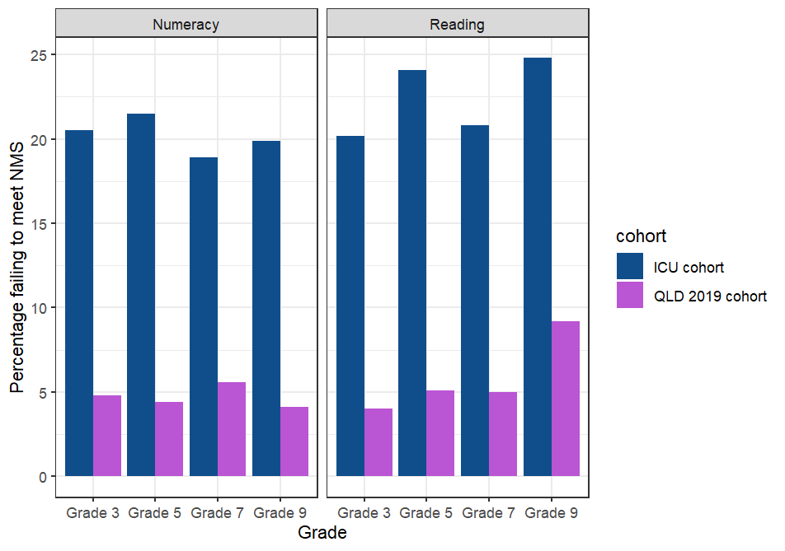
Supplementary Figure 1: Percentage of children failing to meet the national minimum standard on the reading and numeracy domains for the analysed ICU cohort compared to 2019 Queensland population data*.
*Queensland population data was identified through the 2019 NAPLAN national report: https://nap.edu.au/docs/default-source/default-document-library/2019-naplan-national-report.pdf

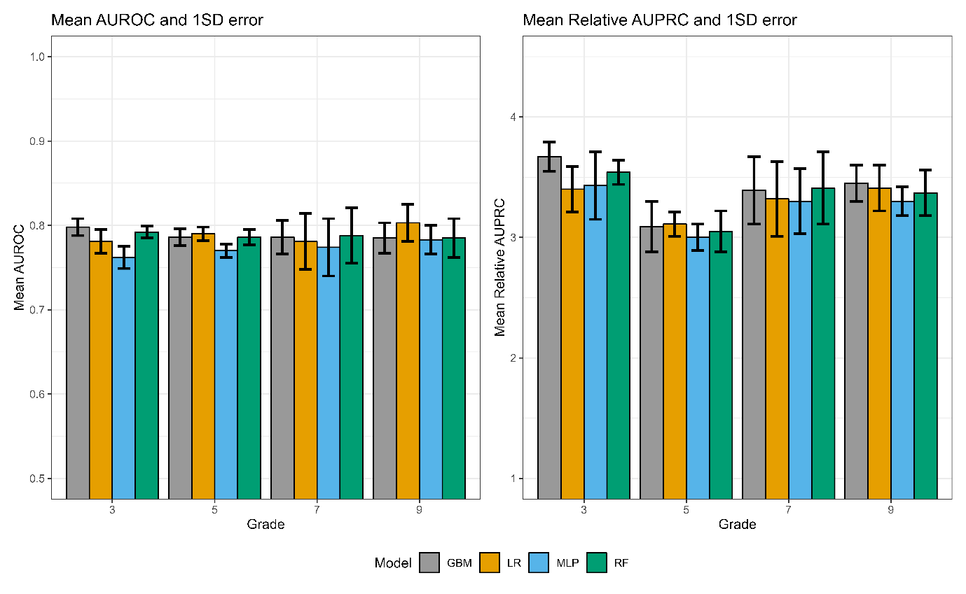
Supplementary Figure 2: Mean area under the receiver operating characteristic curve (AUROC) and mean relative area under the precision recall curve (AUPRC) for each model predicting the primary outcome using the last admission. Error bars indicate ± 1 standard deviation (SD) error.

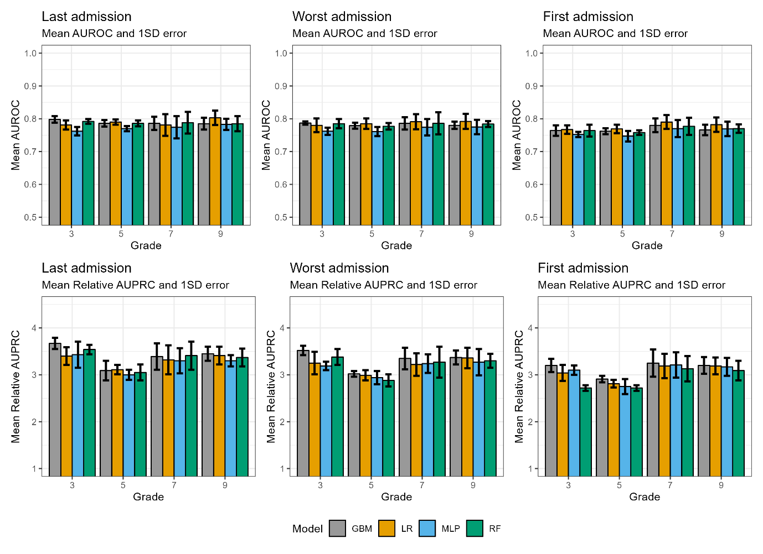
Supplementary Figure 3: Mean area under the receiver operating characteristic curve (AUROC) and mean relative area under the precision recall curve (AUPRC) for each model predicting the primary outcome using the last admission, worst admission and first admission. Error bars indicate ± 1 standard deviation (SD) error.
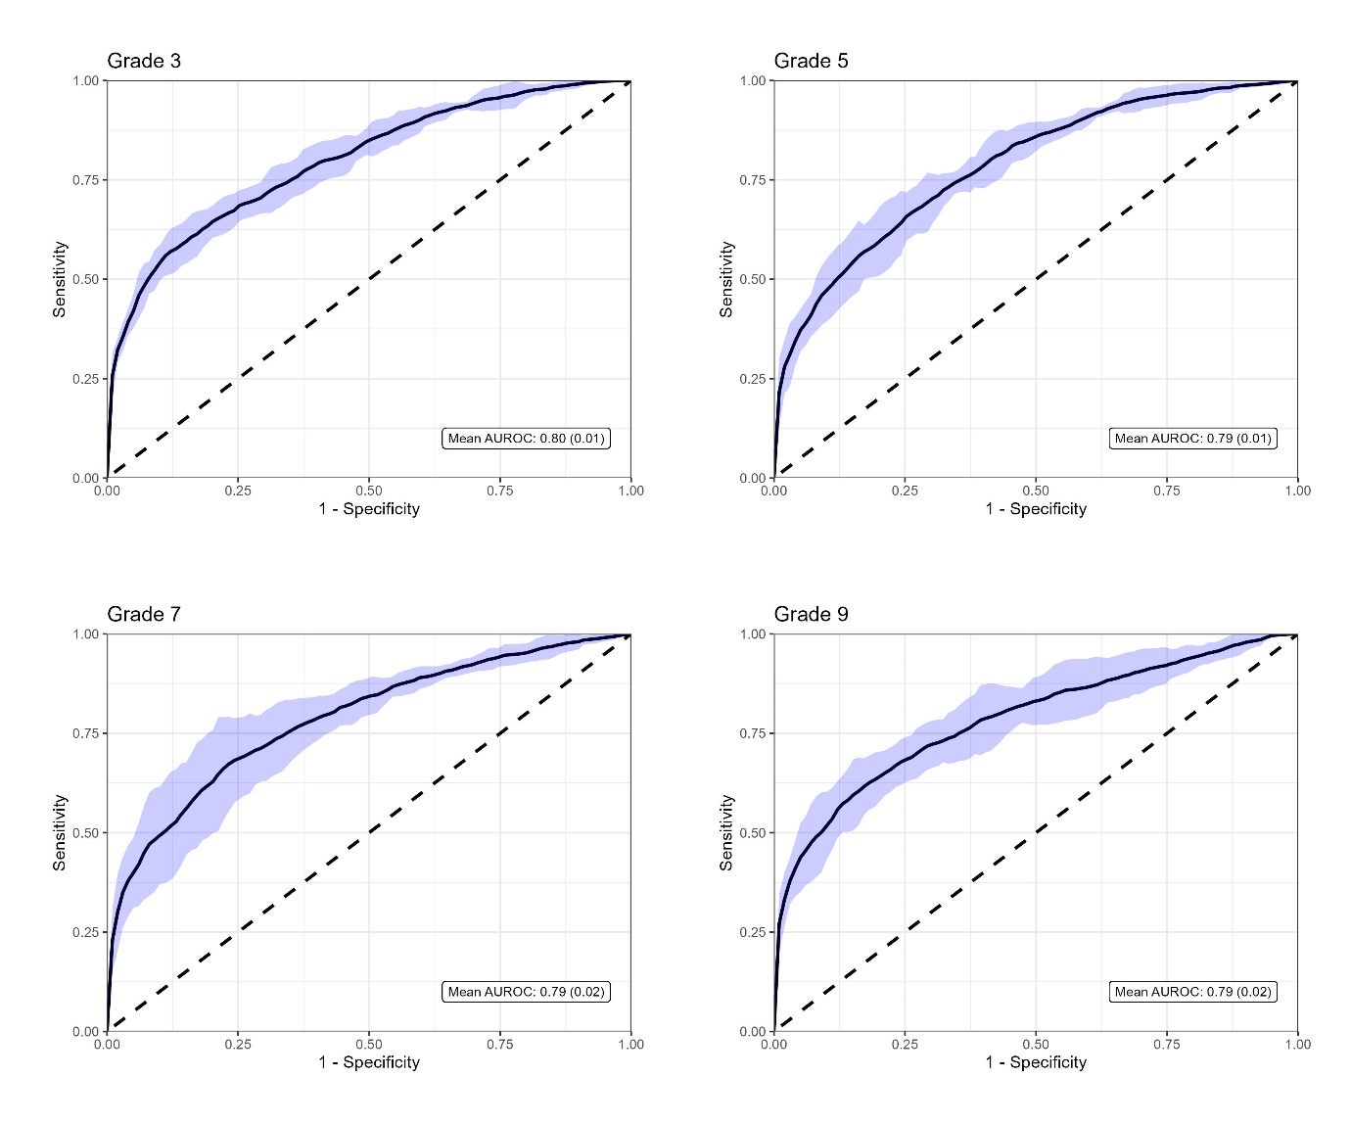

Supplementary Figure 4: Mean receiver operating characteristic curves across cross-validation folds for each grade. Shading indicates ± 2 standard deviation (SD) error. Mean and SD for the area under the receiver operating characteristic curve (AUROC) are also reported for each year grade.

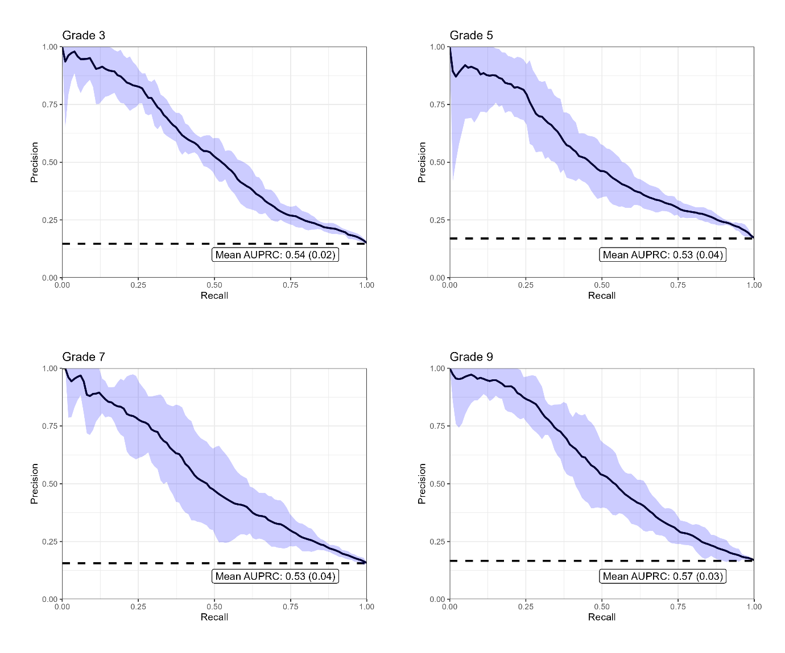
Supplementary Figure 5: Mean precision recall curves across cross-validation folds for each grade. Shading indicates ± 2 standard deviation (SD) error. The Mean and SD for the area under the precision recall curve (AUPRC) are also reported for each grade.

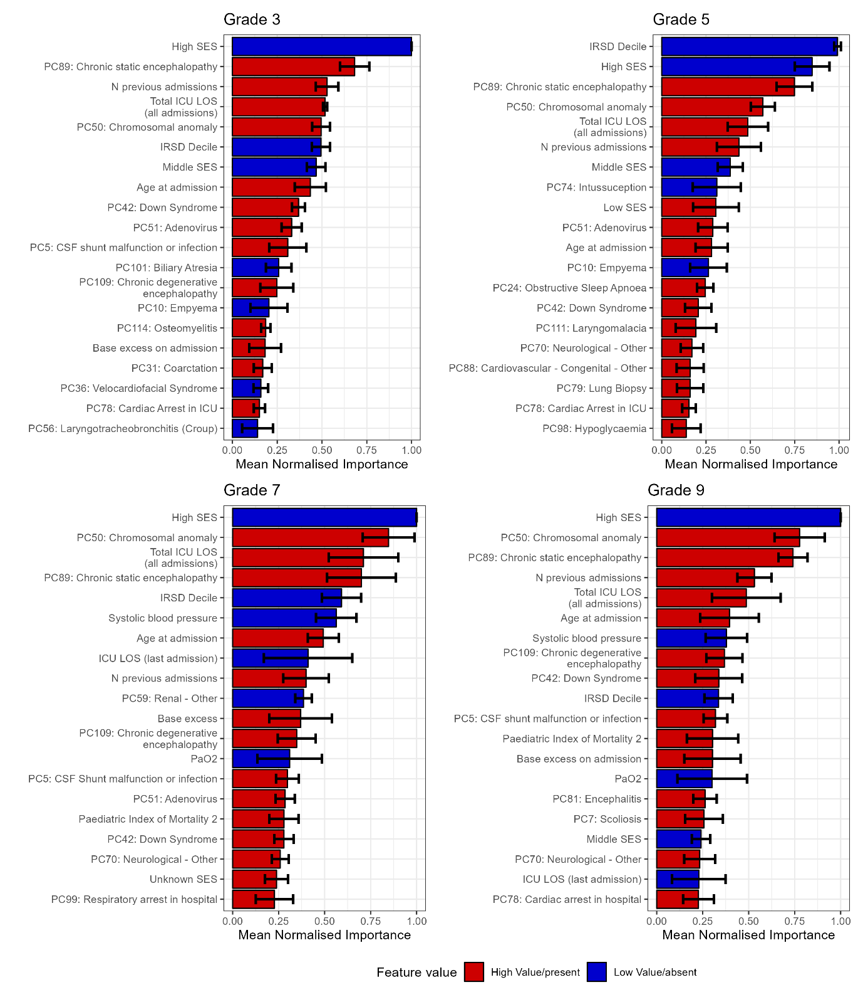
Supplementary Figure 6. Mean normalised Shapley additive explanations (SHAP) importance scores for the top 20 predictors for each grade. The colours reference the direction of each variable for prediction of failing to meet the national minimum standard (NMS) on the Reading and Numeracy domains. Red indicates a higher value or the presence of the variable contributing most to failing to meet the NMS. Blue indicates a lower value or absence of that variable contributing most to failing to meet the NMS. The principal component (PC) variables shown are labelled with the diagnostic ICU code that has the highest component loading. Please refer to Supplementary Table 1 for the list of all codes with high loadings on each PC.
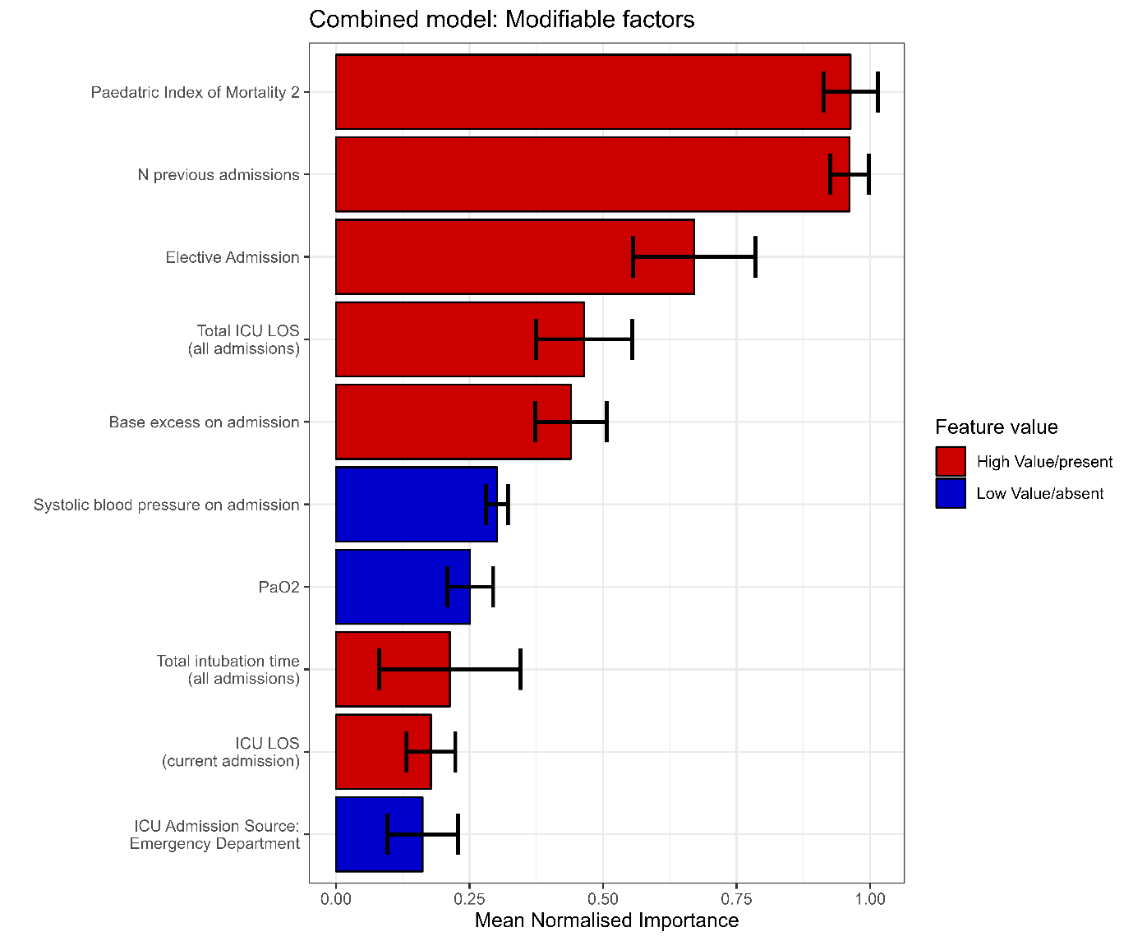

Supplementary Figure 7. Mean normalised Shapley additive explanations (SHAP) importance scores for the top 10 modifiable factors. The colours reference the direction of each variable for prediction of failing to meet the national minimum standard (NMS) on the Reading and Numeracy domains. Red indicates a higher value or the presence of the variable contributing most to failing to meet the NMS. Blue indicates a lower value or absence of that variable contributing most to failing to meet the NMS.
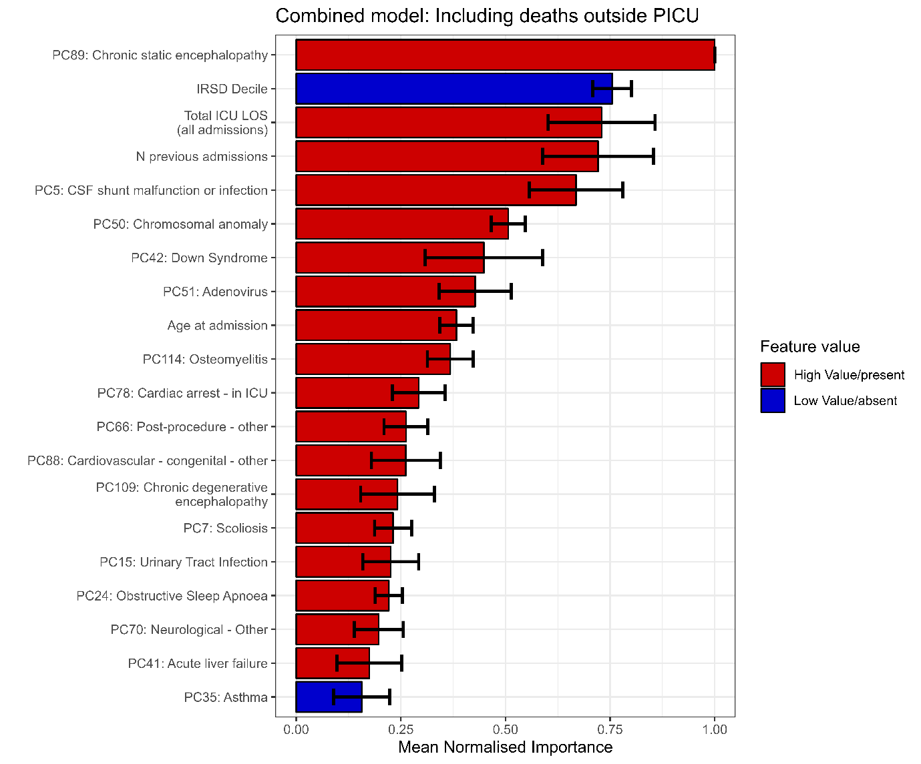
Supplementary Figure 8. Mean normalised Shapley additive explanations (SHAP) importance scores for the top 20 risk factors for the combined model using the composite outcome death after PICU (565/12,029 [4.7%] deaths) or failure to meet NMS. The colours reference the direction of each variable for prediction of failing to meet the national minimum standard (NMS) on the Reading and Numeracy domains. Red indicates a higher value or the presence of the variable contributing most to failing to meet the NMS. Blue indicates a lower value or absence of that variable contributing most to failing to meet the NMS. The principal component (PC) variables shown are labelled with the diagnostic ICU code that has the highest component loading. Please refer to Supplementary Table 1 for the list of all codes with high loadings on each PC.
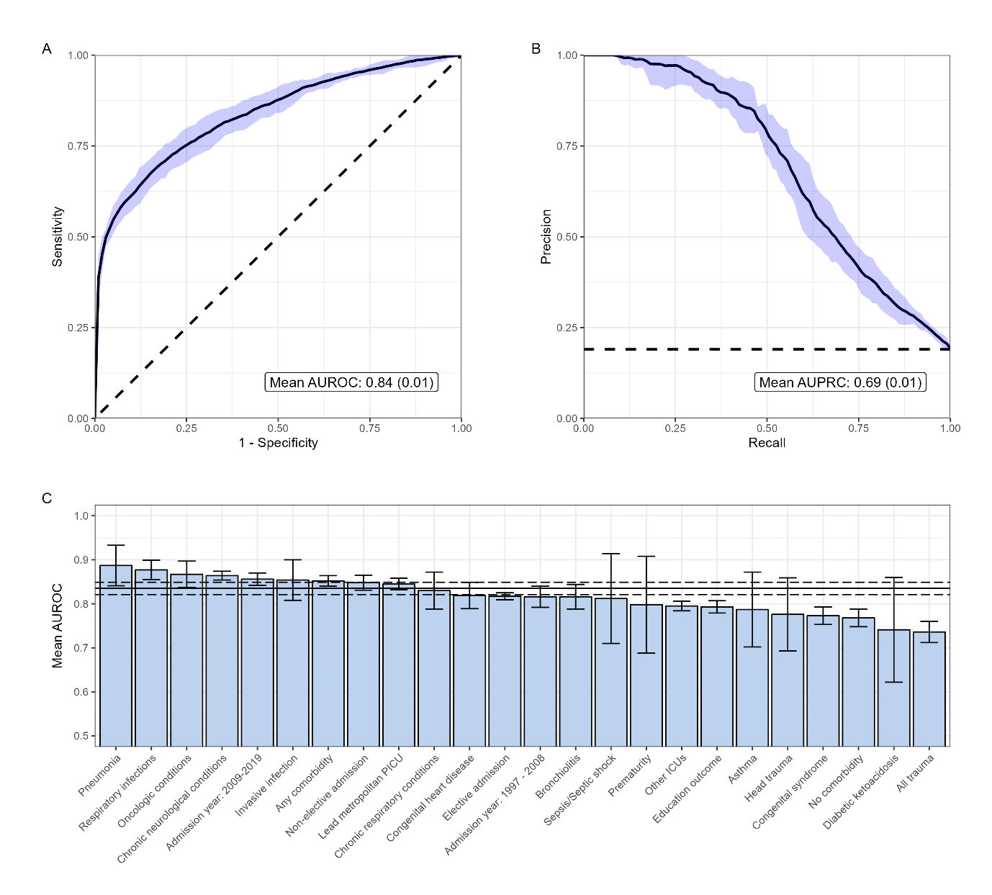
Supplementary Figure 9: Mean area under the receiver operating characteristic curve (AUROC) (panel A), mean area under the precision recall curve (AUPRC) (panel B), and mean AUROCs for specific patient subgroups (panel C) of the machine learning model predicting the composite outcome death after PICU or failure to meet NM. Curves represent findings across cross-validation folds for the combined model. Shading indicates ± two standard deviation error (panel A, B), and ± one standard deviation error for patient subgroups (panel C). The horizontal lines (panel C) indicate the mean AUROC ± one standard deviation of the entire cohort.

