Sepsis-associated acute kidney injury in the intensive care unit: Incidence, Patient Characteristics, Timing, Trajectory, Treatment, and Associated Outcomes

Online Supplement

Table S1. Missing Urine Output and SOFA Scores from ICU Admission to Day 14
 | Missing Data
Variable | Day 1¹ | Day 2¹ | Day 3¹ | Day 4¹ | Day 5¹ | Day 6¹ | Day 7¹ | Day 8¹ | Day 9¹ | Day 10¹ | Day 11¹ | Day 12¹ | Day 13¹ | Day 14¹
Urine NA | 5.50 | 6.30 | 6.59 | 6.30 | 5.58 | 5.01 | 4.40 | 3.99 | 3.76 | 3.48 | 3.33 | 3.12 | 3.14 | 3.08
Urine Zero | 20.63 | 13.85 | 13.25 | 13.40 | 13.40 | 13.60 | 13.73 | 14.16 | 14.67 | 15.40 | 16.07 | 16.53 | 17.31 | 18.14
SOFA Liver | 38.6 | 5.6 | 5.3 | 5.4 | 5.3 | 5.1 | 4.7 | 4.7 | 4.9 | 4.9 | 5.4 | 4.8 | 5.0 | 5.8
SOFA Renal | 20.97 | 2.47 | 1.59 | 1.73 | 1.72 | 1.83 | 1.84 | 1.90 | 2.20 | 2.38 | 2.52 | 2.24 | 2.79 | 2.88
SOFA Respiratory | 12.88 | 10.70 | 12.35 | 12.25 | 11.54 | 10.56 | 10.14 | 9.84 | 9.55 | 10.25 | 10.54 | 10.36 | 10.93 | 11.66
SOFA Cardiovascular | 1.45 | 0.56 | 2.06 | 2.41 | 2.50 | 2.21 | 1.98 | 1.96 | 1.96 | 1.60 | 1.56 | 1.52 | 1.48 | 1.64
SOFA Coagulation | 39.8 | 6.1 | 5.8 | 6.0 | 5.9 | 5.6 | 5.7 | 5.8 | 6.1 | 6.3 | 6.9 | 6.1 | 6.6 | 7.4
¹All values as percentage (%)
Abbreviations: SOFA = sequential organ failure assessment

Table S2. Antibiotic Rank
Rank | Antibiotic
One | Cefazolin, Cefoxitin, Penicillin, Flucloxacillin, Benzylpenicillin, Ampicillin, Amoxicillin, Doxycycline, Trimethoprim & Sulphamethoxazole
Two | Amoxicillin & Clavulanic acid, Ceftriaxone, Azithromycin, Metronidazole, Gentamicin, Tobramycin, Ciprofloxacin, Moxifloxacin, Clindamycin, Lincomycin
Three | Piperacillin, Ticarcillin, Vancomycin, Teicoplanin, Ertapenem, Ceftazidime, Cefepime
Four | Meropenem, Imipenem, Ceftazidime, Ceftaroline, Linezolid, Daptomycin, Colistin, Tigecycline, Aztreonam

Table S3. Calculation of Norepinephrine Equivalent
Drug | Dose | Norepinephrine Equivalent
Adrenaline | 0.1 µg/kg/min | 0.1 µg/kg/min
Noradrenaline | 0.1 µg/kg/min | 0.1 µg/kg/min
Dopamine | 15 µg/kg/min | 0.1 µg/kg/min
Phenylephrine | 1.0 µg/kg/min | 0.1 µg/kg/min
Vasopressin | 0.04 units/min | 0.1 µg/kg/min

Table S4. Urine Output Imputation: Rationale and Methods
Step | Explanation
Rationale | Hourly urine output measures contained missing or incorrectly labelled as zero. The quantity of which is demonstrated in Table S1. A manual examination of patient records demonstrated this was often due to absence of indwelling catheter or transfer outside of the intensive care unit.  The missing or inappropriately labelled 0 data, prevented accurate application of KDIGO definition to determine presence of acute kidney injury. Patients were being classified as an AKI, often stage 2 or 3, due to absence of IDC at the beginning and end of admission and continuous 0 for urine output.  Due to the above we underwent a process of adjusting and imputing some urine output values.
Imputation | Imputation of missing urine output was performed in a backwards direction based on a set of conditions.  - When blank urine outputs were followed by a UO we assessed for criteria to perform imputation of the missing UO.  - If a patient was on RRT or commenced RRT within 1 day, then we did not perform imputation of hourly UO and UO values were unchanged.  - If patient died on the day or the next day, we did not perform imputation of the hourly UO and UO valued were unchanged.  - We then averaged the first non-missing UO after a period of missing UO over the time period that UO was missing. (For example, if UO was missing for five hours, then the next UO was 600mL, this would be an average of 100ml/hr).  - Then, if the average UO was greater than or equal to 0.5 mL/kg/h, then we would perform the imputation. If the averaged UO was less than 0.5 mL/kg/hr we did NOT perform the imputation. (In our example, assuming weight of 100kg, our average UO would be 1 mL/kg/h, therefore imputation would be performed. This would make six hours 100mL after imputation, as opposed to five hours of 0mL and one hour of 600mL.)
 | Patient | Original UO | Adjusted UO | RRT in 48-hrs | Died in 48-hrs
 | 1 | 0 | 0 | 1 | 0
 |  | 0 | 0 | 1 | 0
Examples |  | 0 | 0 | 1 | 0
 |  | 5 | 5 | 1 | 0
 |  | 0 | 0 | 1 | 0
 |  | 10 | 10 | 1 | 0
Examples | 2 | 0 | 50 | 0 | 0
Examples |  | 100 | 50 | 0 | 0
Examples |  | 0 | 100 | 0 | 0
Examples |  | 0 | 100 | 0 | 0
Examples |  | 300 | 100 | 0 | 0
Examples |  | 50 | 50 | 0 | 0
Examples |  | 60 | 60 | 0 | 0
Examples | 3 | 0 | 0 | 0 | 0
Examples |  | 0 | 0 | 0 | 0
Examples |  | 0 | 0 | 0 | 0
Examples |  | 0 | 0 | 0 | 0
Examples |  | 0 | 0 | 0 | 0
Examples |  | 0 | 0 | 0 | 0
Examples |  | 100 | 100 | 0 | 0
Removal of Erroneous Data | Lastly, we made UO missing, or NA, on the following conditions. This was done for all missing or 0 UO measurements.  - If last 24 hours of admission and patient was not on RRT and survived ICU.  - During ICU, if heart rate and temperature were missing for the same hour (as a marker that patients was not in the ICU)  - In the first 24 hours of admission if patient was not on RRT.
Confirmation | We performed multiple sensitivity analysis to confirm the sbsence of systematic bias and misclassification. We compared patient based on their UO being adjusted versus those who had no adjustment (Table S5). Furthermore, we compared patients diagnosed with AKI from the original unadjusted cohort to those diagnosed with AKI from the adjusted cohort (ie the main analysis). The numbers are slightly changed there is no evidence of systematic bias in patients who had UO adjusted. Furthermore, there is no increase in AKI diagnosis with adjustment. Lastly, comparing patients that were diagnosed with AKI from adjusted and unadjusted data and there was no difference in outcomes.

Table S5. Sensitivity Analysis. Patient Characteristics and Outcomes by Patients with or without Urine Output Imputation Performed
 | Urine Output Adjustment
Variable | Yes, N = 53,659¹ | No, N = 30,869¹ | p-value²
Age | 60 (46, 71) | 63 (50, 72) | <0.001
Female | 20,880 (39%) | 12,018 (39%) | >0.9
Body Mass Index | 28 (24, 31) | 28 (25, 33) | <0.001
Post Elective Surgery | 18,939 (35%) | 14,434 (47%) | <0.001
APACHE 2 Score | 15 (11, 20) | 15 (11, 21) | <0.001
APACHE 3 Score | 50 (37, 65) | 52 (39, 71) | <0.001
Ventilation during Admission | 31,618 (59%) | 17,762 (58%) | <0.001
Vasopressors during Admission | 27,401 (51%) | 15,737 (51%) | 0.8
SA-AKI | 8,378 (16%) | 5,073 (16%) | 0.002
AKI during Admission | 22,924 (43%) | 15,414 (50%) | <0.001
Max AKI Stage during Admission |  |  | <0.001
0 | 30,735 (57%) | 15,455 (50%)
1 | 12,227 (23%) | 6,671 (22%)
2 | 5,785 (11%) | 4,238 (14%)
3 | 4,912 (9.2%) | 4,505 (15%)
¹Median (IQR) or Frequency (%)
²Wilcoxon rank sum test; Pearson's Chi-squared test
Abbreviations: SA-AKI = sepsis-associated acute kidney injury; AKI = acute kidney injury.

Table S6. Sensitivity Analysis: Comparing Patients diagnosed with AKI from Unmodified Data and Imputed Data
 | Imputed Data
Variable | Yes, N = 38,338¹ | No, N = 41,096¹ | p-value²
Age | 64 (51, 73) | 63 (50, 73) | <0.001
Female | 14,489 (38%) | 15,791 (38%) | 0.067
Body Mass Index | 28 (26, 34) | 28 (26, 34) | <0.001
Post Elective Surgery | 11,433 (30%) | 12,575 (31%) | 0.017
APACHE 2 Score | 18 (13, 24) | 17 (13, 23) | <0.001
APACHE 3 Score | 61 (46, 79) | 59 (44, 77) | <0.001
Ventilation during Admission | 24,962 (65%) | 25,643 (62%) | <0.001
Vasopressors during Admission | 23,810 (62%) | 24,530 (60%) | <0.001
SA-AKI | 13,451 (35%) | 13,073 (32%) | <0.001
AKI Diagnostic Criteria |  |  | <0.001
Urine Output Only | 23,430 (61%) | 21,949 (60%)
Creatinine Only | 9,195 (24%) | 9,195 (25%)
Both | 5,713 (15%) | 5,713 (16%)
Max AKI Stage during Admission |  |  | <0.001
0 | 0 (0%) | 4,239 (10%)
1 | 18,898 (49%) | 17,852 (43%)
2 | 10,023 (26%) | 10,001 (24%)
3 | 9,417 (25%) | 9,004 (22%)
RRT during Admission | 4,374 (11%) | 4,374 (11%) | <0.001
MAKE-30 | 7,808 (20%) | 7,826 (19%) | <0.001
Renal Recovery |  |  | <0.001
Full | 25,427 (66%) | 28,194 (69%)
None | 11,420 (30%) | 11,411 (28%)
Partial | 1,491 (3.9%) | 1,491 (3.6%)
ICU Mortality | 3,829 (10.0%) | 3,820 (9.3%) | <0.001
Hospital Mortality | 5,215 (14%) | 5,244 (13%) | <0.001
¹Median (IQR); n (%)
²Wilcoxon rank sum test; Pearson's Chi-squared test
Abbreviations: SA-AKI = sepsis-associated acute kidney injury; AKI = acute kidney injury; MAKE-30 = major adverse kidney events at 30 days; RRT = renal replacement therapy.

Table S7. Sensitivity Analysis: Comparing Patients diagnosed with AKI by three Methods used to Estimate Baseline Serum Creatinine (estimation by assume EGFR of 75 ml/min or 60 ml/min or using admission creatinine)
 | Method Used
Variable | eGFR  75  N = 38,338¹ | eGFR  60  ,N = 36,210¹ | Admission  creatinine  N = 33,882¹ | p-value²
Age | 64 (51, 73) | 64 (51, 73) | 63 (50, 73) | <0.001
Female | 14,489 (38%) | 13,708 (38%) | 12,666 (37%) | 0.4
Body Mass Index | 28 (26, 34) | 28 (26, 34) | 29 (26, 35) | <0.001
Post Elective Surgery | 11,433 (30%) | 10,728 (30%) | 10,438 (31%) | 0.001
APACHE 2 Score | 18 (13, 24) | 18 (13, 24) | 17 (13, 24) | <0.001
APACHE 3 Score | 61 (46, 79) | 60 (46, 79) | 59 (45, 78) | <0.001
Ventilation during Admission | 24,962 (65%) | 23,804 (66%) | 22,994 (68%) | <0.001
Vasopressors during Admission | 23,810 (62%) | 22,485 (62%) | 21,155 (62%) | 0.6
SA-AKI | 13,451 (35%) | 12,567 (35%) | 10,976 (32%) | <0.001
Max AKI Stage during Admission |  |  |  | <0.001
1 | 18,898 (49%) | 18,397 (51%) | 18,038 (53%)
2 | 10,023 (26%) | 9,301 (26%) | 8,057 (24%)
3 | 9,417 (25%) | 8,512 (24%) | 7,787 (23%)
RRT during Admission | 4,374 (11%) | 4,374 (12%) | 4,258 (13%) | <0.001
MAKE-30 | 7,808 (20%) | 7,639 (21%) | 7,340 (22%) | <0.001
Renal Recovery |  |  |  | <0.001
Full | 25,427 (66%) | 24,364 (67%) | 24,129 (71%)
None | 11,420 (30%) | 10,363 (29%) | 8,780 (26%)
Partial | 1,491 (3.9%) | 1,483 (4.1%) | 973 (2.9%)
ICU Mortality | 3,829 (10.0%) | 3,725 (10%) | 3,594 (11%) | 0.024
Hospital Mortality | 5,215 (14%) | 5,036 (14%) | 4,803 (14%) | 0.084
¹Median (IQR); n (%)
²Kruskal-Wallis rank sum test; Pearson's Chi-squared test
Abbreviations: SA-AKI = sepsis-associated acute kidney injury; AKI = acute kidney injury; MAKE-30 = major adverse kidney events at 30 days; RRT = renal replacement therapy; 75 = eGFR 75mL/min/1.73m2; 65 = eGFR 60 mL/min/1.73m2; eGFR = estimated glomerular filtration rate.

Table S8. Patient Characteristics and Outcomes by Diagnosis
 | Diagnosis
Variable | SA-AKI, N = 13,451¹ | Sepsis Only, N = 10,104¹ | AKI Only, N = 24,100¹ | None, N = 36,873¹
Age | 64 (52, 74) | 57 (42, 68) | 64 (51, 73) | 59 (45, 69)
Female | 5,592 (42%) | 4,304 (43%) | 8,672 (36%) | 14,330 (39%)
Body Mass Index | 28 (25, 35) | 27 (23, 29) | 29 (26, 34) | 28 (24, 30)
Post Elective Surgery | 20 (0.1%) | 115 (1.1%) | 11,318 (47%) | 21,920 (59%)
APACHE 2 Score | 21 (16, 27) | 16 (12, 21) | 16 (12, 21) | 13 (9, 16)
APACHE 3 Score | 71 (56, 88) | 53 (40, 68) | 55 (42, 71) | 42 (32, 54)
Ventilation during Admission | 8,552 (64%) | 5,661 (56%) | 15,687 (65%) | 19,480 (53%)
Vasopressors during Admission | 9,715 (72%) | 5,647 (56%) | 13,373 (55%) | 14,403 (39%)
Max AKI Stage during Admission
0 | 0 (0%) | 9,317 (92%) | 0 (0%) | 36,873 (100%)
1 | 5,008 (37%) | 278 (2.8%) | 13,612 (56%) | 0 (0%)
2 | 3,570 (27%) | 188 (1.9%) | 6,265 (26%) | 0 (0%)
3 | 4,873 (36%) | 321 (3.2%) | 4,223 (18%) | 0 (0%)
RRT during Admission | 2,528 (19%) | 227 (2.2%) | 1,619 (6.7%) | 0 (0%)
MAKE-30 | 3,865 (29%) | 729 (7.2%) | 3,674 (15%) | 1,125 (3.1%)
Renal Recovery
Full | 7,541 (56%) | 9,535 (94%) | 17,382 (72%) | 36,013 (98%)
None | 5,018 (37%) | 546 (5.4%) | 6,142 (25%) | 860 (2.3%)
Partial | 892 (6.6%) | 23 (0.2%) | 576 (2.4%) | 0 (0%)
ICU Mortality | 1,603 (12%) | 441 (4.4%) | 2,071 (8.6%) | 860 (2.3%)
Hospital Mortality | 2,354 (18%) | 742 (7.3%) | 2,670 (11%) | 1,228 (3.3%)
¹Median (IQR); n (%)
Abbreviations: SA-AKI = sepsis associated acute kidney injury; AKI = acute kidney injury; RRT = renal replacement therapy; MAKE-30 = major adverse kidney events at day 30; ICU = intensive care unit.

Table S9. Outcome Definitions
Outcome | Definition
Major Adverse Renal Outcomes at Day 30 (MAKE-30) | One of the following within 30 days:  - Doubling serum creatine*  - Renal replacement therapy*  - Mortality  *censored at ICU discharge
Renal Recovery  As per ADQI Definition ¹ | Full recovery  - sCr less than or equal to 1.5x baseline levels  Partial recovery  - sCr greater than 1.5x baseline levels  - AND < 3x baseline levels  - AND no ongoing RRT  Non-recovery  - Ongoing RRT  - sCr greater than 3x baseline levels
¹ Chawla LS, Bellomo R, Bihorac A, Goldstein SL, Siew ED, Bagshaw SM, et al. Acute kidney disease and renal recovery: consensus report of the Acute Disease Quality Initiative (ADQI) 16 Workgroup. Nat Rev Nephrol. 2017;13(4):241-57.
Abbreviations: sCr = serum creatinine; AKI = acute kidney injury; ADQI = Acute Disease Quality Initiative; RRT = renal replacement therapy.

Table S10. AKI Diagnostic Criteria by AKI Stage at SA-AKI Diagnosis
 | AKI Stage
AKI Diagnostic Criteria | 1, N = 7,239¹ | 2, N = 3,387¹ | 3, N = 2,825¹
Urine Output Only | 4,696 (65%) | 957 (28%) | 299 (11%)
Creatinine Only | 2,038 (28%) | 1,385 (41%) | 1,219 (43%)
Both | 505 (7.0%) | 1,045 (31%) | 1,307 (46%)
¹n (%)
Abbreviations: AKI = acute kidney injury

Table S11. Treatment during First 7 Days by AKI Diagnostic Criteria in SA-AKI Patients with Stage 1 AKI
 | AKI Diagnostic Criteria
Variable | Urine Output Only, N = 4,696¹ | Creatinine Only, N = 2,038¹ | Both, N = 505¹ | p value²
Any
Ventilation | 3,267 (70%) | 1,169 (57%) | 363 (72%) | <0.001
Invasive ventilation | 3,128 (67%) | 1,087 (53%) | 349 (69%) | <0.001
Non-invasive ventilation | 285 (6.1%) | 143 (7.0%) | 22 (4.4%) | 0.067
Vasopressors | 2,971 (63%) | 1,553 (76%) | 417 (83%) | <0.001
Diuretics | 2,308 (49%) | 1,003 (49%) | 285 (56%) | 0.007
RRT | 127 (2.7%) | 152 (7.5%) | 106 (21%) | <0.001
Nephrotoxic Antibiotics | 1,344 (29%) | 764 (37%) | 213 (42%) | <0.001
Days of Intervention
Ventilation | 2 (0, 5) | 2 (0, 4) | 2 (0, 6) | <0.001
Invasive ventilation | 2 (0, 5) | 1 (0, 4) | 2 (0, 6) | <0.001
Non-invasive ventilation | 0 (0, 0) | 0 (0, 0) | 0 (0, 0) | 0.064
Vasopressors | 2 (0, 5) | 2 (0, 4) | 2 (0, 6) | <0.001
RRT | 2 (0, 3) | 2 (1, 3) | 2 (1, 4) | <0.001
Diuretic | 0 (0, 2) | 0 (0, 2) | 1 (0, 3) | 0.013
Mean Daily
Fluid Balance (mL) | 52.78 (-515.91, 608.45) | -159.18 (-924.52, 488.59) | 242.60 (-376.31, 910.97) | <0.001
NEE Score (ug/kg/min) | 0.03 (0.01, 0.08) | 0.05 (0.02, 0.12) | 0.06 (0.02, 0.16) | <0.001
Furosemide Dose (mg) | 40.00 (20.00, 60.00) | 40.00 (25.00, 65.44) | 44.59 (29.53, 80.00) | <0.001
¹Median (IQR) or Frequency (%)
²Pearson's Chi-squared test; Kruskal-Wallis rank sum test
Abbreviations: SA-AKI = sepsis-associated acute kidney injury; RRT = renal replacement therapy; NEE = norepinephrine equivalent

Table S12. Treatment during First 7 Days by AKI Diagnostic Criteria in SA-AKI Patients with Stage 2 AKI
 | AKI Diagnostic Criteria
Variable | Urine Output Only, N = 957¹ | Creatinine Only, N = 1,385¹ | Both, N = 1,045¹ | p value²
Any
Ventilation | 748 (78%) | 720 (52%) | 730 (70%) | <0.001
Invasive ventilation | 724 (76%) | 674 (49%) | 703 (67%) | <0.001
Non-invasive ventilation | 58 (6.1%) | 84 (6.1%) | 53 (5.1%) | 0.5
Vasopressors | 668 (70%) | 1,070 (77%) | 914 (87%) | <0.001
Diuretics | 531 (55%) | 628 (45%) | 537 (51%) | <0.001
RRT | 34 (3.6%) | 187 (14%) | 393 (38%) | <0.001
Nephrotoxic Antibiotics | 291 (30%) | 517 (37%) | 469 (45%) | <0.001
Days of Intervention
Ventilation | 3 (1, 5) | 1 (0, 4) | 2 (0, 6) | <0.001
Invasive ventilation | 2 (1, 5) | 0 (0, 4) | 2 (0, 6) | <0.001
Non-invasive ventilation | 0 (0, 0) | 0 (0, 0) | 0 (0, 0) | 0.5
Vasopressors | 3 (1, 5) | 1 (0, 4) | 2 (0, 6) | <0.001
RRT | 2 (0, 3) | 2 (1, 4) | 3 (2, 5) | <0.001
Diuretic | 1 (0, 3) | 0 (0, 2) | 1 (0, 2) | <0.001
Mean Daily
Fluid Balance (mL) | 242.83 (-368.54, 810.17) | -178.90 (-886.50, 520.85) | 466.50 (-236.77, 1,195.10) | <0.001
NEE Score (ug/kg/min) | 0.03 (0.01, 0.08) | 0.05 (0.02, 0.12) | 0.08 (0.03, 0.23) | <0.001
Furosemide Dose (mg) | 40.00 (25.00, 66.52) | 40.00 (25.00, 80.00) | 50.00 (30.00, 90.00) | <0.001
¹Median (IQR) or Frequency (%)
²Pearson's Chi-squared test; Kruskal-Wallis rank sum test
Abbreviations: SA-AKI = sepsis-associated acute kidney injury; RRT = renal replacement therapy; NEE = norepinephrine equivalent

Table S13. Treatment during First 7 Days by AKI Diagnostic Criteria in SA-AKI Patients with Stage 3 AKI
 | AKI Diagnostic Criteria
Variable | Urine Output Only, N = 299¹ | Creatinine Only, N = 1,219¹ | Both, N = 1,307¹ | p value²
Any
Ventilation | 132 (44%) | 581 (48%) | 815 (62%) | <0.001
Invasive ventilation | 123 (41%) | 541 (44%) | 763 (58%) | <0.001
Non-invasive ventilation | 14 (4.7%) | 70 (5.7%) | 84 (6.4%) | 0.5
Vasopressors | 123 (41%) | 853 (70%) | 1,088 (83%) | <0.001
Diuretics | 107 (36%) | 475 (39%) | 582 (45%) | 0.002
RRT | 3 (1.0%) | 488 (40%) | 933 (71%) | <0.001
Nephrotoxic Antibiotics | 87 (29%) | 413 (34%) | 610 (47%) | <0.001
Days of Intervention
Ventilation | 0 (0, 2) | 0 (0, 3) | 2 (0, 6) | <0.001
Invasive ventilation | 0 (0, 2) | 0 (0, 3) | 2 (0, 6) | <0.001
Non-invasive ventilation | 0 (0, 0) | 0 (0, 0) | 0 (0, 0) | 0.5
Vasopressors | 0 (0, 2) | 0 (0, 3) | 2 (0, 6) | <0.001
RRT | 0 (0, 2) | 2 (0, 3) | 3 (1, 5) | <0.001
Diuretic | 0 (0, 2) | 0 (0, 1) | 0 (0, 2) | 0.042
Mean Daily
Fluid Balance (mL) | -98.33 (-530.74, 322.17) | -169.90 (-930.07, 536.65) | 320.07 (-426.94, 1,149.62) | <0.001
NEE Score (ug/kg/min) | 0.04 (0.01, 0.07) | 0.06 (0.02, 0.14) | 0.08 (0.03, 0.22) | <0.001
Furosemide Dose (mg) | 30.00 (20.00, 40.83) | 48.03 (30.00, 83.24) | 60.00 (40.00, 110.47) | <0.001
¹Median (IQR) or Frequency (%)
²Pearson's Chi-squared test; Kruskal-Wallis rank sum test
Abbreviations: SA-AKI = sepsis-associated acute kidney injury; RRT = renal replacement therapy; NEE = norepinephrine equivalent

Table S14. Treatment during First 7 Days by AKI Stage at Diagnosis of SA-AKI
 | AKI Stage at Diagnosis
Variable | 1, N = 7,239¹ | 2, N = 3,387¹ | 3, N = 2,825¹ | p value²
Any
Ventilation | 4,799 (66%) | 2,198 (65%) | 1,528 (54%) | <0.001
Invasive ventilation | 4,564 (63%) | 2,101 (62%) | 1,427 (51%) | <0.001
Non-invasive ventilation | 450 (6.2%) | 195 (5.8%) | 168 (5.9%) | 0.6
Vasopressors | 4,941 (68%) | 2,652 (78%) | 2,064 (73%) | <0.001
Diuretics | 3,596 (50%) | 1,696 (50%) | 1,164 (41%) | <0.001
RRT | 385 (5.3%) | 614 (18%) | 1,424 (50%) | <0.001
Nephrotoxic Antibiotics | 2,321 (32%) | 1,277 (38%) | 1,110 (39%) | <0.001
Days of Intervention
Ventilation | 2 (0, 5) | 2 (0, 5) | 1 (0, 4) | <0.001
Invasive ventilation | 2 (0, 4) | 2 (0, 5) | 1 (0, 4) | <0.001
Non-invasive ventilation | 0 (0, 0) | 0 (0, 0) | 0 (0, 0) | 0.6
Vasopressors | 2 (0, 5) | 2 (0, 5) | 1 (0, 4) | <0.001
RRT | 2 (0, 3) | 2 (1, 4) | 2 (0, 4) | <0.001
Diuretic | 0 (0, 2) | 1 (0, 2) | 0 (0, 2) | <0.001
Mean Daily
Fluid Balance (mL) | 10.95 (-610.42, 603.52) | 136.27 (-532.68, 845.80) | 42.33 (-679.26, 804.30) | <0.001
NEE Score (ug/kg/min) | 0.04 (0.02, 0.10) | 0.05 (0.02, 0.14) | 0.06 (0.03, 0.17) | <0.001
Furosemide Dose (mg) | 40.00 (20.00, 62.31) | 40.00 (26.67, 80.00) | 52.00 (31.62, 90.00) | <0.001
¹Median (IQR) or Frequency (%)
²Pearson's Chi-squared test; Kruskal-Wallis rank sum test
Abbreviations: SA-AKI = sepsis-associated acute kidney injury; RRT = renal replacement therapy; NEE = norepinephrine equivalent

Table S15. Treatment during First 7 Days
 | SA-AKI
Variable | Yes, N = 13,451¹ | No, N = 71,077¹ | p value²
Any
Ventilation | 8,525 (63%) | 40,797 (57%) | <0.001
Invasive ventilation | 8,092 (60%) | 39,855 (56%) | <0.001
Non-invasive ventilation | 813 (6.0%) | 1,698 (2.4%) | <0.001
Vasopressors | 9,657 (72%) | 33,292 (47%) | <0.001
Diuretics | 6,456 (48%) | 20,274 (29%) | <0.001
RRT | 2,423 (18%) | 1,717 (2.4%) | <0.001
Nephrotoxic Antibiotics | 4,708 (35%) | 6,048 (8.5%) | <0.001
Days of Intervention
Ventilation | 2 (0, 5) | 1 (0, 2) | <0.001
Invasive ventilation | 2 (0, 4) | 1 (0, 2) | <0.001
Non-invasive ventilation | 0 (0, 0) | 0 (0, 0) | <0.001
Vasopressors | 2 (0, 5) | 1 (0, 2) | <0.001
RRT | 2 (0, 3) | 0 (0, 2) | <0.001
Diuretic | 0 (0, 2) | 0 (0, 1) | <0.001
Mean Daily
Fluid Balance (mL) | 47.50 (-604.23, 703.03) | -40.30 (-515.42, 396.65) | <0.001
NEE Score (ug/kg/min) | 0.05 (0.02, 0.12) | 0.03 (0.01, 0.13) | <0.001
Furosemide Dose (mg) | 40.00 (25.00, 73.33) | 40.00 (23.33, 45.56) | <0.001
¹Median (IQR) or Frequency (%)
²Pearson's Chi-squared test; Wilcoxon rank sum test
Abbreviations: SA-AKI = sepsis-associated acute kidney injury; RRT = renal replacement therapy; NEE = norepinephrine equivalent

Table S16. Outcomes by AKI Diagnosis Criteria in SA-AKI with Stage 1 AKI at Diagnosis
 | AKI Diagnostic Criteria
Variable | Urine Output Only, N = 4,696¹ | Creatinine Only, N = 2,038¹ | Both, N = 505¹ | p value²
Maximum AKI Stage in ICU |  |  |  | <0.001
1 | 3,311 (71%) | 1,466 (72%) | 231 (46%)
2 | 779 (17%) | 332 (16%) | 135 (27%)
3 | 606 (13%) | 240 (12%) | 139 (28%)
Any RRT | 161 (3.4%) | 168 (8.2%) | 112 (22%) | <0.001
ICU LOS (hours) | 85 (46, 151) | 70 (41, 141) | 91 (46, 178) | <0.001
Hospital LOS (hours) | 285 (159, 541) | 284 (163, 567) | 331 (159, 635) | 0.2
ICU Mortality | 380 (8.1%) | 200 (9.8%) | 94 (19%) | <0.001
Hospital Mortality | 582 (12%) | 299 (15%) | 133 (26%) | <0.001
Renal Recovery |  |  |  | <0.001
Full | 4,055 (86%) | 1,101 (54%) | 240 (48%)
Partial | 49 (1.0%) | 55 (2.7%) | 22 (4.4%)
None | 592 (13%) | 882 (43%) | 243 (48%)
MAKE-30 | 625 (13%) | 387 (19%) | 181 (36%) | <0.001
¹Median (IQR) or Frequency (%)
²Pearson's Chi-squared test; Kruskal-Wallis rank sum test
Abbreviations: AKI = acute kidney injury; RRT = renal replacement therapy; ICU = intensive care unit; LOS = length of stay; MAKE-30 = major adverse kidney events at day 30

Table S17. Outcomes by AKI Diagnosis Criteria in SA-AKI with Stage 2 AKI at Diagnosis
 | AKI Diagnostic Criteria
Variable | Urine Output Only, N = 957¹ | Creatinine Only, N = 1,385¹ | Both, N = 1,045¹ | p value²
Maximum AKI Stage in ICU |  |  |  | <0.001
2 | 821 (86%) | 1,023 (74%) | 480 (46%)
3 | 136 (14%) | 362 (26%) | 565 (54%)
Any RRT | 45 (4.7%) | 198 (14%) | 410 (39%) | <0.001
ICU LOS (hours) | 91 (50, 166) | 73 (43, 136) | 99 (51, 203) | <0.001
Hospital LOS (hours) | 324 (183, 586) | 288 (164, 562) | 361 (169, 650) | 0.004
ICU Mortality | 81 (8.5%) | 131 (9.5%) | 269 (26%) | <0.001
Hospital Mortality | 134 (14%) | 210 (15%) | 357 (34%) | <0.001
Renal Recovery |  |  |  | <0.001
Full | 800 (84%) | 445 (32%) | 244 (23%)
Partial | 15 (1.6%) | 286 (21%) | 117 (11%)
None | 142 (15%) | 654 (47%) | 684 (65%)
MAKE-30 | 166 (17%) | 325 (23%) | 587 (56%) | <0.001
¹Median (IQR) or Frequency (%)
²Pearson's Chi-squared test; Kruskal-Wallis rank sum test
Abbreviations: AKI = acute kidney injury; RRT = renal replacement therapy; ICU = intensive care unit; LOS = length of stay; MAKE-30 = major adverse kidney events at day 30
Table S18. Outcomes by AKI Diagnosis Criteria in SA-AKI with Stage 3 AKI at Diagnosis
 | AKI Diagnostic Criteria
Variable | Urine Output Only, N = 299¹ | Creatinine Only, N = 1,219¹ | Both, N = 1,307¹ | p value²
Any RRT | 5 (1.7%) | 491 (40%) | 938 (72%) | <0.001
ICU LOS (hours) | 80 (52, 126) | 70 (40, 134) | 95 (46, 201) | <0.001
Hospital LOS (hours) | 218 (118, 380) | 281 (144, 532) | 382 (190, 700) | <0.001
ICU Mortality | 12 (4.0%) | 121 (9.9%) | 315 (24%) | <0.001
Hospital Mortality | 22 (7.4%) | 193 (16%) | 424 (32%) | <0.001
Renal Recovery |  |  |  | <0.001
Full | 275 (92%) | 239 (20%) | 142 (11%)
Partial | 2 (0.7%) | 233 (19%) | 113 (8.6%)
None | 22 (7.4%) | 747 (61%) | 1,052 (80%)
MAKE-30 | 29 (9.7%) | 553 (45%) | 1,012 (77%) | <0.001
¹Median (IQR) or Frequency (%)
²Pearson's Chi-squared test; Kruskal-Wallis rank sum test
Abbreviations: AKI = acute kidney injury; RRT = renal replacement therapy; ICU = intensive care unit; LOS = length of stay; MAKE-30 = major adverse kidney events at day 30

Table S19. Outcomes in the Entire Cohort
 | SA-AKI
Variable | Yes, N = 13,451¹ | No, N = 71,077¹ | p value²
Any RRT | 2,528 (19%) | 1,846 (2.6%) | <0.001
ICU LOS (hours) | 82 (44, 156) | 28 (20, 66) | <0.001
Hospital LOS (hours) | 302 (162, 575) | 206 (118, 383) | <0.001
ICU Mortality | 1,603 (12%) | 3,372 (4.7%) | <0.001
Hospital Mortality | 2,354 (18%) | 4,640 (6.5%) | <0.001
Renal Recovery |  |  | <0.001
Full | 7,541 (56%) | 62,930 (89%)
None | 5,018 (37%) | 7,548 (11%)
Partial | 892 (6.6%) | 599 (0.8%)
MAKE-30 | 3,865 (29%) | 5,528 (7.8%) | <0.001
¹Median (IQR) or Frequency (%)
²Pearson's Chi-squared test; Wilcoxon rank sum test
Abbreviations: RRT = renal replacement therapy; LOS = length of stay; ICU = intensive care unit; MAKE-30 = major adverse kidney events at day 30.

Table S20. Multivariate Regression for MAKE-30 in Patients with SA-AKI
Variable | OR¹ | 95% CI¹ | p value
AKI Diagnosis by Low Urine Output Only | 0.34 | 0.32, 0.36 | <0.001
Age | 0.98 | 0.98, 0.99 | <0.001
Female | 0.96 | 0.90, 1.02 | 0.2
BMI | 1.00 | 1.00, 1.00 | 0.13
APACHE 3 Score | 1.05 | 1.05, 1.05 | <0.001
Any Vasopressors | 1.32 | 1.22, 1.43 | <0.001
Any Ventilation | 1.53 | 1.42, 1.65 | <0.001
¹OR = Odds Ratio, ²CI = Confidence Interval
Abbreviations: SA-AKI – sepsis-associated acute kidney injury; MAKE-30 = major adverse kidney events at day 30; AKI = acute kidney injury; BMI = body mass index.

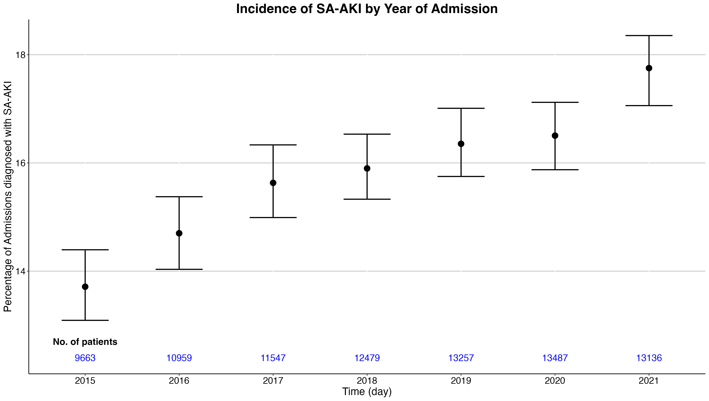
Figure S1: Incidence of SA-AKI by Year of Admission

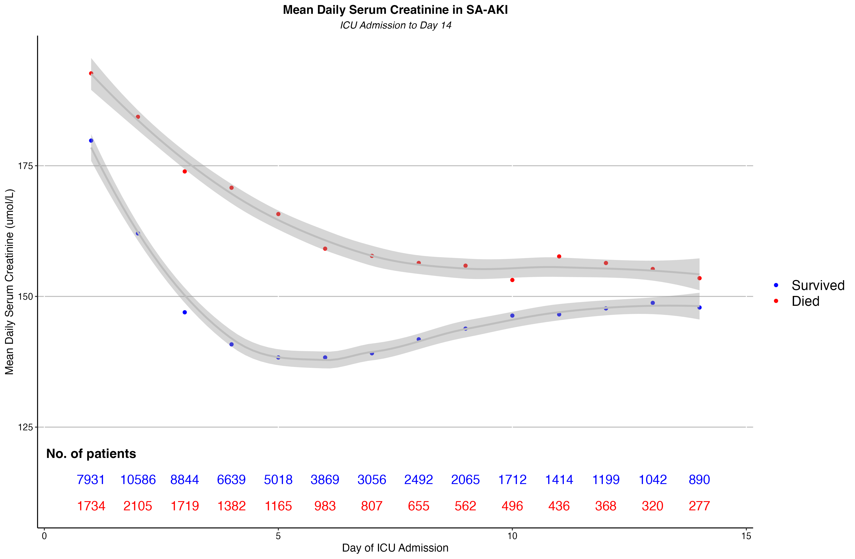
Figure S2: Mean Daily Serum Creatinine by Mortality

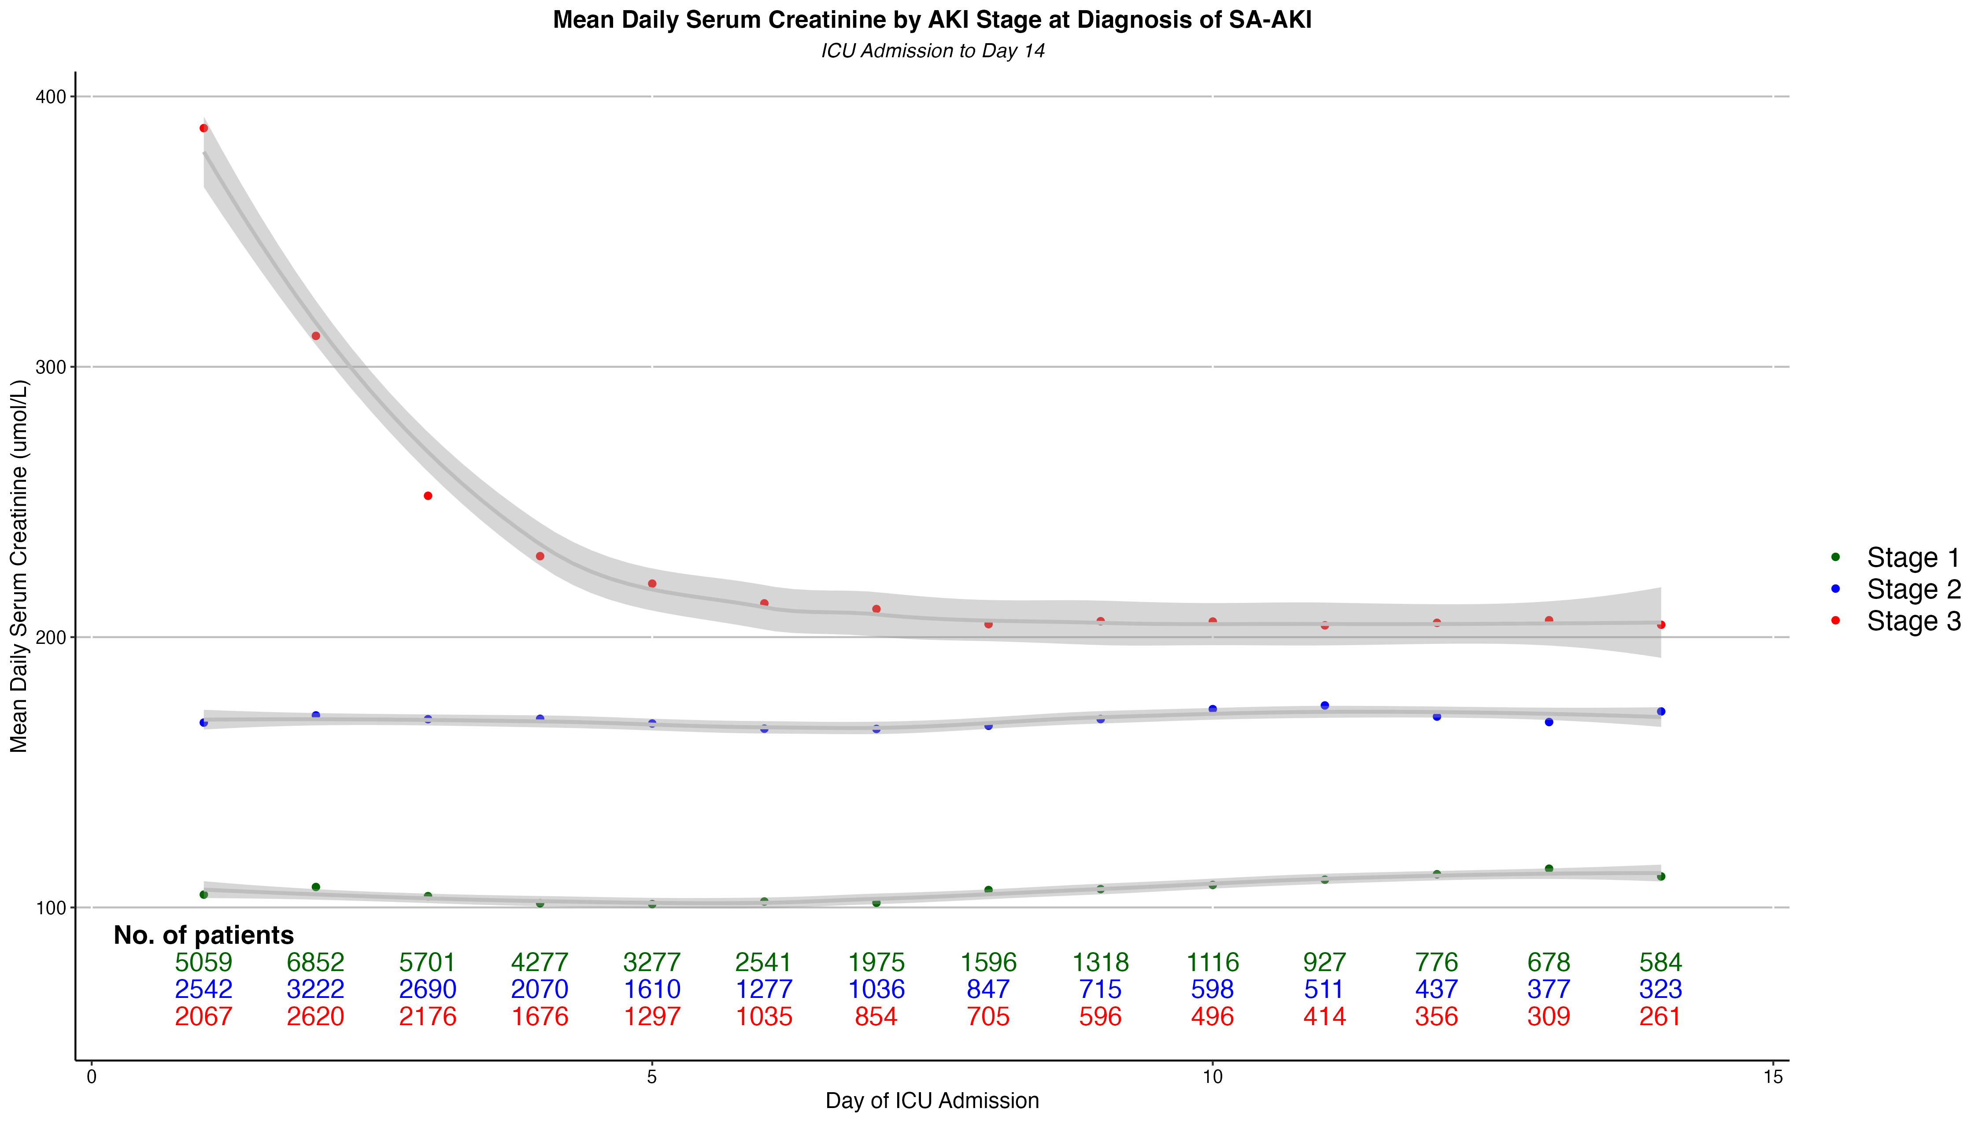
Figure S3: Mean Daily Serum Creatinine by AKI Stage at Diagnosis of SA-AKI

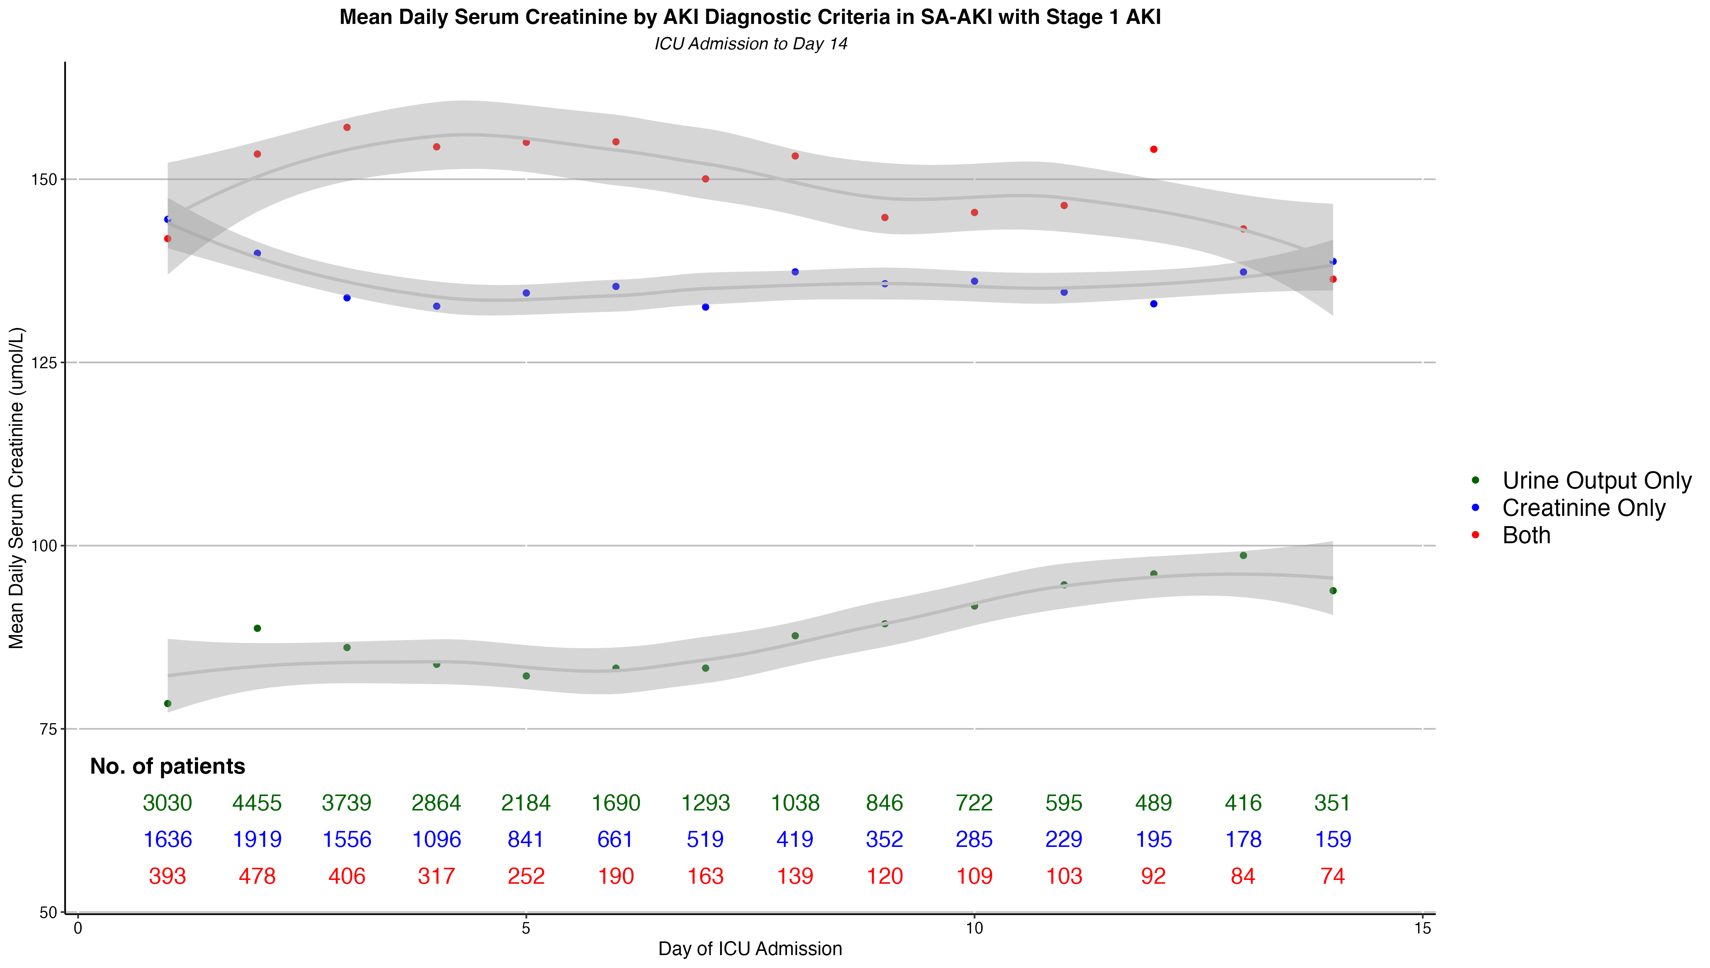
Figure S4: Mean Daily Serum Creatinine by AKI Diagnostic Criteria in SA-AKI with Stage 1 AKI

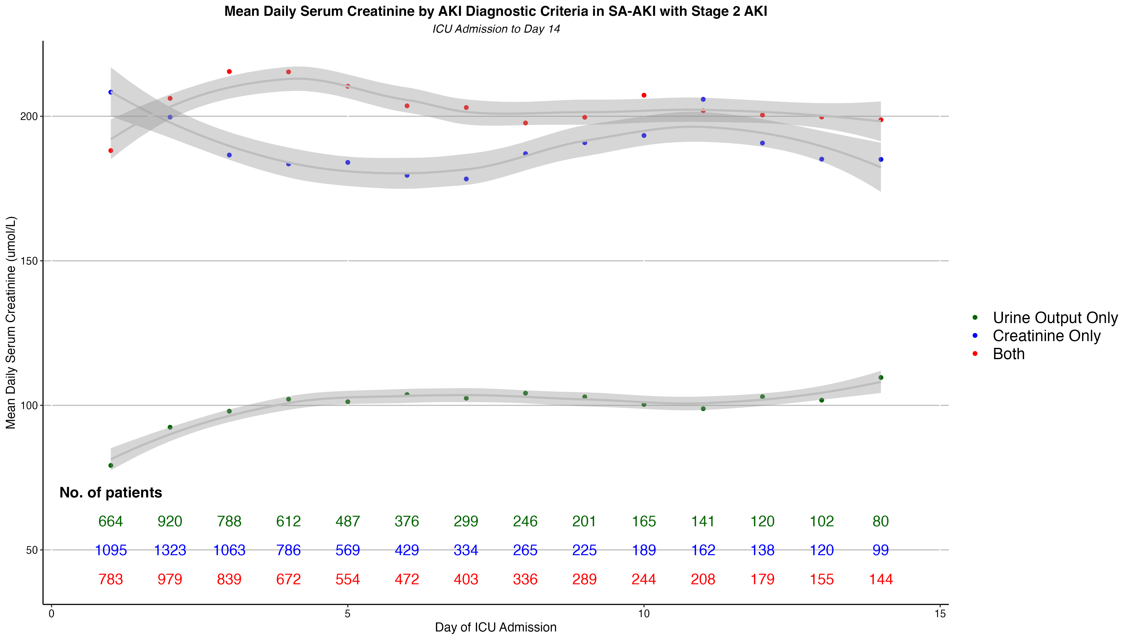
Figure S5: Mean Daily Serum Creatinine by AKI Diagnostic Criteria in SA-AKI with Stage 2 AKI

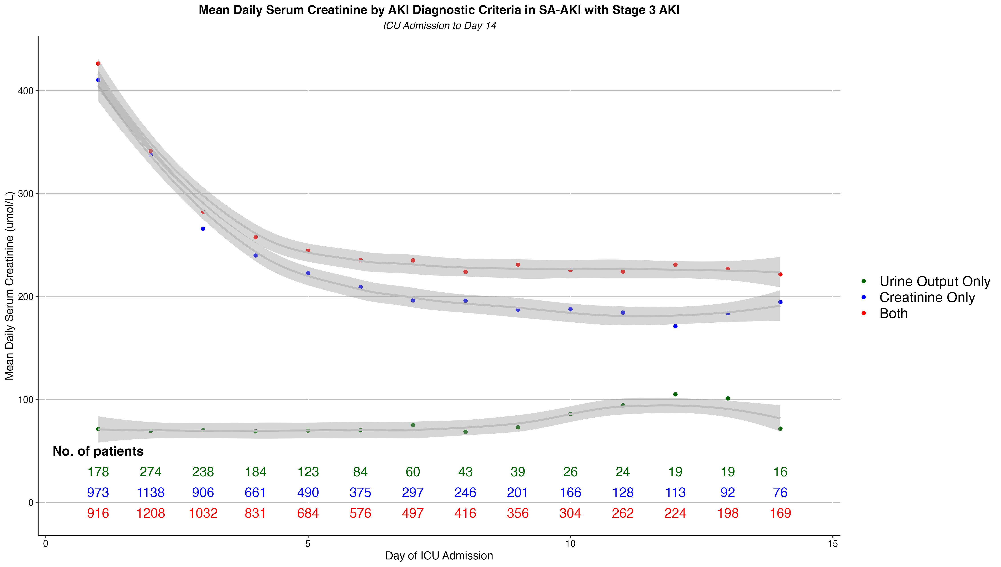
Figure S6: Mean Daily Serum Creatinine by AKI Diagnostic Criteria in SA-AKI with Stage 3 AKI

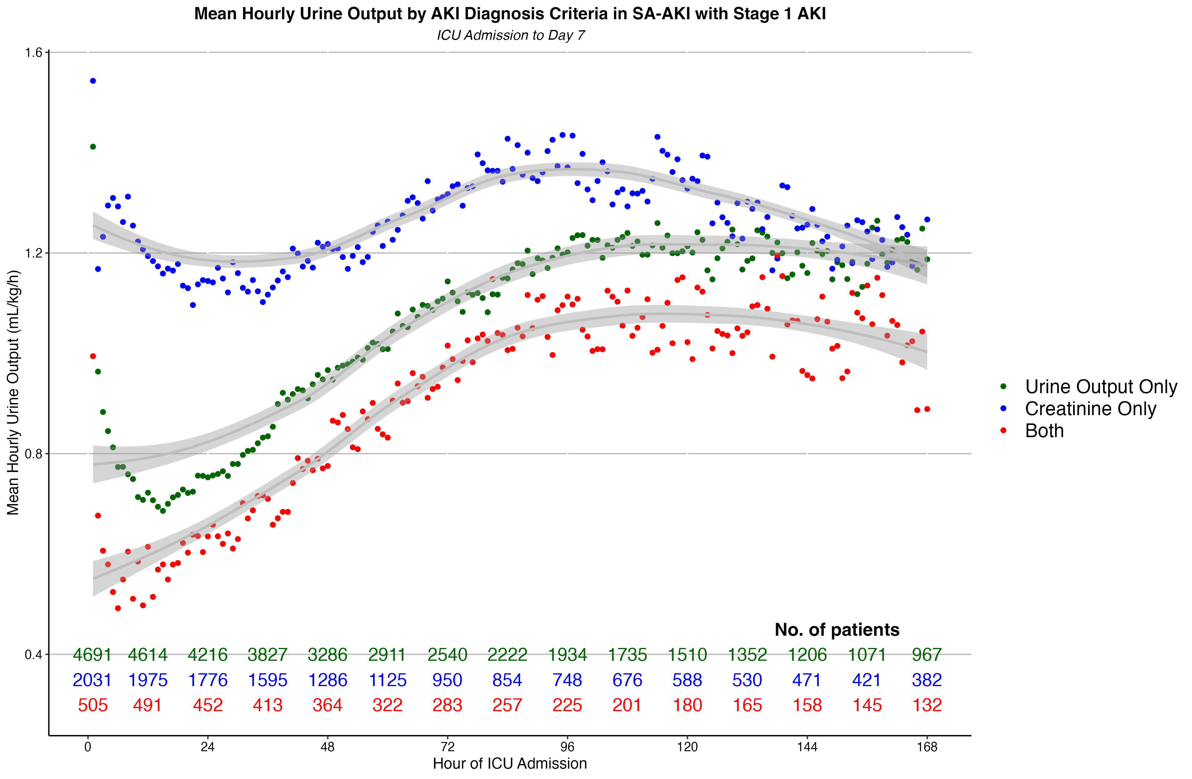
Figure S7: Mean Hourly Urine Output by AKI Diagnosis Criteria in SA-AKI with Stage 1 AKI

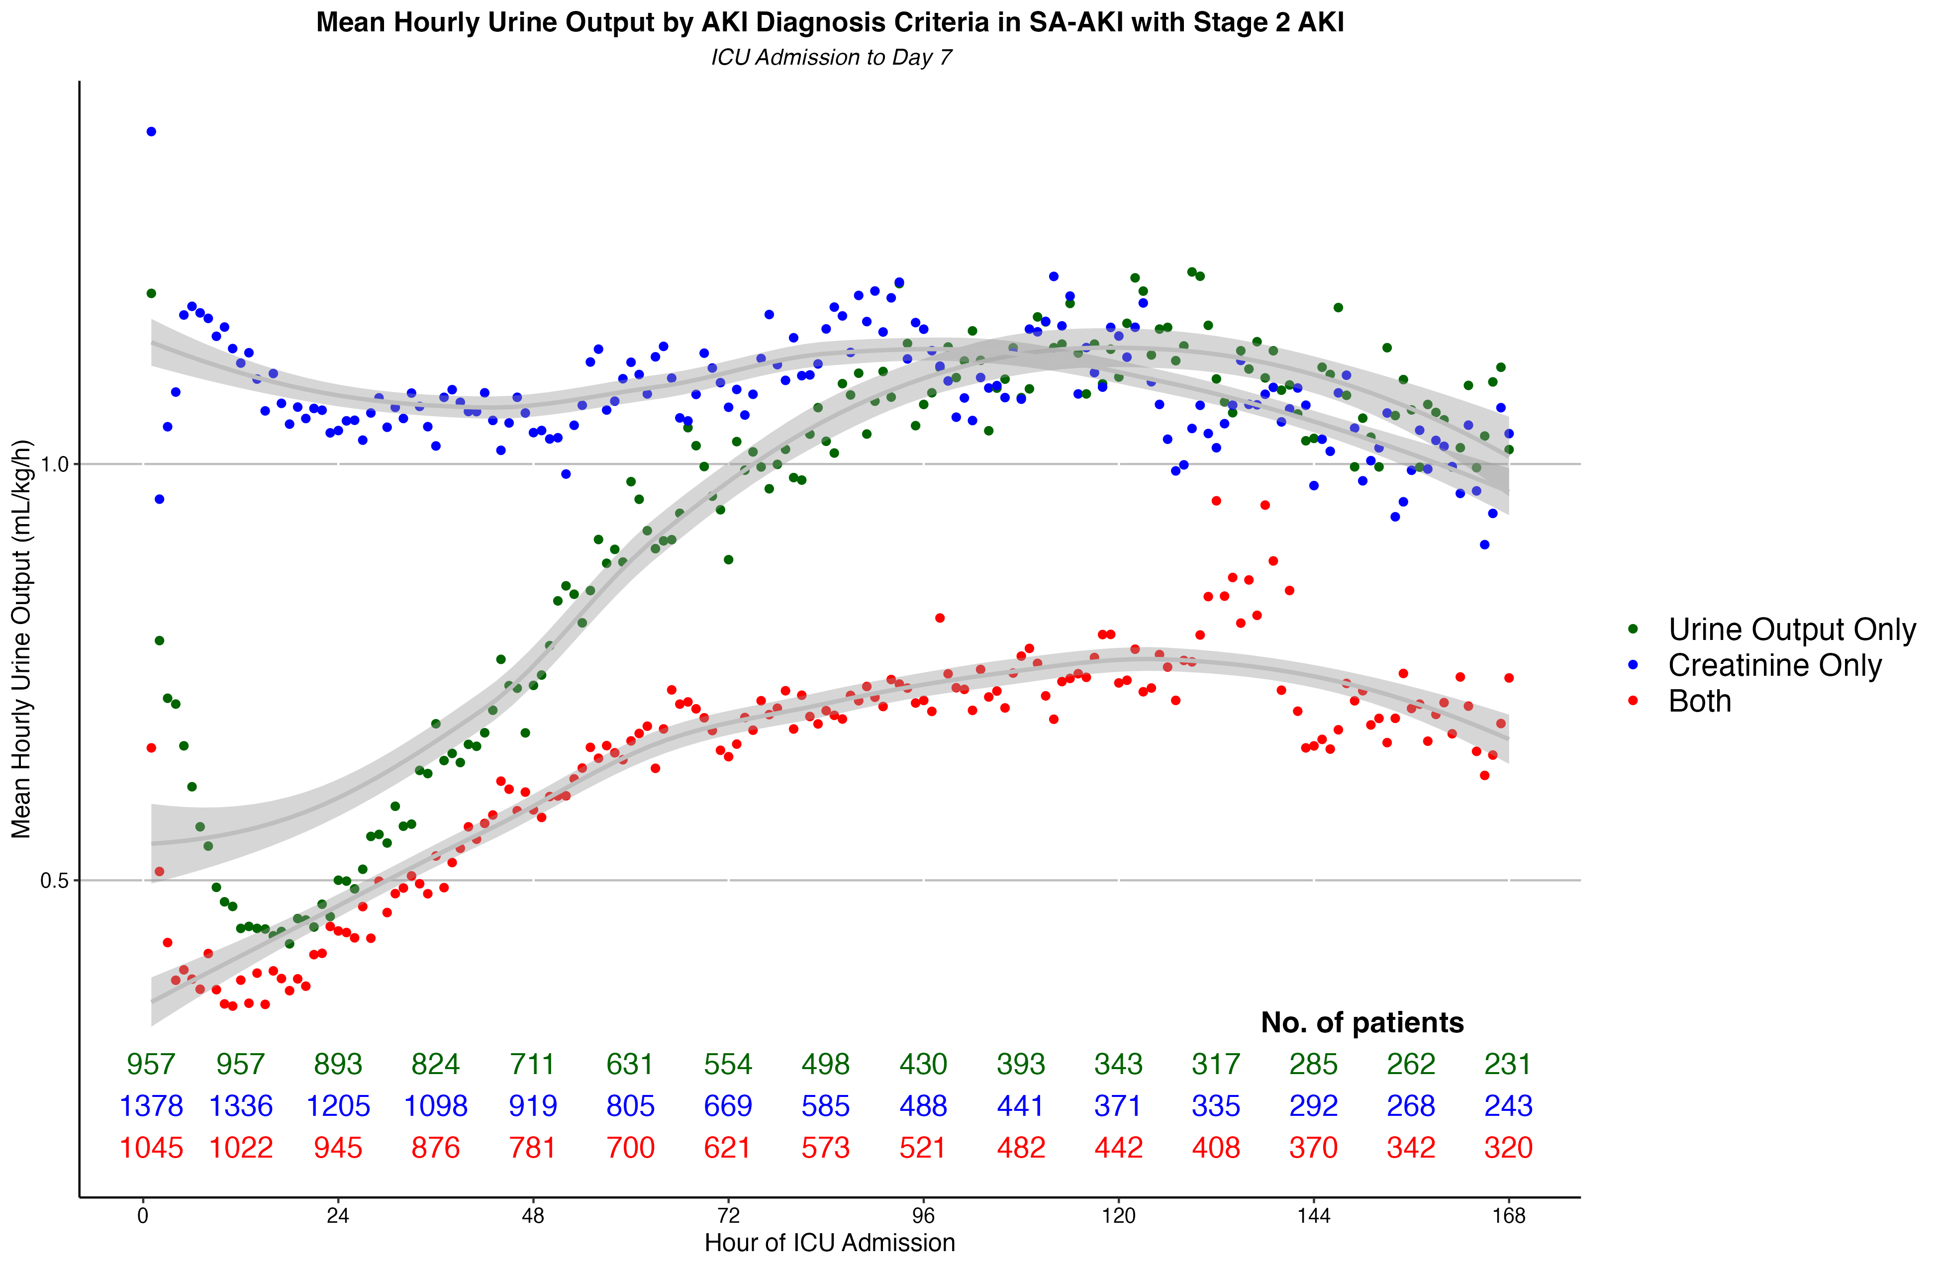
Figure S8: Mean Hourly Urine Output by AKI Diagnosis Criteria in SA-AKI with Stage 2 AKI

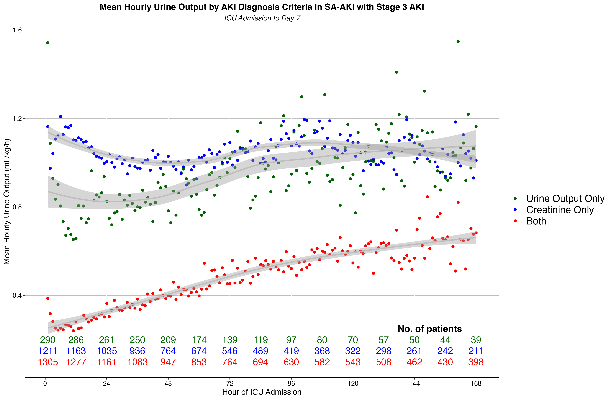
Figure S9: Mean Hourly Urine Output by AKI Diagnosis Criteria in SA-AKI with Stage 3 AKI

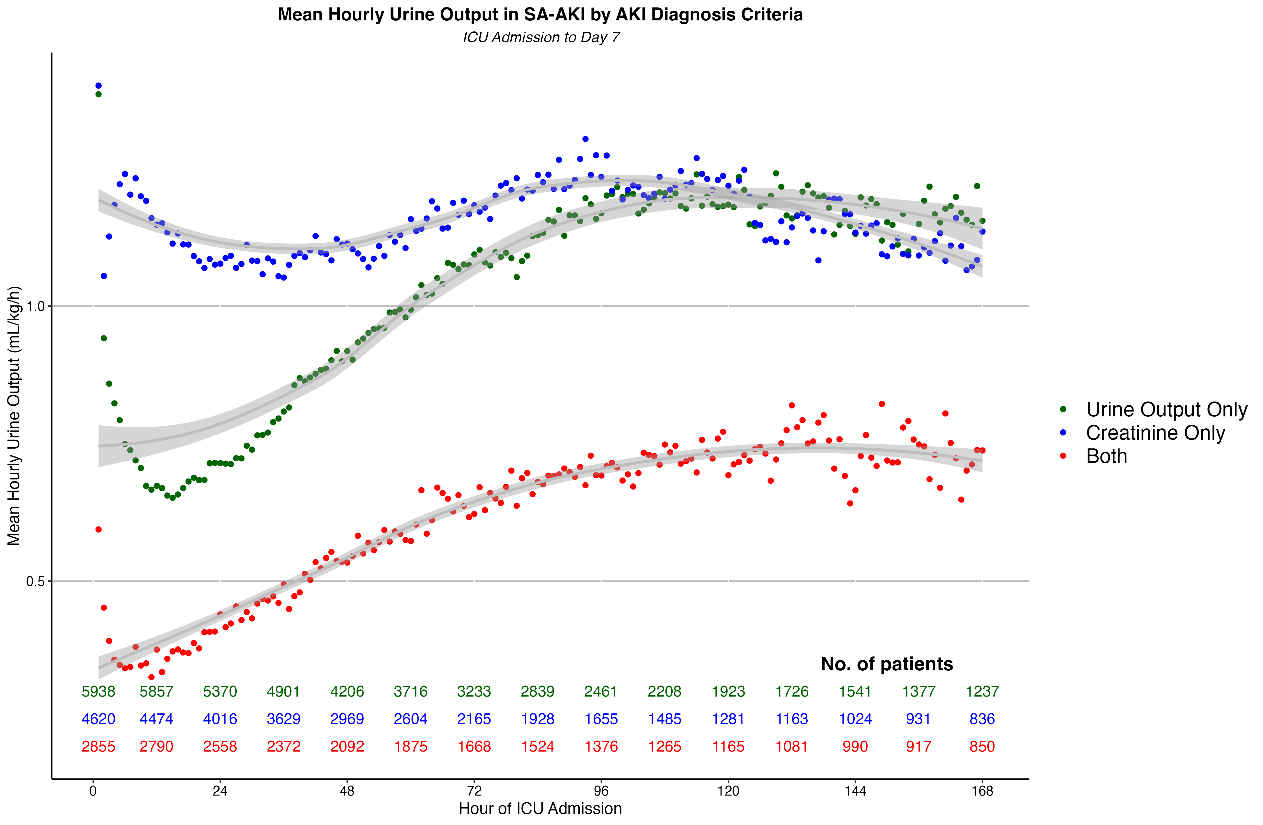
Figure S10: Mean Hourly Urine Output in SA-AKI by AKI Diagnosis Criteria

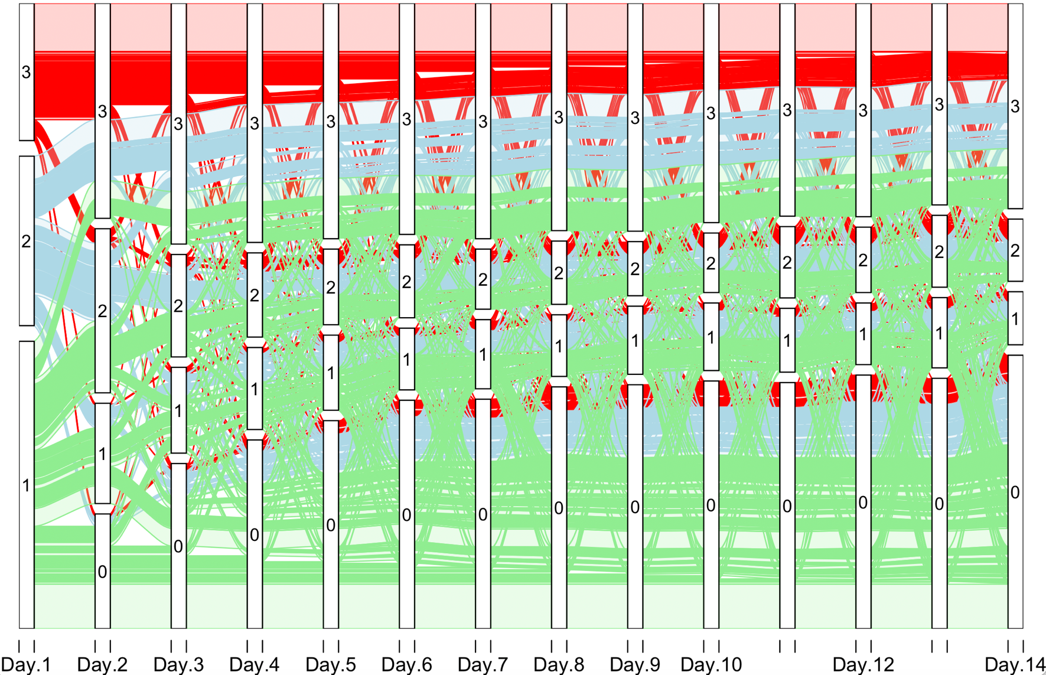
Acute kidney injury stage at diagnosis of SA-AKI on the y-axis. Day of SA-AKI diagnosis on x-axis. Coloured lines represent individual patients throughout ICU admission.
Figure S11: Alluvial Plot – AKI Stage in ALL SA-AKI patients over ICU admission
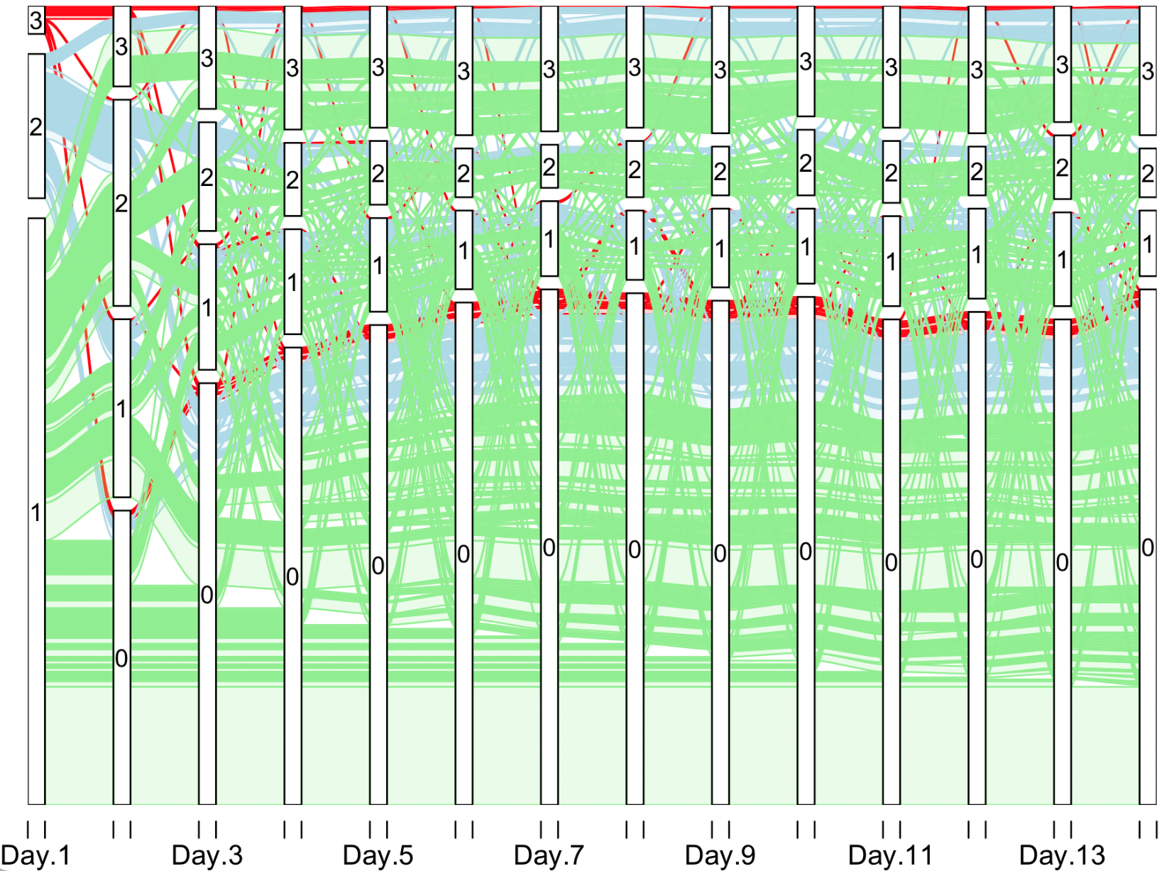
Acute kidney injury stage at diagnosis of SA-AKI on the y-axis. Day of SA-AKI diagnosis on x-axis. Coloured lines represent individual patients throughout ICU admission.
Figure S12: Alluvial Plot – AKI Stage over time in SA-AKI diagnosed by urine output only

