Electronic Supplementary Material

The effect of recombinant erythropoietin on long-term outcome after moderate to severe traumatic brain injury

Skrifvars MB¹, Luethi N², Bailey M³, French C⁴, Nichol A^{3,5}, Trapani T³, McArthur C⁶, Arabi YM⁷, Bendel S⁸, Cooper DJ³, Bellomo R⁹ for the EPO-TBI Investigators and the ANZICS Clinical Trials Group

¹Department of Emergency Medicine and Services, Helsinki University Hospital and University of Helsinki, Finland
²Department of Emergency Medicine, Inselspital, Bern University Hospital, University of Bern, Switzerland
³Australian and New Zealand Intensive Care Research Centre, School of Public Health and Preventive Medicine, Monash University, Melbourne, Victoria, Australia
⁴Department of Intensive Care, Western Health, Melbourne, Victoria, Australia
⁵School of Medicine and Medical Sciences, University College Dublin, Dublin, Ireland
⁶Department of Critical Care Medicine, Auckland City Hospital, Auckland, New Zealand
⁷ King Saud Bin Abdulaziz University for Health Sciences, King Abdullah International Medical Research Center, Intensive Care Department, Ministry of National Guard Health Affairs, Riyadh, Saudi Arabia
⁸Department of Anesthesiology and Intensive Care, Kuopio University Hospital & University of Eastern Finland
⁹Department of Intensive Care, Austin Health, Melbourne, Victoria, Australia

for the EPO-TBI Investigators and the ANZICS Clinical Trials Group

Ethical approvals:

RESEARCH ETHICS AND GOVERNANCE OFFICE ROYAL PRINCE ALFRED HOSPITAL
Protocol No X17-0188 & HRECl17IRPAHl278 -"Long term effects of EPO in
patients with moderate to severe traumatic brain injury: A follow-up study of an international randomised controlled trial"

Health and Disability Ethics Committees Ministry of Health 133 Molesworth Street PO Box 5013 Wellington, New Zealand. 17/NTA/251 Study title: Long term effects of erythropoietin in patients with moderate to severe traumatic brain injury- A follow-up study of an international randomised controlled trial

HELSINGIN JA UUDENMAAN SAIRAANHOITOPIIRI Tutkimuseettiset toimikunnat
HUS/2340/2018 Erytropoietiinin vaikutuksen pitkäaikaisennusteeseen traumaattisen aivovamman jälkeen. Long term effects of erythropoietin in patients with moderate to severe traumatic brain injury -AZICS CTG1617-10

Royal Hobart Hospital, Australia H0017053 Long term effects of Erythropoietin in patients with moderate to severe traumatic brain injury. A follow-up study of an international randomized controlled trial.

Saudi Arabia: National Guard Health Affairs Re: Erythropoietin in Traumatic Brain Injury (EPO-TBI) long term follow up Request approval of telephone consent CT17/010/R – Follow up study of RC10/063

Supplemental Table 1 Baseline characteristics of erythropoietin- and placebo treated patients at centres not included in long-term follow-up

 | Included | No data on long-term outcome | Long-term survival data available
 | (n = 356) | (n = 116) | (n = 131)
Age (years) | 34.1 (15.1) | 41.5 (14.5) | 32.6 (12.2)
Female sex – n (%) | 66 (18.5%) | 20 (17.2%) | 15 (11.5%)
Cause of injury – n (%)
Motor vehicle accident | 158 (44.4%) | 26 (22.4%) | 53 (40.5%)
Motorcycle | 41 (11.5%) | 17 (14.7%) | 12 (9.2%)
Bicycle | 9 (2.5%) | 9 (7.8%) | 8 (6.1%)
Pedestrian | 38 (10.7%) | 4 (3.4%) | 16 (12.2%)
Fall/jump | 75 (21.1%) | 39 (33.6%) | 24 (18.3%)
Hit by object | 25 (7%) | 8 (6.9%) | 18 (13.7%)
Other | 10 (2.8%) | 13 (11.2%) | 0 (0%)
Severe traumatic brain injury – n (%) | 267 (75%) | 98 (84.5%) | 89 (67.9%)
Moderate traumatic brain injury – n (%) | 89 (25%) | 18 (15.5%) | 42 (32.1%)
Pupillary response-n (%)
Both reacting | 293 (82.3%) | 85 (73.3%) | 109 (83.2%)
Dilated and both non-reactive | 1 (0.281%) | 0 (0%) | 0 (0%)
Both non-reactive | 27 (7.6%) | 7 (6%) | 13 (9.9%)
One non-reactive | 31 (8.7%) | 19 (16.4%) | 9 (6.9%)
Unknown | 4 (1.1%) | 5 (4.3%) | 0 (0%)
Hypotension – n (%) | 124 (34.8%) | 19 (16.4%) | 47 (35.9%)
Hypoxia – n (%) | 77 (21.6%) | 8 (6.9%) | 30 (22.9%)
Haemoglobin at baseline (g/dL) – Mean(STD) | 118 (21.1) | 125 (18.8) | 122 (20)
APACHE II Score– Mean(STD) | 20.6 (7.1) | 17.8 (5.9) | 19.8 (6.6)
Injury Severity Score– Mean(STD) | 27 (10.0) | 25.3 (10.2) | 26.9 (11.5)
IMPACT-TBI probability of poor outcome – Mean(STD) | 0.46 (0.23) | 0.50 (0.22) | 0.42 (0.23)
Abbreviated Injury Head Score – Median(IQR) | 4 [3-5] | 4 [4-5] | 4 [3-5]
Marshall CT classification – n (%)
I | 13 (3.7%) | 3 (2.6%) | 7 (5.3%)
II | 216 (60.7%) | 65 (56%) | 85 (64.9%)
III | 47 (13.2%) | 10 (8.6%) | 10 (7.6%)
IV | 12 (3.4%) | 6 (5.2%) | 5 (3.8%)
V | 8 (2.2%) | 3 (2.6%) | 3 (2.3%)
VI | 60 (16.9%) | 29 (25%) | 21 (16%)
Time from injury to randomization, hr – Mean(STD) | 17.9 (5.6) | 15.5 (6.2) | 16.8 (5.4)
Time from injury to first dose, hr– Mean(STD) | 19.2 (5.3) | 17.3 (5.9) | 18.2 (5.3)
APACHE= acute physiology and chronic health evaluation, CT=computed tomography, IMPACT-TBI= International Mission for Prognosis and Analysis of Clinical Trials in traumatic brain injury

Supplemental Table 2 Raw and Adjusted Hazard ratios (EPO vs placebo) for patient survival. Adjusted analysis account for region, TBI severity and the IMPACT-TBI risk for poor outcome with clustering by site included as a shared frailty-

Group | Raw  Hazard Ratio (95%CI) | Adjusted  Hazard Ratio (95%CI)
All patients | 0.73 (0.47-1.14) | 0.68 (0.43-1.06)
Severe TBI | 0.75 (0.46-1.24) | 0.67 (0.41-1.11)
Moderate TBI | 0.68 (0.25-1.81) | 0.67 (0.24-1.84)
No Intracranial mass lesion | 0.67 (0.40-1.12) | 0.63 (0.37-1.06)
Intracranial mass lesion | 0.98 (0.41-2.35) | 0.87 (0.36-2.12)
Extracranial ISS>6 | 1.05 (0.56-1.96) | 0.95 (0.5-1.79)
Extracranial ISS<=6 | 0.52 (0.28-0.98) | 0.49 (0.26-0.93)
AIS>3 in 2 regions | 0.46 (0.23-0.92) | 0.42 (0.21-0.85)
no AIS>3 in 2 regions | 1.04 (0.58-1.87) | 0.94 (0.52-1.72)

AIS=Abbreviated Injury Scale, CI=confidence interval, EPO=Erythropoietin, HR=Hasard ratio, IMPACT-TBI= International Mission for Prognosis and Analysis of Clinical Trials in traumatic brain injury, ISS=Injury Severity Score, TBI=Traumatic Brain Injury

Supplemental Figure 1 Adjusted survival analysis in EPO vs placebo-treated patients indexed by TBI features and whether the patient had multi-trauma or not. Hazard ratios have been adjusted for region, TBI severity and the IMPACT-TBI risk for poor outcome with clustering by site included as a shared frailty.
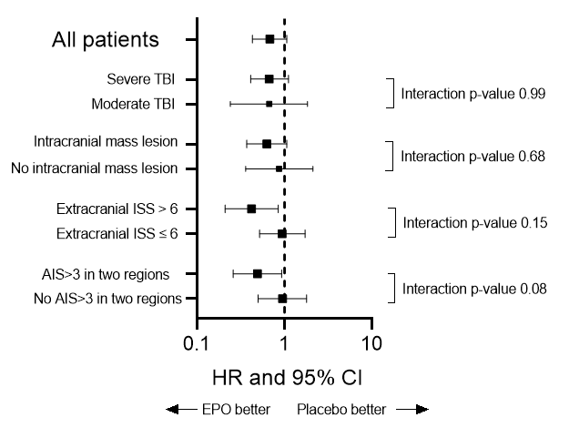

AIS=Abbreviated Injury Scale, CI=confidence interval, EPO=Erythropoietin, HR=Hasard ratio, IMPACT-TBI= International Mission for Prognosis and Analysis of Clinical Trials in traumatic brain injury, ISS=Injury Severity Score, TBI=Traumatic Brain Injury

Supplemental Figure 2 Long-term survival in 140 patients with moderate traumatic brain injury treated with erythropoietin (EPO) or placebo [Hazard ratio EPO vs placebo 0.68, 95% confidence interval 0.25-1.81).
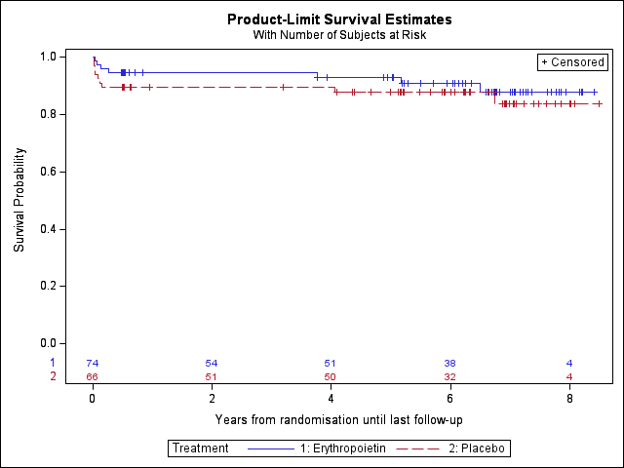

Supplemental Figure 3 Long-term survival in 347 patients with severe traumatic brain injury treated with erythropoietin (EPO) or placebo [Hazard ratio EPO vs placebo 0.75 (95% confidence interval 0.46-1.24)].
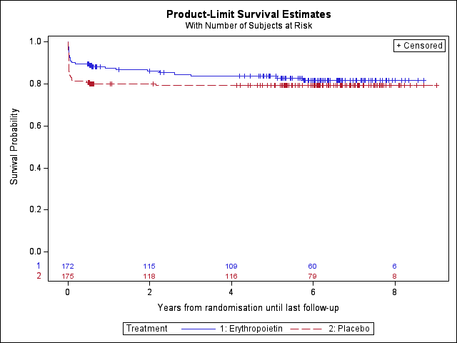

Supplemental Figure 4 Long-term survival in 395 patients with traumatic brain injury and without an intracranial mass lesion treated with erythropoietin (EPO) or placebo [Hazard Ratio (95% confidence interval) EPO vs Placebo 0.67 (0.40-1.12)]
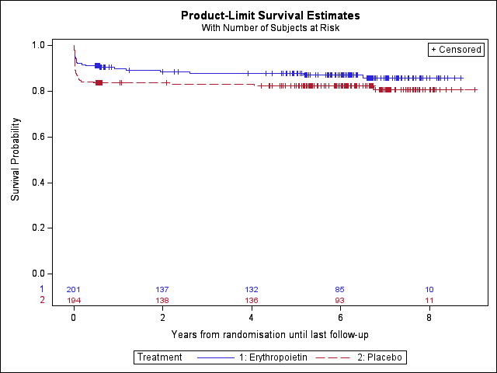

Supplemental Figure 5 Long-term survival in 92 patients with traumatic brain injury and with an intracranial mass lesion treated with erythropoietin (EPO) or placebo [hazard ratio (95% confidence interval) EPO vs placebo 0.98 (0.41-2.35)].
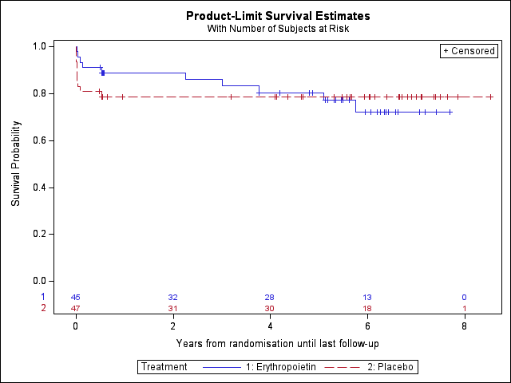

Supplemental Figure 6 Long-term survival in 259 patients with traumatic brain injury and multiple trauma based on an extracranial injury severity score of higher than six treated with erythropoietin (EPO) or placebo [hazard ratio (95% confidence interval) EPO vs placebo 0.52 (0.28-0.98)].

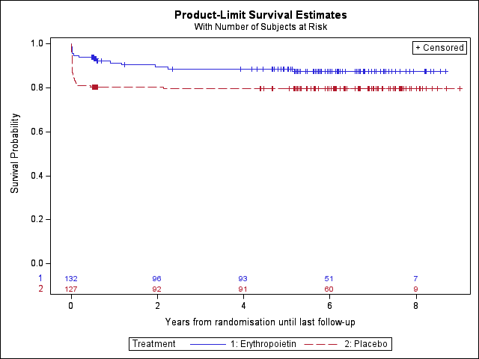

Supplemental Figure 7 Long-term survival in 228 patients with traumatic brain injury without multiple trauma based on an extracranial injury severity score of higher than six treated with erythropoietin (EPO) or placebo [hazard ratio (95% confidence interval) EPO vs placebo 1.05 (0.56-1.96)].
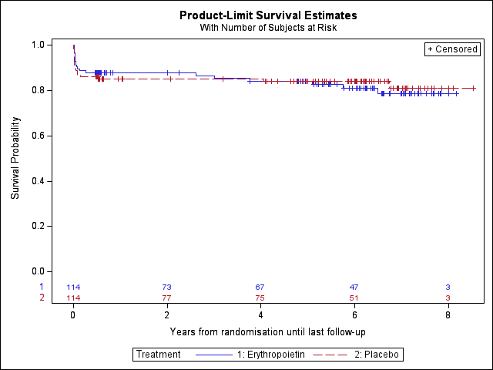

Supplemental Figure 8 Long-term survival in 211 patients with traumatic brain injury with multiple trauma based on an abbreviated injury score of more than three in two regions with erythropoietin (EPO) or placebo [hazard ratio (95% confidence interval) EPO vs placebo 0.46 (0.23-0.92)].
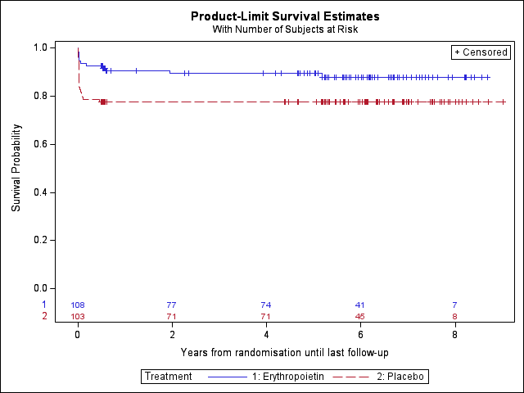

Supplemental Figure 9 Long-term survival in 276 patients with traumatic brain injury without multiple trauma based on an abbreviated injury score of more than three in two regions with erythropoietin (EPO) or placebo [hazard ratio (95% confidence interval) EPO vs placebo 1.04 (0.58-1.87)].
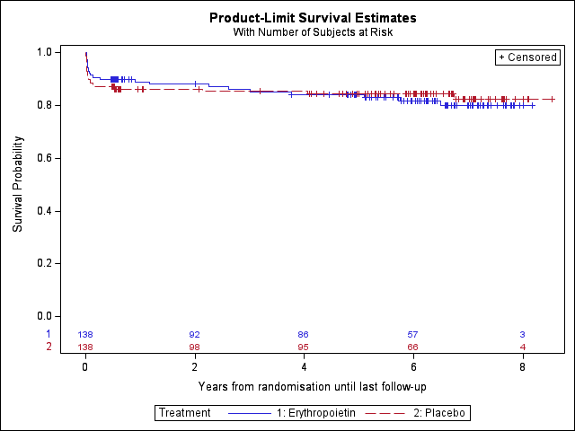

Supplemental Figure 10. Long-term EQ 5D VAS scores in patients with moderate or severe traumatic brain injury treated with either etryhropoietin or placebo.
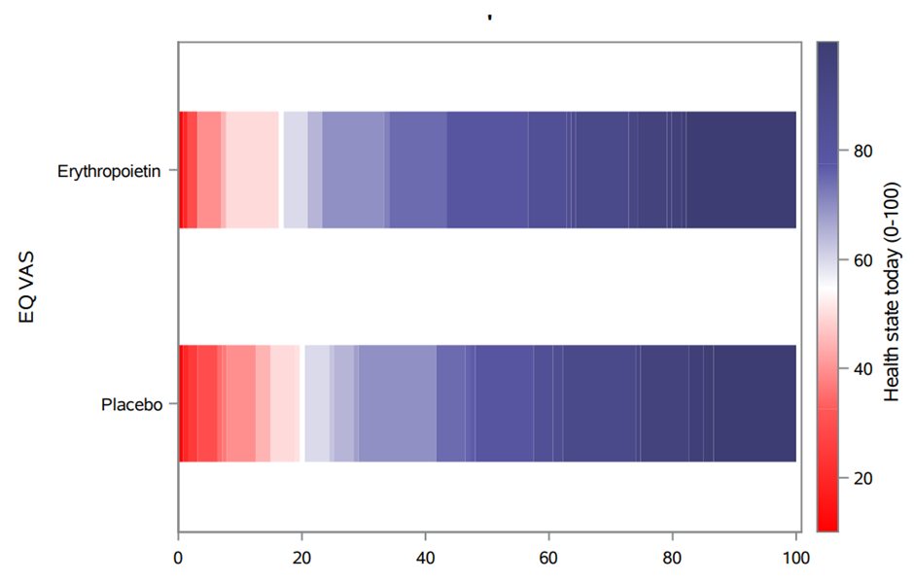

Supplemental Figure 11. Long-term EQ 5D utility scores in patients with moderate or severe traumatic brain injury treated with either etryhropoietin or placebo.
