Electrical Impedance Tomography-Guided Positive End-Expiratory Pressure Titration in ARDS - A Systematic Review and Meta-Analysis
Nickjaree Songsangvorn^{1,2}, Yonghao Xu^{1,3}, Cong Lu¹, Ori Rotstein^{1,4}, Laurent Brochard^{1,5}, Arthur S. Slutsky^{1,5}, Karen E. A Burns^{1,5}, Haibo Zhang^{1,5-7}
¹Keenan Research Centre for Biomedical Science and the Li Ka Shing Knowledge Institute, St. Michael’s Hospital, Unity Health Toronto, Toronto, ON, Canada
²Department of Critical Care Medicine, Bhumibol Adulyadej Hospital, Bangkok, Thailand
³The State Key Laboratory of Respiratory Disease, Guangzhou Institute of Respiratory Disease, The First Affiliated Hospital of Guangzhou Medical University, Guangzhou, China
⁴Department of Surgery, University of Toronto, Toronto, ON, Canada
⁵Interdepartmental Division of Critical Care Medicine, University of Toronto, ON, Canada
⁶Department of Physiology, University of Toronto, Toronto, ON, Canada
⁷Department of Anesthesiology and Pain Medicine, University of Toronto, ON, Canada

Online Supplement

Literature Search Strategy
Database: Scopus

( TITLE-ABS-KEY ( eit OR electrical AND impedance AND tomography ) AND TITLE-ABS-KEY ( ards OR "acute respiratory distress syndrome" OR "acute respiratory failure" OR "acute lung injury" ) AND TITLE-ABS-KEY ( "mechanical ventilat*" OR peep OR "positive end expiratory pressure" OR recruitment OR "tidal volume" ) ) AND PUBYEAR > 2011 AND PUBYEAR < 2024 AND ( LIMIT-TO ( SRCTYPE , "j" ) ) AND ( LIMIT-TO ( EXACTKEYWORD , "Human" ) OR LIMIT-TO ( EXACTKEYWORD , "Adult" ) ) AND ( LIMIT-TO ( DOCTYPE , "ar" ) )

Database: PubMed Search

((EIT[Title/Abstract] OR "electrical impedance tomography"[Title/Abstract]) AND (ARDS[Title/Abstract] OR "acute respiratory distress syndrome"[Title/Abstract] OR "acute respiratory failure"[Title/Abstract] OR "acute lung injury"[Title/Abstract])) AND ("mechanical ventilat*"[Title/Abstract] OR PEEP[Title/Abstract] OR "positive end expiratory pressure"[Title/Abstract] OR recruitment[Title/Abstract] OR "tidal volume"[Title/Abstract]) Filters: Humans, from 2012 - 2023

Database: Medline

Ovid MEDLINE(R) and Epub Ahead of Print, In-Process, In-Data-Review & Other Non-Indexed Citations <1946 to May 01, 2023>
1 (EIT or "electrical impedance tomography").ti,kw,ab. 3035
2 (ARDS or "acute respiratory distress syndrome" or "acute respiratory failure" or "acute lung injury").ti,kw,ab. 49146
3 ("mechanical ventilat*" or PEEP or "positive end expiratory pressure" or recruitment or "tidal volume").ti,kw,ab. 227403
4 1 and 2 and 3 217
5 limit 4 to (humans and yr="2012 - 2023") 110

Database: EBM Reviews - Cochrane Central Register of Controlled Trials <May 2023>

1 (EIT or "electrical impedance tomography").ti,kw,ab. 382
2 (ARDS or "acute respiratory distress syndrome" or "acute respiratory failure" or "acute lung injury").ti,kw,ab. 5088
3 ("mechanical ventilat*" or PEEP or "positive end expiratory pressure" or recruitment or "tidal volume").ti,kw,ab. 48323
4 1 and 2 and 3 73
5 limit 4 to (humans and yr="2012 - 2023") 69

Database: Lilacs

(eit OR electrical impedance tomography) AND (ards OR acute respiratory distress syndrome OR acute respiratory failure OR acute lung injury) AND (mechanical ventilat* OR peep OR positive end expiratory pressure OR recruitment OR tidal volume) AND (year_cluster:[2012 TO 2023])

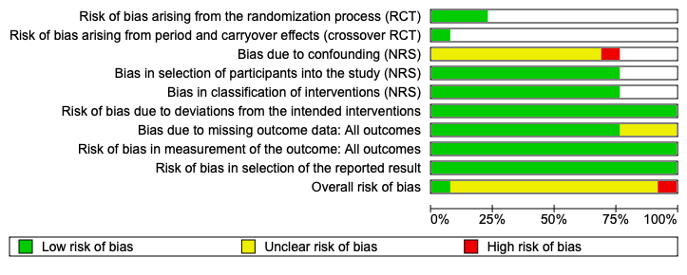
Figure E1. Risk of bias graph

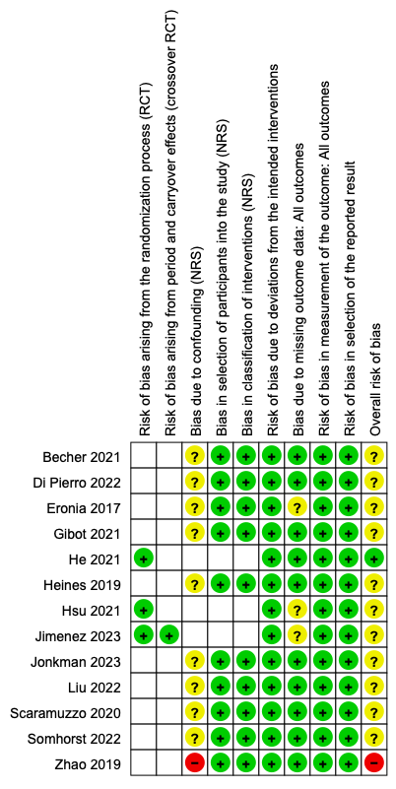

Figure E2. Risk of bias summary for studies included in the systematic review. Green (+) signs indicate that risk of bias was low, yellow (?) marks indicate that risk of bias was some concern, and red (-) marks indicate that risk of bias was high.

Primary and secondary outcome
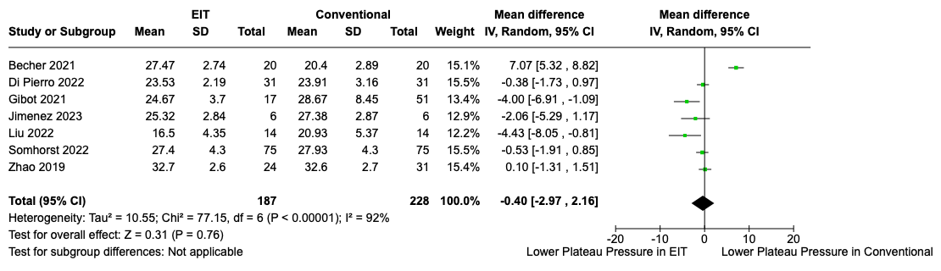Figure E3. The comparison of EIT with conventional guided PEEP in plateau pressure: No statistical significance

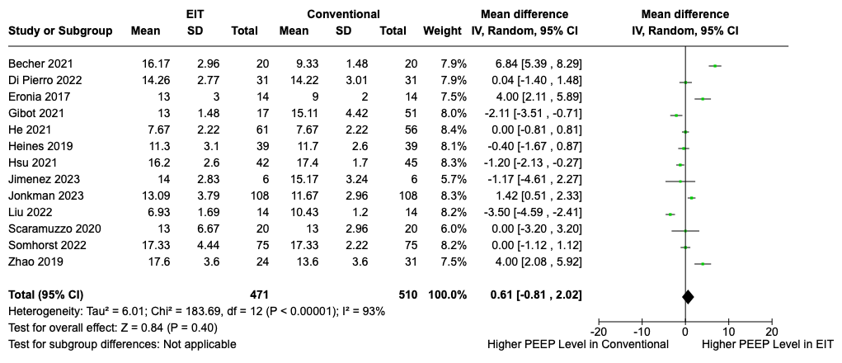 Figure E4. The comparison of EIT with conventional guided PEEP in PEEP level: No statistical significance

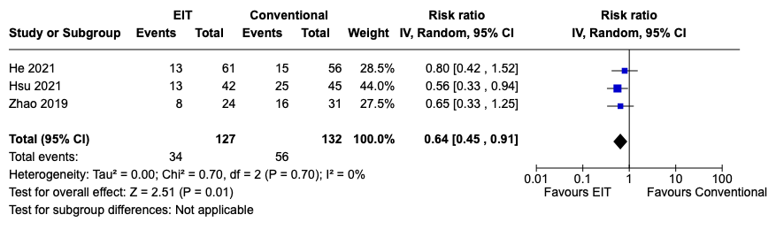

Figure E5. EIT-Guided PEEP Titration Reduced All-Cause Mortality Compared to Conventional Methods of PEEP Titration. The "Events" columns indicate the number of deaths, while the "Total" columns represent the total number of subjects in each group. Abbreviations: CI = confidence interval; df = degrees of freedom; I² = heterogeneity statistic; IV = inverse variance method.

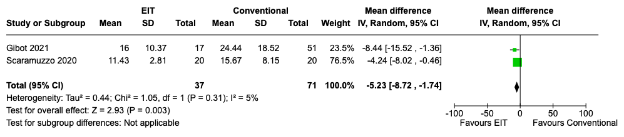 Figure E6. The comparison of EIT with conventional guided PEEP in %silent spaces: EIT guide PEEP decreased %silent spaces (MD = -5.23, 95%CI [-8.73, -1.73], P=0.003, and I²=5%)

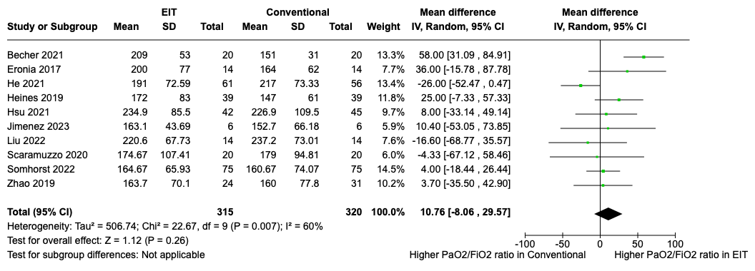
Figure E7. The comparison of EIT with conventional guided PEEP in PaO2/FiO2 ratio: No statistical significance

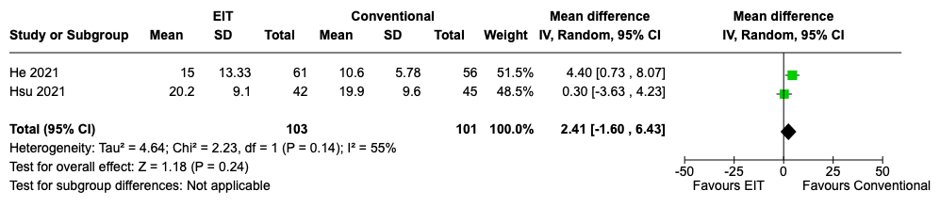
Figure E8. The comparison of EIT with conventional guided PEEP in lengths of ICU stay: No statistical significance

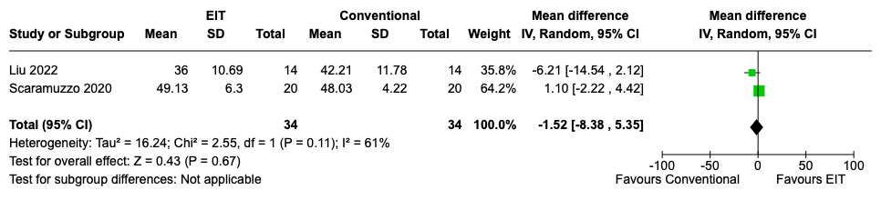
Figure E9. The comparison of EIT with conventional guided PEEP in %COV: No statistical significance

Sensitivity analysis for driving pressure

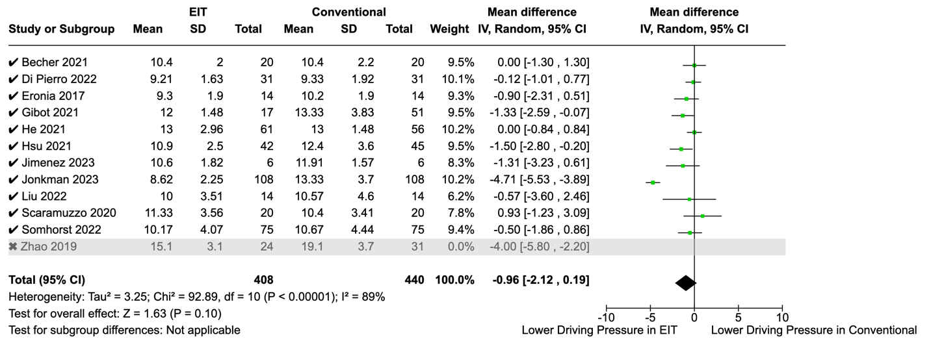

Figure E10. Forest plots of sensitivity analysis for driving pressure by excluding studies with high risk of bias illustrates a slight reduction in mean difference with diminished statistical significance.

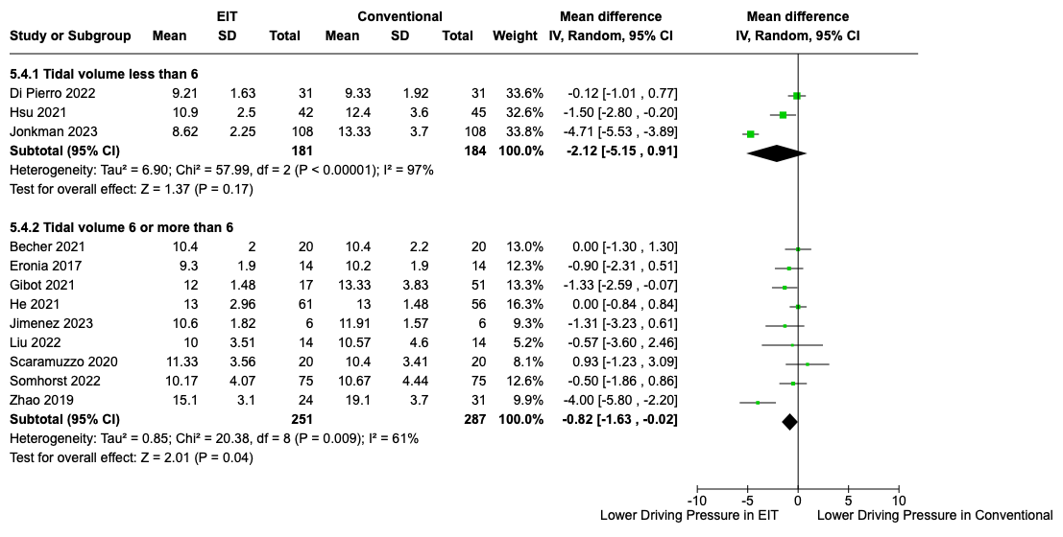

Figure E11. Forest plots of sensitivity analysis for driving pressure by excluding studies with tidal volumes less than 6 demonstrates a notable decrease in heterogeneity while maintaining statistical significance.

Assessment of publication bias
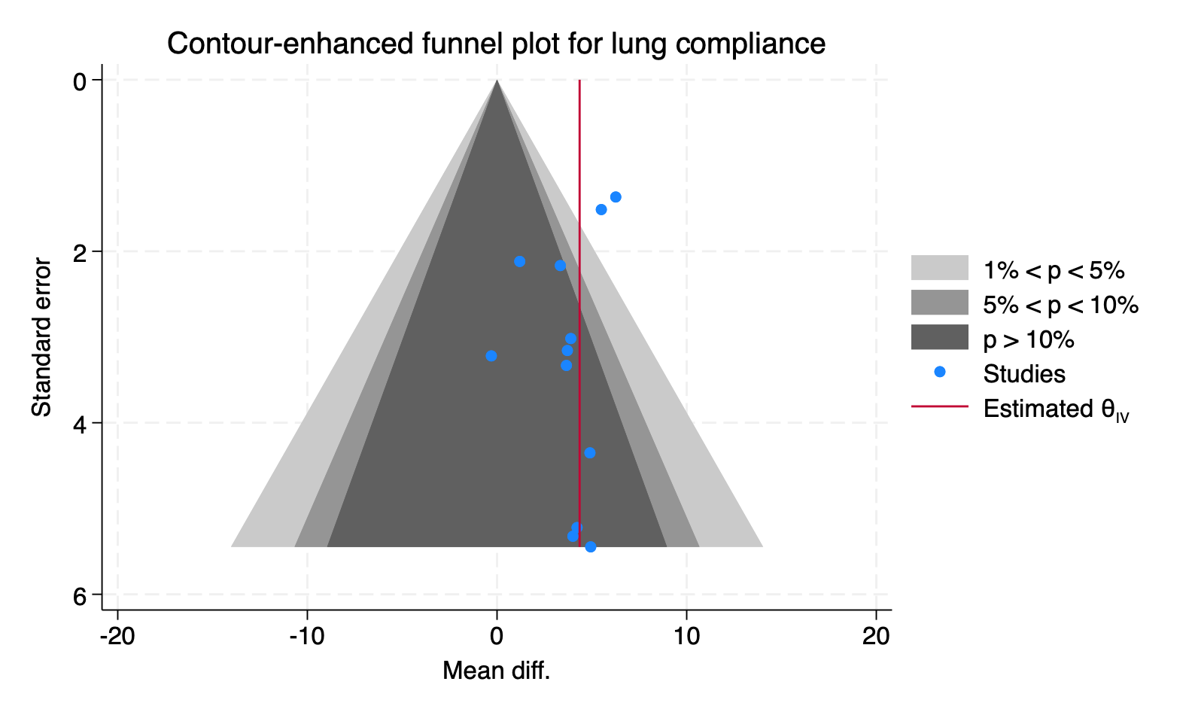
Figure E12. Contour-enhanced funnel plot to assess publication bias for lung compliance. The Egger's test yielded p-value of 0.26, indicating no publication bias.

 | DP | PEEP | PaO2/FiO2 ratio
Age(<60, >60) | P=0.55  I²=0% | P=0.85  I²=0% | P=0.75  I²=0%
BMI (<30, >30) | P=0.52  I²=0% | P=0.29  I²=9.3% | P=0.67  I²=0%
Cause of ARDS (Intra/Extrapulmonary) | P=0.56  I²=0% | P=0.09  I²=65.5% | P=0.40  I²=0%
COVID-19 | P=0.95  I²=0% | P=0.31  I²=13.9% | P=0.61  I²=0%
ARDS severity  (PF<100, 100-200, 200-300) | P=0.009,  I²=85.4% | P=0.004  I²=88% | P=0.73  I²=0%
MV duration before data collection  (<24, >24 h) | P=0.49  I²=0% | P=0.25  I²=23.7% | P=0.22  I²=34.1%
MV duration before inclusion  (<3, 3-7, >7 day) | P=0.19,  I²=42 | P=0.45  I²=0% | P=0.55  I²=0%
Tidal volume (<4, 4-6, 6-8) | P=0.14  I²=49.3% | P=0.83  I²=0% | P=0.90  I²=0%
RM before PEEP trial | P=0.88  I²=0% | P=0.10  I²=64% | P=0.01  I²=84.7%
Incremental/Decremental PEEP | P=0.07,  I²=69% | P=0.23  I²=31% | P=0.55  I²=0%
Conventional intervention | P=0.002,  I²=70.5% | P<0.00001  I²=85.9% | P=0.88  I²=0%
EIT intervention | P=0.33,  I²=13.5% | P<0.00001  I²=97.1% | P=0.004,  I²=73.7%
Table E1: Test for subgroup differences (Heterogeneity investigation)

This table presents the results of subgroup analyses conducted to investigate heterogeneity in outcomes across various studies. Subgroup effects were considered statistically significant when the p-value was less than 0.1. For the outcome "Driving Pressure," statistically significant subgroup effects were observed in the severity of ARDS, incremental/decremental PEEP, and conventional intervention. In the case of "PEEP," statistically significant subgroup effects were identified in cause of ARDS, the severity of ARDS, recruitment maneuver before PEEP trial, and both conventional and EIT interventions. Regarding the "PaO2/FiO2 Ratio," statistically significant subgroup effects were detected in studies involving recruitment maneuver before PEEP trial and EIT intervention."

