Supplementary data

Non-occlusive mesenteric ischemia - the wolf in sheep's clothing

Rafael Käser*, Dominik Bettinger*, Hannes Neeff, Tobias Wengenmayer, Alexander Supady

Methodology
Patients and parameters
We retrospectively searched our electronic records for all patients ≥ 18 years with suspected mesenteric ischemia who received computed tomography angiography (CTA) followed by early colonoscopy (within 4 hours after CTA). Between 03/2009 and 08/2020, 125 patients met the inclusion criteria.
Demographic data, comorbidities, hematology and clinical chemistry results, CTA and endoscopy findings were retrieved from the medical records.
Study design and endpoints
This was a retrospective single-center observational study. The primary endpoint was endoscopy confirmed colon ischemia. Secondary endpoints included the assessment of clinical, laboratory and radiologic findings characteristic for colon ischemia, the need for surgery and in-hospital mortality.
Ethics
The trial conformed to the ethical guidelines of the 1975 Declaration of Helsinki and was approved by the institutional ethics committee of the University of Freiburg (EK-FR 21-1148). Due to the retrospective nature of the study, the need for informed consent was waived.

Statistical analyses
Continuous variables are expressed as medians with interquartile ranges, categorical variables are reported as frequencies and percentages. For continuous variables differences were determined using Wilcoxon-Mann-Whitney and Kruskal-Wallis tests as there was no Gaussian distribution of the data, confirmed by Kolmogorov-Smirnov test. Chi-square or Fisher’s exact tests were used for analysis of categorical variables. Uni- and multivariable logistic regression models (forward variable selection, p(in) < 0.05, p(out) > 0.10, likelihood ratio) were used to identify predictive factors for colon ischemia. Sensitivity and specificity with 95% confidence intervals were calculated for specific radiological findings with regard to detection of colonic ischemia.
A p-value < 0.05 was considered statistically significant. Statistical analyses were performed using SPSS (version 29.0, IBM, New York, USA) and GraphPad Prism (version 10, GraphPad Software, San Diego, USA).

Results
Patient characteristics
Baseline characteristics, comorbidities and preceding treatments were similar in patients with and without endoscopic evidence of colon ischemia (Supplementary Table 1).

 | All patients  (n = 125) | No endoscopic evidence of colon ischemia  (n= 67) | Endoscopy confirmed colon ischemia  (n = 58) | p-value
Demographic data
Age [years] | 68 (59-76) | 68 (58-76) | 69 (59-76) | 0.556
Gender  Female  Male | 48 (38.4 %)  77 (61.6 %) | 21 (31.3 %)  46 (68.7 %) | 27 (46.6 %)  31 (53.4 %) | 0.081
BMI [kg/m²] | 25 (23-30) ª | 25 (23-30) ^{b} | 26 (22-29) ^{c} | 0.907
Comorbidities
CHD | 19 (15.2 %) | 8 (11.9 %) | 11 (19.0 %) | 0.275
CHF | 30 (24.0 %) | 14 (20.9 %) | 16 (27.6 %) | 0.382
PAD | 18 (14.4 %) | 6 (9.0 %) | 12 (20.7 %) | 0.062
COPD | 20 (16.0 %) | 7 (10.4 %) | 13 (22.4 %) | 0.069
CKD | 12 (9.6 %) | 6 (9.0 %) | 6 (10.3 %) | 0.792
Treatment characteristics
ICU treatment | 102 (81.6 %) | 54 (80.6 %) | 48 (82.8 %) | 0.756
Mechanical ventilation | 49 (39.2 %) | 23 (34.3 %) | 26 (44.8 %) | 0.230
Cardiac arrest | 14 (11.2 %) | 6 (9.0 %) | 8 (13.8 %) | 0.392
Sepsis | 72 (57.6 %) | 41 (61.2 %) | 31 (53.4 %) | 0.382
RRT | 21 (16.8 %) | 10 (14.9 %) | 11 (19.0 %) | 0.547
ECMO | 9 (7.2 %) | 5 (7.5 %) | 4 (6.9 %) | 0.999
MAP [mmHg] | 81 (72 – 96) | 83 (72 – 102) | 80 (72 – 95) | 0.677
Heart rate [bpm] | 94 (80 – 105) | 91 (80 – 104) | 97 (82 – 107) | 0.242
Body temperature [°C] | 36.8  (36.2 – 37.4) | 36.8  (36.4 – 37.4) | 36.8  (36.1 – 37.4) | 0.895
Vasopressor treatment at time of CTA | 64 (51.2 %) | 36 (53.7 %) | 28 (48.3 %) | 0.543
Vasopressor treatment at time of colonoscopy | 75 (60.0 %) | 43 (64.2%) | 32 (55.2 %) | 0.305
SOFA score | 10 (4-13) | 9 (4-15) | 10 (4-13) | 0.124
Clinical signs
Abdominal pain | 50 (40.0 %) | 24 (35.0%) | 26 (44.8 %) | 0.305
Hematochezia | 10 (8.0 %) | 3 (4.5 %) | 7 (12.1 %) | 0.186
Nausea/vomiting | 10 (8.0 %) | 6 (9.0 %) | 4 (6.9 %) | 0.751
Medication
PPI | 90 (72.0 %) | 51 (77.3 %) | 39 (67.2 %) | 0.212
Anticoagulation | 40 (32.0 %) | 22 (33.3 %) | 18 (31.0 %) | 0.785
Heparin (LMW or unfractionated) | 26 (20.8 %) | 11 (16.7 %) | 15 (25.9 %) | 0.209
Vitamin K antagonists | 5 (4.0 %) | 3 (4.5 %) | 2 (3.4 %) | 0.999
DOAC | 9 (7.2 %) | 8 (12.1 %) | 1 (1.7 %) | 0.036
Aspirine | 39 (32.2 %) | 18 (27.3 %) | 21 (36.2 %) | 0.285
P2Y₁₂ antagonists | 8 (6.4 %) | 2 (3.0 %) | 6 (10.3 %) | 0.145
Immunosupressive treatment | 17 (13.6 %) | 9 (13.6 %) | 8 (13.8 %) | 0.980
Prior surgery
Abdominal surgery | 32 (25.6 %) | 18 (26.9 %) | 14 (24.1%) | 0.727
Cardiac surgery | 15 (12.0 %) | 7 (10.4 %) | 8 (13.8 %) | 0.566
Other surgery# | 7 (5.6 %) | 4 (6.0 %) | 3 (5.2 %) | 0.999

Supplementary Table 1: Baseline characteristics and comorbidities.
Data are median (IQR) or n (%). ª n = 114; ^{b} n = 60; ^{c} n = 54; # other surgery includes orthopedic and trauma surgery as well as urological surgery.
ICU = intensive-care unit. BMI = body-mass index. CHD = coronary heart disease. CHF = congestive hear failure. PAD = peripheral artery disease. COPD = chronic obstructive pulmonary disease. CKD = chronic kidney disease. ICU = intensive-care unit. RRT = renal replacement therapy. ECMO = extracorporeal membrane oxygenation. MAP = mean arterial pressure. CTA = computed tomography angiography. SOFA = sequential organ failure assessment. LMW = low molecular weight. PPI = proton pump inhibitor. DOAC = direct acting oral anticoagulants.

Hematology and clinical chemistry findings
Serum lactate, a surrogate parameter for tissue hypoxia, did not differ between patients with and without colon ischemia at the time of CTA (2.5 (1.3 – 8.4) mmol/l vs. 2.1 (1.1-6.5) mmol/l; p=0.466) or colonoscopy (2.6 (1.5-7.4) mmol/l vs. 2.4 (1.2-9.2) mmol/l, p=0.375, Supplementary Table 2).
Patients with colon ischemia had significantly higher LDH values compared to patients without endoscopic evidence for ischemia (511 (296-1508) U/l vs. 317 (220-603) U/l; p=0.026). All other parameters did not differ significantly between patients with and without colon ischemia (Supplementary Table 2).

 | All patients  (n = 125) | No endoscopic evidence of colon ischemia  (n= 67) | Endoscopy confirmed colon ischemia  (n = 58) | p-value
White blood count [thousand/µl] | 14.0 (8.8-20.9) | 13.2 (7.8-19.8) | 14.8 (10.8-22.8) | 0.108
Platelets [thousand/µl] | 156 (101-262) | 148 (103-275) | 172 (88-259) | 0.984
Hemoglobin [g/dl] | 9.1 (7.8-11.6) | 8.8 (7.7-10.7) | 9.5 (8.0-12.4) | 0.242
INR | 1.24 (1.09-1.57) | 1.25 (1.10-1.62) | 1.22 (1.07-1.49) | 0.300
PTT [s] | 44 (36-58) | 45 (35-55) | 44 (35-60) | 0.905
Sodium [mmol/l] | 138 (134-144) | 138 (134-142) | 140 (135-144) | 0.280
Potassium [mmol/l] | 4.4 (3.9-4.9) | 4.3 (4.0-4.6) | 4.6 (3.9-5.2) | 0.083
Creatinine [mg/dl] | 1.6 (1.1-2.6) | 1.6 (1.1-2.6) | 1.7 (1.0-2.6) | 0.793
AST³ [U/l] | 58 (37-263) | 59 (34-217) | 57 (42-312) | 0.772
ALT⁴ [U/l] | 46 (23-152) | 44 (25-124) | 59 (21-351) | 0.792
Bilirubin [mg/dl] | 1.2 (0.5-3.1) | 1.3 (0.6-3.3) | 1.2 (0.4-3.0) | 0.471
Albumin [g/dl] | 2.5 (2.1-3.3) | 2.5 (1.9-3.4) | 2.4 (2.1-3.0) | 0.927
LDH [U/l] | 398 (257-884) | 317 (220-603) | 511 (296-1508) | 0.026
C-reactive protein [mg/l] | 106 (59-226) | 112 (58 -192) | 102 (59-267) | 0.495
Procalcitonin [ng/ml] | 5.1 (1.2-18.4) | 5.4 (1.9-19.0) | 4.1 (1.0-15.2) | 0.396
Serum lactate [mmol/l] at time of CTA | 2.3 (1.2-7.2) | 2.5 (1.3-8.4) | 2.1 (1.1-6.5) | 0.466
Serum lactate [mmol/l] at time of colonoscopy | 2.5 (1.3-7.5) | 2.6 (1.5-7.4) | 2.4 (1.2-9.2) | 0.375

Supplementary Table 2: Laboratory parameters in patients with and without colon ischemia.
Data are median (IQR).
INR = international normalized ratio. PTT = partial thromboplastin time. AST = aspartate aminotransferase. ALT = alanine aminotransferase. LDH = lactate dehydrogenase. CTA = computed tomography angiography.

Predictors for colon ischemia

Next, predictors for detection of colon ischemia in the study cohort were assessed. Clinically relevant factors and parameters that differed significantly between groups (patients with and without colon ischemia) were entered in logistic regression models. According to these models, peripheral artery disease (OR 3.70 [1.04-13.11]; p=0.044), local inflammatory reaction of the fat tissue (according to CTA; OR 8.17 [2.64-25.31]; p<0.001), potassium (OR 2.20 [1.25-3.78]; p=0.006) and colon distension (according to CTA; OR 4.40 [1.39-13.96]; p=0.012) were identified as predictors for colon ischemia (Supplementary Table 3).
 | Univariable model |  |  | Multivariable model
 | OR | 95 % CI | p-value | OR | 95 % CI | p-value
Gender  (male vs. female) | 0.52 | 0.25-1.09 | 0.083 | 0.30 | 0.12-0.75 | 0.010
PAD | 2.65 | 0.93-7.60 | 0.069 | 3.70 | 1.04-13.11 | 0.044
COPD | 2.48 | 0.91-6.71 | 0.075
DOAC | 0.13 | 0.02-1.05 | 0.056 | 0.05 | 0.004-0.58 | 0.017
Potassium | 1.56 | 1.01-2.40 | 0.045 | 2.20 | 1.25-3.78 | 0.006
LDH | 1.00 | 0.88-1.02 | 0.600
Local inflammatory reaction of the fat tissue | 3.88 | 1.55-9.70 | 0.004 | 8.17 | 2.64-25.31 | <0.001
Colon distension | 2.73 | 1.02-7.32 | 0.046 | 4.40 | 1.39-13,96 | 0.012
Bowel wall thickening | 0.82 | 0.41-1.67 | 0.593

Supplementary Table 3: Predictive factors for colon ischemia.
PAD = peripheral artery disease. COPD = chronic obstructive pulmonary disease. DOAC = direct acting oral anticoagulants. LDH = lactate dehydrogenase.

Sensitivity and specificity of CTA findings for detection of colon ischemia

None of typical diagnostic criteria for colon ischemia in CTA assessed in this cohort showed both high sensitivity and specificity for detection of colon ischemia (Supplementary Table 4).
 | Sensitivity | Specificity
Bowel wall thickening | 0.53 (0.40-0.66) | 0.42 (0.30-0.54)
Free abdominal fluid | 0.64 (0.50-0.76) | 0.37 (0.26-0.50)
Local inflammatory reaction of the fat tissue | 0.34 (0.23-0.48) | 0.88 (0.77-0.94)
Bowel wall thickening and local inflammatory reaction of the fat tissue | 0.24 (0.14-0.37) | 0.91 (0.81-0.96)
Bowel wall thickening and free abdominal fluid | 0.38 (0.26-0.52) | 0.55 (0.63-0.67)
Bowel wall thickening, local inflammatory reaction of the fat tissue and free abdominal fluid | 0.17 (0.09-0.30) | 0.97 (0.89-0.99)

Supplementary Table 4: Sensitivity and specificity of computed tomography angiography findings for colon ischemia.
Numbers are values for sensitivity or specificity with related 95 % confidence intervals in brackets.

Complications of colonoscopy

In 1/125 patient (0.8 %) during colonoscopy a colon perforation occurred, most likely due to tissue instability in an ischemic area of the colon. As surgery was necessary for the management of ischemia, the perforation itself had no additional clinical consequence. No further colonoscopy associated complications have been detected in this cohort.

Surgical management, intraoperative findings and in-hospital mortality

In 34/58 patients (58.6 %) with confirmed colon ischemia surgery was performed. Mean time between endoscopic confirmation of ischemia and surgery was 8.9 ± 28.2 hours. No surgery was performed in 24 patients (41.4 %) including five patients (8.6 %) in whom surgery was indicated, but after interdisciplinary discussion, it was decided not to proceed due to the overall unfavorable prognosis of the patients. In 28 of the 34 patients with surgery (82.4 %) colon ischemia was confirmed.
60/125 patients (48.0 %) died during hospitalization. 33/67 patients (49.3 %) without colon ischemia died compared to 27/58 patients (46.6%) with ischemia (p=0.858; Supplementary Table 5 and Supplementary Figure 1).

 | All patients  (n = 125) | No endoscopic evidence of colon ischemia  (n= 67) | Endoscopy confirmed colon ischemia  (n = 58) | p-value
In-hospital mortality | 60 (48.0) | 33 (49.3) | 27 (46.6) | 0.858
Abdominal surgery | 34 (27.2) | 0 (0) | 34 (58.6) | < 0.001
Colon ischemia confirmed intraoperatively | 28 (22.4) | - | 28 (48.3) | -

Supplementary Table 5: Surgical management, intraoperative findings and in-hospital mortality.
Data are n (%).
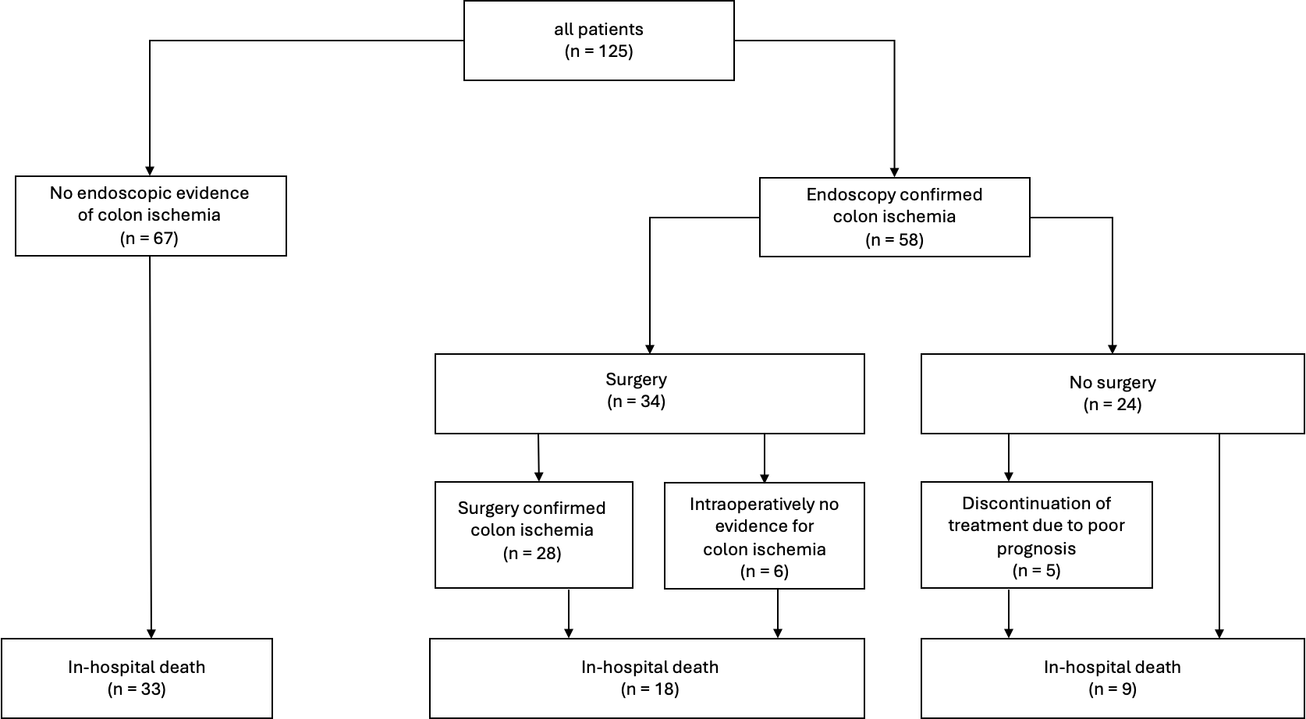

Supplementary Figure 1: Surgical management, intraoperative findings and in-hospital mortality.

