Online Resource 3: The PEN-FAST clinical decision rule
Figure extracted for reference⁹
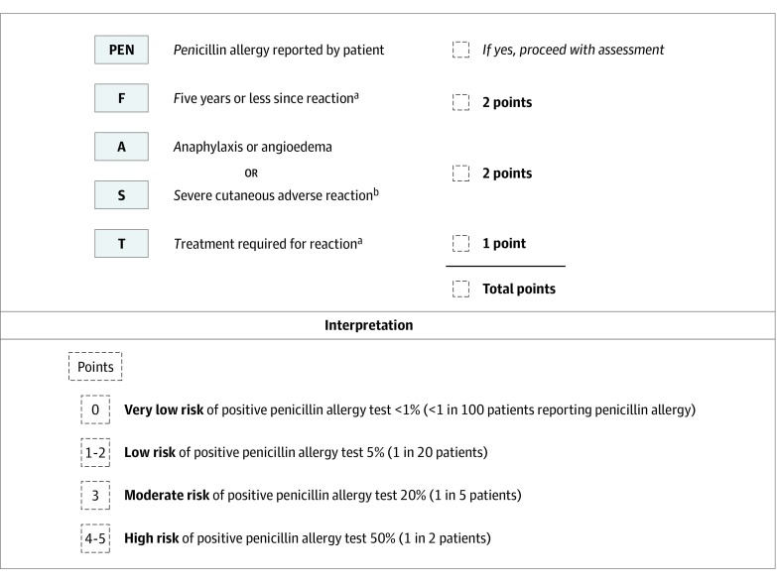
PEN-FAST Penicillin Allergy Clinical Decision Rule
The PEN-FAST clinical decision rule for patients reporting a penicillin allergy uses 3 clinical criteria of time from penicillin allergy episode, phenotype, and treatment required. A total score is calculated using PEN-FAST score in the upper panel, and interpretation for risk strategy is provided in the lower panel.
ªIncludes unknown.
^{b}Forms of severe delayed reactions include potential Stevens-Johnson syndrome, toxic epidermal necrolysis, drug reaction with eosinophilia and systemic symptoms, and acute generalized exanthematous pustulosis. Patients with a severe delayed rash with mucosal involvement should be considered to have a severe cutaneous adverse reaction. Acute interstitial nephritis, drug induced liver injury, serum sickness and isolated drug fever were excluded phenotypes from the derivation and validation cohorts.

