SUPPLEMENTARY TABLES

Supplementary Table 1
Randomized clinical trials constituting the accessible population.
Network, year | Trial name | Main inclusion criteria | Main exclusion criteria | Intervention | Control | Major findings
ARDSNet,  2000 | ARMA | Invasive mechanical ventilation;  The American-European Consensus Conference on ARDS (1994)¹:  - PaO₂/FiO₂ ≤ 300 (indicating the acute onset of hypoxemia)  - Bilateral pulmonary infiltrates on a chest radiograph consistent with the presence of edema  - No clinical evidence of left atrial hypertension or (if measured) a pulmonary-capillary wedge pressure ≤ 18 mmHg. | Age < 18 years; participation in other clinical trials; pregnancy; > 36 hours since meeting inclusion criteria; increased intracranial pressure, neuromuscular disease, sickle cell disease; severe chronic respiratory disease; morbid obesity; burns (> 30% body-surface); bone marrow or lung transplantation; chronic liver disease; high 6 months mortality. | Vt 6ml/kg PBW  Pplat ≤ 30 cmH₂O | 12ml/kg PBW  Pplat < 50 cmH₂O | Mechanical ventilation with a lower tidal volume than was traditionally used resulted in decreased mortality and increases the number of days without ventilator use.
ARDSNet,  2000 | KARMA | Invasive mechanical ventilation;  The American-European Consensus Conference on ARDS (1994)¹ | Same as ARMA; imidazole therapy within 7 days; terfenadine, astemizole, or cisapride within 3 days; allergy to imidazoles. | Ketoconazole | Placebo | In patients with ARDS, ketoconazole did not reduce mortality or duration of mechanical ventilation or improve lung function.
ARDSNet,  2000 | LARMA | Invasive mechanical ventilation;  The American-European Consensus Conference on ARDS (1994)¹.  Concurrent enrollment in ARMA. | Same as ARMA; allergy to methylxanthines. | Lisophylline | Placebo | Stopped for futility.  No significant difference in 28-day mortality, and no evidence that lisophylline had beneficial effects in the treatment of ARDS.
ARDSNet,  2004 | ALVEOLI | Invasive mechanical ventilation;  The American-European Consensus Conference on ARDS (1994)¹. | Age < 13 years; participation in other clinical trials; pregnancy; > 36 hours since meeting inclusion criteria; increased intracranial pressure, neuromuscular disease, sickle cell disease; severe chronic respiratory disease; morbid obesity; burns (> 40% body-surface); vasculitis with alveolar hemorrhage; bone marrow or lung transplantation; chronic liver disease; high 6 months mortality. | Vt 6ml/PBW Kg  Pplat ≤ 30 cmH₂0  Higher PEEP | Vt 6ml/ PBW kg  Pplat ≤ 30 cmH₂O  Lower PEEP | In patients with ARDS who received mechanical ventilation with a tidal-volume goal 6ml/PBW Kg and an Pplat limit of 30 cm of water, clinical outcomes were similar whether lower or higher PEEP levels were used.
ARDSNet,  2006 | FACTT | Invasive mechanical ventilation;  The American-European Consensus Conference on ARDS (1994)¹.  If a patient did not have a central venous catheter, the physician's intent to insert one was required. | Presence of a pulmonary-artery catheter after the onset of acute lung injury; acute lung injury for more than 48 hours; inability to obtain consent; chronic conditions that could influence survival, impair weaning, or compromise compliance with the protocol, (e.g. dependence on dialysis or severe lung or neuromuscular disease); high 6 months mortality. | Conservative fluid management | Liberal fluid management | No significant difference in 60-day mortality; the conservative fluid management strategy improved lung function and shortened the duration of mechanical ventilation and intensive care without increasing nonpulmonary-organ failures.
ARDSNet,  2011 | ALTA | Invasive mechanical ventilation;  The American-European Consensus Conference on ARDS (1994)¹. | Age < 13 years; pregnancy; chronic lung disease; inability to obtain consent; time window exceeded; recent acute myocardial infarction; chronic liver disease; neuromuscular disease; vasculitis with alveolar hemorrhage; high 6 months mortality; physician refusal; not committed to full support. | Aerosolized albuterol | Placebo | Aerosolized albuterol did not improve mortality before hospital discharge in patients with ARDS.
ARDSNet,  2011 | OMEGA | Invasive mechanical ventilation, intended to start enteral nutrition;  The American-European Consensus Conference on ARDS (1994)¹. | . Age < 13 years; pregnancy; chronic lung disease; time window exceeded (acute lung injury >48 hours, intubated > 72 hours); neuromuscular disease; recent intracranial hemorrhage; severe liver disease; morbid obesity; malnutrition; coagulopathy; vasculitis with alveolar hemorrhage; refractory shock; moribund condition; likely fatal underlying disease; total parenteral nutrition; consent refusal | N3 fatty acids, linolenic acid, antioxidant supplementation | Isocaloric, isovolemic EN | Stopped for futility.  Twice-daily enteral supplementation of N3 fatty acids, γ-linolenic acid, and antioxidants did not improve the primary endpoint of ventilator-free days or other clinical outcomes in patients with acute lung injury and may be harmful.
ARDSNet,  2012 | EDEN | Invasive mechanical ventilation;  The American-European Consensus Conference on ARDS (1994)¹. | Age < 13 years; pregnancy; chronic lung disease; time window exceeded (acute lung injury >48 hours, intubated > 72 hours); neuromuscular disease; recent intracranial hemorrhage; severe liver disease; morbid obesity; malnutrition; coagulopathy; vasculitis with alveolar hemorrhage; refractory shock; moribund condition; likely fatal underlying disease; total parenteral nutrition; consent refusal | Trophic enteral nutrition 6 days | Full enteral nutrition for 6 days | Compared with full enteral feeding, a strategy of initial trophic enteral feeding for up to 6 days did not improve ventilator-free days, 60-day mortality, or infectious complications but was associated with less gastrointestinal intolerance.
ARDSNet,  2014 | SAILS | Invasive mechanical ventilation;  The American-European Consensus Conference on ARDS (1994)¹, met during a single 24-hour period.  Known or suspected infection and either of the following (systemic inflammatory response criteria):  - White-cell count > 12,000/mm³ or < 4000/mm³  - Differential count with > 10% band forms  - Body temperature > 38°C or < 36°C. | Age < 18 years; pregnancy; ARDS > 48 hours; intubation > 7 days; chronic conditions that could adversely affect survival, impair weaning from the ventilator, or compromise adherence to the protocol (e.g. chronic lung disease); serum levels of creatine kinase, aspartate aminotransferase, or alanine aminotransferase of more than five times the upper limit of the normal range; statin assumption in the 48 hours before randomization; allergy or intolerance to statins; hypothyroidism; chronic liver disease; cardiac disease (NYHA class IV); recent myocardial infraction; and inability to obtain consent. | Rosuvastatin enteral | Placebo | Stopped for futility.  Rosuvastatin therapy did not improve clinical outcomes in patients with sepsis-associated ARDS and may have contributed to hepatic and renal organ dysfunction.
PETAL,  2019 | ROSE | Invasive mechanical ventilation and met the following criteria for < 48 hours:  - PaO₂/FiO₂ ≤ 150 mmHg with a PEEP ≥ 8 cmH₂0  - Bilateral pulmonary opacities on chest radiography or on computed tomography that could not be explained by effusions, pulmonary collapse, or nodules  - Respiratory failure not explained by cardiac failure or fluid overload.  If results of arterial blood gas analysis were unavailable, the PaO₂ was inferred from the oxygen saturation as measured by pulse oximetry. | Age < 18 years; pregnancy; intubation > 5 days; extracorporeal membrane oxygenation therapy; chronic respiratory failure; home mechanical ventilation; expected duration of mechanical ventilation < 48 hours; vasculitis with alveolar hemorrhage; burns (> 70 % body-surface); moribund condition; hypersensitivity or anaphylactic reaction to cisatracurium; intracranial hypertension; continuous neuromuscular blockade at enrollment. | 48h cisatracurium and deep sedation | Usual care | Among patients with moderate-to-severe ARDS who were treated with a strategy involving a high PEEP, there was no significant difference in mortality at 90 days between patients who received an early and continuous cisatracurium infusion and those who were treated with a usual-care approach with lighter sedation targets.
ARDS: acute respiratory distress syndrome; Vt: tidal volume; PBW: Predicted body weight; Pplat: end-inspiratory plateau-pressure; PEEP: positive end-expiratory pressure;

Supplementary Table 2
Set of baseline covariates included in the super learner technique, the propensity score estimation process, and the multivariable regression models.
Variable | Variable name | Imputation (%)
Trial | STUDY | 0
Age (years) | AGE | 0
Sex (male) | GENDER | 0
Body mass index (kg/m²) | BMI | 3.0
Comorbidities
Diabetes | DIABETES_MELLITUS | 0.1
Malignancy | MALIGNANCY | 0
Immune suppression | IMMUNE_SUPPRESSION | 0
Primary risk factor for ARDS
Pneumonia | PNEUMONIA | 1.6
Sepsis | SEPSIS | 0.1
Other risk factor | OTHER_RISK | 0.1
ARDS severity at baseline | ARDS_SEVERITY_BASELINE | 6.0
Ventilatory ratio at baseline | VENTILATORY_RATIO_0 | 11.4
Radiological quadrants involved | QUADRANTS_CXR | 5.7
Circulatory failure at baseline | CIRCULATORY_FAIL_BASELINE | 0.6
Coagulation failure at baseline | COAGULATION_FAIL_BASELINE | 3.9
Hepatic failure at baseline | HEPATIC_FAIL_BASELINE | 22.8
Neurologic failure at baseline | NEUROLOGIC_FAIL_BASELINE | 2.2
Time from intubation to enrollment (Days) | INTUBATION_ENROLLMENT_DAYS | 0.4
Respiratory mechanics at baseline
Mean airway pressure at baseline (cmH₂O) | MEAN_AIRWAY_PRES_0 | 12.0
PEEP (cmH₂O) | PEEP_0 | 1.1
Pplat (cmH₂O) | P_PLAT_BASELINE | 11.5
Compliance of the respiratory system at baseline(mL/cmH₂O) | COMPLIANCE_RS_0 | 16.7
Baseline serum creatinine (mg/dL) | CREATL | 0
AKI: Acute kidney injury; OR: odds ratio, CI: confidence interval; ARDS: acute respiratory distress syndrome; PEEP: positive end-expiratory pressure; Pplat: end-inspiratory plateau-pressure.

Supplementary Table 3
Set of time-varying covariates included in the super learner technique and in the propensity score estimation process.
Variable | Variable name | imputation at day 1 (%) | imputation at day 2 (%) | imputation at day 3 (%) | imputation at day 4 (%) | imputation at day 5 (%) | imputation at day 6 (%)
Fluid balance | FLUID_BALANCE_X | 3 | 4 | 6 | 10 | - | -
Vasopressors use | VASO_X | 1 | 3 | 4 | 6 | 8 | 11
PaO₂/FiO₂ Ratio (mmHg) | PF_X | 14 | 22 | 28 | 35 | 48 | 54
Ventilatory ratio | VENTILATORY_RATIO_X | 18 | 3 | 38 | 48 | - | -
Mean airway pressure (cmH₂O) | MEAN_AIRWAY_PRES_X | 8 | 19 | 30 | 40 | - | -
PEEP (cmH₂O) | PEEP_X | 3 | 12 | 22 | 32 | - | -
Pplat (cmH₂O) | P_PLAT_X | 21 | 34 | 45 | 53 | - | -
Tidal Volume (mL) | TIDAL_X | 15 | 28 | 40 | 49 | - | -
Compliance of the respiratory system (mL/cmH₂O) | COMPLIANCE_RS_X | 24 | 36 | 47 | 55 | - | -
“X” in variable names is referred to the day after enrollment each variable is referred to. The percentages of missingness are expressed as the number of not available values above the total number of patients still at risk of developing AKI (haven’t died or experienced AKI yet at every day). Data entirely missing for a specific day were not imputed to avoid bias. PEEP: positive end-expiratory pressure; Pplat: end-inspiratory plateau-pressure.

Supplementary Table 4.
The table presents the evaluation of the Super Learner algorithm's performance through cross-validated negative log loss and cross-validated area under the receiver operating curve (AUROC). The evaluation involves comparing a naïve model and a main-terms logistic regression as benchmark comparisons. We can see that a Super Learner predicting cumulative incidence of AKI in the first 7 days outperforms the other candidate estimators.
Outcome | Estimator | Negative log-loss | Area Under the Receiver Operating Curve (AUROC)
AKI | Naïve model | 0.68 | 0.50
AKI | Logistic regression | 0.63 | 0.69
AKI | Super Learner | 0.62 | 0.70
Severe AKI | Naïve model | 0.59 | 0.50
Severe AKI | Logistic regression | 0.53 | 0.72
Severe AKI | Super Learner | 0.52 | 0.73
AKI: acute kidney injury.

Supplementary Table 5
Baseline characteristics. Demographics, comorbidities, and ARDS risk factors across trials
 |  | Trial
Characteristic | Overall | ARMA | ALVEOLI | FACTT | ALTA | EDEN | SAILS | ROSE | p-value
Characteristic | N = 5,148 | N = 876 | N = 525 | N = 965 | N = 235 | N = 968 | N = 649 | N = 930 | p-value
Age, years | 52 (40, 65) | 50 (38, 66) | 50 (39, 65) | 49 (39, 60) | 51 (43, 64) | 52 (42, 63) | 55 (42, 66) | 58 (46, 67) | <0.001
Sex, male | 2,780 (54.0%) | 522 (59.6%) | 291 (55.4%) | 514 (53.3%) | 131 (55.7%) | 494 (51.0%) | 314 (48.4%) | 514 (55.3%) | <0.001
Race, white | 3,771 (73.2%) | 648 (74.0%) | 396 (75.4%) | 620 (64.2%) | 181 (77.0%) | 744 (76.9%) | 516 (79.5%) | 666 (71.6%) | <0.001
Body Mass Index | 28 (23, 34) | 26 (23, 30) | 27 (22, 31) | 27 (23, 32) | 27 (23, 32) | 29 (24, 35) | 29 (24, 35) | 30 (25, 36) | <0.001
Enrollment after surgery | 244 (4.7%) | 73 (8.3%) | 48 (9.1%) | 46 (4.8%) | 8 (3.4%) | 27 (2.8%) | 17 (2.6%) | 25 (2.7%) | <0.001
Comorbidities
Diabetes | 1,112 (21.6%) | 122 (13.9%) | 79 (15.0%) | 173 (17.9%) | 50 (21.3%) | 262 (27.1%) | 146 (22.5%) | 280 (30.1%) | <0.001
Immune suppression | 618 (12.0%) | 90 (10.3%) | 84 (16.0%) | 77 (8.0%) | 16 (6.8%) | 105 (10.8%) | 103 (15.9%) | 143 (15.4%) | <0.001
Malignancy | 343 (6.7%) | 44 (5.0%) | 19 (3.6%) | 48 (5.0%) | 9 (3.8%) | 42 (4.3%) | 81 (12.5%) | 100 (10.8%) | <0.001
Cirrhosis | 264 (5.1%) | 26 (3.0%) | 19 (3.6%) | 33 (3.4%) | 12 (5.1%) | 47 (4.9%) | 32 (4.9%) | 95 (10.2%) | <0.001
ARDS risk factors
Pneumonia | 2,683 (52.1%) | 282 (32.1%) | 210 (40.0%) | 458 (47.5%) | 93 (39.6%) | 625 (64.6%) | 458 (70.1%) | 557 (59.9%) | <0.001
Non-pulmonary sepsis | 1,029 (20.0%) | 228 (26.0%) | 115 (21.9%) | 226 (23.4%) | 62 (26.4%) | 144 (14.9%) | 128 (19.7%) | 126 (13.5%) | <0.001
Aspiration | 683 (13.3%) | 129 (14.7%) | 80 (15.2%) | 141 (14.6%) | 42 (17.9%) | 95 (9.8%) | 45 (6.9%) | 151 (16.2%) | <0.001
Trauma | 302 (5.9%) | 93 (10.6%) | 43 (8.2%) | 71 (7.4%) | 22 (9.4%) | 36 (3.7%) | 6 (0.9%) | 31 (3.3%) | <0.001
Multiple transfusions | 104 (2.0%) | 26 (3.0%) | 27 (5.1%) | 8 (0.8%) | 5 (2.1%) | 16 (1.7%) | 4 (0.6%) | 18 (1.9%)
Other | 351 (6.8%) | 116 (13.3%) | 50 (9.5%) | 61 (6.3%) | 15 (6.4%) | 53 (5.5%) | 9 (1.4%) | 47 (5.1%) | <0.001
Number of radiological quadrants involved |  |  |  |  |  |  |  |  | <0.001
2 | 574 (11.1%) | 54 (6.2%) | 30 (5.7%) | 55 (5.7%) | 33 (14.0%) | 155 (16.0%) | 109 (16.8%) | 138 (14.8%)
3 | 1,157 (22.5%) | 150 (17.2%) | 91 (17.3%) | 154 (16.0%) | 61 (26.0%) | 264 (27.3%) | 160 (24.7%) | 277 (29.8%)
4 | 3,399 (66.0%) | 658 (75.1%) | 404 (77.0%) | 754 (78.1%) | 141 (60.0%) | 549 (56.7%) | 378 (58.2%) | 515 (55.4%)
PaO₂/FiO₂ Ratio (mmHg) | 125 (90, 175) | 120 (86, 163) | 137 (100, 188) | 140 (98, 192) | 134 (89, 183) | 138 (100, 191) | 152 (114, 202) | 95 (73, 118) | <0.001
ARDS severity |  |  |  |  |  |  |  |  | <0.001
Mild | 862 (16.7%) | 115 (13.1%) | 114 (21.7%) | 209 (21.7%) | 43 (18.3%) | 207 (21.4%) | 169 (26.0%) | 5 (0.5%)
Moderate | 2,613 (50.8%) | 429 (49.0%) | 278 (53.0%) | 495 (51.3%) | 116 (49.4%) | 515 (53.2%) | 373.0 (57.5%) | 407 (43.8%)
Severe | 1,673 (32.5%) | 332 (37.9%) | 133 (25.3%) | 261 (27.0%) | 76 (32.3%) | 246 (25.4%) | 107 (16.5%) | 518 (55.7%)
Respiratory system mechanics
Tidal volume (mL/PBW Kg) | 6.7 (6.00, 8.4) | 10.3 (8.6, 11.9) | 7.7 (6.4, 9.2) | 7.0 (6.0, 8.0) | 6.6 (6.00, 7.8) | 6.3 (6.0, 7.3) | 6.2 (6.0, 7.2) | 6.0 (5.9, 6.6) | <0.001
PEEP (cmH₂O) | 10 (7, 12) | 8 (5, 10) | 10 (5, 12) | 10 (5, 12) | 8 (5, 10) | 10 (5, 12) | 10 (5, 10) | 12 (10, 15) | <0.001
Peak airway pressure (cmH₂O) | 30 (25, 37) | 37 (30, 42) | 32 (27, 38) | 32 (26, 37) | 28 (23, 34) | 28 (22, 33) | 27 (21, 32) | 30 (24, 35) | <0.001
Pplat (cmH₂O) | 25 (21, 30) | 29 (24, 35) | 26 (21, 30) | 25 (21, 30) | 24 (20, 28) | 24 (20, 28) | 23 (18, 28) | 26 (22, 29) | <0.001
Driving pressure (cmH₂O) | 15 (12, 20) | 21 (17, 26) | 16 (12, 20) | 16 (12, 20) | 14 (11, 18) | 14 (11, 17) | 14 (10, 18) | 13 (10, 16) | <0.001
Compliance (mL/cmH₂O) | 30 (23, 41) | 32 (24, 42) | 31 (24, 41) | 29 (22, 39) | 32 (24, 42) | 31 (24, 40) | 30 (23, 43) | 30 (22, 42) | 0.072
Percentages and CI are provided taking into account for missing values.
ARDS: acute respiratory distress syndrome; PBW: predicted body weight; PEEP: positive end-expiratory pressure; Pplat: end-inspiratory plateau-pressure.

Supplementary Table 6
Baseline characteristics. Non-pulmonary, non-renal organ failure by outcome
 |  | AKI
 | Overall  N = 5,148 | No | Yes | p-value
 | Overall  N = 5,148 | N = 2897 | N = 2251 | p-value
Heart rate (bpm) | 96 (82, 111) | 95 (82, 110) | 98 (83, 112) | <0.001
Mean arterial pressure (mmHg) | 73 (65, 83) | 75 (67, 85) | 71 (62, 80) | <0.001
Circulatory failure | 2,257 (43.8%) | 1,076 (37.1%) | 1,181 (52.3%) | <0.001
Coagulation failure | 1,345 (26.1%) | 670 (23.1%) | 675 (30.0%) | <0.001
Hepatic failure | 824 (16.0%) | 358 (12.3%) | 466 (20.7%) | <0.001
Neurologic failure | 3,409 (66.2%) | 1,993 (68.8%) | 1,416 (63.0%) | <0.001

Supplementary Table 7
Baseline characteristics. Non-pulmonary, non-renal organ failure across trials
 |  |  |  |  | Trial
 | Overall  N = 5,148 | ARMA  N = 876 |  | ALVEOLI  N = 525 |  | FACTT  N = 965 | ALTA  N = 235 | EDEN  N = 968 | SAILS  N = 649 | ROSE  N = 930 | p-value
Heart rate (bpm) | 96 (82, 111) | 104 (91, 117) |  | 101 (86, 114) |  | 102 (87, 117) | 97 (82, 112) | 94 (81, 108) | 96 (83, 109) | 83 (70, 95) | <0.001
Mean arterial pressure (mmHg) | 73 (65, 83) | 77 (69, 88) |  | 76 (69, 85) |  | 75 (67, 86) | 75 (69, 86) | 76 (69, 84) | 76 (68, 86) | 59 (53, 65) | <0.001
Circulatory failure | 2,257 (43.8%) | 304 (35.9%) |  | 147 (28.0%) |  | 321 (33.3%) | 122 (51.9%) | 474 (49.0%) | 343 (52.8%) | 546 (58.7%) | <0.001
Coagulation failure | 1,345 (26.1%) | 305 (34.8%) |  | 164 (31.2%) |  | 231 (24.0%) | 59 (25.1%) | 190 (19.6%) | 152 (23.4%) | 244 (26.2%) | <0.001
Hepatic failure | 824 (16.0%) | 201 (22.9%) |  | 94 (17.9%) |  | 140 (14.5%) | 42 (17.9%) | 116 (12.0%) | 70 (10.7%) | 161 (17.3%) | <0.001
Neurologic failure | 3,409 (66.2%) | 485 (55.3%) |  | 370 (70.5%) |  | 786 (81.4%) | 204 (86.8%) | 863 (89.2%) | 580 (89.4%) | 121 (13.0%) | <0.001

Supplementary Table 8
Prevalence of Potential CKD across trials
 |  | Trial
 | Overall  N = 5,148 | ARMA  N = 876 | ALVEOLI  N = 525 | FACTT  N = 965 | ALTA  N = 235 | EDEN  N = 968 | SAILS  N = 649 | ROSE  N = 930 | p-value
Potential CKD | 1,883 (36.6%) | 283  (32.3%) | 172  (32.8%) | 303 (31.4%) | 100  (42.6%) | 365  (37.7%) | 246  (37.9%) | 414  (44.5%) | <0.001
CKD: Chronic kidney disease.

Supplementary Table 9
Rapidly improving ARDS by AKI status
 |  | AKI
 | Overall  N = 5,148 | No  N = 2,897 | Yes  N = 2,251 | p-value
Rapidly improving ARDS | 490 (9.5%) | 320 (11.0%) | 170 (7.6%) | <0.001
ARDS: acute respiratory distress syndrome.

Supplementary Table 10
Differences in median cumulative fluid balance at 72 hours after enrollment between control vs. intervention groups, across trials.
Trial |  | Control | Intervention | p-value
ARMA | Cumulative fluid balance at 72h after enrollment, ml | 4,799 (1,083, 10,744) | 5,304 (1,320, 11,123) | 0.5
ALVEOLI | Cumulative fluid balance at 72h after enrollment, ml | 3,399 (467, 6,741) | 3,992 (1,262, 8,868) | 0.09
FACTT | Cumulative fluid balance at 72h after enrollment, ml | 6,521 (1,856, 11,735) | 1,598 (-3,032, 8,172) | <0.001
ALTA | Cumulative fluid balance at 72h after enrollment, ml | 3,542 (-1,185, 9,626) | 5,668 (1,135, 10,220) | 0.13
EDEN | Cumulative fluid balance at 72h after enrollment, ml | 1,672 (-2,042, 5,355) | 657 (-2,696, 4,940) | 0.05
SAILS | Cumulative fluid balance at 72h after enrollment, ml | 1,191 (-2,266, 4,863) | 1,193 (-2,436, 4,307) | 0.7
ROSE | Cumulative fluid balance at 72h after enrollment, ml | 2,049 (-1,438, 5,745) | 2,526 (-1,209, 6,734) | 0.3

Supplementary Table 11
Renal recovery pattern after AKI across trials
 |  | Trial
 | Overall  N = 2,251 | ARMA  N = 332 | ALVEOLI  N = 160 | FACTT  N = 392 | ALTA  N = 98 | EDEN  N = 434 | SAILS  N = 248 | ROSE  N = 587 | p-value
Rapidly improving AKI | 834  (37.1%) | 150 (45.1%) | 81 (50.6%) | 146 (37.2%) | 40 (40.8%) | 165 (38.0%) | 85 (34.3%) | 167 (28.4%) | <0.001
Acute Kidney Disease | 1,041 (46.2%) | 137 (41.3%) | 53 (33.1%) | 175 (44.6%) | 39 (39.8%) | 210 (48.4%) | 115 (46.4%) | 312 (53.2%) | <0.001
AKI: acute kidney injury.

Supplementary Table 12
 |  | AKI
 | Overall  N = 2,251 | Stage 1  N = 829 | Stage 2  N = 357 | Stage 3  N = 1,065 | p-value
Rapidly improving AKI | 834  (37.1%) | 582  (70.2%) | 63  (17.6%) | 189  (17.7%) | <0.001
Acute Kidney Disease | 1,041 (46.2%) | 105  (12.7%) | 193  (54.1%) | 743  (69.8%) | <0.001
AKI: acute kidney injury.
AKI stages across patterns of renal recovery

Supplementary Table 13
Adjusted associations between AKI and 90-day mortality - multivariable regression model.
Variable | Adjusted OR | 95% CI | p-value
AKI | 2.30 | 2.00, 2.65 | <0.001
Trial
ARMA | — | —
ALVEOLI | 0.83 | 0.62, 1.09 | 0.2
FACTT | 0.84 | 0.66, 1.08 | 0.2
ALTA | 0.58 | 0.39, 0.85 | 0.006
EDEN | 0.57 | 0.44, 0.75 | <0.001
SAILS | 0.66 | 0.49, 0.89 | 0.006
ROSE | 1.09 | 0.82, 1.44 | 0.6
Age (years) | 1.04 | 1.04, 1.05 | <0.001
Sex (male) | 1.25 | 1.08, 1.44 | 0.002
Body mass index (kg/m²) | 0.99 | 0.98, 1.00 | 0.004
Comorbidities
Diabetes | 1.07 | 0.91, 1.27 | 0.4
Malignancy | 2.30 | 1.74, 3.05 | <0.001
Immune suppression | 1.50 | 1.20, 1.86 | <0.001
Primary risk factor for ARDS
Pneumonia | 0.18 | 0.01, 1.20 | 0.13
Sepsis | 0.17 | 0.01, 1.13 | 0.12
Other risk factor | 0.15 | 0.01, 1.00 | 0.10
ARDS severity at baseline
Mild | — | —
Moderate | 1.03 | 0.83, 1.27 | 0.8
Severe | 1.22 | 0.96, 1.55 | 0.10
Ventilatory ratio at baseline | 1.27 | 1.15, 1.40 | <0.001
Radiological quadrants involved | 1.15 | 1.03, 1.28 | 0.010
Circulatory failure at baseline | 1.63 | 1.42, 1.88 | <0.001
Coagulation failure at baseline | 1.51 | 1.29, 1.77 | <0.001
Hepatic failure at baseline | 1.83 | 1.54, 2.16 | <0.001
Neurologic failure at baseline | 1.31 | 1.09, 1.57 | 0.004
Time from intubation to enrollment (Days) | 0.98 | 0.92, 1.04 | 0.5
Respiratory mechanics at baseline
Mean airways pressure (cmH₂O) | 1.01 | 0.99, 1.03 | 0.4
PEEP (cmH₂O) | 0.99 | 0.97, 1.02 | 0.5
Pplat (cmH₂O) | 1.02 | 1.00, 1.04 | 0.011
Compliance of the respiratory system, below median (< 30 mL/cmH₂O) | 1.17 | 0.98, 1.41 | 0.087
Hosmer-Lemeshow test P = 0.06
AKI: Acute kidney injury; OR: odds ratio, CI: confidence interval; ARDS: acute respiratory distress syndrome; PEEP: positive end-expiratory pressure; PBW predicted body weight; Pplat: end-inspiratory plateau-pressure.

Supplementary Table 14
Adjusted associations between Severe AKI and 90-day mortality - multivariable regression model.
Variable | Adjusted OR | 95% CI | p-value
Severe AKI | 2.76 | 2.37, 3.21 | <0.001
Trial
ARMA | — | —
ALVEOLI | 0.81 | 0.61, 1.08 | 0.15
FACTT | 0.87 | 0.68, 1.11 | 0.3
ALTA | 0.59 | 0.40, 0.87 | 0.008
EDEN | 0.56 | 0.43, 0.74 | <0.001
SAILS | 0.63 | 0.47, 0.85 | 0.003
ROSE | 1.04 | 0.78, 1.38 | 0.8
Age (years) | 1.04 | 1.04, 1.05 | <0.001
Sex (male) | 1.25 | 1.08, 1.44 | 0.002
Body mass index (kg/m²) | 0.99 | 0.98, 1.0 | 0.002
Comorbidities
Diabetes | 1.08 | 0.91, 1.28 | 0.4
Malignancy | 2.46 | 1.85, 3.27 | <0.001
Immune suppression | 1.50 | 1.20, 1.87 | <0.001
Primary risk factor for ARDS
Pneumonia | 1.08 | 0.91, 1.28 | 0.4
Sepsis | 2.46 | 1.85, 3.27 | <0.001
Other risk factor | 1.50 | 1.20, 1.87 | <0.001
ARDS severity at baseline
Mild | — | —
Moderate | 1.02 | 0.83, 1.26 | 0.9
Severe | 1.21 | 0.95, 1.55 | 0.12
Ventilatory ratio at baseline | 1.25 | 1.13, 1.38 | <0.001
Radiological quadrants involved | 1.13 | 1.01, 1.26 | 0.027
Circulatory failure at baseline | 1.61 | 1.39, 1.86 | <0.001
Coagulation failure at baseline | 1.46 | 1.24, 1.71 | <0.001
Hepatic failure at baseline | 1.80 | 1.52, 2.14 | <0.001
Neurologic failure at baseline | 1.27 | 1.06, 1.53 | 0.009
Time from intubation to enrollment (Days) | 0.98 | 0.92, 1.04 | 0.5
Respiratory mechanics at baseline
Mean airways pressure (cmH₂O) | 1.01 | 0.99, 1.04 | 0.2
PEEP (cmH₂O) | 0.99 | 0.96, 1.01 | 0.4
Pplat (cmH₂O) | 1.02 | 1.00, 1.03 | 0.026
Compliance of the respiratory system, below median (< 30 mL/cmH₂O) | 1.18 | 0.98, 1.42 | 0.076
Hosmer-Lemeshow test P = 0.09
AKI: Acute kidney injury; OR: odds ratio, CI: confidence interval; ARDS: acute respiratory distress syndrome; PEEP: positive end-expiratory pressure; PBW predicted body weight; Pplat: end-inspiratory plateau-pressure.

Supplementary Table 10
Differences in median cumulative fluid balance at 72 hours after enrollment between control vs. intervention groups, across trials.
Trial |  | Control | Intervention | p-value
ARMA | Cumulative fluid balance at 72h after enrollment, ml | 4,799 (1,083, 10,744) | 5,304 (1,320, 11,123) | 0.5
ALVEOLI | Cumulative fluid balance at 72h after enrollment, ml | 3,399 (467, 6,741) | 3,992 (1,262, 8,868) | 0.09
FACTT | Cumulative fluid balance at 72h after enrollment, ml | 6,521 (1,856, 11,735) | 1,598 (-3,032, 8,172) | <0.001
ALTA | Cumulative fluid balance at 72h after enrollment, ml | 3,542 (-1,185, 9,626) | 5,668 (1,135, 10,220) | 0.13
EDEN | Cumulative fluid balance at 72h after enrollment, ml | 1,672 (-2,042, 5,355) | 657 (-2,696, 4,940) | 0.05
SAILS | Cumulative fluid balance at 72h after enrollment, ml | 1,191 (-2,266, 4,863) | 1,193 (-2,436, 4,307) | 0.7
ROSE | Cumulative fluid balance at 72h after enrollment, ml | 2,049 (-1,438, 5,745) | 2,526 (-1,209, 6,734) | 0.3

SUPPLEMENTARY FIGURES

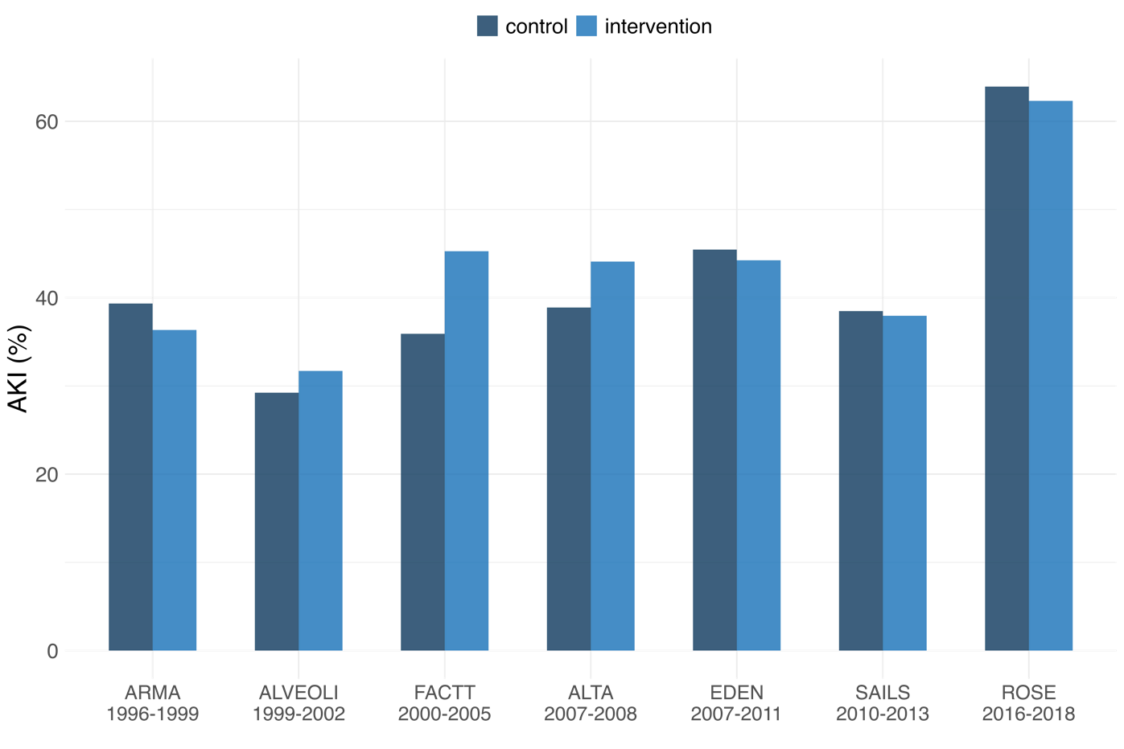

Supplementary Fig. 1
Differences in AKI incidence between control vs. intervention groups, across trials. The p-value for the difference in incidences of AKI between intervention and control groups was 0.003 in FACTT.

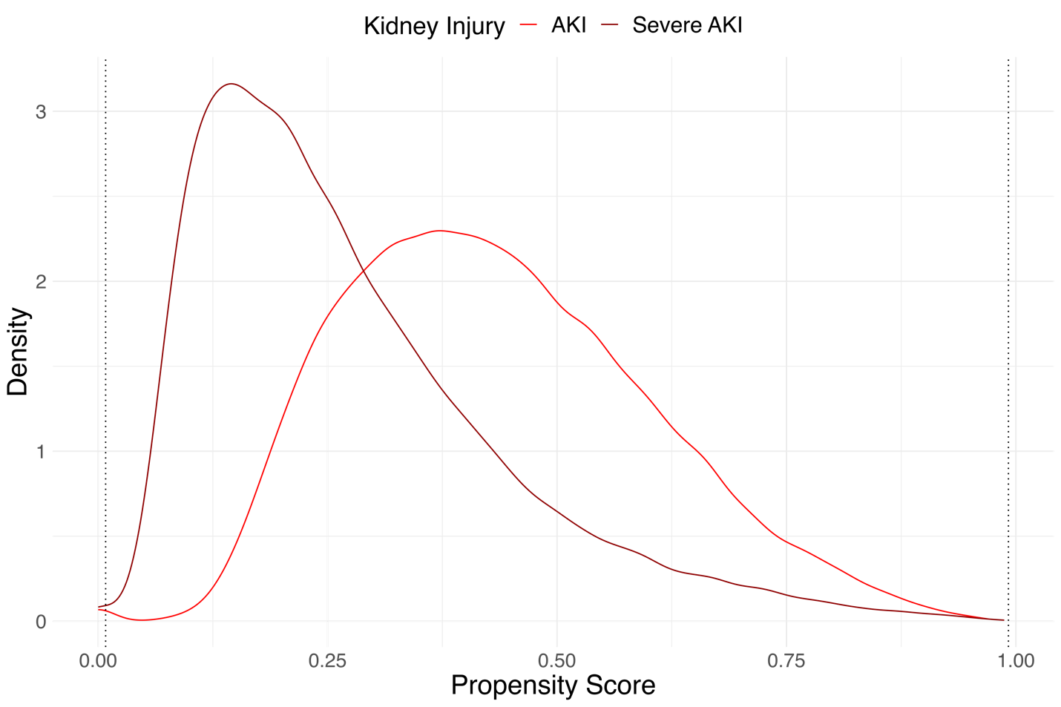
Supplementary Fig. 2
This plot shows the densities (smoothed using a Gaussian kernel) of the estimated propensities of experiencing AKI (bright red) and Severe AKI (dark red) in the dataset with missing covariates imputed using Multiple Imputation by Chained Equations. The dotted lines indicate the minimum observed propensity score value and its complement (1 - minimum observed propensity score), serving as thresholds to assess the risk of generating extreme weights in the cohort. Propensity score densities that do not have little or no mass in the regions below the lower bound or above the upper bound indicate less risk of poor IPTW performance due to extreme weights, which is desirable for a robust Inverse Probability of Treatment Weighting Analysis.

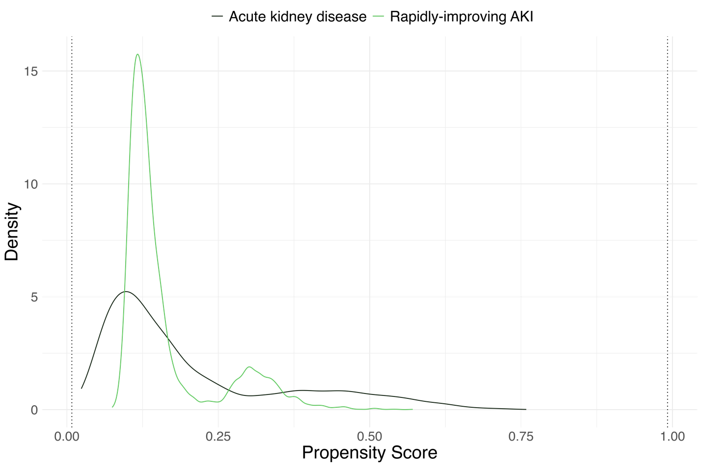
Supplementary Fig. 3
This plot shows the densities (smoothed using a Gaussian kernel) of the estimated propensities of experiencing Rapidly-improving AKI and AKD in the dataset with missing covariates imputed using Multiple Imputation by Chained Equations. The dotted lines indicate the minimum observed propensity score value and its complement (1 - minimum observed propensity score), serving as thresholds to assess the risk of generating extreme weights in the cohort. Propensity score densities that do not have little or no mass in the regions below the lower bound or above the upper bound indicate less risk of poor IPTW performance due to extreme weights, which is desirable for a robust Inverse Probability of Treatment Weighting Analysis.

