Supplement 1

Lower or Higher Oxygenation Targets – A Patient-Level Meta-analysis

Table of content
Inclusion criteria in the HOT-ICU and HOT-COVID trials 2
Exclusion criteria in HOT-ICU and HOT-COVID trials 3
Definitions of baseline characteristics 4
Outcome definitions 6
Subgroup definitions 7
Trial population 10
Handling of missing data 11
Assessments of credibility of subgroup effects 12
Instrument to assess the Credibility of Effect Modification Analyses (ICEMAN). 16
eTable 1. PRISMA checklist for meta-analysis of individual participant data. 19
eTable 2: Expected direction of the intervention effect for each subgroup as pre-specified in the protocol. 23
eTable 3. Baseline characteristics stratified by trial. 25
eTable 4: ICU interventions stratified by oxygenation target. 27
eTable 5: ICU interventions stratified by trial. 28
eTable 6. Number of patients contributing with data on PaO₂, FiO₂, and SaO₂. 29
eTable 7: Interaction magnitude for possible effect modifiers stratified by trialª 30
eTable 8: Post hoc subgroup analyses of death at 90 days with multiplicity adjustment 31
eTable 9: Post hoc subgroup analyses of days alive without life support with multiplicity adjustment 33
eFigure 1. Schematic overview of data clustering in the mixed model 35
eFigure 2. Distribution of the absolute number of days alive without life support within 90 days. 36
References 37

Inclusion criteria in the HOT-ICU and HOT-COVID trials

- Acutely admitted to the ICU (a non-planned admission, which does not include planned recovery after surgery or similar planned admissions. ICU admission does not include admissions to semi-intensive care units, intermediate care units or similar high-dependency units)
- Aged 18 years or older (the age of the patient in whole years at the time of randomisation. The age should be calculated from the date of birth)
- Receiving supplemental oxygen with requirements of:
- Open systems: a flow of at least 10 litres of pure oxygen per minute in an open system irrespective of any flow of atmospheric air, including high-flow systems
- Closed systems including invasive mechanical ventilation, non-invasive ventilation, and continuous positive airway pressure (CPAP):
  - HOT-ICU: a fraction of inspired oxygen (FiO₂) of at least 0.50
  - HOT-COVID: any FiO₂
- Expected to receive supplemental oxygen for at least 24 hours in the ICU
- A functioning arterial line for partial pressure of arterial oxygen (PaO₂) monitoring
- HOT-COVID: any sample from airway secretions or nasopharyngeal swab positive for SARS-CoV-2 infection (confirmed by polymerase chain reaction) at any time leading to or during current hospital admission

Exclusion criteria in HOT-ICU and HOT-COVID trials

- Cannot be randomised within 12 hours of ICU admission: defined as 12 full hours from the time of the present ICU admission; if the patient is transferred from another ICU, the 12 hours will count from the time of the admission to the first ICU
- Receives chronic mechanical ventilation (invasive mechanical ventilation, continuous non-invasive ventilation or continuous mask-CPAP) for any reason. Nocturnal CPAP or non-invasive ventilation due to sleep apnoea and/or obesity hypoventilation syndrome is not regarded as chronic mechanical ventilation
- Use of supplementary oxygen at home (supplementary oxygen given through nasal cannula, mask or tracheostomy on a regular daily basis independent of whether it is continuous, in daytime or nocturnal).
- Previous treatment with bleomycin (any history of bleomycin treatment documented in the patient charts)
- Organ transplant (any kind of solid organ transplant planned or performed during current hospitalisation)
- Withdrawal from active therapy or brain death deemed imminent (clinicians or investigators judge that withdrawal from active therapy or brain death is likely within a few hours)
- Pregnancy confirmed by a positive urine or plasma human chorionic gonadotropin (hCG) (in women <50 years of age, a negative hCG-test must be present before enrolment)
- Carbon monoxide poisoning (confirmed by an arterial or venous blood carboxyhaemoglobin >3% for non-smokers or >10% for active smokers during current hospitalisation)
- Cyanide poisoning (if suspected by the clinicians during current hospitalisation and documented in the patient charts)
- Paraquat poisoning (if suspected by the clinicians during current hospitalisation and documented in the patient charts)
- Methemoglobinemia (a confirmed arterial or venous blood methaemoglobin >8% during current hospitalisation)
- Sickle cell disease (any history of sickle cell disorder documented in patient charts or the presence of haemoglobin S (HbS) in an arterial or a venous blood sample)
- Any condition expected to involve the use of hyperbaric oxygen (HBO) treatment (e.g. necrotising soft tissue infection in sites using HBO for this condition)
- Consent not obtainable according to national regulations (patients where the clinician or investigator is unable to obtain the necessary consent before inclusion of the patient according to the national regulations)
- Previously randomised into the HOT-ICU or HOT-COVID trials (previously screened patients may be eligible if they were not randomised)

Definitions of baseline characteristics

Comorbidities:
- Ischemic heart disease defined as any history of either a myocardial infarction, previous coronary intervention, or stable or unstable angina pectoris, or use of nitrates
- Chronic heart failure was defined as a left ventricular ejection fraction ≤40% or diagnosed chronic heart failure with preserved left ventricular ejection fraction
- Active metastatic cancer defined as the presence of metastases originating from a malignant non-haematological neoplasm that is not considered eradicated
- Chronic dialysis defined as receiving any renal replacement therapy on a regular basis
- Chronic obstructive pulmonary disease (COPD) defined based on a spirometry in stable phase diagnostic of COPD (i.e., forced expiratory volume in one second/forced vital capacity (FEV₁/FVC) <0.7 and FEV₁ <80% of predicted and with flow limitations incompletely reversed with inhaled bronchodilators), or by anamnestic diagnosis of COPD with concomitant use of inhaled beta₂-adrenergic and/or inhaled anticholinergic and/or inhaled glucocorticoids
- Active haematological cancer defined as any intervention within the last six months against any of the following: Leukaemia (acute lymphoblastic leukaemia, acute myelogenous leukaemia, chronic lymphocytic leukaemia, hairy cell leukaemia, T-cell prolymphocytic leukaemia, B-cell prolymphocytic leukaemia, and large granular lymphocytic leukaemia), lymphoma (Hodgkin’s lymphomas, Non-Hodgkin’s lymphoma (small lymphocytic lymphoma, lymphoblastic lymphoma, diffuse large B-cell lymphoma, follicular lymphoma, mantle cell lymphoma, marginal zone lymphoma, Burkitt’s lymphoma, post-transplant lymphoproliferative disorder, Waldenströms macroglobulinemia, and NK- and T-cell lymphomas), and multiple myeloma/plasma cell myeloma, and solitary plasmacytoma). Additionally, myelodysplastic syndromes, myeloproliferative neoplasms (chronic myelogenous leukaemia, chronic neutrophilic leukaemia, primary myelofibrosis, myeloproliferative neoplasm, mast cell diseases), unclassifiable and rare malignant lymphoid and myeloid diseases, or benign haematological diseases (aplastic anaemia, autoimmune haematolytic anaemia)

Acute illnesses:
- Pneumonia as diagnosed by clinicians
- Multiple trauma defined as an acute accident resulting in tissue injury at two or more anatomical sites
- Stroke defined as onset of symptoms prior to randomisation and verified cerebral bleeding, ischemia, or embolism on computed tomography (CT) or magnetic resonance imaging (MRI), or diagnosed by a neurologist
- Traumatic brain injury diagnosed based on fresh lesions on CT or MRI
- Myocardial infarction verified by changes on electrocardiogram, significant rise in coronary biomarkers, and/or acute percutaneous coronary intervention conducted during current hospitalisation prior to randomisation
- Intestinal ischemia defined as onset of gastric, mesenteric, or colonic ischemia verified during current hospitalisation by exploratory or diagnostic abdominal surgery, gastroscopy or colonoscopy, or findings of intestinal ischemia on CT or MRI angiography
- Cardiac arrest defined as clinically diagnosed with initiated cardio-pulmonary resuscitation leading to or occurring during current ICU admission
- Acute Respiratory Distress Syndrome (ARDS) defined according to the Berlin criteria as bilateral chest infiltrates on x-ray and a PaO₂/FiO₂ ratio below 40 kPa in a mechanically ventilated patient with positive end-expiratory pressure (PEEP) ≥5 cm of water or CPAP ≥5 cm of water. The patient’s respiratory failure must not be fully explained by cardiac failure or fluid overload

Sequential Organ Failure Assessment (SOFA) score:
SOFA scores were calculated based on a 0-4 scoring of six components (respiration, coagulation, liver, cardiovascular, central nervous system, and renal). Data for scoring each component were assessed from the 24 hours before randomisation except for respiration, which was assessed at randomisation [1].

Outcome definitions

Primary outcome:
90-day all-cause mortality: Death from any cause within 90 days following the day of randomisation.

Secondary outcome:
Absolute number of days alive without life support in 90 days after randomisation: Life support is defined as the use of mechanical ventilation, renal replacement therapy, or circulatory support within 90 days following randomisation. Mechanical ventilation is defined as invasive or non-invasive mechanical ventilation or CPAP. Intermittent CPAP (CPAP duration below one hour) is not considered mechanical ventilation. Renal replacement therapy is defined as any form of renal replacement therapy. In patients receiving intermittent renal replacement therapy, days between treatments are included as being with the use of renal replacement therapy. Circulatory support is defined as the use of continuously infused norepinephrine, epinephrine, dopamine, phenylephrine, vasopressin analogues, dobutamine, milrinone, or levosimendan.

Subgroup definitions
A total of 14 subgroups were categorised according to the following parameters at baseline:
- Age: Categorised into two subgroups according to the total population median age
  - Age ≥ median age
  - Age < median age
- Sex: Genotypic male or female
- ICU admission type: Categorised into three subgroups:
  - Medical
  - Elective Surgical
  - Emergency Surgical
- Ventilatory support: Categorised into three subgroups:
  - Invasive mechanical ventilation
  - Non-invasive mechanical ventilation or continuous positive airway pressure (CPAP)
  - Open systems
- Chronic obstructive pulmonary disease (COPD): Categorical (Yes/No)
COPD is defined as yes to one of the following two criteria at baseline:
  - Conducted spirometry in stable phase that is diagnostic of COPD: a forced expiratory volume in one second/forced vital capacity (FEV₁/FVC) ratio less than 0.7 or less than the lower limit of normal AND an FEV₁ less than 80 percent of predicted AND flow limitations must be incompletely reversible after the administration of an inhaled bronchodilator
  - Anamnestic COPD AND daily use of inhaled β₂-adrenergic and/or anticholinergic bronchodilators and/or inhaled glucocorticoids including albuterol, levalbuterol, salmeterol, formoterol, arformoterol, indacaterol, vilanterol, olodaterol, tiotropium, aclidinium, umeclidinium, glycopyrronium, budesonide, and fluticasone
- Pneumonia: Categorical (Yes/No). As diagnosed by clinicians
- Intracranial pathology: Categorical (Yes/No)
Defined as yes to one or more of the following criteria at baseline:
  - Cardiac arrest with initiated cardiopulmonary resuscitation leading to or happened during current ICU admission
  - Traumatic brain injury as verified by fresh lesions on CT or MRI.
  - Haemorrhagic or ischemic stroke as verified cerebral bleeding, ischemia or embolism on CT or MRI, or acute ischemia or embolism diagnosed by a neurologist
- Heart disease: Categorical (Yes/No)
Defined as yes to one or more of the following criteria at baseline:
  - Ischemic heart disease: as any of the following in the patients’ medical records:
    - Myocardial infarction: ST-elevation myocardial infarction, non-ST elevation myocardial infarction as defined by significant rise in coronary biomarkers
    - Previous percutaneous coronary intervention (PCI) or coronary artery bypass grafting (CABG)
    - Previous stable or unstable angina pectoris or use of nitrates indicating this
  - Chronic heart failure: left ventricular ejection fraction ≤ 40% OR chronic heart failure with preserved left ventricular ejection fraction
  - Acute myocardial infarction as verified by ECG findings, significant rise in coronary biomarkers and/or PCI/CABG during current hospitalisation
- Chronic dialysis: Categorical (Yes/No)
- Intestinal ischemia: Categorical (Yes/No). Onset of gastric, mesenteric or colonic ischemia verified though exploratory or diagnostic abdominal surgery, gastroscopy or colonoscopy, or findings of intestinal ischemia on CT or MRI angiography during current hospitalisation
- Cancer: Categorical (Yes/No)
Defined as yes to one or both of the following criteria at baseline:
  - Active haematological cancer: Any interventions within the last 6 months against any to the following:
    - Leukaemia: acute lymphoblastic leukaemia (ALL), acute myelogenous leukaemia (AML), chronic lymphocytic leukaemia (CLL), hairy cell leukaemia (HCL), T-cell prolymphocytic leukaemia (T-PLL), B-cell prolymphocytic (B-PLL), large granular lymphocytic leukaemia (LGL)
    - Lymphoma: Hodgkin’s lymphomas, Non-Hodgkin’s lymphoma (e.g. small lymphocytic lymphoma (SLL), lymphoblastic lymphoma, diffuse large B-cell lymphoma (DLBCL), follicular lymphoma (FL), mantle cell lymphoma (MCL), hairy cell leukaemia (HCL), marginal zone lymphoma (MZL), Burkitt’s lymphoma (BL), post-transplant lymphoproliferative disorder (PTLD), Waldenström’s macroglobulinemia, NK- or T-cell lymphomas)
    - Multiple myeloma/plasma cell myeloma, solitary plasmacytoma
    - Myelodysplastic syndromes
    - Myeloproliferative neoplasms (MPN) (e.g. chronic myelogenous leukaemia (CML), chronic neutrophilic leukaemia, primary myelofibrosis (PMF), myeloproliferative neoplasm, unclassifiable, Mast cell diseases
    - Other (rare) malignant lymphoid and myeloid diseases
    - Benign haematological diseases: aplastic anaemia, autoimmune haemolytic anaemia
  - Active metastatic cancer: any metastases from a malignant non-haematological neoplasm, that is not considered eradicated at present. Complete radiological regression through oncological treatment is not considered eradication
- Shock: Categorical (Yes/No). A plasma lactate concentration > 2 mmol/litres AND the use of vasopressors or inotropes (norepinephrine, epinephrine, phenylephrine, vasopressin or dopamine, dobutamine, milrinone or levosimendan)
- SARS-CoV-2 infection: Categorical (Yes/No). Any sample from airway secretions or nasopharyngeal swab positive for SARS-CoV-2 infection (confirmed by polymerase chain reaction) at any time leading to or during current hospital admission
- PaO₂:FiO₂ ratio in patients receiving respiratory support. Categorised into three subgroups:
  - PaO₂:FiO₂ ratio > 26.6 kPa
  - 13.4 kPa < PaO₂:FiO₂ ratio ≤ 26.6 kPa
  - PaO₂:FiO₂ ratio ≤ 13.3 kPa

Trial population
Definition of the intention-to-treat population: All randomised patients except those where follow-up data could not be obtained due to unobtainable or withdrawn consent according to national regulations.

Handling of missing data

Primary outcome
For the primary outcome, 90-day all-cause mortality, data was missing for 69 out of 3654 randomised patients. This was equal to 1.9% of the trial population. In the lower-oxygenation group, this was due to unobtainable or withdrawn consent for the use of data for 34 patients and loss-to-follow-up for 1 patient. In the higher-oxygenation group, this was due to unobtainable or withdrawn consent for the use of data for 33 patients and loss-to-follow-up for 1 patient.

Secondary outcome
For the secondary outcome, absolute number of days alive without life support in 90 days, data was missing for 79 out of 3654 randomised patients. This was equal to 2.2% of the trial population. In the lower-oxygenation group, this was due to unobtainable or withdrawn consent for the use of data for 40 patients and loss-to-follow-up for 1 patient. In the higher-oxygenation group, this was due to unobtainable or withdrawn consent for the use of data for 37 patients and loss-to-follow-up for 1 patient.

Baseline variables:
The aggregated SOFA score at baseline was missing for 65 (3.6%) patients in the lower-oxygenation group and for 68 (3.7%) patients in the higher-oxygenation group. This was equal to 3.6% of all randomised patients. All other baseline variables used in any analysis had missing data at a level below this.

Multiple imputations:
As data in any outcome and in all variables used in any analyses were missing in less than the prespecified cut-off level of 5%, designating that multiple imputation should be performed [2], no imputation of missing data was performed.

Assessments of credibility of subgroup effects

Each effect modifier with an interaction P values <0.10 was evaluated using the Credibility of Effect Modification Analyses (ICEMAN) tool [3].

Relative risk for 90-day all-cause mortality.

Potential effect modifier: age.
1: Is the analysis of effect modification based on comparison within rather than between trials?
Completely within: The meta-analysis used individual patient data from both included trials with clustering for trial level and adjustment for trial specific stratification variables.
2: For within-trial comparisons, is the effect modification similar from trial to trial?
Definitely similar: Effect modification in both included trials were similar in direction and magnitude. See eTable 7.
3: For between-trial comparisons, is the number of trials large?
Very small: Two trials compared.
4: Was the direction of effect modification correctly hypothesised a priori?
Probably no or unclear: A priori hypothesised differential effect, but not specification of direction of effect. Thus vague hypothesis or hypothesised direction unclear.
5: Does a test for interaction suggest that chance is an unlikely explanation of the apparent effect modification?
Chance a likely explanation: Interaction P value = 0.09.
6: Did the authors test only a small number of effect modifiers or consider the number in their statistical analysis?
Definitely no: A total of 14 sub-group analyses of two outcomes were conducted with no adjustments for multiplicity.
7: Did the authors use a random effects model?
Definitively yes: A model allowing for fixed slopes and random intercepts was used.
8: If the effect modifier a continuous variable, were arbitrary cut points avoided?
Probably yes: Dichotomisation of age as below or above and including the median age of the combined population, as prespecified.
9 Optional: Are there any additional considerations that may increase or decrease credibility?
None.

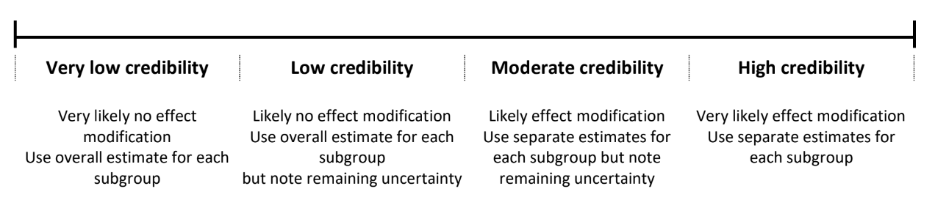
10: How would you rate the overall credibility of the proposed effect modification?

Relative risk for 90-day all-cause mortality.

Potential effect modifier: presence or absence of cancer at baseline.
1: Is the analysis of effect modification based on comparison within rather than between trials?
Completely within: The meta-analysis used individual patient data from both included trials with clustering for trial level and adjustment for trial specific stratification variables.
2: For within-trial comparisons, is the effect modification similar from trial to trial?
Definitely similar: Reported effect modification in both included trials were similar in direction with some difference in magnitude. See eTable 7.
3: For between-trial comparisons, is the number of trials large?
Very small: Two trials compared.
4: Was the direction of effect modification correctly hypothesised a priori?
Definitely no: A priori hypothesised beneficial effect of the lower oxygenation target in patients with cancer. Thus results were inconsistent with hypothesised direction.
5: Does a test for interaction suggest that chance is an unlikely explanation of the apparent effect modification?
Chance a likely explanation or unclear: Interaction P value = 0.03.
6: Did the authors test only a small number of effect modifiers or consider the number in their statistical analysis?
Definitely no: A total of 14 sub-group analyses of two outcomes were conducted with no adjustments for multiplicity.
7: Did the authors use a random effects model?
Definitively yes: A model allowing for fixed slopes and random intercepts was used.
8: If the effect modifier is a continuous variable, were arbitrary cut points avoided?
Not applicable: Presence or absence of cancer is a dichotomous variable.
9 Optional: Are there any additional considerations that may increase or decrease credibility?
Effect modification was found for days alive without life support (a correlated outcome to mortality) in similar direction (interaction P value = 0.02).
10: How would you rate the overall credibility of the proposed effect modification?

Mean difference in absolute number of Day alive without life support in 90 days.

Potential effect modifier: presence or absence of cancer at baseline.
1: Is the analysis of effect modification based on comparison within rather than between trials?
Completely within: The meta-analysis used individual patient data from both included trials with clustering for trial level and adjustment for trial specific stratification variables.
2: For within-trial comparisons, is the effect modification similar from trial to trial?
Definitely similar: Effect modification in both included trials were similar in direction and magnitude. See eTable 7.
3: For between-trial comparisons, is the number of trials large?
Very small: Two trials compared.
4: Was the direction of effect modification correctly hypothesised a priori?
Definitely no: A priori hypothesised beneficial effect of the lower oxygenation target in patients with cancer. Thus results were inconsistent with hypothesised direction.
5: Does a test for interaction suggest that chance is an unlikely explanation of the apparent effect modification?
Chance a likely explanation or unclear: Interaction P value = 0.02.
6: Did the authors test only a small number of effect modifiers or consider the number in their statistical analysis?
Definitely no: A total of 14 sub-group analyses of two outcomes were conducted with no adjustments for multiplicity.
7: Did the authors use a random effects model?
Definitively yes: A model allowing for fixed slopes and random intercepts was used.
8: If the effect modifier is a continuous variable, were arbitrary cut points avoided?
Not applicable: Presence or absence of cancer is a dichotomous variable.
9 Optional: Are there any additional considerations that may increase or decrease credibility?
Effect modification was found for 90-day mortality (a correlated outcome to days alive without life support) in similar direction interaction P value = 0.03).
10: How would you rate the overall credibility of the proposed effect modification?

Mean difference in absolute number of Day alive without life support in 90 days.

Potential effect modifier: presence or absence of COVID-19 at baseline.
1: Is the analysis of effect modification based on comparison within rather than between trials?
Completely within: The meta-analysis used individual patient data from both included trials with clustering for trial level and adjustment for trial specific stratification variables.
2: For within-trial comparisons, is the effect modification similar from trial to trial?
Definitely similar: Effect modification in both included trials was similar in both direction and magnitude. See eTable 7.
3: For between-trial comparisons, is the number of trials large?
Very small: Two trials compared.
4: Was the direction of effect modification correctly hypothesised a priori?
Definitely yes: An increased number of days alive without life support was hypothesised a priori. Thus results were consistent with hypothesised direction.
5: Does a test for interaction suggest that chance is an unlikely explanation of the apparent effect modification?
Chance a likely explanation or unclear: Interaction P value = 0.04.
6: Did the authors test only a small number of effect modifiers or consider the number in their statistical analysis?
Definitely no: A total of 14 sub-group analyses of two outcomes were conducted with no adjustments for multiplicity.
7: Did the authors use a random effects model?
Definitively yes: A model allowing for fixed slopes and random intercepts was used.
8: If the effect modifier is a continuous variable, were arbitrary cut points avoided?
Not applicable: Presence or absence of COVID-19 is a categorical variable.
9 Optional: Are there any additional considerations that may increase or decrease credibility?
None.
10: How would you rate the overall credibility of the proposed effect modification?

Instrument to assess the Credibility of Effect Modification Analyses (ICEMAN).

From the ICEMAN meta-analysis manual [3]:

CREDIBILITY ASSESMENT:
1: Is the analysis of effect modification based on comparison within rather than between trials?
Completely between
Subgroup analysis or meta-regression comparing overall effects of each individual trial.
Mostly between or unclear
Subgroup analysis or meta-regression with most information coming from overall effects, but some trials providing within-trial subgroup information.
Mostly within
Most trials providing within-trial subgroup information; or individual participant data analysis that combines within and between trial information
Completely within
All trials providing within-trial subgroup information or individual participant data; and the analysis separates within from between trial information, e.g., meta-analysis of interactions

2: For within-trial comparisons, is the effect modification similar from trial to trial?

Definitely not similar
Effect modification reported for two or more trials and clearly different directions
Probably not similar or unclear
Effect modification not reported for individual trials or too imprecise to tell
Mostly similar
Effect modification reported for two or more trials, mostly similar in direction, but considerable
differences in magnitude
Definitely similar
Effect modification reported for two or more trials, similar in direction,
only some differences in magnitude

3: For between-trial comparisons, is the number of trials large?

Very small
1 or 2 or in smallest subgroup; 5 or less in continuous meta-regression
Rather small or unclear
3-4 in smallest subgroup; 6-10 in continuous meta-regression
Rather large
5-9 in smallest subgroup; 11 to 15 in continuous meta-regression
Large
10 or more in smallest subgroup; more than 15 in continuous meta-regression

4: Was the direction of effect modification correctly hypothesised a priori?

Definitely no
Clearly post-hoc or results inconsistent with hypothesised direction or biologically very implausible
Probably no or unclear
Vague hypothesis or hypothesised
direction unclear
Probably yes
No prior protocol available but unequivocal statement of a priori hypothesis with correct direction of effect modification
Definitely yes
Prior protocol available and
includes correct specification of direction of effect modification.

5: Does a test for interaction suggest that chance is an unlikely explanation of the apparent effect modification?

Chance a very likely explanation
Interaction or meta-regression p- value >0.05
Chance a likely explanation or unclear
Interaction or meta-regression p-value ≤0.05 and >0.01, or no test of interaction reported and not computable
Chance may not explain
Interaction or meta-regression p-value ≤0.01 and >0.005
Chance an unlikely explanation Interaction or meta-regression p-value ≤0.005

6: Did the authors test only a small number of effect modifiers or consider the number in their statistical analysis?

Definitely no
Explicitly exploratory analysis or large number of effect modifiers tested (e.g., greater than 10) and multiplicity not considered in analysis
Probably no or unclear
No mention of number or 4-10 effect modifiers tested, and number not considered in analysis
Probably yes
No protocol available but
unequivocal statement of 3 or fewer effect modifiers tested
Definitely yes
Protocol available and 3 or fewer effect modifiers tested, or number considered in analysis

7: Did the authors use a random effects model?

Definitely no
Fixed (or common) effect or fixed effects model explicitly stated
Probably no or unclear
Probably fixed effect(s) model
Probably yes
Probably random (or mixed) effects
Definitely yes
Random (or mixed) effects explicitly stated

8: If the effect modifier is a continuous variable, were arbitrary cut points avoided? [ ] not applicable: not continuous
Definitely no
Analysis based on exploratory cut point(s)
Probably no or unclear
Analysis based on cut point(s) of unclear origin
Probably yes
Analysis based on pre-specified cut point(s)
Definitely yes
Analysis based on the full continuum

9 Optional: Are there any additional considerations that may increase or decrease credibility?

Yes, probably decrease
Yes, probably increase

10: How would you rate the overall credibility of the proposed effect modification?
The overall rating should be driven by the items that decrease credibility. The following provides a sensible strategy:
- All responses definitely or probably decrease credibility or unclear → very low
- Two or more responses definitely decrease credibility → maximum usually low even if all other responses satisfy credibility criteria
- One response definitely decreases credibility → maximum usually moderate even if all other responses satisfy credibility criteria
- Two responses probably decrease credibility → maximum usually moderate even if all other responses satisfy credibility criteria
- No response options definitely or probably decrease credibility → high very likely
Place a mark on the continuous line (or type “x” in editable version)

eTable 1. PRISMA checklist for meta-analysis of individual participant data.
PRISMA-IPD  Section/topic | Item No | Checklist item | Reported on page
Title
Title | 1 | Identify the report as a systematic review and meta-analysis of individual participant data. | 1
Abstract
Structured summary | 2 | Provide a structured summary including as applicable: | 2 - 4
Structured summary | 2 | Background: state research question and main objectives, with information on participants, interventions, comparators and outcomes. | 2 - 4
Structured summary | 2 | Methods: report eligibility criteria; data sources including dates of last bibliographic search or elicitation, noting that IPD were sought; methods of assessing risk of bias. | 2 - 4
Structured summary | 2 | Results: provide number and type of studies and participants identified and number (%) obtained; summary effect estimates for main outcomes (benefits and harms) with confidence intervals and measures of statistical heterogeneity. Describe the direction and size of summary effects in terms meaningful to those who would put findings into practice. | 2 - 4
Structured summary | 2 | Discussion: state main strengths and limitations of the evidence, general interpretation of the results and any important implications. | 2 - 4
Structured summary | 2 | Other: report primary funding source, registration number and registry name for the systematic review and IPD meta-analysis. | 2 - 4
Introduction
Rationale | 3 | Describe the rationale for the review in the context of what is already known. | 5
Objectives | 4 | Provide an explicit statement of the questions being addressed with reference, as applicable, to participants, interventions, comparisons, outcomes and study design (PICOS). Include any hypotheses that relate to particular types of participant-level subgroups. | 3, 5, and 6
Methods
Protocol and registration | 5 | Indicate if a protocol exists and where it can be accessed. If available, provide registration information including registration number and registry name. Provide publication details, if applicable. | 5 to 6
Eligibility criteria | 6 | Specify inclusion and exclusion criteria including those relating to participants, interventions, comparisons, outcomes, study design and characteristics (e.g. years when conducted, required minimum follow-up). Note whether these were applied at the study or individual level i.e. whether eligible participants were included (and ineligible participants excluded) from a study that included a wider population than specified by the review inclusion criteria. The rationale for criteria should be stated. | 5 to 7
Identifying studies - information sources | 7 | Describe all methods of identifying published and unpublished studies including, as applicable: which bibliographic databases were searched with dates of coverage; details of any hand searching including of conference proceedings; use of study registers and agency or company databases; contact with the original research team and experts in the field; open adverts and surveys. Give the date of last search or elicitation. | NA
Identifying studies - search | 8 | Present the full electronic search strategy for at least one database, including any limits used, such that it could be repeated. | NA
Study selection processes | 9 | State the process for determining which studies were eligible for inclusion. | 5 to 7 and 10
Data collection processes | 10 | Describe how IPD were requested, collected and managed, including any processes for querying and confirming data with investigators. If IPD were not sought from any eligible study, the reason for this should be stated (for each such study). | 5 to 7
Data collection processes | 10 | If applicable, describe how any studies for which IPD were not available were dealt with. This should include whether, how and what aggregate data were sought or extracted from study reports and publications (such as extracting data independently in duplicate) and any processes for obtaining and confirming these data with investigators. | 5 to 7
Data items | 11 | Describe how the information and variables to be collected were chosen. List and define all study level and participant level data that were sought, including baseline and follow-up information. If applicable, describe methods of standardising or translating variables within the IPD datasets to ensure common scales or measurements across studies. | 5 to 7
IPD integrity | A1 | Describe what aspects of IPD were subject to data checking (such as sequence generation, data consistency and completeness, baseline imbalance) and how this was done. | 5 to 7
Risk of bias assessment in individual studies. | 12 | Describe methods used to assess risk of bias in the individual studies and whether this was applied separately for each outcome. If applicable, describe how findings of IPD checking were used to inform the assessment. Report if and how risk of bias assessment was used in any data synthesis. | 7 to 8
Specification of outcomes and effect measures | 13 | State all treatment comparisons of interests. State all outcomes addressed and define them in detail. State whether they were pre-specified for the review and, if applicable, whether they were primary/main or secondary/additional outcomes. Give the principal measures of effect (such as risk ratio, hazard ratio, difference in means) used for each outcome. | 7 to 8
Synthesis methods | 14 | Describe the meta-analysis methods used to synthesise IPD. Specify any statistical methods and models used. Issues should include (but are not restricted to):  - Use of a one-stage or two-stage approach.  - How effect estimates were generated separately within each study and combined across studies (where applicable).  - Specification of one-stage models (where applicable) including how clustering of patients within studies was accounted for.  - Use of fixed or random effects models and any other model assumptions, such as proportional hazards.  - How (summary) survival curves were generated (where applicable).  - Methods for quantifying statistical heterogeneity (such as I² and τ²).  - How studies providing IPD and not providing IPD were analysed together (where applicable).  - How missing data within the IPD were dealt with (where applicable). | 8 to 9
Exploration of variation in effects | A2 | If applicable, describe any methods used to explore variation in effects by study or participant level characteristics (such as estimation of interactions between effect and covariates). State all participant-level characteristics that were analysed as potential effect modifiers, and whether these were pre-specified. | 7 to 9
Risk of bias across studies | 15 | Specify any assessment of risk of bias relating to the accumulated body of evidence, including any pertaining to not obtaining IPD for particular studies, outcomes or other variables. | 5 to 8 and 10
Additional analyses | 16 | Describe methods of any additional analyses, including sensitivity analyses. State which of these were pre-specified. | 7 to 9
Results
Study selection and IPD obtained | 17 | Give numbers of studies screened, assessed for eligibility, and included in the systematic review with reasons for exclusions at each stage. Indicate the number of studies and participants for which IPD were sought and for which IPD were obtained. For those studies where IPD were not available, give the numbers of studies and participants for which aggregate data were available. Report reasons for non-availability of IPD. Include a flow diagram. | 9 to 10
Study characteristics | 18 | For each study, present information on key study and participant characteristics (such as description of interventions, numbers of participants, demographic data, unavailability of outcomes, funding source, and if applicable duration of follow-up). Provide (main) citations for each study. Where applicable, also report similar study characteristics for any studies not providing IPD. | 9 to 10
IPD integrity | A3 | Report any important issues identified in checking IPD or state that there were none. | NA
Risk of bias within studies | 19 | Present data on risk of bias assessments. If applicable, describe whether data checking led to the up-weighting or down-weighting of these assessments. Consider how any potential bias impacts on the robustness of meta-analysis conclusions. | 9 to 11
Results of individual studies | 20 | For each comparison and for each main outcome (benefit or harm), for each individual study report the number of eligible participants for which data were obtained and show simple summary data for each intervention group (including, where applicable, the number of events), effect estimates and confidence intervals. These may be tabulated or included on a forest plot. | 9 to 11 and Figure 2 and 3
Results of syntheses | 21 | Present summary effects for each meta-analysis undertaken, including confidence intervals and measures of statistical heterogeneity. State whether the analysis was pre-specified, and report the numbers of studies and participants and, where applicable, the number of events on which it is based. | 9 to 11 and Figure 2 and 3
Results of syntheses | 21 | When exploring variation in effects due to patient or study characteristics, present summary interaction estimates for each characteristic examined, including confidence intervals and measures of statistical heterogeneity. State whether the analysis was pre-specified. State whether any interaction is consistent across trials. | 9 to 11 and Figure 2 and 3
Results of syntheses | 21 | Provide a description of the direction and size of effect in terms meaningful to those who would put findings into practice. | 9 to 11 and Figure 2 and 3
Risk of bias across studies | 22 | Present results of any assessment of risk of bias relating to the accumulated body of evidence, including any pertaining to the availability and representativeness of available studies, outcomes or other variables. | 9 to 11 and Supplementary Appendix
Additional analyses | 23 | Give results of any additional analyses (e.g. sensitivity analyses). If applicable, this should also include any analyses that incorporate aggregate data for studies that do not have IPD. If applicable, summarise the main meta-analysis results following the inclusion or exclusion of studies for which IPD were not available. | 9 to 11
Discussion
Summary of evidence | 24 | Summarise the main findings, including the strength of evidence for each main outcome. | 11 to 13
Strengths and limitations | 25 | Discuss any important strengths and limitations of the evidence including the benefits of access to IPD and any limitations arising from IPD that were not available. | 12 to 13
Conclusions | 26 | Provide a general interpretation of the findings in the context of other evidence. | 11 to 13
Implications | A4 | Consider relevance to key groups (such as policy makers, service providers and service users). Consider implications for future research. | 13
Funding
Funding | 27 | Describe sources of funding and other support (such as supply of IPD), and the role in the systematic review of those providing such support. | 14

A1 – A3 denote new items that are additional to standard PRISMA items. A4 has been created as a result of re-arranging content of the standard PRISMA statement to suit the way that systematic review IPD meta-analyses are reported.
© Reproduced with permission of the PRISMA IPD Group, which encourages sharing and reuse for non-commercial purposes [4].

eTable 2: Expected direction of the intervention effect for each subgroup as pre-specified in the protocol.
Subgroup | Expected direction of intervention effectª
Age | We hypothesized a differential effect for patients in the two intervention groups according to age.
Sex | We hypothesised a differential effect for patients in the two intervention groups according to gender.
Admission type | We hypothesised a successively greater effect favouring the 8 kPa PaO₂ target for patients in elective surgical, medical, and emergency surgical admissions.
Ventilatory support | We hypothesised a successively greater effect favouring the 8 kPa PaO₂ target for patients in open systems, NIV or CPAP, and IMV group.
COPD | We hypothesised an increased effect favouring the 8 kPa PaO₂ target in patients with COPD.
Pneumonia | We hypothesised an increased effect favouring the 8 kPa PaO₂ target in patients with pneumonia.
Intracranial pathology | We hypothesised an increased effect favouring the 8 kPa PaO₂ target in patients with intracranial pathology.
Heart disease | We hypothesised an increased effect favouring the 8 kPa PaO₂ target in patients with heart disease.
Chronic dialysis | We hypothesised an increased effect favouring the 8 kPa PaO₂ target in patients with chronic dialysis.
Intestinal ischemia | We hypothesised an increased effect favouring the 8 kPa PaO₂ target in patients with intestinal is ischemia.
Cancer | We hypothesised an increased effect favouring the 8 kPa PaO₂ target in patients with Cancer.
Shock | We hypothesised an effect favouring the 12 kPa PaO₂ target for patients with shock
COVID-19^{b} | We hypothesised an increased effect favouring the 8 kPa PaO₂ target in patients with COVID-19.
PaO₂:FiO₂ ratio | We hypothesised a successively greater effect favouring the 8 kPa PaO₂ target for patients in elective surgical, medical, and emergency surgical admissions.

Overview of subgroups planned for analysis for interaction with the intervention. Originally created as part of the pre-published protocol [2].
Abbreviations: COPD: chronic obstructive pulmonary disease, CPAP: continuous positive airway pressure, FiO₂: fraction of inspired oxygen, HOT-ICU: Handling Oxygenation Targets in the ICU, HOT-COVID: Handling Oxygenation Targets in COVID-19, IMV: invasive mechanical ventilation, NIV: non-invasive ventilation, PaO₂: arterial partial pressure of oxygen, SaO₂: arterial oxygen saturation, COVID-19: Coronavirus disease 19

ª The expected direction of the intervention effect for each subgroup is consistent with those postulated in the HOT-ICU statistical analysis plan where nothing else is stated [5].
^{b} Patients diagnosed with SARS-CoV-2 during their ICU stay, but after randomisation, were included as having COVID-19 at baseline in the HOT-ICU trial since test availability and turnaround time were limited at the beginning of the pandemic leading to diagnostic delays.

eTable 3. Baseline characteristics stratified by trial.
Characteristicª | HOT-ICU  (N=2910) | HOT-COVID (N=720)
Median age (IQR) – yr | 70 (60 - 77) | 66 (56 - 74)
Male sex – no. (%) | 1871 (64.3) | 495 (68.8)
Median interval between hospital admission and randomisation (IQR) – days | 1 (0 - 5) | 2 (1 - 4)
Median interval between ICU admission and randomisation (IQR) – hr | 4 (2 - 7) | 3 (1 - 7)
Coexisting illness – no. (%)
Ischemic heart disease | 410 (14.1) | 72 (10.0)
Active metastatic cancer | 126 (4.3) | 16 (2.2)
Long-term dialysis | 47 (1.6) | 17 (2.4)
Chronic obstructive pulmonary disease | 563 (19.4) | 52 (7.2)
Active hematologic cancer | 168 (5.8) | 61 (8.5)
Type of admission – no. (%)
Medical | 2488 (85.5) | 718 (99.7)
Elective surgical | 39 (1.34) | 2 (0.3)
Emergency surgical | 383 (13.2) | 0 (0.0)
Acute illness – no. (%)
Pneumonia | 1674 (57.5) | 523 (72.6)
Multiple trauma | 53 (1.8) | 1 (0.1)
Haemorrhagic or ischemic stroke | 47 (1.6) | 3 (0.4)
Traumatic brain injury | 24 (0.8) | 0 (0.0)
Myocardial infarction | 183 (6.3) | 8 (1.1)
Intestinal ischemia | 68 (2.3) | 2 (0.3)
Cardiac arrest | 335 (11.5) | 7 (1.0)
ARDS | 373 (12.8) | 293 (40.7)
Invasive ventilation
Patients – no. (%) | 1704 (58.6) | 172 (23.9)
Median tidal volume (IQR) – mL | 499 (428 - 573) | 518 (451 - 606)
Median end–expiratory pressure (IQR) – cm of water | 9 (7 - 10) | 12 (10 - 14)
Median peak pressure (IQR) – cm of water | 22 (19 - 26) | 25 (21 - 27)
Non-invasive ventilation or CPAP
Patients no. (%) | 375 (12.9) | 93 (12.9)
Median end-expiratory pressure (IQR) – cm of water | 7 (5 - 9) | 8 (6 - 9)
Open system – no. (%) | 831 (28.6) | 455 (63.2)
Median PaO₂ (IQR) – kPa | 10.3 (8.3 - 12.5) | 9.4 (8.5 - 11.1)
Median SaO₂ (IQR) – %^{b} | 94 (91 - 97) | 94 (91 - 96)
Median FiO₂ (IQR) – fraction^{c} | 0.70 (0.55 - 0.85) | 0.80 (0.62 - 1.00)
Median PaO₂:FiO₂ ratio (IQR) - kPa
In all systems | 15.7 (11.9 - 20.7) | 12.5 (9.6 - 16.6)
In closed systems | 16.7 (12.4 - 21.9) | 14.4 (10.8 - 22.3)
Median lactate level (IQR) – mmol/L | 1.8 (1.1 - 3.2) | 1.4 (1.0 - 1.9)
Median lowest man arterial pressure (IQR) – kPa^{d} | 7.7 (6.4 - 9.1) | 9.6 (8.3 - 11.2)
Use of inotropes – no. (%) | 70 (2.4) | 0 (0.0)
Use of vasopressors
Patients – no. (%) | 1591 (54.7) | 151 (21.0)
Highest dose of norepinephrine (IQR) – µg/kg/min | 0.21 (0.10 - 0.40) | 0.13 (0.07 - 0.30)
SOFA score^{e} | 8 (5 - 10) | 3 (2 - 5)
Positive test for COVID-19^{f} | 110 (3.8) | 720 (100.0)

ª All baseline variables were missing for 18 patients in the HOT-ICU trial and for 6 patients in the
HOT-COVID trial. ARDS denotes acute respiratory distress syndrome, CPAP continuous positive
airway pressure, ICU intensive care unit, IQR interquartile range, PaO₂ arterial partial pressure of
oxygen, SaO₂ arterial oxygen saturation, and FiO₂ fraction of inspired oxygen.
^{b} Values for arterial oxygen saturation (SaO₂) were not available for 191 patients in the HOT-ICU
trial because this measure was not included in blood gas analyses at one trial site.
^{c} The fraction of inspired oxygen (FiO₂) in open systems was estimated with the use of
standardised conversion tables.
^{d} Listed is the lowest median value of the arterial pressure recorded during the 24 hours before
randomisation.
^{e} Scores on the Sequential Organ Failure Assessment (SOFA) range from 0 to 24 with higher
scores indicating more severe organ failure. Data were missing for 98 patients in the HOT-ICU
trial and for 11patients in the HOT-COVID trial.
^{f} Confirmed using polymerase chain reaction.

eTable 4: ICU interventions stratified by oxygenation target.
Characteristicª | Lower-Oxygenation Group (N=1815) | Higher-Oxygenation Group (N=1815)
Mean number of arterial blood gas samples per day ± SD | 6±2 | 7±2
Mechanical ventilation – no. (%) | 1544 (85.1%) | 1593 (87.8%)
Invasive ventilation – no. (%)† | 1194 (65.8%) | 1252 (67.0%)
Non-invasive ventilation or CPAP – no. (%)^{b} | 276 (15.2) | 318 (17.5)
Prone position – no. (%) | 185 (10.2) | 243 (13.4)
Inhaled vasodilators – no. (%)^{c} | 73 (4.0%) | 103 (5.7%)
ECMO – no. (%) | 21 (1.2%) | 21 (1.2%)
Vasopressors or inotropes – no. (%)^{d} | 1383 (76.2%) | 1435 (79.1%)
Renal replacement therapy – no. (%)^{e} | 326 (18.0%) | 362 (20.0%)
Red blood cell transfusion – no. (%) | 517 (28.5%) | 578 (31.9%)
Median Volume – mL (IQR)^{f} | 600 (300 - 1470) | 735 (300 - 1715)
Invasive ventilation
Median end-expiratory pressure  – cm of water (IQR)^{b} | 8 (7 - 10) | 10 (8 - 11)
Median tidal volume – mL per kg predicted  bodyweight (IQR)^{g} | 7.3 (6.4 - 8.2) | 7.3 (6.5 - 8.3)
Median peak pressure – cm of water (IQR)^{b} | 22 (18 - 26) | 23 (19 - 26)
Non-invasive ventilation or CPAP
Median end-expiratory pressure – cm of water (IQR)^{b} | 8 (6 - 9) | 8 (6 - 9)

ª All variables were missing in 12 patients in each group. ICU denotes intensive care unit, CPAP
continuous positive airway pressure, ECMO extracorporeal membrane oxygenation.
^{b} Ventilation parameters registered once daily at 08:00 hours.
^{c} Use of inhaled nitric oxide or inhaled epoprostenol.
^{d} Continuous infusion of norepinephrine, epinephrine, dopamine, phenylephrine, vasopressin,
dobutamine, milrinone or levosimendan.
^{e} Any continuous or intermittent use of renal replacement therapy.
^{f} In patients receiving red blood cell transfusion.
^{g} Predicted body weight was calculated as 50 kg + 0.91 kg/cm x (height - 152.4 cm) for males and
45.5 kg + 0.91 kg/cm x (height - 152.4 cm) for females.

eTable 5: ICU interventions stratified by trial.
Characteristicª | HOT-ICU trial  (N=2910) | HOT-COVID trial  (N=720)
Mean number of arterial blood gas samples per day ± SD | 6±2 | 7±2
Mechanical ventilation – no. (%) | 2599 (89.3) | 479 (66.5)
Invasive ventilation – no. (%)^{b} | 2031 (69.8) | 415 (57.6)
Non-invasive ventilation or CPAP – no. (%)^{b} | 435 (15.0) | 159 (22.1)
Prone position – no. (%) | 167 (5.7) | 261 (36.3)
Inhaled vasodilators – no. (%)^{c} | 124 (4.3) | 52 (7.2)
ECMO – no. (%) | 26 (0.9) | 16 (2.2)
Vasopressors or inotropes – no. (%)^{d} | 2359 (81.1) | 459 (63.8)
Renal replacement therapy – no. (%)^{e} | 603 (20.7) | 85 (11.8)
Red blood cell transfusion – no. (%) | 954 (32.8) | 141 (19.9)
Median Volume – mL (IQR)^{f} | 735 (300 - 1500) | 900 (486 - 1872)
Invasive ventilation
Median end-expiratory pressure – cm of water (IQR)^{b} | 9 (8 - 10) | 11 (9 - 13)
Median tidal volume – mL per kg predicted  bodyweight (IQR)^{g} | 7.3 (6.5 - 8.2) | 7.4 (6.4 - 8.6)
Median peak pressure – cm of water (IQR)^{b} | 22 (19 - 26) | 25 (21 - 27)
Non-invasive ventilation or CPAP
Median end-expiratory pressure – cm of water (IQR)^{c} | 8 (6 - 9) | 8 (8 - 10)

ª All variables were missing in 18 patients in the HOT-ICU trial and in 6 patients in the HOT-
COVID trial. ICU denotes intensive care unit, CPAP continuous positive airway pressure, ECMO
extracorporeal membrane oxygenation.
^{b} Ventilation parameters registered once daily at 08:00 hours.
^{c} Use of inhaled nitric oxide or inhaled epoprostenol.
^{d} Continuous infusion of norepinephrine, epinephrine, dopamine, phenylephrine, vasopressin,
dobutamine, milrinone or levosimendan.
^{e} Any continuous or intermittent use of renal replacement therapy.
^{f} In patients receiving red blood cell transfusion.
^{g} Predicted body weight was calculated as 50 kg + 0.91 kg/cm x (height - 152.4 cm) for males and
45.5 kg + 0.91 kg/cm x (height - 152.4 cm) for females.

eTable 6. Number of patients contributing with data on PaO₂, FiO₂, and SaO₂.
 | PaO₂ |  | SaO₂ª |  | FiO₂
Day | Lower–Oxygenation Group (N) | Higher–Oxygenation Group (N) | Lower–Oxygenation Group (N) | Higher–Oxygenation Group (N) | Lower–Oxygenation Group (N) | Higher–Oxygenation Group (N)
1 | 1791 | 1795 | 1699 | 1697 | 1789 | 1794
2 | 1718 | 1740 | 1627 | 1651 | 1717 | 1738
3 | 1474 | 1517 | 1395 | 1441 | 1474 | 1516
4 | 1253 | 1333 | 1184 | 1265 | 1253 | 1333
5 | 1069 | 1175 | 1012 | 1115 | 1069 | 1175
6 | 927 | 1039 | 877 | 983 | 927 | 1038
7 | 804 | 935 | 761 | 883 | 804 | 934
8 | 705 | 818 | 670 | 771 | 705 | 817
9 | 639 | 729 | 607 | 686 | 639 | 729
10 | 566 | 672 | 541 | 632 | 566 | 673
15 | 338 | 425 | 322 | 404 | 338 | 424
20 | 240 | 299 | 230 | 283 | 240 | 298
25 | 159 | 209 | 154 | 203 | 158 | 209
30 | 116 | 144 | 113 | 140 | 116 | 144
35 | 78 | 97 | 76 | 96 | 78 | 97
40 | 59 | 68 | 56 | 67 | 59 | 68
45 | 43 | 52 | 41 | 51 | 43 | 52
50 | 35 | 36 | 35 | 36 | 35 | 36
55 | 25 | 25 | 25 | 25 | 25 | 25
60 | 19 | 21 | 18 | 20 | 19 | 21
65 | 15 | 14 | 14 | 13 | 15 | 14
70 | 9 | 14 | 8 | 13 | 9 | 14
75 | 9 | 10 | 8 | 10 | 9 | 10
80 | 7 | 7 | 7 | 7 | 7 | 7
85 | 5 | 7 | 5 | 6 | 5 | 7
90 | 4 | 10 | 4 | 9 | 4 | 10

PaO₂ denotes partial pressure of arterial oxygen, FiO₂ fraction of inspired oxygen, SaO₂ arterial oxygen saturation. Number of patients contributing with data for the graphs of PaO₂, FiO₂, and SaO₂ (Figure 2 and Figures S1-S3), by day and group.
ª SaO₂ values were not available in blood gas analyses from one site and were therefore missing
for 191 patients throughout their intensive care unit admissions.

eTable 7: Interaction magnitude for possible effect modifiers stratified by trialª
Baseline subgroup and outcome | HOT-ICU trial  (N=2887) |  | HOT-COVID trial  (N=697)
Baseline subgroup and outcome | RD  (95% CI) | MD  (95% CI) |  | RD  (95% CI) | MD  (95% CI)
Age ≥69 years^{b}
Death by day 90^{c} | 3.6  (-3.4 - 10.6) |  |  | 6.7  (-7.3 - 20.8)
Cancer^{d}
Death by day 90 | 13.6  (1.9 - 25.4) |  |  | 1.6  (-23.6 - 26.8)
Days alive without life  support^{e} |  | -9.2  (-18.4 - 0.1) |  |  | -4.1  (-24.1 - 15.9)
COVID-19
Days alive without life support^{e} |  | 3.4  (-9.7 - 16.4) |  |  | 5.8  (0.3 - 11.4)^{f}

ª Reported are the risk differences (RD) and mean differences (MD) of the interaction terms of the lower
oxygenation target in subgroups and outcomes where possible heterogeneity of treatment
was found, i.e., with a P value <0.10 according to Instrument to assess the Credibility of Effect
modification Analyses (ICEMAN) [3]. All analyses were conducted using a generalised linear model
with identity links adjusted for trial-specific stratification variables. Risk differences are reported in
percentage points. HOT-ICU denotes Handling Oxygenation Targets in the Intensive Care Unit
trial, HOT-COVID Handling Oxygenation Targets in COVID-19 trial, COVID-19 coronavirus disease
2019.
^{b} Median age for the compiled HOT-ICU and HOT-COVID population.
^{c} The four smallest sites were pooled in the HOT-COVID trial to obtain convergence.
^{d} Cancer includes active haematological cancer and metastatic cancer.
^{e} Days alive without life support was defined as the absolute number of days alive without the use of
invasive ventilation, non-invasive ventilation, non-intermittent continuous positive airway pressure,
vasopressor or inotropic infusion, or any renal replacement therapy in 90 days after
randomisation. For days alive without life support in the HOT-ICU trial N=2878.
^{f} Does not represent an interaction term, but the overall effect estimate of the HOT-COVID trial,
since all patients in this trial had COVID-19 at baseline.

eTable 8: Post-hoc subgroup sensitivity analyses of 90-day all-cause mortality with multiplicity adjustment
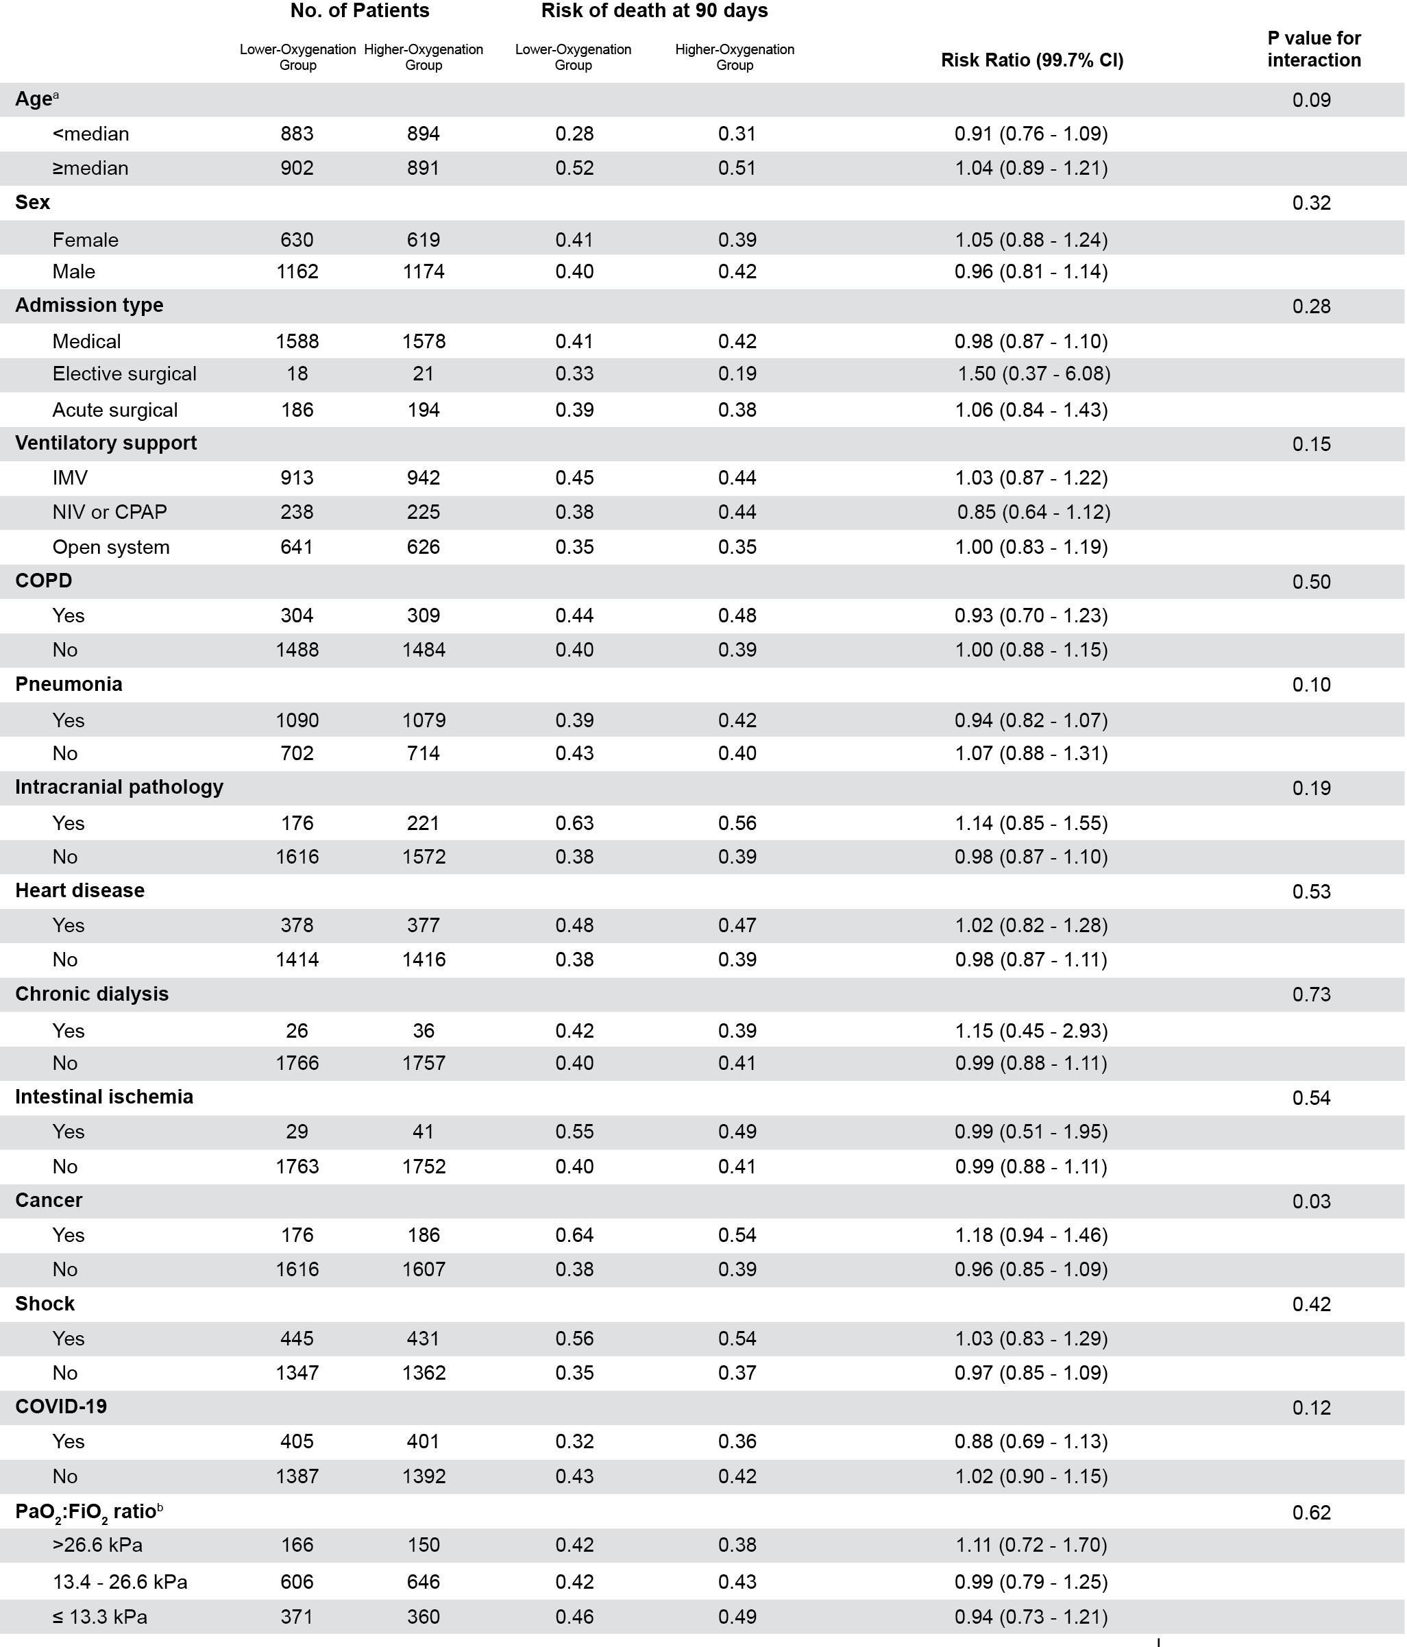
Post-hoc analyses of subgroup intervention effects with multiplicity adjustment ad modum Jakobsen[6] for a total of 30 analyses corresponding to a confidence interval of 99.7%. A multiplicity adjusted P value below 0.003 was considered significant.
All analyses were adjusted for trial-specific stratification variables: haematological cancer, COPD, and trial site in the HOT-ICU trial; trial site in the HOT-COVID trial. IMV denotes invasive mechanical ventilation, NIV non-invasive ventilation, CPAP continuous positive airway pressure, COPD chronic obstructive pulmonary disease, COVID-19 Coronavirus disease 2019, PaO₂ arterial partial pressure of oxygen, and FiO₂ fraction of inspired oxygen.
* Adjusted for both trial-specific stratification variables and the baseline variables age, admission type, presence or absence of metastatic cancer, presence or absence of chronic obstructive pulmonary disease, presence or absence of hematologic cancer, and the sequential organ failure assessment score, which ranges from 0 to 24 with higher scores indicating more severe organ failure.
ª Median age was 69 years.
^{b} Only patients receiving invasive ventilation, non-invasive ventilation, or continuous positive airway pressure at baseline were included.

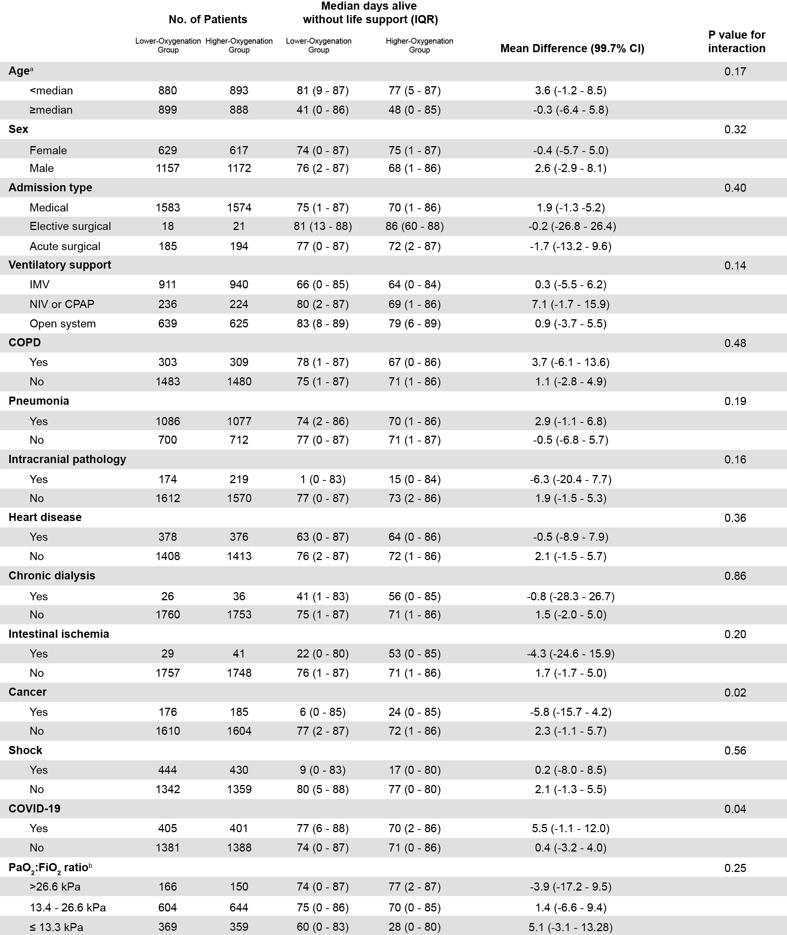
eTable 9: Post-hoc subgroup sensitivity analyses of days alive without life support with multiplicity adjustment

Post-hoc analyses of subgroup intervention effects with multiplicity adjustment ad modum Jakobsen[6] for a total of 30 analyses corresponding to a confidence interval of 99.7%. A multiplicity adjusted P value below 0.003 was considered significant.
Days alive without life support is defined as the absolute number of days alive without the use of invasive ventilation, non-invasive ventilation, non-intermittent continuous positive airway pressure, vasopressor or inotropic infusion, or any renal replacement therapy in 90 days after randomisation.
All analyses were adjusted for trial-specific stratification variables: haematological cancer, COPD, and trial site in the HOT-ICU trial; trial site in the HOT-COVID trial. IMV denotes invasive mechanical ventilation, NIV non-invasive ventilation, CPAP continuous positive airway pressure, COPD chronic obstructive pulmonary disease, COVID-19 Coronavirus disease 2019, PaO₂ arterial partial pressure of oxygen, and FiO₂ fraction of inspired oxygen.
* Adjusted for both trial-specific stratification variables and the baseline variables age, admission type, presence or absence of metastatic cancer, presence or absence of chronic obstructive pulmonary disease, presence or absence of hematologic cancer, and the sequential organ failure assessment score, which ranges from 0 to 24 with higher scores indicating more severe organ failure.
ª Median age was 69 years.
^{b} Only patients receiving invasive ventilation, non-invasive ventilation, or continuous positive airway pressure at baseline were included.

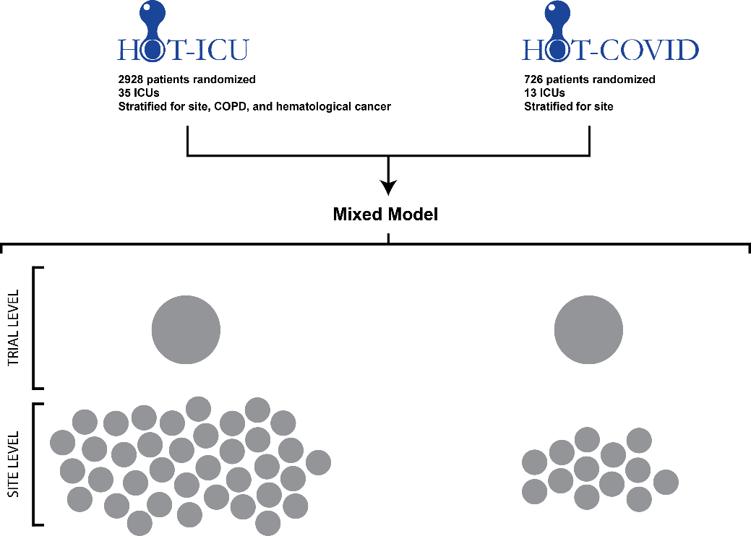
eFigure 1. Schematic overview of data clustering in the mixed model

A schematic overview of how the data is organised and analysed in the mixed model. Briefly, complete patient-level data from the Handling Oxygenation Targets in the ICU (HOT-ICU) trial and Handling Oxygenation Targets in COVID-19 (HOT-COVID) trial are pooled in a one-step approach and analysed using a mixed model. Data are clustered hierarchically at both the trial and site level as shown. Each grey circle represents a data cluster.

eFigure 2. Distribution of the absolute number of days alive without life support within 90 days.
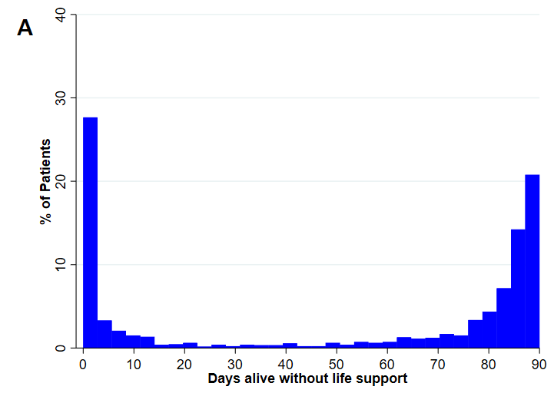
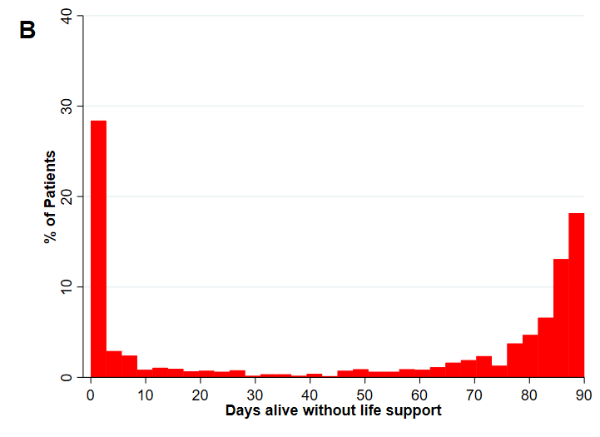

Histograms depicting the data distribution of the secondary outcome absolute number of days alive without life support in 90 days with data from both the HOT-ICU and HOT-COVID trials.
A: Lower-Oxygenation group. B: Higher-Oxygenation group

References
1. Vincent JL, Moreno R, Takala J, et al (1996) The SOFA (Sepsis-related Organ Failure Assessment) score to describe organ dysfunction/failure. On behalf of the Working Group on Sepsis-Related Problems of the European Society of Intensive Care Medicine. Intensive Care Med. 22:707–710
2. Nielsen FM, Klitgaard TL, Bruun NH, et al (2023) Lower or higher oxygenation targets for acute Hypoxaemic respiratory failure: Protocol for an individual patient data meta‐analysis. Acta Anaesthesiol Scand 67:1–9. https://doi.org/10.1111/aas.14220
3. Schandelmaier S, Briel M, Varadhan R, et al (2020) Development of the instrument to assess the credibility of effect modification analyses (ICEMAN) in randomized controlled trials and meta-analyses. CMAJ 192:E901–E906. https://doi.org/10.1503/cmaj.200077
4. Stewart LA, Clarke M, Rovers M, et al (2015) Preferred reporting items for a systematic review and meta-analysis of individual participant data: The PRISMA-IPD statement. JAMA - J Am Med Assoc 313:1657–1665. https://doi.org/10.1001/jama.2015.3656
5. Schjørring OL, Klitgaard TL, Perner A, et al (2021) Lower or Higher Oxygenation Targets for Acute Hypoxemic Respiratory Failure. N Engl J Med 384:1–11. https://doi.org/10.1056/NEJMoa2032510
6. Jakobsen JC, Gluud C, Winkel P, et al (2014) The thresholds for statistical and clinical significance – a five-step procedure for evaluation of intervention effects in randomised clinical trials. 1–12

