Online Supplement

Pulmonary herpes simplex virus and cytomegalovirus in COVID-19 related ARDS patients

Intensive Care Medicine

Leonoor S. Boers, Frank van Someren Gréve, Jarne van Hattem, Justin de Brabander, Tom Zwaan, Hugo van Willigen, Marion Cornelissen, Menno de Jong, Tom van der Poll, JanWillem Duitman, Janke Schinkel, Lieuwe D.J. Bos on behalf of the OPPORTUNE consortium, the Amsterdam UMC COVID study group and the ArtDECO consortium.

Corresponding author: Leonoor Boers, Amsterdam UMC, Intensive Care Medicine, Meibergdreef 9, Room G3-228, 1105 AZ Amsterdam, The Netherlands. Phone: +31 (0)6 54 62 3223. Email: l.s.boers@amsterdamumc.nl. ORCID 0000-0001-7852-7994.

Table of contents
Supplementary methods 2
Clinical data collection 2
Sampling and assays 2
Sampling 2
CMV and HSV PCR in BAL 3
Biomarker assays 4
Statistical analysis 5
Patient population and incidence 5
Viral loads and mortality 6
Re-evaluation of clinically relevant cutoff 7
Alveolar inflammation 7
Supplementary results 9
Alveolar inflammation 9
Supplementary tables 12
Table S1 Inflammatory biomarkers and their abbreviations. 12
Table S2 Serostatus among patient cohorts. 13
Table S3 Alveolar biomarker concentrations of patients with and without HSV-reactivation in the unmatched cross-sectional cohort. 14
Table S4 Comparison of demographics and clinical characteristics of patients in included in the unmatched cross-sectional biomarker analysis. 15
Table S5 Alveolar biomarker concentrations of patients with and without HSV-reactivation in the matched, cross-sectional cohort. 16
Table S6 Biomarker dynamics comparison between HSV-reactivated and non-reactivated patients, pre- and post-reactivation and pre-and post-treatment. 17
Supplementary figures 18
Fig. S1 Transition probabilities for patients. 18
Fig. S2 Distribution plots for CMV and HSV log₁₀ viral loads BAL, classified by PCR result categories. 19
Fig. S3 Probability plot for developing a clinically relevant CMV- or HSV-reactivation 20
Fig. S4 Correlation between CMV and HSV viral loads. 21
Fig. S5 Swimmer plot of all included patients in the study. 22
Fig. S6 Cutoff plot showing the hazard ratio for mortality versus the maximum transition probability on a HSV-reactivation for different cutoffs. 23
Fig. S7 Transition probability plot for the HSV cohort. 24
Fig. S8 Flowchart for cross-sectional biomarker analyses sample selection and matching processes. 25
Fig. S9 Flowchart for longitudinal biomarker analyses sample selection and matching processes. 26
Fig. S10 Matching effectiveness plots for the matched HSV reactivated and non-reactivated cross-sectional study groups. 27
Fig. S11 Matching effectiveness plots for the matched HSV reactivated and non-reactivated study groups for the longitudinal reactivation analysis (pre- and post-reactivation). 28
Fig. S12 CMV and HSV viral load dynamics for HSV-reactivated and non-reactivated patients, pre- and post-reactivation. 29
Fig. S13 Matching effectiveness plots for the matched HSV reactivated and non-reactivated study groups for the longitudinal treatment analysis (pre- and post- treatment). 30
Fig. S14 Plasma biomarker dynamics for HSV-reactivated and non-reactivated patients, pre- and post-reactivation and pre-and post-treatment. 31
References 32

Supplementary methods

Study cohort and clinical data collection
Following the local clinical workflow, all patients in this study cohort who were expected to require mechanical ventilation for more than 24 hours received antibiotics as part of the Selective Digestive Decontamination (SDD) protocol for infection prevention in the ICU of Amsterdam UMC. This protocol included intravenous cefotaxime and the local administration of tobramycin, colistin, and nystatin. Clinical data were prospectively collected on ICU admission day and at the day of BAL, and included demographics, comorbidities, laboratory values, microbiological diagnostics, medication, and data related to respiratory physiology and gas exchange details from patients’ electronic health records. Clinical outcomes (extubation and death) were evaluated daily until 90 days after start of mechanical ventilation through chart reviews. In instances where patients were no longer under our care (e.g. transferred to another hospital or discharged), data were obtained via telephone follow-up. The collected data were securely stored in a pseudonymized database (Castor EDC)[1] .

Sampling and assays

Sampling
Routine diagnostic bronchoscopy with BAL was performed weekly in patients showing no respiratory improvement, as part of clinical practice according to standardized protocol. The decision to perform a BAL was made by joint expert opinion during multidisciplinary team meetings. Respiratory improvement was defined by an increase in PaO₂/FiO₂, a decrease in driving pressure (or increase in compliance of the respiratory system) and/or an improvement in aeration of the lung. Additional more subjective clinical criteria were also taken into account.

CMV and HSV PCR in BAL
To perform the PCR reactions, 300 µl of BAL fluid was used. First, 300 µl MagNA Pure 96 External Lysis Buffer (Roche Life Science products) and 30 µl proteinase K from the MagNA Pure LC Total Nucleic Acid Isolation Kit (03038505001, Roche Life Science products) were used to extract nucleic acids from 300 µl of BAL fluid. The extraction was performed by the MagNA Pure 96 Instrument (Roche Life Science products) with 450 µl mixture, containing 200 µl BAL fluid, producing 50 µl eluate. The PCR reactions were performed using the FLOW System of Roche Life Science products on a LightCycler® 480 Real-Time PCR System (Roche Life Science products). Reactions contained 2 x 10 µl LightCycler® LC480 Probes Master (04902343001, Roche Life Science products). For HSV, 10 µl Mastermix was used, together with 5 µl eluate and 5 µl primer and probe mix, adding up to 20 µl. For CMV, 10 µl Mastermix was used, together with 9 µl eluate and 1 µl primer and probe mix, adding up to 20 µl. Cycling conditions were as follows: 10 minutes at 95 °C, followed by 45 cycles each consisting of 15 seconds at 95 °C and 1 minute at 60 °C. The LightCycler® 480 Real-Time PCR software was used to analyse the data and calculate the Crossing point (Cp)-values. Viral DNA load estimates (in copies per millilitre (c/ml)) were calculated based on Cp-values, employing calibration curves derived from known quantities of virus stock dilutions. When target viral DNA was not present in detectable amounts (Cp > 40), the PCR result was categorized as ‘negative’. Samples with a Cp ≤40 were classified as either positive but below clinically relevant threshold (load ≤10⁴ c/ml), or clinically relevant reactivation (load >10⁴ c/ml). To incorporate negative results (without a Cp-value) into our statistical analyses, their viral loads were approximated as 0.5 times the lowest detection limit. In situations where a reliable Cp-value was unavailable but the PCR result was marked as 'positive', an imputation method was employed. Specifically, the mean Cp-value of all positive samples for the specific virus was used for estimation. The calculations from Cp-values to viral load were made with a calibration curve with diluted known amounts of virus stock. For HSV, the Amplirun HSV-1 and HSV-2 DNA control (MBC023 and MBC024, Vircell) were used to calculate the viral load, whereas for CMV, the Amplirun CMV (AD169 strain) viral qDNA PCR control (MBTC018-R, Vircell) was used.

A viral load of >10⁴ copies/ml (c/ml) in the BAL fluid was considered ‘clinically relevant’, as per local protocol based on expert opinion and extrapolation. According to this protocol, antiviral therapy was started in all patients with non-resolving ARDS and viral loads of >10⁴ c/ml, with potential abstention for patients showing clinical improvement. For CMV treatment, a minimum 10-day course of ganciclovir (5mg/kg, twice daily) was preferred, and for HSV treatment a minimum 10-day course of aciclovir (10mg/kg, 3 times daily). In cases where both viruses reactivated, the treatment of choice was ganciclovir. If the viral load was ≤10⁴ c/ml, no treatment was initiated.

Biomarker assays
The second fraction of BAL fluid was processed within one day for later biomarker assays, and was stored at 4°C until processing. Within 24 hours of the BAL, blood was drawn into an EDTA tube (5 ml). The BAL fluid was centrifuged at 300 g for 10 minutes at 4°C, and blood at 1800 for 10 minutes. Both supernatants were stored in aliquots at −80°C until further analysis. At the end of the study, a comprehensive panel of 41 inflammatory biomarkers (table S1) was measured in BAL and plasma supernatant, by Luminex multiplex assay (R&D Systems, Abingdon, United Kingdom), using the Bio-Plex 200 System (Bio-Rad Laboratories, Hercules, CA, USA). Data quality was assessed by evaluation of beads count (the number of replicates of a biomarker concentration measured). Measurements with a bead count lower than 25 were deemed a too low quality and were excluded. Values below the lowest point of the calibration curve were imputed with the lowest value (typically a concentration below biological relevance). Samples above the highest point of the calibration curve were extrapolated when possible.

Statistical analysis

Patient population and incidence
The correlation between HSV viral loads and CMV viral loads was assessed using the Pearson correlation coefficient. The probability of developing CMV- and HSV-reactivations was displayed in probability plots using multistate modelling (msSurv package) [2]. Four states were defined: 1) intubated without clinically relevant CMV or HSV, 2) intubated with clinically relevant CMV or HSV, 3) extubated, and 4) deceased. All patients started in state 1, and could transition to the end stages 3 (extubated) and 4 (deceased), passing through the event state 2 (i.e. having a clinically relevant reactivation for CMV or HSV) or not. The transition structure with event states is displayed in figure S1.

Differences in demographical and clinical characteristics between patients with and without a clinically relevant (viral load of >10⁴ c/ml) reactivation, were evaluated using a student’s t-test, Mann-Whitney U test or chi-squared test, as appropriate. For characteristics at the time of BAL sampling, the first BAL with a CMV/HSV viral load of >10⁴ c/ml (i.e. clinically relevant reactivation) was used in patients with a clinically relevant reactivation. In patients who did not have a clinically relevant reactivation, measurements of BAL closest to median days from intubation of the reactivation group were displayed.

Viral loads and mortality
The analysis of viral loads and mortality employed a joint modelling approach (JM package) [3], to assess longitudinal changes in alveolar viral loads and the correlation between these changes and outcomes. This method is selected because it provides accurate estimates of time-related associations and because it handles informative censoring, relevant to this specific situation as patients who died are unable to get additional bronchoscopies and will not provide more data points. This statistical approach integrates two types of data: repeated measures over time (alveolar viral loads) and time-to-event data (survival data). The analysis combined a linear mixed model with a Cox proportional hazards model. In the linear mixed model, the log₁₀ viral load served as the dependent variable, with the number of days between intubation and BAL sampling as the fixed-effect variable, alongside random intercepts. For BAL samples with a negative PCR, the viral load was set to 0.5 times the detection limit. For BAL samples with a positive PCR but without available viral load (n = 2), the mean viral load of all positive PCRs for CMV or HSV was used. The linear mixed model was complemented by a Cox proportional hazards model with 90-day mortality as the outcome, incorporating age and BMI as covariates, as those factors were identified as associated with 90-day mortality in the studied cohort.

The initial analysis examined the trajectories of viral loads in BAL samples prior to the initiation or in the absence of antiviral treatment. This approach deliberately excludes the influence of antiviral treatment on the viral load dynamics, allowing us to assess the predictive value of viral load trajectories prior to antiviral treatment. Subsequently, a specific analysis was conducted on patients who received antiviral treatment, including data from its initiation. This analysis focused on understanding the association between viral load dynamics post-treatment and patient outcomes, considering the influence of antiviral therapy. Of note, in this analysis, also prophylactic and pre-emptive dosages including oral antiviral treatment with valganciclovir (for CMV and HSV) and valaciclovir (for HSV) were taken into account.

Re-evaluation of clinically relevant cutoff
To retrospectively re-evaluate the relevance of the a priori defined cutoff of 10⁴ c/ml viral load for a clinically relevant reactivation, we studied the maximum probability of reaction and the association with outcome per cutoff. The first was determined using multistate modelling (msSurv package) [2]. The latter was assessed using a cox-regression model with a time-dependent covariate for viral reactivation (survival package). The analysis was limited to BAL samples collected prior to antiviral treatment initiation and included age and BMI as covariates.

Alveolar inflammation

Cross-sectional analyses
A cross-sectional analysis was performed in all patients with available biomarker data, at the time of the first clinically relevant reactivation in the reactivation group versus the timepoint that was closest to the median number of days until reactivation in the non-reactivation group. Biomarker concentrations were compared between the two groups using a Mann-Whitney U test. As a sensitivity analysis, the groups were divided by nearest-neighbour 1-to-1 propensity score matching to compose comparable study groups on both patient and BAL specific matching criteria (MatchIt package) [4]. Patient specific criteria included sex, age, BMI and diabetes mellitus as comorbidity during admission. BAL specific criteria included number of days between intubation and BAL, sequential organ failure assessment (SOFA) score at the time of the BAL, maximum temperature at the time of the BAL, and positive bacterial culture in BAL. Matching effectiveness was assessed by evaluating love plots and propensity score distribution plots.

Longitudinal analyses
To examine the relationships between viral reactivation and longitudinal biomarker levels and between antiviral treatment and longitudinal biomarker levels, we additionally conducted two distinct longitudinal analyses. These analyses encompassed samples collected both pre- and post-reactivation and pre- and post-treatment for the reactivation group. In the non-reactivation group, we applied propensity score matching in the same manner as for the previous cross-sectional analysis to select comparable patients and samples. The associations between viral reactivation/treatment and the longitudinal biomarker levels were estimated using linear mixed-effects models (lme4 package) [5]. The HSV-status (reactivated or not reactivated), BAL day, and their interaction were incorporated as fixed effects, with random intercepts assigned to each subject. The interaction term, along with its 95% confidence interval (CI) were calculated using bootstrapping.

All biomarker analyses were restricted to patients and samples for whom antiviral treatment had not been administered prior to the sampling moment, with the exception of the post-treatment sample in the longitudinal treatment analysis.

Supplementary results

Alveolar inflammation

Cross-sectional analysis
To compare biomarker profiles between patients who experienced HSV-reactivation and those who did not, we analyzed inflammatory biomarker levels at the time of the first clinically relevant reactivation in the reactivation group. We compared these levels to the BAL samples collected closest to the midpoint of the time required for the reactivation group to experience their initial reactivation, which was 12 days. This comparison revealed no differences in alveolar inflammatory response biomarkers (table S3). Patient and clinical characteristics of the analyzed cohort are displayed in table S4. When comparing the biomarker profiles of two groups formed through propensity score matching, in which matching was conducted based on both patient and BAL-specific criteria, no significant differences were observed (table S5). The propensity matched cohorts consisted of 27 HSV reactivated and 27 non-HSV reactivated patients (figure S8). The matching covariates were well-balanced after matching (figure S10).

Longitudinal analysis (before and after reactivation)

To compare longitudinal biomarker levels before and after reactivation of the reactivated group with longitudinal biomarker levels of the non-reactivated group, the HSV positive BAL of the reactivated group was matched to a comparable sample of the non-reactivated group, based on sampling timing, patient demographics and clinical characteristics (figure S9). The preceding HSV-negative BAL sample served as ‘pre-reactivation’ timepoint in both groups. The propensity matched groups consisted of 20 (10 versus 10) patients, with 40 BAL samples (20 pre- and 20 post-reactivation), with well-balanced covariates (figure S11). HSV-reactivated patients showed a significant increase in biomarker concentrations compared to the non-reactivated patients for the following biomarkers: G-CSF, IL-6, IL-1β, CXCL2, TNF, CD40 Ligand, CCL11, IL-2, IL-12p70, IL-33, and CX3CL1 (table S1 for biomarker abbreviations; figure 3A, table S6-left column). No significant differences between the two groups were found in the longitudinal concentrations of the other biomarkers. Furthermore, to investigate the role of CMV within this analysis, we performed an additional analysis into the viral load dynamics of CMV and HSV between the groups with and without HSV reactivation. Figure S12 shows that CMV loads do not significantly increase following HSV reactivation, whereas HSV loads do exhibit the expected increase after HSV reactivation.

Longitudinal analysis (before and after treatment)
A similar analysis was performed to compare longitudinal biomarker levels before and after treatment of the reactivated group with longitudinal biomarker levels of the non-reactivated group. In this analysis, the HSV positive BAL with no antiviral treatment before the BAL of the reactivated group was matched to a comparable sample of the non-reactivated group (figure S9). The following BAL sample (after treatment for the reactivated and without treatment for the non-reactivated group) served as ‘post-treatment’ timepoint. The propensity matched groups consisted of 22 (11 versus 11) patients, with 44 BAL samples (22 pre- and 22 post-treatment), exhibiting well-balanced covariates (figure S13). In the reactivated and treated group, there was no further increase observed in any of the biomarkers that had previously shown significant elevation after reactivation, as compared to the non-reactivated group (figure 3B). No increase was observed in the remaining biomarkers either (table S6-right column). Conversely, a significant decrease was found in biomarker concentrations of chemokine C-C motif ligand 18 (CCL18) for HSV-reactivated and treated patients, compared to the non-reactivated and non-treated patients.

Supplementary tables

Table S1 Inflammatory biomarkers and their abbreviations.
Biomarker | Abbreviation | Alias | Involved in immune system
Chemokine C-C motif ligand 2 | CCL2 | JE / MCP-1 | Innate
Chemokine C-C motif ligand 3 | CCL3 | MIP-1α | Innate
Chemokine C-C motif ligand 4 | CCL4 | MIP-1ß | Innate
Chemokine C-C motif ligand 5 | CCL5 | Rantes | Innate
Chemokine C-C motif ligand 11 | CCL11 | Eotaxin | Innate
Chemokine C-C motif ligand 18 | CCL18 | MIP-4 / PARC | Innate
Chemokine C-C motif ligand 19 | CCL19 | MIP-3ß | Innate
Chemokine C-C motif ligand 20 | CCL20 | MIP-3α | Innate
Cluster of differentiation 40 ligand | CD40 Ligand | CD154 / TNFSF5 | Adaptive
Chemokine C-X-C motif ligand 1 | CXCL1 | GROα / KC / CINC-1 | Innate
Chemokine C-X-C motif ligand 2 | CXCL2 | GROß / MIP-2 / CINC-3 | Innate
Chemokine C-X-C motif ligand 8 | CXCL8 | IL-8 | Innate
Chemokine C-X-C motif ligand 10 | CXCL10 | IP-10 / CRG-2 | Innate
Chemokine C-3X-C motif ligand 1 | CX3CL1 | Fractalkine | Innate
Granulocyte colony stimulating factor | G-CSF | CSF3 | Innate
Granulocyte macrophage-colony stimulating factor | GM-CSF | CSF2 | Innate
Granzyme B | Granzyme B |  | Innate/Adaptive
Interferon alpha | IFNα |  | Innate
Interferon beta | IFNß |  | Innate
Interferon gamma | IFNγ |  | Innate
Interleukin 1 alpha | IL-1α | IL-1F1 | Inflammasome
Interleukin 1 beta | IL-1ß | IL-1F2 | Inflammasome
Interleukin 1 receptor antagonist | IL-1RA | IL-1F3 | Inflammasome
Interleukin 2 | IL-2 |  | Adaptive
Interleukin 3 | IL-3 |  | Uncertain
Interleukin 4 | IL-4 |  | Adaptive
Interleukin 5 | IL-5 |  | Adaptive
Interleukin 6 | IL-6 |  | Innate
Interleukin 7 | IL-7 |  | Adaptive
Interleukin 10 | IL-10 |  | Innate
Interleukin-12p70 | IL-12p70 |  | Adaptive
Interleukin 13 | IL-13 |  | Adaptive
Interleukin 15 | IL-15 |  | Innate
Interleukin 17 | IL-17 | IL-17A | Adaptive
Interleukin 25 | IL-25 | IL-17E | Adaptive
Interleukin 33 | IL-33 |  | Inflammasome
Programmed death-ligand 1 | PD-L1 | CD274 / B7-H1 | Adaptive
Tissue inhibitor of metallopeptidase 1 | TIMP-1 |  | Innate
Tumor necrosis factor receptor 1 | TNF-R1 | CD120a / TNFRSF1A | Innate
Tumor necrosis factor | TNF | TNFα | Innate
Tumor necrosis factor related apoptosis-inducing ligand | TRAIL | CD253 / TNFSF10 | Uncertain

Table S2 Serostatus among patient cohorts.

Serostatus | Total cohort (n=194) | CMV cohort (n=156) | HSV cohort (n=172)
CMV IgG seropositive, n (%) | 156 (80) | 156 (100) | 141 (82)
HSV IgG seropositive, n (%) | 172 (89) | 141 (90) | 172 (100)
Both CMV and HSV seropositive, n (%) | 141 (73) | 141 (90) | 141 (82)
Number (n) and percentages (%) of seropositive patients among the distinct patient cohorts. Abbreviations: CMV = cytomegalovirus; HSV = herpes simplex virus; IgG = immunoglobulin G.

Table S3 Alveolar biomarker concentrations of patients with and without HSV-reactivation in the unmatched cross-sectional cohort.
Biomarker | No clinically relevant HSV-reactivation n = 66 | Clinically relevant HSV-reactivation  n = 41 | P-value | Adjusted p-value
IL-7 | 3.1 | 1.38 | 0.038 | 0.62
IL-6 | 198 | 498.3 | 0.040 | 0.62
CCL5 | 30.56 | 30.56 | 0.055 | 0.62
CX3CL1 | 332.14 | 266.06 | 0.06 | 0.62
G-CSF | 29.14 | 119.6 | 0.08 | 0.62
CCL19 | 63.51 | 33.29 | 0.10 | 0.62
CXCL10 | 739.58 | 399.96 | 0.12 | 0.62
IFN-ß | 0.36 | 0.36 | 0.19 | 0.62
IL-1b | 34.32 | 155.26 | 0.19 | 0.62
CXCL1 | 10708.18 | 6940.88 | 0.20 | 0.62
TIMP-1 | 30584.07 | 27434.9 | 0.20 | 0.62
TRAIL | 195.15 | 143.7 | 0.22 | 0.62
IL-10 | 7306.57 | 2204.73 | 0.22 | 0.62
GM-CSF | 96.38 | 77.98 | 0.25 | 0.62
CCL18 | 5433.23 | 4140 | 0.25 | 0.62
TNF RI | 438.13 | 308.04 | 0.26 | 0.62
IL-1RA | 3509.21 | 4906.65 | 0.26 | 0.62
CCL11 | 45.82 | 38.64 | 0.33 | 0.73
IL-17 | 2.28 | 1.7 | 0.34 | 0.73
IL-15 | 10.82 | 8.38 | 0.37 | 0.76
TNF | 15.07 | 18.32 | 0.50 | 0.94
IL-13 | 26.87 | 30.43 | 0.52 | 0.94
IL-1a | 8.53 | 11.52 | 0.53 | 0.94
IL-33 | 26.61 | 24.1 | 0.58 | 0.98
IL-2 | 9.28 | 11.4 | 0.61 | 0.98
IL-4 | 0.12 | 0.12 | 0.64 | 0.98
CXCL8 | 4056.85 | 3044.1 | 0.66 | 0.98
IL-25 | 1.88 | 1.88 | 0.67 | 0.98
CCL3 | 78.61 | 69.38 | 0.75 | 0.98
CCL2 | 2098.72 | 1905.69 | 0.80 | 0.98
IL-5 | 1.02 | 1.27 | 0.83 | 0.98
CCL4 | 481.87 | 443.37 | 0.84 | 0.98
IL-3 | 1.85 | 1.85 | 0.86 | 0.98
CCL20 | 567.16 | 388.9 | 0.87 | 0.98
PD-L1 | 31.61 | 32.85 | 0.91 | 0.98
CD40 Ligand | 1455.97 | 1306.55 | 0.91 | 0.98
CXCL2 | 498.35 | 487.99 | 0.92 | 0.98
IFN-α | 2.56 | 2.6 | 0.94 | 0.98
Granzyme B | 103.16 | 72.62 | 0.95 | 0.98
IL-12p70 | 10.01 | 10.01 | 0.96 | 0.98
IFN-γ | 3.77 | 3.38 | 0.98 | 0.98
All patients from the HSV cohort with available biomarker data (n = 107) were included (figure S8). Median biomarker concentrations are shown in pg/ml. Hypothesis testing was performed using a Mann-Whitney U test, last columns show raw and adjusted (corrected for multiple testing using the Benjamini-Hochberg method) p-values. A clinically relevant reactivation is defined as a HSV viral load in BAL of >10⁴ c/ml. All biomarker names and their abbreviations are shown in table S1.

Table S4 Comparison of demographics and clinical characteristics of patients in included in the unmatched cross-sectional biomarker analysis.
 | No HSV  n = 66 | HSV  n = 41 | P-value
Patients characteristics
Male, n (%) | 46 (68.7) | 33 (80.5) | 0.26
Age in years, median [IQR] | 67.0 [59.5, 72.0] | 64.0 [59.0, 71.0] | 0.49
BMI in kg/m², median [IQR] | 29.0 [26.1, 32.8] | 27.8 [24.1, 32.3] | 0.29
Days from ICU admission until intubation, median [IQR] | 0 [0, 3] | 0 [0, 1] | 0.21
Sampling characteristics
Days from intubation until BAL sampling, median [IQR] | 7 [3, 11] | 11 [6, 14] | 0.001
Antivirals before BAL, n (%) * | 0 (0) | 0 (0) | NA
Comorbidities, n (%)
Hypertension (medicated) | 34 (51) | 13 (32) | 0.08
Diabetes mellitus | 24 (36) | 6 (15) | 0.030
Admission characteristics, median [IQR] †
SOFA score | 7 [5, 8] | 7 [5, 8] | 0.56
C-reactive protein, mg/L | 102.5 [77.5, 167.3] | 145.0 [87.0, 199.0] | 0.29
Thrombocytes, x 10⁹ cells | 230 [189, 294] | 213 [176, 299] | 0.44
Leucocytes, x 10⁹ cells | 11.3 [7.1, 15.7] | 10.6 [8.6, 15.3] | 0.81
Creatinine, µmol/L | 93 [76, 123] | 84 [62, 124] | 0.23
Maximum temperature, °C | 37.6 [36.5, 38.3] | 37.2 [36.6, 38.0] | 0.51
Clinical outcomes
Days of mechanical ventilation, median [IQR] | 16 [9, 27] | 23 [16, 47] | 0.004
ICU length of stay in days, median [IQR] | 18 [12, 31] | 33 [19, 50] | 0.002
ICU mortality, n (%) | 40 (60) | 24 (59) | >0.99
Data are median [IQR] or n (%). HSV-reactivation refers to a clinically relevant reactivation (viral load of >10⁴ c/ml in the BAL fluid). Abbreviations: HSV = herpes simplex virus; ICU = intensive care unit; BAL = bronchoalveolar lavage; SOFA = sequential organ failure assessment. * Antivirals used to treat and prevent opportunistic infections caused by (the reactivation of) specific human herpesviruses. † Values within 48 hours after initial ICU admission.

Table S5 Alveolar biomarker concentrations of patients with and without HSV-reactivation in the matched, cross-sectional cohort.
Biomarker | No clinically relevant HSV-reactivation n = 27 | Clinically relevant HSV-reactivation  n = 27 | P-value | Adjusted p-value
IL-25 | 1.88 | 1.88 | 0.14 | 1
CCL2 | 977.47 | 1691.61 | 0.14 | 1
Granzyme B | 69.07 | 66.96 | 0.22 | 1
IL-6 | 242.36 | 498.81 | 0.25 | 1
IL-7 | 2.64 | 1.38 | 0.33 | 1
IL-10 | 1976.12 | 2737.72 | 0.39 | 1
IL-17 | 2.28 | 1.34 | 0.40 | 1
IFN-α | 3.14 | 2.97 | 0.40 | 1
TIMP-1 | 30318.25 | 27578.87 | 0.41 | 1
IL-33 | 26.71 | 21.49 | 0.42 | 1
CXCL1 | 10094.04 | 5830.01 | 0.46 | 1
CCL3 | 52.72 | 96.52 | 0.47 | 1
IL-5 | 1.21 | 1.42 | 0.48 | 1
CCL18 | 4781.64 | 4029.08 | 0.50 | 1
IL-1ß | 57.14 | 119.96 | 0.56 | 1
IL-1RA | 5697.7 | 5030.81 | 0.58 | 1
TNF RI | 292.45 | 245.65 | 0.61 | 1
IFN-ß | 0.36 | 0.36 | 0.61 | 1
CCL5 | 30.56 | 30.56 | 0.61 | 1
TNF | 13.74 | 19.63 | 0.62 | 1
CX3CL1 | 270.76 | 242.36 | 0.63 | 1
PD-L1 | 28.15 | 35.13 | 0.64 | 1
CXCL8 | 8591.6 | 3213.64 | 0.65 | 1
IL-3 | 2.03 | 1.98 | 0.67 | 1
CCL19 | 42.46 | 29.4 | 0.70 | 1
TRAIL | 133.94 | 140.76 | 0.74 | 1
CCL11 | 42.93 | 31.45 | 0.75 | 1
IL-13 | 26.51 | 27.94 | 0.76 | 1
IL-1α | 9.62 | 12.49 | 0.77 | 1
IL-12p70 | 10.01 | 10.01 | 0.80 | 1
CD40 Ligand | 1467.74 | 1306.55 | 0.83 | 1
IFN-γ | 4.15 | 4.92 | 0.83 | 1
CCL4 | 450.38 | 443.37 | 0.85 | 1
G-CSF | 138.3 | 119.6 | 0.90 | 1
GM-CSF | 64.48 | 77.98 | 0.91 | 1
CCL20 | 379.67 | 324.01 | 0.92 | 1
CXCL10 | 279.65 | 272.42 | 0.95 | 1
IL-4 | 0.12 | 0.12 | 0.98 | 1
CXCL2 | 445.89 | 438.97 | 0.99 | 1
IL-2 | 10.94 | 11.8 | 0.99 | 1
IL-15 | 8.86 | 8.38 | >0.99 | 1
Data is shown for all patients from the matched cross-sectional cohort (n = 54) (figure S8). Median biomarker concentrations are shown in pg/ml. Hypothesis testing was performed using a Mann-Whitney U test, last columns show raw and adjusted (corrected for multiple testing using the Benjamini-Hochberg method) p-values. A clinically relevant reactivation is defined as a HSV viral load in BAL of >10⁴ c/ml. All biomarker names and their abbreviations are shown in table S1.

Table S6 Biomarker dynamics comparison between HSV-reactivated and non-reactivated patients, pre- and post-reactivation and pre-and post-treatment.
 | Reactivation analysis (pre- and post)  n = 20 | Treatment analysis (pre- and post)  n = 22
Biomarker | Beta [95% CI] for the interaction term of HSV status * day | Beta [95% CI] for the interaction term of HSV status * day
G-CSF | 1.68 [0.02 - 3.35] * | 0.64 [-0.72 - 2.01]
IL-6 | 1.33 [0.55 - 2.11] * | -0.06 [-1.02 0.91]
IL-1ß | 1.29 [0.19 - 2.38] * | 0.15 [-1.13 - 1.48]
CXCL2 | 0.84 [0.16 - 1.53] *  8 | 0.16 [-0.54 - 0.87]
TNF | 0.78 [0.16 - 1.40] * | -0.13 [-0.84 - 0.58]
CD40 Ligand | 0.77 [0.14 - 1.39] * | 0.05 [-0.43 - 0.53]
CCL11 | 0.61 [0.04 - 1.19] * | 0.04 [-0.49 - 0.57]
IL-2 | 0.58 [0.04 - 1.12] * | 0.08 [-0.43 - 0.59]
IL-12p70 | 0.56 [0.24 - 0.88] * | 0.01 [-0.35 - 0.37]
IL-33 | 0.56 [0.09 - 1.02] * | -0.05 [-0.55 - 0.47]
CX3CL1 | 0.47 [0.03 - 0.91] * | 0.18 [-0.24 - 0.60]
CCL3 | 0.77 [-0.04 - 1.58] | 0.15 [-0.6843 - 1.00]
CCL20 | 0.76 [-0.11 - 1.62] | -0.12 [-1.02 - 0.77]
IL-15 | 0.59 [-0.17 - 1.35] | 0.11 [-0.55 - 0.77]
CXCL1 | 0.55 [-0.05 - 1.15] | 0.15 [-0.49 - 0.79]
IFN-γ | 0.52 [-0.15 - 1.19] | 0.09 [-0.64 - 0.82]
IL-1 α | 0.51 [-0.32 - 1.34] | 0.30 [-0.65 - 1.27]
CXCL8 | 0.46 [-0.45 - 1.36] | 0.06 [-0.69 - 0.82]
IL-1RA | 0.45 [-0.0007 - 0.89] | -0.08 [-0.68 - 0.53]
CCL2 | 0.36 [-0.16 - 0.88] | -0.14 [-0.69 - 0.1]
CCL19 | 0.36 [-0.31 -1.03] | -0.18 [-0.89 - 0.52]
IL-7 | 0.35 [-0.08 - 0.77] | 0.18 [-0.37 - 0.74]
IFN-α | 0.33 [-0.08 - 0.74] | -0.03 [-0.55 - 0.50]
TRAIL | 0.33 [-0.30 - 0.96] | 0.19 [-0.52 - 0.90]
CCL4 | 0.32 [-0.15 - 0.80] | 0.13 [-0.43 - 0.70]
IL-13 | 0.28 [-0.12 - 0.69] | 0.18 [-0.12 - 0.49]
PD-L1 | 0.27 [-0.09 - 0.62] | -0.06 [-0.45 - 0.33]
IL-10 | 0.21 [-1.13 - 1.56] | -0.40 [-1.27 - 0.47]
IL-5 | 0.15 [-0.08 - 0.37] | 0.28 [-0.01 - 0.58]
GM-CSF | 0.13 [-0.33 - 0.59] | -0.14 [-0.61 - 0.32]
IL-17 | 0.10 [-0.12 - 0.32] | 0.11 [-0.19 - 0.40]
CXCL10 | 0.07 [-0.71 - 0.84] | -0.74 [-1.75 - 0.27]
Granzyme B | 0.04 [-0.50 - 0.58] | -0.21 [-0.94 - 0.53]
TNF RI | 0.04 [-0.28 - 0.36] | 0.14 [-0.53 - 0.81]
IL-4 | 0.01 [-0.25 - 0.27] | 0.17 [-0.12 - 0.45]
IL-3 | 0.01 [-0.16 - 0.18] | 0.07 [-0.13 - 0.27]
IL-25 | -0.04 [-0.23 - 0.16] | 0.12 [-0.08 - 0.31]
IFN-ß | -0.04 [-0.74 - 0.66] | 0.14 [-1.03 - 1.31]
TIMP-1 | -0.05 [-0.20 - 0.10] | -0.004 [-0.42 - 0.41]
CCL5 | -0.11 [-0.41 - 0.18] | 0.11 [-0.20 - 0.42]
CCL18 | -0.19 [-1.12 - 0.74] | -0.90 [-1.80 - -0.01] *
This table displays the results of two longitudinal analyses. Left column: sampling timepoints before and after reactivation, for HSV-reactivated patients (n=10), and matched controls without HSV-reactivation (n=10). Right column: sampling timepoints before and after treatment, for HSV-reactivated patients who received antiviral treatment (n=11), and matched controls without HSV-reactivation who did not receive antiviral treatment (n=11). Patient selection for both analyses is shown in figure S9. Beta with confidence intervals (CI) are provided as Beta [95% CI] for the interaction term of HSV status * day. ‘HSV status’ refers to HSV-reactivated or not HSV-reactivated; ‘day’ to day since intubation. Linear mixed-effects models were used to provide Beta and 95% confidence intervals. An asterisk (*) denotes significance based on the 95% confidence intervals of the beta coefficient presented in the table. All biomarker names and their abbreviations are shown in table S1.

Supplementary figures

Fig. S1 Transition probabilities for patients.

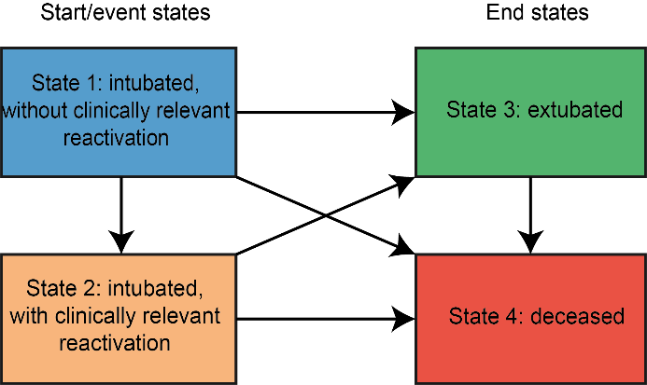
This figure illustrates the transition probabilities within a multistate modelling framework. All patients initially start in state 1 and could transition to the end states 3 (extubated) and 4 (deceased), either or not passing through the event state 2 (i.e. having a clinically relevant reactivation for CMV or HSV). ‘Clinically relevant’ CMV- and HSV-reactivation refers to a viral load of > 10⁴ c/ml. Abbreviations: CMV = cytomegalovirus; HSV = herpes simplex virus.

Fig. S2 Distribution plots for CMV and HSV log₁₀ viral loads BAL, classified by PCR result categories.

A-B. All positive PCR results classified into log₁₀ viral load classes. PCR negative results were not included in this plot. The Y-axis represents the number of BAL samples with corresponding log₁₀ viral loads on the X-axis (panel A for CMV and panel B for HSV). Blue = no clinically relevant reactivation (viral load <10⁴); orange = clinically relevant reactivation (viral load >10⁴). C-D. All PCR results, classified into log₁₀ viral load classes, including PCR negative results. The Y-axis represents the number of BAL samples with corresponding log₁₀ viral load classes on the X-axis (panel C for CMV and panel D for HSV).
The square bracket ‘[‘ represents a closed interval, including the endpoint, while the round bracket ‘)’ represents an open interval, excluding the endpoint. Dark blue = negative PCR result; blue = positive PCR result but no clinically relevant reactivation (viral load <10⁴); orange = clinically relevant reactivation (viral load >10⁴). A viral load cutoff of >10⁴ was a-priori considered ‘clinically relevant’, as per local protocol based on expert opinion and extrapolation.
Abbreviations: BAL = bronchoalveolar lavage; CMV = cytomegalovirus; HSV = herpes simplex virus; excl = excluding; incl = including; PCR = Polymerase Chain Reaction.

Fig. S3 Probability plot for developing a clinically relevant CMV- or HSV-reactivation

The graphs show the estimated time-dependent probability of developing a clinically relevant CMV (panel A) or HSV (panel B) reactivation over a 60-day period. Y-axis: probability scale of transition to CMV- or HSV-reactivation state (transition from state 1 to state 2 (figure S1)); X-axis: number of days since intubation. Black step lines represent the modeled probabilities; green circles indicate the time points at which the development state reaches the reactivation state (2), with circle size reflecting the count of occurrences; green boxplots display this distribution with median (middle line) and interquartile ranges. ‘Clinically relevant’ CMV- and HSV-reactivation refers to a viral load of > 10⁴ c/ml. Probabilities are estimated with multistate modeling. Abbreviations: CMV = cytomegalovirus; HSV = herpes simplex virus.

Fig. S4 Correlation between CMV and HSV viral loads.

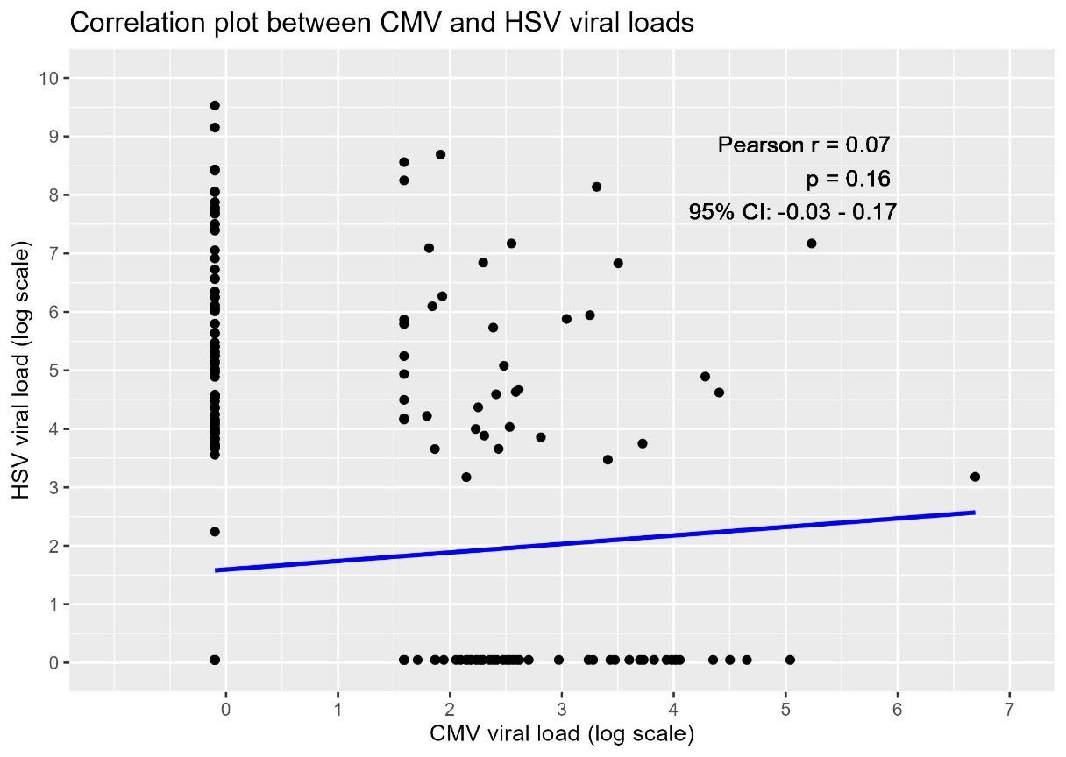
The scatterplot illustrates the log₁₀ viral load (copies/milliliter) for cytomegalovirus (CMV) and herpes simplex virus (HSV) per bronchoalveolar lavage (BAL) sample. Each black dot represents a BAL sample. The blue line indicates the linear relationship between the CMV viral load (on the x-axis) and the HSV viral load (on the y-axis) in logarithmic scale. The Pearson correlation coefficient (R) indicates the strength and direction of the linear relationship between CMV and HSV viral loads, with p-value and 95% confidence intervals (CI) provided. Abbreviations: BAL = bronchoalveolar lavage; CMV = cytomegalovirus; HSV = herpes simplex virus.

Fig. S5 Swimmer plot of all included patients in the study.
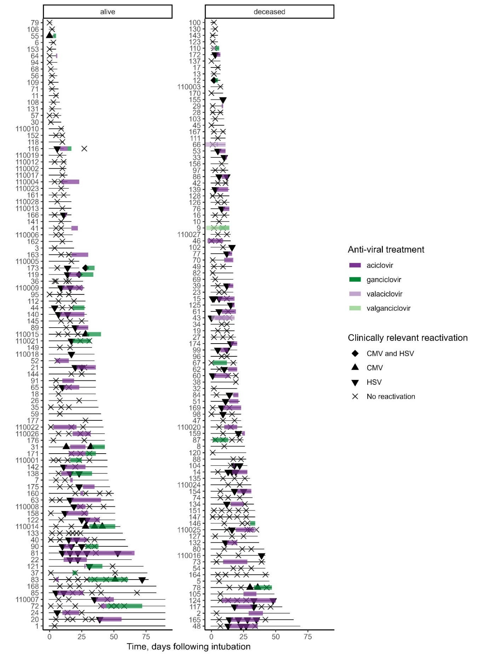
Each line in the figure represents an individual subject enrolled in the study (i.e. limited to CMV/HSV seropositive patients) (figure 1), tracked from intubation until either extubation, death, or a minimum follow-up of day 90. Censored patients remained intubated at the time of the day 90 assessment. Bronchoscopy with BAL was performed at specific timepoints, as indicated in the figure, to assess CMV and HSV-reactivation in the BAL fluid. The shapes indicate the result on clinically relevant (viral load > 10⁴ c/ml) CMV-and HSV-reactivation in the BAL fluid. The colored lines on the figure represent distinct antiviral treatment periods. ‘Clinically relevant’ CMV- and HSV-reactivation refers to a viral load of > 10⁴ c/ml. Abbreviations: BAL = bronchoalveolar lavage; CMV = cytomegalovirus; HSV = herpes simplex virus.

Fig. S6 Cutoff plot showing the hazard ratio for mortality versus the maximum transition probability on a HSV-reactivation for different cutoffs.

The y-axis displays the hazard ratio (HR) for mortality, and the x-axis represents the maximum transition probability for herpes simplex virus (HSV) reactivation. The figure includes various cutoff values of HSV viral loads for positivity, in copies/ml (c/ml). A dashed grey line is provided as a reference, indicating a hazard ratio of one (HR = 1), signifying a neutral association with mortality risk. The reference cutoff for clinically relevant HSV-reactivation (as currently applied in accordance with the local protocol) is 10⁴ c/ml and marked with bold borders and grey surface in the figure.
Abbreviations: HR = hazard ratio; HSV = herpes simplex virus; BAL = bronchoalveolar lavage. Scientific notations on the x-axis: “1e+03" represents 1,000 c/ml; "5e+03" represents 5,000; "1e+04" represents 10,000; "5e+04" represents 50,000; "1e+05" represents 100,000; "5e+05" represents 500,000; "1e+06" represents 1,000,000; "5e+06" represents 5,000,000; "1e+07" represents 10,000,000; "5e+07" represents 50,000,000; "1e+08" represents 100,000,000.

Fig. S7 Transition probability plot for the HSV cohort.

Left: the transition from state 1 (i.e. intubated, without clinically relevant HSV-reactivation) to state 4 (i.e. deceased). Right: the transition from state 2 (i.e. intubated, with clinically relevant HSV-reactivation) to state 4 (i.e. deceased). Y-axis: transition probability. X-axis: days since intubation. Black line: estimated probability (Est). Red lines: lower and upper confidence intervals (CI). ‘Clinically relevant’ HSV-reactivation refers to a viral load of > 10⁴ c/ml in the BAL fluid. Abbreviations: HSV = herpes simplex virus; BAL = bronchoalveolar lavage.

Fig. S8 Flowchart for cross-sectional biomarker analyses sample selection and matching processes.
‘Positive BAL’ refers to a BAL with the result of a ‘clinically relevant’ HSV-reactivation (viral load of >10⁴ c/ml in the BAL fluid); ‘negative BAL’ refers to a BAL with the result of no ‘clinically relevant’ HSV-reactivation (viral load of <10⁴ c/ml in the BAL fluid). ‘Comparable timepoint’ refers to the negative BAL selected in proximity to the median day of HSV reactivation in the HSV group, in cases where multiple BALs were available per patient. The groups were divided by nearest-neighbour 1-to-1 propensity score matching and included both patient and BAL specific matching criteria. Patient specific criteria included sex, age, BMI and diabetes mellitus as comorbidity during admission. BAL specific criteria included number of days between intubation and BAL, sequential organ failure assessment (SOFA) score at the time of the BAL, maximum temperature at the time of the BAL, and positive bacterial culture in BAL. Abbreviations: BAL = bronchoalveolar lavage; CMV = cytomegalovirus; HSV = herpes simplex virus.

Fig. S9 Flowchart for longitudinal biomarker analyses sample selection and matching processes.
‘Positive BAL’ refers to a BAL with the result of a ‘clinically relevant’ HSV-reactivation (viral load of >10⁴ c/ml in the BAL fluid); ‘negative BAL’ refers to a BAL with the result of no ‘clinically relevant’ HSV-reactivation (viral load of <10⁴ c/ml in the BAL fluid). 'Indirect subsequent' refers to any subsequent BAL after the initial positive result, irrespective of immediate sequence. The groups were divided by nearest-neighbour 1-to-1 propensity score matching and included both patient and BAL specific matching criteria. Patient specific criteria included sex, age, BMI and diabetes mellitus as comorbidity during admission. BAL specific criteria included number of days between intubation and BAL, sequential organ failure assessment (SOFA) score at the time of the BAL, maximum temperature at the time of the BAL, and positive bacterial culture in BAL.
Abbreviations: BAL = bronchoalveolar lavage; CMV = cytomegalovirus; HSV = herpes simplex virus.

Fig. S10 Matching effectiveness plots for the matched HSV reactivated and non-reactivated cross-sectional study groups.
Study groups were well balanced after propensity score matching. A. Love plot showing the range of balance across treatment pairs of each covariate, before and after propensity score matching (unadjusted and adjusted). Y-axis: variables used in propensity score matching; X-axis: absolute standardized mean differences. * indicates variables for which the displayed value is the raw (unstandardized) difference in means. B. Distributional balance for the covariates across the two groups, before and after propensity score matching (unmatched and matched). Y-axis: proportion; X-axis; distance. Pink = not HSV-reactivated, blue = HSV-reactivated. Abbreviations: BAL = bronchoalveolar lavage; SOFA = sequential organ failure assessment; DM = diabetes mellitus; HSV = herpes simplex virus.

Fig. S11 Matching effectiveness plots for the matched HSV reactivated and non-reactivated study groups for the longitudinal reactivation analysis (pre- and post-reactivation).

Study groups were well balanced after propensity score matching. A. Love plot showing the range of balance across treatment pairs of each covariate, before and after propensity score matching (unadjusted and adjusted). Y-axis: variables used in propensity score matching; X-axis: absolute standardized mean differences. * indicates variables for which the displayed value is the raw (unstandardized) difference in means. B. Distributional balance for the covariates across the two groups, before and after propensity score matching (unmatched and matched). Y-axis: proportion; X-axis; distance. Pink = not HSV-reactivated, blue = HSV-reactivated. Abbreviations: BAL = bronchoalveolar lavage; SOFA = sequential organ failure assessment; DM = diabetes mellitus; HSV = herpes simplex virus.

Fig. S12 CMV and HSV viral load dynamics for HSV-reactivated and non-reactivated patients, pre- and post-reactivation.

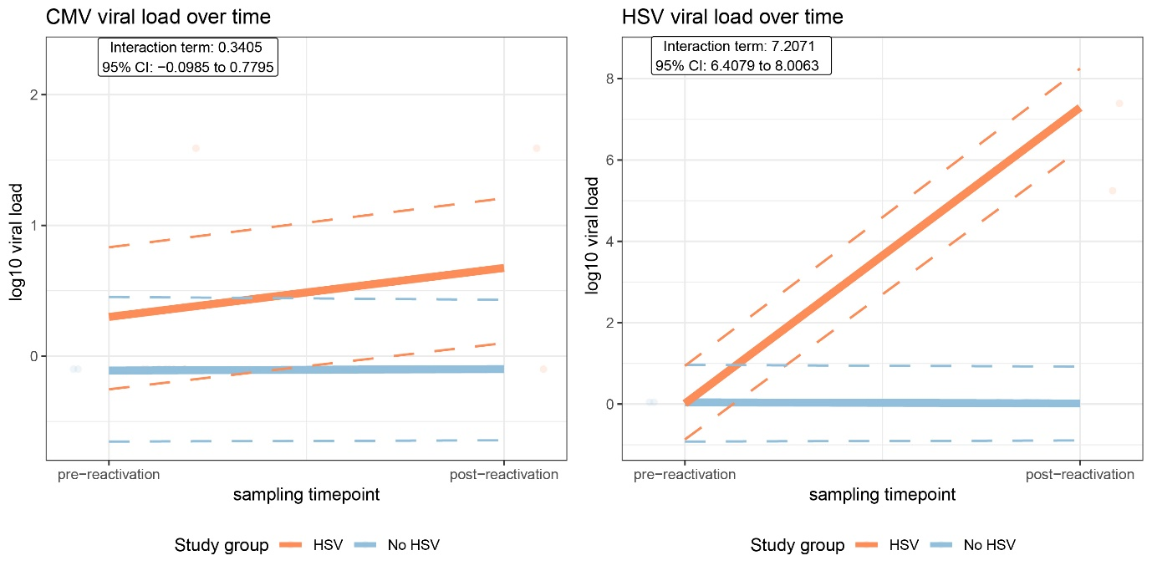
Viral load dynamics before and after reactivation, for HSV-reactivated patients (n=10), and matched controls without HSV-reactivation (n=10). Y-axis shows the log10 viral load (copies/milliliter) for CMV (left) and HSV (right). X-axis shows the sampling timepoints (pre- and post-reactivation). HSV-reactivation refers to a clinically relevant reactivation (viral load of >10⁴ c/ml in the BAL fluid). Patient selection is shown in figure S9. Orange and blue lines indicate the trajectories of viral loads for HSV-reactivated versus non-HSV reactivated patients, respectively. Dotted line indicates the 95% confidence intervals. Linear mixed-effects models were used to provide Beta and 95% confidence intervals. Abbreviations: CMV = cytomegalovirus; HSV = herpes simplex virus; CI = confidence interval.

Fig. S13 Matching effectiveness plots for the matched HSV reactivated and non-reactivated study groups for the longitudinal treatment analysis (pre- and post- treatment).

Study groups were well balanced after propensity score matching. A. Love plot showing the range of balance across treatment pairs of each covariate, before and after propensity score matching (unadjusted and adjusted). Y-axis: variables used in propensity score matching; X-axis: absolute standardized mean differences. * indicates variables for which the displayed value is the raw (unstandardized) difference in means. B. Distributional balance for the covariates across the two groups, before and after propensity score matching (unmatched and matched). Y-axis: proportion; X-axis; distance. Pink = not HSV-reactivated, blue = HSV-reactivated. Abbreviations: BAL = bronchoalveolar lavage; SOFA = sequential organ failure assessment; DM = diabetes mellitus; HSV = herpes simplex virus.

Fig. S14 Plasma biomarker dynamics for HSV-reactivated and non-reactivated patients, pre- and post-reactivation and pre-and post-treatment.

This figure displays the systemic longitudinal profiles of the four selected biologically relevant biomarkers that showed a significant difference in alveolar reactivation biomarker dynamics, compared to the non-reactivated group. HSV-reactivation refers to a clinically relevant reactivation (viral load of >10⁴ c/ml in the BAL fluid). A: Sampling timepoints before and after reactivation, for HSV-reactivated patients (n=9)*, and matched controls without HSV-reactivation (n=10). B: Sampling timepoints before and after treatment, for HSV-reactivated patients who received antiviral treatment (n=11), and matched controls without HSV-reactivation who did not receive antiviral treatment (n=11). Patient selection is shown in figure S9. Orange and blue lines indicate the trajectories of alveolar biomarker concentrations for HSV reactivated versus non-HSV reactivated patients, respectively. Dotted line indicates the 95% confidence intervals. Linear mixed-effects models were used to provide Beta and 95% confidence intervals. Abbreviations: HSV = herpes simplex virus; G-CSF = granulocyte colony stimulating factor; IL = interleukin; TNF = tumor necrosis factor; CI = confidence interval. * A single patient lacked paired plasma sampling for this analysis.

References
1. Castor EDC 2019 [Castor Electronic Data Capture]. Available from: https://castoredc.com.
2. Ferguson N, Datta S, Brock G. msSurv: An R Package for Nonparametric Estimation of Multistate Models. J Stat Softw. 2012;50(14):1-24. DOI:
3. Rizopoulos D. JM: An R Package for the Joint Modelling of Longitudinal and Time-to-Event Data. J Stat Softw. 2010;35(9):1-33. DOI:
4. Ho DE, Imai K, King G, Stuart EA. MatchIt: Nonparametric Preprocessing for Parametric Causal Inference. J Stat Softw. 2011;42(8). DOI:
5. Bates D, Machler M, Bolker BM, Walker SC. Fitting Linear Mixed-Effects Models Using lme4. J Stat Softw. 2015;67(1):1-48. DOI: DOI 10.18637/jss.v067.i01

