SUPPLEMENTARY FILE

Recommendations for clinical trial design in Acute Kidney Injury From the 31st Acute Disease Quality Initiative Consensus Conference
A Consensus Statement
Alexander Zarbock^{1,2,#}, Lui G. Forni^{3,4,#}, Jay L. Koyner⁵, Samira Bell⁶, Thiago Reis^{7,8,9}, Melanie Meersch¹, Sean M. Bagshaw¹⁰, Dana Y. Fuhmann^{11,12,13}, Kathleen Liu¹⁴, Neesh Pannu¹⁵, Ayse Akcan Arikan¹⁶, Derek Angus¹³, D’Arcy Duquette¹⁷, Stuart L. Goldstein¹⁸, Eric Hoste¹⁹, Michael Joannidis²⁰, Niels Jongs²¹, Matthieu Legrand²², Ravindra L. Mehta²³, Patrick T. Murray²⁴, Mitra K. Nadim²⁵, Marlies Ostermann²⁶, John Prowle²⁷, Emily J. See^{28,29,30}, Nicholas M. Selby³¹, Andrew Shaw³², Nattachai Srisawat³³, Claudio Ronco ^{34,35,36}, & John A. Kellum^{12,13}

¹ Department of Anesthesiology, Intensive Care and Pain Medicine, University Hospital of Münster, Münster, Germany
² Outcomes Research Consortium, Cleveland, OH, USA
³ Depatment of Critical Care, Royal Surrey Hospital Foundation Trust, Guildford, Surrey UK
⁴ School of Medicine, Kate Granger Building, University of Surrey, Guildford, Surrey UK
⁵ Section of Nephrology, University of Chicago, Chicago, IL, USA
⁶ Division of Population Health and Genomics, University of Dundee, Dundee, United Kingdom
⁷ Hospital Sírio-Libanês, São Paulo, Brazil⁸ Fenix Nephrology, São Paulo, Brazil
⁹ Laboratory of Molecular Pharmacology, University of Brasília, Brasília, Brazil
¹⁰ Department of Critical Care Medicine, Faculty of Medicine and Dentistry, University of Alberta and Alberta Health Services, Edmonton, Alberta, Canada
¹¹ UPMC Children's Hospital of Pittsburgh, 4401 Penn Avenue, Suite 2000, Pittsburgh, PA, 15224, USA
¹² Center for Critical Care Nephrology, University of Pittsburgh, Pittsburgh, PA, USA
¹³ Department of Critical Care Medicine, University of Pittsburgh, Pittsburgh, PA, USA
¹⁴ Departments of Medicine and Anesthesia, University of California, San Francisco, San Francisco, CA, USA
¹⁵ Department of Medicine, University of Alberta, Edmonton, Alberta, Canada
¹⁶ Division of Nephrology and Critical Care Medicine, Department of Pediatric, Baylor College of Medicine, Houston, Texas, USA
¹⁷ Critical Care Strategic Clinical Network, Alberta Health Services, Calgary, Canada
¹⁸ Division of Nephrology and Hypertension, Cincinnati Children's Hospital Medical Center, USA
¹⁹ Intensive Care Unit, Ghent University Hospital, Ghent University, Belgium
²⁰ Division of Intensive Care and Emergency Medicine, Department of Internal Medicine, Medical University Innsbruck, Austria
²¹ Department of Clinical Pharmacy and Pharmacology, University Medical Center Groningen, University of Groningen, Groningen, the Netherlands
²² Department of Anesthesia and Perioperative Care, Division of Critical Care Medicine, UCSF, San Francisco, CA, USA
²³ Department of Medicine, University of California San Diego, La Jolla, CA, USA
²³ School of Medicine, University College Dublin, Dublin, Ireland
²⁵ Division of Nephrology and Hypertension, Department of Medicine, Keck School of Medicine, University of Southern California, CA, USA
²⁶ Department of Intensive Care, King’s College London, Guy’s & St Thomas’ Hospital, London, UK
²⁷ William Harvey Research Institute, Faculty of Medcicine and Dentistry, Queen Mary University of London, London, UK
²⁸ Department of Critical Care, University of Melbourne, Parkville, Australia
²⁹ Department of Intensive Care, Royal Meelbourne Hospital, Melbourne, Victoria, Australia
³⁰ Department of Nephrology, Royal Melbourne Hospital, Melbourne, Victoria, Australia
³¹ Centre for Kidney Research and Innovation, University of Nottingham, UK.
³² Department of Intensive Care and Resuscitation,, The Cleveland Clinic, Cleveland, OH, USA
³³ Division of Nephrology, Department of Medicine, Faculty of Medicine, and Center of Excellence in Critical Care Nephrology, Chulalongkorn University, Bangkok, Thailand
³⁴ Department of Medicine, University of Padova, Padua, Italy
³⁵ International Renal Research Institute of Vicenza (IRRV), Vicenza, Italy
³⁶ Department of Nephrology, San Bortolo Hospital, Vicenza, Italy
# both authors contributed equally and share first authorship

As no recommendations on endpoints and trial design for studies of AKI prevention and treatment interventions exist, we conducted an ADQI meeting to develop consensus statements. We followed a well-established process: A collaborative group of 28 diverse international experts from different healthcare disciplines and backgrounds were invited, including anaesthesia, critical care, pediatrics, nephrology, and epidemiology, clinical trial design and biostatistics, as well as an individual with lived experience. Prior to the conference, the working groups met online. In the first meeting, they identified key questions in the area. Online searches for articles on endpoints in clinical trials for acute kidney injury were conducted. The search and subsequent bibliographic review were restricted to observational studies, reviews, randomised controlled trials, and meta-analyses, published in English. In addition, we searched the Cochrane database and ClinicalTrials.gov, and reviewed the reference lists of articles. Relevant papers were reviewed by the members of the panel and served to underpin the consensus statements.
During the meeting, a modified Delphi method was applied whereby the different working groups presented their research questions to the entire ADQI panel and received feedback and assistance in refining them. In subsequent break-out sessions, the group developed statements in response to these questions, supported by evidence when available or by expert opinion when no evidence was available or was uncertain. Refined statements were iteratively presented to the whole panel and re-revised in response to feedback until consensus was achieved. Non-anonymous voting was conducted during the final panel meeting. A priori, it was decided that agreement by 90% of votes would be necessary for approval.
In this manuscript, we summarize the consensus statements.

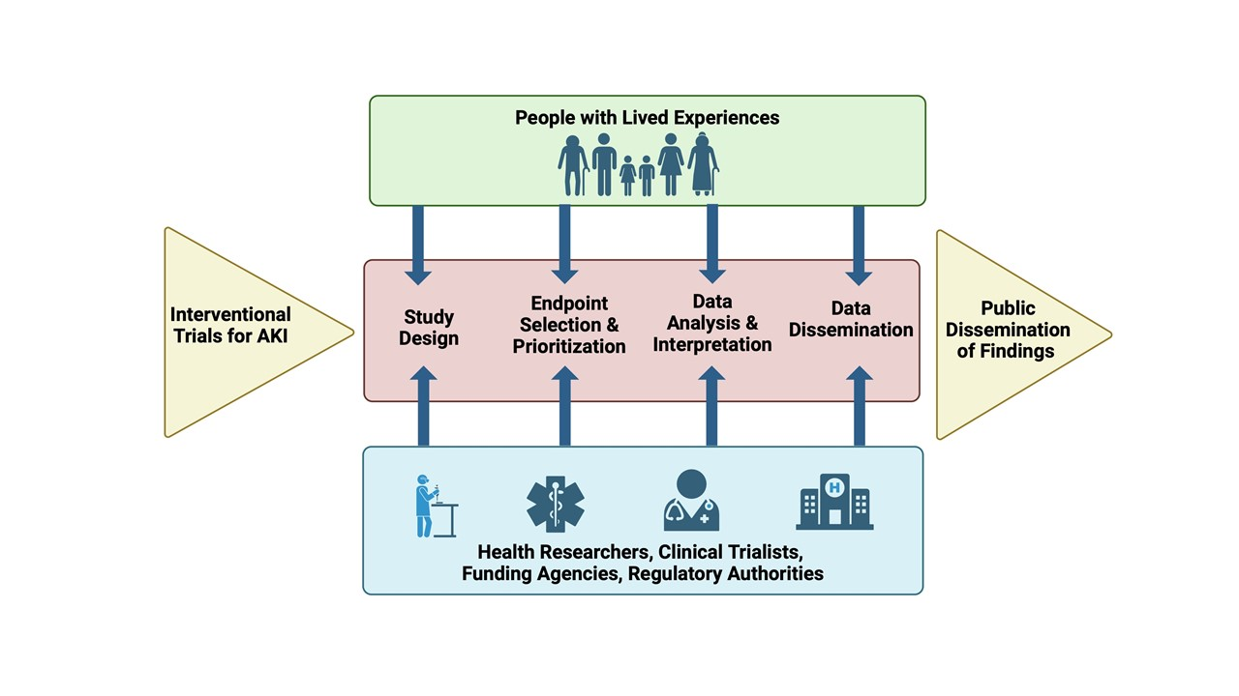Supplementary Figure 1: People with lived experience (PWLE), including patients, family members, and caregivers, who are considered experts due to their firsthand experience with AKI have rarely been involved in trials of prevention or treatment interventions in AKI. To truly appreciate the value of PWLE partners, they must be fully integrated into every aspect of the research process from the study design to the public dissemination of study findings. Source: Acute Disease Quality Initiative 31, www.ADQI.org, used with permission.

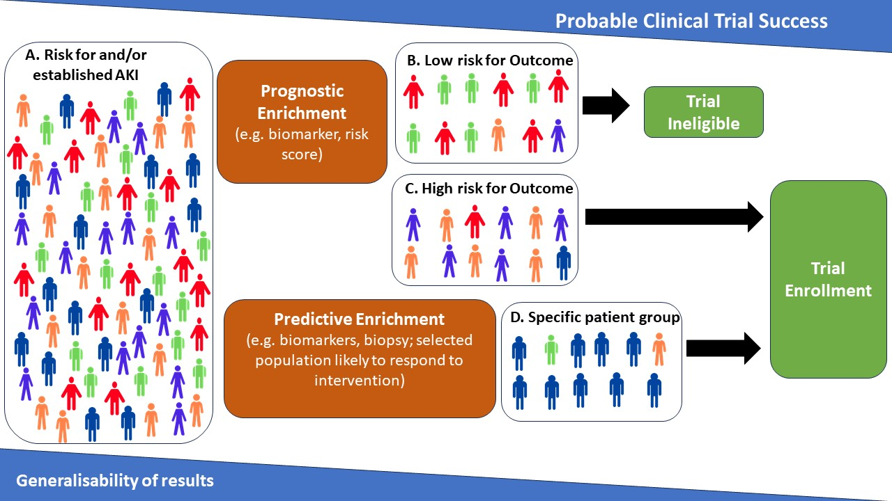Supplementary Figure 2: Enrichment strategies for acute kidney injury (AKI) trials. A. the overall cohort of patients defined by risk for developing AKI or diagnosis of AKI. Prognostic enrichment stratifies B. patients unlikely to develop the endpoint (B; excluded) from patients with an acceptable probability of developing the endpoint (C; enrolled). Predictive enrichment, by contrast, selects a subpopulation (D) from the overall cohort who have an acceptable probability of responding to the intervention and are therefore selected for enrollment into the trial. Predictive enrichment (D) can be combined with Prognostic enrichment (C) for targeted interventions. In both types of enrichment, acceptable probability of outcome (C) or response to intervention (D) is determined by the sample size for a given trial. Trials that utilize enrichment increase the probability of success but necessarily reduce generalization to the overall cohort (A). Source: Acute Disease Quality Initiative 31, www.ADQI.org, used with permission.

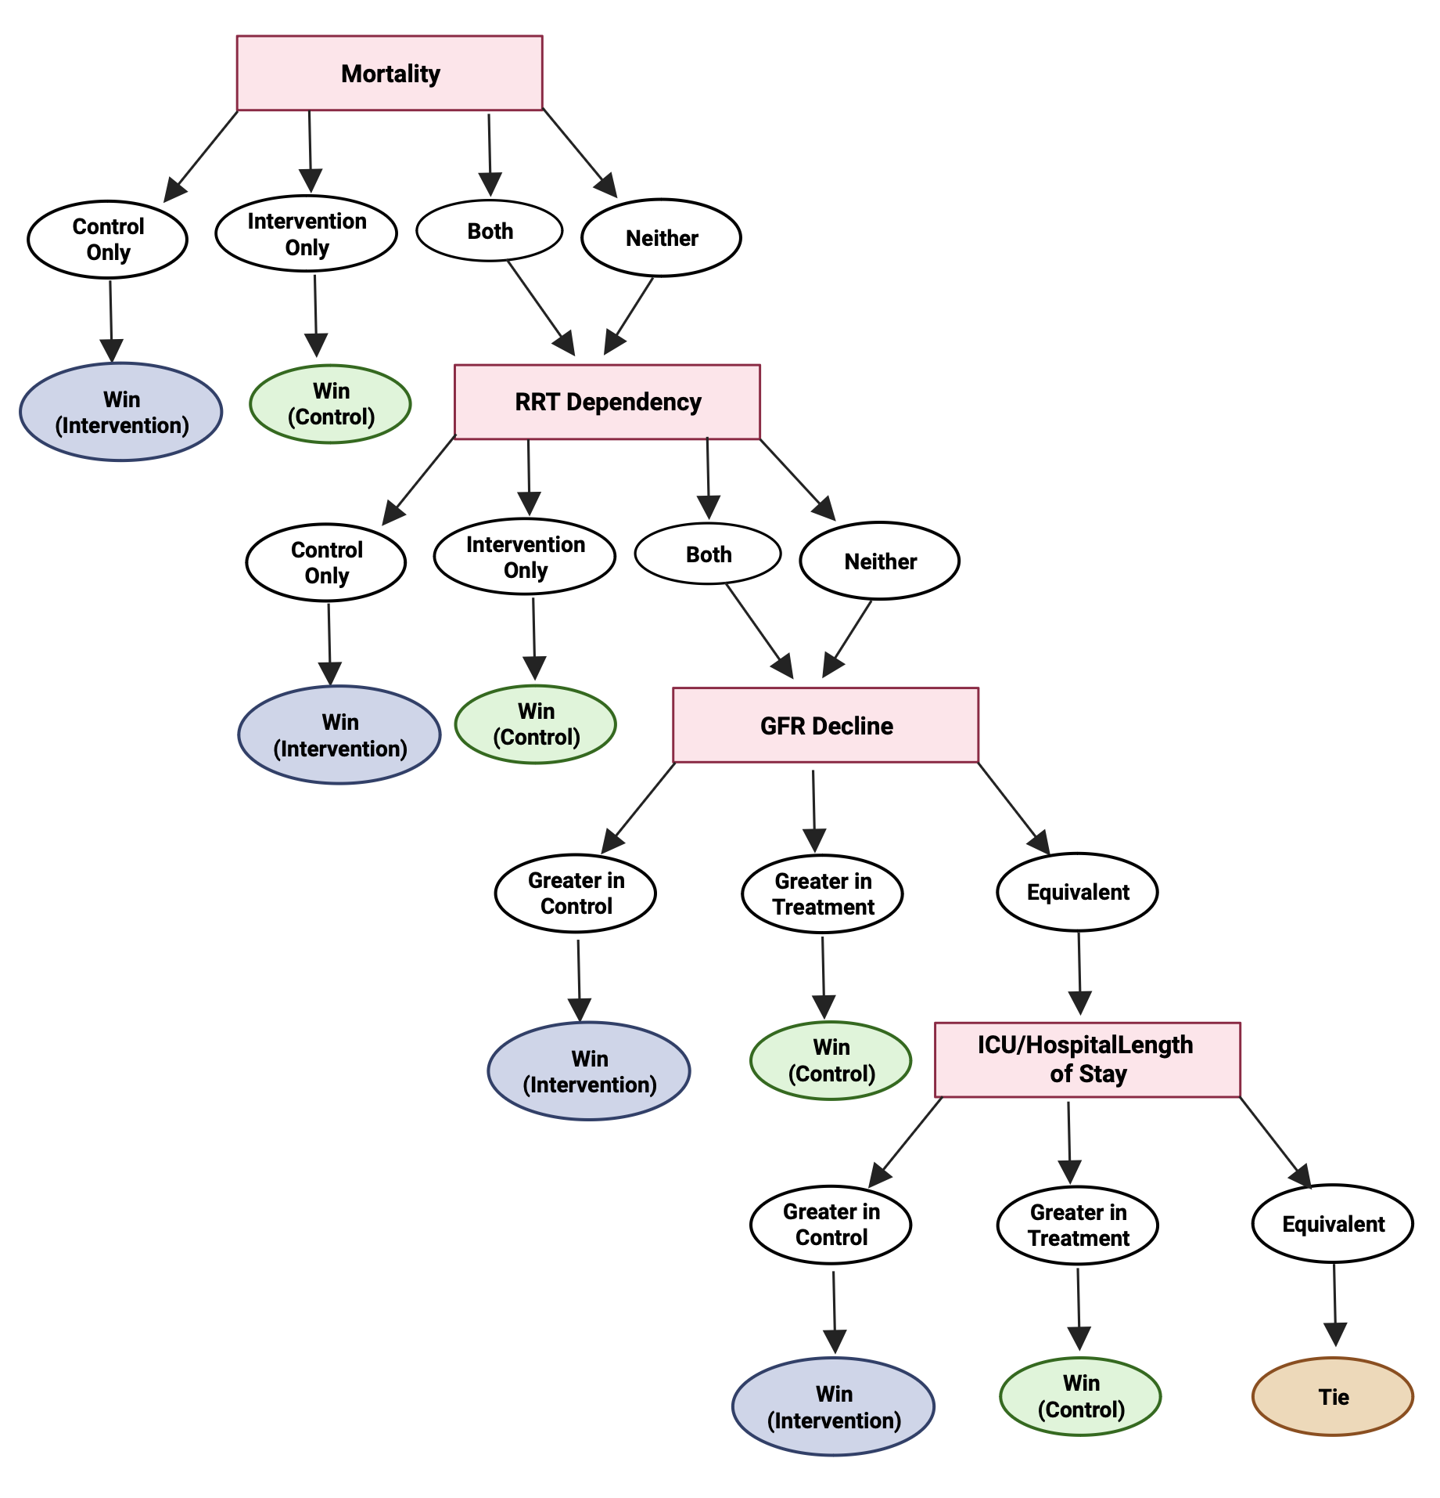
Supplementary Figure 3: A hierarchal composite endpoint allows for the section of a variety of endpoints to be arranged in order of their significance, comparing patients in the control and AKI treatment groups. In this example, death would be the most critical event and ranked as top priority. Following this, renal replacement therapy (RRT) dependency is placed next, given its substantial prognostic importance for patients. Subsequent continuous endpoints might include the trajectory of glomerular filtration rate (GFR) and length of stay. Source: Acute Disease Quality Initiative 31, www.ADQI.org, used with permission.

Supplementary Table 1: Consensus Statements
 | Consensus Statement
General statements for AKI trials  - Consensus Statement 1 | We recommend that researchers, trialists, funding agencies, industry, and regulatory authorities acknowledge the fundamental importance of the perspectives of people with lived experience (PWLE) in the design and selection of endpoints in clinical trials evaluating AKI, and that PWLE are involved in the clinical trial process, including data analysis, interpretation, and dissemination.
Patient Enrichment Strategies  - Consensus Statement 2  - Consensus Statement 3  - Consensus Statement 4  - Consensus Statement 5 | We recommend that investigators consider enriching patient selection for enrollment in AKI clinical trials given the heterogeneous nature of AKI syndromes.  We recommend that prognostic enrichment be considered to identify patients who have a greater likelihood of meeting a defined primary endpoint and/or outcome while minimizing the competing risks of undesired endpoints/outcomes.  We recommend consideration of predictive enrichment and diagnostic precision strategies to identify patients with shared underlying pathobiology.  Enrichment may not be appropriate for all AKI clinical trials.
Prevention and Attenuation Studies  - Consensus Statement 6  - Consensus Statement 7  - Consensus Statement 8 | We recommend that when selecting endpoints for AKI prevention studies, investigators consider trial design and endpoint characteristics including: i) biological plausibility; ii) validity in the target population; iii) practicality; iv) patient-centeredness.  We recommend that in AKI prevention studies, methods of estimating or imputing baseline kidney health be selected with consideration of the patient population and trial design.  For phase 2 prevention trials, we recommend that measures of kidney function or damage in the acute phase are used as primary endpoints for AKI prevention studies. For phase 3 trials, we recommend use of AKI (stage) as the primary endpoint.
Treatment Studies  - Consensus Statement 9  - Consensus Statement 10  - Consensus Statement 11 | We recommend that endpoints for phase 2 trials in AKI be selected to directly inform on efficacy, dose-response, biologic response to the treatment, and safety and ideally, correlate with patient-centered outcomes.  We recommend that feasibility measures be explicitly defined for phase 2 trials and encompass measures of success across domains of recruitment, randomization, protocol fidelity, and endpoint measurement.  We recommend, when selecting a composite endpoint including hierarchal composite endpoints (HCE), component selection be context-specific when necessary, evidence-informed, and guided by PWLE.
Designs of studies other than traditional randomized clinical trials (RCT)  - Consensus Statement 12 | We recommend the use of an innovative clinical trial design when it addresses challenges of AKI that are relevant to the research question, or, when it provides one or more advantages over traditional designs. Elements to be considered when designing innovative clinical trials include unit of randomization, design features and analytic strategy.

Supplementary Table 2: Prognostic and predictive enrichment strategies
 | Definition | Tools | Limitations
Prognostic enrichment strategies | to identify patients more likely to develop the endpoint | Scoring systems (e.g. Cleveland Clinical Foundation Score)  Biomarkers (e.g. TIMP2*IGFBP7) | Mainly focus on susceptibility and do not consider the exposure
Predictive enrichment strategies | to identify patients more likely to respond to the intervention | Biomarkers (e.g. renin)  Characteristics associated with the biological target of a therapeutic agent | Reduce generalizability

Supplementary Table 3: Endpoints used in clinical AKI trials
Endpoint | Advantage | Disadvantage
Prevention trials
Biomarkers | Biomarkers detect kidney damage/injury in the absence of loss of function  Biomarkers can predict outcome in AKI patients | The intervention might not affect the pathway that the biomarker is in
eGFR or serum creatinine | Frequently measured  Sensitive endpoint | The measurement has limitations (e.g. in patients with critical illness or in patients after surgery)  Not a patient-centered outcome
AKI based on the KDIGO definition (stage 1–3 or stages 2–3) | Sensitive endpoint  More severe AKI (stages 2 or 3) is associated with worse outcome | Stage 1 AKI has low specificity (especially the urine output criterion) and is not always associated with worse outcome  Sample size increases, if used as a dichotomous endpoint
Treatment studies
MAKE | Death and chronic dialysis are highly patient-centered  Composite occurs more often than its individual components  Can be used as a hierarchical endpoint | In critically ill patients, death might be caused by different causes
AKI trajectories | Sensitive endpoint  Small sample size is needed  Associated with mortality | Different factors might influence the trajectory  Difficult to capture and requires accurate measurement  Trajectories depend on serum creatinine levels and is therefore affected by its limitations
Dialysis | Patient-centered outcome  Dialysis-free days can be used as a time-based continuous outcome Associated with increased mortality and high health-care costs | Intervention is not standardized (initiation, execution, and cessation)
eGFR reduction or CKD progression | Patient-centered outcome  Good endpoint for AKI treatment studies  CKD progression is associated with an increased morbidity and mortality | Incidence might be low  Requires long-term follow-up
AKI, acute kidney injury; KDIGO, Kidney Disease: Improving Global Outcomes; eGFR, estimated glomerular filtration rate; MAKE, major adverse kidney events; CKD, chronic kidney disease.

Supplementary Table 4: Primary outcomes for AKI trials

 | Intention | Endpoint | Timing | Measurement | Sensitivity | Availability | Affordability | Patient-centred | Other
Phase 2 | Prevention and attenuation | Damage / stress biomarkers (NGAL, TIMP2-IGFBP7, KIM-1) | Hours | Stress or damage | **** | ** | ** | * | Non-invasive  Can be used for enrichment  Sensitive to timing  May not be involved in injury pathway
 | Prevention and attenuation | Serum creatinine/eGFR | Hours to days | Function | **** | **** | ***** | ** | Not specific  Dependent on muscle mass
 | Prevention and attenuation | Creatinine clearance | Days | Function | ** | *** | **** | ** | Prone to error  Useful in extremes of mass
 | Prevention and attenuation | Measured GFR (iohexol, MAG3, DTPA) | Hours to days | Function | ** | ** | ** | * | Varies with muscle mass and medications
 | Prevention and attenuation | Cystatin C | Hours to days | Function | *** | ** | *** | ** | Independent of muscle mass  Reference value unlikely to be available
 | Prevention and attenuation | AKI (KDIGO stage 1-3) | Hours to days | Function | *** | **** | ***** | **
 | Prevention and attenuation | Change in renal SOFA score | Days | Function | ** | *** | ***** | ** | Not routinely collected
 | Prevention and attenuation | Urine output | Hours to days | Function | *** | ***** | ***** | ** | Non-invasive  Not specific  Prone to error
Phase 3 | Prevention | AKI (KDIGO stage 1-3) | Hours to days | Function | *** | **** | ***** | **
 | Attenuation | Moderate to severe AKI (KDIGO 2-3) | Hours to days | Function | ** | **** | ***** | ***
 | Prevention and attenuation | PROMs (e.g. QoL, anxiety, PTSD) | Days to months | N/A | ** | ** | ** | **** | No validated PROMS for AKI
 | Prevention and attenuation | Proteinuria | Days | Stress or damage | ** | **** | **** | **
Phase 4 | Prevention | AKI (KDIGO stage 1-3) | Hours to days | Function | *** | **** | ***** | **
 | Attenuation | Moderate to severe AKI (KDIGO 2-3) | Hours to days | Function | ** | **** | ***** | ***
 | Attenuation | Renal replacement therapy | Hours to days | Function | ** | ** | ***** | **** | Timing is clinician-dependent
 | Prevention and attenuation | Cost effectiveness | Days to months | N/A | N/A | N/A | *** | **
 | Prevention and attenuation | Mortality | Days to months | N/A | ** | **** | **** | ****
 | Prevention and attenuation | Serious adverse events | Hours to days | N/A | N/A | N/A | ** | ****
 | Prevention and attenuation | Length of stay (ICU, hospital) | Days to months | N/A | ** | **** | **** | ****

Supplementary Table 5: Advantages and Disadvantages of different trial designs

Trial Design | Strategy | Description | When to use | Pros | Cons | Examples in AKI
Predictive and Prognostic Enrichment | Increase the efficiency of drug development and support precision medicine by tailoring treatments to those patients who will benefit. | Identification of subsets of patients with or at risk of a specific condition using clinical, laboratory genomic or proteomic biomarkers. | - Intervention is targeted to specific subphenotypes of AKI.  - Clear subgroups can be identified that have higher event rates.  - Clear subgroup that is more likely to respond to the therapy. | Greater likelihood of seeing effect of intervention | - Less generalizable results outside of this population.  - Requires target associated biomarkers be accessible in near real time to inform therapeutic decisions. | PrevAKI: used TIMP-2/IGFBP-7 for risk stratification. ¹  Taking FOCUS 2: utilizing NGAL measurements to allocate KRT in children. ²
Adaptive | Involve a flexible trial design and utilize the accumulated data to change aspects of the trial during its course without undermining the integrity or validity of the trial. | Adaptive trial designs can be used for determining inclusion/exclusion criteria, dose selection, assessing the best treatment schedule, adapting the intervention based on the response, and sample size adjustments. | When there is uncertainty regarding optimal design of the trial and when the collected data can be analyzed in a continuous fashion during the trial to establish subsequent actions that are defined a-priori. The purpose is to make clinical trials more flexible, efficient, and fast. | More efficient with potentially less sample size, fewer patients likely exposed to harm, greater potential for showing treatment benefit. | - Requires detailed planning and complex statistical methods.  - Only pre-specified adaptations are permitted.  - Requires discussion and agreement with regulatory bodies to be accepted for approval. | STOP AKI: utilized an adaptive trial to select the dose for comparison with placebo.³
Sequential Multiple Assignment Randomized trial (SMART) | SMART trials are multistage randomized trial wherein each stage corresponds to a scientific question or questions concerning the selection and adaptation of intervention options. A randomization takes place at each decision point of scientific interest. Some or all participants are randomized more than once. | SMART trials evaluate adaptive interventions where sequential interventions are offered based on the response. Ongoing information about the participant is used to modify type/intensity/modality of the intervention. The adaptive interventions are protocolized and evidence based. | When multiple interventions are being considered. | Can answer multiple questions and provide evidence regarding interactions among sequential treatments, beneficial or harmful, that may otherwise be missed in a 1-stage randomized trial design. | Generally do not provide definitive evidence of the effectiveness of an adaptive intervention. | Could develop a trial where patients are started on one modality of adsorptive therapy and if they don’t respond there are switched to an alternate therapy. For example, all participants start with a Cytosorb therapy and responders continue whereas non-responders are randomized to next therapy.
Trials with Master Protocols | A master protocol is an overarching protocol designed to answer multiple questions. These protocols may involve one or more interventions in one or more diseases, with multiple interventions, each targeting a biomarker-defined population or disease subtype. | Master Protocols share key design components and operational aspects to achieve better coordination than can be achieved in single trials designed and conducted independently. This can be done by sharing key design elements as well as study materials such as patient data and removing redundancies of stand-alone traditional trials each requiring their own infrastructure. | When researchers need to identify and target therapies to subpopulations. | - Streamlines higher quality recruitment process yielding fewer screening failures and shorter recruitment times.  - Single centralized governing bodies such as steering committees, IRBs, and data monitoring committees.  - Central labs and imaging and adjudication committees  - Coordinated screening and gives the advantage of more efficient use of patients and resources. | - Lack of a global cohort of trial ready patients which is essential for most platform trials.  - Requires coordination amongst different sponsors for access to investigational agents and agreements for regulatory agencies. | No current master protocols for AKI.
Umbrella | Allows study of multiple targeted therapies in the context of a single disease. | Focuses on a single disease where multiple treatment options exist that can be studied in parallel. | When there are multiple treatment options targeting different steps in the pathway of the disease and when enough patients can be recruited and targeted for the different treatments. | - Multiple treatments can be evaluated simultaneously.  - Coupled with sequential biomarkers measurement targeted approaches can be built in for more precise management. | Multiple treatment options must be available and requires considerable coordination among different sponsors for the agents | Screen for presence of damage and functional markers for specific targeted application e.g. stress biomarkers (TIMP2*IGFBP7), damage markers (NGAL) and persistence biomarkers (CCL14) could direct specific therapies the are relevant in the phase of disease. Alternative approach could be targeting Inflammation or endothelial or mitochondrial dysfunction with different therapies in AKI.
Basket | For study of a single targeted therapy in the context of multiple diseases or disease subtypes. | Focuses on specific pathways which may be common to multiple diseases. | When the therapeutic target can be clearly defined and is represented in a wide variety of patients with different disease states. | - Ability to leverage knowledge of a common target (mechanism, pathway, pathophysiology) across multiple disease states.  - Therapeutic approach is agnostic to condition, patients can be enrolled from different diseases contributing to larger pool. | Increased risk of false positives, related to the number of "baskets" evaluated - efficacy and safety may be different in different baskets. | Targeting complement pathway in different disease states e.g. HUS, IgA nephropathy and AKI (Alexion CSA-AKI trial, NCT05746559); Alternate could be targeting proteinuria and GFR with SGLT2 inhibitors in diabetic CKD, Diabetic AKI; Non Diabetic AKI, Non Diabetic CKD
Platform | An adaptive design that allows rapid and efficient study of multiple therapies for a single disease. | To study multiple targeted therapies in the context of a single disease in a perpetual manner, with therapies allowed to enter or leave the platform on the basis of a decision algorithm. | When there are multiple therapeutic options that have not been tested in a standardized manner. | Platform trials allow randomization of more patients to a superior treatment arm or to a control group (response adaptive randomization), new treatments can be seamlessly added utilizing the same infrastructure, therapies can be compared to controls or to each other. | - Standard of care may change over duration of trial requiring comparison with historical controls.  - Trial design explicitly assumes heterogeneity in the population will result in heterogeneous treatment effects. | Examples may include targeting sepsis associated organ dysfunction and AKI with different ECOS adsorptive techniques.
Pragmatic Trials | Prioritizes real-world applicability by assessing interventions in routine clinical settings, emphasizing effectiveness over efficacy. | Bridges the gap between research and practice by using flexible inclusion/exclusion criteria, diverse study settings and pragmatic collection of outcomes. | Provides insights into practical impact of interventions in clinical care. | - Real world applicability.  - Increased external validity. | - Heterogeneity of intervention  - Challenges with data quality.
Cluster randomized | Studies interventions that are designed to be applied to whole populations (as opposed to individuals); or when there are practical or acceptability reasons to do so | Randomisation occurs at the cluster level (e.g. site level) as opposed to randomising individual participants | Suited to process of care interventions, requiring training and education of personnel. | - Avoids contamination of control group  - Captures direct and indirect effects of the intervention. | - May require larger sample sizes and be more expensive.  - Results can be affected by heterogeneity between clusters. | IMPROVE AKI: a quality improvement intervention trial for contrast associated AKI ⁴
Stepped wedge | Sequential introduction of intervention applied to whole populations. | All clusters begin the trial in the control arm, and are then randomised to sequentially implement the intervention at set timepoints, until all clusters are exposed to the intervention. | Suited to the evaluation of complex interventions, including those that may take a period of time to implement, and for those in which there is a reason for ensuring that all clusters receive the intervention. | - Improves feasibility when difficult to implement the intervention to all participants at the same time.  - Can overcome practical, ethical or engagement issues relating to withholding intervention in control arm.  - Allow for simultaneous clinical implementation and research evaluation. | - The need to consider approach to informed consent (e.g. waivers of individual patient consent)  - Requirement to consider whether intervention effect changes over time. | RELIEVE AKI: focused on volume removal targets in CRRT (liberal vs restrictive)⁵  CONTRAST RISK: focused on a bundled quality improvement interventions to reduce contrast associated AKI ⁶  TACKLING AKI study:  Complex intervention comprising e-alerts, care bundle and education programme to improve AKI management.⁷

Supplementary Table 6: CREDES checklist
Rational for Delphi Technique
Justification | Supplementary File, page 4, line 1
Planning and Design
Planning and process. | Main manuscript, page 5, line 24
Definition of consensus | Supplementary File, page 4, line 18
Study Conduct
Informational Input | Supplementary File, page 4
Prevention of bias. | No conflicts reported, competing interests are listed in the main manuscript on page 29
Interpretation and processing of results. | Main manuscript, page 6
External validation. | Not available
Reporting
Purpose and rationale. | Main manuscript, page 5, Introduction
Expert panel. | Supplementary File, page 4 and main manuscript page 5/6
Description of the methods. | Supplementary File, page 4 and main manuscript page 5/6
Procedure. | Supplementary File, page 4 and main manuscript page 5/6
Definition and attainment of consensus. | Main manuscript, page 6, line 8
Results. | Main manuscript page 6-16, Supplementary File, Table 1
Discussion of limitations. | Main manuscript, page 17, line 24
Adequacy of conclusions. | Main manuscript, page 17, line 26
Publication and dissemination. | This publication + presentation at meetings

References

1. Zarbock A, Kullmar M, Ostermann M, et al. Prevention of Cardiac Surgery-Associated Acute Kidney Injury by Implementing the KDIGO Guidelines in High-Risk Patients Identified by Biomarkers: The PrevAKI-Multicenter Randomized Controlled Trial. Anesth Analg. Aug 1 2021;133(2):292-302. doi:10.1213/ANE.0000000000005458
2. Goldstein SL, Krallman KA, Roy JP, et al. Real-Time Acute Kidney Injury Risk Stratification-Biomarker Directed Fluid Management Improves Outcomes in Critically Ill Children and Young Adults. Kidney Int Rep. Dec 2023;8(12):2690-2700. doi:10.1016/j.ekir.2023.09.019
3. Pickkers P, Mehta RL, Murray PT, et al. Effect of Human Recombinant Alkaline Phosphatase on 7-Day Creatinine Clearance in Patients With Sepsis-Associated Acute Kidney Injury: A Randomized Clinical Trial. JAMA. Nov 20 2018;320(19):1998-2009. doi:10.1001/jama.2018.14283
4. Brown JR, Solomon R, Stabler ME, et al. Team-Based Coaching Intervention to Improve Contrast-Associated Acute Kidney Injury: A Cluster-Randomized Trial. Clin J Am Soc Nephrol. Mar 1 2023;18(3):315-326. doi:10.2215/CJN.0000000000000067
5. Murugan R, Chang CH, Raza M, et al. Restrictive versus Liberal Rate of Extracorporeal Volume Removal Evaluation in Acute Kidney Injury (RELIEVE-AKI): a pilot clinical trial protocol. BMJ Open. Jul 7 2023;13(7):e075960. doi:10.1136/bmjopen-2023-075960
6. James MT, Har BJ, Tyrrell BD, et al. Effect of Clinical Decision Support With Audit and Feedback on Prevention of Acute Kidney Injury in Patients Undergoing Coronary Angiography: A Randomized Clinical Trial. JAMA. Sep 6 2022;328(9):839-849. doi:10.1001/jama.2022.13382
7. Selby NM, Casula A, Lamming L, et al. An Organizational-Level Program of Intervention for AKI: A Pragmatic Stepped Wedge Cluster Randomized Trial. J Am Soc Nephrol. Mar 2019;30(3):505-515. doi:10.1681/ASN.2018090886

