Supplementary information 2

1) sTable 1. Number of total admission, new admission, length of stay (LOS) and hospital mortality in 2019 across the different departments

Department | Total number of admissions in 2019 | First admissions in 2019 | LOS in 2019  (days) | Hospital mortality in 2019
1 | 402 | 312 | 9 | 1.23%
2 | 803 | 573 | 6 | 6.70%
3 | 1215 | 870 | 6 | 1.91%
4 | 921 | 540 | 12 | 5.31%
5 | 732 | 568 | 5 | 17.35%
6 | 1049 | 628 | 7 | 2.48%
7 | 2174 | 1430 | 6 | 3.10%
8 | 1368 | 890 | 5 | 1.04%
9 | 890 | 376 | 6 | 1.22%
10 | 1053 | 554 | 12 | 3.26%
Total | 10607 | 6741 | 12 | 5.30%

2) sTable 2. Reasons for the low number of identified PET according to clinicians in descending order and use of the CODE alert in the future
Reasons | Doctor | Nurse | Overall | p-valueª
 | N=67 | N=217 | N=284
Fading attention for the study over time | 36 (53.7%) | 162 (74.7%) | 198 (69.7%) | 0.002
Poor visibility of the CODE alert in the EPD | 23 (34.3%) | 110 (50.7%) | 133 (46.8%) | 0.027
Fear of blaming doctors when using the CODE alert | 19 (28.4%) | 96 (44.2%) | 115 (40.5%) | 0.030
Disbelief that the identification will change something at the patient level | 10 (14.9%) | 93 (42.9%) | 103 (36.3%) | < 0.001
Interdisciplinary meetings about end-of-life issues improved during the study | 24 (35.8%) | 76 (35.0%) | 100 (35.2%) | 0.999
End-of-life decisions were better motivated by doctors during the study | 20 (29.9%) | 71 (32.7%) | 91 (32.0%) | 0.772
DNI-DNACPR decisions were more rapidly formalized by doctors in the EPD during the study | 18 (26.9%) | 72 (33.2%) | 90 (31.7%) | 0.412
Doctors listen more actively to the input of nurses during the study | 14 (20.9%) | 66 (30.4%) | 80 (28.2%) | 0.174
Belief that the study was finished and that the CODE alert was no longer active | 8 (11.9%) | 68 (31.3%) | 76 (26.8%) | 0.003
Activating the CODE alert increased the (subsequent) workload | 16 (23.9%) | 53 (24.4%) | 69 (24.3%) | 0.999
DNI-DNACPR decisions and multidisciplinary reflection became a permanent item on the agenda during multidisciplinary meetings | 20 (29.9%) | 40 (18.4%) | 60 (21.1%) | 0.067
Concern about anonymity after activating the CODE alert | 6 (9.0%) | 50 (23.0%) | 56 (19.7%) | 0.018
Fear of detrimental consequences for the patient by activating the CODE alert | 3 (4.5%) | 15 (6.9%) | 18 (6.3%) | 0.669
Fear of other consequences | 1 (1.5%) | 16 (7.4%) | 17 (6.0%) | 0.139
Other reasons | 8 (11.9%) | 8 (3.7%) | 16 (5.6%) | 0.024
Other practical reasons | 5 (7.5%) | 5 (2.3%) | 10 (3.5%) | 0.105
Question concerning the future use of a CODE alert
Would you like to keep on using the CODE alert, even after the study period ? | 48 (71.6%) | 205 (94.5%) | 253 (89.1%) | < 0.001

Abbrevations : EPD, electronic patient data record; DNI-DNACPR; do-not-intubate and do-not-attempt cardiopulmonary resuscitation.

ªp-value for differences between doctors and nurses
3) sTable 3. Improvement in self-reflective items according to the coach : differences in the 50 participating doctors between the first and last session
Item | Self-reflection items (score 0 to 10) | First evaluation | Last evaluation | p-value
1 | Doctor proofs by concrete reflections during the session to have insight in the patient’s perspective | 5.89 | 7.11 | < 0.001
2 | Doctor proofs by concrete reflections during the session to have insight in the family’s perspective | 5.96 | 6.84 | 0.001
3 | Doctor proofs by concrete reflections during the session to have insight in the team’s perspective | 5.64 | 7.16 | < 0.001
4 | Doctor proofs by concrete reflections during the session to have insight in the referring doctor’s perspective | 4.85 | 5.79 | 0.1111
5 | Doctor proofs by concrete reflections during the session to be able to distinguish his/her own avoiding coping strategies (internal barriers) from external barriers | 6.06 | 7.63 | < 0.001

4) sTable 4: List and differences in all other treatment-limitation decisions (other than DNI-DNACPR) in the intervention and control-arm according to the different code types at the Ghent University Hospitalª

 | Intervention  N (%) | Control  N (%) | p-value
Total | 4012 | 2602
CODE 1
code_1_DNACPR | 181 (4.51) | 59 (2.27) | <0.001
code_1_DNA Cardiac defibrillation | 179 (4.46) | 59 (2.27) | < 0.001
CODE 2 withholding of treatments
code_2_DNACPR | 131 (2.27) | 54 (2.08) | 0.005
code_2_DNA cardiac defibrillation | 131 (3.27) | 54 (2.08) | 0.005
code_2_ referral to the ICU | 87 (2.17) | 31 (1.19) | 0.004
code_2_ intubation / IMV | 121 (3.02) | 46 (1.77) | 0.002
code_2_ vasopressors | 84 (2.09) | 27 (1.04) | 0.001
code_2_ dialysis | 104 (2.59) | 34 (1.31) | <0.001
code_2_ antibiotics | 9 (0.22) | 1 (0.04) | 0.115
code_2_ transfusion of blood / blood products | 9 (0.22) | 0 | 0.038
code_2_ artificial nutrition | 29 (0.72) | 12 (0.46) | 0.244
code_2_ surgical intervention | 26 (0.65) | 15 (0.58) | 0.840
CODE 3 withdrawal of treatments | 14 (0.35) | 4 (0.15) | 0.2123

Abbrevations : DNI-DNACPR, do-not-intubate and do-not attempt cardiopulmonary resuscitation; DNA, do-not-attempt ; IMV, invasive mechanical ventilation; ICU, Intensive Care Unit.
ªThe 3 different types of CODES at the Ghent University Hospital are mutually exclusive. Therefore, patients with a DNI-DNACPR in CODE 2 have at least one additional withholding item in the list in comparison to patients with a DNI-DNACPR in CODE 1.

5) sFigure 1 a-b. Factors associated with written DNI-DNACPR decisions and linear exposure-effect of intervention in PET patients and the overall population, respectively
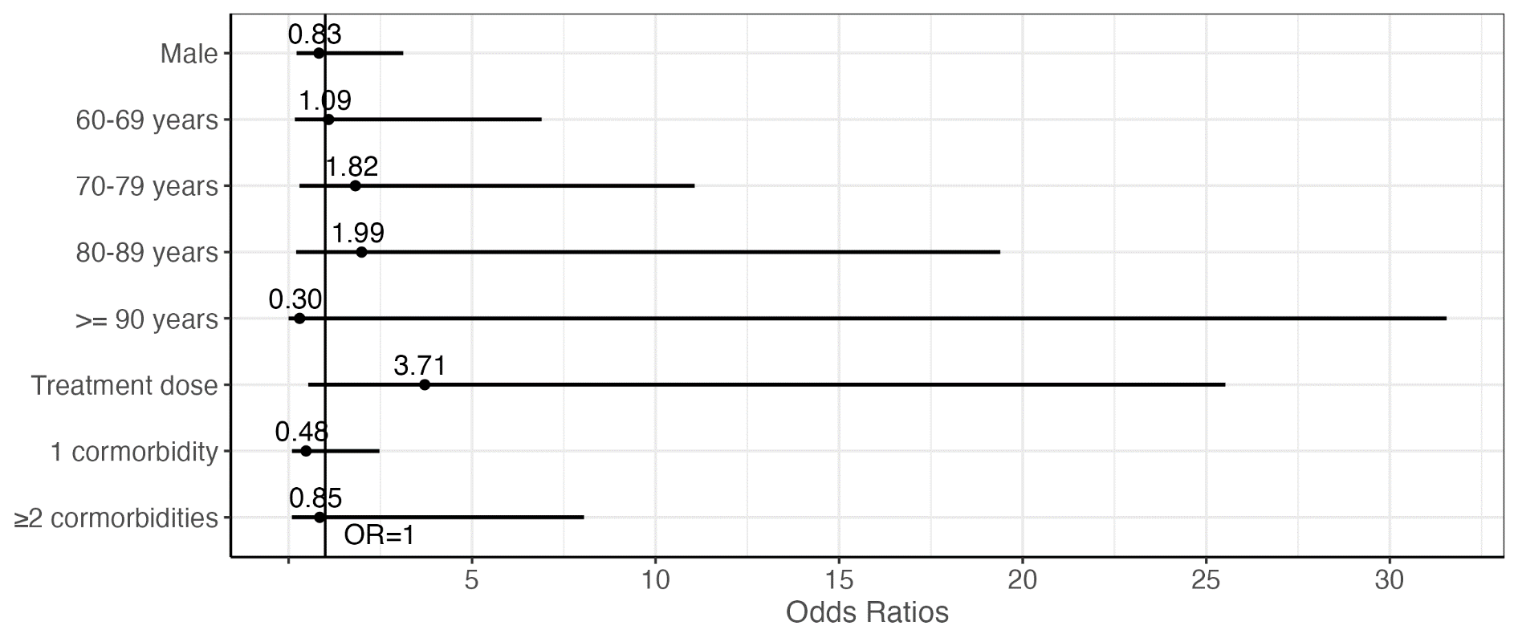

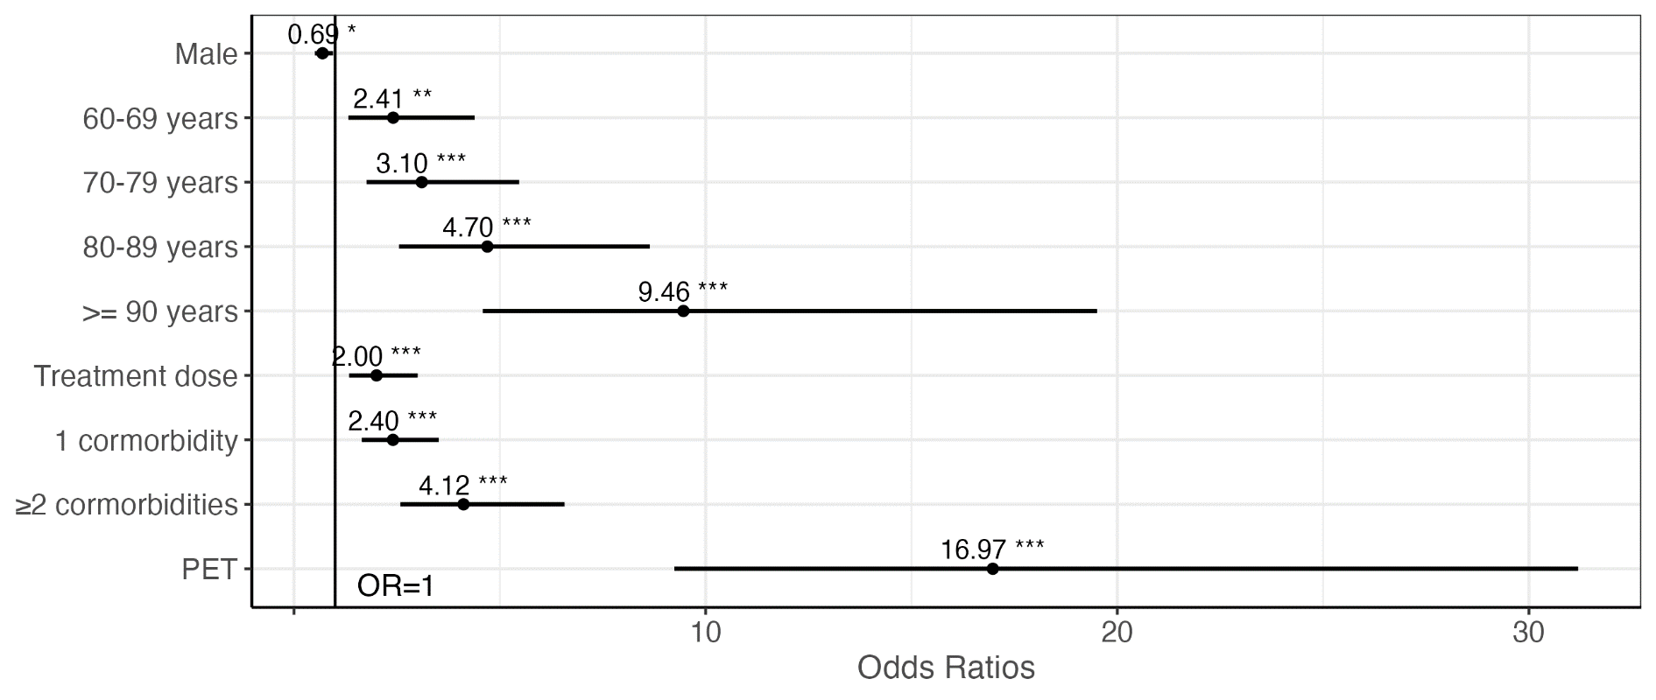

Abbrevations : DNI-DNACPR; do-not-intubate and do-not-attempt cardiopulmonary resuscitation; PET, patients potentially receiving excessive treatment
Coaching exposure (“treatment dose”) was included as a continuous variable in the model. * P<0.05, **P<0.01, ***P <0.001
6) sFigure 2a-b: Kaplan-Meier survival curves in PET and the overall study population

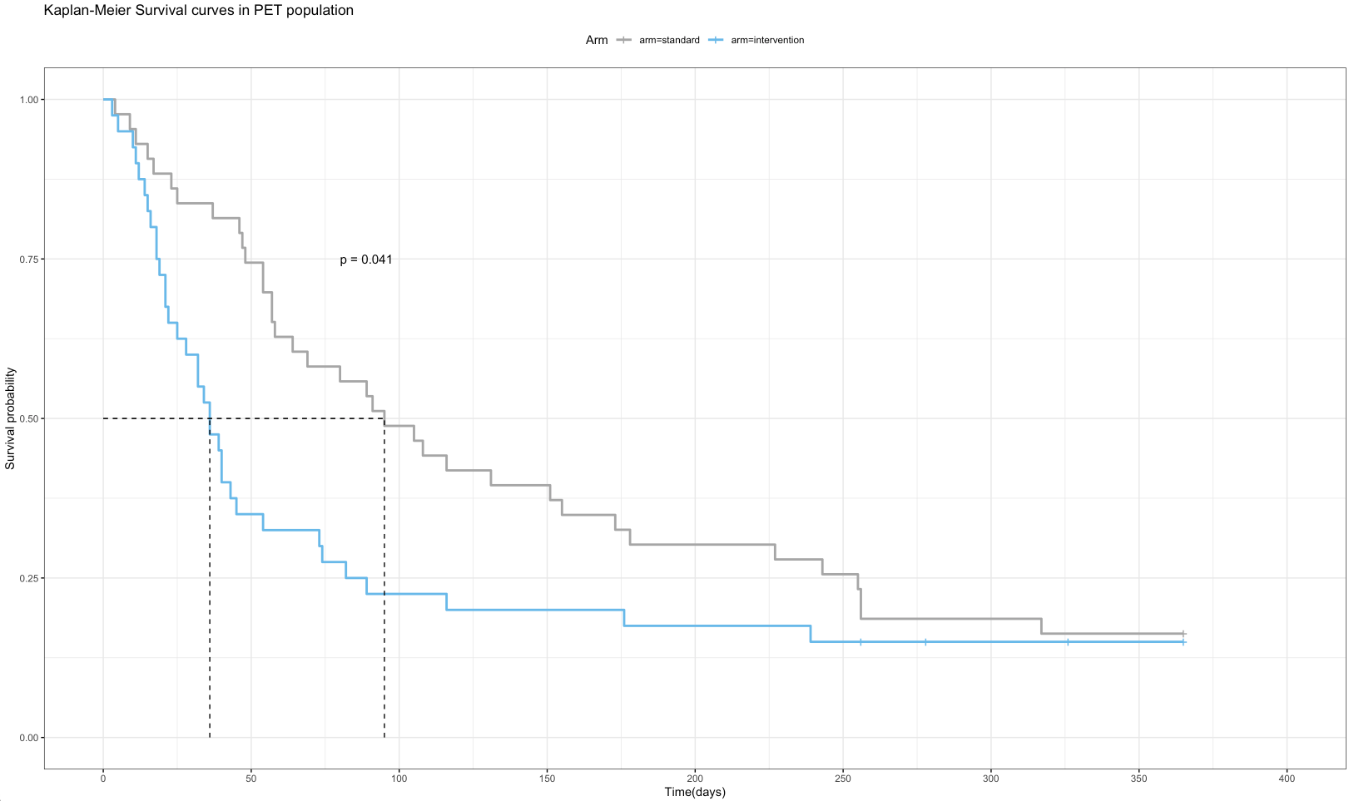

Abbrevation : PET, patients potentially receiving excessive treatment
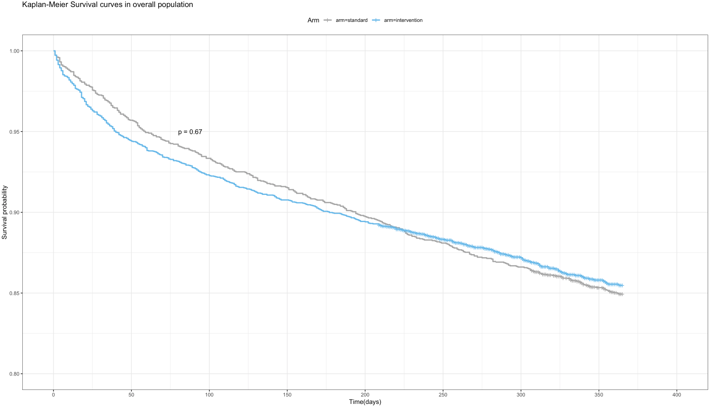

7) sTable 5. Differences in the 30-items EDMCQ pre and post intervention over all cliniciansª
EDMCQ question | Overall
EDMCQ question | N(pre) = 270 | N(post) = 261
F1-Selfreflective and empowering leadership by physicians
l4:Physicians in charge help team members settle their differences | 72 (26.67) | 78 (29.89)
l5:Physicians in charge trust the team members to exercise good judgement | 180 (66.67) | 177 (67.82)
l6:Physicians in charge permit the team members to use their own judgement in solving problems | 125 (46.3) | 147 (56.32)
l7:Physicians in charge encourage initiative in the team members | 126 (46.67) | 131 (50.19)
l8:Physicians in charge treat all team members as their equals | 114 (42.22) | 114 (43.68)
l9:Physicians in charge are well aware of their own emotions and attitudes | 88 (32.59) | 95 (36.4)
l10:Physicians in charge are well aware of their role model function | 132 (48.89) | 140 (53.64)
l11:Physicians in charge dare to show their vulnerability | 83 (30.74) | 85 (32.57)
F2-Practice and climate of open and interdisciplinary reflection
i1:There are regular opportunities for open informal dialogue between healthcare providers | 194 (71.85) | 203 (77.78)
i2:There is regular structured and formal dialogue between the various disciplines within the team to discuss patient care | 200 (74.07) | 217 (83.14)
i3:We regularly reflect on the quality of care provided from the various points of view of the staff | 128 (47.41) | 156 (59.77)
i4:The teams are well coordinated/managed | 144 (53.33) | 160 (61.3)
i5:There is an open and constructive culture in the department such that criticism can be easily expressed | 126 (46.67) | 121 (46.36)
i6:Discussions about patients lead to greater understanding and agreements | 145 (53.7) | 160 (61.3)
i10:The culture in my department makes it easy to learn from the errors of others | 152 (56.3) | 156 (59.77)
e4:There is a structured, formal debriefing after difficult patient care situation | 115 (42.59) | 133 (50.96)
F3-Climate of not avoiding EOL decisions
e8:Death is not perceived as a treatment failure, so decisions to withdraw or withhold therapy are seldom postponed | 198 (73.33) | 192 (73.56)
e9:EOL decisions are not frequently postponed | 120 (44.44) | 127 (48.66)
F4-Climate of mutual respect within the interdisciplinary team
i7:I am always regarded and addressed by everyone in the team as a full-fledged team member | 219 (81.11) | 206 (78.93)
i8:Team members from another discipline respect my work | 200 (74.07) | 192 (73.56)
i9:I have confidence in the professional competence of my team members | 223 (82.59) | 222 (85.06)
F5-Active involvement of nurses in EOL care and decision-making
e5:Nurses are present during the communication of end-of-life information to the family | 170 (62.96) | 191 (73.18)
e6:Nurses are involved in end-of-life decision-making | 177 (65.56) | 195 (74.71)
e7:Nurses and physicians collaborate well with one another during end-of-life situations | 184 (68.15) | 199 (76.25)
F6-Active decision-making by physicians
l1:Physicians in charge make accurate and timely decisions | 122 (45.19) | 121 (46.36)
l2:Physicians in charge take full charge when emergencies arise | 143 (52.96) | 140 (53.64)
l3:Physicians in charge are not hesitant about taking initiative in the group | 151 (55.93) | 141 (54.02)
F7-Practice and climate of ethical awareness
e1:My colleagues understand my thoughts/feelings about difficult end-of-life decisions | 264 (97.78) | 258 (98.85)
e2:Different opinions and values concerning end of life are tolerated | 240 (88.89) | 250 (95.79)
e3:We talk about moral problems | 227 (84.07) | 244 (93.49)

ªNumber (percentage) of clinicians who answered with “totally agree” or “agree” to the different EDMCQ items within the 7 EDMCQ factors.

8) sTable 6. Subanalysis of primary endpoint in patients potentially receiving excessive care (PET) and overall study population : incidence of written DNI-DNACPR decision

 | Intervention |  | Control
Department | Total (N) | Observed DNI-DNACPR (N (%)) | Total (N) | Observed DNI-DNACPR  (N (%))
PET population
Department 1 | 2 | 1 (50.0 %) | 0 | 0 (0.0%)
Department 2 | 5 | 1 (20.0 %) | 1 | 0 (0.0%)
Department 3 | 3 | 1 (33.3 %) | 1 | 0 (0.0%)0
Department 4 | 5 | 5 (100 %) | 3 | 2 (66.7 %)
Department 5 | 12 | 1 (8.3 %) | 9 | 1 (11.1 %)
Department 6 | 3 | 0 (0.0%) | 3 | 0 (0.0%)
Department 7 | 5 | 3 (60.0 %) | 7 | 0 (0.0%)
Department 8 | 2 | 2 (100 %) | 4 | 0 (0.0%)
Department 9 | 0 | 0 | 6 | 2 (33.3 %)
Department 10 | 0 | 0 | 12 | 4 ( 33.3 %)
Overall | 37 | 11 (29.7 %) | 46 | 9 (19.6 %)
Overall population
Department 1 | 467 | 4 (0.9 %) | 42 | 1 (2.4 %)
Department 2 | 272 | 15 (5.5 %) | 43 | 1 (2.3 %)
Department 3 | 835 | 19 (2.3 %) | 88 | 0 (0.0%)
Department 4 | 474 | 67 (14.1 %) | 130 | 17 (13.1 %)
Department 5 | 336 | 6 (1.8 %) | 135 | 1 (0.7%)
Department 6 | 347 | 7 (2.0 %) | 311 | 7 (2.2%)
Department 7 | 628 | 12 (1.9 %) | 559 | 8 (1.4%)
Department 8 | 453 | 2 (0.4 %) | 640 | 2 (0.3%)
Department 9 | 118 | 1 (0.8 %) | 365 | 7 (1.9%)
Department 10 | 82 | 3 (3.7 %) | 289 | 6 (2.1 %)
Overall | 4012 | 136 (3.4 %) | 2602 | 50 (1.9%)

9) sFigure 3. EDMCQ radar charts : variability across all participating departments

