A randomised, double-blind, single-centre, placebo-controlled trial of low-dose clonidine infusion to improve sleep in postoperative patients in the High Dependency Unit

Clonidine at Low dosage postOperatively to Nocturnally Enhance Sleep (CLONES)

Clinical Trial Protocol Version 4 – 09OCT2019

HREC/2018/QPCH/44026

EXECUTIVE SUMMARY
Objective. To determine whether low-dose clonidine infusion administered to elective surgical patients following surgery could safely (1) improve the quality and quantity of sleep,
(2) reduce the incidence of postoperative delirium, and (3) if so, provide evidence and pilot data to justify conducting a multi-centre RCT in the future.
Background. Postoperative delirium affects up to 50% of surgical patients, and is costly, under-diagnosed, and associated with prolonged hospital stays, long-term cognitive decline, and increased mortality. The causes are multifactorial, including physiological stress of surgery, pain, medications (especially opioids), and poor sleep. Treatments for some causes – such as benzodiazepines to improve sleep – are themselves independent risk factors.
Dexmedetomidine is a relatively new alpha2-adrenoreceptor agonist commonly used as an ICU sedative with sympatholytic and analgesic effects, but without the respiratory depression associated with traditional sedatives such as propofol and midazolam. In addition to being less deliriogenic than propofol and benzodiazepines, dexmedetomidine has recently been shown in ICU settings (in part by our team) to be effective at treating and preventing POD, as well as improving both the duration and quality (deeper phases) of sleep.
Rationale. Dexmedetomidine is expensive and requires monitored critical care– making it impractical for routine use. Clonidine, the prototypical alpha2-agonist used to treat hypertension, provides an economical alternative, with substantially longer duration of effect, oral and transdermal formulations, and demonstrated safety in ward environments.
Design. Double-blinded, single-centre, phase II randomised, controlled trial of low- dose clonidine infusion vs. saline placebo administered on the evening of elective surgery.
Population. 120 adult patients admitted to the RBWH Elective Surgical High Dependency Unit (ESHDU) following surgery. This sample size will allow differences of
≥30 mins in total sleep time to be detected with a power of 0.90. Selection criteria includes capacity to provide written consent and excludes use of clonidine ≥1 µg kg⁻¹ intraoperatively or in recovery, pre-operative use of an alpha2-agonist, and comorbidities likely to interfere with outcome measurement (sleep disorders, dementia, etc).
Treatment. IV infusion of either clonidine at 0.3 µg kg-1 hr-1 (up to a maximum dosing weight of 100 kg), or 0.9% NaCl placebo at the same volume rate, from 20:00 on the evening of surgery and ceased at 06:00 the following morning. Allocation will be via simple stratified randomisation with two variables – (1) use of clonidine intraoperatively or in recovery up to 1 µg kg-1 (yes; no), and (2) expected frequent awakenings (e.g. known/suspected Obstructive Sleep Apnoea, or one or two-hourly neurological or neurovascular monitoring) (yes; no).
Outcomes. Primary outcome will be total sleep duration measured using a wrist-worn FitBit Alta HR activity tracker (combined actigraphy and photoplethysmography) – an approach validated against polysomnography. Secondary outcomes will include sleep phase statistics, subjective sleep quality (Richards-Campbell Sleep Questionnaire), and incidence of delirium (Confusion Assessment Method – Intensive Care Unit). Safety will be measured by incidences of and rationale for treating doctors prematurely ceasing study medication.
Significance. Postoperative delirium is associated with significant morbidity and mortality. Dexmedetomidine shows substantial promise as a chemo-prophylactic agent for delirium, but is impractical for routine use. If this trial shows that clonidine is equally safe and effective as dexmedetomidine, and that the protocol is feasible, we would use the data to support a funding application for an NHMRC Project Grant to support a definitive multi- centre, phase III RCT.

GLOSSARY

Term | Description
APACHE | Acute Physiology And Chronic Health Evaluation
CAM-ICU | Confusion Assessment Method – Intensive Care Unit
CRF | Case Report Form
CLONES | Clonidine at Low dosage postOperatively to Nocturnally Enhance  Sleep
eCRF | Electronic Case Report Form
ESHDU | Elective Surgical High Dependency Unit
HREC | Human Research Ethics Committee
ICU | Intensive Care Unit
OSA | Obstructive Sleep Apnoea
PCA | Patient Controlled Analgesia
PCEA | Patient Controlled Epidural Analgesia
RASS | Richmond Agitation-Sedation Scale
RBWH | Royal Brisbane & Women’s Hospital
RCSQ | Richards-Campbell Sleep Questionnaire
RGO | Research Governance Officer
SAE | Serious Adverse Event
SUSAR | Suspected Unexpected Serious Adverse Reaction
TGA | Therapeutic Goods Administration
TPCH | The Prince Charles Hospital
UQ | University of Queensland

GENERAL INFORMATION
This protocol has been developed to comply with the guidelines contained in the Australian Clinical Trial Handbook, published by the Australian Government.
Title
A randomised, double-blind, single-centre, placebo-controlled trial of low-dose clonidine infusion to enhance sleep in post-operative patients in the High Dependency Unit
Short title:
Clonidine at Low dosage postOperatively to Nocturnally Enhance Sleep (CLONES)
Chief investigator

Name: | Dr David Liu
Title: | Principal House Officer – Intensive Care Services Royal Brisbane & Women’s Hospital  Honorary Fellow – UQCCR & School of ITEE The University of Queensland
Address: | Level 8  UQ Centre for Clinical Research Building 71/918  Royal Brisbane and Women's Hospital Herston QLD 4029
Telephone: | XXXX XXX XXX
Email: | XXXX@uq.edu.aud.liu3@uq.edu.au

Coordinating and data management centre

Name: | Department of Intensive Care Services Royal Brisbane & Women’s Hospital
Address: | Level 4  Dr James Mayne Building  Royal Brisbane and Women’s Hospital Cnr Butterfield St and Bowen Bridge Rd Herston QLD 4029

Management Committee
    - Members

Name | Role | Position | Institution
Dr David Liu | Chief Investigator | Registrar – Intensive Care Services, Honorary Fellow | RBWH, UQ
Prof Michael Reade | Principal Investigator | Consultant – Intensive Care Services, Australian Defence Force (ADF) Chair of Military Medicine and Surgery | RBWH, UQ

Dr Jason Pincus | Investigator | Consultant – Anaesthesia & Perioperative Medicine and Intensive Care Services | RBWH
Dr Elizabeth Hallt | Investigator | Junior House Officer – Centre for Medical Officer Recruitment & Education | RBWH
Dr Alanna Platz | Associate Investigator | Principal House Officer – Intensive Care Services | RBWH
Ms Melissa Lassig- Smith | Research Coordinator | Research Coordinator – Intensive Care Services | RBWH
Ms Christine Woods | Research Coordinator | Nurse Manager – Centre for Excellence and Innovation In Anaesthesia | RBWH
Ms Kymberley Herbst | Research Coordinator | Acting Nurse Unit Manager – Pre- admission Clinic | RBWH
Mr Alain Humblet | Research Coordinator | Medical Student (Year II) | UQ
    - Responsibilities
Overseeing all aspects of the study including:
      - Design, production and approval of final protocol and case report form
      - Design, production and approval of patient information and consent form
      - Database design and management
      - Management of study budget and liaison with funding bodies
      - Preparation and arrangement of contracts
      - Management of regulatory affairs (TGA, CTN, etc, plus compliance, as far as this is possible, with the requirements of the US Food and Drug Administration and other foreign regulatory bodies)
      - Co-ordination and assistance with HREC applications
      - Study initiation
      - Legal accountability and indemnity authorisation
      - Budgetary oversight
      - Oversight of all aspects of project management and data analysis
      - Protocol training of Research Coordinators
      - Organisation of investigator meetings
      - Data collection and data entry/transfer
      - Monitoring and assessment of adverse events
      - Liaison with Data and Safety Monitoring committee
      - Preparation of presentations and publications
      - Media liaison

Data Safety and Monitoring Committee
    - Members

Name | Position | Position | Institution
Dr Jayesh Dhanani | Chair | Consultant – Intensive Care Services | RBWH
Dr Victoria Eley | Member | Consultant – Anaesthesia and Perioperative Medicine | RBWH
    - Responsibilities
      - Determination of study stopping rules
      - Review of summary data of serious adverse events
      - Liaison with study Management Committee Participating centres
    - Sites
This study will be conducted at a single centre: Royal Brisbane & Women’s Hospital (SSA/2019/QRBW/44026), a 921 acute-bed tertiary referral hospital. The Principal Investigator at this site is Professor Michael Reade.
    - Responsibilities
      - Overall management of study in line with the study protocol
      - Study nurse recruitment and orientation
      - Patient recruitment
      - Protocol education of colleagues and attending clinicians
      - Data query resolutions
      - Adherence to local HREC guidelines and reporting guidelines
      - Adverse event reporting to HREC in line with study protocol.

BACKGROUND INFORMATION
Background
    - Postoperative delirium
Delirium is a form of acute brain dysfunction characterized by a sudden onset of altered and fluctuating level of consciousness, inattention, and disorganized thinking.[1] It is the most common surgical complication in elderly patients, with a prevalence of up to 50% of postoperative patients,[2] is costly to treat, often under-diagnosed, and has serious consequences.[3] Development of delirium is associated with prolonged hospital stays, long-term cognitive decline, increased risk of other major complications, and increased mortality.[4, 5]
Delirium is commonly diagnosed in, and associated with, its hyperactive form where there is a hyperactive level of psychomotor activity accompanied by mood lability, agitation, and/or refusal to cooperate with medical care.[1] However, the hypoactive form, with a hypoactive level of psychomotor activity that is accompanied by sluggishness and lethargy approaching stupor, occurs more frequently in postoperative delirium and is associated with worse prognosis.[6] The mixed form of delirium involves fluctuation between the hyperactive and hypoactive forms.
A commonly used method for diagnosing delirium in intensive care is the Confusion Assessment Method for the Intensive Care Unit (CAM-ICU) scale.[7] It defines delirium by the presence of acute onset fluctuations in mental status, disturbance in attention, plus either an altered level of consciousness, or the presence of disorganized thinking.
    - Reducing the incidence of postoperative delirium
Given the high prevalence and substantial burden of disease associated with postoperative delirium, preventing and treating postoperative delirium was recently identified as a “top 10” research priority for perioperative intensive care medicine research.[8]
The causes of delirium are multifactorial, but major risk factors for the development of postoperative delirium include presence of cognitive and behavioural disorders (e.g. dementia, pain, sleep deprivation), disease- or illness- related conditions (comorbidities), metabolic conditions (malnutrition, dehydration, electrolyte disturbances), functional impairments (e.g. poor functional status, immobilization), elderly age, polypharmacy, psychotropic medication use, urinary retention or catheter use, and constipation.[9]
Strategies to prevent the development of postoperative delirium include addressing modifiable risk factors by avoiding the use of delirium-causing medications, minimizing systemic opioid administration, and prolonged critical care admissions.[10] Some of these strategies may be conflicting; for example, the use of systemic opioid medications to relieve pain and benzodiazepine medications to improve sleep (and therefore reduce delirium) may actually increase the risk of delirium.
    - Pharmacological prophylaxis for postoperative delirium
The evidence for the effective prevention of postoperative delirium using pharmacological agents is limited.[11] A wide range of agents have previously been investigated for postoperative delirium prophylaxis, including antipsychotics, statins, melatonin, dexamethasone, gabapentin, diazepam, and dexmedetomidine. These findings are often limited by study design and methodological issues such as small study populations and non-blinded randomized controlled trials.
The pharmacological agents with greatest evidence in support for their use as prophylactic agents for postoperative delirium are haloperidol and dexmedetomidine.
Low-dose intravenous haloperidol at 0.1 mg h⁻¹ for 12 h following non-cardiac surgery in elderly intensive care patients has been demonstrated as an effective agent for preventing postoperative delirium compared to placebo, with an absolute risk reduction of 7.9% (RR 0.659) for the incidence of delirium in the first seven days after surgery.[12]
Dexmedetomidine has been shown to be effective at reducing delirium compared to propofol-based sedation, and as a prophylactic agent against delirium. In a trial of 183 elderly patients post cardiac surgery, sedation using dexmedetomidine (0.4 mcg kg⁻¹ loading dose followed by 0.2-0.7 mcg kg⁻¹ h⁻¹ infusion) substantially reduced the

incidence of delirium (OR 0.46, 95% CI 0.23-0.92, p=0.028) compared to propofol (25- 50 mcg kg⁻¹ min⁻¹).[13]
More recently, a study of low-dose infusion of dexmedetomidine (0.1 µg kg⁻¹ h⁻¹, no loading dose and untitrated) by Su, et al. in 700 elderly intensive care patients following non-cardiac surgery until 0800 h the next morning found a substantially lower incidence of delirium with an absolute risk reduction of 14% (OR 0.35) compared to saline placebo.[14]
However, when dexmedetomidine was administered intraoperatively and for two hours postoperatively at a dose of 0.5 µg kg⁻¹ h⁻¹, no reduction in the incidence of delirium was found compared to placebo.[15]
    - The emerging role of alpha2-agonists in preventing delirium
The aforementioned postoperative findings – that dexmedetomidine can reduce the incidence of delirium – are consistent with studies of its use as an ICU sedative. Dexmedetomidine-based sedation has been shown to more effective at preventing delirium compared to benzodiazepines.[16-18] When administered nocturnally at low doses (0.2 mcg kg⁻¹ hr⁻¹, titrated by 0.1 mcg kg⁻¹ hr⁻¹ to maintain RASS of -1 or maximum of dose of 0.7 mcg kg⁻¹ hr⁻¹), dexmedetomidine substantially reduced the incidence of delirium in ICU patients compared to placebo (RR 0.44, 95% CI 0.23-0.82, p=0.006).[19] Dexmedetomidine has also been shown to be effective at treating established delirium, both in mechanically ventilated patients with severe agitated delirium who were otherwise ready to be extubated,[20] and in non-intubated patients with agitated delirium refractory to haloperidol.[21]
As a selective, central α2-adrenoreceptor agonist, dexmedetomidine acts to reduce noradrenaline release from sympathetic nerve terminals.[22] This reduces neuronal signalling in the central nervous system, prominently in the locus coeruleus, causing both sedation and anxiolysis. Both central and spinal inhibition of noradrenergic transmission also reduces conduction and perception of pain impulses. Stimulation of α2 receptors also reduces cardiovascular sympathetic tone, causing bradycardia and hypotension. The 2A subtype of the α2 receptor is the major mediator of sedation and analgesia. Combining analgesic, hypnotic and possibly direct anti-delirium effects (as discussed above), α2- adrenoreceptor agonists are the only agents to address simultaneously each of the three components of the “ICU cognitive triad”: pain, delirium, and agitation.[23]
Dexmedetomidine has many desirable properties for use as a sedative agent compared to GABA-agonists such as minimal respiratory depression, greater rousability at similar levels of unstimulated hypnosis, and analgesia. Its prophylactic effects against postoperative delirium may potentially be due to, in addition to its sedative effects, facilitating physiological sleep and reducing the need for delirium-causing medications such as benzodiazepines, propofol, and systemic opioids.
    - Sleep deprivation contributing towards postoperative delirium
Poor sleep quality is extremely common in the ICU, characterized by reduced total sleep time with significant fragmentation of sleep, lack of deep sleep, and circadian rhythm disruption, and often results in sleep deprivation.[24-26]
An observational study of 57 adult patients in a tertiary Australian ICU using polysomnography showed that patients had a median total sleep time (TST) of 5:00 (hh:mm, IQR 02:52 to 07:14), with a median of 41% of sleep occurring during daytime hours.[25] The majority of sleep was spent in light sleep, dominated by stages N1 (median 19%) and N2 (median 73%). Slow-wave and REM sleep stages were scant with medians of 0% for both, respectively. Patients frequently woke from sleep at a median rate of 27 times per hour, and a median duration of sleep without waking of only 3 minutes. Patients subjectively rated their sleep quality as poor, with a mean Richards-Campbell Sleep Questionnaire score of 47 mm (on a 0-100 mm visual analogue scale, with 100 mm representing sleeping well) on the day of discharge from ICU.
Sleep deprivation shares many of the same clinical features and risk factors as hypoactive delirium, and is considered to be a contributing – possibly independent – risk factor for the development of delirium in ICU patients.[27]
Common causes of poor sleep in the ICU include pathophysiological factors, such as stress, organ dysfunction, inflammatory response, pain, and psychosis, and environmental factors, e.g. noise, lighting, patient care activities, diagnostic procedures, sedatives, and analgesics.[28] For example, after major intraabdominal surgery stage N3 and REM sleep appears to be suppressed on the night of surgery,[29, 30] but not during laparoscopic cholecystectomy.[31]
Addressing modifiable risk factors for poor sleep using non-pharmacological interventions have previously been shown to reduce the incidence of delirium in ICU patients, but can require substantial resources.[32] Pharmacological approaches to improve sleep quality, however, are appealing because of their ease of implementation.[33]
    - Measuring sleep quality in the ICU
The gold standard for objectively measuring sleep in ICU patients is polysomnography – but this is an intrusive, labour intensive, and costly, and is impractical for routinely measuring sleep in large numbers of patients.[34] Other methods for measuring sleep quality include bispectral index (BIS) monitoring, but this is also intrusive and prone to patient dislodgement.
Wrist actigraphy has been used as a less intrusive and less costly approach for measuring sleep in ICU patients.[34] It involves patients wearing a small device on their wrist or ankle that continuously monitors gross motor movements, which are then used to determine whether patients are asleep. However, actigraphy is unable to describe sleep architecture, i.e. time spent in each sleep stage. Actigraphy has not been validated in large-scale ICU studies, but trials are currently under way.[35]
A study of 7 short-stay post-cardiothoracic surgery ICU patients showed that actigraphy can detect sleep with high sensitivity (median 94%) but has poor specificity (median 19%).[36] That is, sleep can be reliably detected by lack of gross motor movements, but actigraphy is unable to reliably detect when patients are awake but not moving, such as when they receive sedation, are restrained, or administered neuromuscular blockers. Total sleep time is therefore overestimated compared to polysomnography.
Recent consumer sleep tracking devices, such as the FitBit Alta HR (FitBit Inc., San Francisco, CA, USA), however, combine wrist actigraphy with reflective

photoplethysmography to also measure heart rate for more precise sleep estimation. Using the two modalities, these devices can measure both the time spent in each sleep stage (wake, N1 and N2, N3, and REM) and sleep statistics (such as total sleep time, percentage of time in sleep phases, awakenings, etc.) with moderate-to-good reliability in healthy middle-aged volunteers when compared to polysomnography.[37]
Sleep quality can also be subjectively measured using questionnaires. At least 13 questionnaires have been published or used in ICU research,[38] but the Richards- Campbell Sleep Questionnaire (RCSQ) is the only scale to have been validated in an ICU patient population.[39] The RCSQ is a brief, five-item questionnaire using 100 mm visual analogue scales that asks patients to rate their perceived sleep depth, sleep latency, number of awakenings, sleep efficiency (percentage of time asleep), and sleep quality (see Appendix J, page 51). Validation of the RCSQ against polysomnography in 70 critically ill males showed good correlation with an internal consistency reliability score of 0.9,[39] but it is unclear whether bedside nurses’ assessment of sleep quality using the RCSQ is a reliable substitute for patient self-assessment.[40, 41]
    - Improving sleep quality with dexmedetomidine
In healthy adult volunteers, dexmedetomidine has been shown to induce sleep that with a similar architecture to normal physiological sleep.[42, 43] Recent findings with dexmedetomidine suggest that it can potentially improve sleep quality in postoperative ICU patients; a population associated with poor sleep quality.
In a pilot RCT of 76 elderly patients admitted to the ICU after non-cardiac surgery, Wu and colleagues compared low-dose dexmedetomidine infusion administered at 0.1 µg kg- 1 h-1 for 15 hours on the evening of surgery to saline placebo.[44] This is the same dose used to prevent delirium in another trial.[14]
Dexmedetomidine was associated with a larger quantity of sleep and improved sleep architecture in Wu, et al.’s polysomographic study on the first night after surgery. In the dexmedetomidine group, there was an absolute increase in percentage of stage N2 sleep time by 14.7% (95% CI 0.0-31.9%, p=0.019), increased total sleep time by 69 min (95%
CI 7-132 min, p=0.028), increased median sleep efficiency by 7.8% (95% CI 0.8-14.6%, p=0.033), reduction of percentage of stage N1 sleep by 15.0% (95% CI -34.2 to -0.3%, p=0.038), and increased median duration of stage N2 sleep by 41 min (95% CI 3-83 min, p=0.019). There were no statistically significant differences in duration of N1 sleep, duration of N3 sleep, duration of REM sleep, nor sleep fragmentation index.
Subjective sleep quality in the same study was measured on an 11-point Likert scale, with 0 indicating best possible sleep and 10 worst possible sleep. Dexmedetomidine infusion was associated with a sleep quality rating of 2 (IQR 1-4) compared to placebo group, 4 (IQR 2-8), p=0.004. However, on the second and third night following surgery (when polysomnography was not recorded) the differences in subjective sleep quality were not statistically significant.
These findings show that low-dose dexmedetomidine can improve the sleep architecture of postoperative ICU patients, but this effect did not appear to persist beyond the first night (after which the infusion was stopped).

    - Clonidine as an alternative to dexmedetomidine
Given the advantages and success of dexmedetomidine-based sedation, there has been a renewed interest in repurposing clonidine for sedation and as an analgesia adjunct in intensive care – especially in its oral formulation,[45] which may also have previously unknown antipyretic effects.[46] Trials of clonidine as a sedative agent in paediatric [47] and geriatric [48] populations are currently under way.
Clonidine (trade names include Catapres and Kapvay) is the prototypical α2- adrenoreceptor agonist with a long history of use, well-known, and safe for community use.[49] It was first synthesized in the 1960s as a nasal decongestant, before being approved in the USA in 1974 for the treatment of hypertension. Clonidine is marketed in enteral, intravenous, and transdermal (depending upon market) formulations.
Other α2-adrenoreceptor agonists exist – e.g. guanfacine, guanabenz, lofexidine, tizanidine, and xylazine (veterinary use) – but there is no information on their use in critically ill or postoperative patients. Guanfacine (trade names include Tenex® and Intuniv®) is currently available in an extended release enteral formulation for the treatment of attention-deficit/hyperactivity disorder (ADHD) in the USA, Europe, and Australia.
There have been no studies to date investigating whether clonidine would be an effective prophylactic agent against postoperative delirium, or whether it would improve sleep in ICU patients. Clonidine has numerous advantages over dexmedetomidine if it were found to be an effective at preventing postoperative delirium, including lower cost, oral and transdermal formulations, fewer cardiovascular side effects, and longer half-life.
Clonidine is substantially cheaper than dexmedetomidine, especially in its non- intravenous formulations. At RBWH, the nominal cost for an ampoule (200 µg / 2 mL) of intravenous dexmedetomidine in 2017 was $52.00, compared to $5.70 for an ampoule (150 µg / 1 mL) of intravenous clonidine. Oral formulations are even cheaper; with a 150 µg tablet of clonidine costing only $0.39 each under the Pharmaceutical Benefits Scheme.
Dexmedetomidine is only available in intravenous formulation, therefore administering it to postoperative patients is invasive (requiring intravenous access), requires additional equipment (infusion pump), and is more labour intensive for nursing staff (setting up and removing the infusion). Clonidine, on the other hand, is available in oral formulation and therefore requires minimal cost and labour to administer. Transdermal clonidine (not currently available in Australia) would allow continuous low-dose administration of clonidine.
Given dexmedetomidine’s potential cardiovascular side effects (profound bradycardia and hypotension requiring treatment), it can only be given in monitored, critical-care environments. Therefore, this prevents its use outside of ICU and HDU for postoperative patients, e.g. on surgical wards. In contrast, clonidine (in oral and transdermal formulations) can be safely self-administered by patients in the community, and would therefore potentially be feasible for administration in surgical wards.
Finally, dexmedetomidine’s short elimination half-life of two hours allows for easy titration when used as a sedative,[22] but if it is used for low-dose prophylaxis then ability to titrate dosing is a less useful characteristic. Although the protective effects against delirium found for dexmedetomidine appeared to last for up to one week,[14] subjective

sleep quality improvements did not persist beyond the first night.[44] Clonidine’s substantially longer elimination half-life of 12-16 hours means that any protective effects against postoperative delirium or improvement in sleep – if they exist – may potentially last longer than for dexmedetomidine.
    - Clonidine dosing for postoperative delirium prophylaxis
As there have been no prior studies of clonidine use as a postoperative delirium prophylaxis agent, the optimal dosing level is unclear. Large loading doses are associated with haemodynamic side effects (hypotension, bradycardia). High maintenance infusion rates are associated with sedation (less desirable when used as a prophylaxis agent), haemodynamic side effects, and accumulation due to the relatively long (12-16 hour) elimination half-life.
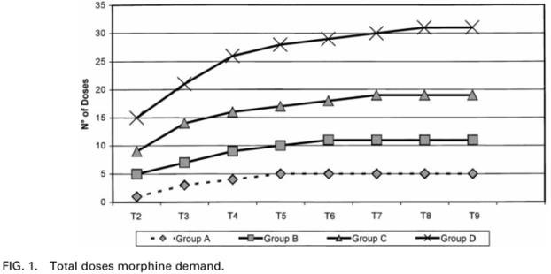
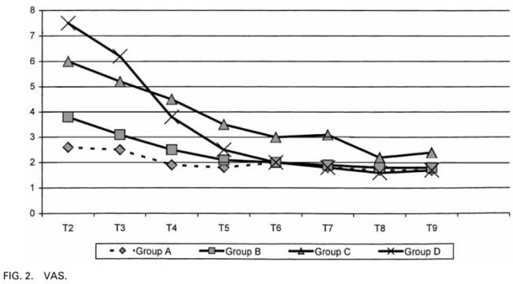
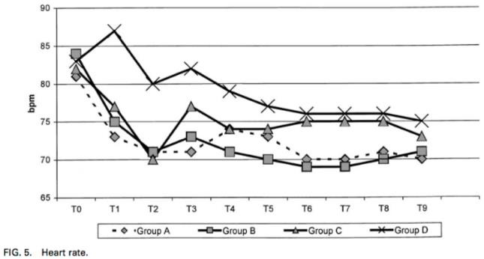
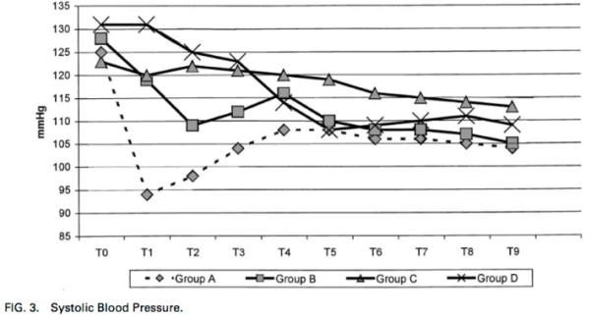
Marinangeli, et al. conducted a double-blind, randomized dose-finding study in 80 patients undergoing lumbar hemilaminectomy.[50] This study shows the greatest similarities to the sub-sedative postoperative administration of dexmedetomidine in the Su, et al. study.[14] Subjects were assigned to one of four treatment groups (N=20 per group); three groups received an intravenous loading dose of clonidine 30 minutes prior to the end of surgery (either 5, 3, or 2 µg kg⁻¹ for groups A, B, and C, respectively), followed by infusion at 0.3 µg kg-1 h-1 for 12 hours. The remaining group (D) received saline placebo bolus and infusion. The following figures from the study show the analgesia-sparing effects of postoperative clonidine, with a dose-dependent reduction of PCA requests and VAS pain scores, and haemodynamic effects associated with larger loading doses but otherwise stable maintenance infusion haemodynamics. Time points T2-T9 refer to 1, 2, 3, 4, 5, 6, 9, 12 hours post-operatively, respectively.

The above figures from the Marinangeli, et al. study show that the intravenous loading doses of clonidine peri/postoperatively are associated with small reductions in heart rate and blood pressure. No loading dose of dexmedetomidine was administered in the Su, et al. study, and unfortunately there was no “clonidine infusion only” group in the Mariangeli, et al. study for direct comparison.
The current Australian Medicines Handbook guidelines for clonidine as an anaesthesia adjunct recommends an intravenous loading dose of 1.5-5.0 µg kg⁻¹ (maximum 600 µg) followed by infusion at 0.3 µg kg⁻¹ h⁻¹.[51]
This recommendation appears to be based on the Bernard, et al. study of the effects of clonidine vs. placebo on haemodynamic and adrenergic responses during anaesthesia recovery.[52] A loading dose of oral clonidine at 3.5 µg kg⁻¹ clonidine was administered pre-operatively, followed by postoperative infusion at 0.3 µg kg⁻¹ h⁻¹. The loading dose was associated with a mean reduction in blood pressure by 15 mm Hg and heart rate by 20 bpm. After the loading dose and six hours of maintenance infusion, the mean reduction in blood pressure and heart rate was 13 mm Hg and 22 bpm, respectively.
Srivastava et al. compared intravenous clonidine with intravenous dexmedetomidine (N=35 in each group) for short-term sedation in ICU patients (mostly postoperative surgical), with doses titrated to target Ramsay Sedation Scale scores of 3 (awake; responsive to commands only) or 4 (asleep; brisk response to light glabellar tap or loud auditory stimulus), but limited by haemodynamic side effects.[53] Median infusion doses were 0.4 µg kg⁻¹ h⁻¹ for dexmedetomidine, and 1.4 µg kg⁻¹ h⁻¹ for clonidine, for similar levels of sedation. Assuming a linear conversion, scaling the 0.4 µg kg⁻¹ h⁻¹ dexmedetomidine dose down to 0.1 µg kg⁻¹ h⁻¹ used in the Su, et al. study[14] would result in an equivalent infusion rate of 0.35 µg kg⁻¹ h⁻¹ for clonidine. This is similar to the
0.3 µg kg⁻¹ h⁻¹ maintenance rate used in the Marinangeli, et al. study and also recommended by the Australian Medicines Handbook guidelines. Loading doses of intravenous clonidine reported in the literature were administered at doses of 1 µg kg⁻¹ or higher and associated with immediate dose-dependent side effects of bradycardia and hypotension, but did not require treatment at lower doses.[50, 53-56]
Transdermal clonidine, Catapres-TTS®, marked as a 7-day antihypertensive patch in New Zealand and the USA (but not Australia), provides continuous delivery of clonidine at a rate of 100, 200, or 300 µg day⁻¹.[57] This formulation of clonidine is most similar to the low dose, sub-sedative infusion rate of dexmedetomidine in the Su, et al. study,[14] in contrast to clonidine studies where loading boluses were administered intravenously, or oral dosing. For an average 90 kg adult (see RBWH HDU audit data, below), clonidine patches would hypothetically provide an equivalent infusion rate of 0.05, 0.09, or 0.14 µg kg⁻¹ h⁻¹. According to the Catapress-TTS® prescribing information, therapeutic effects (i.e. antihypertensive) are not expected to begin until 2-3 days after initial patch application.
Therefore, administration of a low dose clonidine infusion at a rate of 0.3 µg kg⁻¹ h⁻¹ (without a loading bolus) on the night of elective surgery would not be expected to be associated with anti-hypertensive or other noticeable side effects.

    - RBWH ESHDU audit data
The Royal Brisbane & Women’s Hospital Elective Surgical High Dependency Unit (ESHDU) is an intermediate care unit [58] for postoperative elective surgical patients requiring a higher level of care than surgical wards, but not requiring intensive care admission. The key differences between the ESHDU and ICU are that the ESHDU admits postoperative elective surgical patients only, is staffed primarily by surgical nurses and one ICU nurse, includes haemodynamic monitoring and respiratory support (e.g. CPAP), but excludes patients with respiratory instability.
An unpublished audit of RBWH ESHDU admissions between March 2015 and February 2017 (inclusive) showed an average of 66.2 ESHDU admissions per month (range 31- 94). Patients were admitted to the ESHDU on average at 16:48 on the day of surgery, and discharged 12:51 on the following day.
The average weight of ESHDU patients was 89.8 kg. The proportion of patients aged under 55 years, between 55 and 64 years, and over 65 years, was 37%, 20%, and 43%, respectively.
Patient Controlled Analgesia (PCA) devices were in situ at the time of admission for 23% of HDU patients. Only 1% of patients were prescribed clonidine at the time of HDU admission, and no HDU patients were prescribed dexmedetomidine.
While in ESHDU, 6% of patients (4.0 month-1) were prescribed an antipsychotic, and 8% of patients (5.5 month-1) were prescribed a benzodiazepine.
The distribution of surgical specialties and discharge destinations for ESHDU patients is shown below:

Surgical specialty | Patients |  | Destination | Patients
Neurosurgery | 18.1% |  | 8AS | 21.2%
General | 17.2% |  | 7BW | 16.3%
Vascular | 11.9% |  | 9AS | 12.8%
ENT | 8.5% |  | 7AN | 8.9%
Orthopaedic | 6.5% |  | 8AN | 8.0%
Urology | 3.7% |  | 9AN | 7.6%
Plastic | 2.1% |  | 7BS | 4.7%
Not specified | 22.7% |  | 6AN | 4.3%
 |  |  | Home | 10.2%

An audit of pre-admission clinics held in the three-month period between 1st February 2018 until 1st May 2018 showed that 202 patients were booked for ESHDU at the clinic. Of these 202 patients, 120 (59%) were subsequently admitted to either ESHDU or ICU by June 2018. Since ICU research coordinators are only available on weekdays until 18:00, the subset of patients who were admitted to and discharged from ESHDU during business hours was determined from the audit data. A total of 59 patients (29% of ESHDU bookings) were admitted prior to 18:00 between Monday and Thursday, inclusive. A further 24 patients (total of 83 patients, 41%) were admitted in the next two hours, 18:00 and 20:00, between Monday and Thursday.

Trial rationale
Postoperative delirium (POD) is a common complication in surgical ICU patients, and it is associated with substantial morbidity and mortality. Sleep quality is notoriously poor in this population, and this is considered to be an independent risk factor for delirium. Medications such as opioids to manage postoperative pain and benzodiazepines to aid sleep are associated with increased risk of delirium.
Recent findings reported by Su, et al. and Wu, et al. – that low-dose dexmedetomidine infusion on the first night following surgery can reduce the incidence of delirium,[14] as well as improve the quantity and quality of sleep,[44] – show the promising potential of dexmedetomidine as an agent for postoperative delirium prophylaxis and improving sleep.
The cost of dexmedetomidine, however, is substantial – especially if it were to be administered routinely in postoperative patients. Furthermore, due to its cardiovascular side effects dexemedetomidine can only be administered in critical care environments – limiting its use to ICU and HDU settings.
If similar benefits of reduced delirium and improved sleep were found for clonidine, this would result in improved care with substantial cost savings compared to dexmedetomidine. With clonidine’s substantially longer half-life, the improvement in sleep quality may potentially persist longer than for one night as with dexmedetomidine.
Intravenous clonidine is being studied in this trial to determine whether the effects of improved sleep and reduced incidence of delirium reported in the Wu, et al.[44] and Su, et al.[14] studies with intravenous dexmedetomidine also exist with clonidine administered in the same manner. Furthermore, if any adverse effects were to occur or be suspected with clonidine, as an infusion it can be ceased immediately.
If this study were to find similar results with clonidine, and that it is safe to be administered as a postoperative infusion, then its oral or transdermal formulations can be investigated in the future. Postoperative clonidine could potentially be administered with minimal resources outside of ICU and HDU settings, such as in general surgical wards – much like how venous thromboembolism prophylaxis is routinely administered to patients postoperatively.

TRIAL AIM & HYPOTHESIS
Trial objectives
The aim of the clinical research program that includes this study is to reduce delirium in post-operative patients using α2-agonists as chemoprophylaxis agents. Dexmedetomidine has been shown to be effective at preventing delirium in postoperative ICU patients, but it is not known whether the same effects would be found with clonidine, as a less selective α2-agonist than dexmedetomidine. There have been no large, multicentre, phase III trials of α2-agonists for postoperative delirium prophylaxis, therefore it is also not known whether this would be feasible.
The primary measure of sleep quality will be Total Sleep Time (hours). Principal secondary measures relate to sleep, delirium, and fever.

Trial aims
The specific aims of this trial are to:
- Determine whether a fixed, low-dose intravenous infusion of clonidine improves sleep in elective post-operative ESHDU patients.
- Demonstrate the safety of low-dose IV clonidine infusions in ESHDU patients.
- Provide preliminary data and sample size estimates for delirium outcomes.
- Test the feasibility of the research protocol for a future phase III, multi-centre RCT that is adequately powered to show differences in delirium outcomes.
Hypotheses
  - Total sleep time will be statistically significantly higher in the clonidine group by at least 30 mins compared to the control group.
  - There will be a non-statistically significant trend of reduced incidence of delirium in the clonidine group, which would justify confirmation in a multicentre RCT.
Trial feasibility
    - Ethical imperative and clinical equipoise
Postoperative delirium is a common surgical complication that is associated with substantial morbidity and mortality. Interventions that reduce delirium could therefore benefit a large patient population. Furthermore, as the ESHDU is an intermediate care unit with patients who are not critically ill, if this study demonstrates improved sleep and/or reduced delirium with clonidine infusion there would be evidence in support for testing postoperative clonidine in less acute settings such as surgical wards.
There is clinical equipoise for randomizing subjects to clonidine or saline placebo. Medications such as benzodiazepines are frequently prescribed to postoperative patients in hospital to facilitate sleep, but many of them are known to be deliriogenic and the sleep they produce is non-physiologic. Evidence is emerging that α2-agonists such as dexmedetomidine can reduce delirium and improve sleep in the ICU, but there have been no formal trials of clonidine for this indication. Clonidine is a safe medication with 30 years of use as an anti-hypertensive agent. However, there are no published high quality (i.e. multicentre, phase III studies) validating the use of any pharmacological agents to prevent delirium in postoperative patients at this time. Non-pharmacological approaches to reducing the incidence of delirium have been demonstrated in the literature, and this study protocol would not prevent their use.
    - Investigator track record
The Chief and Principal Investigators (DL and MR) have established research track records. MR (site Principal Investigator) has extensive research experience in delirium and sedation in the ICU, including conducting an RCT of dexmedetomidine to treat established delirium.[20]
Representatives from stakeholder departments are involved in this study as investigators and research coordinators on the management committee, including pre-admission clinic (KH), anaesthesia and perioperative medicine (JP, LD), and intensive care services (DL, MR, JP, AL).

This study includes research training for a medical intern (EH) and medical student (AH), supervised by the Chief Investigator (DL).
Trial compliance
The management committee take responsibility for this trial and will ensure that it will be conducted in accordance with the protocol and international standards of Good Clinical Practice in the Australian context.

TRIAL DESIGN
Type/design of the trial
CLONES will be a single centre, prospective, randomised, placebo-controlled, double- blinded Phase II effectiveness study comparing clonidine and placebo IV infusion in post-operative HDU patients.
Measures taken to minimise/avoid bias
    - Randomisation and allocation concealment of study treatment
Randomisation will be achieved using a computerised randomization scheme generated by the Robust Randomization App (RRApp) (accessed via https://clinicalresearch- apps.com/RRApp.html) prior to recruitment, and uploaded to the Randomization Module in the REDCap eCRF database hosted by MNHHS.
Enrolled subjects will be randomized to the study treatment group by an un-blinded ICU research coordinator accessing the REDCap Randomization Module.
To minimise the effects of potential confounding by imbalances in baseline characteristics on sleep, simple stratified randomisation will be used with four strata based upon two binary variables:
      - Intraoperative or PACU administration of either IV or oral clonidine up to a maximum total dose of 1 µg kg⁻¹ (yes; no)
      - Expected frequent awakenings, i.e. one or more of the following: known or suspected Obstructive Sleep Apnoea, two-hourly or more frequent neurological or neurovascular monitoring (yes; no)
    - Blinding
Both clonidine and normal saline placebo will be given by continuous infusion.
To preserve blinding of the patient, clinical staff and investigators, infusion syringes/bags will be prepared away from the bedside by an ICU research coordinator who will not be involved in the assessment of the same patient’s outcomes or the direct care of the patient. Such syringes/bags will be marked with a number corresponding to the study registry (see Appendix I, page 50), with access restricted to a site research coordinator who is not responsible for ascertainment of patient outcome.

ASSESSMENT OF EFFICACY AND SAFETY
Specification of the efficacy parameters
    - Primary
Total Sleep Time (hours)
    - Secondary Efficacy:
      - Sleep
        - Awakenings (number of events)
        - Sleep fragmentation index (awakenings / total sleep time)
        - REM sleep time (hours) and proportion of total sleep (%)
        - Light sleep time (hours) and proportion of total sleep (%)
        - Deep sleep time (hours) and proportion of total sleep (%)
        - Awake time (hours)
        - Sleep efficiency (%)
        - Subjective sleep quality reported by subject Richards-Campbell Sleep Questionnaire (RCSQ) scored using 100 mm visual analogue scales (Appendix J, page 51)
          - Sleep depth
          - Sleep latency
          - Awakenings
          - Returning to sleep
          - Sleep quality
            - Total score (average of items 1-5)
            - Noise – scale item additional to original RCSQ[39]
          - Nurse’s RCSQ scores – as above
      - Delirium
        - Presence of post-operative delirium, measured using CAM-ICU (Appendix K, page 52) (yes/no) at:
          - Start of study (HDU admission)
          - End of study (between 0700-0900h on Day 1 post op)
        - Presence of post-operative agitation, measured using RASS (Appendix L, page 53), at the same time points as for CAM-ICU
        - Need for supplementary antipsychotic medication, including but not limited to haloperidol, olanzapine, quetiapine (yes/no)
        - Need for supplementary sedatives, including but not limited to benzodiazepines, propofol (yes/no)
        - Nursing reports of delirium during HDU admission assessed between 0700-0900h on Day 1 post op (yes/no)
        - Nursing reports of agitation during HDU admission assessed between 0700-0900h on Day 1 post op (yes/no)
      - Fever
        - Incidence of fever > 38.0 deg C between 2000-0600 (yes / no)
        - Time patient was febrile > 38.0 deg C between 2000-0600 (hours)
      - General
        - Duration of study drug infusion assessed between 0700-0900h on Day 1 post op (hours : minutes)
        - Total opioid use in ESHDU between 20:00 and 06:00 (fentanyl equivalent in mcg)
        - ESHDU length of stay (hours : minutes)
        - Acute hospital length of stay (days)

Safety:
- Instances of study medication being prematurely ceased (see Appendix M, page 54)
- Indication for ceasing study medication (e.g. hypotension, bradycardia)
- Treatments given or complications associated with ceasing study medication (e.g. fluids, vasopressors)
- Details of any SAEs or SUSARs
Demographics:
- Age (years)
- Sex (male; female)
- Duration of surgery (hours : minutes)
- Time of ESHDU admission (24 hour time)
- Whether patient was transferred to ICU due to ESHDU closure for staffing reasons (yes/no)
- Type of anaesthesia (general; spinal; regional)
- Admission diagnosis
- APACHE II score at HDU admission
- APACHE Physiology Score
- APACHE II risk of death
- Total clonidine administered intraoperatively (µg)
- Total clonidine administered in PACU (µg)
- Postoperative analgesia at ESHDU admission (PCA, PCEA, epidural infusion only, none of the above)
Methods and timing for assessing, recording, and analysing of efficacy parameters
Total sleep and sleep phase times will be recorded using a commercial wrist-worn device, Fitbit Alta HR, that combines actigraphy and photoplethsymography. The device will be applied once the subject has been enrolled into the study following ESHDU admission on the day of surgery. The FitBit will be removed the following morning after the study medication has been ceased.
Patients will complete their own RCSQ (or with the assistance of the study-coordinator) after the study medication has been ceased the following morning.
Delirium assessment (CAM-ICU) and sedation assessment (RAAS) will be measured at study enrolment (shortly after HDU admission) and conclusion (the morning after surgery).
If the study medication is prematurely ceased, the FitBit device will continue to record data and other assessments will occur at the normal times (to facilitate intention-to-treat analyses).
Standard care and patient monitoring in ESHDU
Patients participating in the study will continue to receive the standard care of monitoring while in HDU, plus any specific monitoring required due to the nature of their surgery or comorbidities.

- Continuous nursing visual observations with 1:1 nurse:patient allocation (or 1:2 if lower acuity) plus regular patient assessments (minimum four hourly)
- 12-lead ECG upon admission
- Continuous telemetry (including derived respiratory rate)
- Continuous pulse oximetry
- Non-invasive blood pressure (minimum four hourly)
- Neurological observations (GCS and pain assessment) (minimum four hourly)
- Twice-daily (minimum) full assessments by ICU registrar for the pod
- Evening assessment by ICU senior registrar
- Twice-daily (minimum) assessments by ICU consultant
Monitoring specific to particular types of surgery or comorbidities when clinically indicated may include:
- Continuous arterial blood pressure
- Hourly drain outputs and patency assessment, e.g. indwelling catheter, extra- ventricular drains
- Daily drain outputs and patency assessment – e.g. wound drains
- Hourly Patient-Controlled Analgesia usage
- Hourly neurological observations
- Hourly neurovascular limb observations, including Doppler pulses
- End-tidal CO2 (if using high-flow nasal prongs)
- More frequent or specific types of observations if requested by surgical team
- ICU registrar immediately available for urgent patient reviews in ESHDU, plus ICU senior registrars + consultant on call
- On-call surgical staff for advice and/or reviews for urgent clinical deteriorations
The monitoring described above is standard care for patients admitted to ESHDU. For this study, however, only the data items explicitly listed in section 5.1 Specification of the efficacy parameters (page 20) will be collected in the Case Report Form.

STATISTICS
Sample size and justification
    - Sample size
A total of 120 patients will be recruited (60 in each group) from the RBWH Elective Surgery High Dependency Unit (ESHDU).
    - Justification
Power analysis indicates that 120 patients are needed to show a 30-minute difference in Total Sleep Time between treatment groups using a two-tailed Student’s t-test with two independent groups, alpha of 0.05, power of 0.90. Effect size was calculated based on a mean Total Sleep Time of 407.1 minutes (SD 50.1 minutes) reported in a healthy population of middle aged adults using polysomnography.[37]

This study is not powered to detect statistically significant differences in incidence of delirium (based on CAM-ICU assessment) between treatment groups. However, findings from this study will be used to determine sample sizes required for future studies where delirium incidence is a primary outcome.
Statistical methods
A detailed statistical analysis plan will be developed before completion of recruitment:
      - All analyses will be conducted on an intention-to-treat basis.
This study was registered with the Australia New Zealand Clinical Trials Registry (ACTRN12619000669190) under Universal Trial Number U1111-1229-9703 prior to recruitment of subjects.
Interim analysis
No interim efficacy analysis is planned. A blinded interim safety analysis may be performed by the Data and Safety Monitoring Committee at their request, but this will not affect the Type I error rate of the study.
Criteria for the termination of the trial
The Data and Safety Monitoring Committee will terminate the trial if there are substantiated reports of attributable serious adverse effects associated with either treatment arm that suggest enrolment in the trial is associated with harm, or if there is a significant increase in adverse safety outcomes at the time of any interim analysis.

SELECTION AND WITHDRAWAL OF SUBJECTS
Subject inclusion criteria
- Post-operative elective surgical patients admitted to the RBWH Elective Surgery High Dependency Unit (ESHDU).
- ESHDU doctor (registrar or consultant) agrees to the subject’s participation.
Subject exclusion criteria
- Age less than 18 years.
- Pregnancy or breastfeeding.
- Patients admitted to ICU (instead of ESHDU) due to their clinical status. Patients who are admitted to an ICU bed for logistical reasons (e.g. ESHDU pod closure) will remain eligible.
- ICU research coordinators are not available for enrolment (e.g. after 20:00) or completion of study assessments (Saturday morning – i.e. Friday admissions).
- Patients who are expected to be discharged home directly from ESHDU the day after surgery.
- Patients who take an α2 agonist (e.g. clonidine, moxonidine, lofexidine, guanfacine) as a regular medication prior to surgery.
- Patients prescribed an α2 agonist (e.g. clonidine or dexmedetomidine) during the current admission (e.g. as premedication, perioperatively as an adjunct to anaesthesia, or as a PCA/PCEA adjunct) except:

  - IV or oral clonidine up to maximum total dose of 1 µg kg⁻¹ administered either intraoperatively or in the Post Anaesthesia Care Unit will be permitted.
- Advanced dementia (in the premorbid state requiring professional nursing care), or does not have capacity to provide valid consent pre-operatively.
- The patient has previously been enrolled in a clinical trial of a sedative, antipsychotic or anti-delirium medication during this admission.
- Severe bradyarrhythmia resulting from either sick sinus syndrome or AV block of second or third degree.
- Known allergy to α2-agonists including clonidine or dexmedetomidine.
- End-stage kidney disease (CKD Stage 5) or use of dialysis (prior to or during current admission).
- Comorbidities that will prevent or interfere with sleep measurement via the FitBit Alta HR, i.e. disease or condition such that wearing the device is either not possible (e.g. bilateral amputee, burns, loss of skin, etc), or will not be effective due to abnormal limb movement (e.g. quadriplegia, severe motor neuron disease, etc).
Subject withdrawal criteria
- Subjects may withdraw at any time without prejudice. The study medication infusion will be stopped. The wrist actigraphy device can continue collecting data until the end of study, and sleep questionnaires completed, if the patient consents (for intent- to-treat analyses), otherwise they will also be removed and omitted.
- Treating clinicians (both intensivist in HDU or treating surgical team) may cease the study medication infusion at their discretion, e.g. if they are concerned about study medication related side effects. The wrist actigraphy device will continue to record sleep data, and the patient will be retained in the intent-to-treat analysis.
- Subjects transferred to ICU during the study period may have the study medication continued or discontinued at the discretion of the treating intensivist. Data collection (via FitBit, surveys) should continue if possible and the treating intensivist agrees.
    - Unblinding
Patients whose study drug infusion is discontinued will not be unblinded unless knowledge of the randomised treatment allocation would influence future patient care in a significant fashion. The physician responsible for the clinical care of the patient will have sole authority to unblind the patient, after discussion with the (Site) Principal Investigator, Chief Investigator, or member of the Data and Safety Monitoring Committee.
The reason for unblinding will be provided, together with details of the name of the clinician making the decision, the date and time the decision was made and any documentation that supports the decision.
In any case of unblinding, the follow-up schedule of data collection will be maintained to enable full analysis of all patient data on an intention-to-treat basis.
    - Data management of withdrawn patients
In patients in whom the study medication infusion has been discontinued, the wrist actigraphy device will continue to record data and further data collection will continue (unless the patient or their representative has specifically withdrawn consent).

Patients in whom the study medication infusion has been discontinued will be included in the final analysis on an intention to treat basis where data is available (i.e. the wrist actigraphy device was not removed, and sleep questionnaires have been completed).

TREATMENT OF SUBJECTS
Study treatment description, dosage and usage regimen
The study medication, either active treatment or placebo, will be administered in the ESHDU as a continuous intravenous infusion. Active treatment will be clonidine at a maintenance rate of 0.3 µg kg⁻¹ h⁻¹ (up to a maximum dosing weight of 100 kg) with no loading dose. Placebo will be 0.9% saline administered in the same volume and rate as the active treatment.
The study medication will be supplied to the bedside nurse in identical 30 or 60 mL syringes (depending upon body weight) containing drug diluted from the original vials by an unblinded research coordinator or clinical nurse not involved in the patient’s care or assessment of outcomes. Active treatment syringes will contain either 300 µg of clonidine in 30 mL 0.9% saline, or 450 µg of clonidine in 45 mL 0.9% saline (the same concentration used in the ICU). Placebos will contain 30 or 45 mL of 0.9% saline.
Duration of expected participation
Study enrolment and participation will commence once the subjects are admitted to ESHDU following surgery. Study medication infusion will commence at 20:00 on the evening (same day) of surgery and cease at 06:00 the morning after surgery, for a total duration of 10 hours.
No further contact will be made with patients post discharge from ESHDU to the ward.
Medication(s)/treatment(s) permitted and not permitted before and/or during the trial
Whilst receiving the study treatment, any other element of standard care may be administered. Specifically, antipsychotic (e.g. haloperidol, olanzapine, quetiapine), sedative (e.g. propofol, benzodiazepines), and analgesics (e.g. morphine, fentanyl) may be administered according to the preference of the treating clinicians.
The only prohibited medications will be supplemental α2 agonists including but not limited to clonidine, dexmedetomidine, moxonidine, lofexidine, and guanfacine. If the treating doctors consider supplemental clonidine (i.e. in addition to the study medication) or dexmedetomidine to be in the best interests of the subject, then the study medication will be ceased and the subject withdrawn from further treatments (but data collection using the FitBit and questionnaires will continue).
α2 antagonists (such as phenoxybenzamine) are permitted during trial.
Patient management will be otherwise unaffected and the treating clinicians will be free to provide whatever other medical care is deemed necessary for the patient.

Accountability procedures
    - Study treatment inspection
The unblinded ICU Research Coordinator will be responsible for preparing the blinded study medication, and document study medication use and disposal to enable comprehensive tracking and reconciliation of all study treatments.
    - Disposal of used and unused blinding material and study treatment
Once recruitment is complete, any unused study medication will remain in the ICU for clinical use.
Maintenance of study treatment randomisation codes
Randomisation of subjects to treatment conditions will be performed using simple stratified randomisation electronically using the REDCap Randomization Module.
Randomisation codes for enrolled patients will be archived by the Department of Intensive Care Services research office according to local procedures.
All staff apart from the Chief and Principal Investigators (DL, MR) and the research staff member responsible for preparation of the study medication infusion will be blinded as to the treatment allocation. The other investigators (JP, EH) will remain blinded, and will perform any blinded causality assessments if required.

STUDY PROCEDURES
This section describes the CLONES study procedures and how they relate to patient flow through elective surgery and ESHDU bookings. Refer also to the Schedule of Events in Appendix C, page 42.
Pre-Admission Clinic
All patients booked for ESHDU at pre-admission clinic will be advised that they may be invited to participate in the study. (Some patients booked for an ESHDU bed may have their bookings cancelled at a later date.)
After all pre-admission clinic activities have been completed – but before the patient booked for ESHDU leaves the clinic – one of the pre-admission clinic nurses will hand the patient an information sheet about the CLONES study (see Appendix D, page 43).
After Pre-admission Clinic But Prior to Day of Surgery
Potential CLONES study subjects will primarily be identified through the RBWH ICU Bed Bookings Calendar. (Some of these potential subjects may have received an information sheet at the pre-admission clinic appointment.) Patients booked for an ESHDU bed will be contacted at least one day prior to their surgery to invite their potential participation in the study, discuss any concerns, and gain their verbal consent if they are willing to participate. Contact will be via phone calls (Appendix F – Telephone Script, page 47) and/or text message (Appendix N – Mobile Text Message Template, page 55) will be conducted by a study investigator (e.g. EH, AP, DL). Alternatively,

where an investigator is not available, an anaesthetic research coordinator will call the patients (with follow up from a study doctor if necessary).
Day of Surgery
    - Prior to Surgery
After the patient has arrived in hospital on the day of surgery and signed in, an anaesthetics research coordinator will seek written consent from potential subjects (see Appendix E, page 45). Patients who have been electively admitted to the ward prior to the day of surgery will have written consent sought either on the ward, or in the perioperative waiting areas. Patients who were not identified at pre-admission clinic will be provided an information sheet and given sufficient time to read it prior to providing written consent.
Written consent forms will either remain in the patients’ chart (until they are admitted to ESHDU) or be pre-emptively collected by an ICU research coordinator.
    - Surgery and Recovery
Participation in the CLONES study will have no direct involvement of the anaesthetic or surgical teams intraoperatively, or in the post anaesthesia care unit.
    - ESHDU Admission
After potential CLONES subjects are admitted to ESHDU, an ICU research coordinator will:
      - Assign potential subjects a screening number.
      - Formally assess eligibility criteria.
      - Confirm with ESHDU doctor that they consent to the subject participating in the study.
      - Enrol subjects into the CLONES study if eligible.
      - Conduct a baseline CAM-ICU assessment (prior to randomisation and treatment group allocation).
      - Apply the FitBit Alta HR device to the subjects’ wrist.
      - Request that another (unblinded) ICU research coordinator randomises the subject and prepares study medication – see below.
      - Request the ESHDU doctor prescribe the study medication in Metavision.
      - Request the bedside nurse sets up and administers the study medication to begin at 20:00 (or the ICU research coordinator will do this if the bedside nurse is busy) and cease at 06:00.
      - Leave a Richards-Campbell Sleep Questionnaire to be completed by the overnight bedside nurse immediately before shift change at 07:00 the following morning, and chart this task in Metavision.
      - Document the patients’ participation in the study in Metavision, and also document that any doctor may cease the study medication at any point if clinically indicated (see Appendix G, page 48).
An unblinded ICU research coordinator will:
      - Randomise the subject to treatment group via the REDCap Randomization Module.
      - Prepare the study medication at a location away from the ESHDU (ICU Pod 1).

      - Have no (further) direct involvement in measurement of outcomes (such as CAM- ICU and RCSQ) nor patient care activities once they are unblinded to treatment group for the patient.
If the ESHDU admission occurs late in the day and only one ICU research coordinator is available, the same research coordinator can perform all of the CLONES study activities required on the first day of ESHDU admission. This includes enrolling the subject, conduct the CAM-ICU assessment, randomising the subject, preparing study medications, etc. As randomisation occurs after CAM-ICU assessment, this will not result in loss of blinding. However, a different ICU research coordinator will need to assess patient outcomes the following morning.
Morning After Surgery
The bedside nurse looking after the patient overnight will complete a Richards-Campbell Sleep Questionnaire with their subjective ratings of the patient’s sleep quality (and will refrain from discussing their scores with the patient) before shift change at 07:00 the morning after surgery.
Study medication infusion will be ceased at 06:00 the following morning after surgery by the bedside nurse (as scheduled in the Metavision prescription).
After the study medication has been ceased, an ICU research coordinator (blinded to the treatment group) will:
- Remove the FitBit Alta HR device from the patient.
- Conduct a CAM-ICU assessment.
- Assist the patient in completing the RCSQ.
- Collect the RCSQ completed by the bedside nurse.
- Download sleep data from the FitBit Alta HR device.
- Export and retain an electronic copy of the FitBit Alta HR sleep statistics data as source data.
- Record CRF data including the subject’s demographics, data relating to study medications, adverse events, safety data (e.g. premature termination of study medication), etc.
The subject’s involvement in the study will conclude at this point, and no further follow up will be undertaken (unless required for serious adverse event reporting).
Hospital Discharge
The CRF will be finalised after the subject has been discharged from hospital.

ASSESSMENT OF SAFETY
Adverse Event and Serious Adverse Event Reporting
    - Adverse events
Adverse events (AEs) are defined as any untoward medical occurrence in a patient or clinical investigation subject administered an investigational intervention and which does not necessarily have to have a causal relationship with this treatment.

It is recognised that the patient population in the HDU will experience a number of common aberrations in laboratory values, signs and symptoms due to the severity of the underlying disease and the impact of standard therapies. These will not necessarily constitute an adverse event unless they require significant intervention or are considered to be of concern in the investigator’s clinical judgement.
In all cases, the condition or disease underlying the symptom, sign or laboratory value should be reported.
    - Serious adverse events (SAE)
SAEs are defined as any untoward medical occurrence that:
      - Results in death
      - Is life-threatening
      - Requires inpatient hospitalisation or prolongation of existing hospitalisation
      - Results in persistent or significant disability/incapacity
      - Is a congenital anomaly/birth defect
      - Is an important medical event which may require intervention to prevent one of the previously listed outcomes
With particular reference to the study medications, the following are defined as serious adverse events that will require discontinuation of the study medication:
      - Severe hypotension thought to be due to study treatment and requiring high dose (as defined by the treating clinician) inotropic or vasopressor support.
      - Severe bradycardia thought to be due to study treatment and requiring high dose (as defined by the treating clinician) chronotropic support.
      - Unanticipated and confirmed sustained ventricular arrhythmia
In this study all SAEs will be reported regardless of suspected causality.
    - Reporting
SAEs which occur from the time of commencement of study medication to ESHDU discharge will be reported to the Chief or Principal Investigator as soon as possible, including the following information:
      - Patient initials and study number
      - Nature of the event
      - Commencement and cessation of the event
      - An investigator’s opinion of the relationship between study involvement and the event (unrelated, possibly, probably or definitely related).
      - Whether treatment was required for the event and what treatment was administered.
The Chief or Principal Investigator will report the SAE to the TPCH HREC, RBWH RGO, and Therapeutic Goods Administration (TGA) as appropriate.
Serious adverse events (SAEs) which are unexpected and thought to be related to the study treatment are subject to expedited reporting to the TGA.
SAEs that are expected (because the event is recognised to be associated with the study treatment and is reported in the Product Information in Appendix A on page 35, and in the Therapeutic Guidelines Toxicology: Clonidine in Appendix B on page 40) will also

be reported but these events are not usually subject to expedited reporting to the regulatory authorities.
SAEs which are not thought to be related to the study treatment are not subject to expedited reporting.
Adverse Events, Adverse Drug Reactions, and Unexpected Adverse Drug Reactions suspected to be either caused by the study medication or exacerbated by the study medication will result in the study medication being terminated prematurely (as per the advice given to treating doctors – see Appendix G, page 48 – and in the Metavision prescription of the study medication). Data related to these incidences will be captured in data collection requirements for this study (see Appendix M, page 54). These data will be monitored throughout the study and analysed for evidence of any possible increase in trend in AEs or ADRs (e.g. increased frequency), which may then need to be reported to the applicable regulatory authorities if any safety issues emerge during this process.
    - Timing of reporting & responsibilities
The Chief or Principal Investigator will ensure that any Serious Adverse Events (SAEs) or Suspected Unexpected Serious Adverse Reactions (SUSARs) are reported to the TPCH HREC, RBWH RGO, UQ HREC, and TGA as per the SAE / Safety / SUSAR reporting to a Human Research Ethics Committee and Queensland Health GCP Standard Operating Procedures SOP 9: TGA Notification and SAE Reporting Requirements guidelines.
Timelines for reporting will comply with standard local procedures.

DIRECT ACCESS TO DATA & DOCUMENTS
The study may be audited by the Therapeutic Goods Administration, TPCH HREC, or the UQ HREC. Therefore, access to medical records, other source documents such as ICU charts and other study related files will be made available for monitoring and audit purposes during the course of the study and after its completion.

QUALITY CONTROL AND QUALITY ASSURANCE MONITORING
Quality Control
The standard quality control procedures used by the RBWH Intensive Care Services research coordinators will apply to the CLONES study.
Monitoring
Electronic CRF data will be reviewed by the Chief Investigator (DL) with 100% data monitoring, and other investigators (MR, JP, EH) will review at least 5% of recorded data. At least 5% of source data (electronic or handwritten) will be reviewed by DL, and other investigators may review at their discretion.

ETHICAL CONSIDERATIONS
Informed Consent
CLONES study subjects will be provided sufficient information and time to consider their participation in order to provide informed and valid consent prior to their anaesthetic and surgery. Only patients who can provide their own consent are eligible for this study, i.e. substitute decision maker consent will not be sought.
At the pre-admission clinic, potentially eligible subjects (i.e. patients booked for ESHDU) will be provided an information sheet by a pre-admission clinic nurse once they complete all their other appointments.
A member of the study team (EH or DL), or an anaesthetic research coordinator if the study team member is not available, will phone potential subjects after their clinic appointment (see phone script in Appendix F, page 47). This will likely occur within one week of their appointment, i.e. 1-5 weeks prior to their surgery. Any questions or concerns regarding the study will be discussed and addressed, and the potential subject’s verbal consent to participate will be requested.
One working day prior to the planned surgery, a member of the study team will phone the potential subject again to confirm their willingness to participate in the study and advise them that an anaesthetic research coordinator will seek their written consent the following morning.
Subjects will only be formally enrolled into the CLONES study once they have been admitted to ESHDU and their eligibility confirmed.
Potential subjects will have multiple opportunities to decline to participate – at pre- admission clinic, during the phone calls, on the day of surgery, or after surgery. If a patient declines to participate prior to being enrolled, they will have no further contact regarding the CLONES study.
If a subject asks to withdraw from the study after being enrolled, the study medication infusion will be ceased. The subject will be asked if they consent to continue data collection from the wrist-worn device and questionnaires in the morning (to support intention-to-treat analyses).
Ethical Review
The CLONES study has been submitted to TPCH HREC for ethical review (submission number HREC/2018/QPCH/44026, ERM Project ID 44026), and will be submitted to the UQ HREC for ratification following full approval.
Regulatory Approval
CLONES will be conducted under the Therapeutic Goods Administration Clinical Trial Notification (CTN) scheme (submission number CT-2019-CTN-00795-1 v2) with The University of Queensland as the sponsor for both:
- Intravenous clonidine, for a novel indication of a post-marketing medication
- FitBit Alta HR, as an unregistered patient monitoring device

DATA HANDLING AND RECORD KEEPING
Folders will be provided for ICU Research Coordinators to file any paper documents used for any form of data collection for each patient and to store in the locked ICU research office, including the signed and dated consent forms.
Electronic Case Report Forms and the randomisation scheme will be hosted in a password-protected REDCap database hosted by the Metro North Hospital and Health Service.
Backups of electronic records will be archived in accordance with standard procedures in the Department of Intensive Care Services, RBWH.

FINANCING AND INSURANCE
The study is an investigator-initiated study. As an investigator-initiated study performed in public hospitals, indemnity insurance will be provided by Queensland Health. Clinical Trial Insurance is provided by The University of Queensland’s automatic coverage (with trial details lodged on 09JAN2019).
CLONES will be funded via a Queensland Health Junior Doctor Research Fellowship (DL), and RBWH Foundation 2019 Research Project Grant.

PUBLICATION POLICY
CLONES study results will be published in relevant anaesthetics and/or intensive care conferences and journals. All members of the Management Committee will be invited as co-authors of these publications. Any other people who meet the International Committee of Medical Journal Editors’ guidelines for authorship will also be invited as co-authors.

PROJECT TIMELINE
The following is a proposed timeline for the CLONES study:

Date | Project Milestone
31/05/2018 | RBWH Foundation Research Grant EOI submission
12/06/2018 | Departmental presentation: Pre-admission Clinic
14/06/2018 | Departmental presentation: Intensive Care Services
28/06/2018 | Departmental presentation: Anaesthesia and Perioperative Services
20/07/2018 | RBWH Foundation Research Grant EOI successful
13/08/2018 | TPCH HREC initial application
31/08/2018 | RBWH Foundation Research Grant application submission
02/10/2018 | TPCH HREC further information requested
05/11/2018 | TPCH HREC approval granted (Protocol V2)
04/12/2018 | RBWH Foundation Research Project Grant success notification
11/12/2018 | UQ HREC ratification approved (Protocol V2)

04/04/2019 | ANZCTR clinical trial pre-registration
16/04/2019 | RBWH SSA approval (Protocol V2)
07/05/2019 | Recruitment commenced
05/08/2019 | TPCH HREC amendment approved (Protocol V3)
08/10/2019 | TPCH HREC amendment submission (Protocol V4)
30/06/2020 | Recruitment concludes
30/07/2020 | Database lock
31/08/2020 | Submission of manuscript for publication

LIST OF APPENDICES
APPENDIX A. CLONIDINE PRODUCT INFORMATION 35
APPENDIX B. CLONIDINE TOXICOLOGY 40
APPENDIX C. SCHEDULE OF EVENTS 42
APPENDIX D. PARTICIPANT INFORMATION SHEET 43
APPENDIX E. PARTICIPANT CONSENT FORM 45
APPENDIX F. TELEPHONE SCRIPT 47
APPENDIX G. METAVISION NOTE FOR TREATING DOCTORS 48
APPENDIX H. CASE REPORT FORM 49
APPENDIX I. BLINDED STUDY MEDICATION LABEL 50
APPENDIX J. RICHARDS-CAMPBELL SLEEP QUESTIONNAIRE 51
APPENDIX K. CAM-ICU WORKSHEET 52
APPENDIX L. RICHARD AGITATION-SEDATION SCALE 53
APPENDIX M. PROTOCOL VIOLATION / STUDY DISCONTINUATION FORM 54
APPENDIX N. MOBILE TEXT MESSAGE TEMPLATE 55

Appendix A. Clonidine Product Information
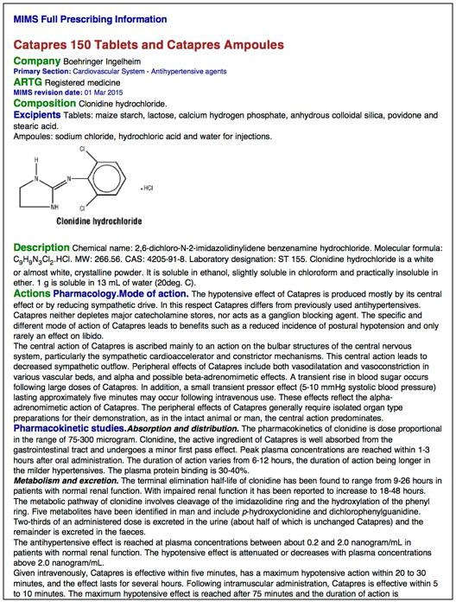

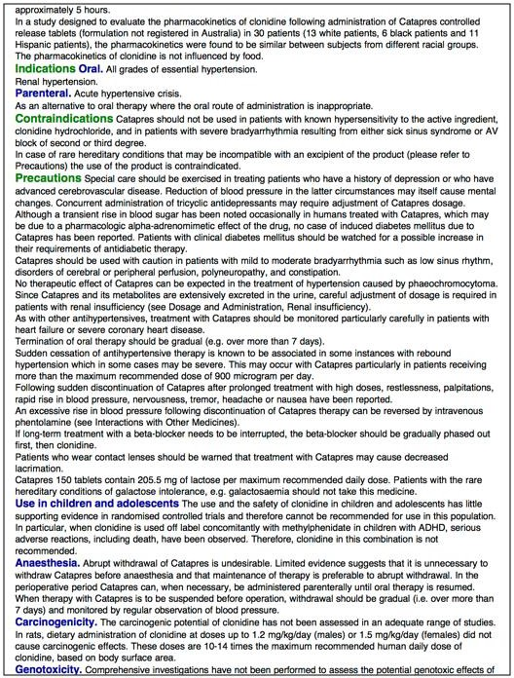

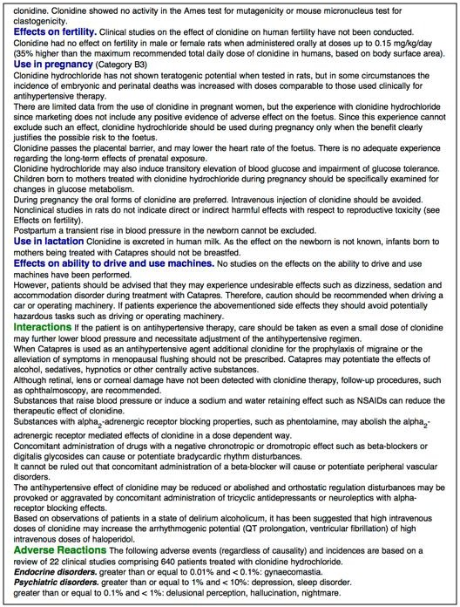

Clonidine at Low dosage postOperatively to Nocturnally Enhance Sleep (CLONES) Version 4 09OCT2019 37

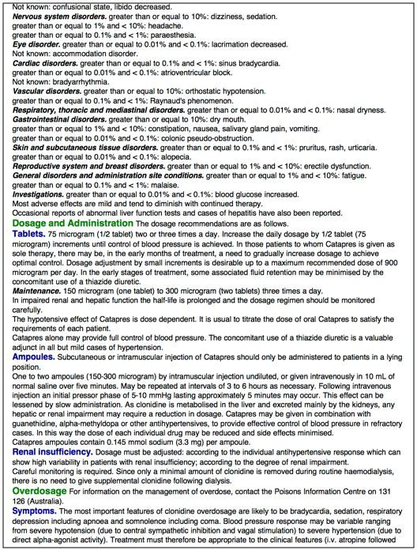

Clonidine at Low dosage postOperatively to Nocturnally Enhance Sleep (CLONES) Version 4 09OCT2019 38

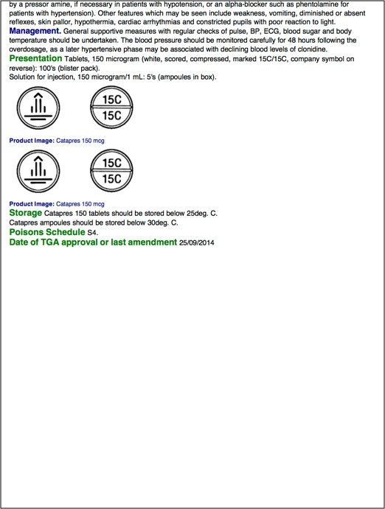

Clonidine at Low dosage postOperatively to Nocturnally Enhance Sleep (CLONES) Version 4 09OCT2019 39

Appendix B. Clonidine Toxicology


Toxicology: clonidine

Risk assessment for clonidine poisoning
Clonidine is a centrally acting alpha₂ agonist that produces a reduced level of consciousness including coma with mild bradycardia and hypotension in overdose. In children, the effects can be more signiﬁcant.
Toxic dose
Ingestions of more than 10 micrograms/kg clonidine are associated with potentially signiﬁcant poisoning in children, and such patients should be admitted.

Clinical presentation
Clonidine is commonly ingested in young children and adolescents but rarely causes major problems if less than 10 micrograms/kg is ingested. The classic presentation is CNS depression, bradycardia and miosis. Bradycardia may persist for 24 to 48 hours.
Systemic effects of clonidine overdose include:
CNS effects—drowsiness progressing to coma, respiratory depression, miosis cardiovascular effects—early transient hypertension, bradycardia, hypotension other less common effects—hypotonia, hypothermia, seizures.

Treatment of clonidine poisoning
Airway and breathing
The majority of cases will not require airway or ventilatory support, but intubation and mechanical ventilation are indicated for coma and respiratory depression in severe poisoning. Consider the potential for profound bradycardia with the use of suxamethonium. Atropine is useful to minimise this effect. Use:



atropine 0.5 to 1.5 mg IV bolus, repeat after 15 minutes if necessary (child: 0.02 mg/kg up to 0.5 mg IV bolus, repeat after 5 minutes if necessary up to a maximum of 1 mg).

Circulation
Hypotension due to the effects of clonidine on the peripheral circulation should be treated with ﬂuids (see Resuscitation: circulation).
Although bradycardia will respond transiently to the administration of atropine, it is only indicated if there is associated hypotension. Use:



atropine 0.5 to 1.5 mg IV bolus, repeat after 15 minutes if necessary (child: 0.02 mg/kg up to 0.5 mg IV bolus, repeat after 5 minutes if necessary up to a maximum

of 1 mg).

Patients should be observed for the duration of their bradycardia, although heart rate monitoring is sufficient in patients without hypotension.
Early hypertension is rarely observed because it has usually resolved before presentation. No treatment is required because it resolves spontaneously and the antihypertensive drugs will exacerbate the hypotensive phase.

Decontamination
Activated charcoal should be considered with caution because of the potential for rapid-onset CNS depression. Only consider activated charcoal in a cooperative patient within 1 hour of the estimated time of ingestion if there are no features of CNS depression (see Single-dose activated charcoal).

Specific pharmacological therapies

Antidotal therapy

Although there are reports of naloxone being effective for reversing respiratory and CNS depression, particularly in children, clonidine overdose can be safely managed with supportive care.
Naloxone may be trialled, in the severely symptomatic patient, while specialist intervention is arranged.

Observation and patient disposition after clonidine poisoning
Criteria for discharge: Patients should be monitored for 4 hours after ingestion and can be discharged if no effects are observed.
Criteria for admission: All patients with symptoms should be observed for at least 12 hours after ingestion or until the bradycardia has resolved. Any child who has ingested a dose of more than 10 micrograms/kg requires admission.

Published July 2012. © Therapeutic Guidelines Ltd (eTG March 2018 edition)

Therapeutic Guidelines Limited (www.tg.org.au) is an independent not-for-profit organisation dedicated to deriving guidelines for therapy from the latest world literature, interpreted and distilled by Australia's most eminent and respected experts.© Therapeutic Guidelines Ltd

Appendix C. Schedule of Events

Activity | Day | Pre-AC | Before Surgery | Day Of Surgery |  |  | Days After Surgery
Activity | Day | -2 to -42 | -1 | 1 | 1 | 1 | 2 | 2 to 30
Activity | Study Personnel |  |  | Pre-op | Surgery / Recovery | HDU | HDU | Post-HDU discharge
Elective patients booked for ESHDU at pre-AC | - | X
Information sheet given to all surgical patients booked for ESHDU | Pre-AC RC | X
Identify potential subjects via ICU Bed Bookings Calendar and text message / phone call to discuss CLONES study participation | Investigator / Anaesthetics RC |  | X
HDU bookings for patients may be cancelled prior to surgery | - | X | X
Subjects provide written consent after they arrive in hospital (prior to any pre-medications or anaesthetic agents being given) | Anaesthetics RC |  |  | X
No direct involvement of anaesthetists is required in this study | - |  |  |  | X
Eligibility check; formal study enrolment; CAM-ICU assessment | ICU RC |  |  |  |  | X
Randomisation to treatment group; study medication preparation | ICU RC (unblinded) |  |  |  |  | X
Handover to HDU registrar and bedside nurse; request study medication charting in Metavision; documentation of participation | ICU RC |  |  |  |  | X
Study medication infusion set up; to commence at 20:00 | HDU nurse / ICU RC |  |  |  |  | X
FitBit Alta HR device applied to subject's wrist | ICU RC |  |  |  |  | X
HDU registrar or consultant (or another medical officer) may choose to cease study medication at any time if clinically indicated | - |  |  |  |  | X | X
RCSQ – completed by bedside nurse before end of shift at 07:00 | HDU nurse |  |  |  |  |  | X
Study medication infusion to cease at 06:00 | HDU nurse |  |  |  |  |  | X
CAM-ICU assessment | ICU RC |  |  |  |  |  | X
RCSQ – completed by patient (at direction of ICU RC) | ICU RC |  |  |  |  |  | X
Remove FitBit Alta HR device and download sleep statistics | ICU RC |  |  |  |  |  | X
Electronic Case Report Form – demographics, treatment, outcomes | ICU RC |  |  |  |  |  | X
Patient discharged from HDU – no further follow up | - |  |  |  |  |  | X
Patient discharged from hospital | - |  |  |  |  |  |  | X
Electronic Case Report Form – hospital LOS | ICU RC |  |  |  |  |  |  | X

Appendix D. Participant Information Sheet

Clonidine at LOw dosage postOperatively to Nocturnally Enhance Sleep (CLONES)
Participant Information Sheet
You have received this flyer because you may potentially be invited to participate in a voluntary research study at the Royal Brisbane and Women’s Hospital (RBWH). If eligible for the study, a study representative (doctor or nurse) will contact you by phone before your surgery to discuss the study and answer any questions you may have.

What is the purpose of this research?
Patients sometimes have trouble sleeping after major surgery due to a variety of reasons, including the physical stress of surgery, pain, medications, or the noisy or unfamiliar hospital environment. This can make patients more susceptible to delirium: a condition caused by disruption to normal brain function that results in inattention, disorganised thinking, or restlessness. Delirium can be a serious complication and is associated with poorer outcomes and recovery following surgery. Modern hospitals such as RBWH implement many best-practice processes to reduce the risk of delirium following surgery. This research study is investigating whether a medication called clonidine administered through a cannula (“drip”) after surgery can help patients sleep better after surgery and reduce their chance of developing delirium.

What is clonidine?
Clonidine is a well-known drug normally used to treat high blood pressure. It is also commonly used during, or after, surgery to help alleviate pain. Previous studies of a similar medication, dexmedetomidine, have shown that it may improve sleep and reduce delirium following surgery – but it cannot be given outside of ICU due to potent side effects. As clonidine is a safer medication, we are investigating whether it could similarly improve sleep and reduce delirium after surgery. Clonidine is not currently approved by the Therapeutic Goods Administration for this purpose.

Why am I being asked to take part?
This study will recruit patients booked to stay in the RBWH Elective Surgical High Dependency Unit (ESHDU) after their surgery (either for monitoring, or due to their medical conditions). Not all patients will be eligible to participate, however, because their surgery may finish too late in the evening, or they may be admitted elsewhere in the hospital. You have received this flyer because you have been booked for an ESHDU bed; therefore, you may potentially be eligible to participate.

Do I have to participate?
Your participation in this study is completely voluntary. Even if you agree to participate, you can change your mind and withdraw at any time – even after your involvement has begun. This study is independent of your treating surgeons and anaesthetists, therefore whether or not you choose to participate will have no bearing on your surgery, nor the quality of care you will receive.

What are the alternatives to participation?
If you choose not to participate, you will receive standard clinical care for your surgery.

What are the possible benefits of taking part?
By taking part in this study, you will be contributing towards research on improving sleep and reducing the risk of delirium after surgery. However, there is no guarantee that you will personally
CLONES Study – Information Sheet – Version 3 – 05AUG2019 – HREC/2018/QPCH/44026 1

benefit from participating in this study. This is an experimental (as yet unproven) use of clonidine, and there is a 50% chance you will be randomly allocated to a “placebo” arm of the study.

What are the possible risks and disadvantages of taking part?
All medications, including clonidine, have side effects. Common and rare-but-important side effects of clonidine may include a slow heart rate, low blood pressure, dizziness, drowsiness, dry mouth, or allergic reaction. As part of your care in the ESHDU, you will have a bedside nurse and a doctor based in the unit monitoring you at all times. If there is any concern regarding the safety of the study medication or your wellbeing, the study medication will be ceased immediately.
How does the study work?
A member of the research team (either doctor or nurse) may phone you the day before your scheduled surgery to discuss this study and answer any questions you may have. If you agree to participate, you will be asked to confirm your consent in writing on the morning of your surgery.

After your surgery, if you are admitted to the ESHDU and meet the eligibility criteria, you will be enrolled into the study. You will be randomly selected by computer into either the “treatment” group (who receive a low-dose infusion of the study drug, clonidine) or the “placebo” group (who receive an infusion of inert saline). The infusion will begin at 8 pm on the evening of your surgery via an IV cannula (a new one might need to be placed), and will cease at 6 am the following morning. To ensure the integrity of the study, neither you (nor your doctors or nurses) will know which group you have been allocated to. No blood tests nor specimen collections are required.

To record your sleep, you will be asked to wear a FitBit Alta HR (a small watch-like device that monitors your body movements and heart rate) on your wrist. Research coordinators will ask you to fill out a questionnaires the morning after surgery when the infusion finishes and the FitBit device is removed. No further participation will be required from you after this point. You will not have access to the (experimental) study medication once your participation has concluded.

What information about me will be used for the study?
In addition to asking you questions and recording your sleep patterns, a research coordinator will also collect information from your medical record. This includes your age and gender, type and duration of surgery, time spent in the ESHDU, details about your anaesthetic, other medications you have received, vital signs, and complications from the study medication (if any). This information will be collected using a de-identified (anonymous) code to maintain your privacy.
Further information and who to contact
If eligible, you will be contacted before your surgery by one of our study doctors or nurses to discuss this study. They will explain the study to you over the phone and give you plenty of time to ask any questions you may have. If you have any concerns regarding the conduct of the study, you can contact any of the following people:

Clinical contact person
Dr David Liu
Complaints contact person
Anitha Dinesh
Ethics committee contact
Anne Carle

RBWH ICU Registrar RBWH A/Research Governance Officer TPCH HREC Coordinator and Manager

Telephone: 07 3646 8111
Telephone: 07 3646 8579
Telephone: 07 3139 4500

Email: d.liu3@uq.edu.au Email: RBWH-RGO@health.qld.gov.au Email: ResearchTPCH@health.qld.gov.au
CLONES Study – Information Sheet – Version 3 – 05AUG2019 – HREC/2018/QPCH/44026 2

Appendix E. Participant Consent Form
Name of Study Doctor/ Researcher (please print)

Signature Date
Form for Consent to Participation

Title Clonidine at LOw dosage postOperatively to Nocturnally Enhance Sleep
Short Title CLONES
Protocol Number Version 3, Dated 5th August 2019
Principal Investigator Dr David Liu
Associate Investigator(s) Prof Michael Reade Dr Jason Pincus
Dr Elizabeth Hallt
Ms Amelia Livermore Ms Christine Woods Ms Kymberley Herbst Mr Alain Humblet
Location The Royal Brisbane and Women’s Hospital

Declaration by Participant

I have read the Participant Information Sheet Version 3 dated 5th August 2019 or someone has read it to me in a language that I understand.

I understand the purposes, procedures and risks of the research described in the project.

I have had an opportunity to ask questions and I am satisfied with the answers I have received.

I freely agree to participate in this research project as described and understand that I am free to withdraw at any time during the study without affecting my future health care.
I understand that I will be given a signed copy of this document to keep. I understand that, if I decide to discontinue the study treatment, I may be asked to provide follow-up information to allow collection of information regarding my health status. Alternatively, a member of the research team may request my permission to obtain access to my medical records for collection of follow-up information for the purposes of research and analysis.
Declaration by Study Doctor/Researcher

I confirm that the participant has been given a verbal (phone) explanation of the research project, its procedures and risks and I believe that they have understood that explanation.
Clonidine at LOw dosage postOperatively to Nocturnally Enhance Sleep (CLONES)
HREC/2018/QPCH/44026 Consent Form RBWH Version 3, 5th August 2019
Page 1 of 2

Name of Participant (please print) Signature Date

Name of Study Doctor/ Researcher (please print)

Signature Date
Form for Withdrawal of Participation

Title Clonidine at Low dosage postOperatively to Nocturnally Enhance Sleep
Short Title CLONES
Protocol Number Version 3, Dated 5th August 2019
Principal Investigator Dr David Liu
Associate Investigator(s) Prof Michael Reade Dr Jason Pincus
Dr Elizabeth Hallt
Ms Amelia Livermore Ms Christine Woods Ms Kymberley Herbst Mr Alain Humblet
Location The Royal Brisbane and Women’s Hospital

Declaration by Participant

I wish to WITHDRAW from participation in the above research project and understand that such withdrawal will not affect my routine treatment, my relationship with those treating me, or my relationship with The Royal Brisbane and Women’s Hospital.

I agree to the use of my data that was collected prior to my withdrawal of consent.

Yes / No (please circle)

I agree to the study investigators continuing to collect information about me, specifically in relation to my progress in hospital.
Yes / No (please circle)
Declaration by Study Doctor/Researcher
I have given a verbal explanation of the implications of withdrawal from the research project and I believe that the participant has understood that explanation.
Clonidine at LOw dosage postOperatively to Nocturnally Enhance Sleep (CLONES)
HREC/2018/QPCH/44026 Consent Form RBWH Version 3, 5th August 2019
Page 2 of 2

Name of Participant (please print) Signature Date

Appendix F. Telephone Script

Clonidine at LOw dosage postOperatively to Nocturnally Enhance Sleep (CLONES)
Phone Script
Name of patient: URN:

Date of surgery: / / Date of call: / / Time of call: : AM / PM

Hello. I am a researcher/research coordinator from the Royal Brisbane and Women’s Hospital, calling about a research study that you have been invited to take part in during your pre-admission clinic appointment.

The study is called Clonidine at Low Dosage Postoperatively to Nocturnally Enhance Sleep – abbreviated as CLONES. Have you had a chance to read through the CLONES study information sheet □ given to you during your pre-admission clinic appointment / □ sent via text message to your mobile? □ Yes □ No

If No ➔ read out and discuss each section from the Participant Information Sheet.

Topic | Discussed
What is the purpose of this research? | □
What is clonidine? | □
Why am I being asked to take part? | □
Do I have to participate? | □
What are the alternatives to participation? | □
What are the possible benefits of taking part? | □
What are the possible risks and disadvantages of taking  part? | □
How does the study work? | □
What information about me will be used for the study? | □
Further information and who to contact? | □

Do you have any questions or concerns about your participation in the CLONES study? □ Yes □ No Please document any specific concerns or topics discussed:

Based on the information you have received about the CLONES study, do you agree to participate in the study (knowing that you are free to change your mind at any time)? □ Yes □ No

If yes ➔ A research coordinator will follow up with you on the day of surgery for your written signature.

I am satisfied that the above patient has been provided sufficient information to make an informed decision about their participation in the CLONES study, and that they have capacity to provide consent:

Name: Date: / / Signature:
CLONES Study – Phone Script – Version 2, 9th October 2019

Appendix G. Metavision Note for Treating Doctors

Appendix G. Metavision Note for Treating Doctors
Clonidine at Low dosage postOperatively to Nocturnally Enhance Sleep (CLONES) Study
This patient has been enrolled in the CLONES study, which is a double-blinded, randomized, placebo-controlled trial investigating the use of low-dose clonidine infusion in elective surgical patients to improve sleep and reduce delirium.
- Patients: Elective patients admitted to ESHDU before 20:00 on the night of surgery (who may have received clonidine perioperatively up to a max of 100 mcg total).
- Intervention: Clonidine IV maintenance-only infusion at 0.3 mcg/kg/hr (actual body weight, up to max 100 kg dosing weight) from 20:00 on the night of surgery until 06:00 the following morning, delivered using a 300 mcg / 30 mL saline syringe.
- Comparator: Normal saline IV infusion at the same volume rate.
- Outcome: Sleep statistics recorded using a wrist-worn FitBit Alta HR; sleep and delirium questionnaires.
For ESHDU doctors:
- Clonidine maintenance infusion at 0.3 mcg/kg/hr (without loading dose) is not associated with hypotension nor bradycardia in previously published dose-finding studies in healthy volunteers.
- If you are concerned about the patient’s wellbeing (e.g. hypotension or bradycardia of clinical concern), then you may cease the study medication at any time regardless of causality.
- Indications and rationale for premature cessation of study medication should be documented in Metavision. If possible, please continue data collection via the wrist-worn FitBit Alta HR device (which records wrist movements and heart rate, but has no therapeutic effect).
- Please avoid administering any further doses of alpha2-adrenoreceptor agonists (i.e. clonidine or dexmedetomidine) while the study medication infusion is running. If you would like to change the dose of clonidine infusion in any way, then please formally cease the study medication (as above) and re-chart a new infusion.
- Except for clonidine/dexmedetomidine, there are no restrictions on other medications or treatments for patients enrolled in this study.
This study is being conducted by Dr David Liu (Chief Investigator; Junior Registrar – ICU) and Prof Michael Reade (Site Principal Investigator; Consultant – ICU). If you have any questions or concerns regarding this study, please contact the ICU Research Office during business hours. Otherwise, you may contact Dr David Liu on XXXX XXX XXX with any urgent concerns.

A summary of the above information will also appear in the Metavision study medication prescription.

Clonidine at Low dosage postOperatively to Nocturnally Enhance Sleep (CLONES) Version 2 14OCT2018 47

Appendix H. Case Report Form
An electronic Case Report Form will be developed and hosted using the MNHHS REDCap eCRF system.

Appendix I. Blinded Study Medication Label
The following label will be used to mark blinded study medication syringes:

PRESCRIPTION ONLY MEDICATION
KEEP OUT OF REACH OF CHILDREN

Clonidine at Low dosage postOperatively to
Nocturnally Enhance Sleep

PRESCRIPTION ONLY MEDICATION
KEEP OUT OF REACH OF CHILDREN

Clonidine at Low dosage postOperatively to
Nocturnally Enhance Sleep

This study is blinded.

CLONES INFUSION

Patient Initials Study No

This study is blinded.

CLONES INFUSION
(Fold down over syringe bevel)
(Fold down over syringe bevel)

Patient Initials Study No

Total volume: 30 mL

Medication: 300 mcg clonidine OR placebo

Total volume: 30 mL

Medication: 300 mcg clonidine OR placebo

Dose: 0.3 mcg/kg/hr (total body weight, max 100 kg) from 20:00 on night of surgery until 06:00 (10 hr)

Also contains: 0.9% sodium chloride

Prepared by Study Site: RBWH Date Time

Dose: 0.3 mcg/kg/hr (total body weight, max 100 kg) from 20:00 on night of surgery until 06:00 (10 hr)

Also contains: 0.9% sodium chloride

Prepared by Study Site: RBWH Date Time

Expiry Expiry

CLONES Study Medication Label V2 09OCT2019 CLONES Study Medication Label V2 09OCT2019

PRESCRIPTION ONLY MEDICATION
KEEP OUT OF REACH OF CHILDREN

Clonidine at Low dosage postOperatively to
Nocturnally Enhance Sleep
PRESCRIPTION ONLY MEDICATION
KEEP OUT OF REACH OF CHILDREN

Clonidine at Low dosage postOperatively to
Nocturnally Enhance Sleep

This study is blinded.

CLONES INFUSION

Patient Initials Study No

This study is blinded.

CLONES INFUSION
(Fold down over syringe bevel)
(Fold down over syringe bevel)

Patient Initials Study No

Total volume: 45 mL

Medication: 450 mcg clonidine OR placebo

Total volume: 45 mL

Medication: 450 mcg clonidine OR placebo

Dose: 0.3 mcg/kg/hr (total body weight, max 100 kg) from 20:00 on night of surgery until 06:00 (10 hr)

Also contains: 0.9% sodium chloride

Prepared by Study Site: RBWH Date Time

Dose: 0.3 mcg/kg/hr (total body weight, max 100 kg) from 20:00 on night of surgery until 06:00 (10 hr)

Also contains: 0.9% sodium chloride

Prepared by Study Site: RBWH Date Time

Expiry Expiry

CLONES Study Medication Label V2 09OCT2019 CLONES Study Medication Label V2 09OCT2019

Appendix J. Richards-Campbell Sleep Questionnaire

Modified Richards-Campbell Sleep Questionnaire
This form was completed by the: □ Patient □ Bedside nurse
Subject: Date: Time:

Each of these questions is answered by placing an “X” on the answer line. Place your “X” anywhere on the line that you feel best describes your sleep last night.

  - My sleep last night was:

light sleep deep sleep

  - Last night, the first time I got to sleep, I:

just never could fell asleep almost
fall asleep immediately

  - Last night, I was:

awake all awake very
night long little

  - Last night, when I woke up or was awakened, I:

couldn’t get got back to sleep
back to sleep immediately

  - I would describe my sleep last night as:

a bad night’s sleep a good night’s sleep

  - I would describe the noise level last night as:

very noisy very quiet

Clonidine at Low dosage postOperatively to Nocturnally Enhance Sleep (CLONES) – RCSQ – Version 1 – 13SEP2018

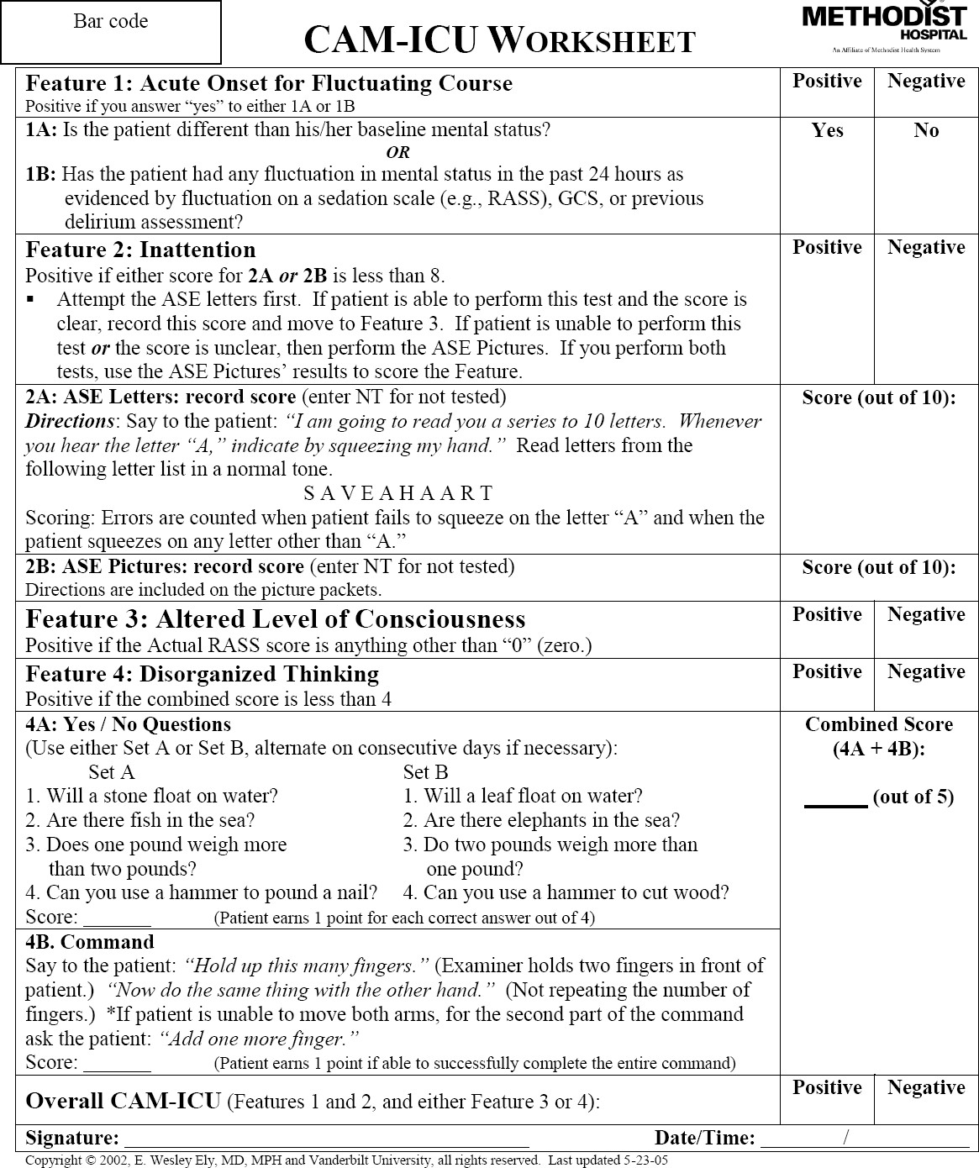
Appendix K. CAM-ICU Worksheet

Appendix L. Richard Agitation-Sedation Scale
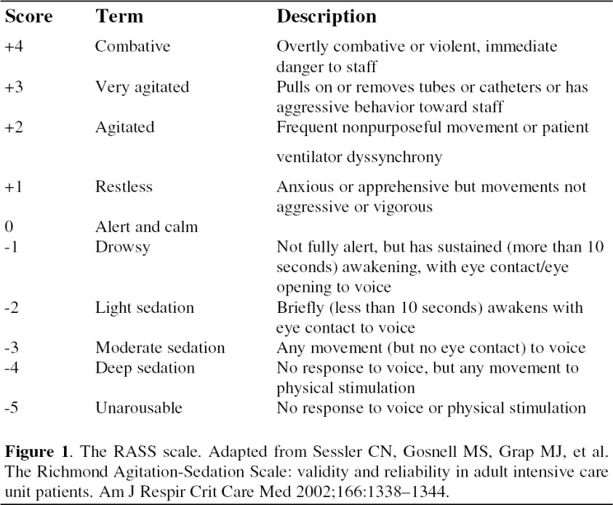

Appendix M. Protocol Violation / Study Discontinuation Form

Clonidine at LOw dosage postOperatively to Nocturnally Enhance Sleep (CLONES)
Protocol Violation / Study Discontinuation Form

Subject ID: Date of enrolment: / /

This form should be completed if a CLONES subject is successfully enrolled into the study, but the study infusion does not commence at 20:00 as intended, is prematurely ceased before 06:00 the next morning, data collection is not successfully completed, or if any protocol violations occur.

1. Did the study medication infusion commence at 20:00 on the night of surgery? | □ Yes | □ No
2. Did the study medication infusion continue until 06:00 the following morning? | □ Yes | □ No
3. Did any SAEs or SUSARs occur during the study? | □ Yes | □ No
4. Were all case report form items successfully recorded? | □ Yes | □ No

If No to any of the above, please document details (such as reasons for ceasing the study medication, treatments given or complications arising from study medication, relevant outcomes, details of any SAEs/SUSARs, or reasons for subjects withdrawing their consent prior to study completion):

Researcher: Date: / / Signature:

CLONES Study – Study Discontinuation Form – Version 1, 13th September 2018

Appendix N. Mobile Text Message Template
The following text message will be sent to patients booked for an ESHDU bed and who have a mobile phone number listed in their contact information, along with the CLONES Participant Information Sheet (see Appendix D, page 43) as an attachment:

Good morning/afternoon. Your RBWH surgical/anaesthetic team has booked an overnight stay for you in the High Dependency Unit (part of the ICU) after your surgery. The ICU doctors are conducting a voluntary clinical trial of a medication (clonidine) to improve sleep and reduce delirium postoperatively. Please find attached a two-page Participant Information Sheet. A study doctor will call you shortly to discuss whether you wish to participate? We look forward to speaking with you soon.

REFERENCES

1. (2011) Diagnostic and Statistical Manual of Mental Disorders, Fourth Edition, Text Revision (DSM-IV-TR). American psychiatric Association, Arlington, VA
2. Maldonado JR, (2017) Acute Brain Failure: Pathophysiology, Diagnosis, Management, and Sequelae of Delirium. Crit Care Clin 33: 461-519
3. Inouye SK, Westendorp RG, Saczynski JS, (2014) Delirium in elderly people. Lancet 383: 911-922
4. Robinson TN, Raeburn CD, Tran ZV, Angles EM, Brenner LA, Moss M, (2009) Postoperative delirium in the elderly: risk factors and outcomes. Ann Surg 249: 173-178
5. Veiga D, Luis C, Parente D, Fernandes V, Botelho M, Santos P, Abelha F, (2012) Postoperative delirium in intensive care patients: risk factors and outcome. Rev Bras Anestesiol 62: 469-483
6. Robinson TN, Raeburn CD, Tran ZV, Brenner LA, Moss M, (2011) Motor subtypes of postoperative delirium in older adults. Arch Surg 146: 295-300
7. Ely EW, Margolin R, Francis J, May L, Truman B, Dittus R, Speroff T, Gautam S, Bernard GR, Inouye SK, (2001) Evaluation of delirium in critically ill patients: validation of the Confusion Assessment Method for the Intensive Care Unit (CAM-ICU). Crit Care Med 29: 1370-1379
8. Gillies MA, Sander M, Shaw A, Wijeysundera DN, Myburgh J, Aldecoa C, Jammer I, Lobo SM, Pritchard N, Grocott MPW, Schultz MJ, Pearse RM, (2017) Current research priorities in perioperative intensive care medicine. Intensive Care Med 43: 1173-1186
9. Chow WB, Rosenthal RA, Merkow RP, Ko CY, Esnaola NF, American College of Surgeons National Surgical Quality Improvement P, American Geriatrics S, (2012) Optimal preoperative assessment of the geriatric surgical patient: a best practices guideline from the American College of Surgeons National Surgical Quality Improvement Program and the American Geriatrics Society. J Am Coll Surg 215: 453-466
10. American Geriatrics Society Expert Panel on Postoperative Delirium in Older A, (2015) Postoperative delirium in older adults: best practice statement from the American Geriatrics Society. J Am Coll Surg 220: 136-148 e131
11. Tremblay P, Gold S, (2016) Prevention of Post-operative Delirium in the Elderly Using Pharmacological Agents. Can Geriatr J 19: 113-126
12. Wang W, Li HL, Wang DX, Zhu X, Li SL, Yao GQ, Chen KS, Gu XE, Zhu SN, (2012) Haloperidol prophylaxis decreases delirium incidence in elderly patients after noncardiac surgery: A randomized controlled trial. Crit Care Med 40: 731-739
13. Djaiani G, Silverton N, Fedorko L, Carroll J, Styra R, Rao V, Katznelson R, (2016) Dexmedetomidine versus Propofol Sedation Reduces Delirium after Cardiac Surgery: A Randomized Controlled Trial. Anesthesiology 124: 362-368
14. Su X, Meng ZT, Wu XH, Cui F, Li HL, Wang DX, Zhu X, Zhu SN, Maze M, Ma D, (2016) Dexmedetomidine for prevention of delirium in elderly patients after non-cardiac surgery: a randomised, double-blind, placebo-controlled trial. Lancet
15. Deiner S, Luo X, Lin HM, Sessler DI, Saager L, Sieber FE, Lee HB, Sano M, and the Dexlirium Writing G, Jankowski C, Bergese SD, Candiotti K, Flaherty JH, Arora H, Shander A, Rock P, (2017) Intraoperative Infusion of Dexmedetomidine for Prevention of Postoperative Delirium and Cognitive Dysfunction in Elderly Patients Undergoing Major Elective Noncardiac Surgery: A Randomized Clinical Trial. JAMA Surg 152: e171505
16. Pandharipande PP, Pun BT, Herr DL, Maze M, Girard TD, Miller RR, Shintani AK, Thompson JL, Jackson JC, Deppen SA, Stiles RA, Dittus RS, Bernard GR, Ely EW, (2007) Effect of sedation with dexmedetomidine vs lorazepam on acute brain dysfunction in mechanically ventilated patients: the MENDS randomized controlled trial. JAMA 298: 2644-2653
17. Riker RR, Shehabi Y, Bokesch PM, Ceraso D, Wisemandle W, Koura F, Whitten P, Margolis BD, Byrne DW, Ely EW, Rocha MG, (2009) Dexmedetomidine vs midazolam for sedation of critically ill patients: a randomized trial. JAMA 301: 489-499
18. Mo Y, Zimmermann AE, (2013) Role of dexmedetomidine for the prevention and treatment of delirium in intensive care unit patients. Ann Pharmacother 47: 869-876
19. Skrobik Y, Duprey MS, Hill NS, Devlin JW, (2018) Low-Dose Nocturnal Dexmedetomidine Prevents ICU Delirium. A Randomized, Placebo-controlled Trial. Am J Respir Crit Care Med 197: 1147-1156
20. Reade MC, Eastwood GM, Bellomo R, Bailey M, Bersten A, Cheung B, Davies A, Delaney A, Ghosh A, van Haren F, Harley N, Knight D, McGuiness S, Mulder J, O'Donoghue S, Simpson N, Young P, Dah LIAI, the A, New Zealand Intensive Care Society Clinical Trials G, (2016) Effect of Dexmedetomidine Added to Standard Care on Ventilator-Free Time in Patients With Agitated Delirium: A Randomized Clinical Trial. JAMA
21. Carrasco G, Baeza N, Cabre L, Portillo E, Gimeno G, Manzanedo D, Calizaya M, (2016) Dexmedetomidine for the Treatment of Hyperactive Delirium Refractory to Haloperidol in Nonintubated ICU Patients: A Nonrandomized Controlled Trial. Crit Care Med 44: 1295-1306
22. Weerink MAS, Struys M, Hannivoort LN, Barends CRM, Absalom AR, Colin P, (2017) Clinical Pharmacokinetics and Pharmacodynamics of Dexmedetomidine. Clin Pharmacokinet 56: 893-913
23. Reade MC, Finfer S, (2014) Sedation and delirium in the intensive care unit. N Engl J Med 370: 444-454
24. Boyko Y, Jennum P, Toft P, (2017) Sleep quality and circadian rhythm disruption in the intensive care unit: a review. Nat Sci Sleep 9: 277-284
25. Elliott R, McKinley S, Cistulli P, Fien M, (2013) Characterisation of sleep in intensive care using 24-hour polysomnography: an observational study. Crit Care 17: R46
26. Friese RS, Diaz-Arrastia R, McBride D, Frankel H, Gentilello LM, (2007) Quantity and quality of sleep in the surgical intensive care unit: are our patients sleeping? J Trauma 63: 1210-1214
27. Weinhouse GL, Schwab RJ, Watson PL, Patil N, Vaccaro B, Pandharipande P, Ely EW, (2009) Bench-to-bedside review: delirium in ICU patients - importance of sleep deprivation. Crit Care 13: 234
28. Pisani MA, Friese RS, Gehlbach BK, Schwab RJ, Weinhouse GL, Jones SF, (2015) Sleep in the intensive care unit. Am J Respir Crit Care Med 191: 731-738
29. Aurell J, Elmqvist D, (1985) Sleep in the surgical intensive care unit: continuous polygraphic recording of sleep in nine patients receiving postoperative care. Br Med J (Clin Res Ed) 290: 1029-1032
30. Knill RL, Moote CA, Skinner MI, Rose EA, (1990) Anesthesia with abdominal surgery leads to intense REM sleep during the first postoperative week. Anesthesiology 73: 52-61
31. Rosenberg-Adamsen S, Skarbye M, Wildschiodtz G, Kehlet H, Rosenberg J, (1996) Sleep after laparoscopic cholecystectomy. Br J Anaesth 77: 572-575
32. Flannery AH, Oyler DR, Weinhouse GL, (2016) The Impact of Interventions to Improve Sleep on Delirium in the ICU: A Systematic Review and Research Framework. Crit Care Med 44: 2231-2240
33. Nuzzo E, Girard TD, (2018) The Sandman in the ICU: A Novel Use of Dexmedetomidine? Am J Respir Crit Care Med 197: 1098-1099
34. Bourne RS, Minelli C, Mills GH, Kandler R, (2007) Clinical review: Sleep measurement in critical care patients: research and clinical implications. Crit Care 11: 226
35. Delaney LJ, Currie MJ, Huang HC, Litton E, Wibrow B, Lopez V, Haren FV, (2018) Investigating the application of motion accelerometers as a sleep monitoring technique and the clinical burden of the intensive care environment on sleep quality: study protocol for a prospective observational study in Australia. BMJ Open 8: e019704
36. van der Kooi AW, Tulen JH, van Eijk MM, de Weerd AW, van Uitert MJ, van Munster BC, Slooter AJ, (2013) Sleep monitoring by actigraphy in short-stay ICU patients. Crit Care Nurs Q 36: 169-173
37. Fonseca P, Weysen T, Goelema MS, Most EIS, Radha M, Lunsingh Scheurleer C, van den Heuvel L, Aarts RM, (2017) Validation of Photoplethysmography-Based Sleep Staging Compared With Polysomnography in Healthy Middle-Aged Adults. Sleep 40
38. Jeffs EL, Darbyshire JL, (2019) Measuring Sleep in the Intensive Care Unit: A Critical Appraisal of the Use of Subjective Methods. J Intensive Care Med 34: 751-760
39. Richards KC, O'Sullivan PS, Phillips RL, (2000) Measurement of sleep in critically ill patients. J Nurs Meas 8: 131-144
40. Frisk U, Nordstrom G, (2003) Patients' sleep in an intensive care unit--patients' and nurses' perception. Intensive Crit Care Nurs 19: 342-349
41. Kamdar BB, Shah PA, King LM, Kho ME, Zhou X, Colantuoni E, Collop NA, Needham DM, (2012) Patient-nurse interrater reliability and agreement of the Richards-Campbell sleep questionnaire. Am J Crit Care 21: 261-269
42. Akeju O, Hobbs LE, Gao L, Burns SM, Pavone KJ, Plummer GS, Walsh EC, Houle TT, Kim SE, Bianchi MT, Ellenbogen JM, Brown EN, (2018) Dexmedetomidine promotes biomimetic non-rapid eye movement stage 3 sleep in humans: A pilot study. Clin Neurophysiol 129: 69-78
43. Huupponen E, Maksimow A, Lapinlampi P, Sarkela M, Saastamoinen A, Snapir A, Scheinin H, Scheinin M, Merilainen P, Himanen SL, Jaaskelainen S, (2008) Electroencephalogram spindle activity during dexmedetomidine sedation and physiological sleep. Acta Anaesthesiol Scand 52: 289-294
44. Wu XH, Cui F, Zhang C, Meng ZT, Wang DX, Ma J, Wang GF, Zhu SN, Ma D, (2016) Low-dose Dexmedetomidine Improves Sleep Quality Pattern in Elderly Patients after Noncardiac Surgery in the Intensive Care Unit: A Pilot Randomized Controlled Trial. Anesthesiology 125: 979-991
45. Gagnon DJ, Fontaine GV, Riker RR, Fraser GL, (2017) Repurposing Valproate, Enteral Clonidine, and Phenobarbital for Comfort in Adult ICU Patients: A Literature Review with Practical Considerations. Pharmacotherapy 37: 1309-1321
46. Mokhtari M, Sistanizad M, Farasatinasab M, (2017) Antipyretic Effect of Clonidine in Intensive Care Unit Patients: A Nested Observational Study. J Clin Pharmacol 57: 48-51
47. Neubert A, Baarslag MA, Dijk MV, Rosmalen JV, Standing JF, Sheng Y, Rascher W, Roberts D, Winslade J, Rawcliffe L, Hanning SM, Metsvaht T, Giannuzzi V, Larsson P, Pokorna P, Simonetti A, Tibboel D, Consortium C, (2017) The CLOSED trial; CLOnidine compared with midazolam for SEDation of paediatric patients in the intensive care unit: study protocol for a multicentre randomised controlled trial. BMJ Open 7: e016031
48. Neerland BE, Hov KR, Bruun Wyller V, Qvigstad E, Skovlund E, MacLullich AM, Bruun Wyller T, (2015) The protocol of the Oslo Study of Clonidine in Elderly Patients with Delirium; LUCID: a randomised placebo-controlled trial. BMC Geriatr 15: 7
49. Lowenthal DT, Matzek KM, MacGregor TR, (1988) Clinical pharmacokinetics of clonidine. Clin Pharmacokinet 14: 287-310
50. Marinangeli F, Ciccozzi A, Donatelli F, Di Pietro A, Iovinelli G, Rawal N, Paladini A, Varrassi G, (2002) Clonidine for treatment of postoperative pain: a dose-finding study. Eur J Pain 6: 35-42
51. (2017) Clonidine (anaesthesia).Australian Medicines Handbook [Internet]
52. Bernard JM, Kick O, Bonnet F, (1995) Comparison of intravenous and epidural clonidine for postoperative patient-controlled analgesia. Anesth Analg 81: 706-712
53. Srivastava U, Sarkar ME, Kumar A, Gupta A, Agarwal A, Singh TK, Badada V, Dwivedi Y, (2014) Comparison of clonidine and dexmedetomidine for short-term sedation of intensive care unit patients. Indian J Crit Care Med 18: 431-436
54. Bernard JM, Bourreli B, Hommeril JL, Pinaud M, (1991) Effects of oral clonidine premedication and postoperative i.v. infusion on haemodynamic and adrenergic responses during recovery from anaesthesia. Acta Anaesthesiol Scand 35: 54-59
55. Hall JE, Uhrich TD, Barney JA, Arain SR, Ebert TJ, (2000) Sedative, amnestic, and analgesic properties of small-dose dexmedetomidine infusions. Anesthesia & Analgesia 90: 699-705
56. Zochowski RJ, Lada W, (1986) Intravenous clonidine treatment in acute myocardial infarction (with comparison to a nitroglycerin-treated and control group). J Cardiovasc Pharmacol 8 Suppl 3: S41-45
57. (2016) Catapres-TTS® Transdermal Therapeutic System: Prescribing Information. In: Editor (ed)^(eds) Book Catapres-TTS® Transdermal Therapeutic System: Prescribing Information. Boehringer Ingelheim, City, pp.
58. Plate JDJ, Leenen LPH, Houwert M, Hietbrink F, (2017) Utilisation of Intermediate Care Units: A Systematic Review. Crit Care Res Pract 2017: 8038460

