SUPPLEMENTARY MATERIAL

Rethinking ARDS Classification: Oxygenation Impairment Fails to Predict VILI Risk

Giulia Catozzi^{1,2}, Tommaso Pozzi², Domenico Nocera^{1,3}, Beatrice Donati^{1,2}, Stefano Giovanazzi^{1,4}, Valentina Ghidoni^{1,5}, Mauro Galizia^{1,2}, Rosanna D’Albo^{1,3}, Mattia Busana¹, Federica Romitti¹, Alessandro Gatta⁶, Onnen Mörer¹, Konrad Meissner¹, Michael Quintel¹, Peter Herrmann¹, Davide Chiumello^{2,7}, Luigi Camporota⁸, Luciano Gattinoni¹

Affiliations
¹Department of Anaesthesiology, University Medical Center Göttingen, Robert Koch Str 40, 37075, Göttingen, Germany;
²Department of Health Sciences, University of Milan, Via Festa del Perdono 7, 20122, Milano, Italy;
³Department of Medical and Surgical Sciences, Alma Mater Studiorum, University of Bologna, Via Massarenti 9, 40138, Bologna, Italy;
⁴Department of Medical and Surgical Specialties, Radiological Sciences and Public Health, University of Brescia, Piazzale Spedali Civili 1, 25121, Brescia, Italy;
⁵Department of Health Science, Department of Anesthesia and Intensive Care, AOU Careggi, Largo Brambilla 3, 50139, Firenze, Italy;
⁶Department of Anesthesia and Intensive Care, Ceccarini Hospital, AUSL della Romagna, Via Frosinone, 47838, Riccione, Italy;
⁷Department of Anesthesia and Intensive Care, ASST Santi Paolo e Carlo, San Paolo University Hospital Milan, Via Antonio di Rudinì 8, 20142, Milan, Italy;
⁸Department of Adult Critical Care, Guy's and St. Thomas' NHS Foundation Trust, Centre for Human & Applied Physiological Sciences, School of Basic & Medical Biosciences. King’s College London, London, UK

Corresponding Author
Prof. Luciano Gattinoni, Department of Anaesthesiology, University Medical Center Göttingen, Robert Koch Str 40, 37075, Göttingen, Germany, gattinoniluciano@gmail.com (https://orcid.org/0000-0001-5380-2494).

Supplementary Methods

Study Population. The study population includes 228 patients with acute respiratory distress syndrome (ARDS), enrolled between May 2003 and July 2024, from San Paolo University Hospital of Milan (Italy), Universitatmedizin Center Goettingen (Germany), Ospedale Maggiore Policlinico of Milan (Italy), Azienda Ospedaliera San Gerardo Monza (Italy) and Pontificia Universidad Catolica de Chile (Chile). The study population comprises patients enrolled in previously published studies; however, the complete dataset of patients used for this study has never been utilized before.
VILI Predictive Variables. The driving pressure (DP) was defined as
$$Driving Pressure = Plateau Pressure – PEEP$$
The mechanical power (MP) was computed as
$$MP=0.098×RR×\{{V_{T}}^{2}×\left[\frac{1}{2}×E_{rs}+RR×\frac{1+I:E}{60×I:E}×R_{aw}\right]+V_{T}×PEEP\}$$
where RR is the respiratory rate, V_{T} the tidal volume, E_{rs} the respiratory system elastance, I:E the ratio of inspiratory time to the expiratory time, R_{aw} the airways resistance and PEEP the positive end-expiratory pressure. The mechanical power ratio was computed as the ratio of the actual mechanical power to the expected normal mechanical power, as previously reported [1], assuming the following normal values for the variables involved:
$$Respiratory Rate=15 bpm$$
$$Tidal Volume=\frac{0.1 (l ∙\min^{-1}) ×IBW \left(kg\right)}{Respiratory Rate}$$
where the IBW is the ideal body weight, and 0.1 l/min is the expected normal minute ventilation per kg, as in the ventilatory ratio computation [2].
The E_{rs}, the inverse of the respiratory system compliance (1/C_{rs}), was derived assuming a linear relationship between compliance and lung gas volume. The formula is based on the assumption that a normal individual has an average functional residual capacity (FRC) of 2.5 l and a lung compliance of 80 ml/cmH₂O (or 0.08 l/cmH₂O). To estimate the compliance of a patient, whose FRC is predicted based on their demographic characteristics (using the Ibañez formula[3]), we use the following equation:
$$\frac{2.5}{0.08}=\frac{{FRC}_{ID}}{{CRS}_{ID}}$$
Where Crs_{ID} is the estimated ideal compliance for the given FRC (FRC_{ID}). The compliance can be calculated as:
$$\frac{80×{FRC}_{ID}}{2.5}$$
To obtain elastance, we take the reciprocal of compliance, leading to the final equation for elastance:
$${E_{rs}}_{ID}=\frac{2.5 l}{FRC_{ID}∙0.08 l∙{cmH_{2}O}^{-1}}$$
This provides the ideal estimated elastance (Ers_{ID}) based on the patient’s predicted FRC.
The ideal FRC (FRC_{ID}) was computed according to the Ibañez equation [3], expressed in litres:
Men: $FRC=5.48 height-7.05$; Women: $FRC=1.39 height-0.424$
With the heigh expressed in meters. We also assumed a I:E ratio of 1:2 (i.e., 0.5), normal airways resistance including the endotracheal tube of 10 cmH₂O/l/s and a PEEP of 0 cmH₂O.
Thus, the final formula to calculate the expected MP is as follows:
$$MP_{expected}=1.47 ×{V_{T}}^{2} (l)×\left(\frac{0.015625}{{FRC}_{ID} (l)}+0.5×RR (bpm)\right)$$
We opted to use the mechanical power ratio because mechanical power per se—defined as energy per unit of time—is an extensive property, meaning it depends on the size of the system. As a result, it varies with the dimensions of the respiratory system and cannot be reliably used to compare individuals with different respiratory system sizes. In contrast, normalizing mechanical power to its expected values (i.e., using the mechanical power ratio) removes this dependency on system size, allowing for accurate comparisons between individuals with different respiratory system dimensions. Driving pressure is also an intensive property of the system.
Statistical Analysis. Continuous variables are presented as mean and standard deviation. Linear regression was used to assess the relationship between continuous variables. A p-value of <0.05 was considered as statistically significant. Respiratory system mechanics data were incomplete or missing in 31 patients (13%), hence mechanical power and driving pressure could be computed in 204 and 208 patients respectively. Analyses were performed without any imputation for missing data. Analysis and figures were prepared using RStudio (RStudio Team 2020; RStudio: Integrated Development for R. RStudio, PBC, Boston, MA, URL http://www.rstudio.com/).

Supplementary Results

Fig. S1 Current recommendation of intensity of therapy according to ARDS severity_{P/F}. Rearranged from “Current American Thoracic Society guidelines for the management of acute respiratory distress syndrome. New or updated recommendations in current guideline” [4].
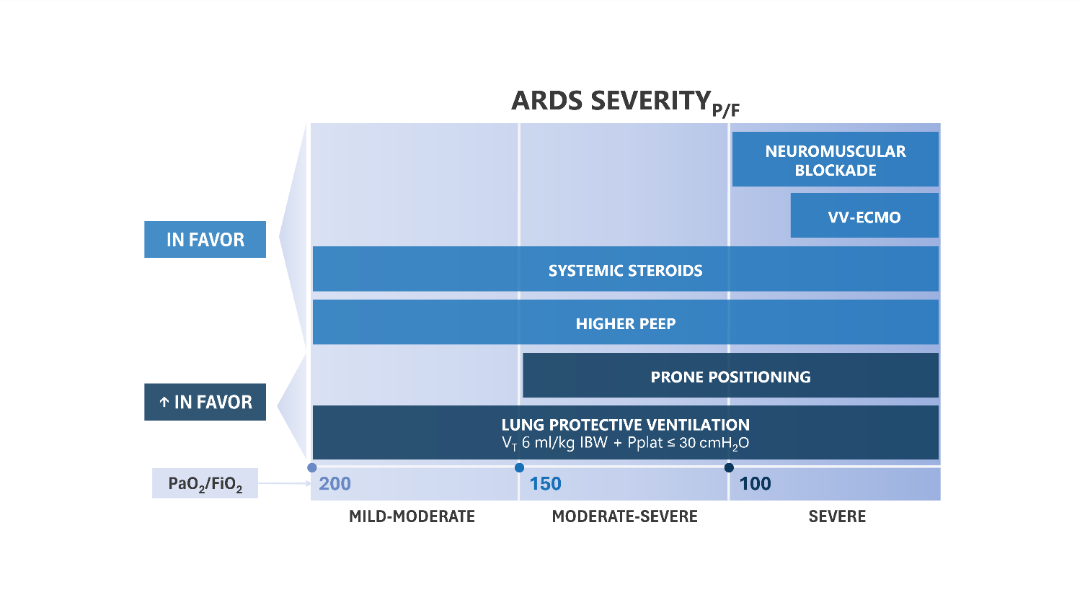ARDS: acute respiratory distress syndrome; IBW: ideal body weight; P/F: PaO₂/FiO₂ (ratio of the partial pressure of oxygen to the inspiratory fraction of oxygen); P_{plat}: plateau pressure; VT: tidal volume; VV-ECMO: veno-venous extracorporeal membrane oxygenation.

Fig. S2 Linear regression between delta of not-inflated tissue at 45 and 5 cmH₂O of PEEP and total lung tissue at 5 cmH₂O of PEEP.
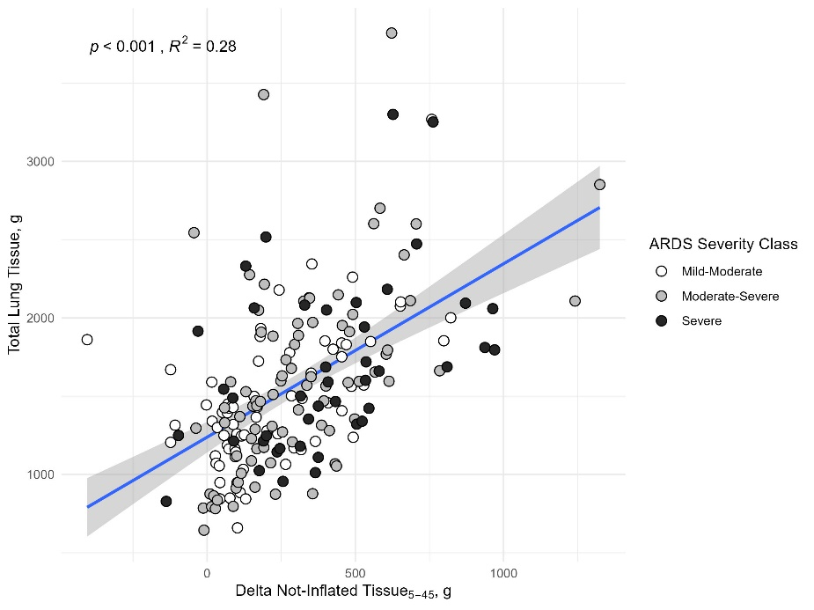

Fig. S3 Linear regression between well-inflated tissue and total lung gas volume.
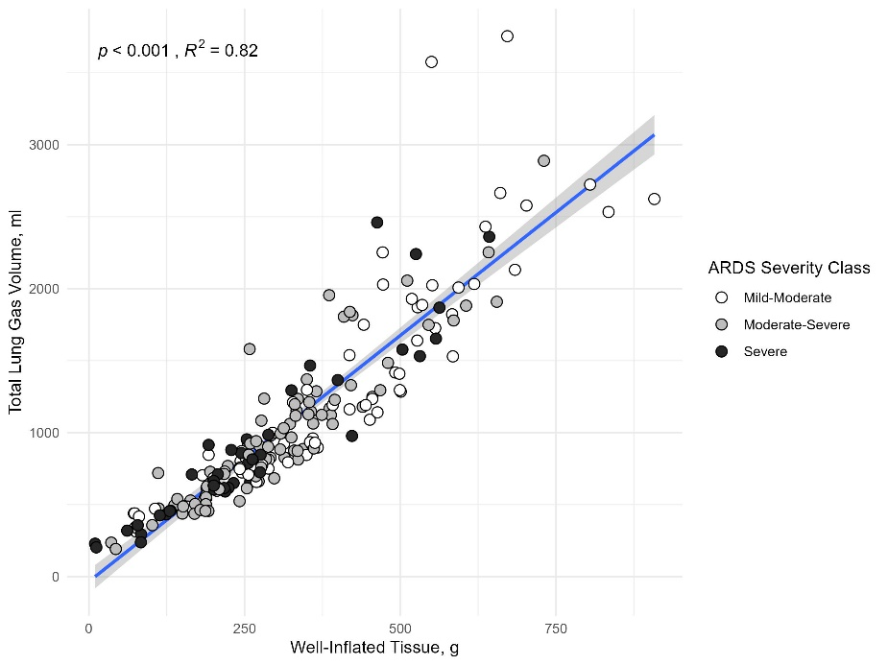

Fig. S4 Linear regression between well-inflated tissue and PaO₂.
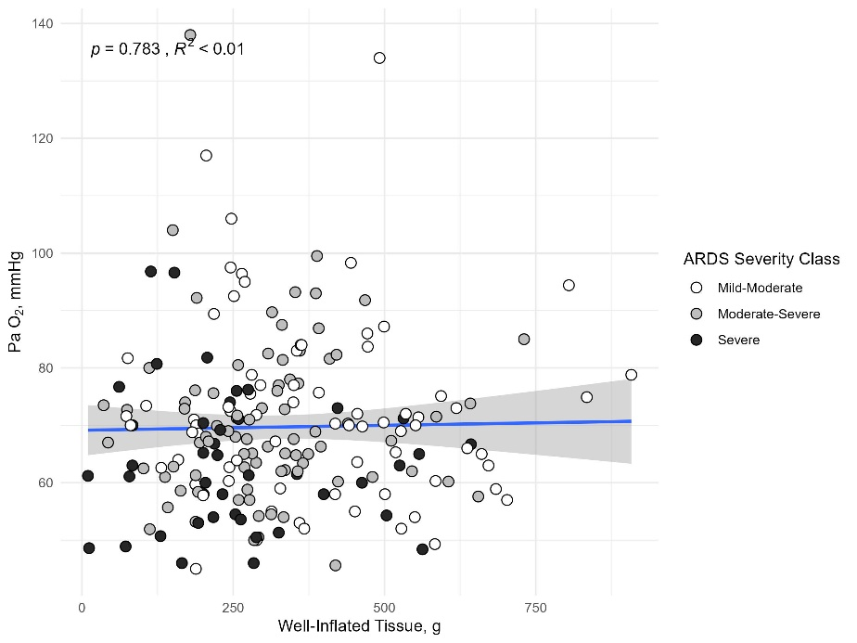

Fig. S5 Linear regression between not-inflated tissue and PaO₂.
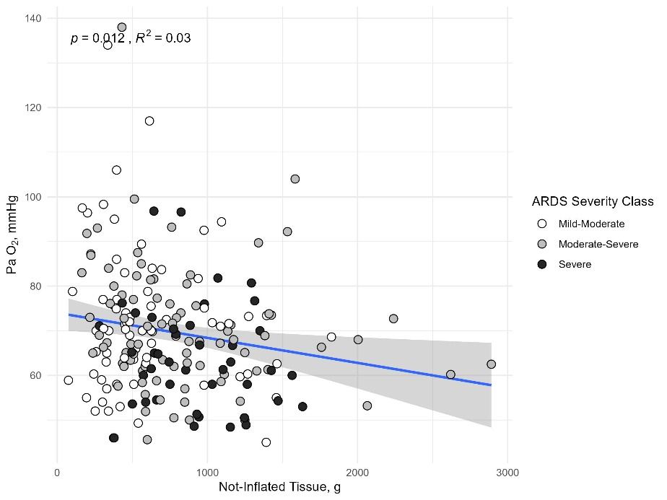

Fig. S6 Linear regression between total lung gas volume and PaO₂.
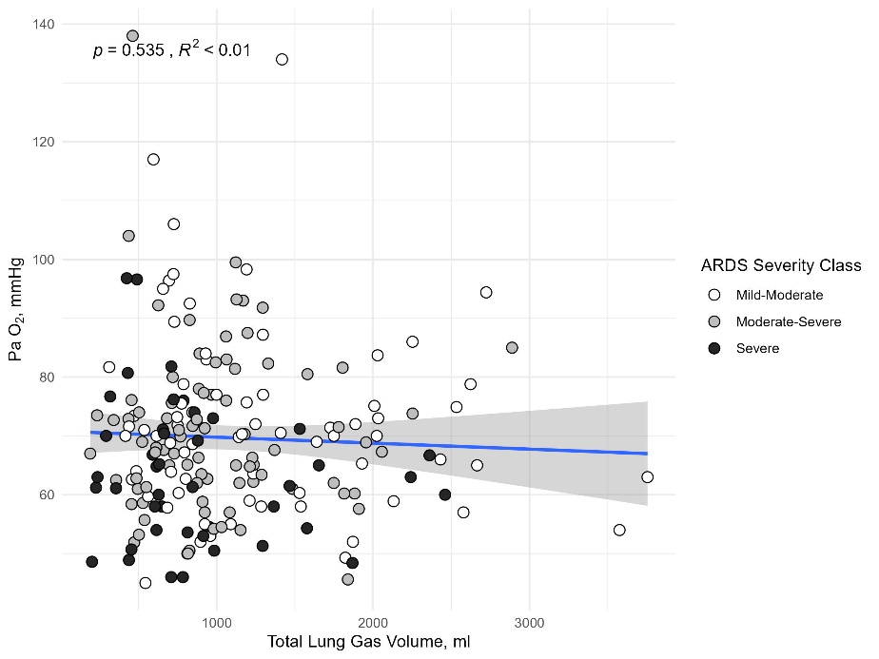

Fig. S7 Linear regression between total lung tissue and PaO₂/FiO₂, mechanical power ratio and driving pressure.
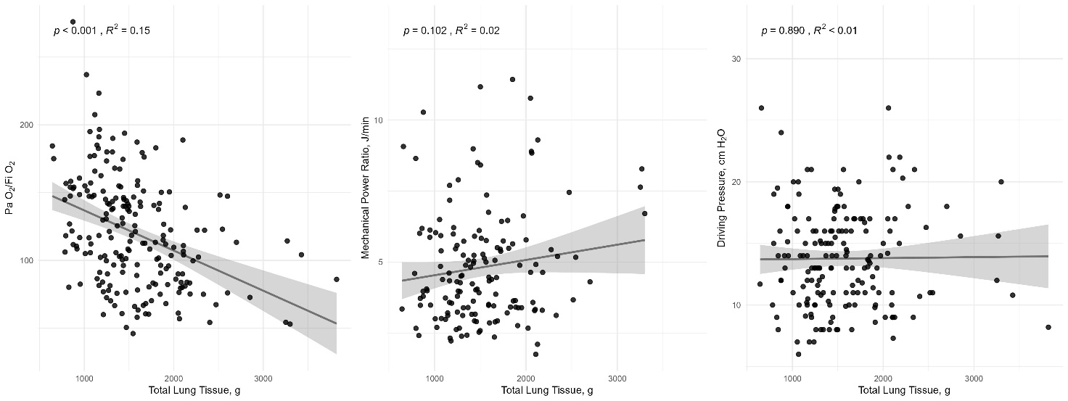

Fig. S8 Linear regression between overinflated tissue and PaO₂/FiO₂, mechanical power ratio and driving pressure.
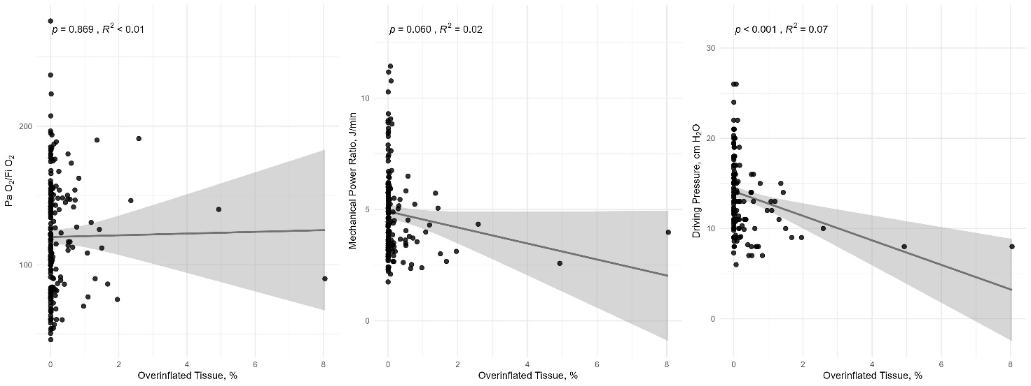

Fig. S9 Linear regression between well-inflated tissue and PaO₂/FiO₂, mechanical power ratio and driving pressure.
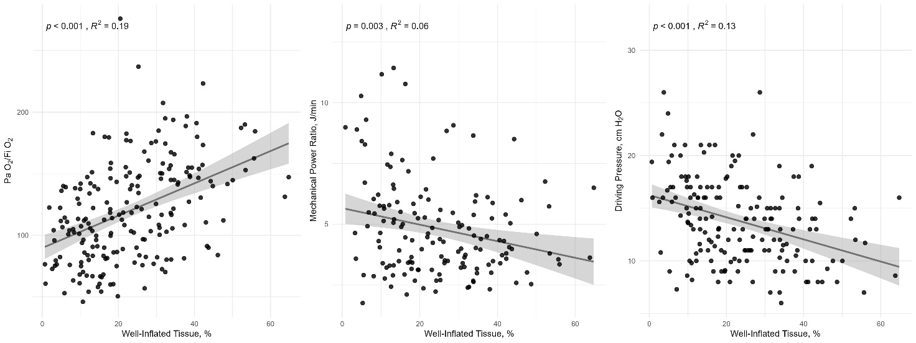

Fig. S10 Linear regression between poorly inflated tissue and PaO₂/FiO₂, mechanical power ratio and driving pressure.
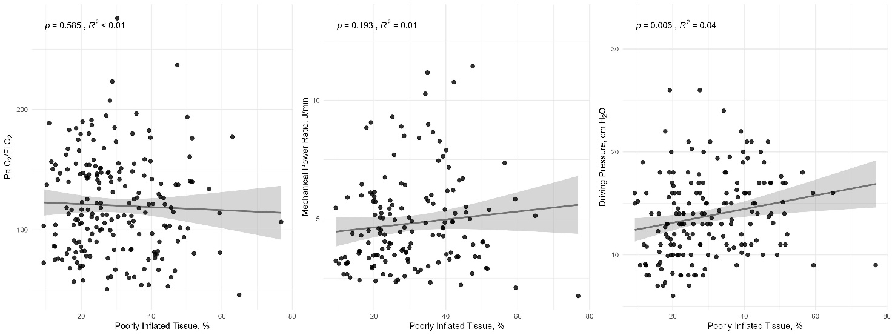
Fig. S11 Linear regression between not-inflated tissue and PaO₂/FiO₂, mechanical power ratio and driving pressure.
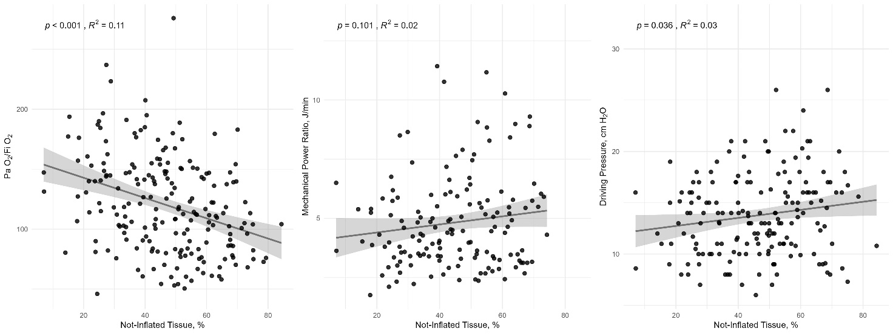

Fig. S12 Linear regression between total gas volume and PaO₂/FiO₂, mechanical power ratio and driving pressure.
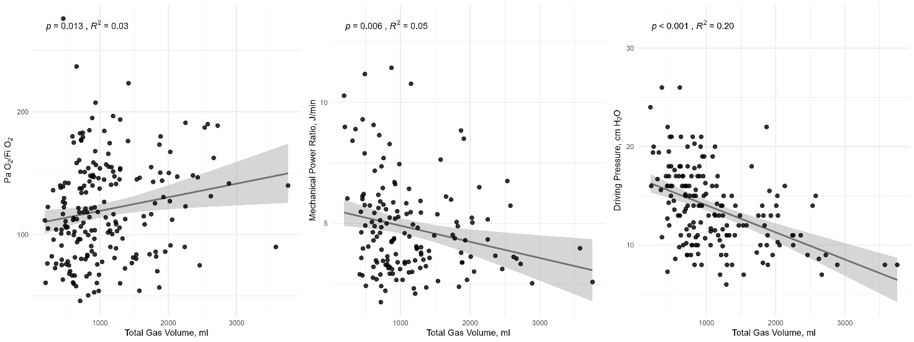

Fig. S13 Linear regression between recruitability and PaO₂/FiO₂, mechanical power ratio and driving pressure.
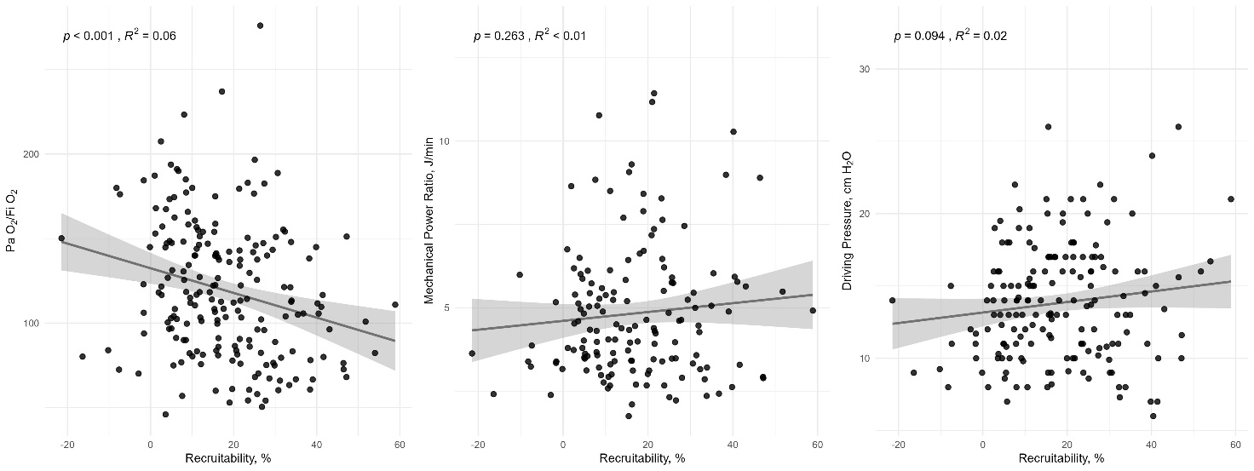
Fig. S14 Linear regression between PaO₂ and mechanical power ratio and driving pressure.
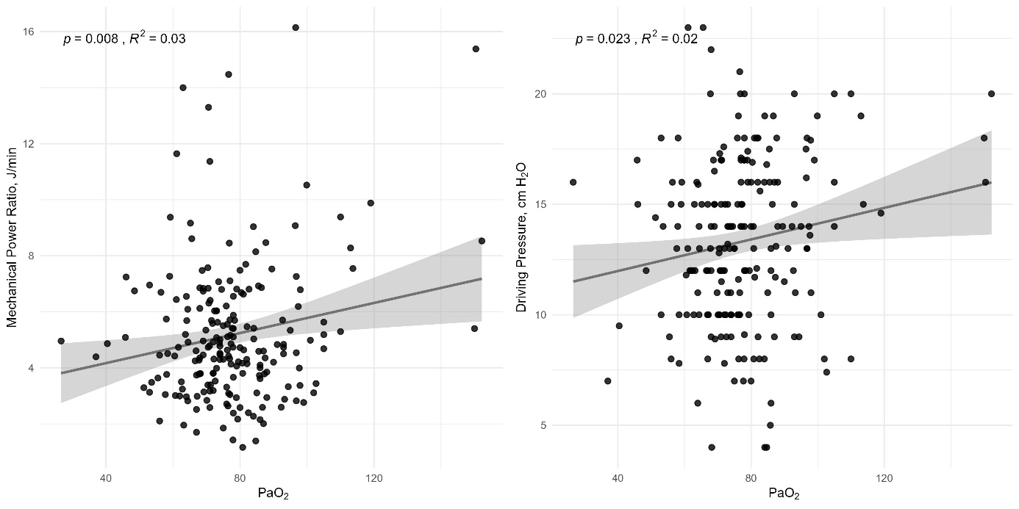

Fig. S15 Linear regression between FiO₂ and mechanical power ratio and driving pressure.
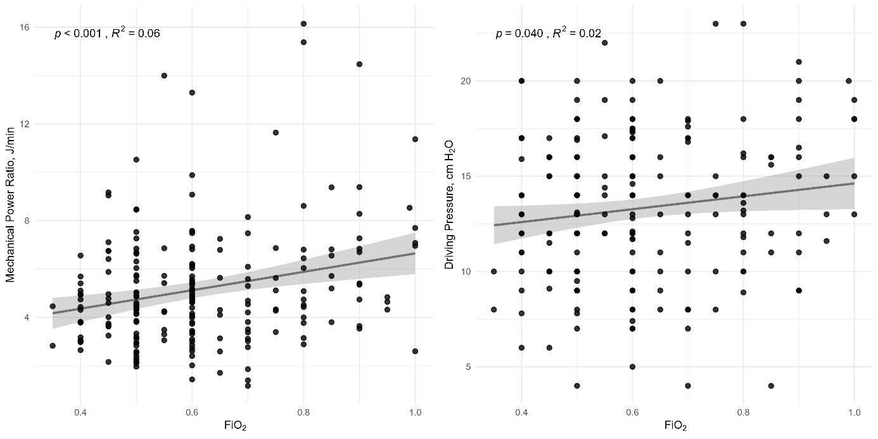

Fig. S16 Linear regression between PaO₂/FiO₂ and mechanical power ratio and driving pressure.
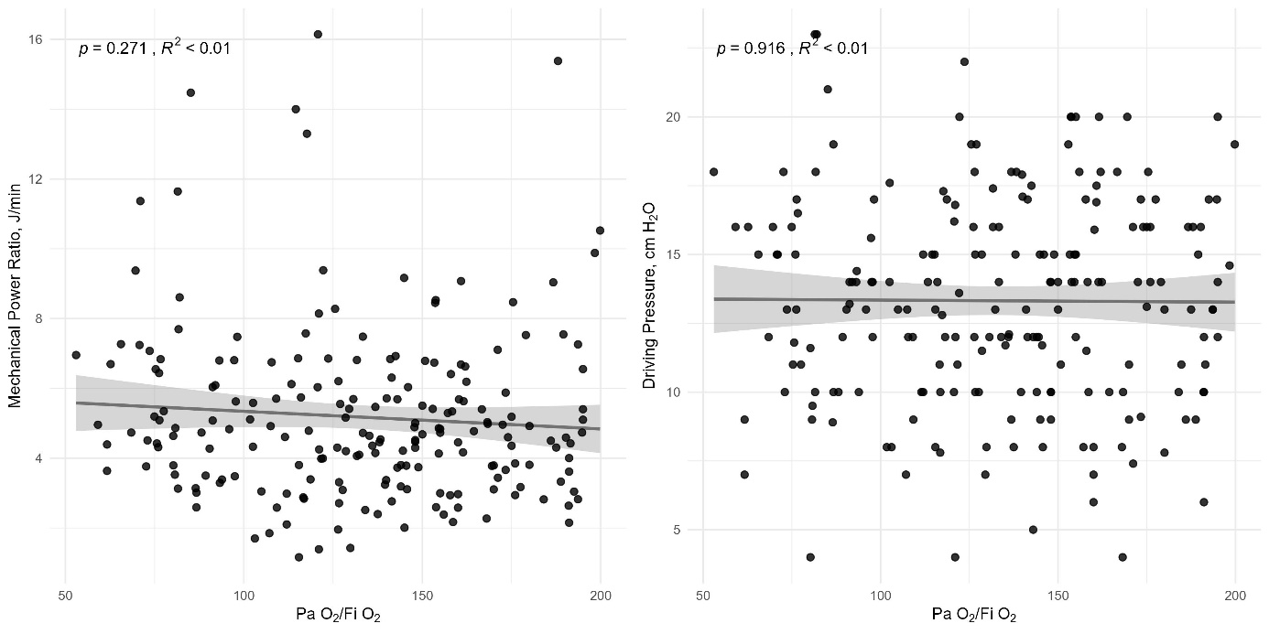

Fig. S17 Linear regression between PaCO₂ and PaO₂/FiO₂, mechanical power ratio and driving pressure.
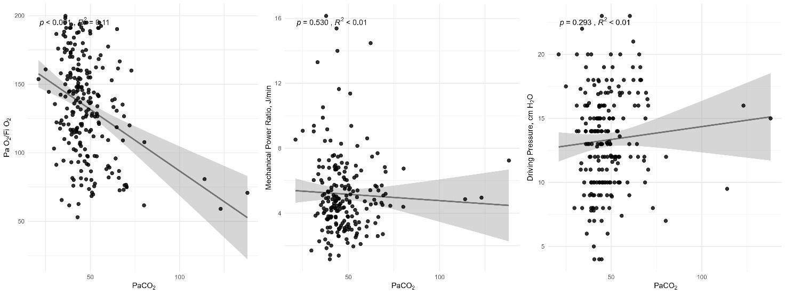

Fig. S18 Linear regression between minute ventilation and PaO₂/FiO₂, mechanical power ratio and driving pressure.
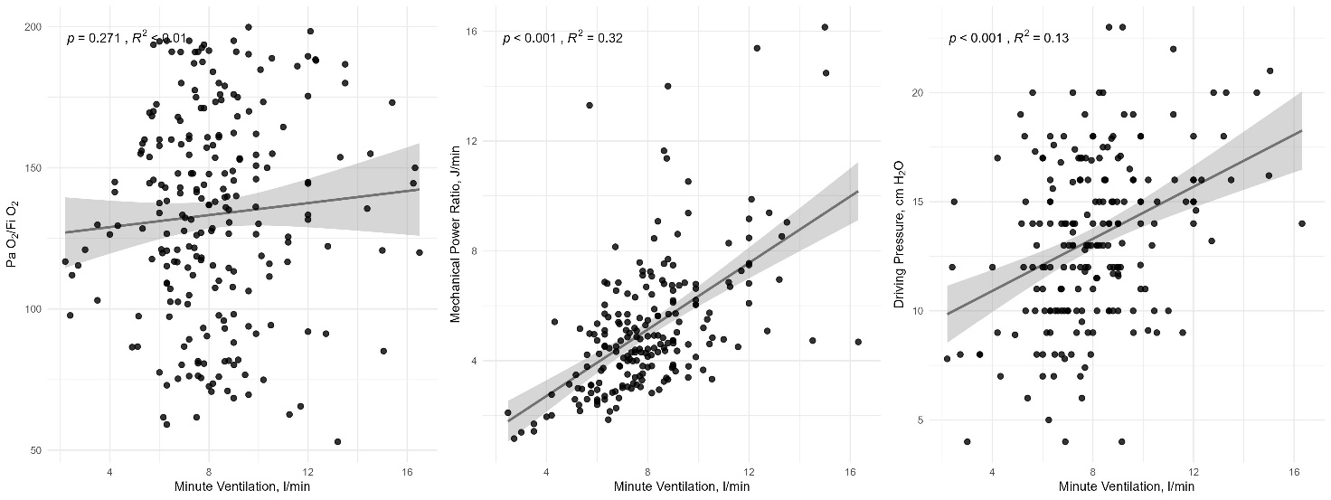

Fig. S19 Linear regression between ventilatory ratio and PaO₂/FiO₂, mechanical power ratio and driving pressure.
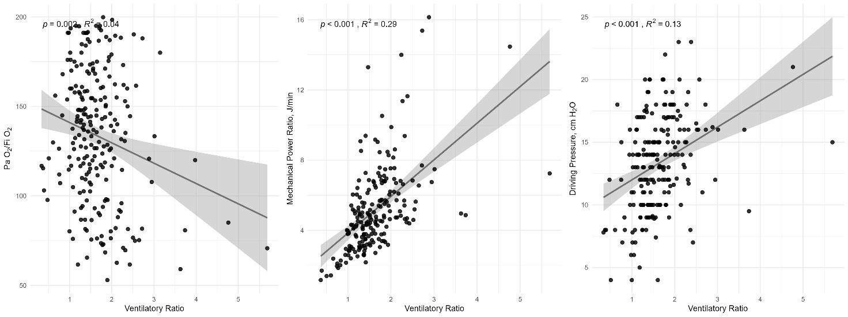

Fig. S20 Linear regression between respiratory system elastance and PaO₂/FiO₂.
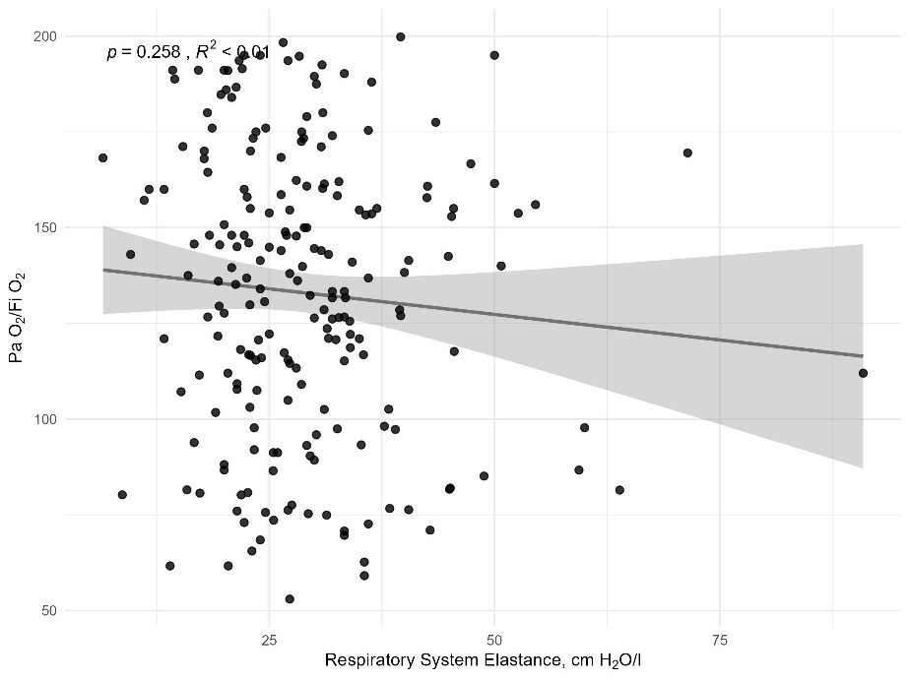

Fig. S21 Linear regression between lung elastance and PaO₂/FiO₂.
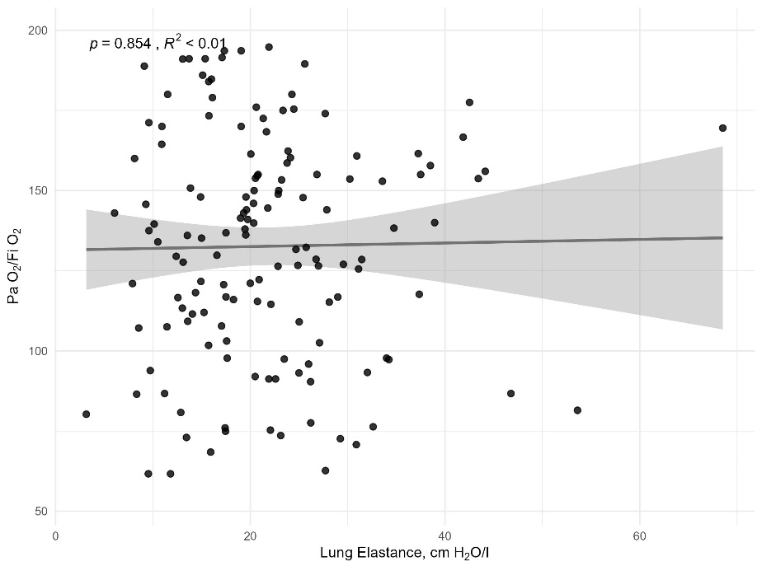

Fig. S22 Linear regression between peak pressure and PaO₂/FiO₂.
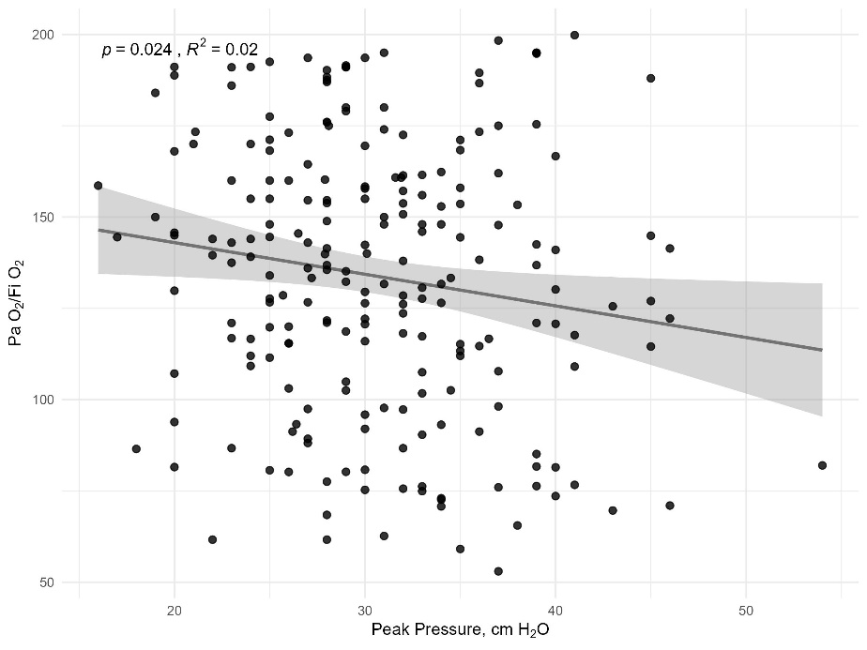

Fig. S23 Linear regression between plateau pressure and PaO₂/FiO₂.
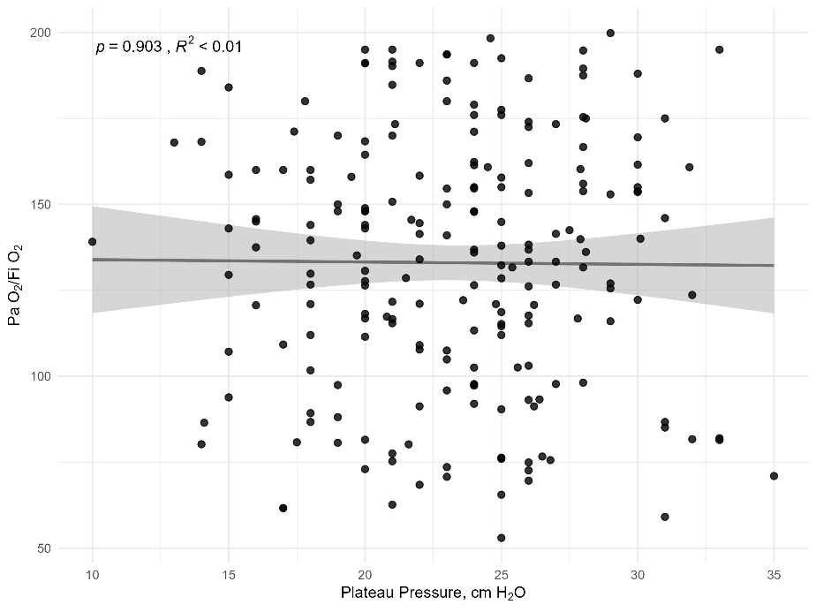

Fig. S24 Linear regression between stress and PaO₂/FiO₂, mechanical power ratio and driving pressure.
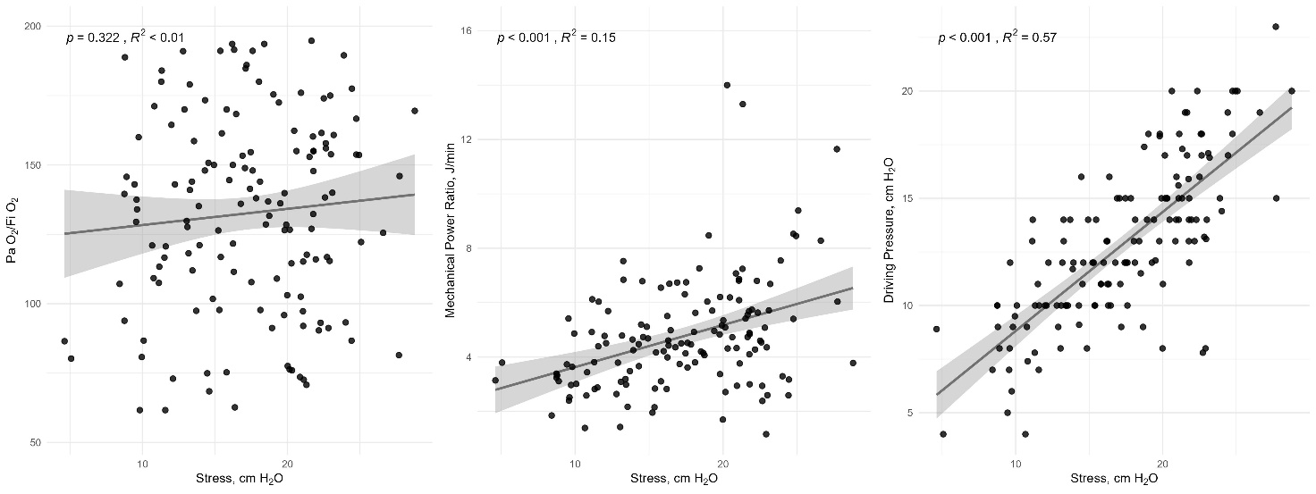

Fig. S25 Linear regression between strain and PaO₂/FiO₂, mechanical power ratio and driving pressure.
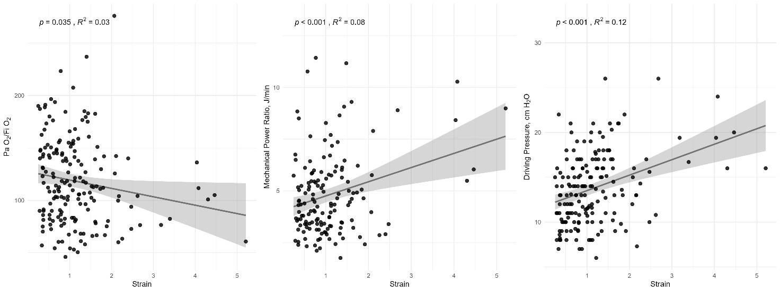

Fig. S26 Linear regression between tidal volume per kg of ideal body weight and PaO₂/FiO₂.
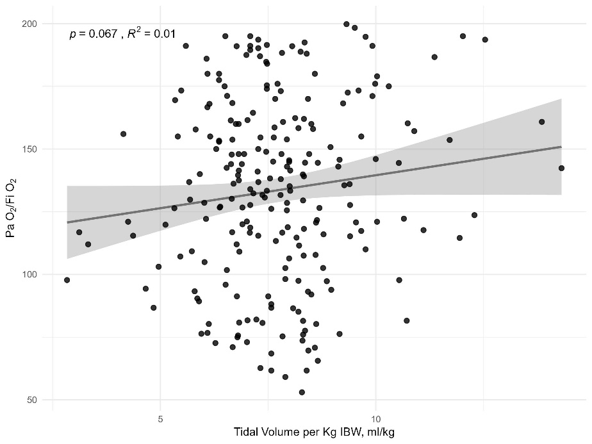
Fig. S27 Linear regression between respiratory rate and PaO₂/FiO₂.
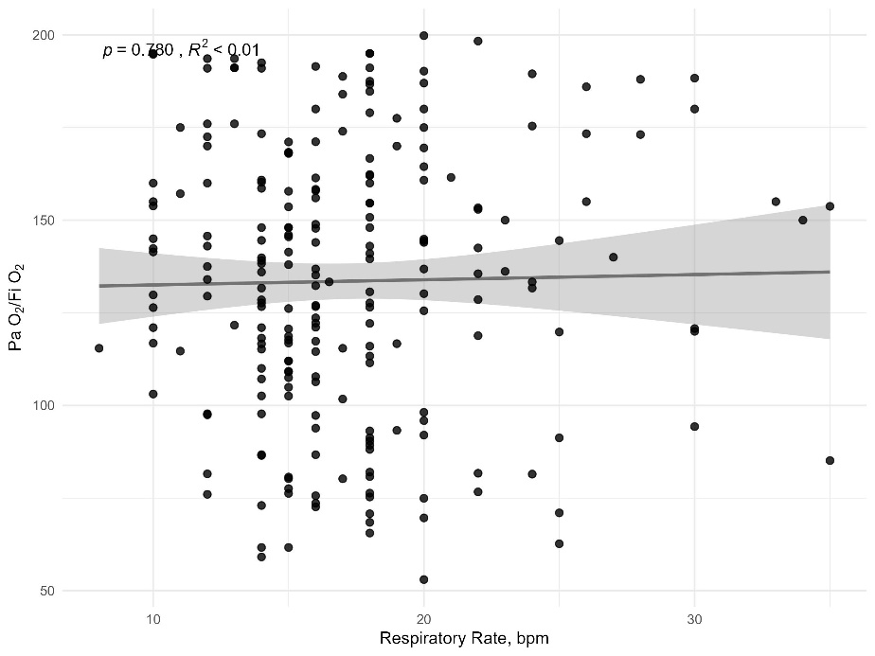

Fig. S28 Linear regression between inspiratory flow and PaO₂/FiO₂.
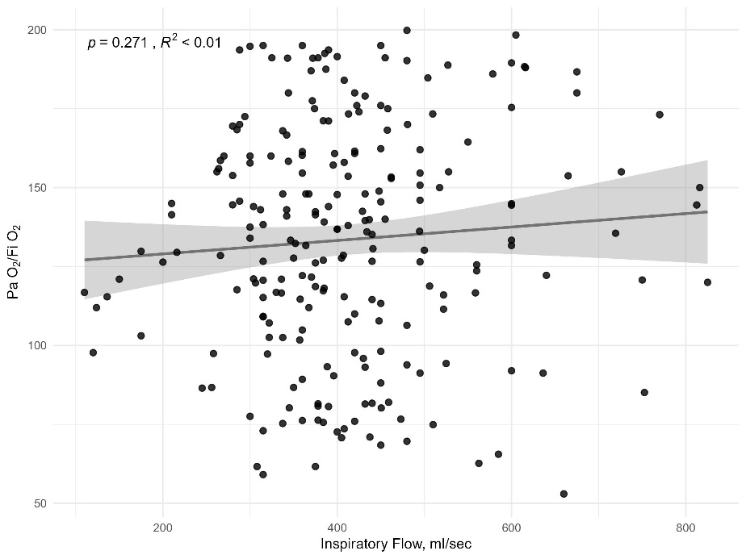

Fig. S29 Linear regression between PEEP and PaO₂/FiO₂, mechanical power ratio and driving pressure.
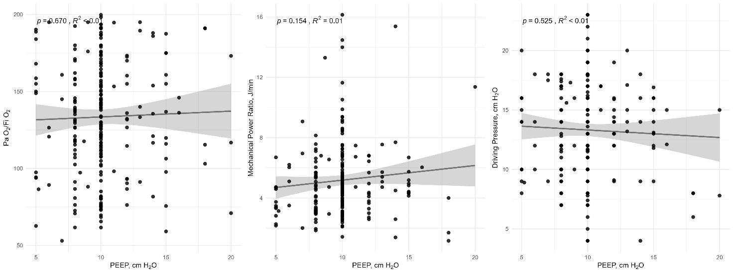

Fig. S30 Linear regression between age and PaO₂/FiO₂, mechanical power ratio and driving pressure.
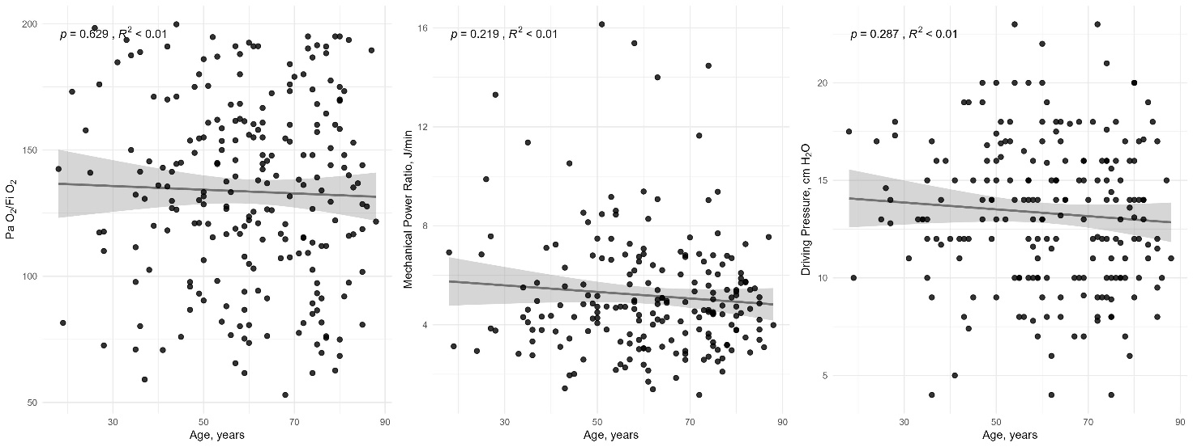

Fig. S31 Linear regression between body mass index and PaO₂/FiO₂, mechanical power ratio and driving pressure.
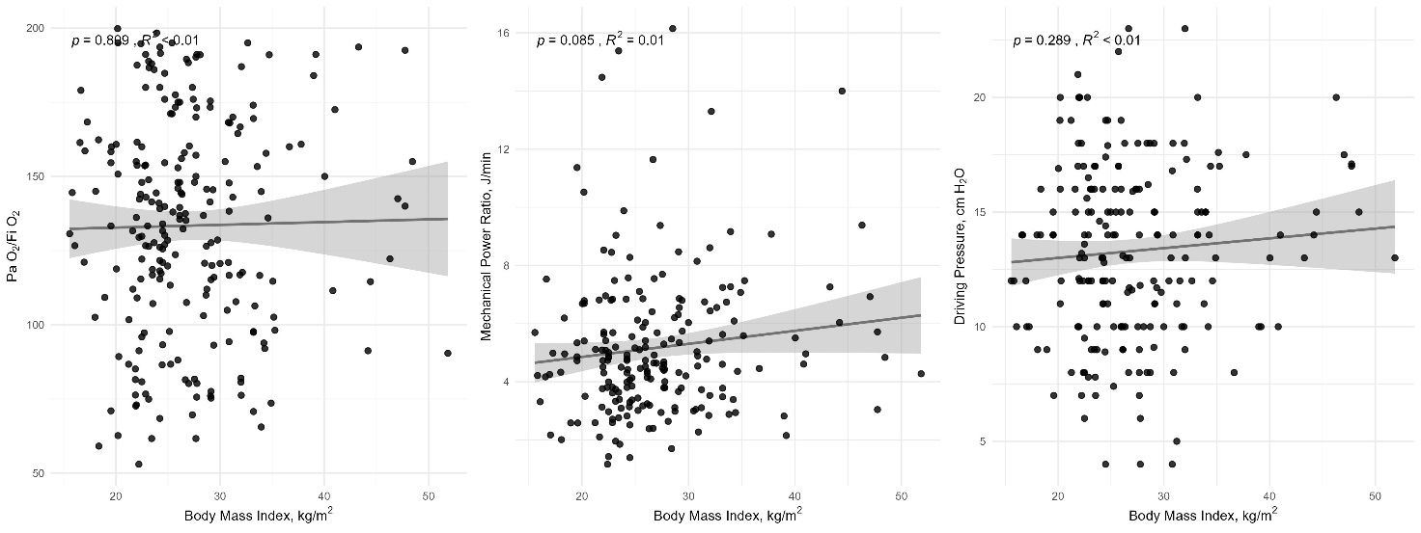

Fig. S32 Linear regression between SAPS II and PaO₂/FiO₂, mechanical power ratio and driving pressure.
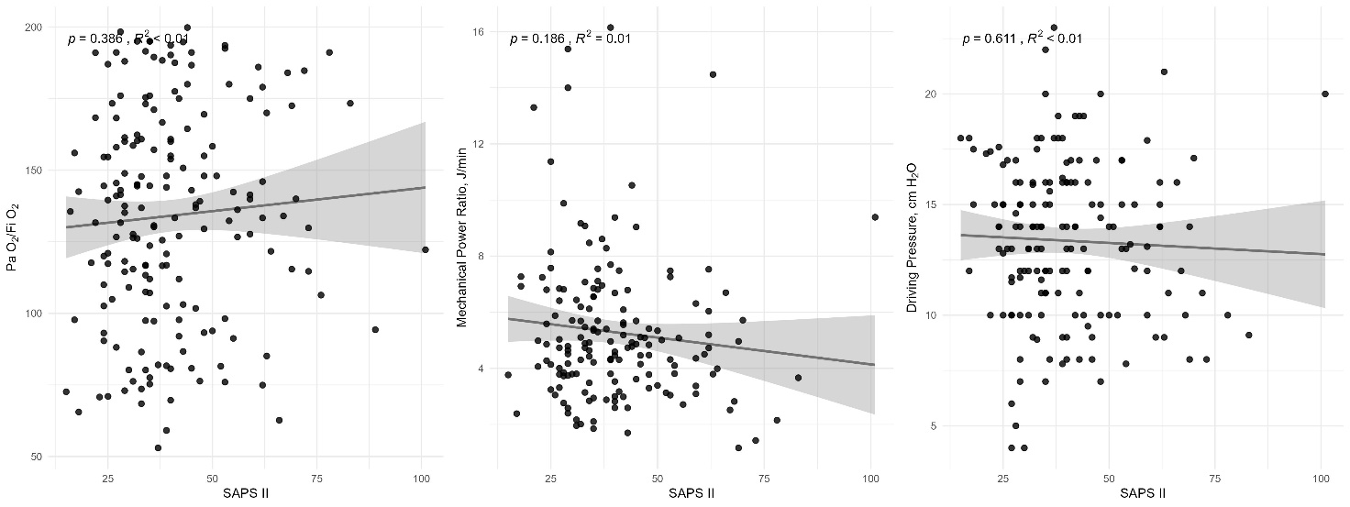

Fig. S33-36 Daily mean (95% confidence interval) of PaO₂, PEEP, PaCO₂ and Minute Ventilation, until day 15, of patients treated with ECMO and controls.

Taken from Supplementary Appendix of Combes A, Hajage D, Capellier G, et al. Extracorporeal membrane oxygenation for severe acute respiratory distress syndrome. N Engl J Med 2018;378:1965-75. DOI: 10.1056/NEJMoa1800385 [5]. Copyright ©(2018) Massachusetts Medical Society. Reprinted with permission from Massachusetts Medical Society.
PaCO₂: partial pressure or carbon dioxide; PaO₂: partial pressure of oxygen; PEEP: positive end-expiratory pressure.

References
1. Gattarello S, Coppola S, Chiodaroli E, et al (2023) Mechanical Power Ratio and Respiratory Treatment Escalation in COVID-19 Pneumonia: A Secondary Analysis of a Prospectively Enrolled Cohort. Anesthesiology 138:. https://doi.org/10.1097/ALN.0000000000004465
2. Sinha P, Fauvel NJ, Singh S, Soni N (2009) Ventilatory ratio: A simple bedside measure of ventilation. Br J Anaesth 102:. https://doi.org/10.1093/bja/aep054
3. Ibañez J, Raurich JM, Moris SG (1982) A simple method for measuring the effect of PEEP on functional residual capacity during mechanical ventilation. Crit Care Med 10:. https://doi.org/10.1097/00003246-198205000-00010
4. Qadir N, Sahetya S, Munshi L, et al (2024) An Update on Management of Adult Patients with Acute Respiratory Distress Syndrome: An Official American Thoracic Society Clinical Practice Guideline. Am J Respir Crit Care Med 209:. https://doi.org/10.1164/rccm.202311-2011ST
5. Combes A, Hajage D, Capellier G, et al (2018) Extracorporeal Membrane Oxygenation for Severe Acute Respiratory Distress Syndrome. New England Journal of Medicine 378:. https://doi.org/10.1056/nejmoa1800385

