APPENDIX ONE

Table of Contents

Item | Page
Table 1: Accurate Consensus Reporting Document (ACCORD) Checklist | 2-3
Search Strategy Used for Drafting Round One Clinical Statements | 4-5
Figure 1: PRISMA Flowchart of Studies Included for Qualitative Evidence Synthesis | 6
Table 2: Final studies included for drafting statements of the Delphi rounds | 7-16
References for the final studies included | 17-20
Table 3: Demographic Data of the Expert Panellists | 21-22
Table 4: Primary Specialty of the Experts | 22
Figure 2: Figure 2: Delphi Process and Involvement of the Experts | 23
Table 5: Future Research Priorities for Sepsis Management in Resource Limited Settings | 24

Table 1: The ACCORD (ACcurate COnsensus Reporting Document) checklist for reporting Delphi studies

﻿Manuscript section | ﻿Item wording | Page no.
﻿Title | ﻿Identify the article as reporting a consensus exercise and state the consensus methods used in the title. | 1
﻿Introduction | ﻿Explain why a consensus  s exercise was chosen over other approaches. | 7
﻿Introduction | ﻿State the aim of the consensus exercise, including its intended audience and geographical scope (national, regional, global). | 7
﻿Introduction | ﻿If the consensus exercise is an update of an existing document, state why an update is needed, and provide the citation for the original document. | 7
﻿Methods > Registration | ﻿If the study or study protocol was prospectively registered, state the registration platform and provide a link. If the exercise was not registered; this should be stated. | 8
﻿Methods > Selection of SC and/or panelists | ﻿Describe the role(s) and areas of expertise or experience of those directing the consensus exercise. | 8
﻿Methods > Selection of SC and/or panelists | ﻿Explain the criteria for panelist inclusion and the rationale for panelist numbers. State who was responsible for panelist selection. | 8
﻿Methods > Selection of SC  and/or panelists | ﻿Describe the recruitment process (how panelists were invited to participate) | 9
﻿Methods > Selection of SC and/or panelists | ﻿Describe the role of any members of the public, patients, or carers in the different steps of the study. | 9
﻿Methods > Preparatory  research | ﻿Describe how information was obtained prior to generating items or other materials used during the consensus exercise | 9
﻿Methods > Preparatory  research | ﻿Describe any systematic literature search in detail, including the search strategy and dates of search or the citation if published already. | Appendix P. 4 & 5 Figure 1, P. 6
﻿Methods > Preparatory  research | ﻿Describe how any existing scientific evidence was summarized and if this evidence was provided to the panelists. | 9
﻿Methods > Assessing  consensus | ﻿Describe the methods used and steps taken to gather panelist input and reach consensus (for example, Delphi, RAND/ UCLA, nominal group technique). | 9
﻿Methods > Assessing  consensus | ﻿Describe how each question or statement was presented and the response options. State whether panelists were able to or required to explain their responses, and whether they could propose new items | 10
﻿Methods > Assessing  consensus | ﻿State the objective of each consensus step. | 10
﻿Methods > Assessing  consensus | ﻿State the definition of consensus (for example, number, percentage, or categorical rating, such as “agree” or “strongly agree”) and explain the rationale for that definition. | 10
﻿Methods > Assessing  consensus | ﻿State whether items that met the prespecified definition of consensus were included in any subsequent voting rounds. | 10
﻿Methods > Assessing  consensus | ﻿For each step, describe how responses were collected, and whether responses were collected in a group setting or individually. | 10
﻿Methods > Assessing  consensus | ﻿Describe how responses were processed and/or synthesized. | 10
﻿Methods > Assessing consensus | ﻿Describe any piloting of the study materials and/or survey instruments | 9, 10
﻿Methods > Assessing  consensus | ﻿If applicable, describe how feedback was provided to panelists at the end of each consensus step or meeting. | 10
﻿Methods > Assessing  consensus | ﻿State whether anonymity was planned in the study design. Explain where and to whom it was applied and what methods were used to guarantee anonymity. | 9, 10
﻿Methods > Assessing  consensus | ﻿State if the steering committee was involved in the decisions made by the consensus panel. | 9
﻿Methods > Participation | ﻿Describe any incentives used to encourage responses or participation in the consensus process. | 9
﻿Methods > Participation | ﻿Describe any adaptations to make the surveys/meetings more accessible. | 9
﻿﻿Results | ﻿State when the consensus exercise was conducted. List the date of initiation and the time taken to complete each consensus step, analysis, and any extensions or delays in the analysis. | Appendix Figure 2  P.23
﻿Results | ﻿Explain any deviations from the study protocol, and why these were necessary | 9
﻿Results | ﻿For each step, report quantitative (number of panelists, response rate) and qualitative (relevant socio-demographics) data to describe the participating panelists. | Appendix Figure 2  P.23
﻿Results | ﻿Report the final outcome of the consensus process as qualitative (for example, aggregated themes from comments) and/or quantitative (for example, summary statistics, score means, medians, and/or ranges) data. | Table 1 and Table 2
﻿Results | ﻿List any items or topics that were modified or removed during the consensus process. Include why and when in the process they were modified or removed. | Appendix Figure 2  P.23
﻿Discussion | ﻿Discuss the methodological strengths and limitations of the consensus exercise. | 21-23
﻿Discussion | ﻿Discuss whether the recommendations are consistent with any preexisting literature and, if not, propose reasons why this process may have arrived at alternative conclusions. | 11-23
﻿Other information | ﻿List any endorsing organizations involved and their role. | 9
﻿Other information | ﻿State any potential conflicts of interests, including among those directing the consensus study and panelists. Describe how conflicts of interest were managed. | 26
﻿Other information | ﻿State any funding received and the role of the funder | 25

﻿﻿UCLA, University of California, Los Angeles, not applicable; PRISMA, Preferred Reporting Items for Systematic Reviews and Meta-Analyses; SC,
Steering Committee.
Search Strategy Used for Drafting the Round One Clinical Statements
A focused search was performed for this report through Medline and Embase databases using keywords sepsis management”, “sepsis treatment, sepsis diagnosis” “global burden of disease”, “Shock, Septic", “transfer”, “critical care”, “intensive care units”, “health resources”, “health care costs”, “adult”, “risk factors”, “organ dysfunction scores”, "Resource-Limited Settings" "Developing Countries", and following search strategy:

PubMed:
(((( "Sepsis/classification"[Mesh] OR "Sepsis/complications"[Mesh] OR "Sepsis/diagnosis"[Mesh] OR "Sepsis/diagnostic imaging"[Mesh] OR "Sepsis/drug therapy"[Mesh] OR "Sepsis/epidemiology"[Mesh] OR "Sepsis/microbiology"[Mesh] OR "Sepsis/mortality"[Mesh] OR "Sepsis/physiopathology"[Mesh] OR "Sepsis/prevention and control"[Mesh] OR "Sepsis/surgery"[Mesh] OR "Sepsis/therapy"[Mesh] )) OR ( "Shock, Septic/classification"[Mesh] OR "Shock, Septic/complications"[Mesh] OR "Shock, Septic/diagnosis"[Mesh] OR "Shock, Septic/diagnostic imaging"[Mesh] OR "Shock, Septic/drug therapy"[Mesh] OR "Shock, Septic/epidemiology"[Mesh] OR "Shock, Septic/etiology"[Mesh] OR "Shock, Septic/microbiology"[Mesh] OR "Shock, Septic/mortality"[Mesh] OR "Shock, Septic/physiopathology"[Mesh] OR "Shock, Septic/prevention and control"[Mesh] OR "Shock, Septic/surgery"[Mesh] OR "Shock, Septic/therapy"[Mesh] )) AND "Resource-Limited Settings"[Majr]) OR "Developing Countries"[Majr]
Embase:
(sepsis)/br OR (('septic shock')/br) AND (('resource limited setting')/br) OR (('developing country')/br) AND ([Controlled Clinical Trial]/lim OR [Randomized Controlled Trial]/lim OR [Meta Analysis]/lim) AND [2000-2023]/py
Between January 1, 2000 and March 1, 2023. Only original studies, excluding narrative reviews, scoping reviews, case series, and case reports were included. The literature was screened with titles and abstract by two interrater (SNM, PN) and full-text was retrieved for the selected article. Further, the literature was filtered for adult (>18 years) humans. Due to logistic issues and unavailability of a translators for the project, those articles where the full text was unavailable in English were excluded. A total of 39 articles were excluded as non-English of which 12 articles seemed relevant after screening the title and abstract. The search result and final studies included are presented in the Prisma flow diagram (Figure 1) and Table 2. The selected articles that were used to draft the statements of the Round 1 of Delphi project are presented in Table 2. Besides the focused search, the references included in the recent edition of surviving sepsis campaign guidelines [14] for the management of sepsis and septic shock was also included for drafting the clinical statements of Round 1.

Figure 1: PRISMA Flowchart of Studies Included for Qualitative Evidence Synthesis
From: Page MJ, et al. The PRISMA 2020 statement: an updated guideline for reporting systematic reviews. BMJ 2021;372: n71.

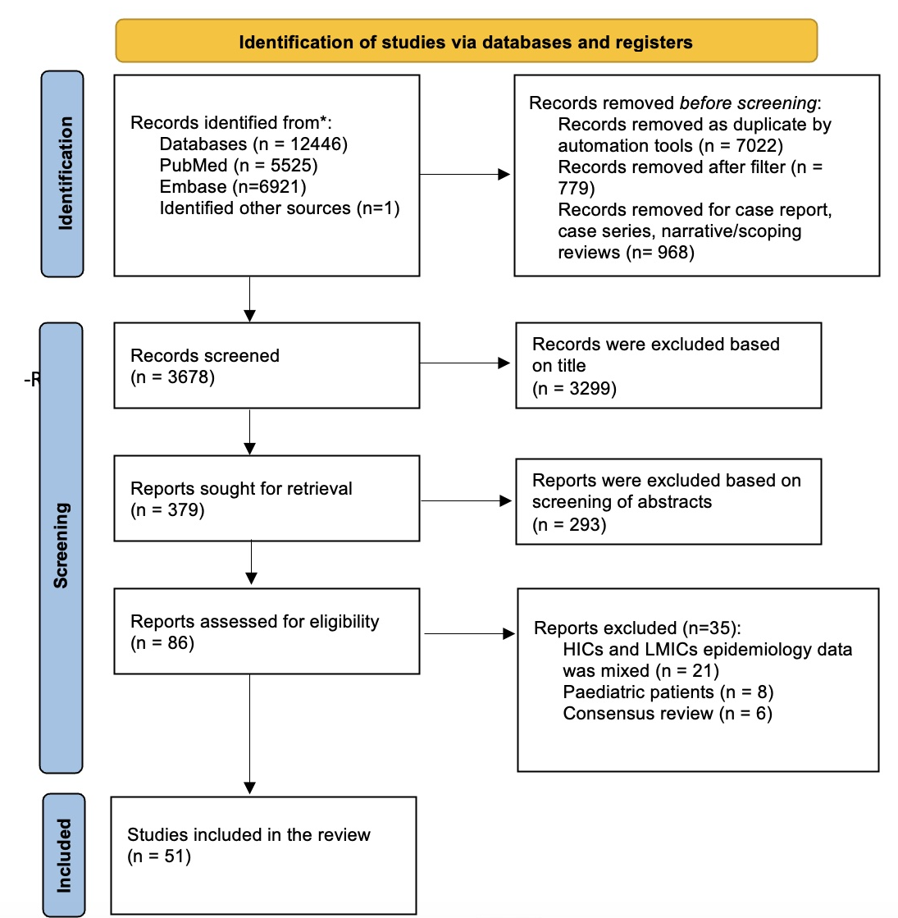

Table 2: Final studies included for drafting statements of the Delphi rounds

First Author, year of publication | Type of study | Country | Number of patients (articles) | Intervention | Comparator | Main findings | Relevant Domain(s)
Allel K, 2023 [1] | meta-analysis | LMICs | 109 articles | BSI caused by antibiotic resistant bacteria | BSI caused antibiotic sensitive  bacteria | there was paucity and wide heterogeneity of data between different geographic regions. However, antibiotic resistance was associated with substantial disease and economic burden in LMICs. | 1, 2
Kataria S, 2023 [2] | prospective observational study | India | 135 | septic shock patients | - | septic shock patients fulfilling the hypoperfusion and non-hypoperfusion context exhibited similar 28-d all-cause hospital mortality, although patients with hypoperfusion displayed a more severe circulatory dysfunction. Lactate levels at 6h had a better predictive value in predicting 28-d mortality than other parameters. Persistently high P(cv-a) CO₂ (> 6 mmHg) or increased CRT (> 4 s) at 3 h and 6 h during early resuscitation can be a valuable additional aid for prognostication of septic shock patients. | 4
Kwizera A, 2023 [3] | prospective observational study | Uganda | 499 | COVID-19- associated ARDS | - | standard oxygen therapy and HFNO as well as awake proning are associated with a lower mortality resulting from COVID-19-associated ARDS compared to NIV and invasive mechanical ventilation. | 5
Do SN, 2022 [4] | prospective observational study | Vietnam | 252 | sepsis patients | - | despite poor discriminatory ability, qSOFA could independently predict mortality in ICU in resource-limited settings. | 4
Levin AT, 2022 [5] | meta-analysis | developing countries | 97 articles | COVID-19 among adults | - | burden of COVID-19 is higher in developing countries because of increased transmission among middle-aged and older adults. | 1, 2
Li A, 2022 [6] | point-prevalence study | 22 (Asia) | 386 ICUs | sepsis patients | - | overall prevalence of sepsis in ICU was 22.4%. There was low compliance to sepsis bundle in HICs. Mortality due to sepsis was higher in LICs/LMICs. Delay in antibiotic administration beyond three hours was an independent risk factor for increased mortality. | 1, 2, 5
Lei S, 2022 [7] | meta-analysis | China | 324,020 | sepsis patients | - | the prevalence of sepsis in Chinese ICUs was 25.5%. The risk factors influencing prevalence was sex, sepsis severity, infection site, causative microorganism, and infection type. | 1-3
Do Sn, 2022 [8] | multi-center observational study | Vietnam | 252 | sepsis patients | - | sepsis management needs improvement with increasing resources allocation for ICUs, training program, along with improvement in compliance of sepsis bundles, and treating underlying etiology of sepsis and shock optimally. | 1-3
Puchalski Ritchie LM, 2022 [9] | observational mixed-method study | Ethiopia | 113 | sepsis patients | - | no improvement in sepsis outcomes was found but a trend for increasing odds of survival post-implementation and no significant change in knowledge pre- and post-implementation of sepsis tailored treatment protocol | 1,2
Jog S, 2022 [10] | retrospective observational Study | India | 1,201 | COVID-19 related ARDS | - | HFNO and/or NIV could successfully avoid invasive mechanical ventilation in COVID-19 with PO₂/FiO₂ ratio <150. Those who needed IMV due to failure of HFNO or NIV had high (87.5%) mortality. | 5
Rosenthal VD, 2022 [11] | prospective observational study | LMICs | 7,775 | ICU patients | - | increase rates of HAI in seven LMICs during the first five months of the COVID-19 pandemic. | 1, 2
Liang P, 2022 [12] | prospective observational study | China | 146 | shock | without shock | no significant difference was seen with procalcitonin and neutrophil-lymphocyte ratio in the gram-positive cocci infection group. However, PCT change was significantly higher in the gram-negative cocci group. Combination of both has the highest accuracy in patients with blood-stream infection. | 4
Hung TM, 2022 [13] | retrospective | Vietnam |  | dengue, sepsis and tetanus | - | considerable cost of treatment for patients in ICU. | 1, 2
Rice B, 2022 [14] | post-hoc analysis of prospective observational. | sub-Saharan Africa | 10,437 | sepsis patients | - | despite quality of care available for sepsis patient has improved, mortality has not reduced. | 1, 2
Kumar, 2022 [15] | cross-sectional  study | 15 (Asia-Pacific region) | 59 hospitals |  | - | Lower middle-income countries and upper middle income countries ICUs had lower nurse-to patient ratio and surge capacity along with limited access to CRRT, ECMO, physiotherapy and MRI services compared to HICs. Most (77%) hospitals adopted surviving sepsis campaign guidelines. | 1, 2
Machado FR, 2021 [16] | Multi-center observational study | Brazil | 10,271 | Two cohorts of infection and sepsis | - | qSOFA ≥ 2 has low sensitivity for predicting mortality in patients with suspected infection. However, qSOFA score ≥ 1 or combining lactate to a qSOFA score ≥ 1 may improve sensitivity. | 4
Zampieri FG, 2021 [17] | RCT | Brazil | 11,052 | balanced solution | 0.9% saline | among critically ill patients requiring fluid challenges, use of a balanced solution compared with 0.9% saline solution did not significantly reduce 90-day mortality. | 5
Losonczy LI, 2021 [18] | white paper | - | - | - | - | management of critical care resources in resource-limited settings. | 1-3
Ali WA, 2021 [19] | RCT | Egypt | 60 | procalcitonin | CRP | procalcitonin is a more accurate for diagnosis and prognosis of sepsis than CRP. Procalcitonin could reduce the exposure to duration of antibiotics and hospital length of stay. | 4
Evans L, 2021 [20] | guidelines | global | - | - | - | surviving sepsis campaign guidelines on the management of sepsis and septic shock | 4,5
Booraphun S, 2021 [21] | prospective observational study. | Thailand | 903 | sepsis patients | - | sepsis fast track was associated with improved sepsis care and lower mortality. | 4, 5
Adegbite BR, 2021 [22] | meta-analysis | LMICs | 27,237 | - | - | individual sepsis performance scores performed poor to acceptable for diagnosis and prediction of mortality in sepsis. | 4
Brizuela V, 2021 [23] | point prevalence study | 52 countries | - | - | - | poor maternal outcomes among the post-partum or post-abortion period from facilities located in LICs (adjusted odds ratio 1·84 [95% CI 1·05-3·22]). | 1,2
Cheshire J, 2021 [24] | before-and after observational study | Malawi | - | maternal sepsis | - | FAST-M complex intervention was feasible and led to the improved recognition and management of suspected maternal sepsis in a low-resource setting such as Malawi. | 4,5
Thuy DB, 2020 [25] | prospective observational study | Vietnam | 838 | ICU admissions | - | high prevalence of antibiotic-resistant organisms in Vietnamese ICUs. On admission, colonization prevalence of antibiotic-resistant organism from community (62.2%) was comparable to those transferred from other hospitals (63.8%). | 1,2
Stephen AH, 2020 [26] | systematic review | LMICs | - | sepsis patients | - | guidelines specific to LMICs for sepsis and septic shock management need further improvement and studied prospectively. | 1
Dubin A, 2020 [27] | prospective observational study | Argentina | 787 | sepsis patients | - | Use of a fluid bolus with 0.9% saline and RL and the use of norepinephrine as first vasopressor was similar to world-wide practice. After initial resuscitation 413 patients developed persistent or recurrent hypoperfusion, which required further volume expansion. In this setting, the assessment of fluid- responsiveness with dynamic tests to guide fluid resuscitation was independently associated with decreased mortality. | 1,2, 5
Rawat N, 2020 [28] | RCT | India | 50 | RL | acetate solution | RL and acetate solution was equally efficacious in correction of metabolic acidosis in critically ill adults. | 5
Wani SJ, 2020 [29] | RCT | India | 100 | vitamin C, thiamine and hydrocortisone (n = 50) | standard therapy (n = 50) | no difference in the in-hospital mortality and 30-day mortality but lower vasopressors and faster lactate clearance in intervention arm. | 5
Silberberg B, 2020 [30] | systematic review | sub-Saharan Africa | - | - | - | international guidelines contain disparate recommendations on intravenous fluid use, lack specificity and are largely unattainable in low-income countries given available resources. | 1,2
McBride A, 2019 [31] | observational study | Vietnam | 188 | septic shock and dengue |  | high payments incurred by septic shock and dengue shock patients respectively, and high mortality. | 1
Teparrukkul P, 2019 [32] | prospective observational study | Thailand | 4989 | malaria positive | - | qSOFA and SOFA could be used as disease severity in adults with malarial sepsis | 4
Estenssoro E, 2019 [33] | prospective observational study | Argentina | 809 | sepsis patients | - | patients admitted in public hospitals belong to a socially disadvantaged group and were sicker at admission, more likely to be in shock, with a higher mortality. | 1, 2
Lewis JM, 2019 [34] | meta-analysis | sub-Saharan Africa | 2800 | sepsis patients | - | TB and HIV are the common cause of sepsis in Sub-Saharan Africa. Optimal treatment strategies and long-term outcomes are lacking. | 1,2, 5
Curcio D, 2019 [35] | meta-analysis | developing countries | 99 articles | SSI in developing countries | SSI in developed countries | incidence of SSI is higher in developing countries compared to those of developed world. | 1,2, 5
Dondorp A, 2019 [36] | Book | resource-limited setting | - | - | - | book on the management of sepsis in resource-limited setting which is a largely unexplored frontier with important opportunities for research, training, and other initiatives for improvement. | 1, 2, 5
McGloughlin S, 2018 [37] | report | tropical countries | - | sepsis | - | published sepsis guidelines are based on studies primarily performed in HICs and may or may not be relevant to practice in the tropical countries. | 1, 2
Amin P, 2018 [38] | report | tropical countries |  | dengue fever | - | dengue hemorrhagic fever and dengue shock syndrome are among the leading causes of morbidity and mortality in patients with dengue. Effective fluid management is the mainstay of management. | 4, 5
Abdu M, 2018 [39] | cross-sectional study | Malawi | 23 healthcare centers, 13 hospitals | - | - | challenges in the implementation of existing surviving sepsis campaign recommendations in low-income countries because of resource limitations. | 1, 2
Lie KC, 2018 [40] | prospective observational | China | 454 | critically ill patients | - | community-acquired sepsis is due to a variety of pathogens and usually managed outside the ICU and with poor compliance to sepsis bundles in Southeast Asia. In this population, calculation of SOFA scores is feasible and associated with mortality. | 4
Schultz M, 2017 [41] | expert Review | global | - | - | - | evidence on the sepsis management in resource-limited settings is lacking and largely unexplored. There is a need for research, training, and other policy initiatives for improvement. | 1, 2
Sendagire C, 2017 [42] | prospective observational study | Uganda | 118 | ICU patients |  | modified SOFA (replacing PaO₂/FiO₂ ratio with SPO₂/FiO₂) is feasible. More research is needed to prove its correlation with mortality. | 4
Dondorp A, 2017 [43] | guidelines | Global | - | - | - | an international panel of experts with experience in resource-limited ICU settings evidence-based (GRADE) recommendations for the management of severe falciparum malaria and severe dengue. | 1, 2, 5
Morton B, 2017 [44] | meta-analysis | sub-Saharan Africa | 3 articles | - | - | research is lacking in early recognition and management of sepsis in Sub-Saharan Africa. Meta-analysis of two RCTs found higher mortality with early goal-directed fluid resuscitation. | 1, 2
WHO, 2017 [45] | Report | Global | - | - | - | knowledge gaps on the epidemiology and impact of sepsis in LMICs. Vulnerable populations are pregnant, postpartum, neonates, and staying in LMICs | 1, 2
Machado FR, 2017 [46] | one-day point prevalence study | Brazil | 2632 | sepsis patients | - | burden of sepsis in resource-limited settings is high and outcomes are dependent on resources availability. | 1, 2
Kwizera A, 2016 [47] | experts report | resource-limited settings | - | - | - | recommendations for sepsis recognition and management in resource-limited settings. | 1-5
Endris M, 2014 [48] | cross-sectional  study | Ethiopia | 83 | VL patients | - | prevalence of focal infection is associated with bacterial infection and sepsis in VL patients, predominant due to Staph. aureus | 5
Jacob ST, 2013 [49] | prospective observational study | Uganda | 368 | HIV infected patients | - | among HIV-infected patients admitted with sepsis, 25% had MTB bacteremia. Standard tests for diagnosing pulmonary TB were inaccurate and MTB bacteremia risk score could help in early diagnosis of co-infection. | 5
Dünser MW, 2012 [50] | guidelines | global | - | - | - | Evidence is scarce on the t management of pediatric and adult sepsis in resource-limited settings. | 1, 2
Allegranzi B, 2011 [51] | meta-analysis | developing countries | 220 articles | HAI in developing countries | HAI in developed countries | Incidence of HAI was 15.5 per 100 patients much higher than reported in Europe and USA. SSIs were most common with gram-negative bacteria most common isolate. | 5

LMICs: low-and middle-income countries, BSI: blood-stream infection, HFNO: high-flow nasal oxygen, COVID-19: coronavirus disease 2019, ARDS: acute respiratory distress syndrome, NIV: non-invasive ventilation, SOFA: sequential organ failure assessment, qSOFA: quick SOFA, ICU: intensive care unit, LICs, low-income countries, HICs: high-income countries, PO₂/FiO₂: ratio of partial pressure of oxygen to fractional concentration of oxygen, IMV: invasive mechanical ventilation, HAI: healthcare-associated infections, PCT: procalcitonin, CRRT: continuous renal replacement therapy, ECMO: extra-corporeal membrane oxygenation, RCT: randomized controlled trial, RL: ringer’s lactate, SSI: surgical-site infections, VL: visceral leishmaniasis, HIV: human-immunodeficiency virus, MTB: mycobacterium tuberculosis,

References for the final studies included

- Allel, K., et al., The impact of inpatient bloodstream infections caused by antibiotic-resistant bacteria in low- and middle-income countries: A systematic review and meta-analysis. PLoS Med, 2023. 20(6): e1004199. DOI: 10.1371/journal.pmed.1004199.
- Kataria, S., et al., Hypoperfusion context as a predictor of 28-d all-cause mortality in septic shock patients: A comparative observational study. World J Clin Cases, 2023, 11(16): p. 3765-3779. DOI: 10.12998/wjcc. v11.i16.3765.
- Kwizera, A., et al., Respiratory Support Techniques for COVID-19-Related ARDS in a Sub-Saharan African Country: A Multicenter Observational Study. Chest, 2023, 164(2): p. 369-80. DOI: 10.1016/j.chest.2023.01.039.
- Do, S.N., et al., Predictive validity of the quick Sequential Organ Failure Assessment (qSOFA) score for the mortality in patients with sepsis in Vietnamese intensive care units. PLoS One, 2022, 17(10): e0275739. DOI: 10.1371/journal.pone.0275739.
- Levin, A.T., et al., Assessing the burden of COVID-19 in developing countries: systematic review, meta-analysis and public policy implications. BMJ Glob Health, 2022, 7(5): e008477. DOI: 10.1136/bmjgh-2022-008477.
- Li, A., et al., Epidemiology, Management, and Outcomes of Sepsis in ICUs among Countries of Differing National Wealth across Asia. Am J Respir Crit Care Med, 2022, 206(9): p. 1107-16. DOI: 10.1164/rccm.202112-2743OC.
- Lei, S., et al. Prevalence of sepsis among adults in China: A systematic review and meta-analysis. Front Public Health, 2022, 10: 977094. DOI: 10.3389/fpubh.2022.977094.
- Do, S.N., et al., Factors relating to mortality in septic patients in Vietnamese intensive care units from a subgroup analysis of MOSAICS II study. Sci Rep, 2021; 11(1): 18924. DOI: 10.1038/s41598-021-98165-8.
- Puchalski Ritchie, L.M., et al., Effect of a tailored sepsis treatment protocol on patient outcomes in the Tikur Anbessa Specialized Hospital, Ethiopia: results of an interrupted time series analysis. Implement Sci, 2022, 17(1): p. 45. DOI: 10.1186/s13012-022-01221-8.
- Jog, S., et al., Noninvasive Respiratory Assist Devices in the Management of COVID-19-related Hypoxic Respiratory Failure: Pune ISCCM COVID-19 ARDS Study Consortium (PICASo). Indian J Crit Care Med, 2022, 26(7): p. 791-7. DOI: 10.5005/jp-journals-10071-24241.
- Rosenthal, V.D., et al., The impact of COVID-19 on health care-associated infections in intensive care units in low- and middle-income countries: International Nosocomial Infection Control Consortium (INICC) findings. Int J Infect Dis, 2022, 118: p. 83-8. DOI: 10.1016/j.ijid.2022.02.041.
- Liang, P., and Yu, F., Predictive Value of Procalcitonin and Neutrophil-to-Lymphocyte Ratio Variations for Bloodstream Infection with Septic Shock. Med Sci Monit, 2022, 28: e935966. DOI: 10.12659/MSM.935966.
- Hung, T.M., et al., Direct Medical Costs of Tetanus, Dengue, and Sepsis Patients in an Intensive Care Unit in Vietnam. Front Public Health, 2022, 10: p. 893200. DOI: 10.3389/fpubh.2022.893200.
- Rice, B., et al., Emergency care of sepsis in sub-Saharan Africa: Mortality and non-physician clinician management of sepsis in rural Uganda from 2010 to 2019. PLoS One, 2022, 17(5): e0264517. DOI: 10.1371/journal.pone.0264517.
- Kumar, A., et al., Critical care resources, disaster preparedness, and sepsis management: Survey results from the Asia Pacific region. Journal of Hospital Administration, 2022, 11(1): p. 23-34. DOI: 10.5430/jha. v11n1p23.
- Machado, F.R., et al., Predictive Accuracy of the Quick Sepsis-related Organ Failure Assessment Score in Brazil. A Prospective Multicenter Study. Am J Respir Crit Care Med, 2020, 201(7): p. 789-98. DOI: 10.1164/rccm.201905-0917OC.
- Zampieri, F.G., et al., Effect of Intravenous Fluid Treatment with a Balanced Solution vs 0.9% Saline Solution on Mortality in Critically Ill Patients: The BaSICS Randomized Clinical Trial. JAMA, 2021; 326(9): p. 1–12. DOI: 10.1001/jama.2021.11684.
- Losonczy, L.I., et al., White Paper on Early Critical Care Services in Low Resource Settings. Ann Glob Health, 2021, 87(1): p. 105. DOI: 10.5334/aogh.3377.
- Ali, W. A., et al., A randomized trial to compare procalcitonin and C-reactive protein in assessing severity of sepsis and in guiding antibacterial therapy in Egyptian critically ill patients. Ir J Med Sci, 2021; 190(4): p. 1487-95. DOI: 10.1007/s11845-020-02494-y.
- Evans, L., et al., Surviving sepsis campaign: international guidelines for management of sepsis and septic shock 2021. Intensive Care Med, 2021, 47(11): p. 1181-1247. DOI 10.1007/s00134-021-06506-y.
- Booraphun, S., et al., Effectiveness of a sepsis programme in a resource-limited setting: a retrospective analysis of data of a prospective observational study (Ubon-sepsis). BMJ Open, 2021, 11(2): e041022. DOI: 10.1136/bmjopen-2020-041022.
- Adegbite, B.R., et al., A comparison of different scores for diagnosis and mortality prediction of adults with sepsis in Low-and-Middle-Income Countries: a systematic review and meta-analysis. EClinicalMedicine, 2021; 42: 101184. DOI: 10.1016/j.eclinm.2021.101184.
- Brizuela, V., et al., Availability of facility resources and services and infection-related maternal outcomes in the WHO Global Maternal Sepsis Study: a cross-sectional study. Lancet Glob Health, 2021, 9(9): e1252-e1261. DOI: 10.1016/S2214-109X(21)00248-5.
- Cheshire, J., et al., The FAST-M complex intervention for the detection and management of maternal sepsis in low-resource settings: a multi-site evaluation. BJOG, 2021, 128(8): p. 1324-33. DOI: 10.1111/1471-0528.16658.
- Thuy, D.B., et al., A one-year prospective study of colonization with antimicrobial-resistant organisms on admission to a Vietnamese intensive care unit. PLoS One, 2017; 12(9): e0184847. DOI: 10.1371/journal.pone.0184847.
- Stephen, A.H., et al., Sepsis and Septic Shock in Low- and Middle-Income Countries. Surg Infect (Larchmt), 2020; 21(7): p. 571-78. DOI: 10.1089/sur.2020.047.
- Dubin, A., et al., Characteristics of resuscitation, and association between use of dynamic tests of fluid responsiveness and outcomes in septic patients: results of a multicenter prospective cohort study in Argentina. Ann Intensive Care, 2020; 10(1): 40. DOI: 10.1186/s13613-020-00659-7.
- Rawat, N., et al., Comparison of Commercially Available Balanced Salt Solution and Ringer's Lactate on Extent of Correction of Metabolic Acidosis in Critically Ill Patients. Indian J Crit Care Med, 2020; 24(7): p. 539-43. DOI: 10.5005/jp-journals-10071-23488.
- Wani, S.J., et al., Combination of vitamin C, thiamine and hydrocortisone added to standard treatment in the management of sepsis: results from an open label randomised controlled clinical trial and a review of the literature. Infect Dis (Lond), 2020, 52(4): p. 271-8. DOI: 10.1080/23744235.2020.1718200.
- Silberberg, B., et al., Recommendations for fluid management of adults with sepsis in sub-Saharan Africa: a systematic review of guidelines. Crit Care, 2020, 24(1): p. 286. DOI: 10.1186/s13054-020-02978-4.
- McBride, A., et al., Catastrophic health care expenditure due to septic shock and dengue shock in Vietnam. Trans R Soc Trop Med Hyg, 2019, 113(10): p. 649-51. DOI: 10.1093/trstmh/trz064.
- Teparrukkul, P., et al., Utility of qSOFA and modified SOFA in severe malaria presenting as sepsis. PLoS One, 2019, 14(10): e0223457. DOI: 10.1371/journal.pone.0223457.
- Estenssoro, E., et al., Health inequities in the diagnosis and outcome of sepsis in Argentina: a prospective cohort study. Crit Care, 2019; 23(1): p. 250. DOI: 10.1186/s13054-019-2522-6.
- Lewis J.M., et al., Aetiology and outcomes of sepsis in adults in sub-Saharan Africa: a systematic review and meta-analysis. Crit Care, 2019, 23(1): p. 212. DOI: 10.1186/s13054-019-2501-y.
- Curcio, D., et al., Surgical site infection in elective clean and clean-contaminated surgeries in developing countries. Int J Infect Dis, 2019; 80: p. 34-45. DOI: 10.1016/j.ijid.2018.12.013.
- Dondorp, A.M., et al., Sepsis management in resource-limited settings, ed. B. Mahidol-Oxford Research Unit (MORU) Mahidol University. 2019, Bangkok, Thailand.
- McGloughlin, S., et al., Sepsis in tropical regions: Report from the task force on tropical diseases by the World Federation of Societies of Intensive and Critical Care Medicine. J Crit Care, 2018, 46: p. 115-8. DOI: 10.1016/j.jcrc.2017.12.018.
- Amin, P., et al., Dengue fever: Report from the task force on tropical diseases by the World Federation of Societies of Intensive and Critical Care Medicine. J Crit Care, 2018, 43: p. 346-51. DOI: 10.1016/j.jcrc.2017.11.003.
- Abdu, M., et al. Resource availability for the management of maternal sepsis in Malawi, other low-income countries, and lower-middle-income countries. Int J Gynaecol Obstet, 2018; 140(2): p. 175-83. DOI: 10.1002/ijgo.12350.
- Lie, K.C., et al., Utility of SOFA score, management and outcomes of sepsis in Southeast Asia: a multinational multicenter prospective observational study. J Intensive Care, 2018 ;6: p. 9. DOI: 10.1186/s40560-018-0279-7.
- Schultz, M.J., et al., Current challenges in the management of sepsis in ICUs in resource-poor settings and suggestions for the future. Intensive Care Med, 2017, 43(5): p. 612-24. DOI: 10.1007/s00134-017-4750-z.
- Sendagire, C., et al., Feasibility of the modified sequential organ function assessment score in a resource-constrained setting: a prospective observational study. BMC Anesthesiol, 2017; 17(1): p. 12. DOI: 10.1186/s12871-017-0304-8.
- Dondorp, A.M., et al., Recommendations for the management of severe malaria and severe dengue in resource-limited settings. Intensive Care Med, 2017; 43(11): p. 1683-5. DOI: 10.1007/s00134-016-4602-2.
- Morton, B., et al., The Early Recognition and Management of Sepsis in Sub-Saharan African Adults: A Systematic Review and Meta-Analysis. Int J Environ Res Public Health, 2018; 15(9): p. 2017. DOI: 10.3390/ijerph15092017.
- World Health Organization, Seventieth World Health Assembly. WHA Resolution A70/13-Improving the prevention, diagnosis and clinical management of sepsis. Report by the Secretariat. 2017, World Health Organization Geneva. p. 1-4.
- Machado, F.R., et al., The epidemiology of sepsis in Brazilian intensive care units (the Sepsis PREvalence Assessment Database, SPREAD): an observational study. Lancet Infect Dis, 2017; 17(11): p. 1180-9. DOI: 10.1016/S1473-3099(17)30322-5.
- Kwizera, A., et al. What's new in sepsis recognition in resource-limited settings? Intensive Care Med, 2016, 42(12): p: 2030-3. DOI: 10.1007/s00134-016-4222-x.
- Endris, M., at al., Bacterial sepsis in patients with visceral leishmaniasis in Northwest Ethiopia. Biomed Res Int, 2014; 2014: 361058 DOI: 10.1155/2014/361058.
- Jacob, S.T, et al., Mycobacterium tuberculosis bacteremia in a cohort of hiv-infected patients hospitalized with severe sepsis in uganda–high frequency, low clinical suspicion [corrected] and derivation of a clinical prediction score. PLoS One, 2013, 8(8): e70305. DOI: 10.1371/journal.pone.0070305.
- Dünser, M.W., et al., Recommendations for sepsis management in resource-limited settings. Intensive Care Med, 2012; 38(4): p. 557-74. DOI: 10.1007/s00134-012-2468-5.
- Allegranzi, B., et al. Burden of endemic health-care-associated infection in developing countries: systematic review and meta-analysis. Lancet, 2011; 377(9761): p. 228-41. DOI: 10.1016/S0140-6736(10)61458-4.

Table 3: Demographic Data of the Expert Panellists

No. | Name | Gender | Country | Country Income Status*
1 | Dita Aditianingsih | Female | Indonesia | L/MIC
2 | Massimo Antonelli | Male | Italy | HIC
3 | Yaseen M Arabi | Male | Saudi Arabia | HIC
4 | Andrew Argent | Male | South Africa | L/MIC
5 | Luciano Azevedo | Male | Brazil | L/MIC
6 | Elizabeth Bennett | Female | Fiji | L/MIC
7 | Arunaloke Chakrabarti | Male | India | L/MIC
8 | Kevin De Asis | Male | Philippines | L/MIC
9 | Jan De Waele | Male | Belgium | HIC
10 | Jigeeshu Vasishtha Divatia | Male | India | L/MIC
11 | Elisa Estenssoro | Female | Argentina | L/MIC
12 | Laura Evans | Female | United States of America | HIC
13 | Abul Faiz | Male | Bangladesh | L/MIC
14 | Naomi E Hammond | Female | Australia | HIC
15 | Madiha Hashmi | Female | Pakistan | L/MIC
16 | Margaret S Herridge | Female | Canada | HIC
17 | Shevin T Jacob | Male | Uganda | L/MIC
18 | Jimba Jatsho | Male | Bhutan | L/MIC
19 | Yash Javeri | Male | India | L/MIC
20 | Karima Khalid | Female | Tanzania | L/MIC
21 | Lie Khie Chen | Male | Indonesia | L/MIC
22 | Mitchell Levy | Male | United States of America | HIC
23 | Ganbold Lundeg | Male | Mongolia | L/MIC
24 | Flavia R Machado | Female | Brazil | L/MIC
25 | Yatin Mehta | Male | India | L/MIC
26 | Mervyn Mer | Male | South Africa | L/MIC
27 | Do Ngoc Son | Male | Vietnam | L/MIC
28 | Gustavo A. Ospina-Tascón | Male | Columbia | L/MIC
29 | Marlies Ostermann | Female | United Kingdom | HIC
30 | Chairat Permpikul | Male | Thailand | L/MIC
31 | Hallie C Prescott | Female | United States of America | HIC
32 | Konrad Reinhart | Male | Germany | HIC
33 | Gloria Rodriguez Vega | Female | Puerto Rico | L/MIC
34 | Halima S-Kabara | Female | Nigeria | L/MIC
35 | Gentle S Shreshta | Male | Nepal | L/MIC
36 | Wangari Siika | Female | Kenya | L/MIC
37 | Toh Leong Tan | Male | Malaysia | L/MIC
38 | Subhash Todi | Male | India | L/MIC
39 | Swagata Tripathy | Female | India | L/MIC
40 | Bala Venkatesh | Male | Australia | HIC
41 | Jean-Louis Vincent | Male | Belgium | HIC

*According to World Bank Classification
HIC – High Income Country
L/MIC – Low OR Middle-Income Country

Table 4: Primary Specialty of the Experts

Primary specialty | N (%)
Intensive Care Medicine | 18 (44%)
Anaesthesiology | 10 (25%)
Internal Medicine | 6 (15%)
Infectious Disease | 3 (7%)
Pediatrics | 2 (5%)
Emergency Medicine | 1 (2%)
Surgery | 1 (2%)

Figure 2: Delphi Process and Involvement of the Experts

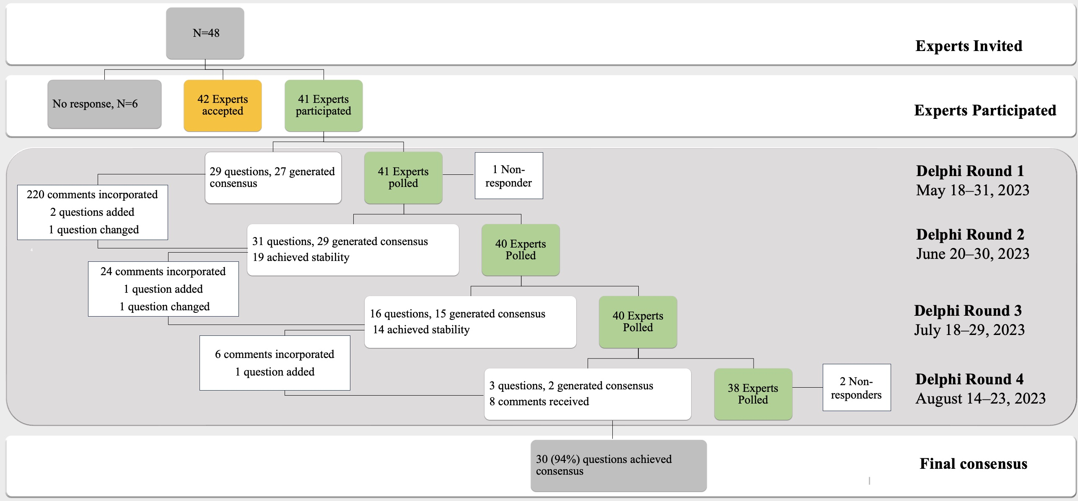

Table 5: Future Research Priorities for Sepsis Management in Resource Limited Settings

Feasibility, reliability and validation of the clinical practice statements
Optimal methods to enhance community awareness and implement prevention strategies for sepsis
Optimal methods for training health care providers
Optimal methods for early detection and cost-effective diagnostics
Optimal strategies for triaging patients
Prevention of healthcare-associated infections
Management of sepsis caused by tropical infections.
Management of infections specific to low- and middle-income countries
Epidemiology and management strategies for multi-drug resistant organisms
Research on whether fixed duration antimicrobial regimes are safe and can shorten duration of antimicrobial therapy in patients with sepsis and septic shock
Clinical signs of hypoperfusion such as body temperature and capillary refill time in dark-skinned individuals
Choice of fluids and fluid resuscitation strategies to improve outcomes
Feasibility of peripheral vasopressor therapy if central venous access is not feasible
Efficacy and safety of corticosteroids in the sepsis management
Cost-economic analysis of sepsis management in resource - limited settings
Effect of remote monitoring / tele ICU on patient outcomes and acceptance by patients and families.
Patient and relative’s perspectives on management of sepsis
Inception cohort studies to understand current practice and practice variability in management of sepsis in resource limited settings
Inception cohort studies to understand longer term outcomes, ongoing health problems and ongoing health care resource use of patients recovering from sepsis in resource limited settings

